**MyCalendar**

**Aras Innovator Community Projects**

**Description**

**What is “MyCalendar”**

* Narrowing conditions down and changing display order in status and container information are the standard functions of Aras Innovator. The function [my calendar] was implemented to express these functions more visually.
* Workflow task (1) and Project task (2) are displayed in the monthly calendar visually, understandable and divided by different colors. At the same time, only the tasks that were assigned to logged in user are shown as it happens in “InBasket”.

**Deploy documentation**

1. Copy folders below a Client folder to Aras Innovator folders below a Client folder.
2. Copy folders below a Server folder to Aras Innovator folders below a Server folder.

If necessary, merge method-config.xml.

1. Import packages below a Package folder into Aras Innovator. To import, please, use Aras Innovator utility tool.

**Folder layout**

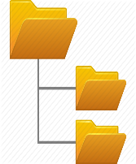

Installation destination/Innovator

Client

Solutions

Javascript (JS File)

Scripts

Styles (Css File)

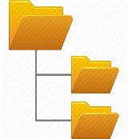

**Screen shot**

InBasket is visually displayed in Calendar format.

Project task information is shown pink (milestones are green), blue is used to show workflow information.

When a cursor is superimposed on the calendar task, the detailed information is shown.

If workflow task at the task bar is chosen, it will transit to target Item Type linked to it, if project task is chosen it will transit to target Item Type linked to it, what makes it possible to verify the content.

Screen shot on the left shows the example of opening ECO Item Type from [Calendar], screen shot on the right shows the example of opening Project Item Type from Project Task.

**Additional future functions:**

* Workflow tasks are displayed according to “active start date” of the calendar and we will provide the function that allows displaying them according to “cutoff date”.
* Depending on workflow priority, it is possible to add color scheme setting function.
* Add the function that allows linking the calendar to outlook exchange and google calendar.
* Add the function that allows displaying event information and factory calendar in addition to the main task.