Purpose:
To give Project managers a tool to simplify the understanding, documenting and analysis of risk in their project plans, and provide a workflow-driven means to mitigate specific risk elements.

Summary:
This package builds on the Aras standard Quality Planning application, integrating the best-practices FMEA (Failure Mode Effects Analysis) technique with Project planning to support Project risk analysis. Since Project FMEA’s are integrated within Aras Innovator, normal team collaboration, reporting and workflow functions can be used to discover and mitigate Project risk.

Screenshot of the Project Tree showing the new Risk column
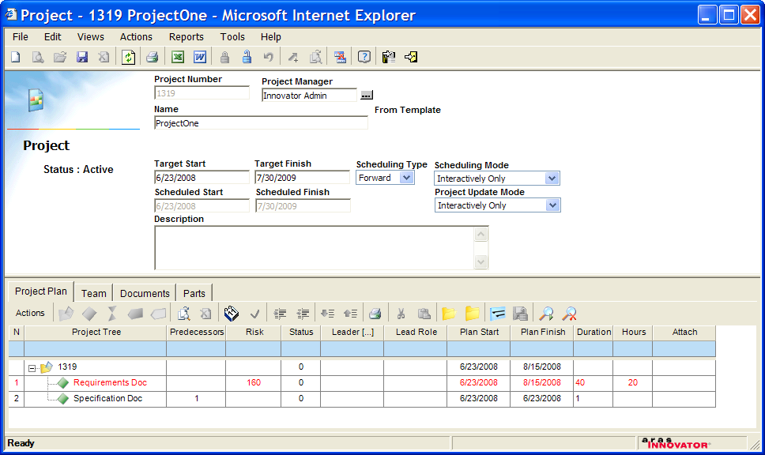

For each Project Activity, 1 or more criteria, such as Cost or Schedule can be analyzed using FMEA techniques, using the FMEA Risk Analysis tab on the Activity form. The result is an RPN (risk profile number) automatically calculated for each combination of Failure Mode, Effect, Cause, Occurrence and Detection probability. The RPN maximum is then rolled up to the Activity, and also reported in the Project Tree view. This provides a way for the project manager to rapidly scan the Project WBS structure to identify the highest risks to success. Each RPN is linked to an Action Item, which connects a workflow-driven closed loop process to the FMEA.
All mitigation actions are also documented within the Project plan.

Screenshot of the Activity Form showing the Risk Analysis Tab
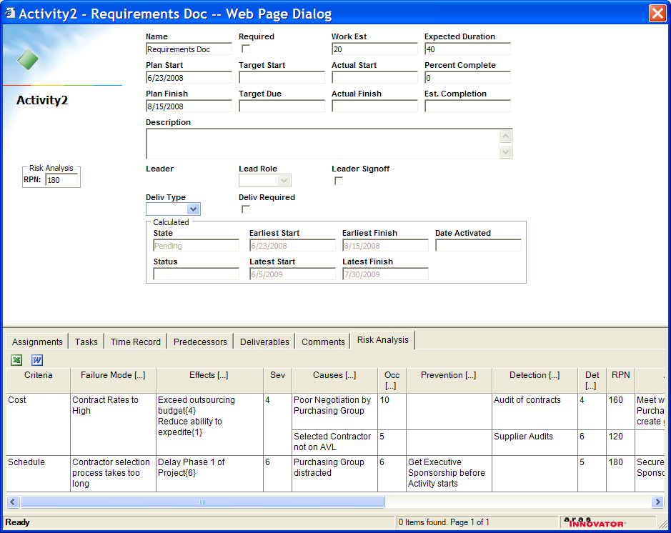

Status:
This first build of the solution is being distributed to promote dialog on the topics of Project risk management and to define the requirements for a future production-solution.
With this release, an FMEA can be data entered for each Activity on a Project, saved and viewed. The resulting RPN is rolled up and displayed on the Project Tree.

Installation:
This RISK package can be installed with the standard Solution Import/Export tools. NOTE: it is dependent on the Quality Planning solution. Package Import has been tested on the version 9.0.1 standard Innovator Solutions database.

After import of the package, you may want to edit the Preferences for the Project Tree grid columns. By default, the Import places the Risk column to the far right of the tree. Easier to scan the risk values if the column is moved to the left side.

Still to-do:
- InBasket currently does not display Risk action items without a server patch (contact me for the patch)
- Rollup of Activity RPN to the WBS level is not enabled
- Rollup of maximum(RPN) to the Activity is not 100% perfect
- Risk analysis grid should insert “Cost” and “Schedule” as two default criteria so the user does not start with a blank grid
- Need Reports and Dashboards
- Need to set the RPN Thresholds by Project to establish reporting and dashboard criteria

Peter Schroer
pschroer@aras.com

