Instructions on how to configure an ItemProperty to be hidden on the Form, but displayed on the face of a TAB.
In the example, the Project Item has a property of type=Item pointing to a Marketing Brief item. The Field is hidden on the form, but displayed on a tab face.

Screen Shot of the result:
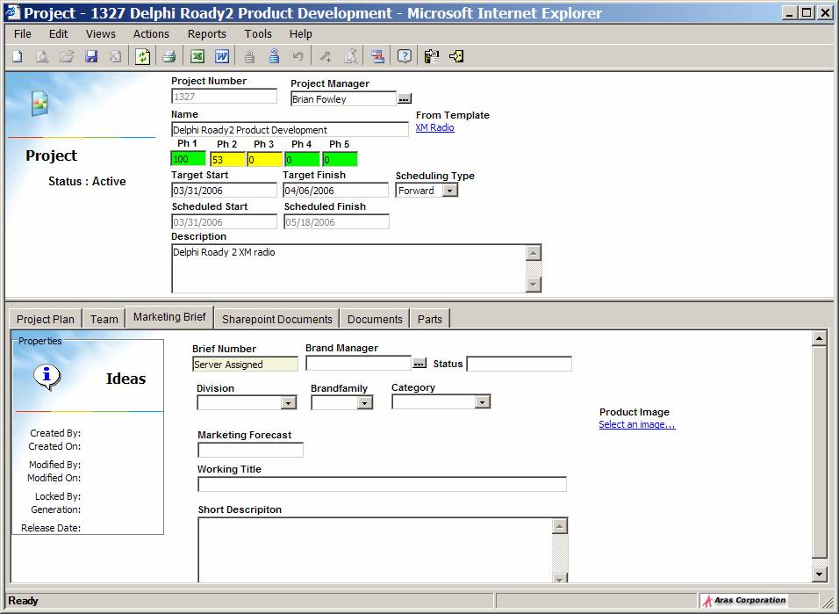

How to configure:

On the Project Item, add the Item Property pointing to the second Item.
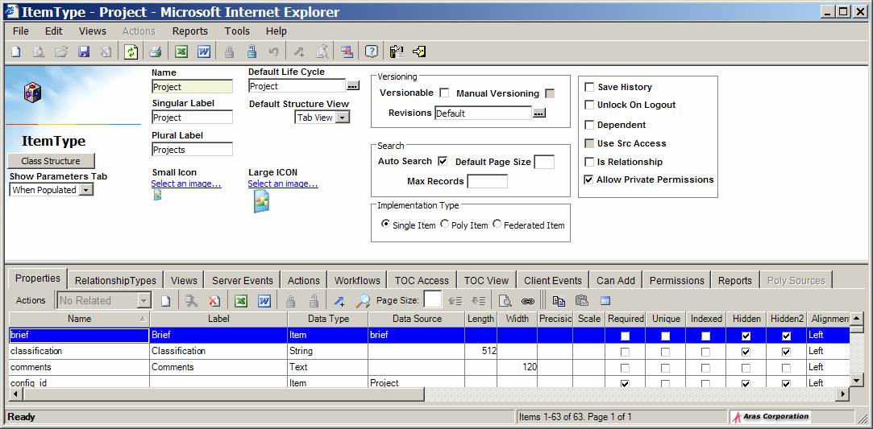

Then add a relationship. It won’t be used for data, just to create the TAB.

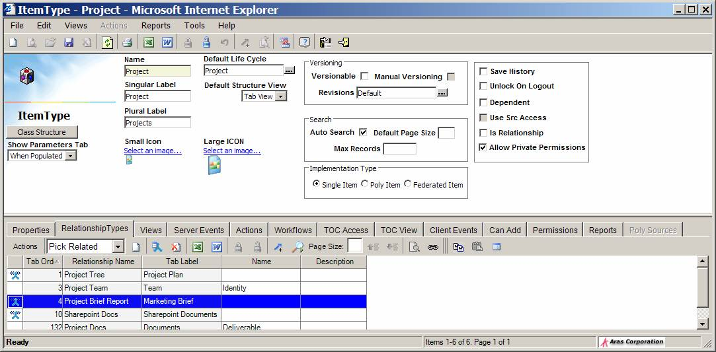

Edit the RelationshipType to set a VIEW.

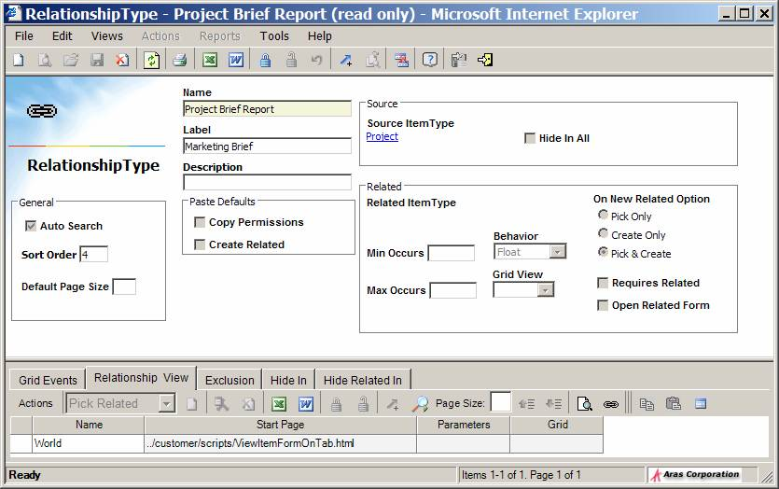

On the Project Form, make sure the Brief field is instantiated, but it can be (maybe should be) Hidden.

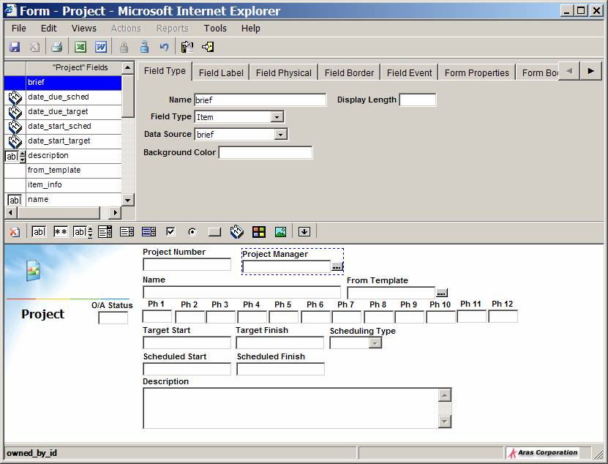
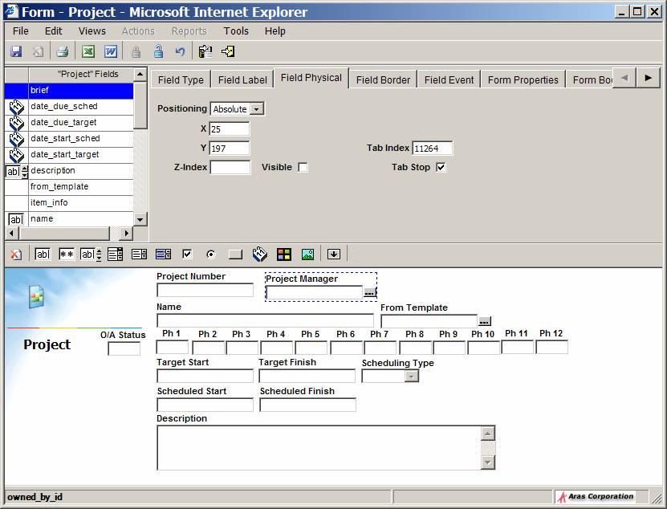

And save the attached ZIP file into the ../client/customer/scripts folder.

The HTML page is fairly generic. Has 2 variables at the top that set the name and type of the property that should be rendered on the Tab.
If desired, we can pass these as parameters on the Relationship View, and have the HTML file be universally generic.

