***Introduction Business Problem:***

*I would like to review the venues in different neighborhoods of North York, Toronto to determine in which neighborhood I have a higher chance of opening a Café.*

***Data:***

*I need the name of the Neighborhoods of North York Toronto, and I need the list of venues each neighborhood has. The name of Neighborhoods as well as their latitudes and longitudes are opening via Wikipedia and Google*

***Solution:***

*Determining the top 10 most common venue types in each neighborhood and chose a neighborhood that Café is the 10th most common type of venue, which that obviously means there is not enough café at that neighborhood.*

***Steps:***

First, we are getting the Toronto’s map along with All districts/Boroughs and Neighborhoods.

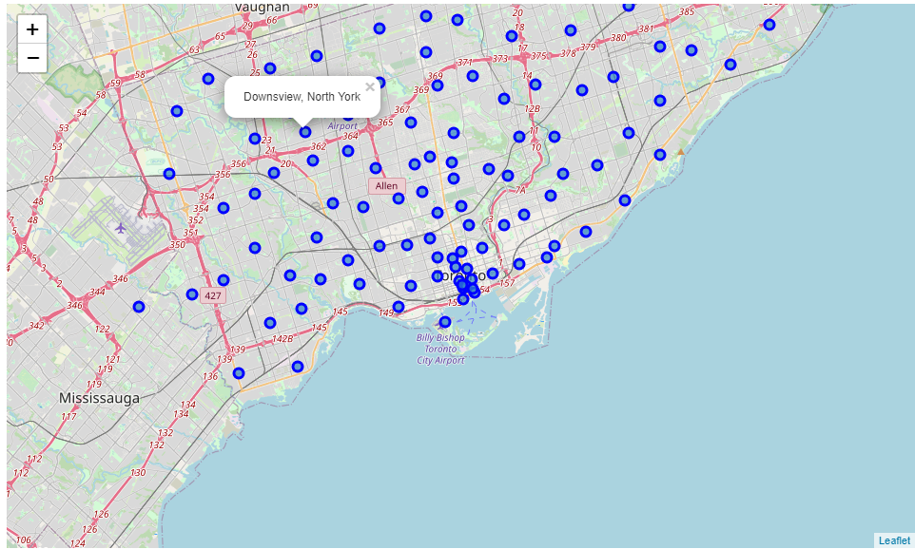

Next, I am going to create the map of North York with all it’s neighborhoods

*  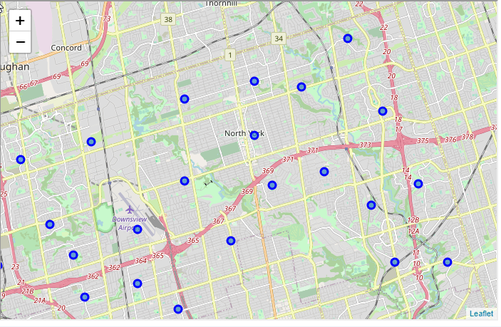

After that I am going to find a list of North York’s neighborhoods

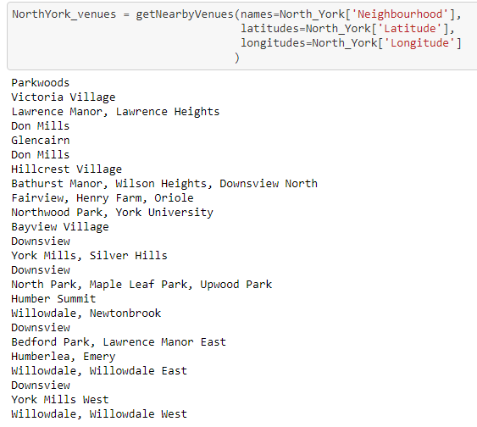

Next, I am going to analyze the list of different venues in North York Borough to determine what kind of business are in North York

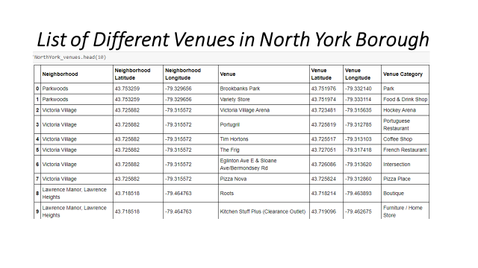

* Next, we are finding a most common venues in different neighborhoods of North York
* We are finding the 10th most common venue in each neighborhood
* We will select a neighborhood that Café is the 10th most common venue, which means obviously, there is a need for a café in that neighborhoods.

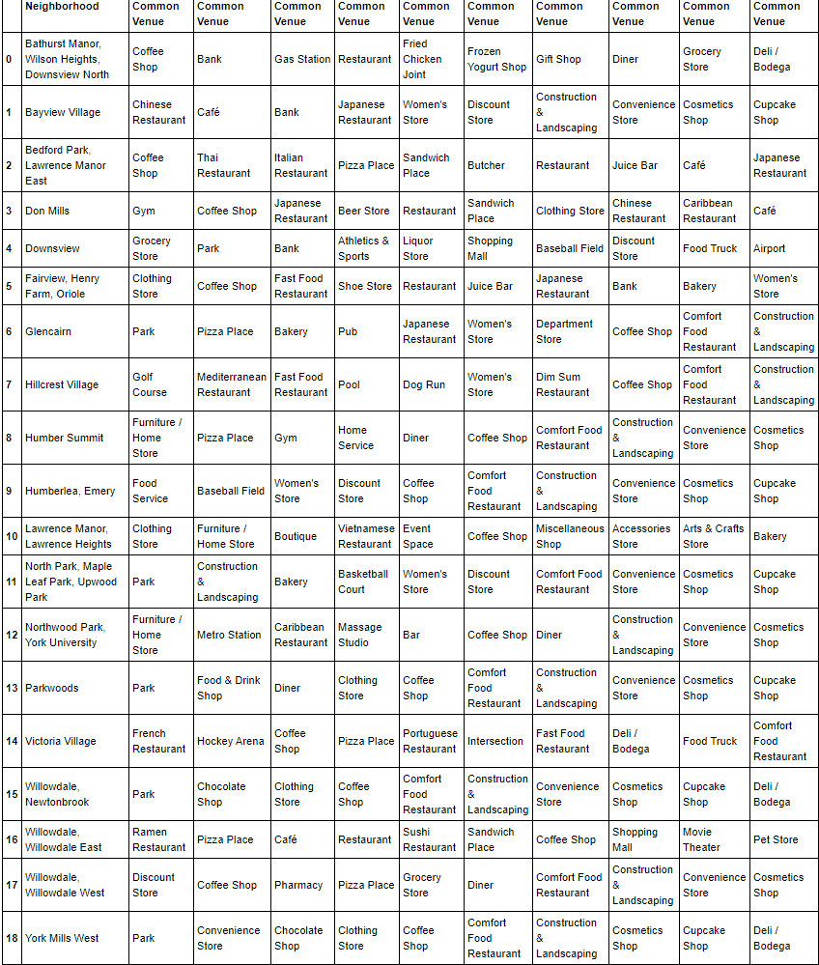

**Conclusion**

* **Conclusion is that in Don Mills Neighborhood of Noth York Cafe's are the 10 most common business, therefore there is a shortage of Cafes and it is a good Neighborhood to open a Cafe**