1. Quyidagi ro’yhatni shakllantiring.  
   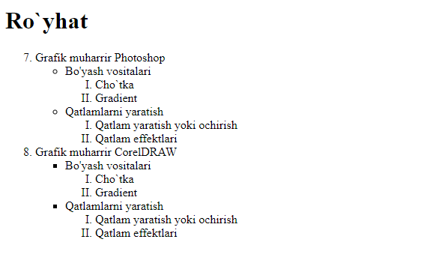
2. Quyidagi ro’yhatni shakillantiring  
   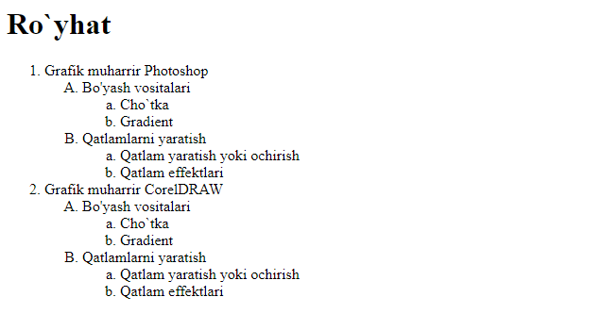
3. Quyidagi ro’yhatni shakillantiring  
   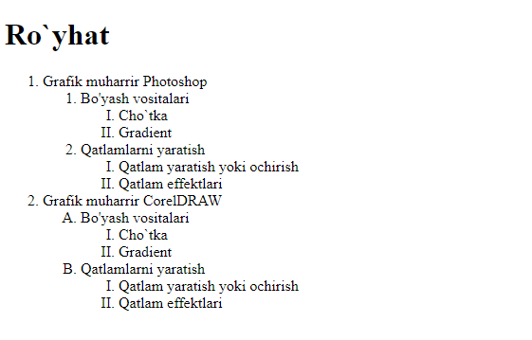
4. Quyidagi ro’yhatni shakillantiring  
   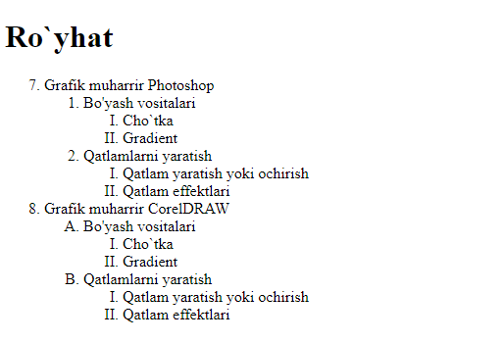
5. Quyidagi ro’yhatni shakillantiring  
   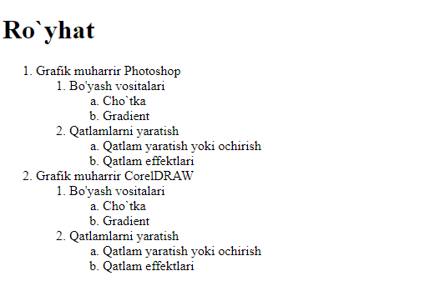
6. Quyidagi ro’yhatni shakillantiring  
   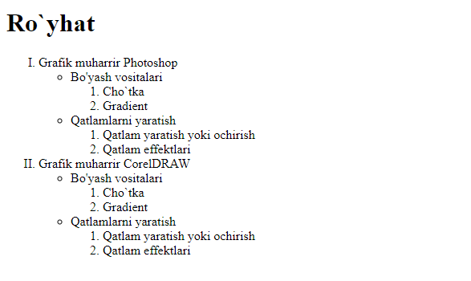
7. Quyidagi ro’yhatni shakillantiri