SedSAT User’s Manual
Arash Massoudieh
Allen C. Gellis
Cara L Peterman-Phipps
April 2023
Table of Contents

Executive Summary
The Sediment Source Assessment Tool3 (SedSAT3) User’s Manual provides comprehensive guidance for users of the SedSAT3 software, a tool developed for sediment source fingerprinting. SedSAT3 is an update to the earlier version of SedSAT (Gorman Sanisaca, Gellis, and Lorenz 2017). The software facilitates the analysis of sediment sources and their contributions to a particular target site by utilizing elemental composition data. Key functions of SedSAT3 include data preparation, statistical analysis, and sediment source attribution using various methods such as Levenberg-Marquardt Maximum Likelihood Estimation, Genetic Algorithm Estimation, and Bayesian Inference. The manual outlines the steps required for importing and preparing raw data, followed by pre-analysis tasks like correlation matrix generation, outlier detection, and organic matter and particle size corrections. It also provides tools for advanced statistical analysis, including variance analysis and discriminant function analysis, to aid in selecting the most effective elements for fingerprinting. The manual culminates in detailed instructions for executing source attribution models and performing uncertainty analysis. A mathematical appendix explains the theoretical foundations for the modeling methods used in the software, offering users both practical and technical insights for sediment fingerprinting.

1 Raw data preparation
The raw data for SedSAT3 must be prepared as a single Excel spreadsheet file with multiple tabs. The first tab contains the elemental profiles of the target samples, and each subsequent tab contains the elemental profiles for one source group. In each sheet, each row corresponds to one sample, the first column contains the sample names, and each remaining column represents one element. Grain size and/or organic content may appear in any column. For SedSAT3 to function correctly, the data must be properly formatted; an example dataset is available at https://sedsat.org/wp-content/Data/SampleData.xlsx. The specific text used for column or field headers is not important, but the relative position of columns in the source and target datasets must be identical—this is a core requirement for the program to run successfully. Column or field headers should be unique; no field name may match another field name within the same dataset. Note that each sheet must contain exactly the same elements, named in exactly the same way.

1.1 Importing the data
To import the data, choose File$→$Import Data from Excel from the menu bar at the top left of the program, then navigate to the Excel file.
Before the Excel file is imported, you must select the tabs you want SedSAT3 to import.
Once the Excel file is imported, a dialog box will appear asking you to identify the sheet containing the target samples (Fig. 1.1). Select the radio button corresponding to the target sample sheet, confirm that each remaining Excel sheet is a source sample sheet, and then click Ok.
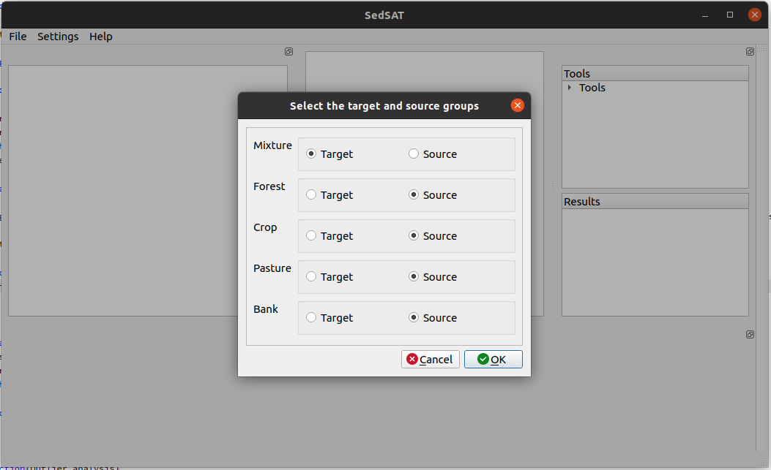
Figure 1.1: Indicating the target sample
After identifying the target sample spreadsheet, a dialog box will appear that lets you include or exclude samples, followed by the constituent properties window (Fig. 1.2). Each window panel and individual columns can be resized by hovering your mouse between column headers; a double arrow will appear that lets you resize them for better viewing.
The middle window panel contains five columns. The constituents are listed in the first column. In the second column (Constituent Type), you can double-click on each entry to open a drop-down menu with the following options:
- Element
- Isotope
- Particle size
- Organic carbon
- Exclude
You can also exclude an element from the analysis by unchecking the value in the fifth column of the table. For isotopes, you must choose the base element and the standard isotope ratio. These are needed for converting $δ$ values to the elemental content of the isotope. For example, for $​^{15}N$, the base element is $N$ and the standard isotope ratio is ${\left(​^{15}N/N\right)}_{std}=0.003676$. If a constituent is designated as particle size or organic matter, it will be used directly in sediment fingerprinting for size and organic matter corrections.
You can revisit the constituent properties at any time through the top menu item Settings$→$Constituent properties.
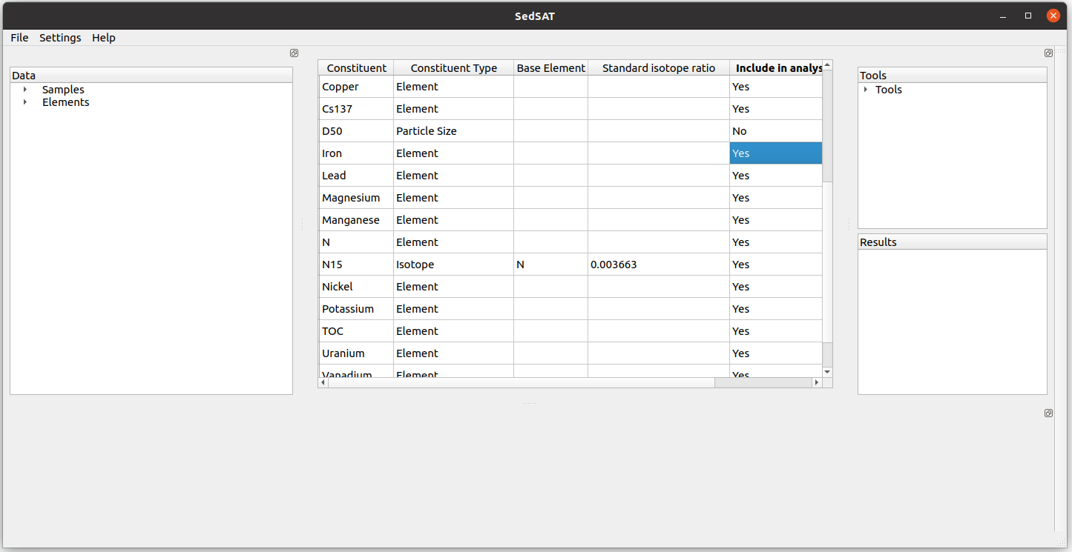
Figure 1.2: Specifying constituents’ properties
Now is a good time to save your project using File$→$Save or pressing Ctrl+S. The file is saved in a readable JSON format with the extension .cmb (CMB Source file). You can open it in any text editor to inspect its contents, and you can reload the project at any time.
You can visualize the elemental profiles using the tree view on the left side of the screen labeled Data: select any element to display its profile (Fig. 1.3).
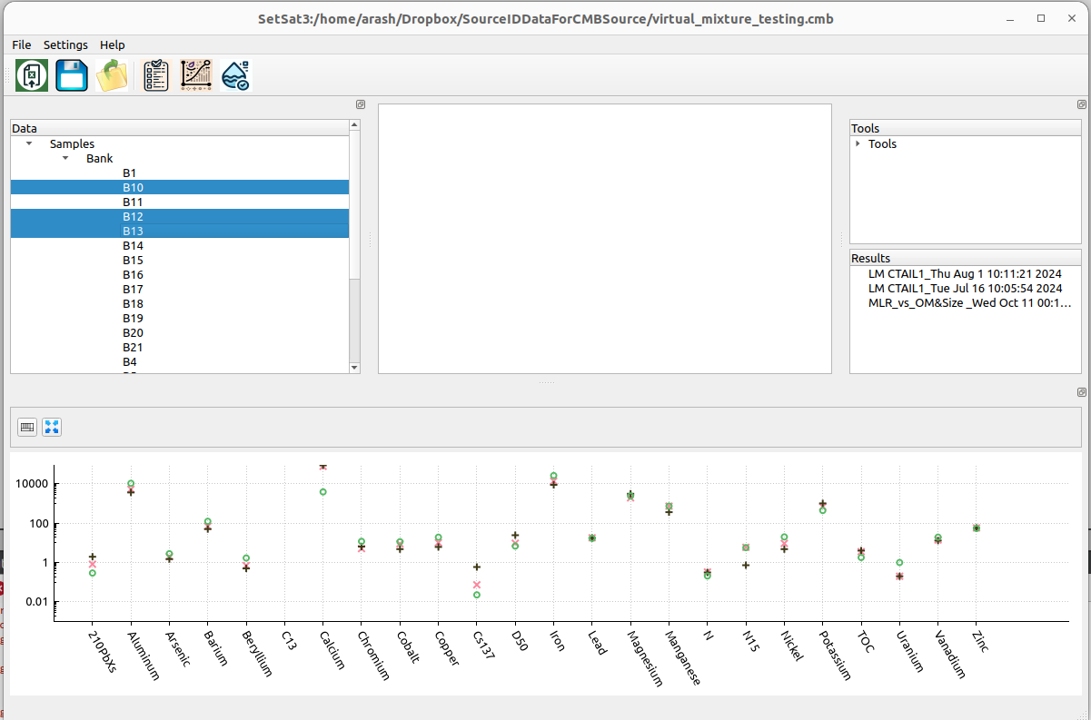
Figure 1.3: Visualizing the raw data

1.1.0.1 Choosing samples to be discarded
After you confirm the target and source group assignments, an Include/Exclude Samples dialog appears. This dialog lets you mark individual samples for exclusion from all subsequent analyses without removing them from the dataset.
The dialog contains one tab per source group (and one for the target samples). Each tab shows three columns:
- Sample — the sample name as imported from Excel.
- Include — whether the sample is included in the analysis. Double-click a cell to toggle between Yes and No.
- Notes — automatically populated annotations, such as which elements (if any) were flagged as outliers. Samples with outlier flags are highlighted in red (see Section 2.1).
At the import stage, the Notes column will typically be empty because the outlier test has not yet been run. You can leave all samples included for now and revisit this dialog later, after running the outlier analysis, organic matter and particle size regressions, or any other diagnostic that may suggest a sample should be discarded.
To exclude a sample at any time, return to this dialog through Settings$→$Include/Exclude Samples in the top menu, then double-click the Include cell next to the sample name and set the value to No. Excluded samples remain in the project file but are skipped by all analyses that respect the include/exclude flag. To re-include a sample later, set the value back to Yes.
Note: Do not deselect target samples at this stage. Target samples are listed on the top tab of the dialog, but the include/exclude flag for target samples is used only by certain batch tools. For deterministic and Bayesian fingerprinting, the target sample is selected explicitly when each analysis is run.

2 Deterministic Fingerprinting Tools
This chapter outlines the complete sequence of steps and tools required to perform maximum-likelihood (deterministic) sediment fingerprinting. The process consists of the following steps, in order: outlier analysis (Section 2.1), organic matter and particle size correction (Section 2.2), and bracketing analysis (Section 2.3). Section 2.4 introduces the theoretical basis of discriminant function analysis (DFA), which is then applied in Section 2.5 to perform multi-way stepwise DFA across all source groups — the standard tracer-selection step in the workflow. The chapter concludes with the fingerprinting procedure itself, available as a single-sample tool (Section 2.6) and a batch tool (Section 2.7).

2.1 Outlier analysis
The outlier analysis detects possible outliers in the elemental content of individual samples. For each source group, it first maps the concentration of each element using the Box–Cox transformation to bring its distribution as close as possible to a Gaussian:
${\hat{y}}_{i,j,k}=\left\{\begin{matrix}\frac{{\left(\frac{y_{i,j,k}}{σ_{i,j}}\right)}^{λ}-1}{λ} & \text{for }λ≠0 \\ log\left(\frac{y_{i,j,k}}{σ_{i,j}}\right) & \text{for }λ=0\end{matrix}\right.$ (2.1.1)
where $σ_{i,j}$ is the standard deviation of element $j$ in source group $i$.
The outlier analysis module first finds the optimal value of $λ$ that brings the transformed elemental concentrations closest to a normal distribution, then transforms the data using this optimal $λ$. Normality is assessed using the Kolmogorov–Smirnov test. To view the optimal values of $λ$, use Tools$→$Other Statistical Tools$→$Optimal Box-Cox parameters.
After the Box–Cox transformation, the outlier analysis feature reports the deviation from the mean for each element in each sample of the selected source group. The deviation measure is calculated as:
$z=\frac{y_{i}-μ}{σ}$ (2.1.2)
where $μ$ and $σ$ are the mean and standard deviation of the transformed elemental content in the group.
SedSAT3 runs the outlier test automatically when data is imported from Excel. A pop-up box will appear confirming that you want to use a threshold of 3. To view samples that fail the outlier test, open the Include/Exclude Samples tab. A window like Fig. 2.1 will appear. In the Notes column, samples that contain an element flagged as an outlier are highlighted in red. Note that outliers are shown by source group, which can be changed using the tab at the top. Although target samples are listed on the top tab, they should not be deselected. To exclude a sample from further analysis, double-click the Include cell next to the sample name and uncheck the box.
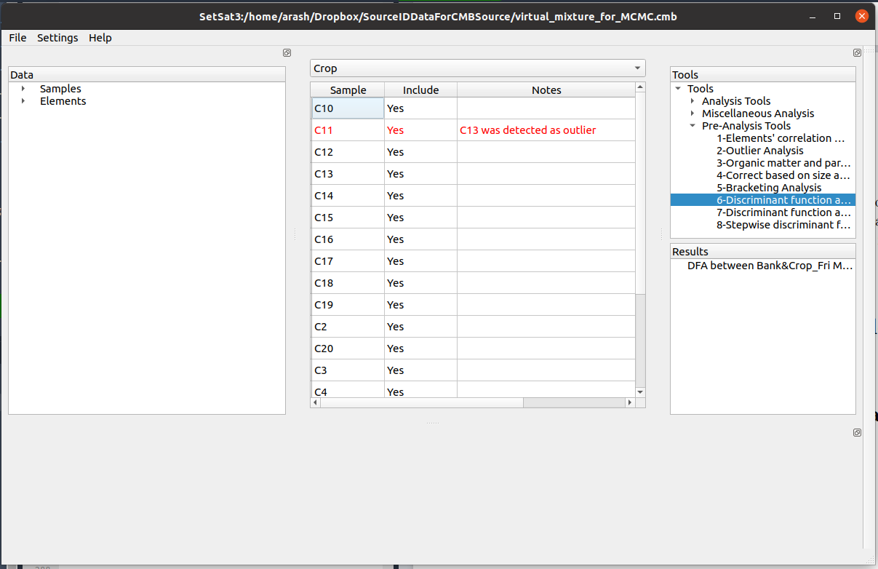
Figure 2.1: Including or excluding samples from the analysis
Although the program performs the test automatically, you can change the outlier deviation threshold by double-clicking Tools$→$Pre-Analysis Tools$→$1-Outlier Analysis. In the form that appears, select the source group on which you want the outlier analysis to be performed. The threshold sets the value of $\left|z\right|$ above which an item is highlighted in red.
Click the Ok button at the bottom of the form, then click the table button  on the window that appears. A table like Figure 2.2 will be displayed. Values outside the specified threshold are highlighted in red.
If you want to remove a sample based on the outlier analysis, go to Settings$→$Include/Exclude samples in the top menu, then in the Include column, double-click and uncheck the sample. The entry will change to ‘No’ (Fig. 2.1).
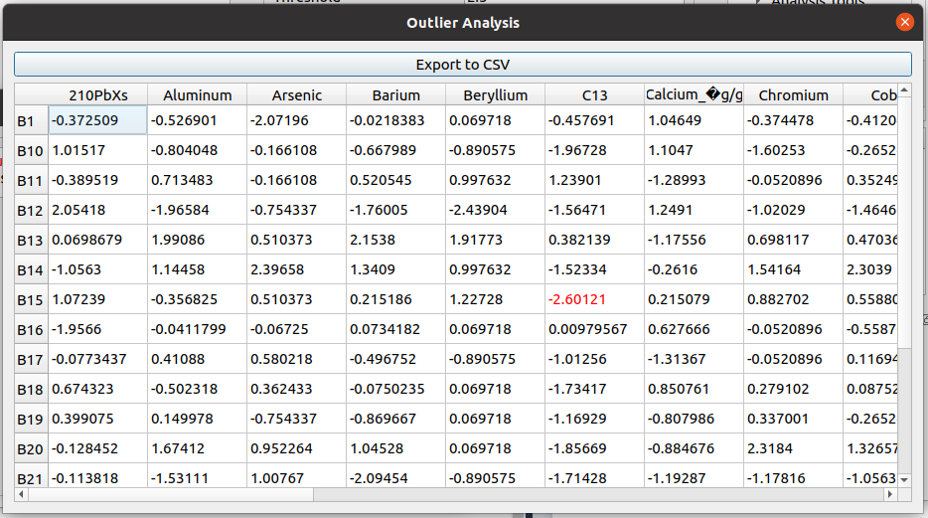
Figure 2.2: Outlier table

2.2 Organic matter and particle size correction
In sediment source fingerprinting, organic matter and particle size corrections are important when identifying and apportioning sediment sources within a watershed or catchment. These corrections account for variation in organic matter content and grain size distribution among different sediment sources, such as soil erosion, agricultural activities, and construction (Gorman-Sanisaca et al., 2017). Specifically, they account for the fact that the fraction of particles mobilized from a source may have a different organic matter content and size distribution than the bulk samples collected to represent that source. To make these corrections, SedSAT3 fits a multiple linear or non-linear regression relating the elemental content of each element to organic matter content and the mean or effective particle size. The fitted relationship is then used to correct each source sample’s elemental content using the organic matter content and particle size of the target sample.
SedSAT3 provides two regression options: linear regression and power-law regression.
Linear regression:
y=a+i​biei (2.2.3)
Power regression:
lny=a+i​bilnei (2.2.4)
where $a$ is the intercept, $b_{i}$ is the coefficient for independent variable $i$, and $e_{i}$ is the value of independent variable $i$. The independent variables can be particle size, organic matter content, or both. Once the regression coefficients and intercept have been estimated, the corrected value of each element in each source sample is computed as follows.
Linear regression:
yc=y+i​biei,t-ei,s (2.2.5)
Power regression:
yc=yi​ei,tei,sbi (2.2.6)
where $e_{i,t}$ is the value of independent variable $i$ in the target sample, and $e_{i,s}$ is the value of independent variable $i$ in the source sample.

2.2.0.1 Performing organic matter and particle size correction
In the tools window, click Tools$→$Deterministic Sediment Fingerprinting$→$2-Organic Matter and Particle Size Correction.
In the form that appears, select the regression equation from the Equation drop-down menu, then select the constituents representing organic matter and particle size. If a constituent representing organic matter or particle size is not available, or if you only want to correct based on one of them, leave the unused field blank. Click Ok at the bottom of the form. The results window that appears contains the regression results for every constituent in every source group. To visualize the regressions, click the graph button 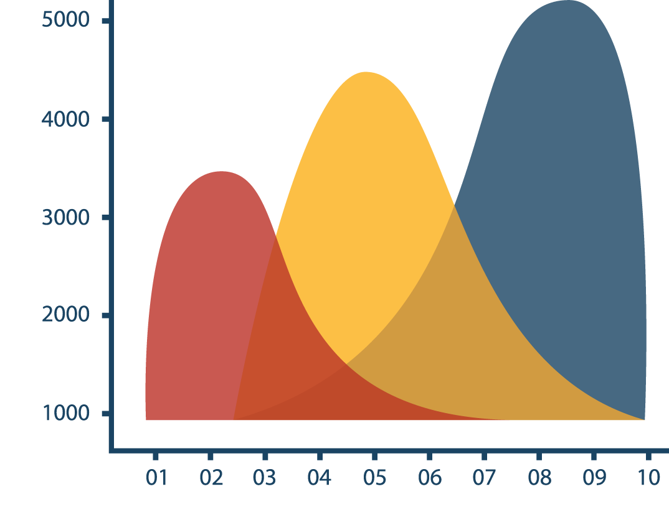. A window like Fig. 2.3 will appear. Use the combo boxes at the top to select different constituents and independent variables.
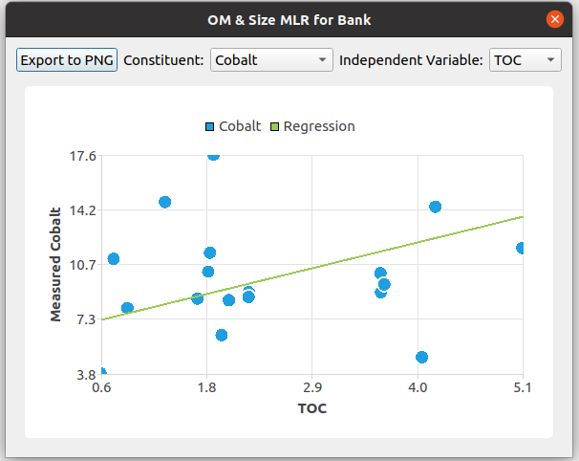
Figure 2.3: Graphical representation of OM and size correction regressions
To see the regression results in tabular form, click the table button on the side of each source group in the results window.
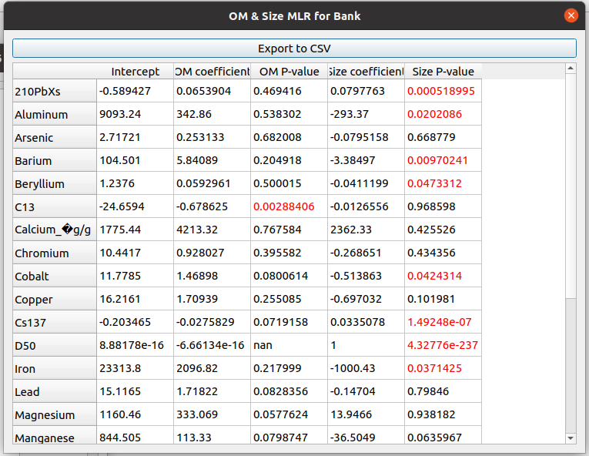
Figure 2.4: OM and size correction results
The table reports the p-values indicating the statistical significance of organic matter and size as predictors. Values below the selected threshold (e.g., 0.05) are shown in red.

2.2.0.2 Viewing the corrected elemental profiles
Based on the p-values for the OM and size coefficients, you can decide whether to apply each correction. From the top menu, select Settings$→$Organic Matter and Size Correction. A form containing the regression results will appear in the middle panel (Fig. 2.5).
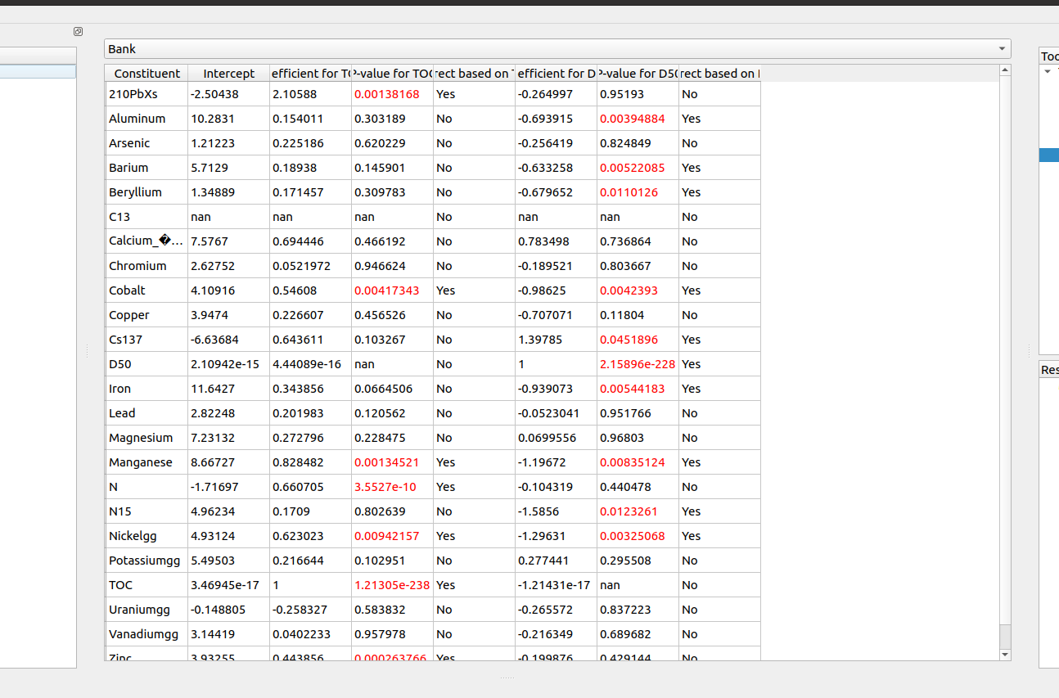
Figure 2.5: Indicating OM and size correction
The combo box at the top lets you navigate between source groups. The columns P-value for TOC and P-value for D50 display the p-values for the regression coefficients on organic matter and particle size, respectively. The columns Correct based on TOC and Correct based on D50 let you specify whether to apply each correction for each element. Elements with a p-value below 0.05 are selected for correction by default.
To view how the correction affects the elemental profiles of a particular source group for a specific target sample, choose Tools$→$2-Organic Matter and Particle Size Correction$→$2a-Corrected results (after size and organic correction) from the tools panel. In the form in the middle panel, choose the target sample on which to base the correction. The results window will contain a panel for each source group. To see the corrected elemental profiles for any source group, click the table button on the side of that panel (Fig. 2.6).
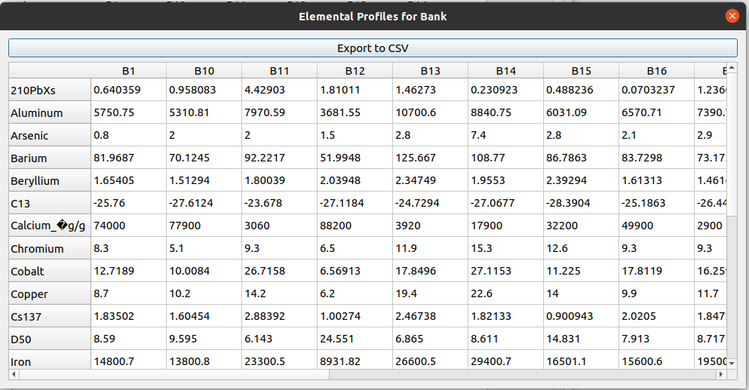
Figure 2.6: Corrected elemental profiles based on size and organic matter
You can export the corrected elemental profiles to a CSV file to compare them with the original values.

2.3 Bracketing analysis
A bracketing analysis checks whether any element in the target sample has a value higher than in all the source samples. If the content of a particular element in the target sample exceeds that of every source sample, no linear combination of sources can reproduce an elemental profile close to the target’s, and that element should be excluded from the analysis.
To perform a bracketing analysis, go to Tools$→$Deterministic Sediment Fingerprinting$→$3-Bracketing Analysis in the tools window. Choose whether to run the bracket test on samples corrected for size and organic matter, and whether to use only selected samples and elements, then click Ok. The results window indicates which elements passed and which failed the bracketing analysis. To view the results in tabular form or export them to a CSV file, click the table button (Fig. 2.7).
Elements that fail the bracket test must be removed manually: go to Settings$→$Constituent Properties, then in the Include in analysis column, uncheck each element that did not pass the bracket test. Once all failing elements have been excluded, you can proceed to the next step in sediment fingerprinting: 4-Stepwise Discriminant Function Analysis.
Note: Bracketing results are specific to each target sample. Before running the bracketing analysis on a different target sample, return to Settings$→$Constituent Properties, re-include all elements, and then re-run the bracket test for the new target sample to determine which elements to exclude.
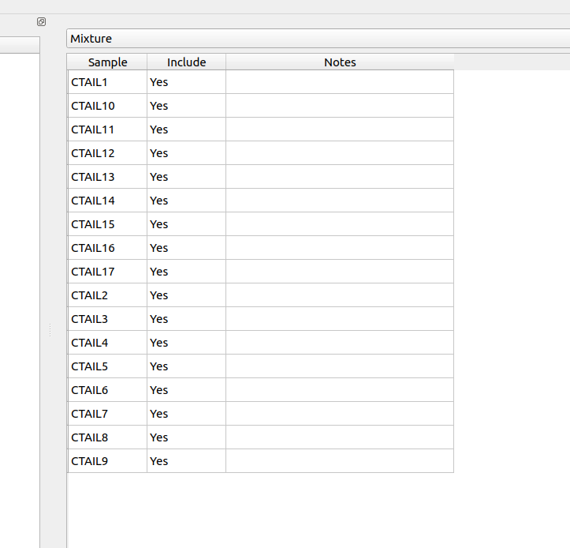
Figure 2.7: Bracketing test results

2.4 Stepwise Discriminant Function Analysis (DFA)
Once the bracketing analysis has identified the elements suitable for inclusion, the next step is to select from among those a subset that best discriminates between source groups. This section introduces the theoretical basis of discriminant function analysis (DFA); Section 2.5 describes how SedSAT3 applies it across all source groups simultaneously.
Discriminant function analysis is a multivariate statistical technique used to predict the group membership of individuals or objects based on a set of predictor variables, by finding a linear combination of those variables that maximally discriminates between two or more groups (Collins et al. 2010). The method determines a discriminant function that separates observations from different groups by reducing within-group variability while increasing between-group variability. In the context of sediment fingerprinting, DFA is used to identify which elements most effectively differentiate between two or more sources. The linear discriminant function provides a scalar value calculated as a linear combination of the elemental contents for each sample:
$D\left({\tilde{y}}_{k}\right)=w^{T}{\tilde{y}}_{k}+c$ (2.4.7)
where $D\left({\tilde{y}}_{k}\right)$ is the discriminant score of sample $k$, $w$ is a vector of weights, ${\tilde{y}}_{k}$ is the vector containing the elemental profile of sample $k$, and $c$ is a constant.
SedSAT3 uses Fisher’s linear discriminant method (Fisher 1936). The discriminant functions are found by solving an optimization problem that maximizes the Fisher criterion, which is the ratio of between-class variance to within-class variance:
$J\left(w\right)=\frac{w^{T}S_{b}w}{w^{T}S_{w}w}$ (2.4.8)
where $S_{b}$ is the between-class scatter matrix, which measures the variance between group means, and $S_{w}$ is the within-class scatter matrix, which measures the variance within groups.
This criterion is maximized by finding the eigenvectors of the matrix $S_{w}^{-1}S_{b}$. The eigenvectors corresponding to the largest eigenvalues are the directions (weights) that define the discriminant functions:
$S_{w}^{-1}S_{b}w=λw$ (2.4.9)
The weight vector is obtained as the eigenvector corresponding to the eigenvalue with the largest absolute value.
Wilks’ Lambda, $Λ$ (Wilks 1932), measures the ratio of within-group variability to total variability:
$Λ=\frac{\left|S_{w}\right|}{\left|S_{b}+S_{w}\right|}$ (2.4.10)
The associated $χ^{2}$ statistic is calculated using Bartlett’s approximation (Rencher and Christensen 2012):
$χ^{2}=-\left(n-1-\frac{p+g}{2}\right)ln\left(Λ\right)$ (2.4.11)
with $df=p×\left(g-1\right)$ degrees of freedom, where $n$ is the total number of samples across all source groups, $p$ is the total number of elements, and $g$ is the number of groups.
An F-test can also be used to test the null hypothesis that the centroids of the discriminant scores (Eq. (2.4.7)) are the same for all groups.

2.5 Multi-way discriminant function analysis
Multi-way DFA performs discriminant analysis between all source groups holistically. It provides test statistics based on weight vectors that maximize the separation between source groups. The procedure is the standard multi-group extension of Fisher’s linear discriminant analysis described in Section 2.4 (Fisher 1936; Rencher and Christensen 2012), applied in the stepwise, forward-selection manner conventionally used to select composite fingerprints in sediment source tracing (Collins, Walling, and Leeks 1997; Collins et al. 2010).
The results are similar to those for two-way and one-vs-the-rest stepwise discriminant function analysis (located in the Other Statistical Tools menu), but here the statistics are calculated between each source group and all other source samples taken together. Figure 2.8 shows the $χ^{2}$ p-values. Significant tracers are selected one at a time, beginning with the highest $χ^{2}$ p-value (left side of Fig. 2.8) and proceeding to the lowest. In the example shown, the tracers are selected in the order C13 through N.
To run the test, choose Tools$→$Deterministic Sediment Fingerprinting$→$4-Stepwise Discriminant Function Analysis (Multi-way). Decide whether to use a Box–Cox transformation, whether to apply organic matter and size corrections, and whether to restrict subsequent analyses to the elements selected by the DFA (the Modify the included elements based on the results option). Click Ok.
The result window contains three panels:
- The first panel shows the $χ^{2}$ p-values for the separation between samples in each source group and the remaining samples. A higher p-value indicates weaker separation between that source group and the rest.
- The second panel lists the Elements to be Selected.
- The third panel displays Wilks’ Lambda.
The graph button in the top panel displays the $χ^{2}$ p-values (Fig. 2.8), and the table button displays the same p-values in tabular form (Fig. 2.9).
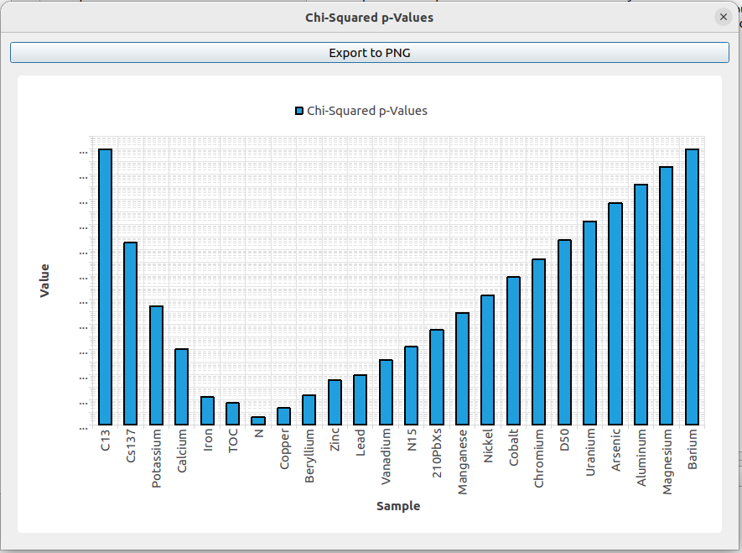
$χ^{2}$Figure 2.8: p-values vs. the number of elements included for multi-way DFA
Click the table button on the side of any panel to see the values in tabular format (Fig. 2.9a). In the example shown, Fig. 2.9a indicates weaker separation between Pasture samples and the rest of the samples than for the other source groups.
a) | b)
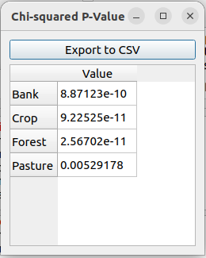 | 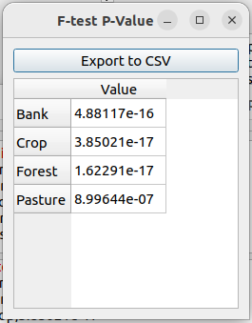

Figure 2.9: a) $χ^{2}$ p-values between each source group and the rest of the samples. b) F-test p-values between each source group and the rest of the samples, when Beryllium, $​^{13}C$, $​^{137}Cs$, Manganese, N, Nickel, and Uranium are included in the analysis.
The third panel contains the discriminant scores based on the eigenvectors obtained for each source group. Click the graph button on the side of the panel. In the graph window that appears, use the drop-down menus at the top to select the two source groups to plot (Fig. 2.10). The x-axis shows the discriminant scores based on the eigenvector that maximizes the separation between the first selected source group and the rest of the samples; the y-axis shows the discriminant scores based on the eigenvector obtained from the second selected source group.
a) | b)
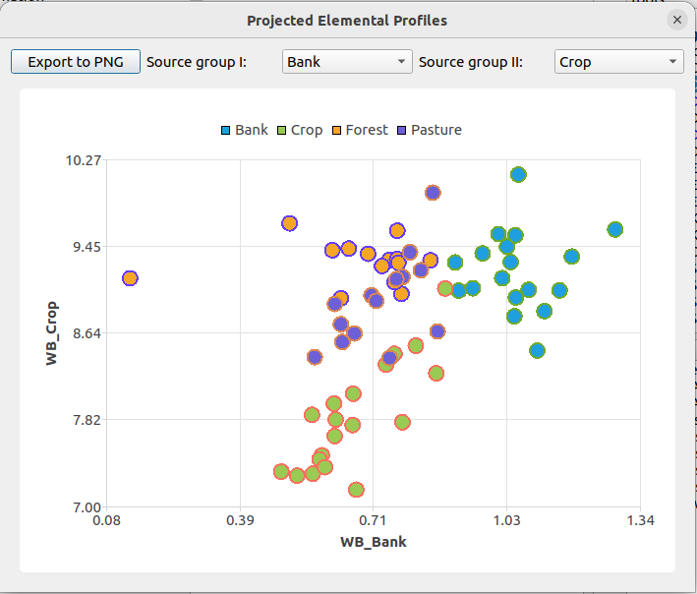 | 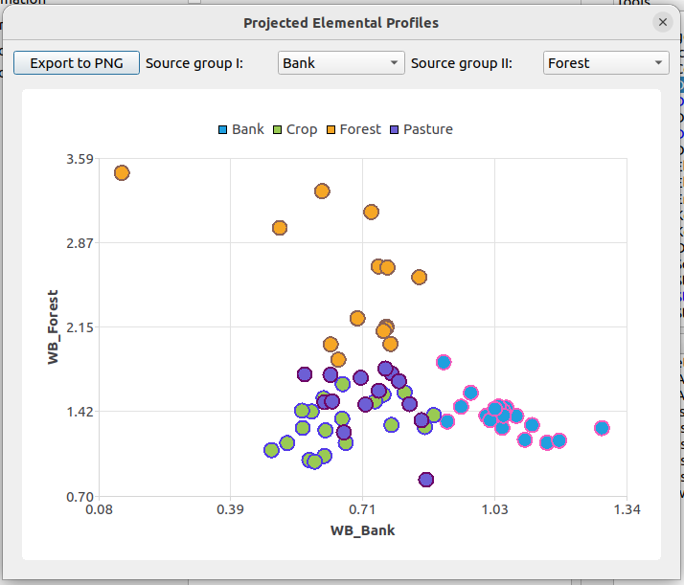
c) | d)
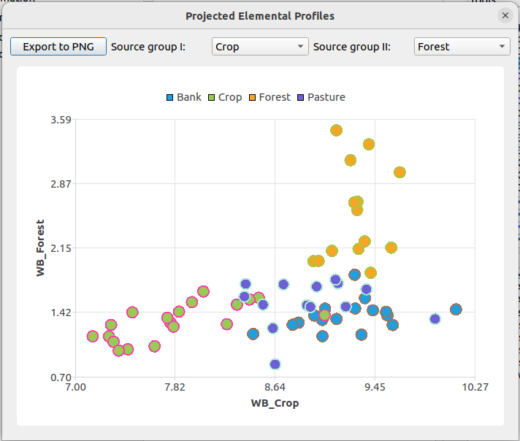 | 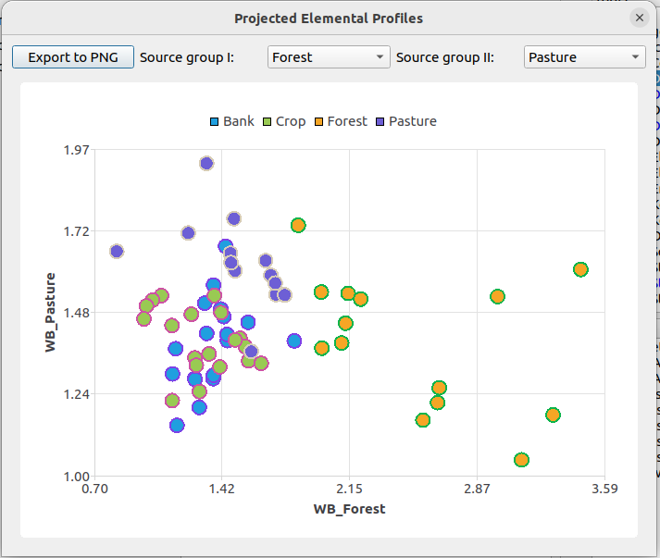

Figure 2.10: Scatter plots showing discriminant scores based on the eigenvectors obtained from: a) Bank and Crop, b) Bank and Forest, c) Crop and Forest, and d) Forest and Pasture.
Finally, the fourth panel contains the eigenvectors obtained by maximizing the separation between each source group and the rest. Click the table button on the side of the panel to view the eigenvectors in tabular form (Fig. 2.11).
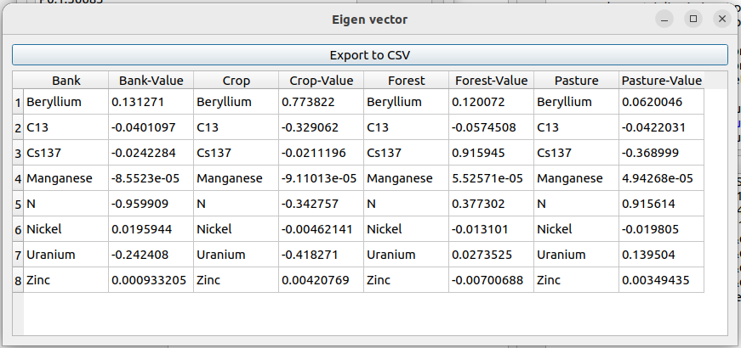
Figure 2.11: Estimated eigenvectors based on maximizing the separation of samples in each source group from all other samples.

2.6 Fingerprinting
The Levenberg–Marquardt Maximum Likelihood Estimation (LMMLE) is the simplest fingerprinting method implemented in SedSAT3. LMMLE uses the Levenberg–Marquardt optimization algorithm (Levenberg 1944; Marquardt 1963)—a damped least-squares method that interpolates between Gauss–Newton and gradient descent—to maximize the log-likelihood in Eq. (5.2.11). The transformation function $g$ is assumed to be log-normal, and the scale factor $σ$ of the log-normal distribution is assumed to be the same for all elements.
The modeled target sample elemental profile $C$ is calculated as the arithmetic average of the elemental profiles of all samples in each source group (Eq. (5.2.8)).
To perform LMMLE, select Tools$→$Deterministic Sediment Fingerprinting$→$5-Fingerprinting from the tools window.
Checking Apply size and organic correction applies the previously fitted size and organic matter correction to the source samples; the most recently fitted correction model is used. The correction is applied to the elements, particle size, and/or organic matter according to the selections in Settings$→$Organic Matter and Size Correction. If no correction has been performed yet, an error message will prompt you to perform one. You can either uncheck the correction option and proceed without it, or perform the correction and then return to this tool.
Choose the target sample you have been working with (since the bracketing test) from the Target Sample drop-down menu. The Softmax option maps the source contributions from the $\left[0,1\right]$ domain to the $\left[-∞,∞\right]$ domain through the softmax transformation:
$x_{i}=\frac{e^{ζ_{i}}}{\sum_{j=1}^{n}{e^{ζ_{j}}}}$ (2.6.12)
When this option is selected, the optimization is performed in terms of $ζ$ values rather than $x$ values. The softmax transformation implicitly enforces the constraint that the contributions sum to 1.0 (Eq. (5.1.1)), and searching in the unbounded domain is more efficient than searching in $\left[0,1\right]$.
Click the Ok button at the bottom of the form. The progress window will show the mean squared error (MSE) as the Levenberg–Marquardt iterations proceed. After convergence, the result window will appear. It contains four panels.
The first panel shows the inferred source contributions. Click the graph button on the side of the panel to view the results as a pie chart (Fig. 2.12).
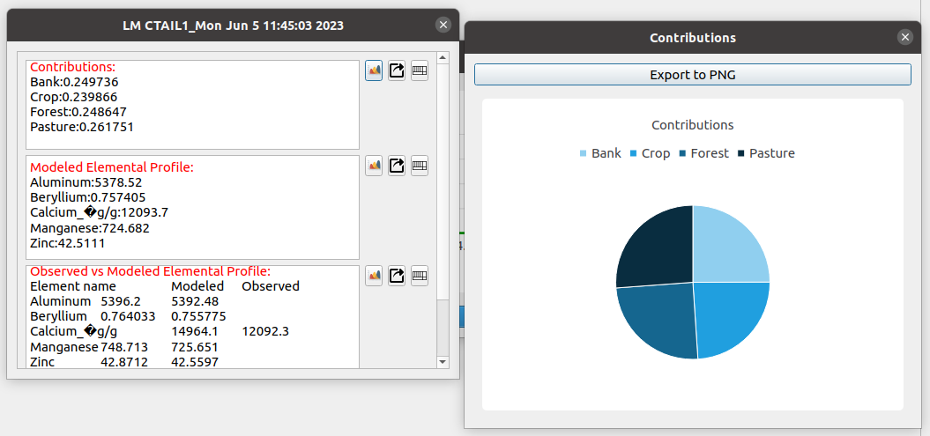
Figure 2.12: Source contributions obtained from the LMMLE method
The second panel shows the modeled target sample elemental profile, $C$. The third panel shows the modeled and observed elemental profiles side by side, which you can use to evaluate how closely the mixture of source contributions reproduces the observed target sample profile. Click the graph button on the side of the panel to view the comparison graphically (Fig. 2.13).
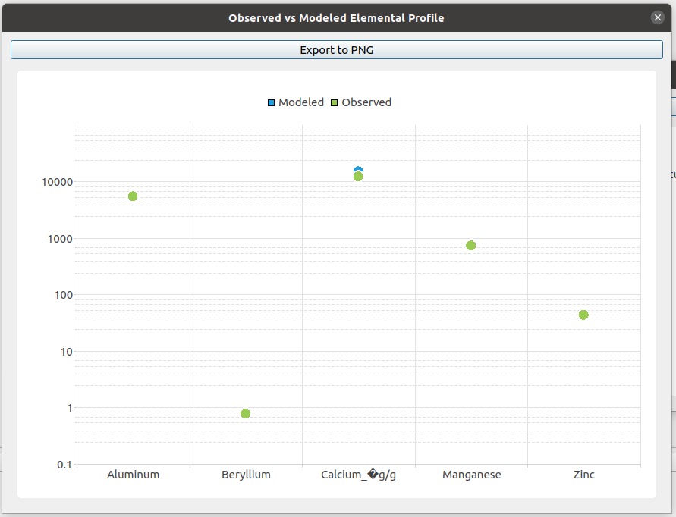
Figure 2.13: Modeled vs. observed elemental profiles
The fourth panel shows the modeled vs. measured isotope ratios, if any constituents in the analysis are isotopes.

2.7 Fingerprinting (Batch)
The batch fingerprinting tool runs Levenberg–Marquardt maximum likelihood fingerprinting on all target samples simultaneously rather than one at a time. It is intended for studies in which multiple target samples are analyzed under identical settings, and it saves the effort of opening, configuring, and saving the fingerprinting tool for each sample individually.
Note: Use the batch option only when all target samples share the same set of elements and the same pre-processing decisions (outlier exclusion, bracketing, OM and size correction, element selection from DFA). Because the analysis runs across all target samples in one pass, any element that does not pass bracketing for at least one target sample should be excluded for all of them before the batch is run; otherwise, the affected samples may produce misleading contributions.
To run the batch analysis, select Tools$→$Deterministic Sediment Fingerprinting$→$Levenberg-Marquardt Optimization (Batch) from the tools window. In the form that appears, choose whether to apply the OM and size correction to the source samples, and whether to use the softmax transformation (see Section 2.6 for details on what each option does). Click Ok and wait for the analysis to complete. Processing time depends on the number of target samples, the number of source groups, and the number of elements retained in the analysis.
The batch version of LMMLE reports less diagnostic detail than the single-sample version: only the estimated source contributions for each target sample are returned, without the modeled-versus-observed elemental profiles, MSE history, or modeled isotope ratios. If you need those diagnostics for a particular target sample, re-run the single-sample fingerprinting tool (Section 2.6) on that sample.
The result panel contains one row per target sample and one column per source group. Click the graph button on the side of the panel to view the contribution of each source to each target sample as a stacked bar chart (Fig. 2.14), or the table button to view the same results in tabular form (Fig. 2.15). The table can be exported to a CSV file using the Export to CSV button at the top of the window, which is useful for downstream analysis or for combining results across batches.
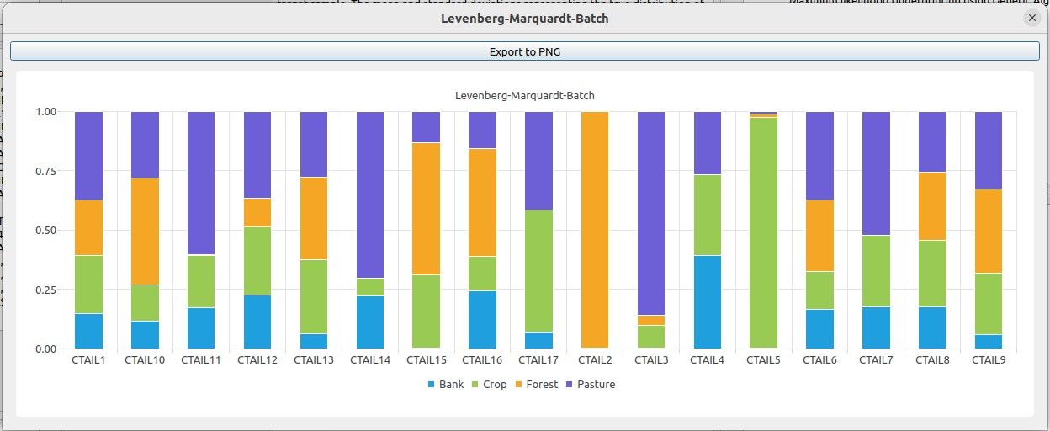
Figure 2.14: Stacked bar chart of Levenberg–Marquardt batch fingerprinting results, showing the source contributions to each target sample.
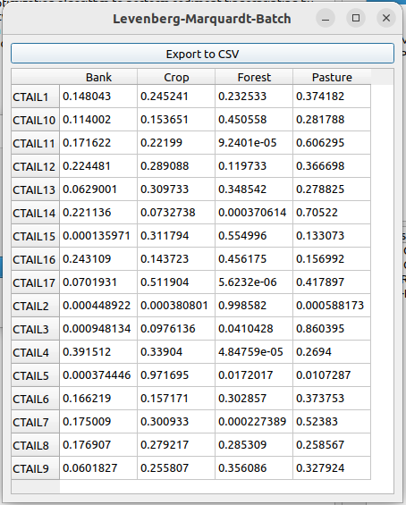
Figure 2.15: Levenberg–Marquardt batch results in tabular format.

3 Bayesian Sediment Fingerprinting
This chapter covers the Bayesian fingerprinting method implemented in SedSAT3. The pre-analysis steps required for Bayesian fingerprinting—namely, Outlier Analysis, Organic Matter and Particle Size Correction, Bracketing Analysis, and Stepwise Discriminant Function Analysis—were presented in the previous chapter. The focus here is on the Bayesian sediment fingerprinting procedure, which produces the final results of the analysis.

3.1 Bayesian Chemical Mass Balance Analysis
As discussed in Section 5.3, sediment fingerprinting is subject to several sources of uncertainty, including (but not limited to) measurement error, lack of representativeness of source samples, the presence of unidentified sources, and equifinality. Rather than producing point estimates as the maximum likelihood approach does, the Bayesian approach yields a full probability distribution for each source contribution, allowing these uncertainties to be quantified. The Bayesian chemical mass balance formulation implemented in SedSAT3 follows Massoudieh et al. (2013) and Stewart, Massoudieh, and Gellis (2015). The posterior distribution is sampled using Markov chain Monte Carlo (MCMC).
To perform Bayesian fingerprinting, select Tools$→$Bayesian Sediment Fingerprinting$→$Bayesian Chemical Mass Balance Analysis from the tools window.
The settings in the central form are:
- Apply size and organic matter correction: whether to perform the analysis on the elemental profiles corrected for particle size and organic matter content. Note that the size and organic matter correction step (Section 2.2) must have been performed beforehand for this option to take effect.
- Dissolve Chains: when checked, MCMC chains with significantly lower posterior probability are discarded during sampling and replaced by chains with higher posterior probability. This improves the convergence speed of the algorithm.
- Number of Chains: the number of MCMC chains to run in parallel.
- Number of Samples: the total number of MCMC samples to generate. Typically, 100,000 samples or more are required for full convergence.
- Sample: the label of the target sample to be analyzed.
- Samples file name: the text file in which the MCMC samples will be saved.
- Samples to be discarded (burn-in): the number of samples to discard from the beginning of each MCMC chain. If the total number of samples is 100,000, a burn-in of 20,000 is recommended.
After setting the parameters, click Ok to start the analysis. The runtime depends on the number of samples requested.
The progress window (Fig. 3.1) provides diagnostic information that can help you tune the MCMC sampling parameters.
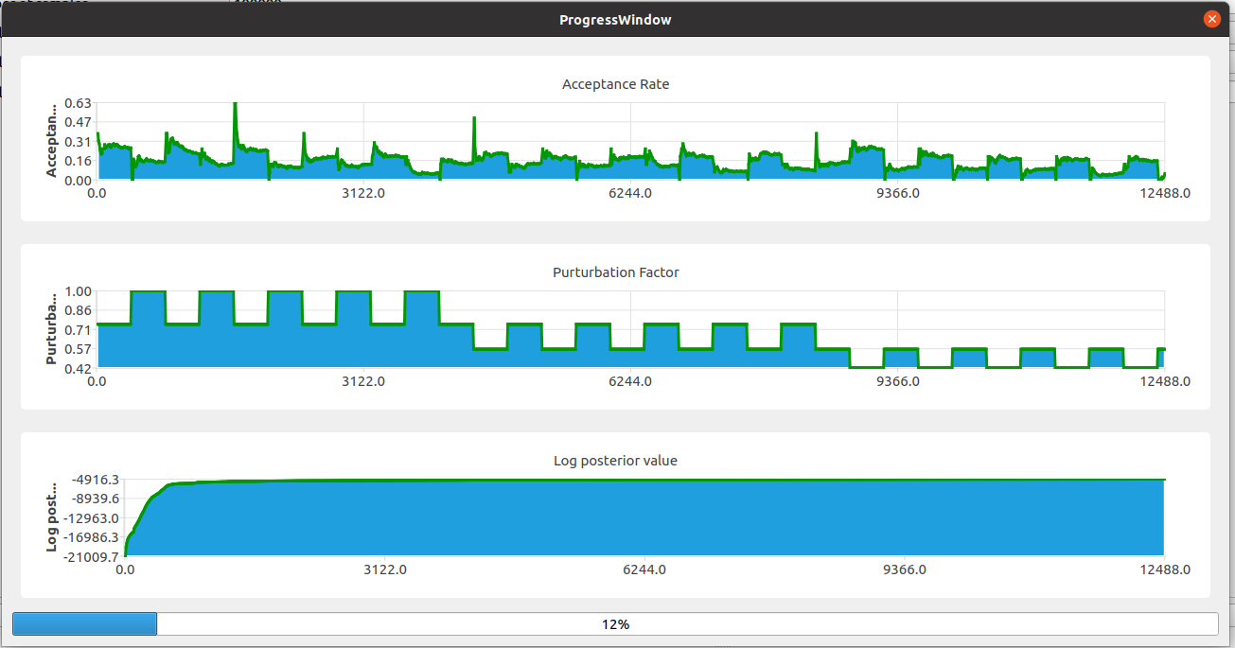
Figure 3.1: Progress window of the Bayesian chemical mass balance analysis.
The top panel shows the average acceptance rate (the fraction of proposed samples that are accepted). The middle panel shows the perturbation factor, which is automatically adjusted to maintain an acceptance rate of approximately 15%. The bottom panel shows the maximum value of the posterior numerator (Eq. (5.3.20)). Initially, this value is low because the samples are far from the maximum-likelihood region; as the algorithm proceeds, the value rises and eventually stabilizes. A reasonable burn-in length can be chosen as the number of samples it takes for this curve to stabilize.
Once MCMC sampling is complete, a result window appears containing five panels.
The first panel contains the MCMC samples for every estimated parameter: source contributions, the $μ$ and $σ$ parameters of the log-normal distributions assumed for the elemental content of each source group, and the error standard deviations. Click the graph button to visualize the samples (Fig. 3.2), and use the drop-down menu at the top of the graph to switch between parameters. Inspect these plots to assess convergence. For example, in Fig. 3.2 the bank and crop contribution samples indicate that the algorithm takes approximately 25,000 samples to converge.
a) | b)
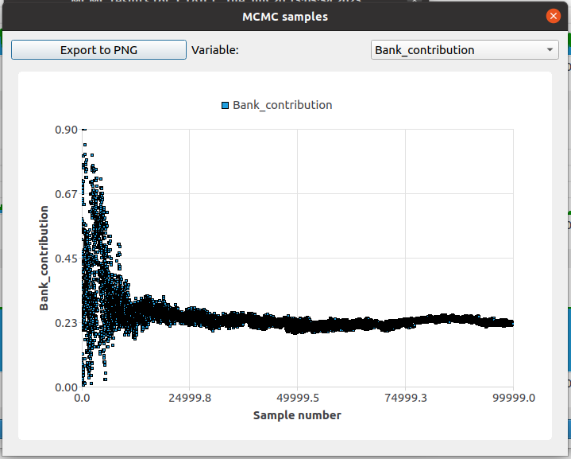 | 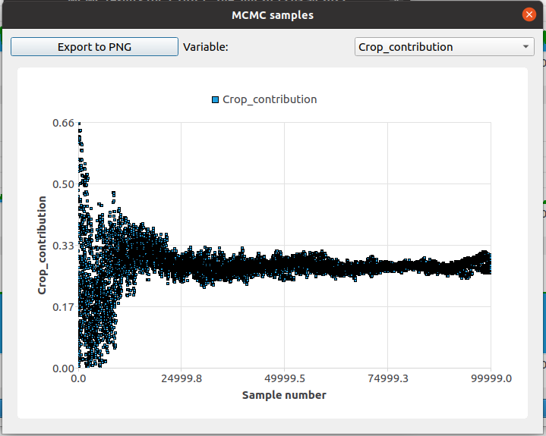

Figure 3.2: Visualization of MCMC samples: a) bank contribution samples, b) crop contribution samples.
The second panel shows the posterior distributions estimated from the samples. Click the graph button to view the posterior distributions for all parameters (Fig. 3.3).
a) | b)
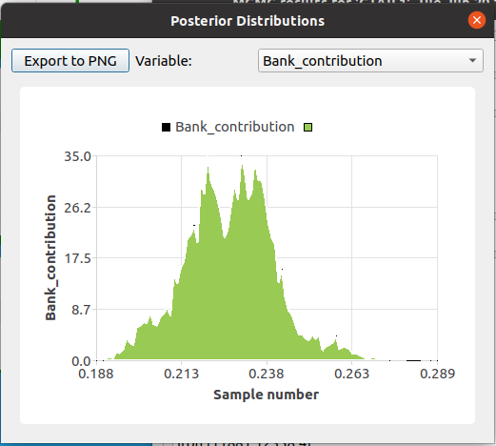 | 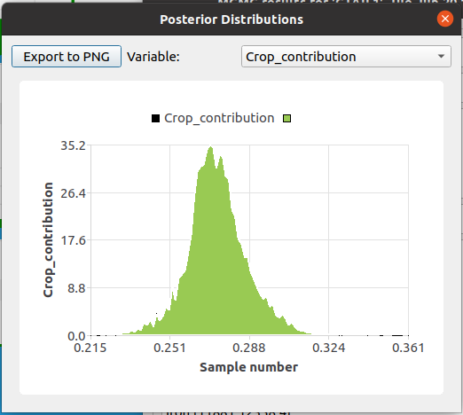

Figure 3.3: Visualization of the posterior distribution for a) bank contribution and b) crop contribution.
The third panel contains the 95% credible intervals for the source contributions: the range within which each source contribution lies with 95% probability (Fig. 3.4). In addition to the lower and upper bounds of the credible interval, the panel also reports the expected value (mean) and median of each posterior distribution.
Click the table button on the side of the panel to view the intervals in tabular form, or the graph button to view them graphically.
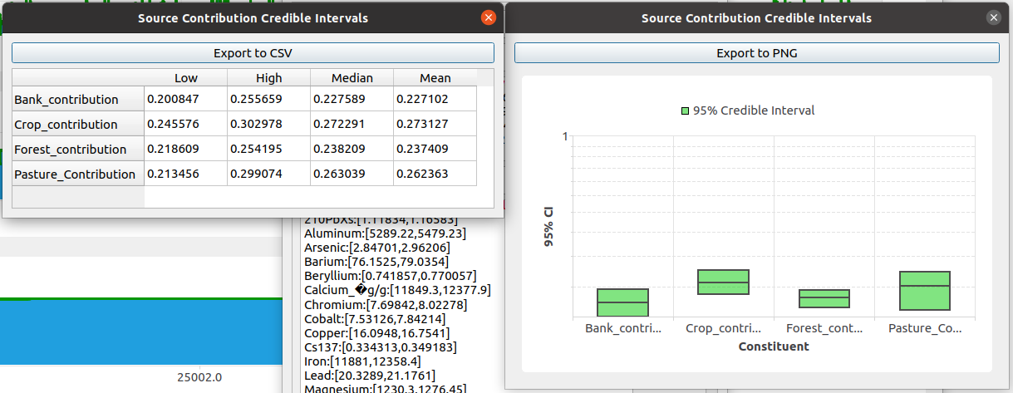
Figure 3.4: Credible intervals for source contributions.
The fourth panel contains the posterior predictive distribution of elemental content in the target sample. Click the graph button to view the distributions graphically. Use the drop-down menu at the top of the graph to display the predicted distribution for each element (Fig. 3.5). The distribution is constructed by computing the modeled target elemental profile for each MCMC sample. The vertical dashed line on each graph indicates the measured concentration in the target sample.
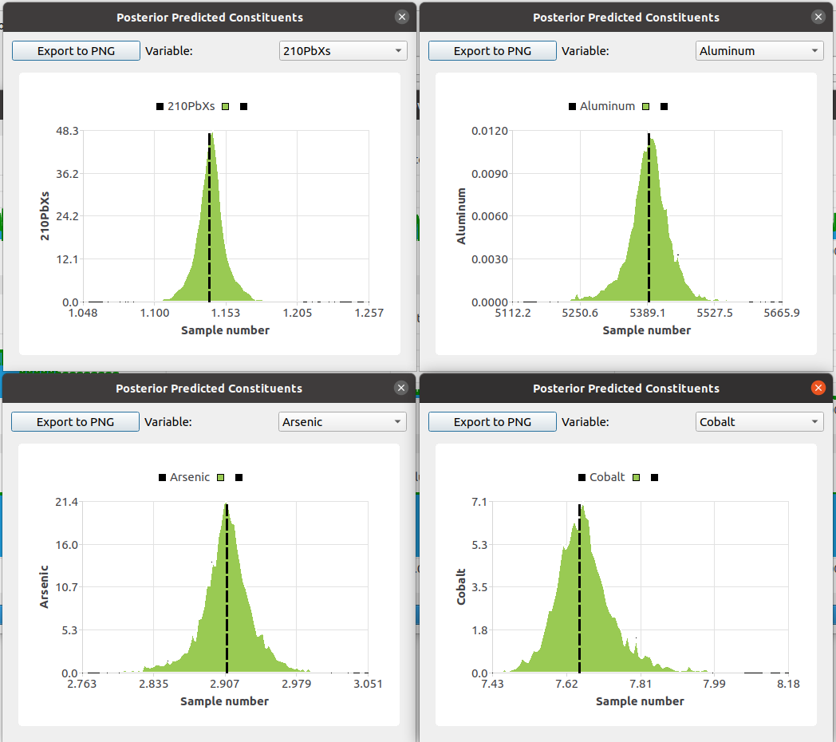
Figure 3.5: Posterior predictive distribution of elemental content in the target sample.
The fifth panel contains the 95% credible intervals for the predicted elemental content in the target sample. Click the table button on the side of the panel to view the intervals in tabular form, or the graph button to view them graphically. The graph also displays the measured elemental content in the target sample for each element as dot symbols. The difference between the 95% credible interval and the measured value provides insight into how well each element’s content can be reproduced by the inferred combination of sources.
Panels six and seven contain analogous information to panels four and five, but for isotope ratios, when isotopes are included in the analysis.

3.2 Bayesian Chemical Mass Balance Analysis (Batch)
The batch version of the Bayesian Chemical Mass Balance tool runs Bayesian fingerprinting on all target samples in a single pass, avoiding the need to select and save each sample manually. Instead of displaying results as interactive tables and graphs, the analysis writes the outputs to text files that can be plotted in any spreadsheet or graphing application. The settings are identical to those described for the single-sample Bayesian Chemical Mass Balance Analysis (Section 3.1).
To run the batch analysis, select Tools$→$Bayesian Sediment Fingerprinting$→$Bayesian Chemical Mass Balance Analysis (Batch) from the tools window.
Note: A large number of samples (at least 100,000) is required for the chains to converge, and approximately 10% of the total should be designated as burn-in. The analysis can take a substantial amount of time depending on the number of target samples, the number of source groups, the number of MCMC samples per chain, and your hardware. For long batches, consider running the analysis overnight or on a dedicated workstation.
When the analysis is complete, a folder is created for each target sample in the same directory as the project file (Fig. 3.6). Each folder contains seven text files (Fig. 3.7).
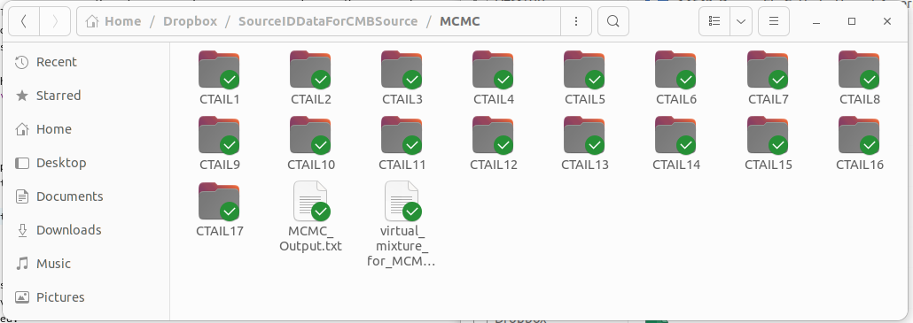
Figure 3.6: Folders created after running the batch Bayesian chemical mass balance analysis. One folder per target sample is created in the project directory.
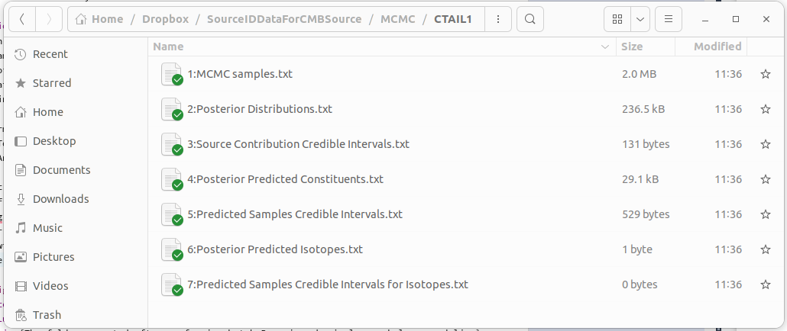
Figure 3.7: The seven text files written for each target sample by the batch Bayesian chemical mass balance analysis.
The contents of each file are as follows:
- 1:MCMC samples.txt — contains all MCMC samples generated. Each column corresponds to one estimated parameter: the source contribution for each source group, the mean and standard deviation of each element in each source group, and the likelihood value for each parameter set.
- 2:Posterior Distributions.txt — contains the MCMC samples converted into frequency distributions (histograms). Columns come in pairs: the first column of each pair contains the parameter values (bin centers), and the second contains the corresponding frequencies. For example, to plot the posterior distribution of Bank Contribution, plot column B against column A; the next parameter follows in columns C and D, and so on.
- 3:Source Contribution Credible Intervals.txt — contains the 95% credible intervals for each parameter extracted from the posterior distribution (Fig. 3.8).
- 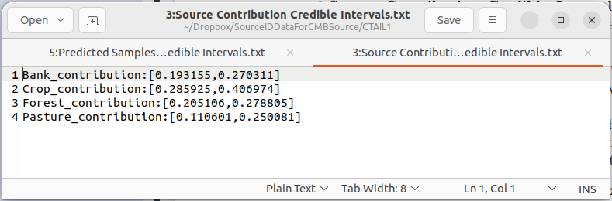
- Figure 3.8: Excerpt from the 95% credible interval file for model parameters.
- 4:Posterior Predicted Constituents.txt — contains the posterior predictive distributions of the target sample elemental concentrations, computed from the MCMC samples and presented as frequency distributions. Columns come in pairs (value, frequency); for example, to plot the predicted distribution of $​^{210}Pb$, plot column B against column A.
- 5:Predicted Samples Credible Intervals.txt — contains the 95% credible intervals of the predicted target sample elemental profile, derived from the predicted constituents in file 4 (Fig. 3.9).
- 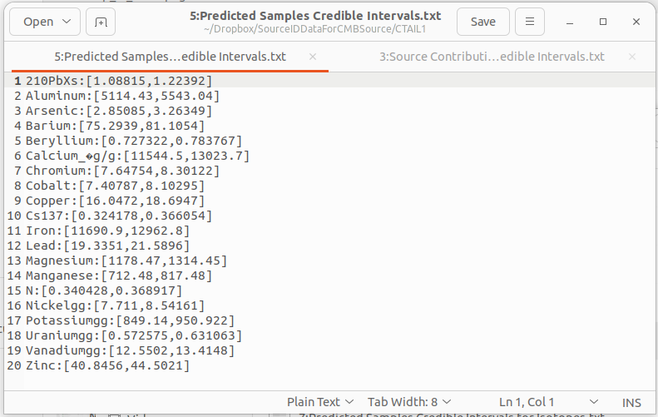
- Figure 3.9: Excerpt from the 95% credible interval file for predicted target sample elemental content.
- 6:Posterior Predicted Isotopes.txt — contains the posterior predictive distributions of the target sample isotope ratios, presented as frequency distributions. Columns come in pairs (value, frequency). This file is empty if no isotopes are included in the analysis.
- 7:Predicted Samples Credible Intervals for Isotopes.txt — contains the 95% credible intervals of the predicted target sample isotope ratios, derived from the isotope predictions in file 6.

4 Other Statistical Tools
This chapter describes additional statistical tools that, while not part of the core fingerprinting workflow, are useful for exploring the data and supporting decisions about which elements and samples to include in the analysis.

4.1 Elements’ correlation matrix
The correlation between constituents within a source group is useful information when deciding which constituents to include in the fingerprinting analysis. Highly correlated tracers carry redundant information and can degrade the conditioning of the inverse problem.
The correlation between elements $j$ and $j'$ in source group $i$ is calculated as the Pearson product-moment correlation coefficient (Pearson 1895):
rj,j'=k​yj,k-yjyj',k-yj'k​yj,k-yj2k​yj',k-yj'2 (4.1.1)
where $y_{j,k}$ and $y_{j',k}$ are the measured contents of elements $j$ and $j'$ in sample $k$ of the source group, and ${\overset{‾}{y}}_{j}$ and ${\overset{‾}{y}}_{j'}$ are the mean contents of elements $j$ and $j'$ in the source group.
To generate a correlation matrix, double-click Tools$→$Pre-Analysis Tools$→$Elements’ Correlation Matrix from the tools panel. In the form that appears:
- Choose the source or target group from the Source/Target group drop-down.
- The Threshold field sets the value above which correlations are highlighted in the resulting matrix.
- Check Use only selected elements to restrict the matrix to elements marked for inclusion in Settings$→$Constituent Properties.
- Check Use only selected samples to restrict the matrix to samples marked for inclusion in Settings$→$Include/Exclude Samples.
- To run the correlation analysis on source elemental profiles adjusted for size, organic matter, or both, select the target sample on which the correction should be based.
Click Ok. A window similar to Fig. 4.1 will appear. Click the table button to view the matrix in tabular form (Fig. 4.2), and the export button  to save the results to a CSV file.
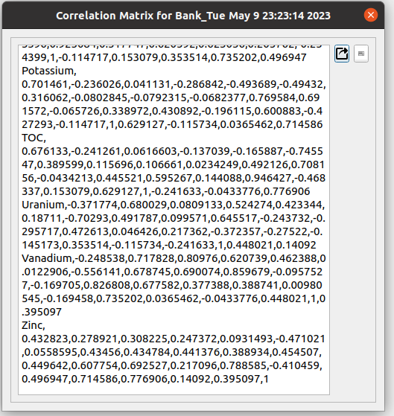
Figure 4.1: Correlation matrix results.
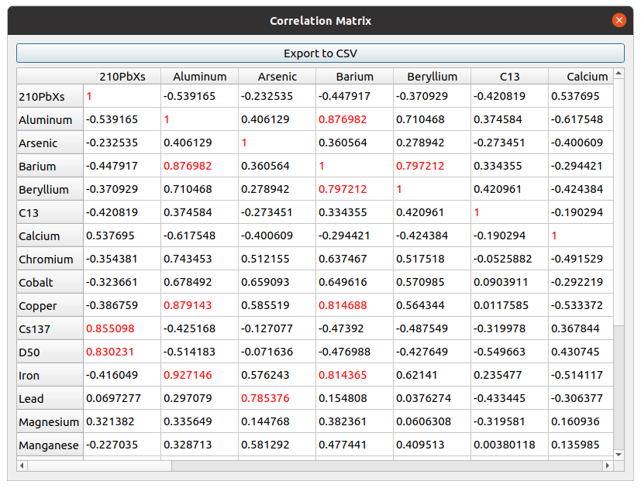
Figure 4.2: Correlation matrix in tabular form.
Based on the correlation analysis, you can decide whether to eliminate any tracers from further analysis. Typically, a tracer is removed if it is highly correlated with another tracer across all source groups, since the two carry redundant information. To remove a tracer, go to Settings$→$Constituent Properties and uncheck the element in the Include in analysis column. All correlation results you generate are retained in the results panel beneath the tools panel, so you can revisit them later.

4.2 Analysis of Variance
Analysis of variance (ANOVA) (Fisher 1925) helps evaluate how effectively each element distinguishes between source groups by comparing the variation in elemental content between groups against the variation within groups. Elements that show large between-group differences relative to within-group variability are good candidates for fingerprinting.
One-way ANOVA is a statistical technique used to compare the means of three or more samples (assuming equal variances) to determine whether at least one sample mean differs significantly from the others. The F-statistic is the ratio of between-group variance to within-group variance:
$F=\frac{MS_{between}}{MS_{within}}$ (4.2.2)
where $MS_{between}$ (mean square between) is the variance between groups and $MS_{within}$ (mean square within) is the variance within groups.
The mean squares are calculated as:
$MS_{between}=\frac{SS_{between}}{df_{between}}, MS_{within}=\frac{SS_{within}}{df_{within}}$ (4.2.3)
where $SS_{between}$ and $SS_{within}$ are the sums of squares between and within groups, $df_{between}=n-1$ is the degrees of freedom between groups (with $n$ the number of groups), and $df_{within}=l-n$ is the degrees of freedom within groups (with $l$ the total number of observations).
The sums of squares are calculated as:
$SS_{between}=\sum_{i=1}^{n}{n_{i}}{\left({\overset{‾}{y}}_{i}-\overset{‾}{y}\right)}^{2}$ (4.2.4)
$SS_{within}=\sum_{i=1}^{n}{\sum_{k=1}^{n_{i}}{{\left(y_{i,k}-{\overset{‾}{y}}_{i}\right)}^{2}}}$ (4.2.5)
where $n_{i}$ is the number of observations in group $i$, ${\overset{‾}{y}}_{i}$ is the mean of group $i$, $\overset{‾}{y}$ is the overall mean across all observations, and $y_{i,k}$ is the $k$th observation in group $i$.
The resulting $F$ value is converted to a p-value:
$p=1-Ξ\left(F; n-1, l-n\right)$ (4.2.6)
where $Ξ$ is the cumulative distribution function of the $F$ distribution with $n-1$ and $l-n$ degrees of freedom.
To perform ANOVA, select Tools$→$Pre-Analysis Tools$→$Analysis of Variance. You can run the analysis on raw elemental contents, log-transformed contents, or Box–Cox transformed contents. To use source elemental profiles adjusted for size, organic matter, or both, select the target sample on which the correction should be based. Selecting Modify the included elements based on the results automatically excludes elements whose p-value exceeds the specified P-value threshold; this threshold identifies elements with low discriminating power. Click Ok to run the analysis.
When the analysis is complete, click the graph button to view the p-values for each element graphically, or the table button to view them in tabular form. For example, Fig. 4.3 shows that Arsenic and Cobalt have low discriminating power in the demonstration dataset.
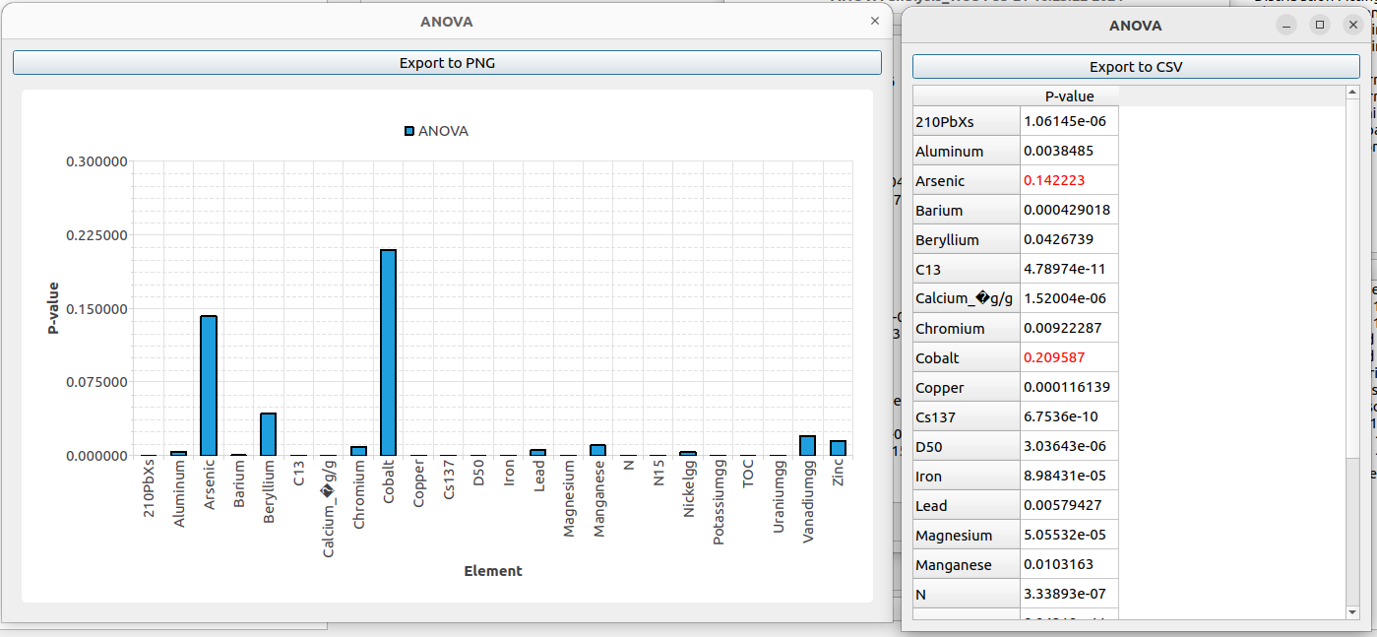
Figure 4.3: Results of the ANOVA analysis.

4.3 Auto-select elements
The auto-select tool identifies a small set of elements that effectively distinguishes between all pairs of source groups. For each pair of source groups, it performs a t-test on each element and then selects a predetermined number of elements with the lowest p-values from each pair.
To use this tool, select Tools$→$Pre-Analysis Tools$→$Auto-select Elements. In the form that appears, you can choose whether to include isotopes in the analysis and whether to adjust the source elemental profiles based on size and organic matter. To apply the selection automatically to the constituent inclusion list, check Modify the included elements based on the results. The Number of elements from each pair field sets how many of the lowest-p-value elements are selected from each pair of source groups; a larger number yields a larger total selection. Click Ok to run the analysis.
The result window contains two panels. The first panel shows the p-value for each element from the t-test on each pair of source groups (Fig. 4.4). The second panel lists the selected elements along with the source-group pair and p-value that triggered each selection (Fig. 4.5).
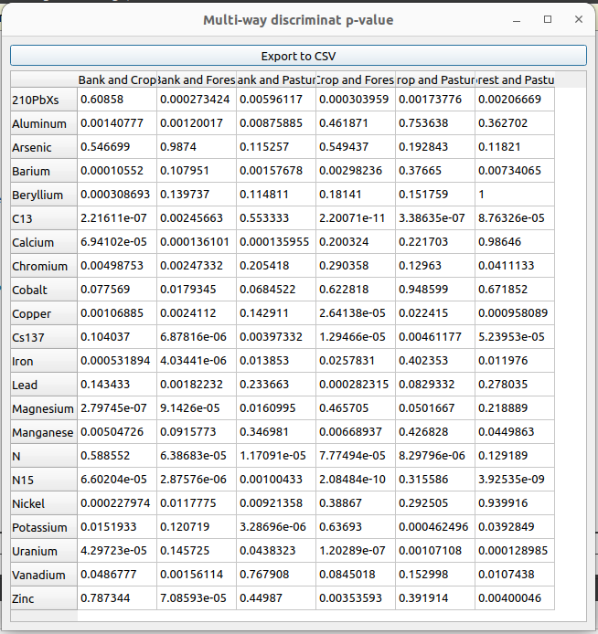
Figure 4.4: Pairwise t-test p-values for auto-selection of elements.
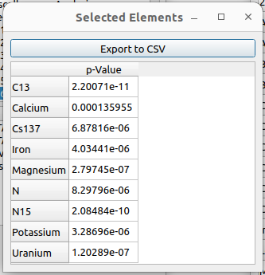
Figure 4.5: Elements selected by the auto-select tool.

4.4 Two-way DFA
The two-way DFA performs discriminant function analysis between two specified source groups. The first step in any DFA is to determine which elements to include by evaluating the $χ^{2}$ statistic and Wilks’ Lambda. The stepwise DFA begins with the element that provides the highest discriminating power between the two sources and then adds elements one by one, at each step selecting the element that maximizes the discriminating power.
To perform a stepwise two-way DFA, choose Tools$→$Other Statistical Tools$→$Stepwise Discriminant Function Analysis (Two-way) from the tools window. In the central form, specify the two source groups for which the DFA is to be performed. Check Box-Cox transformation to perform the DFA on data transformed using the optimal $λ$ for normality. Click Ok.
The result window contains three panels. The first panel contains the $χ^{2}$ p-values as a function of the number of elements included. Click the table button to view the values in tabular form, or the graph button to view them graphically.
For example, Fig. 4.6 shows that $​^{13}C$ has the highest discriminating power, and that elements from Lead through Vanadium do not substantially increase the discriminating power between the two selected source groups. Note that an element with low discriminating power between one pair of groups may still discriminate effectively between other pairs.
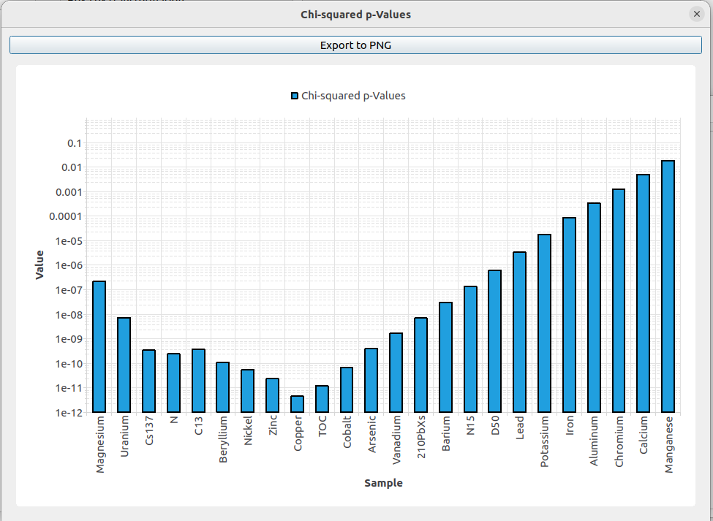
$χ^{2}$Figure 4.6: p-values for two-way stepwise DFA as a function of the number of elements included.
The graph shows that $χ^{2}$ decreases as elements are added up to Copper, then begins to rise as additional elements are included. With all elements included, the $χ^{2}$ p-value is smaller than 0.05.
The second panel shows Wilks’ $Λ$ as a function of the number of elements included (Fig. 4.7).
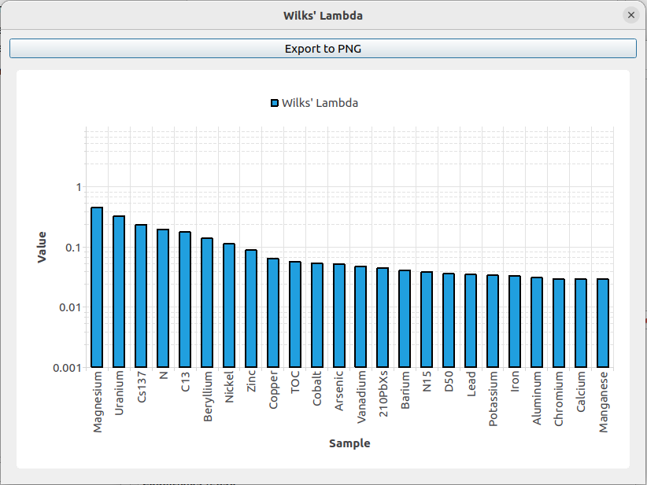
Figure 4.7: Wilks’ $Λ$ values as elements are added successively in two-way DFA.
In this case, Wilks’ $Λ$ continues to improve through the last element added.
The third panel shows the p-value for the F-test on the discriminant scores obtained from the two source groups (Fig. 4.8).
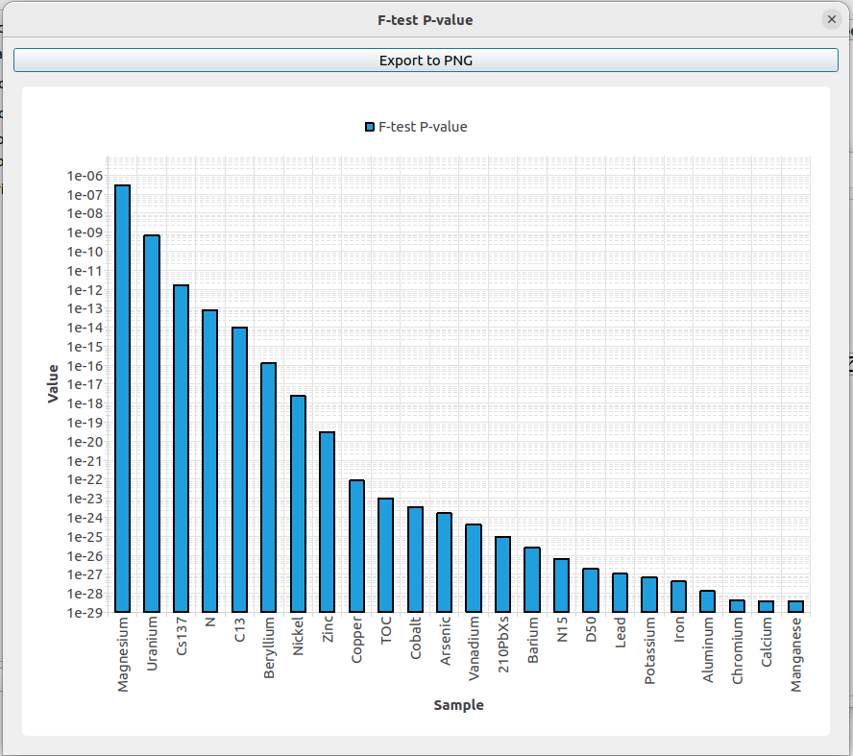
Figure 4.8: F-test p-values as elements are added successively in two-way DFA.
To view the separation produced by a chosen set of elements, first select the elements to include via Settings$→$Constituent Properties (the stepwise DFA results can guide this choice). Then choose Tools$→$Other Statistical Tools$→$Discriminant Function Analysis (Two-way). Select the two source groups, choose whether to apply the OM and size correction and the Box–Cox transformation, and check Use only selected elements so that only the elements marked for inclusion are considered. The result window contains the $χ^{2}$ p-value, the F-test p-value, and the calculated discriminant scores for the two source groups. Click the graph button on the side of the Projected Elemental Profiles panel to view the discriminant scores for the samples in each source group (Fig. 4.9).
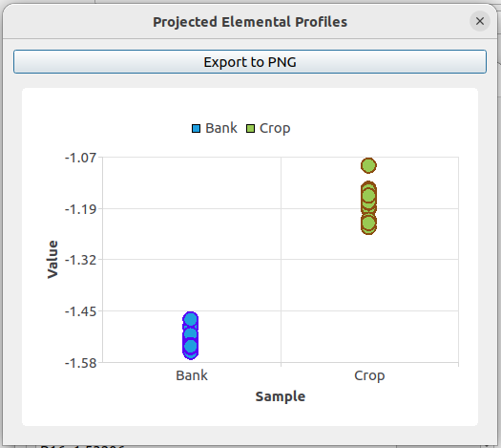
Figure 4.9: Discriminant scores for samples in source groups Bank and Crop when Beryllium, $​^{13}C$, $​^{137}Cs$, Manganese, N, Nickel, and Uranium are included in the analysis.

4.5 One vs. the rest DFA
The one-vs-the-rest DFA performs discriminant function analysis between all samples belonging to one specified source group and all other samples taken together. To perform a stepwise one-vs-the-rest DFA, choose Tools$→$Other Statistical Tools$→$Stepwise Discriminant Function Analysis (One vs. the Rest) from the tools panel. In the central form, select the source group to be tested against all others, and choose whether to apply the Box–Cox transformation and the organic matter and size correction. Click Ok.
The results are analogous to those of the two-way stepwise DFA, except that the statistics are calculated between the chosen source group and the pooled remainder of the samples. Figure 4.10 shows the $χ^{2}$ p-values for the Bank source group versus the rest of the samples.
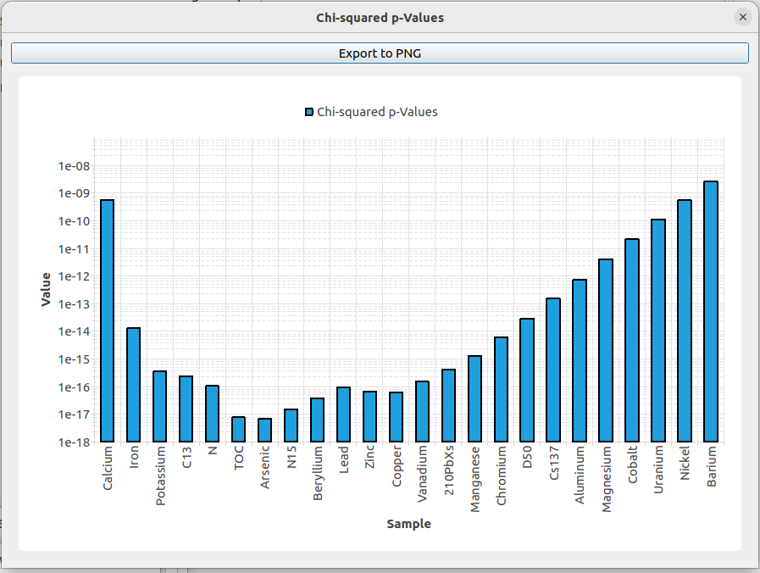
$χ^{2}$Figure 4.10: p-values vs. the number of elements included for the one-vs-the-rest DFA between Bank and the other sources.
After running the stepwise DFA, you can use the results to choose which elements to include in subsequent fingerprinting analyses. To do so, go to Settings$→$Constituent Properties and use the Include in analysis column to mark each constituent as included or excluded.
To visualize the separation produced by a chosen set of elements, choose Tools$→$Other Statistical Tools$→$Discriminant Function Analysis (One vs. the Rest). Select the source group to be tested, choose whether to apply the OM and size correction and the Box–Cox transformation, and check Use only selected elements so that only the included elements are considered. The result window contains the $χ^{2}$ p-value, the F-test p-value, and the calculated discriminant scores. Click the graph button on the side of the Projected Elemental Profiles panel to view the discriminant scores (Fig. 4.11). The weight vector $w$ is chosen to maximize the separation between the selected source group (Bank, in this example) and the remaining samples.
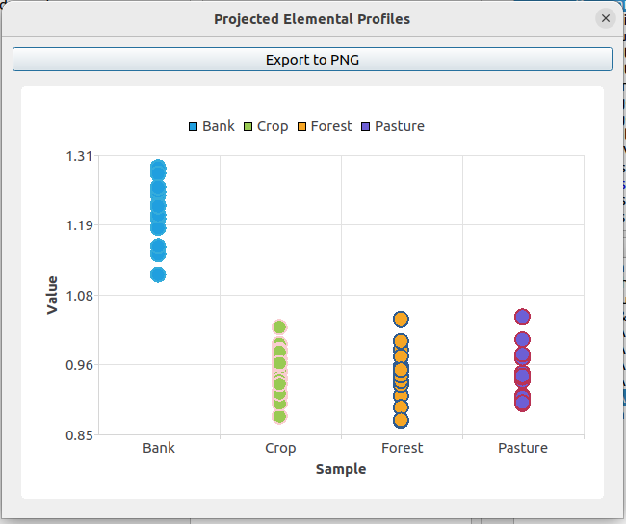
Figure 4.11: Discriminant scores from one-vs-the-rest DFA for the Bank source group versus the rest, when Beryllium, $​^{13}C$, $​^{137}Cs$, Manganese, N, Nickel, and Uranium are included in the analysis.

4.6 Distribution fitting
The distribution fitting tool lets you visually inspect the frequency distribution of constituent content within a source group to determine whether it is better described by a normal or log-normal distribution. To run distribution fitting, select Tools$→$Other Statistical Tools$→$Distribution Fitting from the tools menu. In the central form:
- Choose the element and source group.
- Choose whether to include all samples or only the selected ones.
- Choose whether to fit the distribution to the raw data or to Box–Cox transformed elemental contents.
- To run the fit on data corrected for size and organic matter, select the target sample on which the correction should be based. To run the fit on uncorrected data, leave the OM and Size corrected based on target sample field blank.
Click Ok.
In the results window, click the graph button next to the PDF (top) panel or the CDF (bottom) panel to view the fits. If the Box–Cox transformation was selected, the graphs show the transformed elemental contents fitted with a Gaussian distribution. Otherwise, the graphs show both normal and log-normal fits to the raw data (Fig. 4.12).
a) | b)
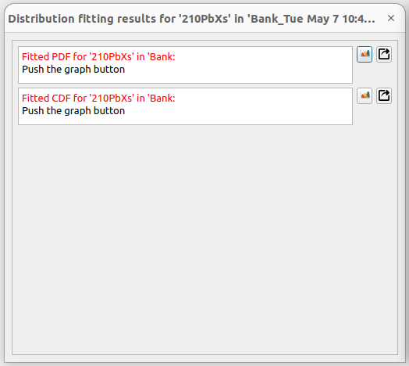 | 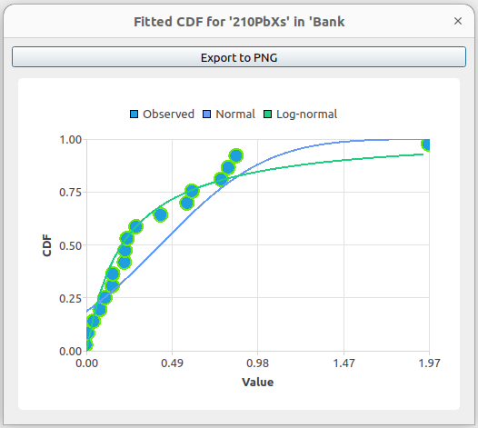

Figure 4.12: Distribution fitting without Box–Cox transformation: a) results window, b) CDF graph showing the empirical distribution with fitted normal and log-normal curves.
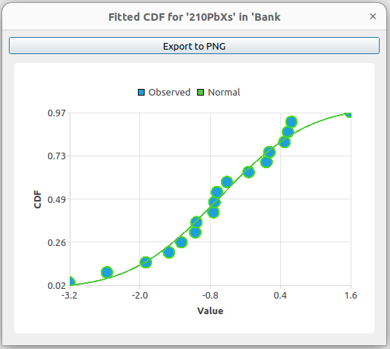
Figure 4.13: Distribution fitting with Box–Cox transformation, showing the transformed data fitted with a Gaussian distribution.

4.7 Elements’ Discriminant Power (Multi-way)
The Elements’ Discriminant Power (Multi-way) tool evaluates each element’s ability to distinguish between every pair of source groups. It produces three types of results for each element and source pair:
- The ratio of the between-group mean distance to the within-group standard deviation.
- The discriminant fraction: the proportion of samples that can be correctly assigned to one of the two source groups based on that single element alone.
- A t-test p-value for the null hypothesis that the mean elemental content is the same in the two source groups.
To run the multi-way discriminant power analysis, select Tools$→$Other Statistical Tools$→$Elements’ Discriminant Power (Multi-way). In the central form:
- Choose whether to run the analysis on untransformed or log-transformed elemental contents.
- Check the corresponding box to include target samples in the analysis.
- Set the p-value threshold to determine the cutoff above which values are highlighted in the resulting table.
- To run the analysis on data corrected for size and organic matter, select the target sample on which the correction should be based. To run on uncorrected data, leave the OM and Size corrected based on target sample field blank.
Click Ok.
The result window contains three panels. The first panel reports the ratio of the between-group mean distance to the within-group standard deviation for every pair of source groups. Click the table button next to the panel to view the values in tabular form. A higher value indicates greater discriminating power between the corresponding pair of source groups.
The second panel reports the discriminant fraction for each element and source pair. Click the table button next to the panel to view the values. A discriminant fraction of 0.5 means that samples with a given elemental content are equally likely to belong to either source group, indicating no discriminating power; values closer to 1 indicate stronger discriminating power.
a) | b)
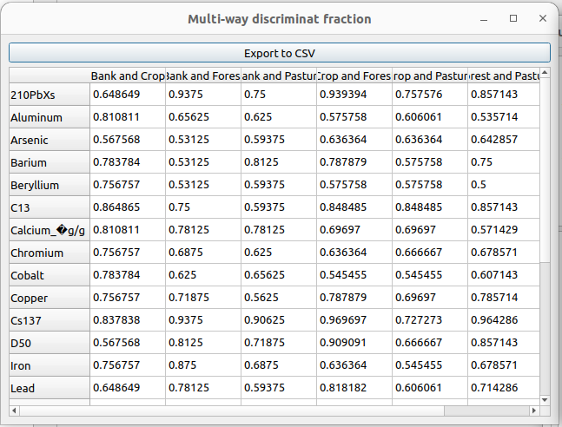 | 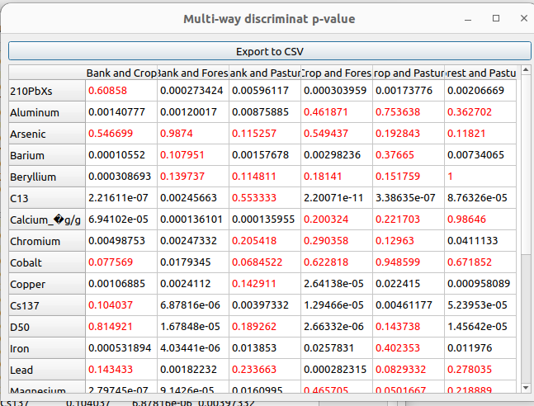

Figure 4.14: a) Discriminant fraction for each element and source-group pair. b) Discriminant t-test p-value for each element and source-group pair.
The third panel reports the t-test p-value for each element and source pair. Click the table button next to the panel to view the values. Entries highlighted in red indicate that the element lacks significant discriminating power between the corresponding pair of source groups (i.e., the p-value exceeds the threshold).

4.8 Elements’ Discriminant Power (Two-way)
This tool functions like the multi-way version described in the previous section, except that the analysis is performed between two specific source groups that you choose, rather than across all pairs.

4.9 Error Analysis
The error analysis tool performs uncertainty analysis on the estimated source contributions by bootstrapping. In each realization, it randomly excludes a specified percentage of source samples and then re-estimates the source contributions using the Levenberg–Marquardt algorithm. The distribution of contributions across realizations gives a measure of how sensitive the inferred contributions are to the particular source samples used.
To perform error analysis, select Tools$→$Other Statistical Tools$→$Error Analysis from the tools window. In the central form, choose the target sample, the number of realizations, and the percentage of source samples to exclude in each realization. You can also choose whether to run the analysis on source elemental profiles corrected for OM and particle size. Click Ok.
When the analysis is complete, the result window displays three panels.
The first panel shows the source contributions estimated for each realization. Click the table button next to the panel to view the inferred contributions in tabular form. If the number of realizations is fewer than 100, you can also view the results as a graph.
The second panel shows the frequency distribution of the inferred contributions across realizations. Click the graph button next to the panel to view the distribution for each source group (Fig. 4.15).
a) | b)
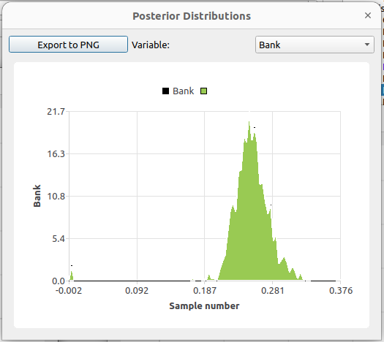 | 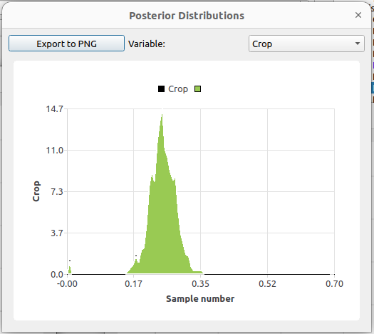
c) | d)
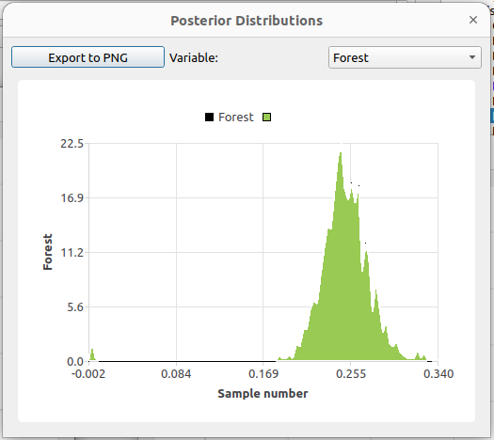 | 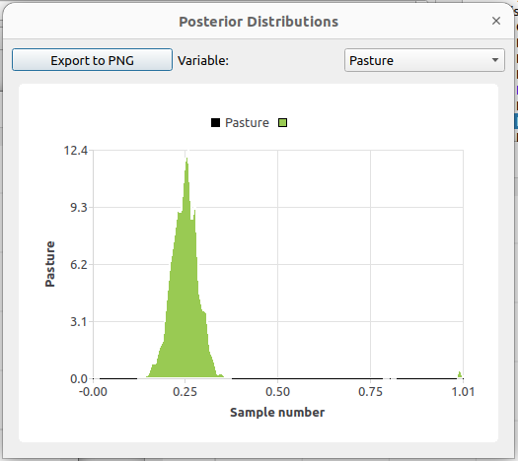

Figure 4.15: Frequency distributions of inferred source contributions from the error analysis for the a) Bank, b) Crop, c) Forest, and d) Pasture source groups.
The third panel contains the 95% credible intervals of the source contributions. Click the graph button next to the panel to view the 95% bounds graphically (Fig. 4.16).
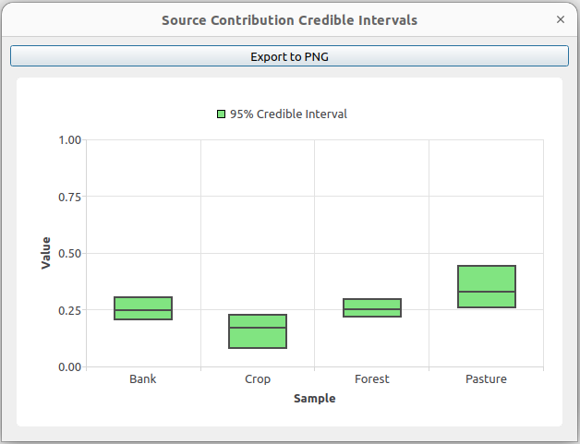
Figure 4.16: 95% bounds of the source contributions from the error analysis.

4.10 Kolmogorov-Smirnov test for an individual group and element
The Kolmogorov–Smirnov (K–S) tool (Kolmogorov 1933; Smirnov 1948; Massey 1951) lets you visually inspect the normality of an element’s distribution within a source group. The K–S test assesses normality based on the maximum difference between the empirical distribution function (EDF) of the sample and the cumulative distribution function (CDF) of a specified theoretical distribution (either normal or log-normal).
To perform the K–S test, select Tools$→$Other Statistical Tools$→$Kolmogorov-Smirnov Test for an Individual Group/Element. In the central form, choose the element, the source group, and the theoretical distribution (normal or log-normal) against which to test. Click Ok.
In the results window, click the graph button to view the empirical distribution, the fitted theoretical distribution, and the difference between them (Fig. 4.17). The magnitude of the maximum difference between the empirical and theoretical CDFs indicates how well the chosen distribution represents the element’s data: a smaller difference indicates a better fit.
a) | b)
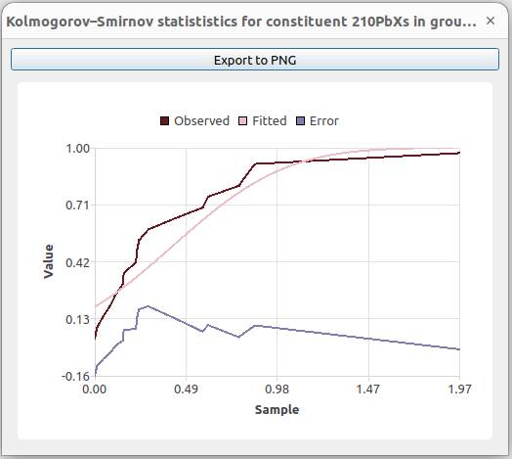 | 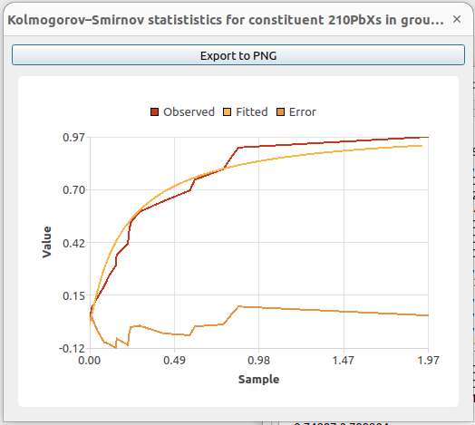

Figure 4.17: K–S test for an element fitted with a) a normal distribution and b) a log-normal distribution.

4.11 Kolmogorov-Smirnov test for a group
The Kolmogorov–Smirnov test for a group runs the K–S analysis on every element in a specified source group and reports the maximum difference between the empirical and theoretical CDFs for each element.
To use this tool, select Tools$→$Other Statistical Tools$→$Kolmogorov-Smirnov Test for a Group. In the central form, choose the source group and the theoretical distribution (normal or log-normal), then click Ok.
In the result window, click the table button to view the maximum CDF differences in tabular form, or the graph button to view them as a bar chart (Fig. 4.18).
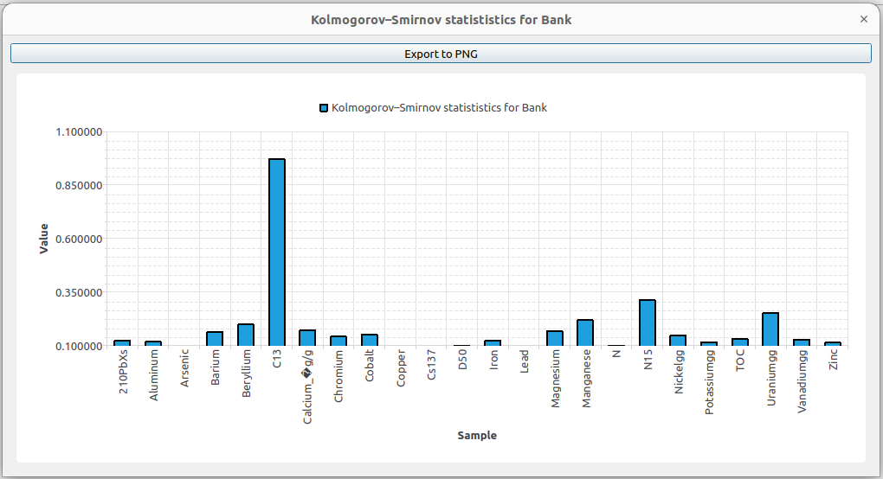
Figure 4.18: K–S test results for all elements in a source group.

4.12 Optimal Box-Cox parameters
The optimal Box–Cox parameters tool determines the value of $λ$ that transforms the elemental content of a specified source group to most closely resemble a normal distribution. The Box–Cox transformation (Box and Cox 1964) is defined as:
${\hat{y}}_{i,j,k}=\left\{\begin{matrix}\frac{{\left(\frac{y_{i,j,k}}{σ_{i,j}}\right)}^{λ}-1}{λ} & \text{for }λ≠0 \\ log\left(\frac{y_{i,j,k}}{σ_{i,j}}\right) & \text{for }λ=0\end{matrix}\right.$ (4.12.7)
The optimization minimizes the maximum difference between the CDF of the transformed data and a fitted normal distribution, as measured by the Kolmogorov–Smirnov statistic. A value of $λ$ close to 1 indicates that the data are already well represented by a normal distribution; a value close to 0 indicates that the data more closely follow a log-normal distribution.
To compute the optimal Box–Cox parameters, select Tools$→$Other Statistical Tools$→$Optimal Box-Cox Parameters. In the central form, choose the source group to analyze and click Ok.
The result window contains the optimal $λ$ for every element in the specified source group. Click the table button to view the values in tabular form.

4.13 Source Verification
The source verification tool assesses how well individual source samples align with their overall source group. It treats each source sample within a group as a target sample and performs fingerprinting using the Levenberg–Marquardt algorithm. If a source sample’s elemental profile closely matches that of its source group, the analysis should identify that group as the dominant contributor.
To perform source verification, select Tools$→$Other Statistical Tools$→$Source Verification from the tools window. In the central form, choose the source group on which to perform the analysis and whether to apply the size and organic matter correction. Click Ok.
Note: Only the elements and samples marked for inclusion in Settings$→$Constituent Properties and Settings$→$Include/Exclude Samples are considered in the analysis.
The result window shows the estimated contribution of each source group to each sample in the selected source group. Click the table button or the graph button to view the results in tabular or graphical form (Fig. 4.19).
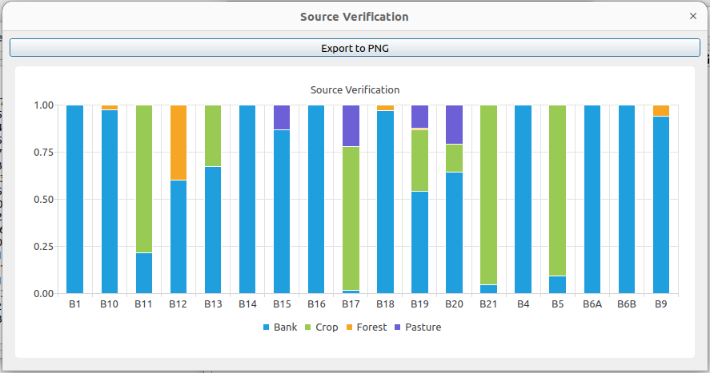
Figure 4.19: Source verification results: estimated contribution of each source group to each sample within the selected source group.

4.14 Genetic Algorithm estimation
The genetic algorithm (GA) (Holland 1975; Goldberg 1989) estimation method does not compute the mean elemental profile of each source group directly from the source samples; instead, it estimates the mean of each constituent in each source as part of the inverse modeling. Each constituent in each source group is assumed to follow a log-normal distribution:
${\tilde{y}}_{i,j}∼\frac{1}{\sqrt{2π} σ_{j} y_{i,j}}exp\left(-\frac{{\left[ln\left(y_{i,j}\right)-μ_{i,j}\right]}^{2}}{2σ_{j}^{2}}\right)$ (4.14.8)
where $σ_{j}$ is the shape parameter of the log-normal distribution for element $j$, assumed to be the same for all source groups, and $μ_{i,j}$ is the scale parameter. The values of $σ_{j}$ and $μ_{i,j}$ are estimated jointly with the source contributions. For a given set of $σ$, $μ$, and source contribution values, the mean elemental profile of each source is computed from the parameters of the log-normal distribution as:
$y_{i,j}=exp\left(μ_{i,j}+\frac{σ_{j}^{2}}{2}\right)$ (4.14.9)
Because the number of parameters to be estimated is much larger here than in the case where the mean elemental profiles are calculated directly from the source samples, SedSAT3 uses a genetic algorithm for the optimization. An optional hybrid mode combines a conventional binary genetic algorithm with a stochastic gradient descent step (Alikhani et al. 2017).
To run GA fingerprinting, select Tools$→$Deterministic Sediment Fingerprinting$→$Maximum Likelihood Fingerprinting using Genetic Algorithm. The settings in the form that appears are:
- Apply size and organic matter correction: whether to run the analysis on elemental profiles corrected for size and organic matter. The size and organic matter correction step (Section 2.2) must have been performed beforehand.
- Sample: the target sample to be analyzed.
- Population: the number of individuals in each GA generation. Increase this value if the GA does not converge with the default; 100 is usually adequate.
- Number of Generations: the number of generations run by the GA. Increase this value if convergence has not been reached.
- Crossover probability: the probability of crossover in the GA. The default value of 1.0 is usually appropriate.
- Mutation probability: the probability of mutation in the GA. The default value is usually appropriate.
- Numerical crossover: when checked, the algorithm uses a numerical crossover operator rather than a binary one.
- Shake coefficient: the magnitude of the numerical perturbation applied when the GA fails to improve the likelihood over several consecutive generations. Leave at the default value.
- Shake coefficient reduction factor: the factor by which the shake coefficient is reduced if the likelihood does not improve after several consecutive shaking iterations.
- Gradient Descent: when checked, combines the genetic algorithm with a gradient descent step, often resulting in faster and more accurate convergence.
- Number of threads used: the number of processor threads used for the GA optimization. If the value exceeds the number of CPU cores available, all cores are used.
- GA output file: the text file in which detailed information about the GA process is saved.
Note: The GA is not guaranteed to find the global optimum within a given number of generations. As a check, run the fingerprinting multiple times to verify that the inferred contributions are consistent, or increase the number of generations and check whether the results change. Substantial run-to-run variation may indicate equifinality, in which several distinct source combinations produce similarly good fits to the target sample.
After setting the parameters, click Ok and wait for the analysis to complete. The result window contains nine panels:
- Inferred source contributions — click the graph button to view the contributions as a pie chart (Fig. 4.20).
- 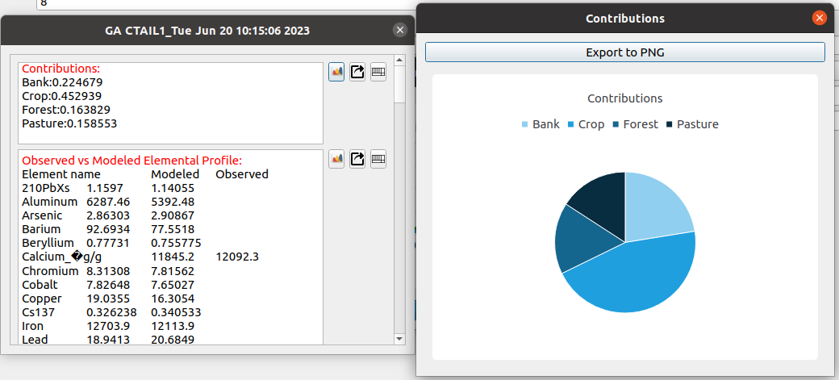
- Figure 4.20: Estimated source contributions from the genetic algorithm.
- Modeled vs. measured elemental contents (Fig. 4.21).
- 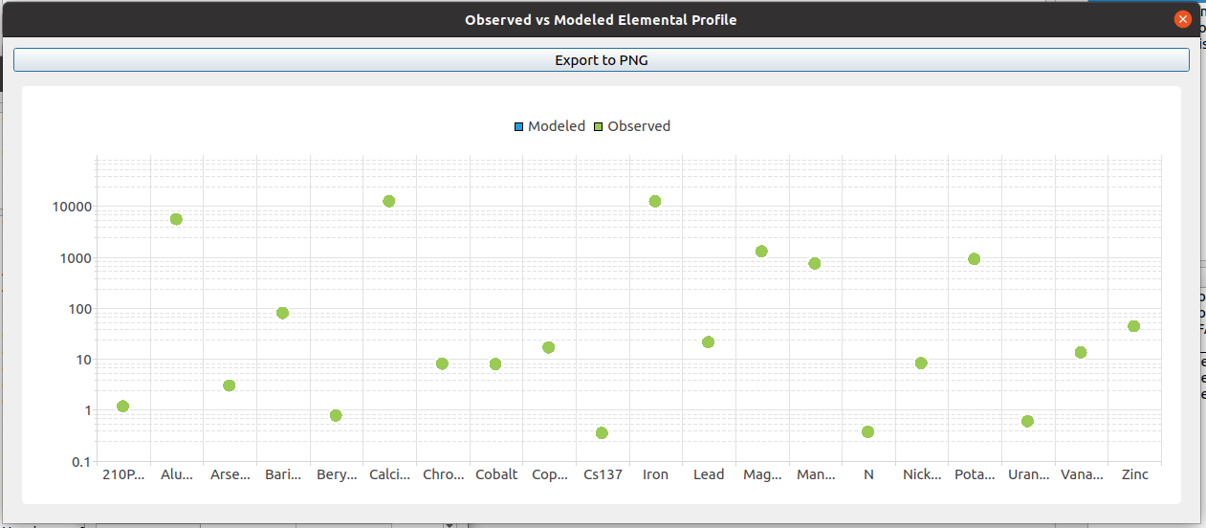
- Figure 4.21: Modeled vs. measured elemental contents from the genetic algorithm.
- Modeled vs. measured isotope $δ$ values, shown when isotopes are included in the analysis.
- Calculated element means for each source group, computed directly from the source samples.
- Estimated element means based on the estimated log-normal distribution parameters.
- Calculated scale parameter $μ$ of the log-normal distribution for each element in each source, computed from the geometric mean of the source-sample elemental contents.
- Estimated scale parameter $μ$ from the genetic algorithm.
- Calculated shape parameter $σ$ of the log-normal distribution for each element, computed from the source samples.
- Estimated shape parameter $σ$ from the genetic algorithm.
Panels 4–5 and 6–9 are particularly useful for diagnosing the results: large discrepancies between the calculated values (computed directly from the source samples) and the estimated values (recovered by the GA) may indicate convergence problems or model misfit.

5 Mathematical Basis

5.1 Mass balance formulation
The basis of sediment fingerprinting is the use of tracer groups (each representing a distinct sediment source) to identify statistically significant differences in chemical properties between the source areas and the fluvial sediments (the target sample). If $n$ sources are mixed and $y_{i,j}\left[M/M\right]$ is the mass fraction of element $j$ in source $i$, the content of element $j$ in the mixture (the target sample) is:
$c_{j}=∑x_{i}y_{i,j}$ (5.1.1)
where $x_{i}$ is the contribution fraction of source $i$. Equation (5.1.1) can be written for all elements in the analysis in matrix form:
$C=YX$ (5.1.2)

where $C_{m}={\left[…c_{j}…\right]}^{T}$ is the vector containing the target sample elemental profile, $X_{n}={\left[…x_{i}…\right]}^{T}$ is the vector of source contribution fractions, $Y_{n×m}=\left[y_{i,j}\right]$ is the matrix of source elemental contents, and $m$ is the number of elements (or signatures) included in the analysis.
The contribution fractions must sum to one:
$∑x_{i}=1$ (5.1.3)

5.1.1 Stable isotopes
Stable isotopes are also commonly used for sediment fingerprinting. The stable isotope content of a sample is conventionally expressed using the $δ$ value:
$δ​^{u}E=\left(\frac{\frac{​^{u}E}{E}}{{\left(\frac{​^{u}E}{E}\right)}_{std}}-1\right)×1000$ (5.1.4)
where $​^{u}E$ is the isotope content and $E$ is the base element content. The quantity ${\left(\frac{​^{u}E}{E}\right)}_{std}$ is a standard isotope ratio used as the reference for the $δ$ value. Solving Eq. (5.1.4) for $​^{u}E$ gives:
$​^{u}E=\left(\frac{δ​^{u}E}{1000}+1\right){\left(\frac{​^{u}E}{E}\right)}_{std}E$ (5.1.5)
When several sediment sources are mixed, the isotope content of the mixture is:
$ζ_{j}=∑x_{i}υ_{i,j}$ (5.1.6)
where $ζ_{j}$ is the content of isotope $j$ in the mixture and $υ_{i,j}$ is the mean content of isotope $j$ in source $i$, calculated via Eq. (5.1.5).
Substituting Eq. (5.1.5) into Eq. (5.1.6) yields the mixture $δ$ value:
$δζ_{j}=\frac{∑x_{i}δυ_{i,j}y_{i,j}}{∑x_{i}y_{i,j}}$ (5.1.7)
where ${δυ}_{i,j}$ is the $δ$ value of isotope $j$ in source $i$.
The set of equations obtained from isotopes can be appended to Eq. (5.1.2). Note that to include an isotope in the analysis, the base element of that isotope must also be measured.

5.2 Maximum likelihood estimation
The goal of sediment fingerprint modeling is to estimate the source contributions $X$ given measurements of the elemental profiles of a number of source groups, $Y$, and the elemental profile of the target sample, $C$. We denote the measured source elemental profiles by $\tilde{Y}$ and the measured target sample profile by $\tilde{C}$. The goal is then to infer $X$ given $\tilde{Y}$ and $\tilde{C}$. Because multiple samples typically represent each source group, there are multiple instances of $\tilde{Y}$; we denote the elemental profile of source sample $k$ by ${\tilde{Y}}_{k}$.

5.2.1 Treating source elemental composition deterministically
The simplest assumption is that $Y$ is known deterministically as the arithmetic average over all samples representing each source group:
$y_{i,j}=\frac{1}{ns_{i}}∑{\tilde{y}}_{i,j,k}$ (5.2.8)
where $ns_{i}$ is the number of samples in source group $i$.
Assuming conditional independence of errors, the probability density of observing the measured target elemental profile $\tilde{C}$ given a contribution vector $X$ is:
$p\left(\tilde{C}|X\right)=∏\frac{g'_{j}\left({\tilde{c}}_{j}\right)}{σ_{j}}ϕ\left\{\frac{g_{j}\left[c_{j}\left(X\right)\right]-g_{j}\left({\tilde{c}}_{j}\right)}{σ_{j}}\right\}$ (5.2.9)
where $ϕ$ is the standard normal density, $σ_{j}$ is the error standard deviation for element $j$, and $g_{j}$ is a transformation function chosen to map the error distribution onto a normal distribution. The choice of $g_{j}$ determines the assumed error structure: $g_{j}\left(c_{j}\right)=c_{j}$ yields a Gaussian likelihood (additive errors), while $g_{j}\left(c_{j}\right)=ln\left(c_{j}\right)$ yields a log-normal likelihood (multiplicative errors).
The log-likelihood is typically used for maximum likelihood estimation:
$ln\left[p\left(\tilde{C}|X\right)\right]=∑ln\left[g'_{j}\left({\tilde{c}}_{j}\right)\right]-∑ln\left(σ_{j}\right)-\frac{m}{2}ln\left(π\right)-∑\frac{\{g_{j}\left[c_{j}\left(X\right)\right]-g_{j}\left({\tilde{c}}_{j}\right)\}^{2}}{2σ_{j}^{2}}$ (5.2.10)
Because the first three terms are independent of $X$, maximizing the log-likelihood is equivalent to maximizing the last term, which is a least-squares problem in the transformed space. An optimization algorithm can be used to estimate both $X$ and the $σ_{j}$ values that maximize the log-likelihood.
If the error structure is log-normal and multiplicative, it is often reasonable to assume that the error standard deviation $σ$ is the same for all elements (i.e., the expected relative error is the same for all elements). Under this assumption, Eq. (5.2.10) simplifies to:
lnpC|X=j​lng'jcj-mlnσ-m2lnπ-12σ2∑{gjcjX-gjcj}2 (5.2.11)
so that estimating $X$ reduces to minimizing the sum of squared errors $∑\{g_{j}\left[c_{j}\left(X\right)\right]-g_{j}\left({\tilde{c}}_{j}\right)\}^{2}$.

5.2.2 Treating source elemental composition as unknown
Because the number of samples collected per source is typically limited, the estimate of $\text{Y}$ obtained from Eq. (5.2.8) may not be accurate. We can instead assume that the elemental content of each source follows a probability distribution:
${\tilde{y}}_{i,j}∼p_{y,i,j}\left(θ_{i,j}\right)$ (5.2.12)
or, in matrix form:
$Y∼P_{y}\left(Θ\right)$ (5.2.13)
where $θ_{i,j}$ is the parameter vector of the distribution for element $j$ in source $i$, $Θ$ collects all such parameters across elements and sources, and $P_{y}$ denotes the joint distribution of all elemental contents in all sources.
For maximum likelihood estimation in this case, the joint probability of observing the target elemental profile and the source elemental profiles of all samples should be maximized:
pC,Y|X,Y=j​g'jcjσjϕgjcjX,Θ-gjcjσjk​PyYk;Θ (5.2.14)
where ${\tilde{Y}}_{k}$ is the observed source elemental matrix for sample $k$. Because the expected value of $P_{y}$ depends on its parameters $Θ$, the predicted target elemental profile depends jointly on the source contributions and the source distribution parameters:
cjX,Θ=i​xiEyi,j;θi,j (5.2.15)
where $E\left(y_{i,j};θ_{i,j}\right)$ is the expected value of $y_{i,j}$ under the source elemental content distribution:
$E\left(y;θ\right)=∫yp_{y}\left(y;θ\right)dy$ (5.2.16)
For example, if $p_{y}$ is a log-normal distribution with parameters $θ≡\{μ,σ\}$, then $E\left(y\right)=e^{μ+\frac{σ^{2}}{2}}$.
Assuming the distributions of elemental contents in different sources are independent, the log-likelihood is obtained by taking the logarithm of Eq. (5.2.14):
lnpC,Y|X,Y=j​lng'jcj-j​lnσj-m2lnπ-j​{gjcjX,θi,j-gjcj}22σj2+i​j​k​lnpy,i,jyi,j,k;θi,j (5.2.17)
Because the first three terms are independent of $X$ and $Θ$, the optimization reduces to maximizing the last two terms.

5.3 Bayesian inference
Sediment fingerprinting is subject to several sources of uncertainty, including measurement errors in both target and source samples, non-uniform selection or release of source material, model structural errors arising from changes in elemental composition during transport, the presence of unmodeled sources, and equifinality.
Measurement errors are an unavoidable part of chemical analysis and can also arise from the natural variability of sediment characteristics. Non-uniform source selection occurs when the elemental profile of a source varies systematically across space, so that the distribution of material actually mobilized from a source differs from the distribution obtained from a spatially uniform sampling of that source. Structural errors arise because the model is a simplification of the real processes; for example, changes in elemental composition during transport can introduce model structural error. Some sediment sources may not be included in the analysis at all, leading to inaccuracies in the inferred contributions. Equifinality refers to the situation in which multiple source combinations produce equally good matches to the target sample, making it difficult to identify the true source mixture uniquely.
Quantifying these uncertainties is essential for making sound engineering or management decisions based on sediment fingerprinting results. In contrast to maximum likelihood approaches, which produce point estimates, Bayesian inference yields a joint probability distribution over the inferred parameters.
Bayesian inference is based on Bayes’ theorem:
$p\left(Υ|Ξ\right)=\frac{p\left(Ξ|Υ\right)p\left(Υ\right)}{p\left(Ξ\right)}$ (5.3.18)
where $Υ$ denotes the model parameters, $Ξ$ denotes the observed data, $p\left(Ξ|Υ\right)$ is the likelihood, $p\left(Υ\right)$ is the prior distribution of the parameters, and $p\left(Ξ\right)$ is a normalizing constant ensuring that the posterior distribution $p\left(Υ|Ξ\right)$ integrates to one. For all but the simplest problems, the posterior cannot be evaluated analytically, and methods such as Markov chain Monte Carlo (MCMC) are used to draw a large number of samples from it. MCMC does not require the absolute value of the posterior density; it requires only the ratio of densities at any two parameter values. Because the denominator in Eq. (5.3.18) is independent of $Υ$, it can be omitted, yielding the proportionality:
$p\left(Υ|Ξ\right)∝p\left(Ξ|Υ\right)p\left(Υ\right)$ (5.3.19)
In the context of sediment fingerprinting, Eq. (5.3.19) becomes:
$p\left(X,Y|\tilde{C},\tilde{Y}\right)∝p\left(\tilde{C},\tilde{Y}|X,Y\right)p\left(X\right)p\left(Y\right)$ (5.3.20)
where $p\left(X\right)$ is the prior on source contributions and $p\left(Y\right)$ is the prior on the source elemental profiles. In the absence of additional information, a reasonable choice is to set $p\left(X\right)$ to a symmetric Dirichlet distribution with concentration parameter $α=1$ (which is the uniform distribution over the simplex). The prior $p\left(Y\right)$ is taken to be non-informative, since $Y$ is already constrained by the likelihood through the source-sample observations. The likelihood $p\left(\tilde{C},\tilde{Y}|X,Y\right)$ is computed from Eq. (5.2.14).
Alikhani, Jamal, Imre Takacs, Ahmed Al-Omari, Sudhir Murthy, and Arash Massoudieh. 2017. “Evaluation of the Information Content of Long-Term Wastewater Characteristics Data in Relation to Activated Sludge Model Parameters.” Water Science and Technology 75 (6): 1370–89.
Box, G. E. P., and D. R. Cox. 1964. “An Analysis of Transformations.” Journal of the Royal Statistical Society: Series B (Methodological) 26 (2): 211–52.
Collins, A. L., D. E. Walling, and G. J. L. Leeks. 1997. “Source Type Ascription for Fluvial Suspended Sediment Based on a Quantitative Composite Fingerprinting Technique.” Catena 29 (1): 1–27.
Collins, A. L., D. E. Walling, L. Webb, and P. King. 2010. “Apportioning Catchment Scale Sediment Sources Using a Modified Composite Fingerprinting Technique Incorporating Property Weightings and Prior Information.” Geoderma 155 (3–4): 249–61.
Fisher, R. A. 1925. Statistical Methods for Research Workers. Edinburgh: Oliver; Boyd.
———. 1936. “The Use of Multiple Measurements in Taxonomic Problems.” Annals of Eugenics 7 (2): 179–88.
Goldberg, David E. 1989. Genetic Algorithms in Search, Optimization, and Machine Learning. Reading, MA: Addison-Wesley.
Gorman Sanisaca, Lillian E., Allen C. Gellis, and David L. Lorenz. 2017. “Determining the Sources of Fine-Grained Sediment Using the Sediment Source Assessment Tool (Sed_SAT).” Open-File Report 2017–1062. U.S. Geological Survey.
Holland, John H. 1975. Adaptation in Natural and Artificial Systems. Ann Arbor, MI: University of Michigan Press.
Kolmogorov, A. N. 1933. “Sulla Determinazione Empirica Di Una Legge Di Distribuzione.” Giornale Dell’Istituto Italiano Degli Attuari 4: 83–91.
Levenberg, Kenneth. 1944. “A Method for the Solution of Certain Non-Linear Problems in Least Squares.” Quarterly of Applied Mathematics 2 (2): 164–68.
Marquardt, Donald W. 1963. “An Algorithm for Least-Squares Estimation of Nonlinear Parameters.” Journal of the Society for Industrial and Applied Mathematics 11 (2): 431–41.
Massey, Frank J. 1951. “The Kolmogorov-Smirnov Test for Goodness of Fit.” Journal of the American Statistical Association 46 (253): 68–78.
Massoudieh, Arash, Allen Gellis, William S Banks, and Michael E Wieczorek. 2013. “Suspended Sediment Source Apportionment in Chesapeake Bay Watershed Using Bayesian Chemical Mass Balance Receptor Modeling.” Hydrological Processes 27 (24): 3363–74.
Pearson, Karl. 1895. “Note on Regression and Inheritance in the Case of Two Parents.” Proceedings of the Royal Society of London 58: 240–42.
Rencher, Alvin C., and William F. Christensen. 2012. Methods of Multivariate Analysis. 3rd ed. Hoboken, NJ: John Wiley & Sons.
Smirnov, N. 1948. “Table for Estimating the Goodness of Fit of Empirical Distributions.” Annals of Mathematical Statistics 19 (2): 279–81.
Stewart, Heather A, Arash Massoudieh, and Allen Gellis. 2015. “Sediment Source Apportionment in Laurel Hill Creek, PA, Using Bayesian Chemical Mass Balance and Isotope Fingerprinting.” Hydrological Processes 29 (11): 2545–60.
Wilks, S. S. 1932. “Certain Generalizations in the Analysis of Variance.” Biometrika 24 (3–4): 471–94.

