Domain Review of SedSAT3
Completed 10/21/26
By Lillian Gorman Sanisaca

Review Summary
The Sediment Source Assessment Tool3 (SedSAT3) is a powerful statistical toolbox to explore sediment fingerprinting datasets. It contains many new options and tools, and runs quickly and efficiently. While some instances of difficulty navigating the interface are noted, on the whole, the UI can be navigated fairly easily. The documentation provides both directions for use and explanation of methods. This program may be difficult to run for the novice user, but users with experience with sediment fingerprinting analysis will find it to be a powerful analysis tool.
As part of my review, I provided comments in the User Manual as well as this summary document.

Model/Data setup used
- System
  - Edition Windows 11 Enterprise
  - Version 25H2
  - Installed on ‎4/‎8/‎2026
  - OS build 26200.9711
  - Experience Windows Feature Experience Pack 1000.26100.372.0
- SedSAT3 version
- 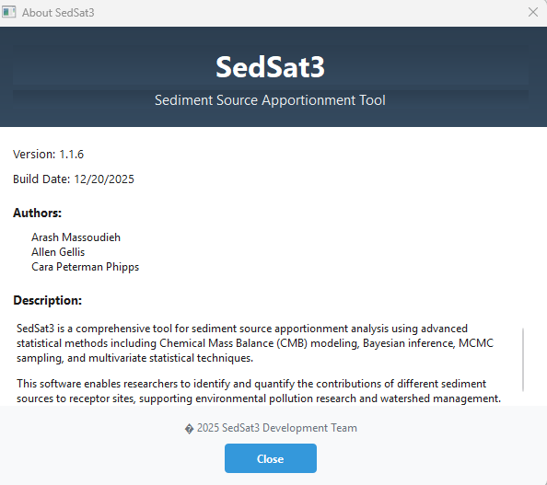
SampleData.xlsx used for testing found here https://code.usgs.gov/cphipps/SedimentSourceAssessmentTool3/-/blob/main/examples/SampleData.xlsx?ref_type=heads. Applied the following modifications
- Aluminum moved to column 2
- Arsenic column name changed to “Arsenic space”
- Calcium column name changed to “Calcium_µg/g”
- Aluminum value for CTAIL1 changed to 10000 to test bracket test
Within the program the following decisions were made
- Lead was removed within the program (arbitrarily for testing purposes)
- Outliers were removed
- Aluminum removed once bracket test failed
- Both Size and OM corrections made
- BoxCox transformations used

Critical errors where program closed
- Tools->Other Statistical Tools -> Correct based on size and organic matter, graph clicked
- Tools$→$Deterministic Sediment Fingerprinting$→$5-Fingerprinting
- Tools$→$Deterministic Sediment Fingerprinting$→$6-Fingerprinting (batch)
- Tools$→$Other Statistical Tools$→$Distribution Fitting
- Tools$→$Other Statistical Tools$→$Elements’ Discriminant Power (Multi-way).
- Tools$→$Other Statistical Tools$→$Error Analysis
- Tools$→$Other Statistical Tools$→$Source Verification

Readme notes
- Neither the readme nor the documentation have up -to-date instructions on how to install and run the program. Instructions are only available in the readme within the zip file here Package registry · Phipps, Cara L / SedSATv3 · GitLab. Both front page readme on code.usgs.gov and the documentation should have basic setup instructions.
- Opening paragraph ends in “…” is it incomplete? Monte Carlo should be spelled out. Later the abbreviation MCMC is used, in the first paragraph put (MCMC) after the full name.
- Links to github will need to be updated to code.usgs.gov
- Citation needs DOI, not github url https://sedsat.org/
- I do not know the regulations around storing software on a non-government public website. Please verify that this meets software release guidelines.
- I do not know the regulations around online forms and the collection of information like Name, email, and company. Please verify that this meets guidelines for online forms.
- From the Readme, I interpret that https://sedsat.org/ is just for the windows download, but I see links here for MacOS and Linux, do these links bypass the need for the instructions in the Readme for Linux and MacOS?
- Clicked on the windows download, when trying to save I received a warning that the website may not be safe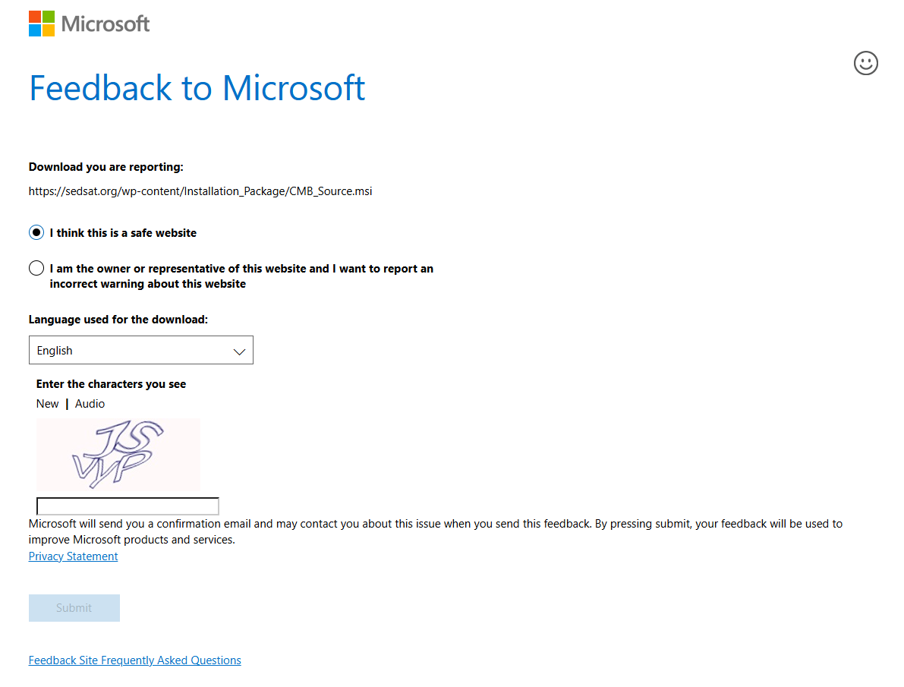

SampleData notes
- I found 3 example data files
    - https://code.usgs.gov/cphipps/SedimentSourceAssessmentTool3/-/blob/main/examples/SampleData.xlsx?ref_type=heads
    - https://sedsat.org/wp-content/Installation_Package/SampleData.xlsx
    - https://code.usgs.gov/cphipps/SedimentSourceAssessmentTool3/-/package_files/20469/download sample-data/virtual-mixture.xlsx
- The 2 files called SampleData.xlsx were identical
    - Differences in the virtual-mixture.xlsx file shown below
- $SampleData_org.xlsx
- ✔ No differences

- $`virtual-mixture.xlsx`
- `names(old)[5:11]`: "Arsenic" "Barium" "Beryllium" "Calcium" "Chromium" "Cobalt" "Copper"
- `names(new)[5:11]`: "Arsenic" "Barium" "Beryllium" "Calcium_µg/g" "Chromium" "Cobalt" "Copper"

- names(old) | names(new)
- [13] "Lead" | "Lead" [13]
- [14] "Magnesium" | "Magnesium" [14]
- [15] "Manganese" | "Manganese" [15]
- [16] "Nickel" - "Nickelgg" [16]
- [17] "Potassium" - "Potassiumgg" [17]
- [18] "Uranium" - "Uraniumgg" [18]
- [19] "Vanadium" - "Vanadiumgg" [19]
- [20] "Zinc" | "Zinc" [20]
- [21] "C13" | "C13" [21]
- [22] "N15" | "N15" [22]

- `old$Calcium` is a double vector (12092.30482, 4055.785714, 4040.714286, 37241.66667, 3031.052632, ...)
- `new$Calcium` is absent

- `old$Nickel` is a double vector (8.006129908, 6.992857143, 7.121428571, 12.19444444, 5.715789474, ...)
- `new$Nickel` is absent

- `old$Potassium` is a double vector (886.1099624, 861.5, 1345.571429, 568, 769.3684211, ...)
- `new$Potassium` is absent

- `old$Uranium` is a double vector (0.580857593, 0.346153846, 0.621428571, 0.461111111, 0.894736842, ...)
- `new$Uranium` is absent

- `old$Vanadium` is a double vector (13.02588764, 10, 14.58571429, 15.33888889, 12.17894737, ...)
- `new$Vanadium` is absent

- `old$Calcium_µg/g` is absent
- `new$Calcium_µg/g` is a double vector (12092.30482, 4055.785714, 4040.714286, 37241.66667, 3031.052632, ...)

- `old$Nickelgg` is absent
- `new$Nickelgg` is a double vector (8.006129908, 6.992857143, 7.121428571, 12.19444444, 5.715789474, ...)

- `old$Potassiumgg` is absent
- `new$Potassiumgg` is a double vector (886.1099624, 861.5, 1345.571429, 568, 769.3684211, ...)

- And 2 more differences ...

SedSat3.exe notes
- many steps have the checkboxes below, but there doesn’t appear to be anything stopping the user from selected yes one part of the analysis and no on another. I’m not sure that is a valid thing to allow.
  - Use only selected elements
  - Use only selected samples
  - Are the users selections saved somewhere?
- After getting error in DFA with linear corrections, attempted to go back to step 2 and select Power transforms, but when I got to the bracket test step only 6 tracers appeared.
  - 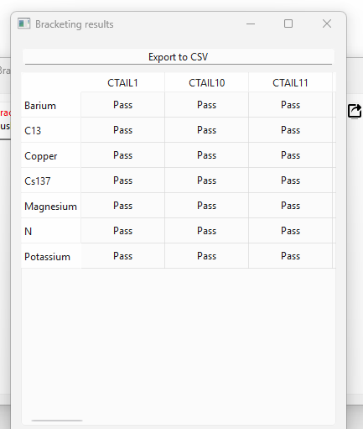
  - Restarted with data import and now all constituents appear in bracket test
  - Warnings should be given both in the program and in the documentation that returning to a previous step can result in mixups.
- In many cases once a step has completed running there is a progress window with 100%. Is it possible to have this close automatically when the step results window is closed 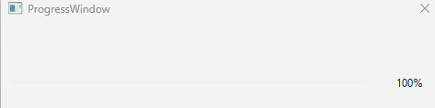
- Several instances of plots with edge points, meaning the point is at the axis limit, recommend expanding the axis limits to fully include all points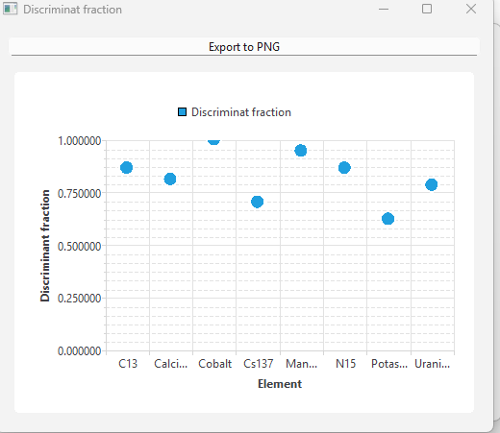
- Suggest checking axis labels and tickmarks on all plots
- Suggest adding User Manual Section numbers to each step in the Description field

Documentation notes
- Documentation provided as a word document in review email does not match documentation link from sedsat.org
- “Panels” mentioned frequently in the documentation. For novice users, I would recommend explaining what you mean by panels. Specifically, tell them to scroll down to see additional results.
- In general, more user guidance is needed in results interpretation, even if it is just references to other work. A novice in statistics will have difficulty using this tool.
- It would be helpful to include an updates/changes section/table that lists all methods changes (or new methods) from SedSat v1.0 to SedSat v3.0
- Figures are often too small to see without zooming in.
- Several instances of naming differences between Manual and the program

