**Instruction to setup**

**Install require tool**

1. Install GIT (<https://git-scm.com/>)
2. Install Maven (<https://maven.apache.org/>)
3. Install Tomcat for Deployment (<http://tomcat.apache.org/>) (Can user other deployment tool)

**Build Project**

* *Command Line*

1. Go to workspace location
2. Run “mvn package”



1. War file will be on target folder

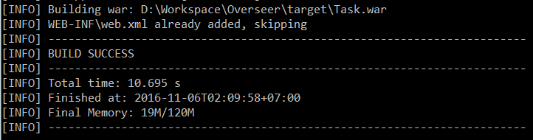

1. Deploy and Test

* *Eclipse*

1. Right click on project > Run As > Maven Clean
2. Right click on project > Run As > Maven Install

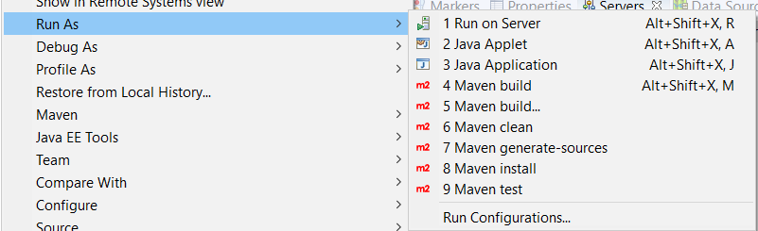

1. War file will be on target folder

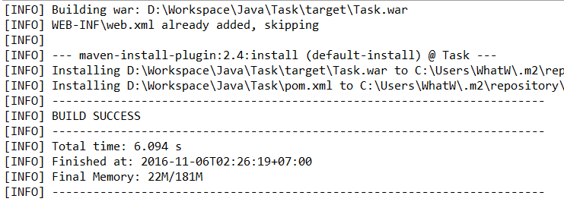

1. Deploy and Test