**Week -3 Task ( class and object)**

**Class and object program**

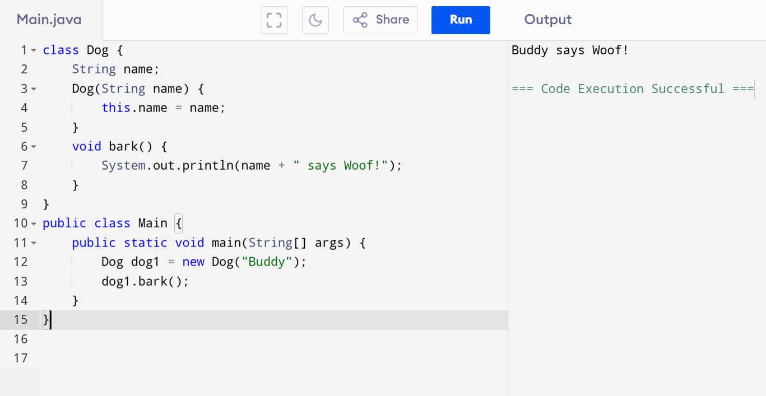

class Dog {

String name;

Dog(String name) {

this.name = name;

}

void bark() {

System.out.println(name + " says Woof!");

}

}

public class Main {

public static void main(String[] args) {

Dog dog1 = new Dog("Buddy");

dog1.bark();

}

}

**Local** variable

class Main {

public static void main(String[] args)

{

int num = 10;

System.out.println(" Variable: " + num);

}

}

Output

Variable: 10

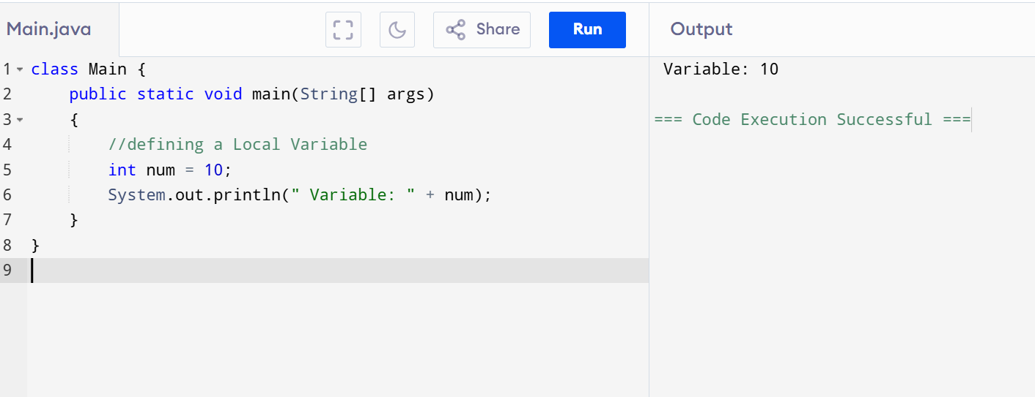

**Static variable:**

class Main {

static class Student {

static int age;

}

public static void main(String args[]) {

Student s1 = new Student();

Student s2 = new Student();

s1.age = 24;

s2.age = 21;

Student.age = 23;

System.out.println("S1's age is: " + s1.age);

System.out.println("S2's age is: " + s2.age);

}

}

