Robot Motor Parts Assembly Test
Date: 2026/06/09 Duration: 3 hours

Achievements

Parts Found

Servo Motor: -
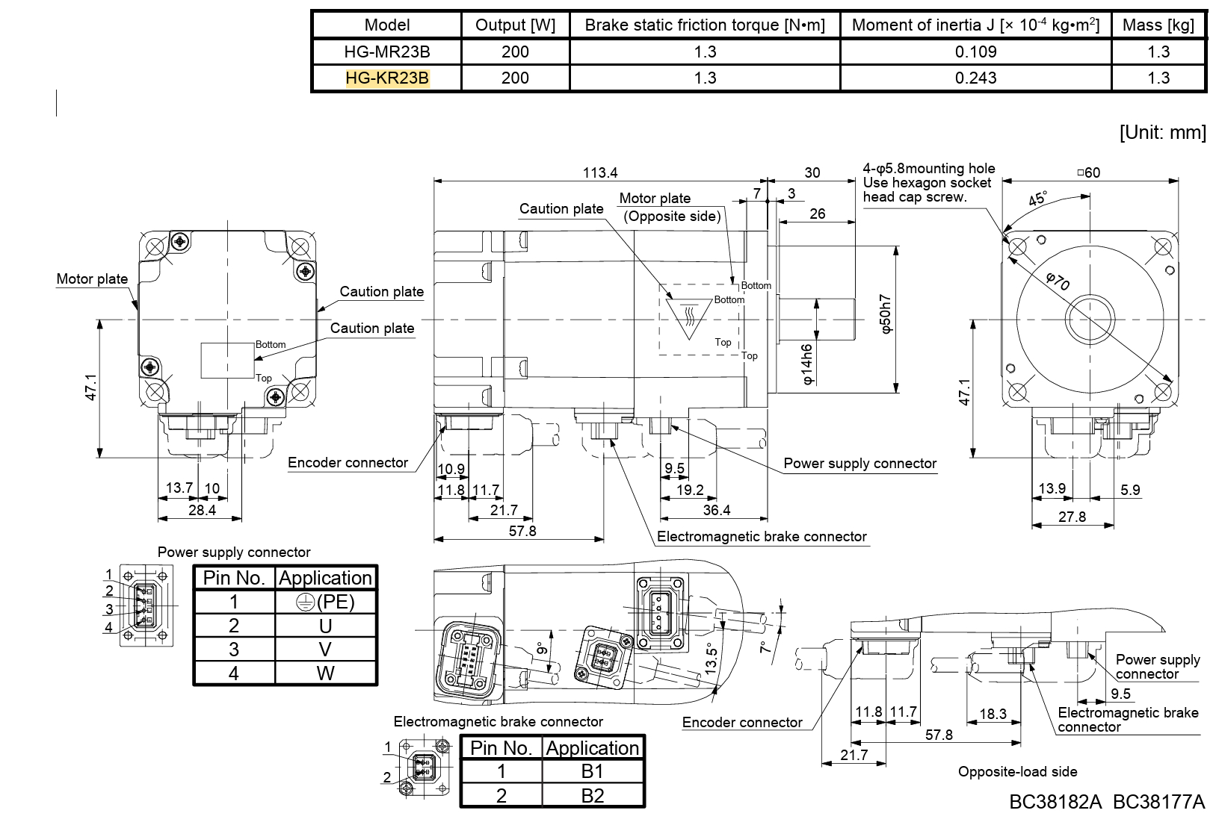 HG-KR23B Manual

Servo Amplifier
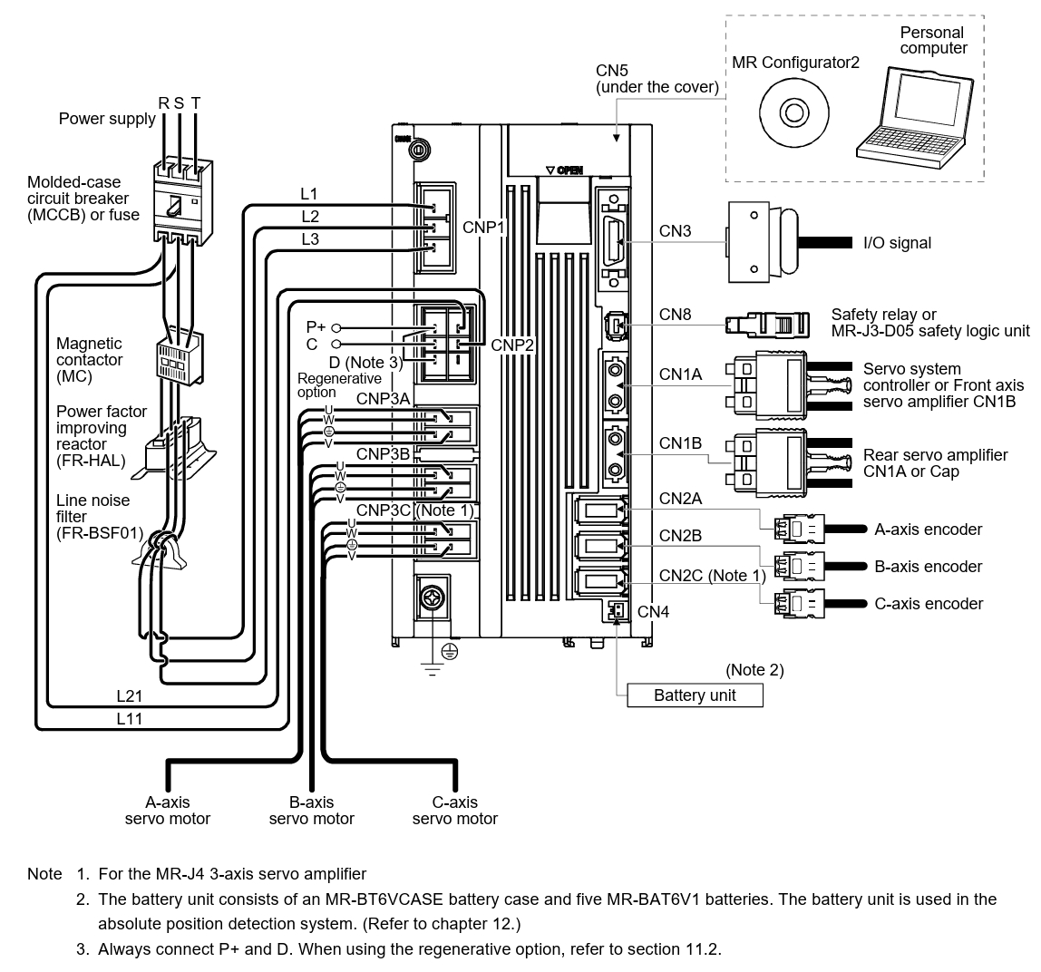 MR-J4W3-222B Manual

Power Supply
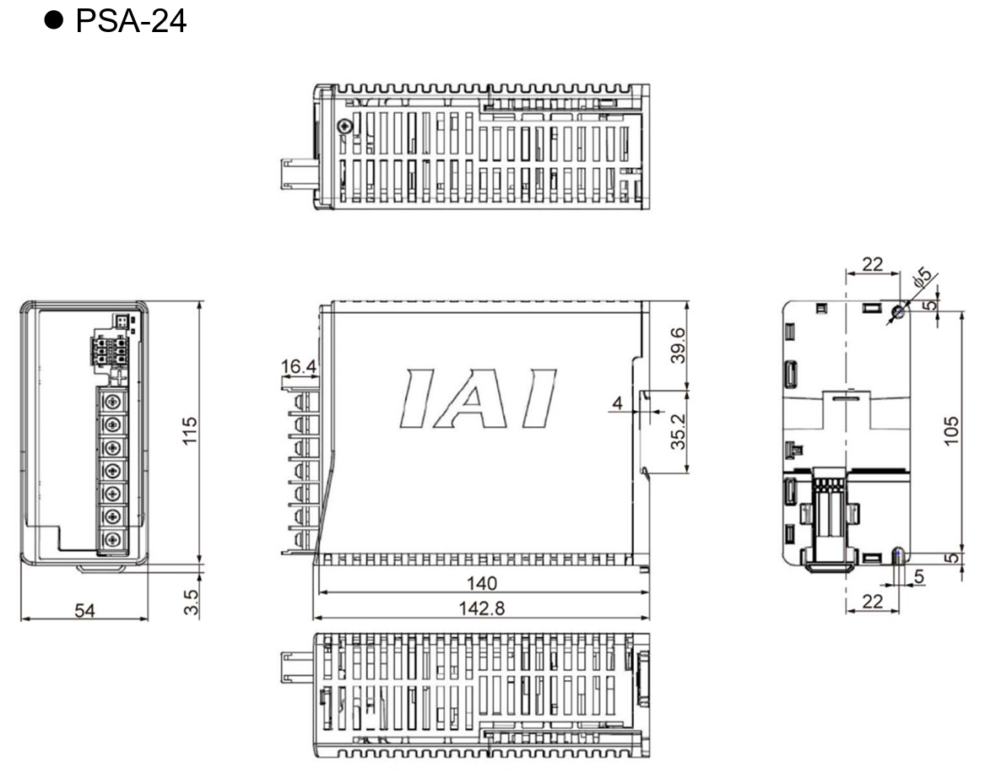 Power Supply Manual

Missing Parts

Motor Parts
- Electromagnetic Brake Part (Connecting to the motor)

Amp Parts
- Line Noise Filter (FR-BSF01)
- Power factor improving reactor (FR-HAL)
- Magnetic Contactor (MC)

Wiring and Cable Connection Progess
- Power Supply Input Wiring (100AC -> Plug)
- Motor Power Supply Connector -> Servo Amp Power Supply Connection 1 (1/3)
  - Directly Compatible Cable Connection
- Motor Encoder Connector -> Servo Amp Encoder Connection 1 (1/3)
  - 4 Wires (E-U-V-W) -> Amp JST Connector
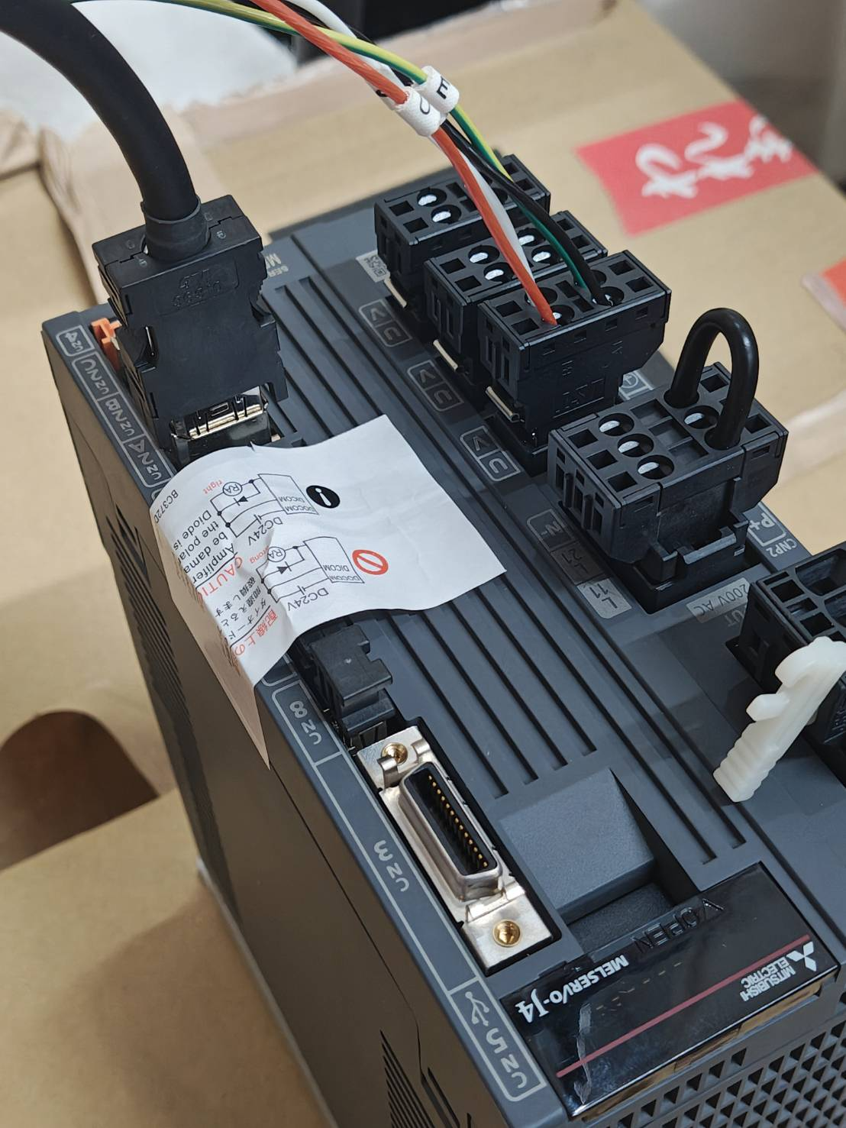
Cable Connection Progress
Note The White handle on the right buttom is the tool to open the connector pin holders

TO DO
- Confirm the missing parts against the purchase parts purchase list and see what is missing.
- Research How to control the Servo Amp with a computer
  - The Servo Amp has a Mini USB Port that can connect to a PC

