Technical Implementation Description: Distributed Control of a 40-Linear-Actuator System
This section describes the implemented control architecture for a distributed electromechanical system composed of 40 linear actuators and draw wire sensors. Wiring this many components would exceed pin count and processing capacity of any standard microcontroller. This paper implements a modular system architecture. A coordinated 40-actuator system demands a distributed control architecture to manage scale, modularity , and responsiveness. While modularity ensures scaling the actuation units reliably , it requires a centralized coordinator to orchestrate motion across all actuators. The architecture distributes this responsibility: low-latency firmware-level control on each node ensures deterministic motor response and sensor reads, while a series of REST API Python servers supervise the status of the motion in real-time. This separation, real-time embedded loops decoupled from network-facing command APIs, isolates each process, eliminates jitter from network delays and preserves tight feedback timing on local sensor-to-actuator cycles. The control objective is deterministic target tracking in the actuator sensor domain, with network-facing command and telemetry exchange exposed through REST interfaces and node-facing real-time execution performed over USB serial links.

Hardware Architecture and Specifications
Each control node consists of the following components:
- REST API client implemented in Rhino and Grasshopper that issues GET requests to read current sensor values and POST requests to set linear actuator targets.
- Python REST API server that receives requests on an API port and communicates with an Arduino Mega on a serial USB COM port
- Arduino Mega reads 4 analogue input from the sensors and drives 4 linear actuators via separate H-Bridges
- Total actuators/sensor pairs: 40
- Node count: 10
- Actuators per node: 4
- Node controller: Arduino Mega microcontroller (1 unit per node)
- Node-PC physical link: USB serial (1 serial link per node)
- Sensor per actuator: CWP-S1000v1 draw-wire potentiometer
- Linear actuator model: PLACEHOLDER_MODEL

Per-Node Hardware Interface Definition
Each Arduino Mega node uses one analog sensing channel and two PWM drive channels via an h-bridge component per actuator: Each actuator is driven towards a target length value (read from the sensor) until it is close enough to it. The closeness threshold is determined based on the required accuracy and the existing noise in the sensor readings.
- Sensor channels: A1, A2, A3, A4
- Drive channels (forward/reverse half-bridge command):
  - Actuator 1: RPWM=2, LPWM=3
  - Actuator 2: RPWM=4, LPWM=5
  - Actuator 3: RPWM=6, LPWM=7
  - Actuator 4: RPWM=8, LPWM=9

Host Port Mapping and Node Addressing
The main PC relies on a centralized configuration JSON file (port_map.json) to maintain a dynamic registry of all networked nodes. Each node in the system is uniquely identified by a dedicated API port and COM port pair. This mapping file serves as a critical lookup table that enables the main controller to:
- Route API requests to the correct node by resolving node identifiers to their respective API ports
- Establish serial communication by associating each node with its corresponding COM port for hardware-level control
- Support scalability by allowing new nodes to be added or existing nodes to be reconfigured without modifying the core controller logic
- Provide flexibility in node deployment, permitting nodes to be assigned different ports across different system configurations or environments
By externalizing this configuration into a JSON file rather than hardcoding port assignments, the system maintains loose coupling between the controller and individual nodes, facilitating easier maintenance, testing, and expansion of the multi-node architecture. Table ## illustrates how each node is represented by a unique API port and COM port pair. The indices on the target shape shown in figure #A# illustrate the port mapping and the corresponding linear actuators. This mapping is loaded at launch time and validated for structural correctness and API port uniqueness. Figure #B# showcases the dataflow form a centralized control unit to each actuator group.
Node Key | COM Port | API Port | Actuator Indices
API00 | COM17 | 7500 | 0:0:0, 0:0:1, 0:0:2, 0:0:3
API01 | COM16 | 7501 | 0:1:0, 0:1:1, 0:1:2, 0:1:3
API02 | COM15 | 7502 | 0:2:0, 0:2:1, 0:2:2, 0:2:3
API03 | COM14 | 7503 | 0:3:0, 0:3:1, 0:3:2, 0:3:3
API04 | COM13 | 7504 | 0:4:0, 0:4:1, 0:4:2, 0:4:3
API10 | COM12 | 7510 | 1:0:0, 1:0:1, 1:0:2, 1:0:3
API11 | COM11 | 7511 | 1:1:0, 1:1:1, 1:1:2, 1:1:3
API12 | COM10 | 7512 | 1:2:0, 1:2:1, 1:2:2, 1:2:3
API13 | COM9 | 7513 | 1:3:0, 1:3:1, 1:3:2, 1:3:3
API14 | COM7 | 7514 | 1:4:0, 1:4:1, 1:4:2, 1:4:3
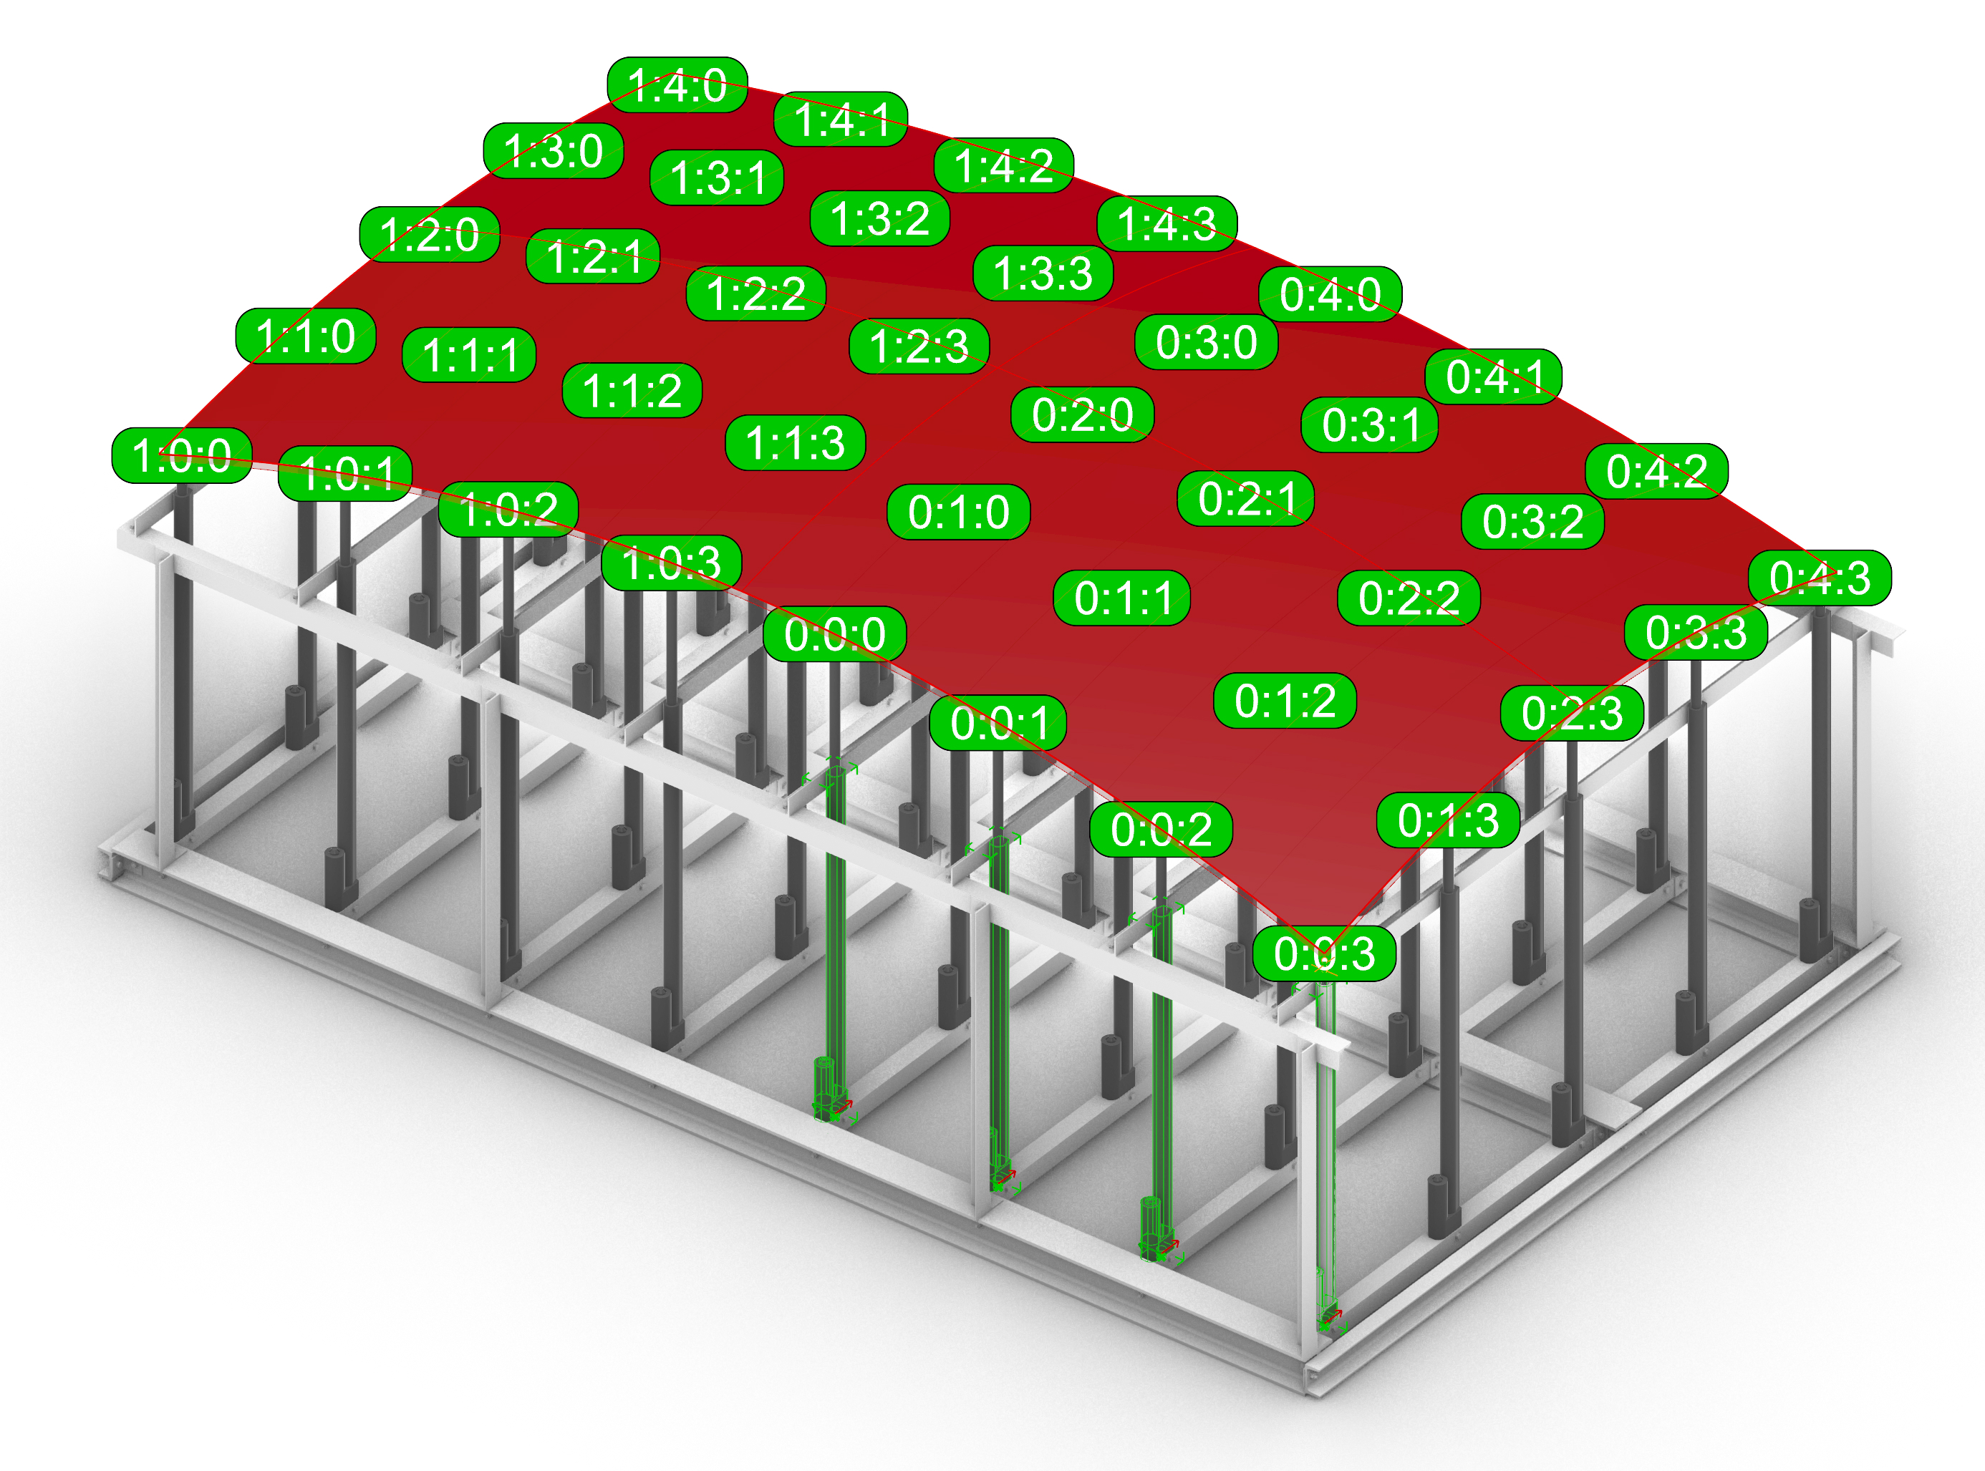
Figure #A#. Linear Actuator Configuration: Index grid layout for linear actuators are displayed on the target surface. The 4-unit linear actuator node is highlighted in green.
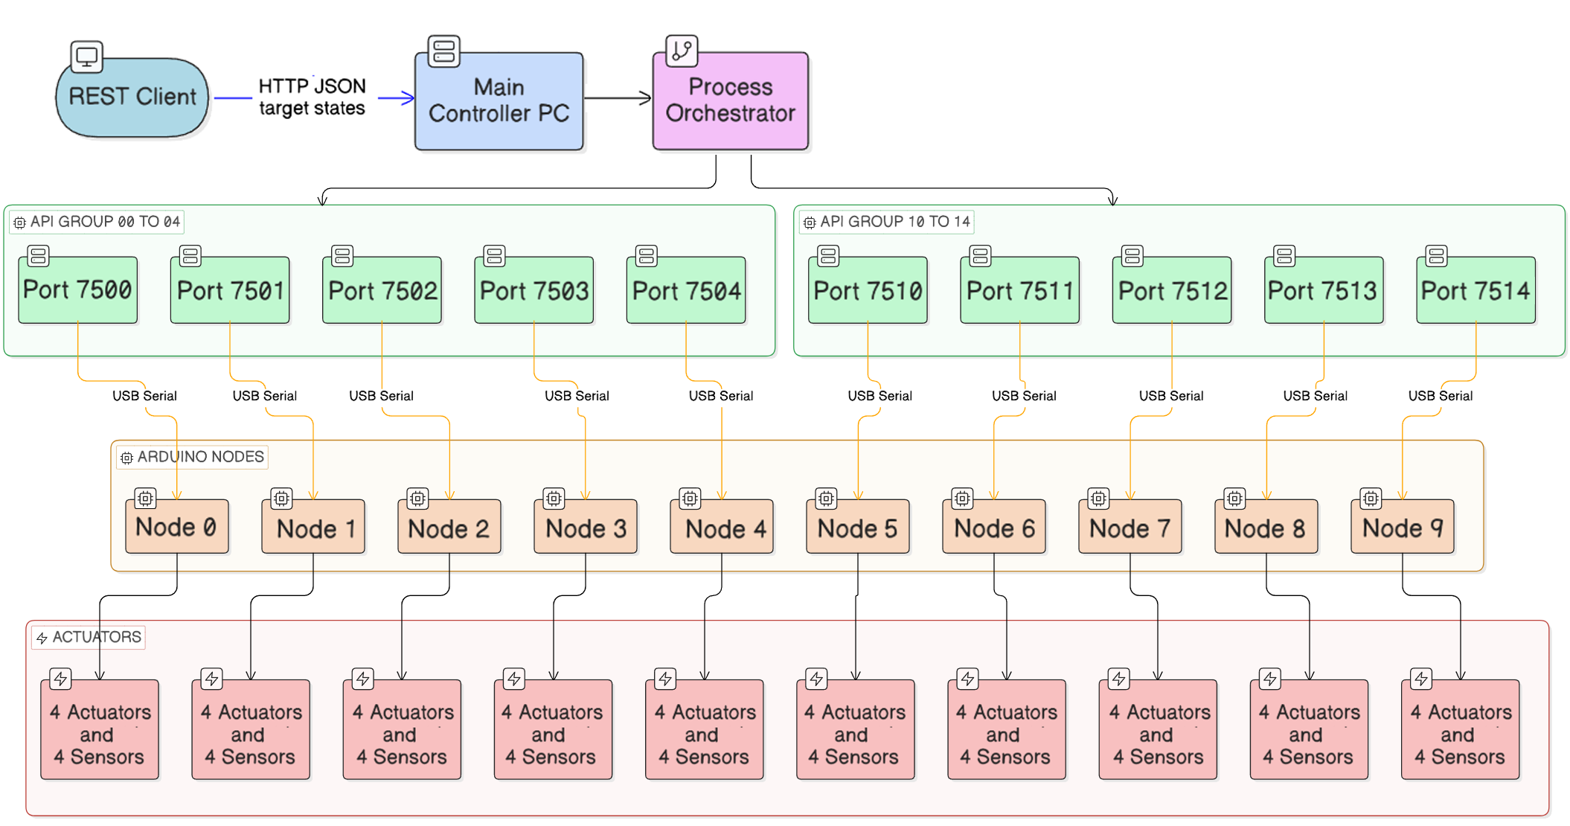
Figure #B#. Dataflow Diagram: Linear actuator target requests originating from the REST client reaching to the actuators via the modular system

Server Process Model and Concurrency Strategy
Each mapped API process is an independent Flask API application bound to one API port and one serial device. Within a node process, two execution contexts are used (Figure #C#). Each of the Flask API applications acts as the source of truth bound to one API port and one serial device. A thread-safe wrapper protects the shared state in memory using a lock. This ensures the API and serial reader don’t read or write at the same time, preventing data corruption. Within a node process, two execution contexts are used: The multi-node runtime is established by a launcher that parses the mapping file, validates entries, and spawns one Python Flask API processes per mapping key.
- API/Main thread: handles HTTP GET/POST requests and serial writes.
- Serial reader thread: continuously reads telemetry lines from serial and updates only current fields in memory.
- When the API receives a new target, it updates server state immediately.
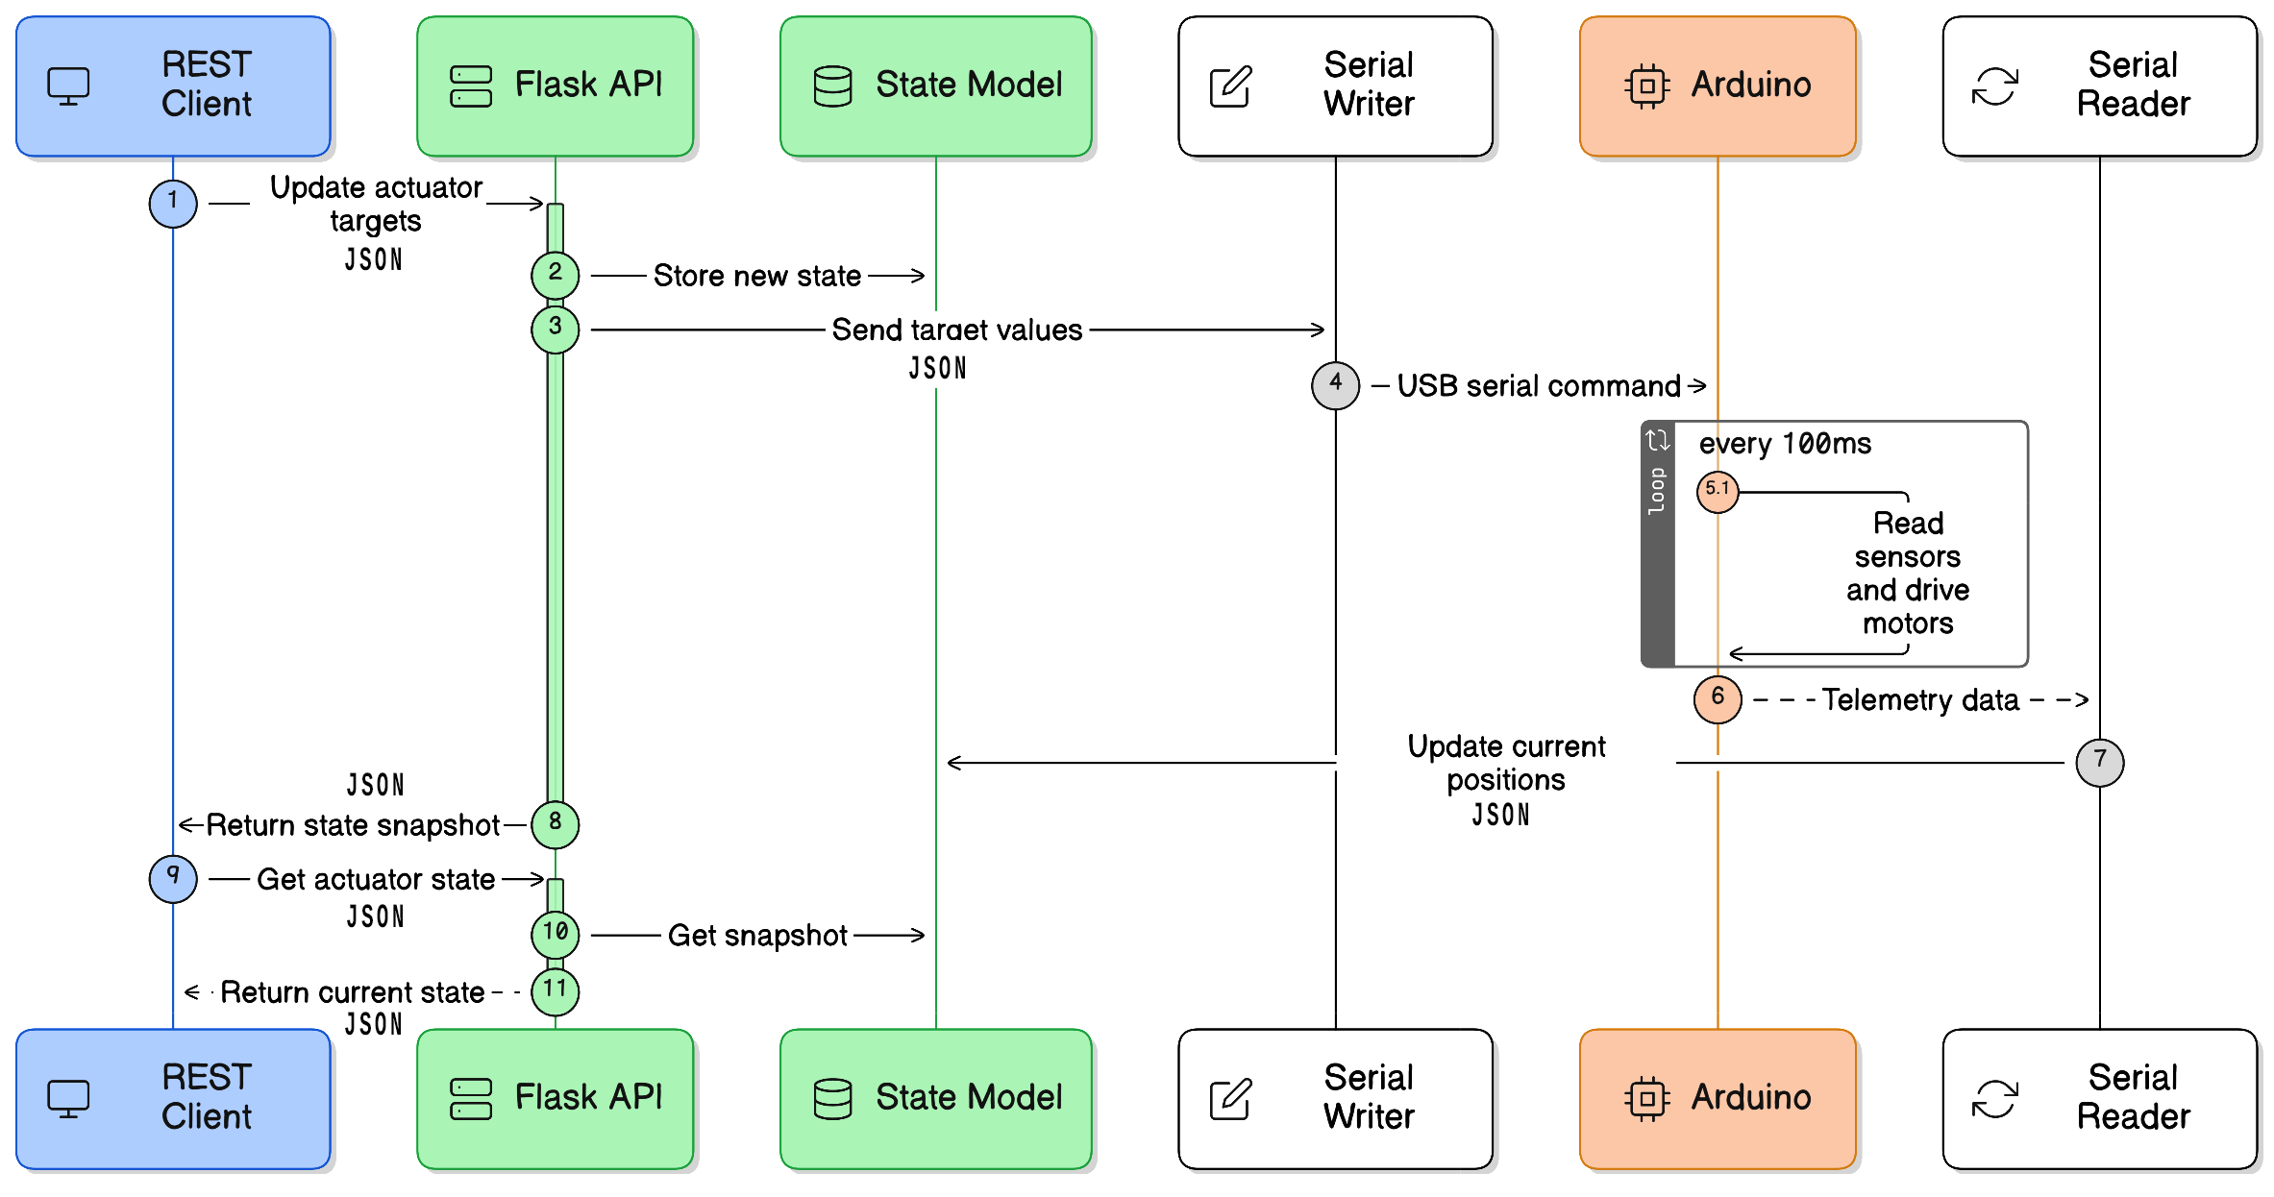
Figure #C#. Target and Sensor Data Update Model: Each Flask API app acts as the source of truth for the linear actuator and the REST client

