Lab12-Postgresql

Aminur Rasul

Table of Contents
CLASS =12 A (Class) 2
LAB Exercise 12 B (Class) 7
Lab exercise 12B (Lab) 9
Lab Exercise 12 C (Class Example) 12
Lab Exercise 12 C (Lab Exercise) 16

CLASS =12 A (Class)

Name : Aminur Rasul
Tuesday April 29, (Introduction)
Class example:

CLASS =12 A

Lab exercise 1
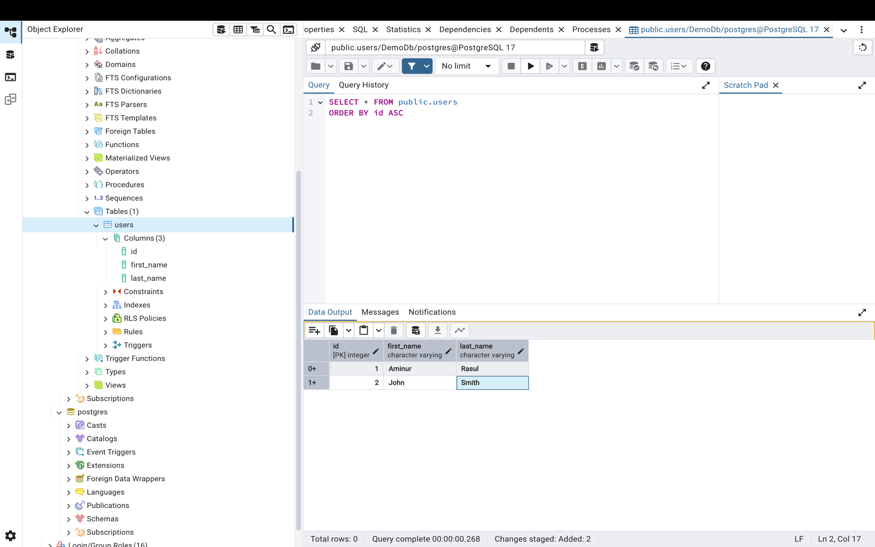

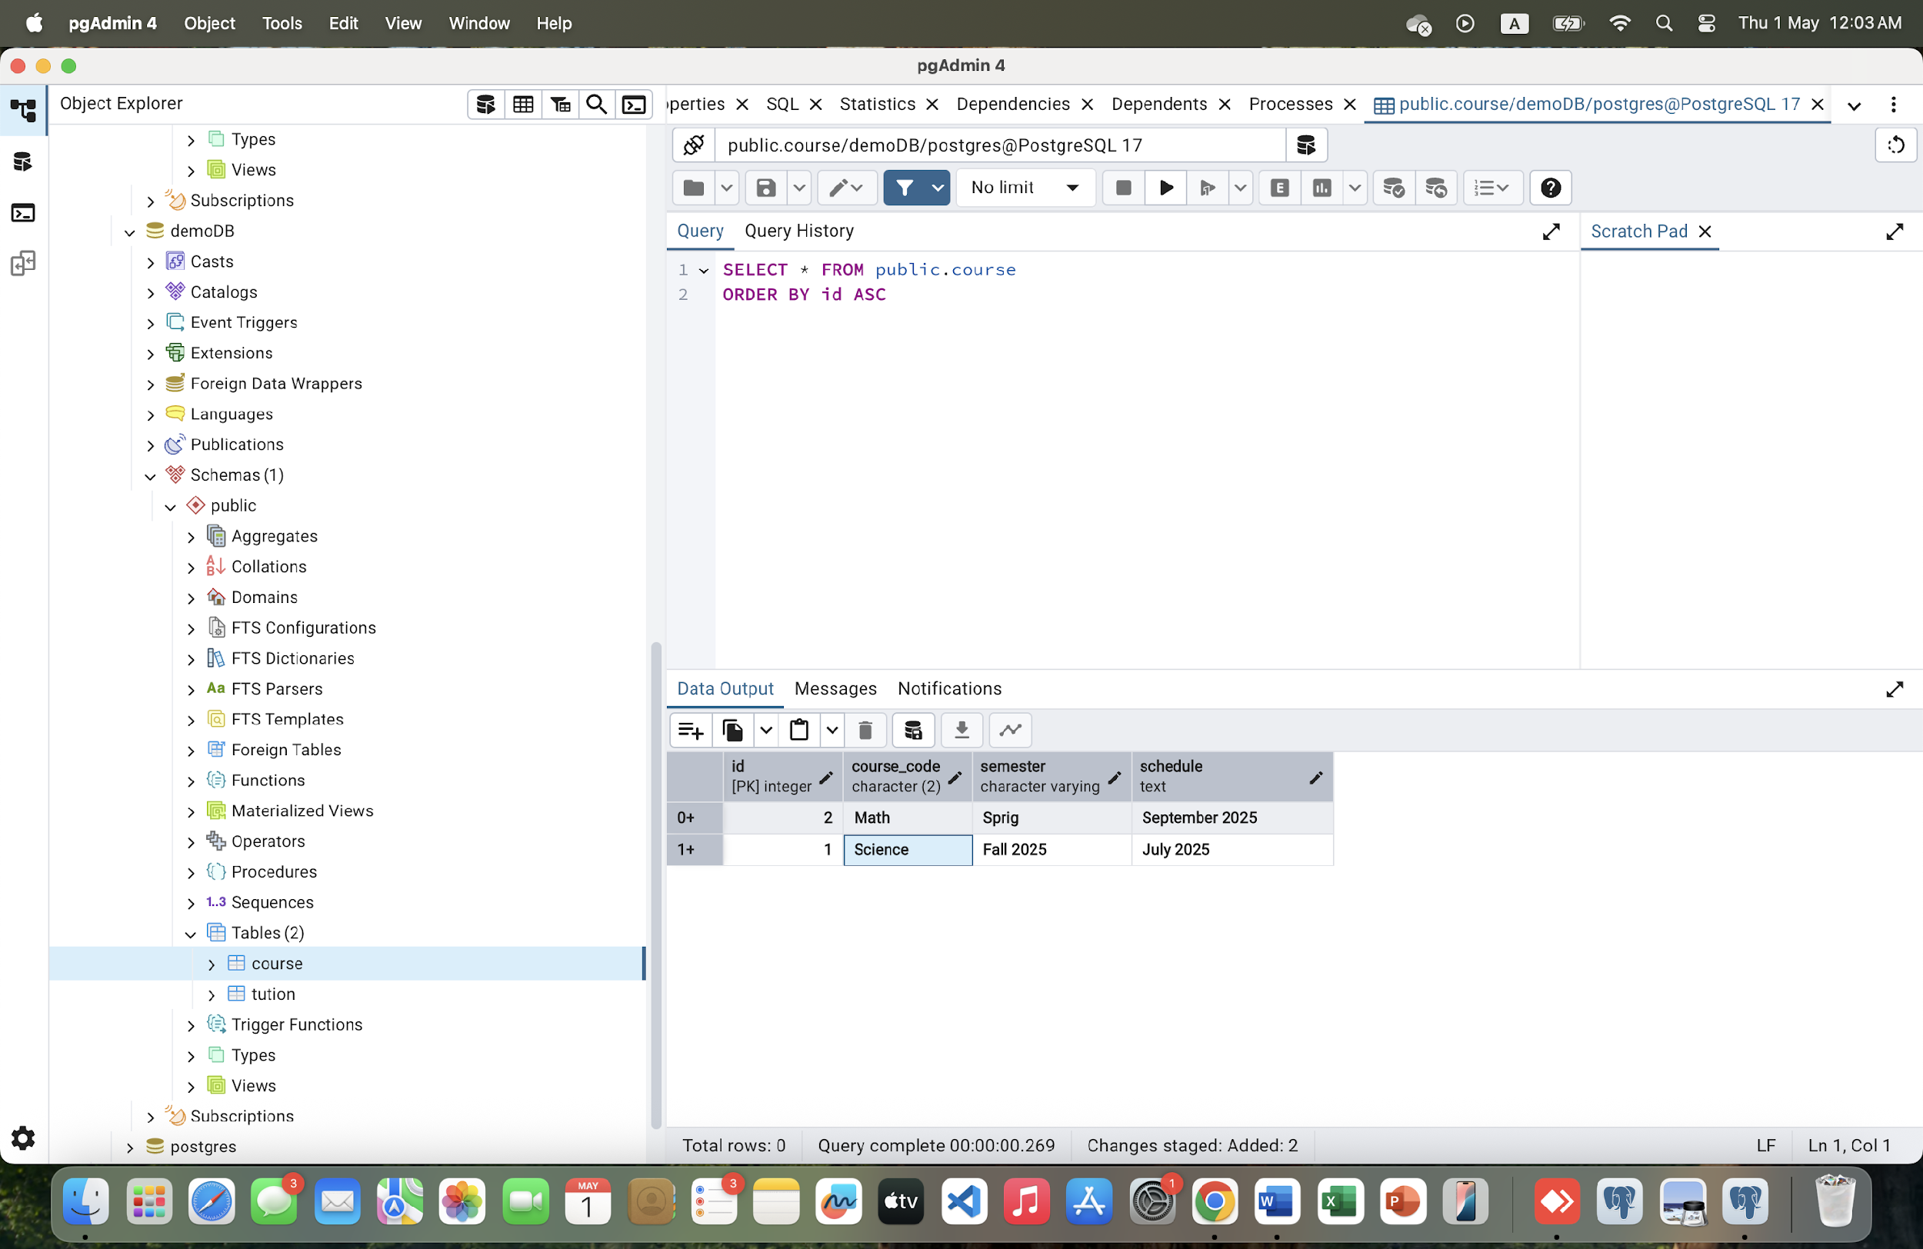

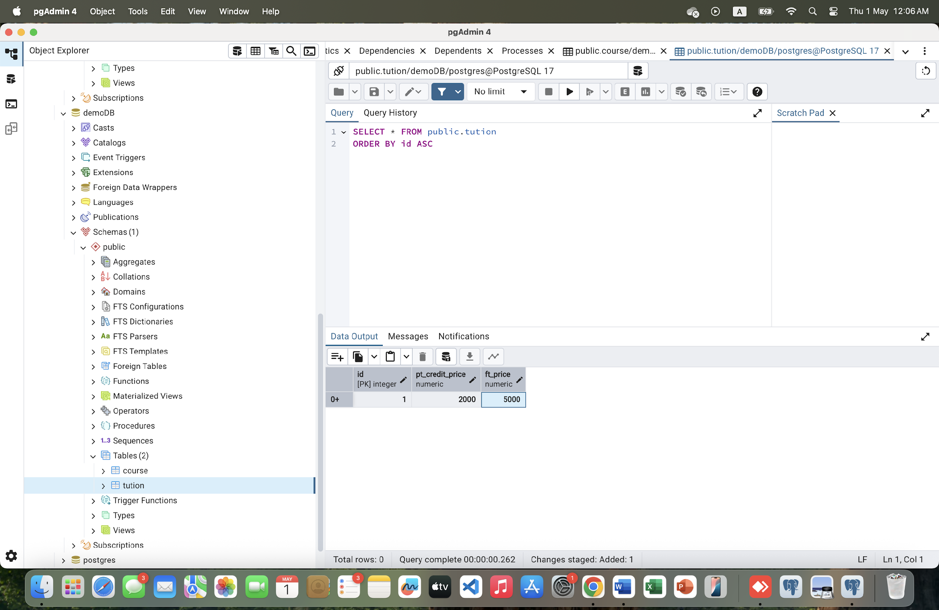

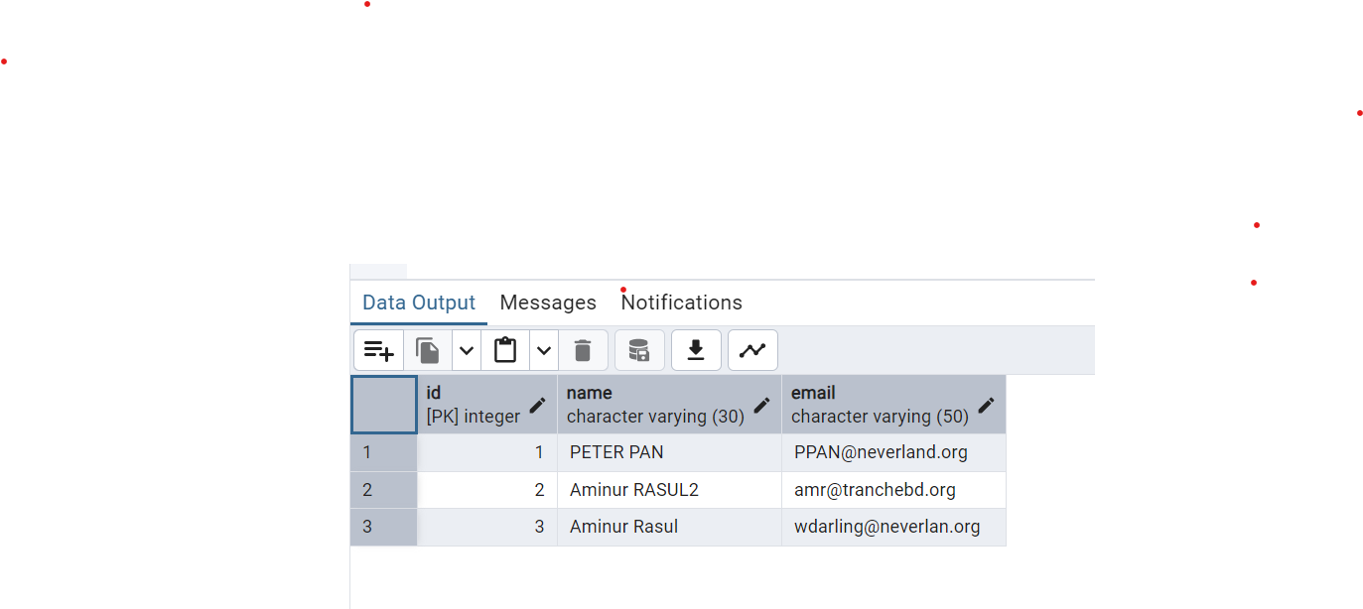

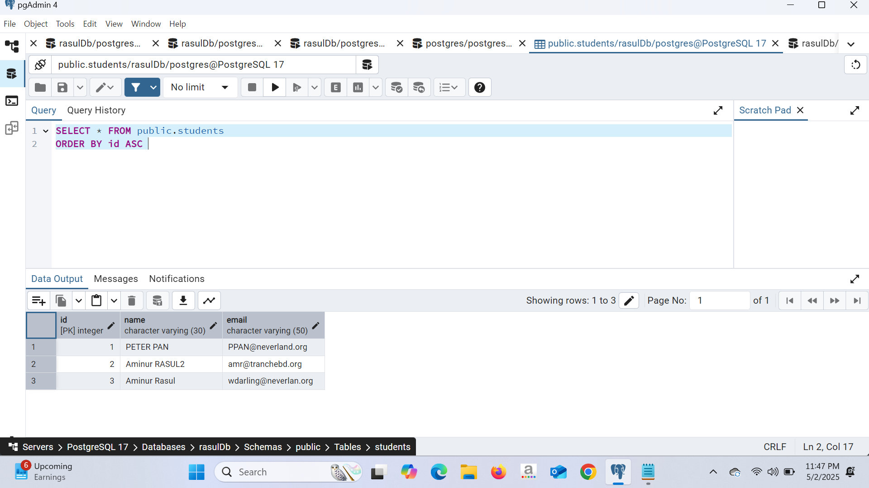

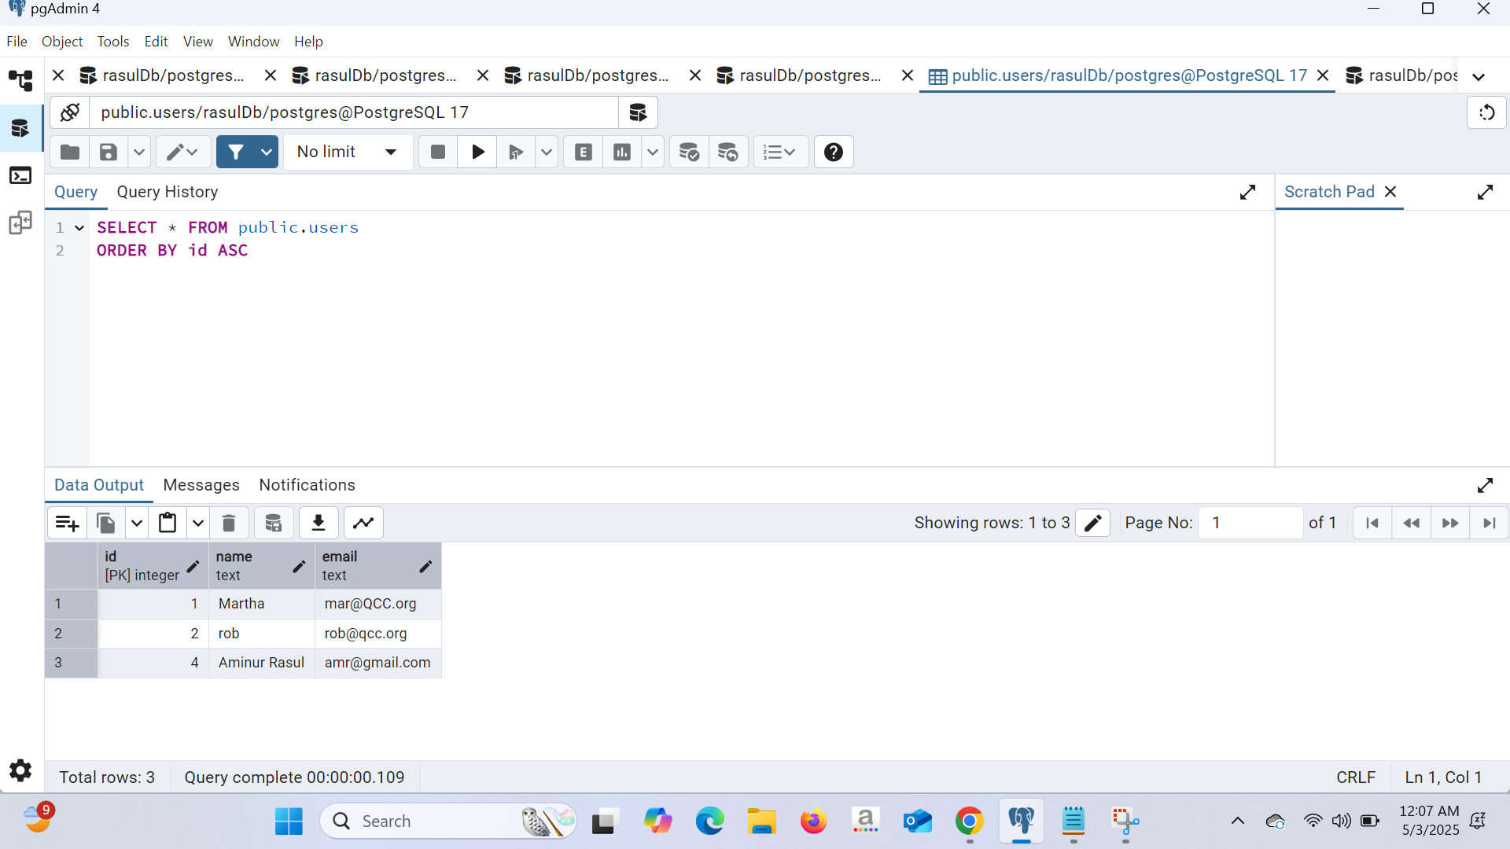

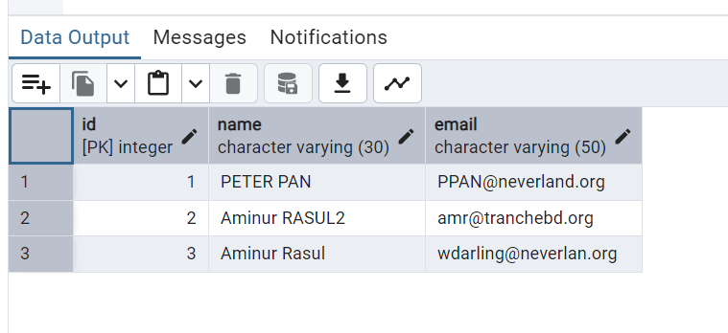

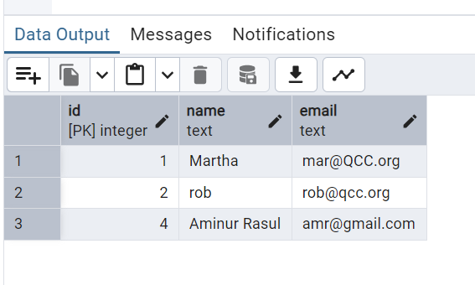

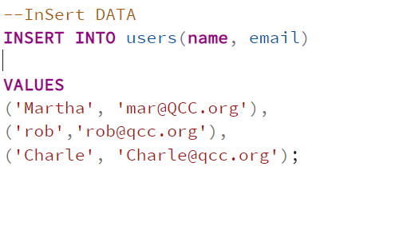
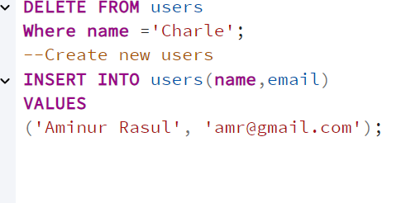
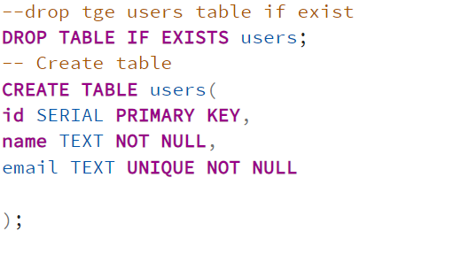


LAB Exercise 12 B (Class)
Date: 2nd May 2025

Class Example :

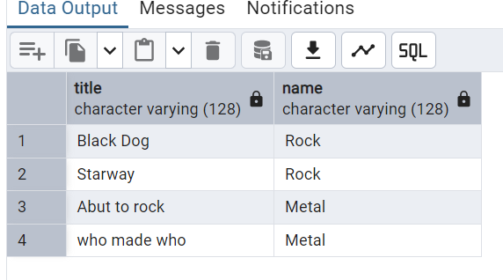

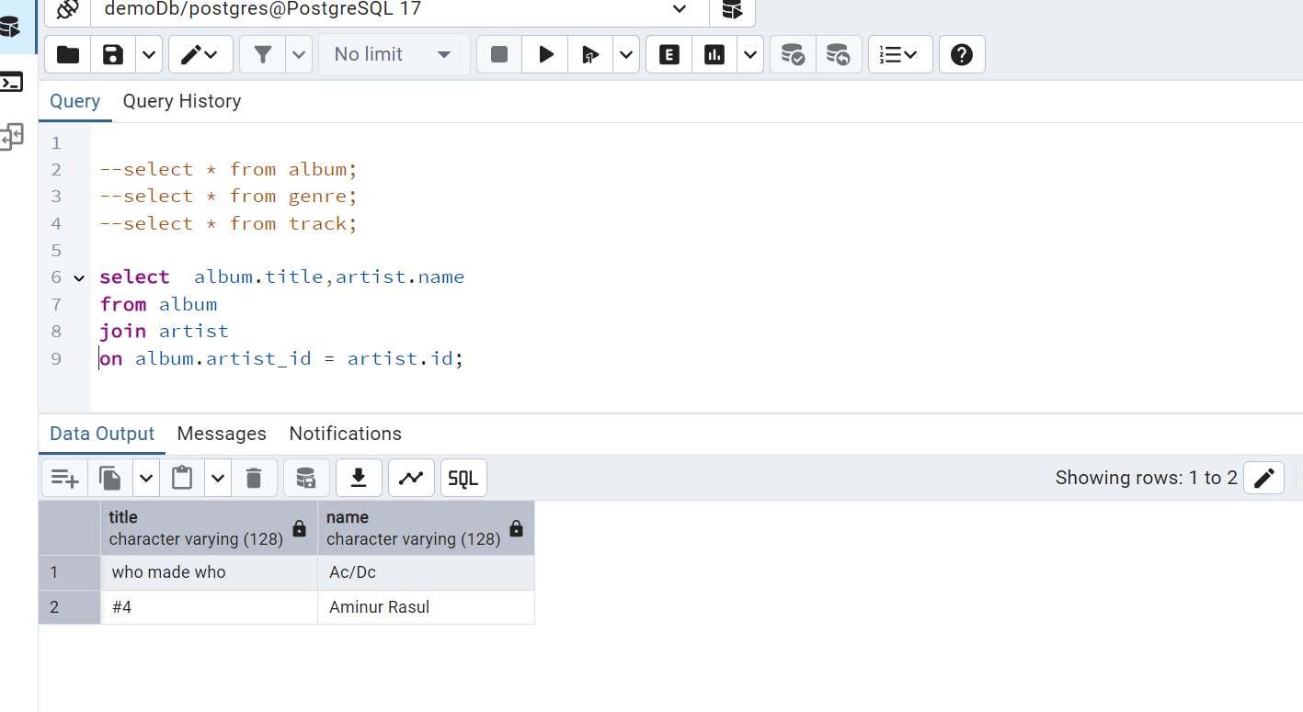

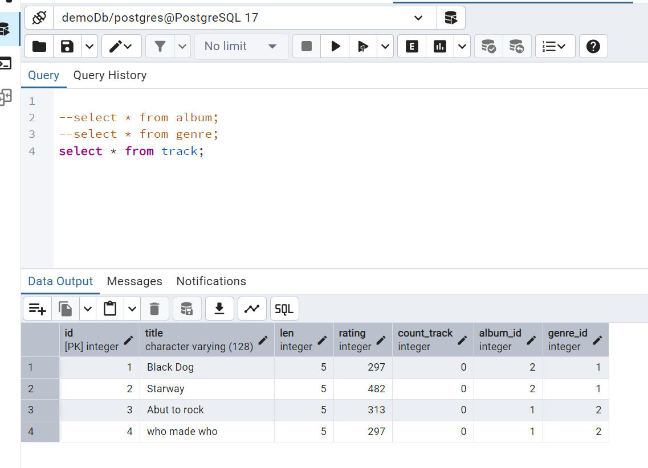


Lab exercise 12B (Lab)

Create table for books

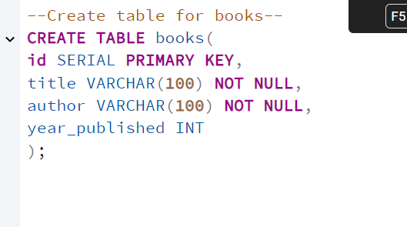
Insert the data in the table

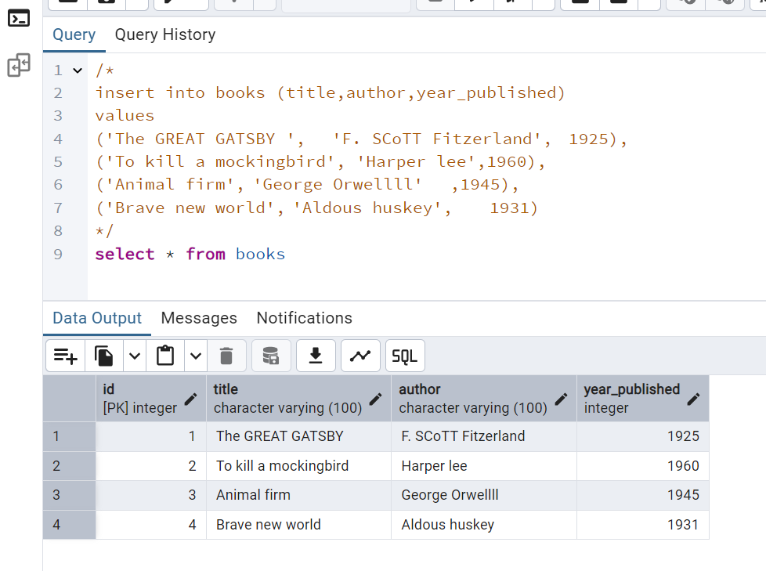

Read the data



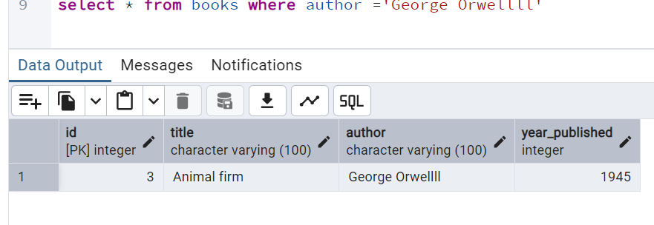

Update the year_published of Brave New World to 1931.

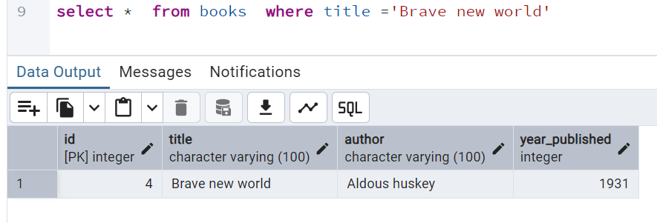

Delete the record for To Kill a Mockingbird.

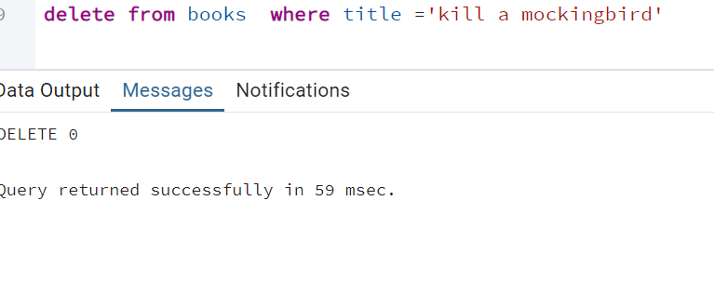

Select all records from the books table to verify your changes.

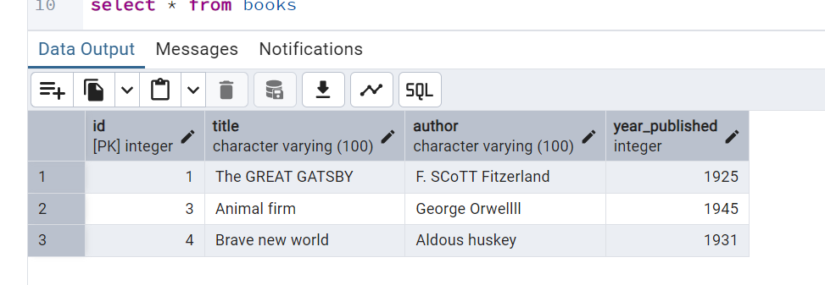

Add a new column genre to the books table.
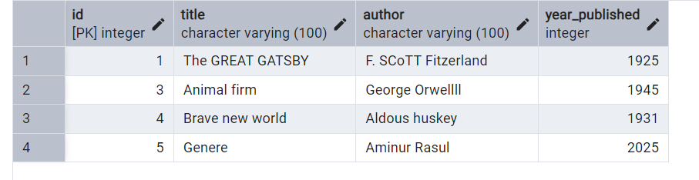

Update the genre for each book.

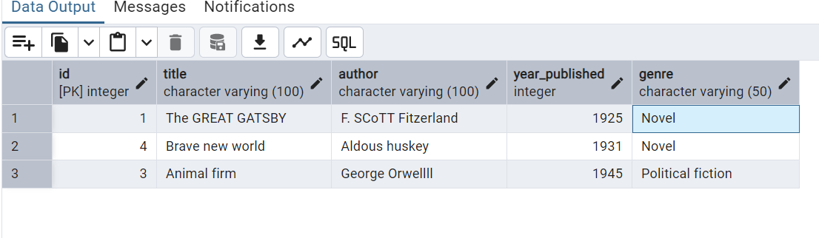
Select all books grouped by genre.

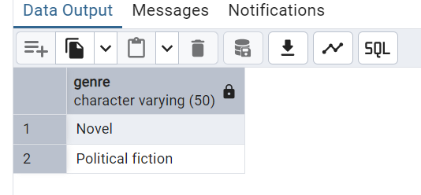

Lab Exercise 12 C (Class Example)

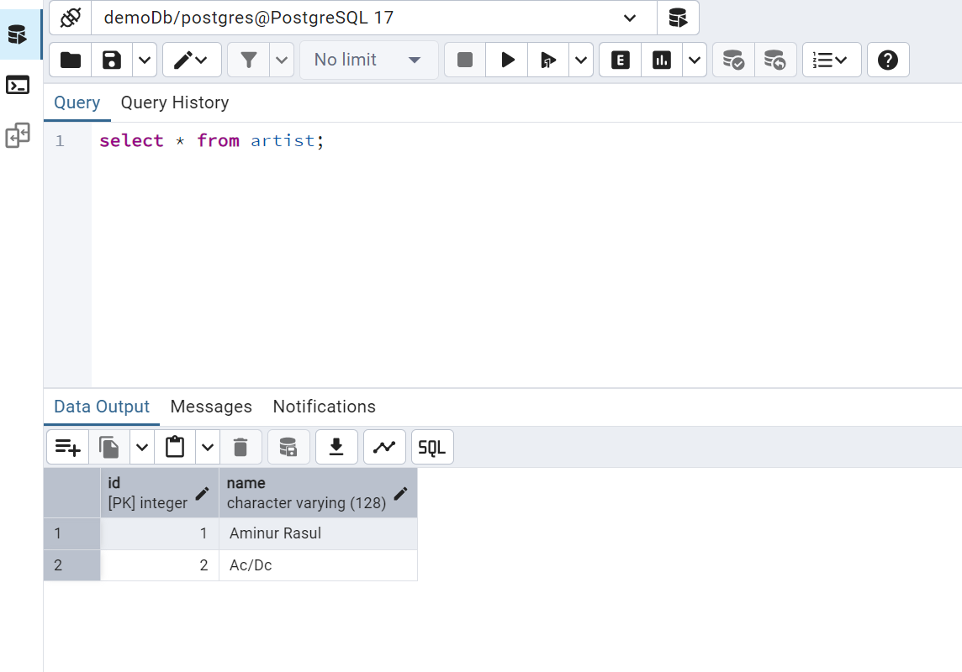

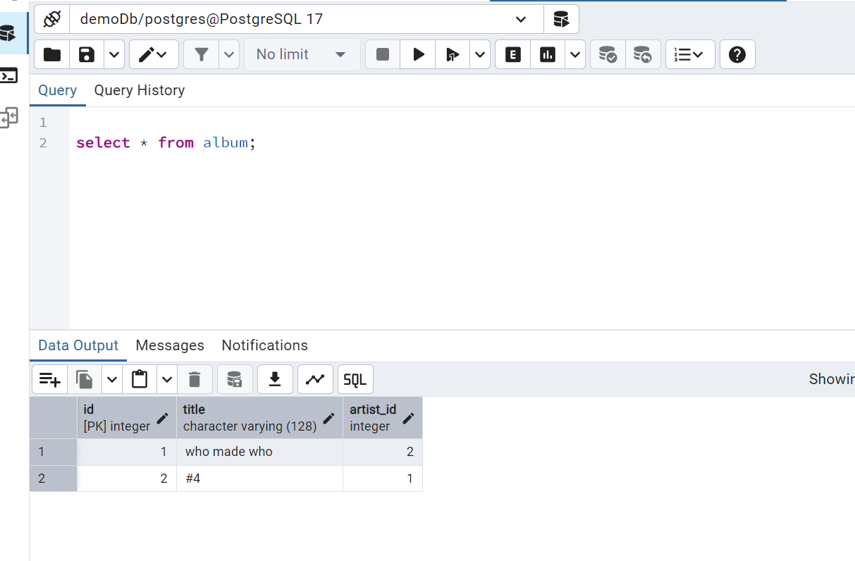

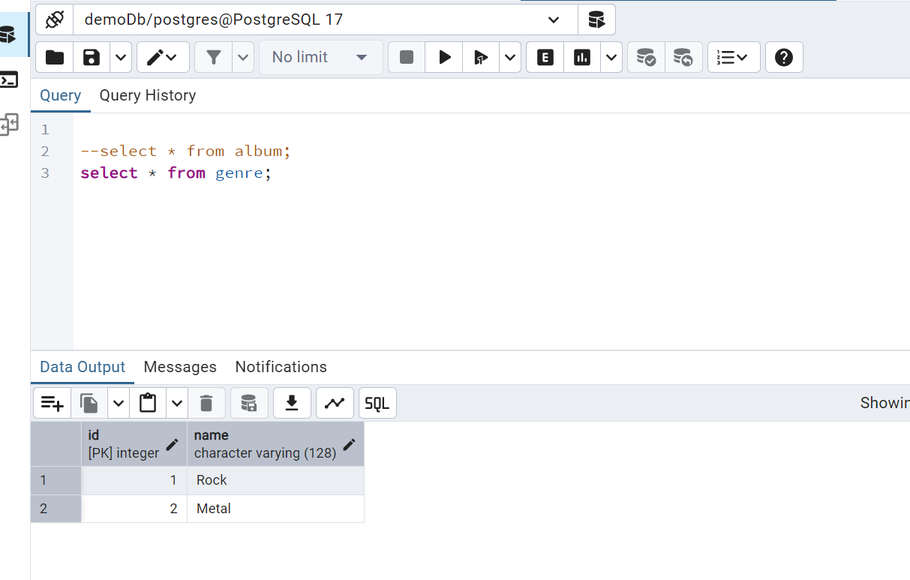







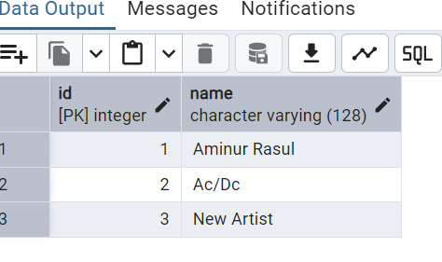


Lab Exercise 12 C (Lab Exercise)

LAB EXERCISE
Relational database

CREATE TABLE students(ID serial primary key, name VARCHAR(100), major VARCHAR(100)
create table course (id serial primary key , title varchar(100),department varchar(100)
create table enrollments ( id serial primary key , grade char(2),student_id int,course_id int,department_id int,
CONSTRAINT enrollemnts_student_id_fkey FOREIGN KEY (student_id)
REFERENCES students (id) ,
CONSTRAINT enrollemnts_course_id_fkey FOREIGN KEY (course_id)
REFERENCES course (id) ,
CONSTRAINT enrollemnts_deparment_id_fkey FOREIGN KEY (department_id)
REFERENCES course (id)
insert into students (name,major) values
('Alice Brown', 'Major: Computer Science'),
('Peter Pan', 'Major: Mathematics'),
('Annie Chen', 'major: Physics'),
('Aminur Rasul', 'major: Mathematics')
*/
/*
insert into course (title,department) values
('Database Systems', 'department: computer science'),
('Linear algebra', 'department: mathematics'),
('Quantum mechanics', 'department: physics'),
('Python programming', 'department: computer science'),
('Calculus III', 'department: mathematics')
insert into students (name,major) values
('Alice Brown', 'Major: Computer Science'),
('Peter Pan', 'Major: Mathematics'),
('Annie Chen', 'major: Physics'),
('Aminur Rasul', 'major: Mathematics')
insert into enrollments (grade,student_id,course_id,department_id)
values('A',4,2,2),
values ('B+',3,3,3),
values ('C',2,2,2),
values ('B+',1,1,1),
values ('A-',1,1,1);

Read all students and their major
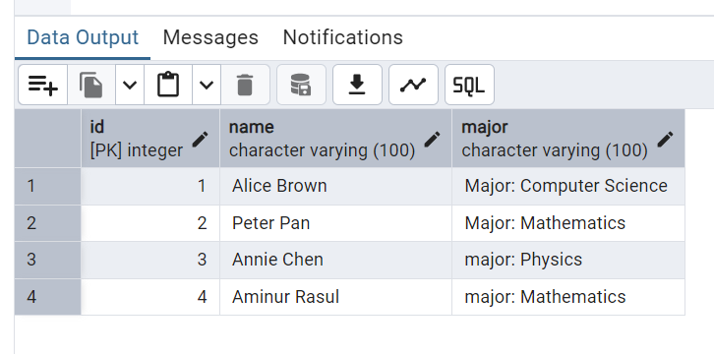
Read the Titles of courses each student is enrolled in.

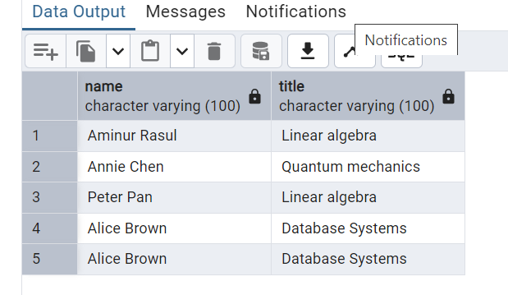
read all students with grade and courses.

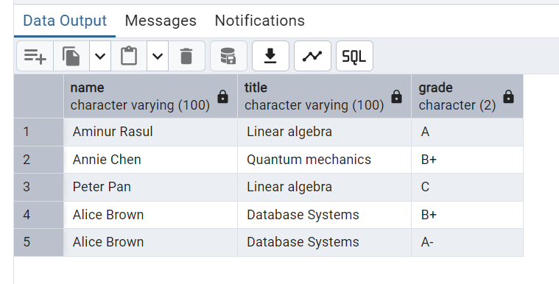
Read how many students have a grade of B+.
