**ARATHI RAJAGOPALAN**

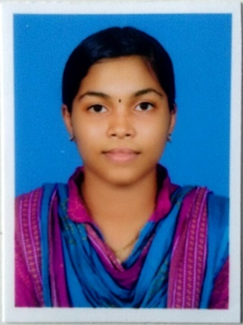Perilavalappu,

Udayamangalam,

Udma(P O),

Kasaragod-671319,

Kerala,India

Email :[arathirajagopalan22@gmail.com](mailto:arathirajagopalan22@gmail.com)

Contact no:8078109272

___________________________________________________________________________

**OBJECTIVE**

* Software developer
* To be expert in JAVA,MYSQL,PHP,C++

**EDUCATION QUALIFICATION**

|  |  |  |  |  |
| --- | --- | --- | --- | --- |
| **QUALIFICATION** | **BOARD/UNIVERSITY** | **INSTITUTION** | **YEAR OF PASS OUT** | **GRADE(points)** |
| BCA | SRINIVAS UNIVERSITY | Srinivas University  Pandershwara,  Mangaluru | 2017-2018  2018-2019 | |  |  | | --- | --- | | Semester |  | | First | 8.48 | | Second | 7.84 | | Third | 9.29 | | Fourth | 8.71 | |
| PUC | Kerala Board | G H S SUdma,  Bara(p o),  Kasaragod,  Kerala | 2015-2017 | 77% |
| SSLC | Kerala Board | G H S SUdma,  Bara(p o),  Kasaragod,  Kerala | 2015 | 94% |

**Career Objective**

To obtain a professional position in the consulting industry utilizing my relevant experience, technical expertise and problem solving skills.

**Area of Interest**

* Software Develop
* To work with Visual Studio,DataBase
* Windows 10,7,Linux,Ubuntu

**PROJECT WORKS**

**Mini project**

* Online Mobile shopping
* College website

**STRENGTHS**

* Dynamic
* Positive Attitude
* Presentation skill
* Good team member
* High Interpersonal Skill
* Communication skill

**PERSONAL DETAILS**

* Age : 19
* DOB : 22-01-2000
* Gender : Female
* Father’s Name : KV Rajagopalan
* Profession : Bank Manager
* Mother’s Name : Thilothama
* Profession : House wife
* Languages known : Malayalam, Hindi, English
* Marital status : single

**DECLARATION**

I do here by confirm that the information given in this form is true to the best of my knowledge and belief.

Place : Kasaragod Yours,Faithfully

Date : ARATHI RAJAGOPALAN

