LOGISTICS DATA ANALYST INTERNSHIP

WEEK 3 TASK REPORT : Advanced Data Analysis and Visualization in Logistics

Submitted By: Arati Balaso Deokate
Internship Role: Logistics Data Analyst Intern
Internship Organization: YuvaIntern
Task: Advanced Data Analysis and Visualization in Logistics
Tools Used: Python, Pandas, NumPy, Matplotlib, Seaborn, Google Colab
Dataset Type: Hypothetical / Simulated Logistics Dataset

CONTENTS
- Introduction
- Objectives
- Data Simulation
- Dataset Structure
- Exploratory Data Analysis
5.1 Transport Mode Distribution
5.2 Regional Distribution
- Descriptive Statistical Analysis
- Delivery Status Analysis
- Correlation Analysis
- Data Visualization
9.1 Delivery Time Distribution
9.2 Delivery Status Distribution
9.3 Transportation Cost by Transport Mode
9.4 Delivery Time by Transport Mode
9.5 Distance vs. Transportation Cost
- Correlation Heatmap
- Key Logistics Insights
- Potential Logistics Bottlenecks
- Recommendations
- Python Tools and Techniques Used
- Sample Python Code
- How Visualizations Support Logistics Decision-Making
- Conclusion
- Project / GitHub
- References

1. INTRODUCTION
Logistics operations generate large amounts of data related to transportation, shipment volumes, delivery times, costs, distances, fuel consumption, and delivery performance. Analysing these variables helps organizations understand operational efficiency, identify cost drivers, detect potential bottlenecks, and improve delivery performance.
The objective of this Week 3 task was to perform advanced data analysis and visualization using Python on a hypothetical logistics dataset. Since the task required a simulated dataset, a dataset containing 1,000 shipment records was generated using Python and NumPy.
The analysis focused on delivery time, shipment volume, transportation cost, distance travelled, fuel cost, delivery delays, transport modes, geographical regions, and delivery status. Exploratory Data Analysis (EDA), descriptive statistics, correlation analysis, and multiple visualization techniques were applied to understand the relationships between these variables.
The final analysis demonstrates how data visualization can convert raw logistics data into meaningful business insights that can support operational and strategic decision-making.

2. OBJECTIVES
The main objectives of this task were:
- To create a hypothetical logistics dataset using Python.
- To understand the structure and characteristics of logistics data.
- To perform Exploratory Data Analysis (EDA).
- To calculate important statistical measures such as averages and distributions.
- To analyse relationships between logistics variables using correlation analysis.
- To create meaningful visualizations using Matplotlib and Seaborn.
- To identify potential logistics cost drivers and operational patterns.
- To interpret analytical results from a logistics-management perspective.
- To provide recommendations based on the observed data patterns.

3. DATA SIMULATION
A hypothetical logistics dataset was generated using Python. A fixed random seed of 42 was used to make the results reproducible.
A total of 1,000 shipment records were generated. Shipment dates were distributed across the year 2025.
The dataset included four transport modes:
- Road
- Rail
- Air
- Sea
Five regions were also included:
- North
- South
- East
- West
- Central
The numerical variables were generated using appropriate probability distributions and formulas to represent realistic logistics conditions.
For example, transportation cost was influenced by distance, transport mode, and shipment volume. Delivery time was influenced by transport mode, distance, shipment volume, and random variation. Fuel cost was primarily related to distance.
The dataset generation process used NumPy and Pandas and was then converted into a Pandas DataFrame for analysis.

4. DATASET STRUCTURE
The simulated dataset contained the following 11 variables:
Variable | Description
shipment_id | Unique identification number for each shipment
shipment_date | Date of shipment
delivery_time_days | Total delivery time in days
shipment_volume | Volume of the shipment
transportation_cost | Transportation cost associated with shipment
distance_km | Distance travelled in kilometres
fuel_cost | Estimated fuel cost
delay_days | Number of days delayed or early
transport_mode | Mode of transportation
region | Geographical region
delivery_status | Delivery classification as Delayed or On-Time
The dataset was designed to contain both categorical and numerical variables, making it suitable for statistical analysis and visualization.

5. EXPLORATORY DATA ANALYSIS
Exploratory Data Analysis was performed to understand the dataset before drawing conclusions.
The analysis included:
- Dataset shape and structure
- Numerical-variable analysis
- Transport-mode distribution
- Regional distribution
- Delivery-status distribution
- Descriptive statistics
- Correlation analysis
- Visualization of important logistics variables
The dataset contained 1,000 shipments.

5.1 Transport Mode Distribution
The distribution of shipments by transport mode was:
Transport Mode | Number of Shipments
Road | 503
Rail | 209
Sea | 153
Air | 135
Road transportation represented the largest share of the simulated shipments, with 503 records.
This indicates that road transport was the dominant transportation mode in the hypothetical logistics operation.

5.2 Regional Distribution
The regional distribution was:
Region | Number of Shipments
Central | 214
South | 212
West | 208
North | 193
East | 173
The shipment distribution across regions was relatively balanced. Central had the highest number of shipments, while East had the lowest.

6. DESCRIPTIVE STATISTICAL ANALYSIS
Important average values calculated from the dataset were:
Metric | Average
Delivery Time | 6.07 days
Shipment Volume | 78.88
Transportation Cost | 2058.76
Distance | 757.77 km
Fuel Cost | 201.16
Delay | 0.63 days
The average delivery time was 6.07 days, indicating the typical time required to complete a shipment in the simulated dataset.
The average shipment volume was 78.88, while the average transportation cost was 2058.76.
The average shipment travelled approximately 757.77 km, and the corresponding average fuel cost was 201.16.
The average delay was 0.63 days, indicating that delays were present in the simulated logistics operation.

7. DELIVERY STATUS ANALYSIS
Delivery status was classified into two categories:
- Delayed
- On-Time
The results were:
Delivery Status | Number | Percentage
Delayed | 567 | 56.7%
On-Time | 433 | 43.3%
Total | 1000 | 100%
The analysis shows that 56.7% of shipments were delayed, while 43.3% were delivered on time.
This is an important operational finding because the simulated dataset contains a higher proportion of delayed shipments than on-time shipments.
From a logistics-management perspective, such a pattern would require investigation into factors such as transportation mode, route distance, operational scheduling, capacity planning, and other potential sources of delay.

8. CORRELATION ANALYSIS
Correlation analysis was performed to understand the linear relationships between numerical logistics variables.
The correlation matrix included:
- Delivery time
- Shipment volume
- Transportation cost
- Distance
- Fuel cost
- Delay
Important correlation values included:
Variable Pair | Correlation
Distance – Fuel Cost | 0.93
Distance – Transportation Cost | 0.62
Fuel Cost – Transportation Cost | 0.57
Delivery Time – Distance | 0.45
Delivery Time – Fuel Cost | 0.43
Shipment Volume – Transportation Cost | 0.27
Delivery Time – Delay | 0.02
Distance – Delay | 0.01
The strongest relationship was between distance and fuel cost, with a correlation of 0.93. This indicates a very strong positive linear relationship in the simulated data: longer distances are generally associated with higher fuel costs.
Distance also had a positive correlation of 0.62 with transportation cost, showing that distance is an important factor associated with transportation expenses.
Delivery time had moderate positive relationships with distance and fuel cost, with correlations of 0.45 and 0.43, respectively.
The relationship between delay and the other numerical variables was very weak in this simulated dataset. For example, distance and delay had a correlation of only 0.01.
Correlation should be interpreted as association rather than proof of causation.

9. DATA VISUALIZATION
Six major visualizations were created using Matplotlib and Seaborn.
These visualizations were selected because they provide different perspectives on logistics performance.

9.1 Delivery Time Distribution
Visualization: Histogram with KDE
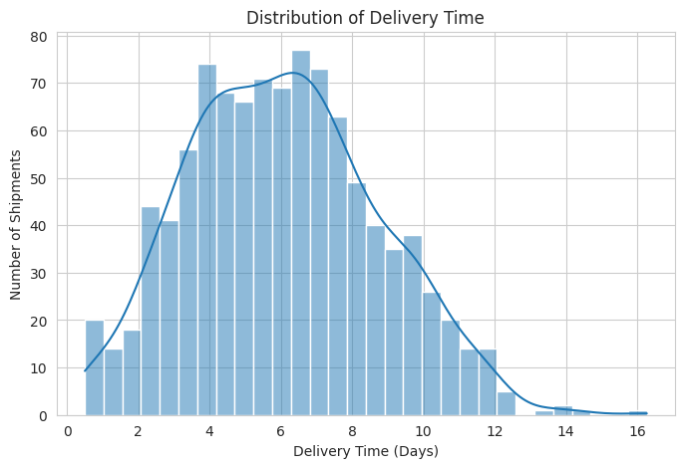
Figure 1: Distribution of Delivery Time
The delivery-time histogram was used to understand the distribution of delivery times across all shipments.
A histogram is suitable for identifying the general shape of a numerical distribution and observing how frequently different delivery-time ranges occur.
The visualization helps logistics managers understand the typical delivery-time pattern and identify unusually high or low delivery times.

Interpretation
The average delivery time was 6.07 days. The distribution visualization provides a broader view of shipment delivery performance than the average alone.
This can help organizations determine whether most shipments are completed within a relatively narrow time range or whether delivery performance varies substantially between shipments.

9.2 Delivery Status Distribution
Visualization: Count Plot
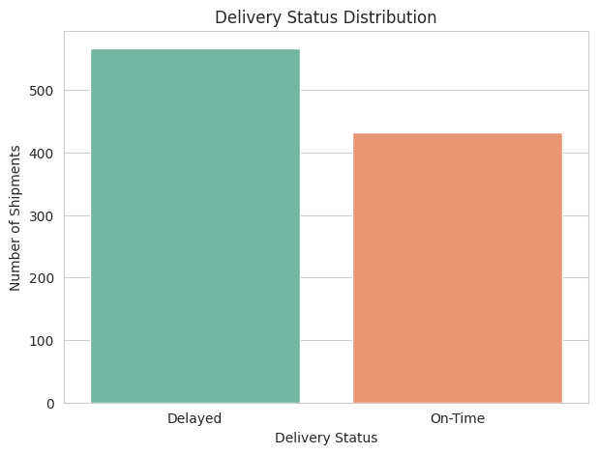
Figure 2: Delivery Status Distribution
A count plot was used to compare the number of delayed and on-time shipments.
The chart clearly shows:
- Delayed shipments: 567
- On-Time shipments: 433

Interpretation
The visualization highlights that delayed shipments are more numerous than on-time shipments in the simulated dataset.
A high delay proportion can negatively affect customer satisfaction, operational reliability, and service-level performance.
Therefore, delivery-status monitoring should be treated as an important logistics KPI.

9.3 Transportation Cost by Transport Mode
Visualization: Box Plot
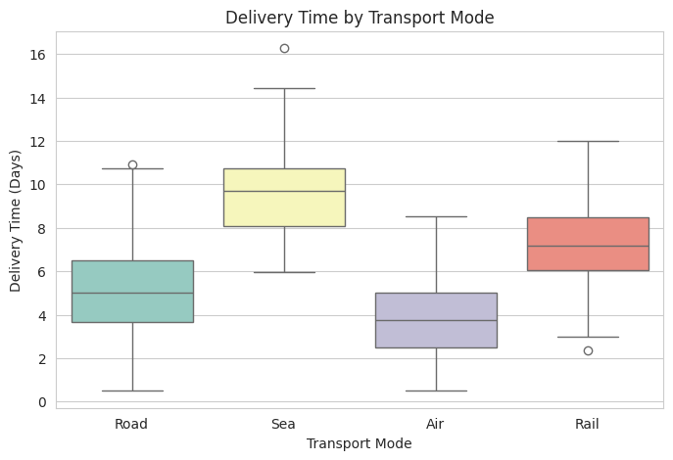
Figure 3: Transportation Cost by Transport Mode
A box plot was used to compare transportation costs across Road, Rail, Air, and Sea transportation.
Box plots are useful because they display the distribution, central tendency, and variability of numerical values across categories.

Interpretation
Transportation costs vary by transport mode because different modes were assigned different cost-per-kilometre assumptions during dataset simulation.
Air transportation was assigned the highest cost-per-kilometre factor, while Sea transportation was assigned the lowest.
Therefore, transport-mode selection can have an important effect on logistics cost, especially for long-distance shipments.
However, mode selection should not be based only on cost. Delivery requirements, urgency, capacity, and service-level expectations should also be considered.

9.4 Delivery Time by Transport Mode
Visualization: Box Plot
Figure 4: Delivery Time by Transport Mode
A box plot was used to compare delivery-time distributions across different transport modes.

Interpretation
The simulated dataset assigned different base delivery-time factors to each transport mode.
Air transportation was assigned the shortest base delivery time, while Sea transportation was assigned the longest.
The visualization therefore helps demonstrate how transportation mode can influence expected delivery speed.
For urgent shipments, faster transportation modes may be more suitable. For less time-sensitive shipments, slower modes may offer better cost efficiency.

9.5 Distance vs. Transportation Cost
Visualization: Scatter Plot
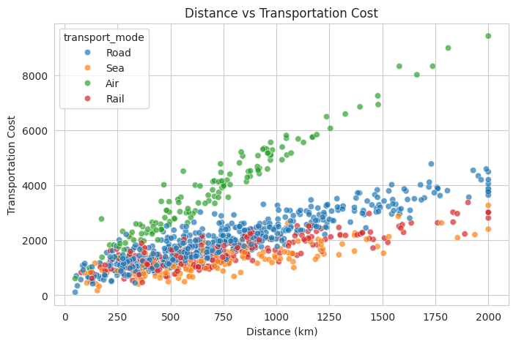
Figure 5: Distance vs. Transportation Cost by Transport Mode
A scatter plot was used to study the relationship between distance travelled and transportation cost.
Transport mode was included as a grouping variable to make it easier to observe differences between transportation categories.

Interpretation
The scatter plot shows a positive relationship between distance and transportation cost.
This is consistent with the correlation result of 0.62 between distance and transportation cost.
As shipment distance increases, transportation cost generally tends to increase.
The chart is useful for logistics planning because it demonstrates why route optimization and transportation-mode selection are important for controlling costs.

10. CORRELATION HEATMAP
Visualization: Correlation Heatmap
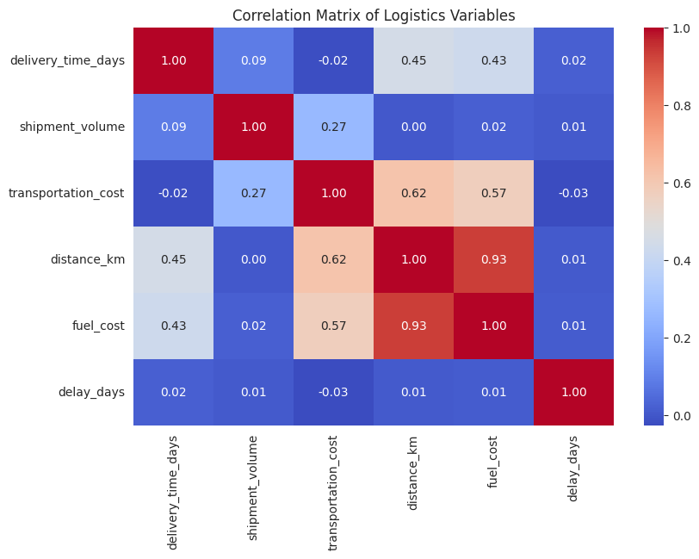
Figure 6: Correlation Matrix of Logistics Variables
The correlation heatmap provides a visual representation of the relationships between numerical logistics variables.
The strongest relationship visible in the analysis was between:
Distance and Fuel Cost = 0.93
Other important relationships included:
- Distance and Transportation Cost = 0.62
- Fuel Cost and Transportation Cost = 0.57
- Delivery Time and Distance = 0.45
- Delivery Time and Fuel Cost = 0.43

Interpretation
The heatmap makes it easy to identify strong and weak relationships between multiple variables at the same time.
For logistics managers, this can help identify potential cost drivers and operational relationships that deserve further investigation.

11. KEY LOGISTICS INSIGHTS
The analysis generated several important insights.

11.1 Road Transportation Dominates
Road transport accounted for 503 out of 1,000 shipments, making it the most frequently used transportation mode in the simulated dataset.
This suggests that road transportation is an important component of the hypothetical logistics network.

11.2 High Proportion of Delayed Shipments
A total of 567 shipments were classified as delayed, representing 56.7% of all shipments.
This indicates that improving delivery reliability should be a major operational priority.

11.3 Distance is an Important Cost Factor
Distance showed a correlation of 0.62 with transportation cost.
This indicates that longer transportation routes are generally associated with higher transportation expenses.

11.4 Fuel Cost is Strongly Related to Distance
Distance and fuel cost had a correlation of 0.93.
This was the strongest correlation observed in the analysis and demonstrates that distance is closely associated with fuel expenditure in the simulated data.

11.5 Transportation Mode Influences Cost and Delivery Time
The simulation used different cost and delivery-time assumptions for Road, Rail, Air, and Sea.
Therefore, transportation mode is an important variable when evaluating the trade-off between delivery speed and transportation cost.

11.6 Shipment Volume Has a Moderate Cost Relationship
Shipment volume had a correlation of 0.27 with transportation cost.
This indicates a relatively modest positive relationship in the simulated data.

12. POTENTIAL LOGISTICS BOTTLENECKS
Based on the analysis, the following areas could represent potential operational concerns:
- High proportion of delayed shipments.
- Long-distance transportation routes.
- High transportation costs associated with increasing distance.
- Dependence on road transportation.
- Higher costs associated with faster transportation modes.
- Fuel expenditure associated with long-distance shipments.
These areas should be investigated further using real-world operational data.

13. RECOMMENDATIONS
Based on the analytical findings, the following recommendations can be considered:

13.1 Improve Delivery Monitoring
Since 56.7% of shipments were delayed, logistics teams should closely monitor delivery performance and identify recurring causes of delay.

13.2 Optimize Transportation Routes
Because distance has a strong relationship with fuel cost and a moderate relationship with transportation cost, route optimization can help control operating expenses.

13.3 Use Transport Modes Strategically
Transportation modes should be selected according to shipment urgency, distance, cost requirements, and service-level expectations.
For urgent shipments, faster modes may be appropriate, while slower and potentially lower-cost modes may be suitable for non-urgent shipments.

13.4 Monitor Fuel Costs
The strong distance–fuel-cost relationship indicates that fuel expenditure should be monitored as an important logistics cost component.

13.5 Develop Logistics Dashboards
Organizations can use dashboards containing KPIs such as:
- Average delivery time
- Delay percentage
- Transportation cost
- Fuel cost
- Shipment volume
- Distance
- Transport-mode performance
Such dashboards can support faster operational decision-making.

14. PYTHON TOOLS AND TECHNIQUES USED
The following Python libraries were used:

Pandas
Pandas was used for creating and manipulating the logistics DataFrame and performing statistical analysis.

NumPy
NumPy was used for random data generation, probability distributions, mathematical calculations, and numerical processing.

Matplotlib
Matplotlib was used to create and customize visualizations.

Seaborn
Seaborn was used for statistical visualizations including histograms, count plots, box plots, scatter plots, and heatmaps.

Google Colab
Google Colab was used as the development and execution environment for the Python notebook.

15. SAMPLE PYTHON CODE
The following is an example of the Python approach used in the analysis:
import pandas as pd
import numpy as np
import matplotlib.pyplot as plt
import seaborn as sns
np.random.seed(42)
n = 1000
shipment_id = [
f"SHP{str(i).zfill(5)}"
for i in range(1, n + 1)
]
shipment_date = pd.date_range(
start="2025-01-01",
end="2025-12-31",
periods=n
)
transport_mode = np.random.choice(
["Road", "Rail", "Air", "Sea"],
size=n,
p=[0.50, 0.20, 0.15, 0.15]
)
region = np.random.choice(
["North", "South", "East", "West", "Central"],
size=n
)
Correlation analysis was performed using:
numeric_columns = [
"delivery_time_days",
"shipment_volume",
"transportation_cost",
"distance_km",
"fuel_cost",
"delay_days"
]
correlation_matrix = logistics_data[numeric_columns].corr()
sns.heatmap(
correlation_matrix,
annot=True,
fmt=".2f"
)
plt.title("Correlation Matrix of Logistics Variables")
plt.show()
These techniques enabled systematic analysis of the simulated logistics dataset.

16. HOW VISUALIZATIONS SUPPORT LOGISTICS DECISION-MAKING
Data visualization plays an important role in logistics because it transforms numerical information into patterns that can be quickly understood.
The histogram helps identify delivery-time distributions and variation.
The delivery-status count plot makes it easy to compare delayed and on-time shipments.
Box plots allow managers to compare transportation cost and delivery time across transport modes.
The scatter plot helps identify the relationship between distance and transportation cost.
The correlation heatmap provides an overall view of relationships among multiple numerical variables.
Together, these visualizations allow logistics professionals to identify performance issues, understand cost drivers, compare transportation alternatives, and prioritize areas for improvement.

17. CONCLUSION
This Week 3 task provided practical experience in advanced data analysis and visualization for logistics operations.
A hypothetical dataset containing 1,000 shipment records was successfully created using Python. Exploratory Data Analysis was then performed to understand shipment distributions, delivery performance, transportation costs, distance, fuel cost, and delays.
The analysis showed that 56.7% of shipments were delayed and 43.3% were on time. The average delivery time was 6.07 days, while the average transportation cost was 2058.76.
Correlation analysis identified a very strong relationship between distance and fuel cost, with a correlation of 0.93. Distance also showed a positive relationship with transportation cost.
Six visualizations were created to communicate these findings effectively. The analysis demonstrates how Python-based data analysis and visualization can help logistics organizations understand operational performance and make more informed decisions.
Overall, this task strengthened practical skills in data simulation, exploratory analysis, statistical interpretation, correlation analysis, and logistics-focused data visualization.

18. PROJECT / GITHUB
GitHub Project:
https://github.com/Arati-Deokate/ecommerce-logistics-data-analysis
The GitHub repository contains the project work associated with the logistics data analysis internship.

19. REFERENCES
- Python Documentation – Python programming language.
- Pandas Documentation – Data analysis and manipulation using Pandas.
- NumPy Documentation – Numerical computing with Python.
- Matplotlib Documentation – Data visualization in Python.
- Seaborn Documentation – Statistical data visualization.
- Google Colab – Cloud-based Python notebook environment.

