LOGISTICS DATA ANALYST INTERNSHIP

WEEK 4 TASK REPORT : Predictive Modeling and Optimization in Logistics Systems
Submitted By: Arati Balaso Deokate
Internship Role: Logistics Data Analyst Intern
Internship Organization: YuvaIntern
Task: Predictive Modeling and Optimization in Logistics Systems
Tools & Technologies: Python, Pandas, NumPy, Matplotlib, Scikit-learn, Google Colab

CONTENTS
- Introduction
- Objectives
- Problem Definition
- Dataset Simulation and Structure
- Data Quality and Preprocessing
- Exploratory Data Analysis
  - 6.1 Delivery Time Distribution
  - 6.2 Average Delivery Time by Transport Mode
  - 6.3 Distance vs. Delivery Time
- Feature Selection
- Predictive Model Selection
  - 8.1 Linear Regression
  - 8.2 Random Forest Regression
- Model Evaluation and Comparison
- 5-Fold Cross-Validation
- Actual vs. Predicted Delivery Time
- Logistics Optimization Analysis
- Correlation Analysis
- Key Findings
- Logistics Optimization Recommendations
- Python Code and Methodology
- How Predictive Analytics Supports Logistics Decisions
- GitHub Project
- Conclusion
- References

1. INTRODUCTION
Predictive analytics is an important component of modern logistics and supply-chain management. Logistics organizations handle large amounts of operational data related to transportation, shipment volume, distance, fuel consumption, transportation costs, delivery times, and delays. Analyzing this information can help organizations forecast delivery performance and make better operational decisions.
The objective of this Week 4 task was to develop a predictive modeling workflow for forecasting shipment delivery time. A synthetic logistics dataset containing 1,000 shipment records was generated using Python. The dataset included transportation-related numerical and categorical variables such as distance, shipment volume, transportation cost, fuel cost, transport mode, and region.
Two regression models, Linear Regression and Random Forest Regression, were implemented and evaluated using Mean Absolute Error (MAE), Root Mean Squared Error (RMSE), and R² score. Five-fold cross-validation was also performed to evaluate the stability of the selected model.
In addition to prediction, transport-mode analysis was conducted to identify potential optimization opportunities by comparing delivery time, transportation cost, and fuel cost across Road, Rail, Air, and Sea transportation.

2. OBJECTIVES
The main objectives of this task were:
- To define a logistics forecasting problem.
- To simulate a realistic logistics dataset using Python.
- To identify important variables for predicting delivery time.
- To implement suitable machine learning regression models.
- To compare Linear Regression and Random Forest Regression.
- To evaluate models using MAE, RMSE, and R².
- To validate model performance using 5-fold cross-validation.
- To analyze the relationship between logistics variables.
- To compare transport modes based on cost and delivery time.
- To identify logistics optimization opportunities.
- To provide practical recommendations based on predictive analysis.

3. PROBLEM DEFINITION
The forecasting problem selected for this project is:
Predict the delivery time of a shipment in days using available logistics and transportation characteristics.

Target Variable
delivery_time_days

Input Features
- Shipment volume
- Transportation cost
- Distance
- Fuel cost
- Transport mode
- Region
Accurate delivery-time prediction can help logistics organizations improve planning, estimate expected delivery dates, allocate transportation resources, and identify shipments that may require special attention.

4. DATASET SIMULATION AND STRUCTURE
A synthetic logistics dataset containing 1,000 shipment records and 11 variables was generated using Python.
The dataset represents shipment operations during 2025.

Dataset Variables
Variable | Description | Type
shipment_id | Unique shipment identifier | Categorical
shipment_date | Shipment date | Date
transport_mode | Mode of transportation | Categorical
region | Shipment region | Categorical
distance_km | Transportation distance | Numerical
shipment_volume | Shipment volume | Numerical
transportation_cost | Estimated transportation cost | Numerical
fuel_cost | Estimated fuel cost | Numerical
delivery_time_days | Actual simulated delivery time | Numerical
delay_days | Delivery delay | Numerical
delivery_status | On-Time or Delayed | Categorical
The transport modes considered were Road, Rail, Air, and Sea, while the regions were North, South, East, West, and Central.

5. DATA QUALITY AND PREPROCESSING
The simulated dataset was inspected before model development.
The dataset contained:
- 1,000 records
- 11 columns
- No missing values
- Numerical and categorical variables
- No additional missing-value treatment was required.
Descriptive statistical analysis was performed using Pandas to understand the distribution and range of the numerical variables.

Important Dataset Statistics
Metric | Mean
Delivery Time | 6.07 days
Shipment Volume | 78.88
Transportation Cost | 2058.76
Distance | 757.77 km
Fuel Cost | 201.16
The average delivery time was approximately 6.07 days, while the average shipment distance was approximately 757.77 km.

6. EXPLORATORY DATA ANALYSIS

6.1 Delivery Time Distribution
A histogram was created to examine the distribution of delivery times.
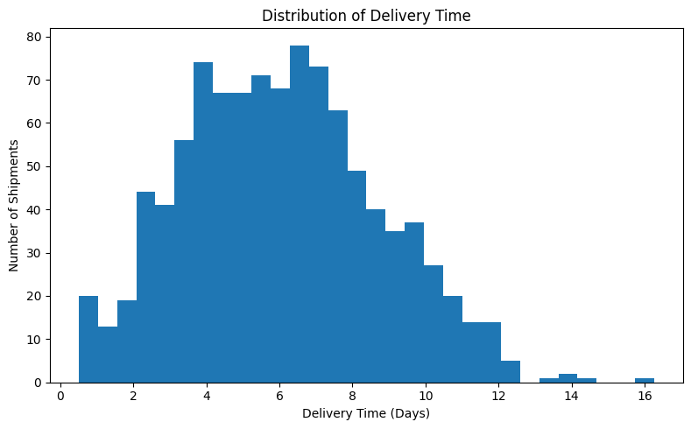
Figure 1: Distribution of Delivery Time
The delivery-time distribution was concentrated primarily between approximately 3 and 10 days. The average delivery time was 6.07 days, with some shipments requiring considerably more time.
The analysis indicates that delivery performance varies between shipments and therefore provides a suitable target for predictive modeling.

6.2 Average Delivery Time by Transport Mode
The average delivery time for each transportation mode was calculated.
Transport Mode | Average Delivery Time
Air | 3.82 days
Road | 5.13 days
Rail | 7.21 days
Sea | 9.62 days
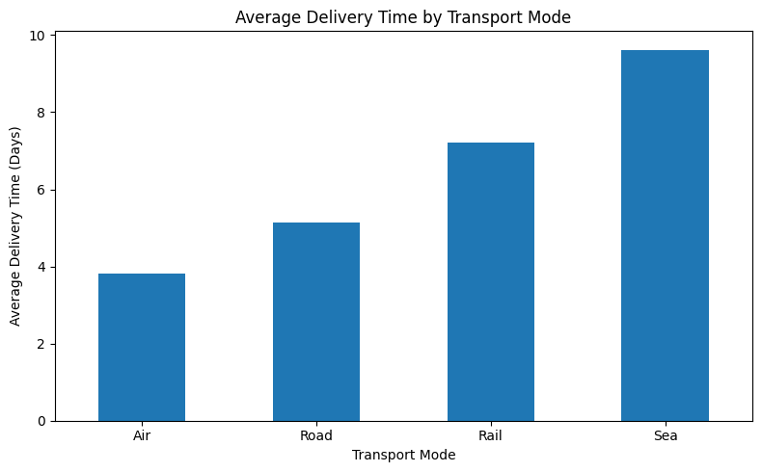
Figure 2: Average Delivery Time by Transport Mode
Air transportation had the shortest average delivery time at 3.82 days, while Sea transportation had the longest average delivery time at 9.62 days.
Road transportation provided a middle position with an average delivery time of 5.13 days.

6.3 Distance vs. Delivery Time
A scatter plot was created to analyze the relationship between transportation distance and delivery time.
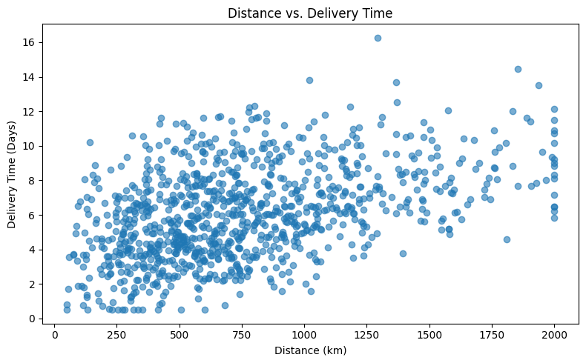
Figure 3: Distance vs. Delivery Time
The visualization shows a generally positive relationship between distance and delivery time. As transportation distance increases, delivery time tends to increase as well.
This observation is also supported by the correlation analysis performed later in the project.

7. FEATURE SELECTION
The following variables were selected as predictors:
shipment_volume
transportation_cost
distance_km
fuel_cost
transport_mode
region
The target variable was:
delivery_time_days
Categorical variables such as transport mode and region were converted into machine-readable form using One-Hot Encoding.
The dataset was divided into:
- 80% training data
- 20% testing data
Therefore:
- Training records = 800
- Testing records = 200

8. PREDICTIVE MODEL SELECTION
Two regression algorithms were selected for the forecasting problem.

8.1 Linear Regression
Linear Regression was selected as a baseline predictive model because it is simple, interpretable, computationally efficient, and useful for understanding relationships between input variables and delivery time.
The model was trained using the selected numerical and categorical features.

Linear Regression Results
- MAE: 1.1874 days
- RMSE: 1.4269 days
- R²: 0.6991
The R² value of 0.6991 indicates that the model explains approximately 69.91% of the variation in delivery time within the test dataset.

8.2 Random Forest Regression
Random Forest Regression was selected as a second model because it can capture nonlinear relationships and interactions between multiple logistics variables.
The Random Forest model used multiple decision trees and was configured with:
- 200 trees
- Maximum depth = 12
- Minimum samples split = 4
- Random state = 42

Random Forest Results
- MAE: 1.2495 days
- RMSE: 1.5245 days
- R²: 0.6566

9. MODEL EVALUATION AND COMPARISON
The two models were compared using three evaluation metrics.

Model Comparison
Model | MAE | RMSE | R²
Linear Regression | 1.1874 | 1.4269 | 0.6991
Random Forest | 1.2495 | 1.5245 | 0.6566

Interpretation
Lower MAE and RMSE values indicate better prediction accuracy, while a higher R² indicates that the model explains more variation in the target variable.
Based on all three metrics, Linear Regression performed better than Random Forest on the test dataset.
Therefore:
Linear Regression was selected as the final predictive model for this project.
The model's MAE of 1.1874 means that its predictions differed from the actual delivery time by approximately 1.19 days on average.

10. 5-FOLD CROSS-VALIDATION
Five-fold cross-validation was performed on the Linear Regression model to examine whether its performance remained stable across different subsets of the dataset.

Cross-Validation Results
Fold | RMSE
Fold 1 | 1.5386
Fold 2 | 1.5470
Fold 3 | 1.6018
Fold 4 | 1.4680
Fold 5 | 1.5200
Mean CV RMSE | 1.5351
The mean cross-validation RMSE was 1.5351 days.
The fold results are reasonably close to one another, indicating that the model has relatively stable performance across the different validation subsets.
The test-set RMSE was 1.4269 days, compared with the mean cross-validation RMSE of 1.5351 days. The results are reasonably consistent, supporting the use of Linear Regression for this forecasting problem.

11. ACTUAL VS. PREDICTED DELIVERY TIME
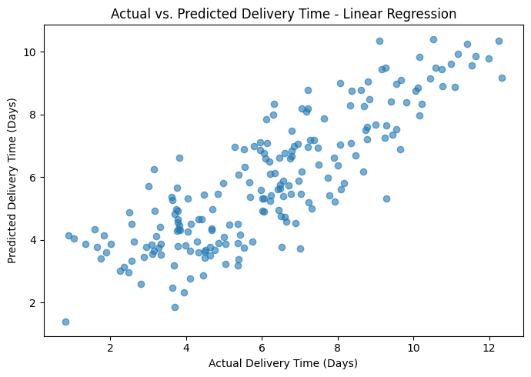
Figure 4: Actual vs. Predicted Delivery Time
The actual-versus-predicted scatter plot compares the delivery times observed in the test dataset with the values predicted by the Linear Regression model.
The plot shows a clear positive relationship between actual and predicted delivery times. Most observations follow the overall upward pattern, demonstrating that the model captures a substantial portion of the variation in shipment delivery time.
Some observations deviate from the general pattern. These deviations represent prediction errors and indicate that additional operational variables could potentially improve future model performance.

12. LOGISTICS OPTIMIZATION ANALYSIS
An optimization analysis was performed by comparing transportation modes based on average delivery time, transportation cost, and fuel cost.

Transport Mode Comparison
Transport Mode | Avg. Delivery Time | Avg. Transportation Cost | Avg. Fuel Cost
Air | 3.82 days | 3867.67 | 187.90
Road | 5.13 days | 2003.34 | 202.37
Rail | 7.21 days | 1586.45 | 208.59
Sea | 9.62 days | 1290.06 | 198.75

Analysis
The results demonstrate a clear trade-off between transportation speed and transportation cost.
Air transportation provides the fastest average delivery time at 3.82 days, but it also has the highest average transportation cost of 3867.67.
Sea transportation has the lowest average transportation cost at 1290.06, but its average delivery time is the longest at 9.62 days.
Road transportation provides a middle-ground option, with an average delivery time of 5.13 days and transportation cost of 2003.34.
Rail has a relatively low transportation cost of 1586.45, although its average delivery time is higher than Road transportation.
Therefore, transportation mode should be selected according to shipment urgency, cost constraints, and required service levels.

13. CORRELATION ANALYSIS
Correlation analysis was performed to understand the linear relationship between delivery time and other logistics variables.

Correlation with Delivery Time
Variable | Correlation
Delivery Time | 1.000
Distance | 0.448
Fuel Cost | 0.428
Shipment Volume | 0.086
Delay Days | 0.020
Transportation Cost | -0.019

Interpretation
Distance had the strongest positive correlation with delivery time at 0.448. This indicates that longer transportation distances generally tend to be associated with longer delivery times in the simulated dataset.
Fuel cost had the second strongest relationship with delivery time at 0.428. Since fuel cost is related to transportation distance in the simulated data, this relationship is also operationally meaningful.
Shipment volume showed only a weak positive correlation of 0.086.
Delay days had a correlation of 0.020, indicating almost no linear relationship with delivery time in this particular simulated dataset.
Transportation cost had a correlation of −0.019, indicating a negligible linear relationship with delivery time.
These correlations should be interpreted as relationships within the simulated dataset and should not be considered evidence of causation.

14. KEY FINDINGS
The major findings of the project are:
- The average shipment delivery time was 6.07 days.
- The average transportation distance was 757.77 km.
- Linear Regression outperformed Random Forest for the selected test dataset.
- Linear Regression achieved:
  - MAE = 1.1874
  - RMSE = 1.4269
  - R² = 0.6991
- The Linear Regression model achieved a mean 5-fold CV RMSE of 1.5351 days.
- Air was the fastest transportation mode with an average delivery time of 3.82 days.
- Sea was the lowest-cost transportation mode with an average transportation cost of 1290.06.
- Road provided a relatively balanced combination of delivery speed and transportation cost.
- Distance had the strongest positive correlation with delivery time at 0.448.
- Fuel cost also showed a moderate positive relationship with delivery time at 0.428.

15. LOGISTICS OPTIMIZATION RECOMMENDATIONS
Based on the predictive and optimization analysis, the following recommendations can be made.

15.1 Use Transport Modes According to Shipment Priority
Air transportation should be considered for urgent or time-sensitive shipments where faster delivery justifies the higher transportation cost.
For less urgent shipments, Rail or Sea can be considered to reduce transportation expenditure.

15.2 Use Road Transportation for Balanced Requirements
Road transportation provides a useful compromise between speed and cost. It can be considered when the organization requires reasonable delivery times without the high cost associated with Air transportation.

15.3 Monitor Long-Distance Shipments
Distance was the strongest positively correlated variable with delivery time. Therefore, long-distance shipments should receive additional monitoring and planning attention.

15.4 Improve Delivery-Time Forecasting
The Linear Regression model can be used as a baseline forecasting system to estimate expected delivery time before shipment completion.

15.5 Integrate More Operational Features
Future models could potentially improve by incorporating additional variables such as:
- Weather conditions
- Warehouse processing time
- Traffic conditions
- Number of distribution centers
- Carrier performance
- Loading and unloading time
- Historical delivery performance
- Seasonal demand

15.6 Develop a Cost-Speed Optimization Framework
Instead of minimizing cost alone or delivery time alone, logistics organizations can develop a multi-objective optimization strategy that balances:
Cost + Delivery Time + Service-Level Requirements
This would allow transportation decisions to be based on business priorities.

16. PYTHON CODE AND METHODOLOGY
The project was implemented in Python using Pandas, NumPy, Matplotlib, and Scikit-learn.

Basic Modeling Workflow
# Define target and features
target = "delivery_time_days"

features = [
"shipment_volume",
"transportation_cost",
"distance_km",
"fuel_cost",
"transport_mode",
"region"
]

X = df[features]
y = df[target]

# Split data
X_train, X_test, y_train, y_test = train_test_split(
X, y, test_size=0.20, random_state=42
)

# Train Linear Regression
linear_model.fit(X_train, y_train)

# Generate predictions
linear_pred = linear_model.predict(X_test)

# Evaluate
linear_mae = mean_absolute_error(y_test, linear_pred)
linear_rmse = np.sqrt(mean_squared_error(y_test, linear_pred))
linear_r2 = r2_score(y_test, linear_pred)

Cross-Validation
cv_scores = cross_val_score(
linear_model,
X,
y,
cv=5,
scoring="neg_root_mean_squared_error"
)

cv_rmse = -cv_scores

print("Mean CV RMSE:", cv_rmse.mean())
The complete implementation was developed and executed in Google Colab.

17. HOW PREDICTIVE ANALYTICS SUPPORTS LOGISTICS DECISIONS
Predictive analytics can support logistics organizations in several ways.

Delivery Planning
Predicted delivery times can help organizations estimate expected arrival dates and improve customer communication.

Resource Allocation
Forecasting can help logistics teams allocate vehicles, warehouses, drivers, and other resources more effectively.

Transport Selection
The transport-mode analysis demonstrates how different modes involve different cost and delivery-time trade-offs.

Risk Management
Shipments predicted to require longer delivery times can be monitored more closely.

Cost Management
Organizations can select lower-cost transportation options for shipments where delivery speed is less critical.

Operational Planning
Historical and predicted delivery patterns can support capacity planning and continuous improvement.

18. GITHUB PROJECT
The project code, notebooks, datasets, and related internship work are maintained in the GitHub repository:
GitHub – Arati-Deokate/ecommerce-logistics-data-analysis
For Week 4, the following files should be uploaded to the repository:
- Week_4_Logistics_Predictive_Modeling.ipynb
- week4_analysis.py
- Week_4_Logistics_Synthetic_Dataset.csv
- Week_4_Model_Comparison.csv
- Week_4_Transport_Mode_Summary.csv
- Week_4_Logistics_Predictive_Modeling_Report.docx
Important: Save your Colab notebook after running all cells so that the graphs and outputs are visible when the notebook is opened on GitHub.

19. CONCLUSION
This Week 4 project demonstrated how predictive modeling and optimization techniques can be applied to logistics systems. A synthetic dataset containing 1,000 shipment records was developed and analyzed using Python.
Two regression algorithms, Linear Regression and Random Forest Regression, were implemented to predict shipment delivery time. Based on MAE, RMSE, and R², Linear Regression performed better than Random Forest on the test dataset. It achieved an MAE of 1.1874 days, RMSE of 1.4269 days, and R² of 0.6991. Five-fold cross-validation produced a mean RMSE of 1.5351 days, indicating reasonably stable model performance.
The optimization analysis showed that transportation modes involve a significant speed-cost trade-off. Air provided the fastest average delivery time, while Sea had the lowest average transportation cost. Road offered a relatively balanced alternative.
Correlation analysis identified distance as the strongest positively associated variable with delivery time. Overall, the project demonstrates how predictive analytics can support logistics forecasting, transportation planning, cost management, and operational decision-making.

20. REFERENCES
- Python Documentation — Python programming language and standard libraries.
- Pandas Documentation — Data manipulation and analysis using Python.
- NumPy Documentation — Numerical computing and array operations.
- Matplotlib Documentation — Data visualization and plotting.
- Scikit-learn Documentation — Machine learning algorithms, preprocessing, model evaluation, and cross-validation.
- Google Colab — Cloud-based Python development and notebook execution environment.

