LOGISTICS DATA ANALYST INTERNSHIP

WEEK 2 TASK REPORT : Data Collection, Cleaning and Preprocessing for Logistics Analysis

Submitted By: Arati Balaso Deokate
Internship: Logistics Data Analyst Intern
Task: – Data Collection, Cleaning, and Preprocessing for Logistics Analysis
Internship Organization: YuvaIntern
Dataset: Brazilian E-Commerce Public Dataset by Olist
Tools & Technologies: Python | Pandas | NumPy | Matplotlib | Seaborn | Scikit-learn | Google Colab

CONTENTS
- Introduction
- Dataset Collection and Understanding
- Data Inspection
- Data Quality Assessment
- Data Cleaning and Preprocessing
- Feature Engineering
- Outlier Detection
- Final Preprocessed Dataset
- Preprocessing Results and Business Interpretation
- Conclusion
- References

1. INTRODUCTION
Data preprocessing is an essential stage in logistics data analytics because the quality of the input data directly affects the reliability of analytical results. Logistics datasets may contain missing values, duplicate records, incorrect data types, and unusual observations. If these issues are not handled appropriately, they can produce inaccurate delivery-performance measurements.
The objective of this week's task was to collect, inspect, clean, and preprocess e-commerce logistics data using Python. The Brazilian E-Commerce Public Dataset by Olist was selected because it contains information related to orders, customers, sellers, products, payments, and delivery activities.
The analysis focused primarily on the Olist Orders Dataset. Important delivery-related variables were transformed into usable numerical features, including delivery time and delivery delay. Missing values and duplicates were investigated, and the Interquartile Range (IQR) method was used to identify potential delivery-time outliers.
The final preprocessed dataset was prepared for the next stages of the project, including exploratory data analysis and predictive modelling.

2. DATASET COLLECTION AND UNDERSTANDING

2.1 Dataset Description
The Brazilian E-Commerce Public Dataset by Olist is a publicly available e-commerce dataset containing approximately 100,000 orders from the Brazilian market.
The complete dataset consists of multiple related tables, including:
- Orders
- Customers
- Sellers
- Products
- Order Items
- Payments
- Reviews
The main variables used were:
Column | Description
order_id | Unique order identifier
customer_id | Customer identifier
order_status | Current order status
order_purchase_timestamp | Date and time when order was purchased
order_approved_at | Order approval date and time
order_delivered_carrier_date | Date when order was handed to carrier
order_delivered_customer_date | Actual customer delivery date
order_estimated_delivery_date | Estimated delivery date

2.2 Dataset Characteristics
Characteristic | Result
Dataset | Olist Orders Dataset
Domain | E-Commerce and Logistics
File format | CSV
Initial records | 99,441
Columns | 8
Programming language | Python
Main analysis library | Pandas
Development environment | Google Colab

3. DATA INSPECTION
The first step was to inspect the dataset structure using Pandas.

Python Code
import pandas as pd
import numpy as np

orders = pd.read_csv("olist_orders_dataset.csv")

print(orders.head())
print("Shape:", orders.shape)
print(orders.info())
The initial dataset contained 99,441 records and 8 columns.
All eight columns were initially stored as object/string data types. Since five columns contained date information, these columns required conversion into datetime format before calculating delivery durations.

Dataset Structure
Category | Number
Total records | 99,441
Total columns | 8
Date columns | 5
Identifier/status columns | 3
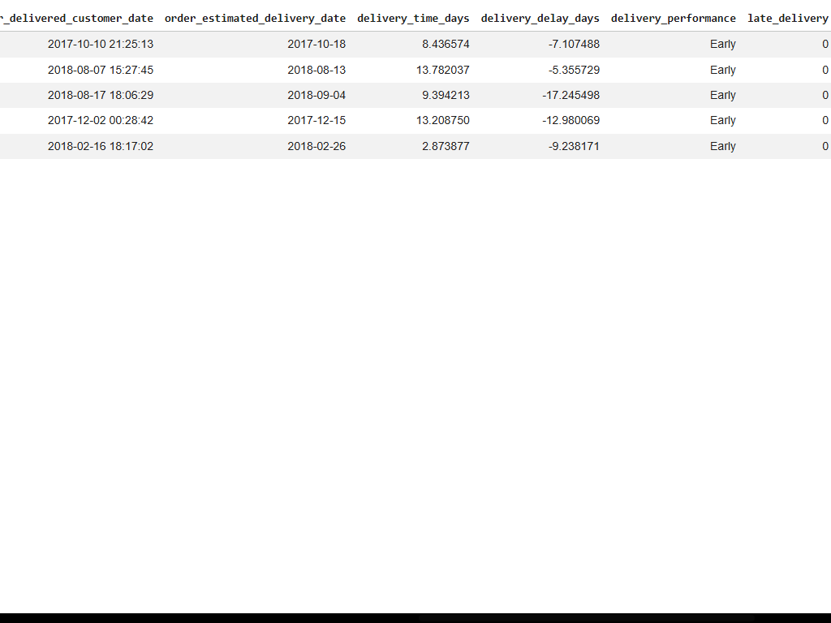
Figure 1: Initial dataset structure and data types

4. DATA QUALITY ASSESSMENT
Data-quality checks were performed to identify missing values and duplicate records.

4.1 Missing Values
The missing-value analysis produced the following results:
Column | Missing Values | Missing %
order_id | 0 | 0.00%
customer_id | 0 | 0.00%
order_status | 0 | 0.00%
order_purchase_timestamp | 0 | 0.00%
order_approved_at | 160 | 0.16%
order_delivered_carrier_date | 1,783 | 1.79%
order_delivered_customer_date | 2,965 | 2.98%
order_estimated_delivery_date | 0 | 0.00%
The largest number of missing values was found in order_delivered_customer_date.
However, missing delivery dates do not necessarily indicate incorrect data. Some orders may not have complete delivery information. Therefore, these values were not artificially replaced.
Among the 96,478 delivered orders, 8 records did not contain an actual customer delivery date. These 8 records could not be used to calculate actual delivery time and delivery delay, so they were excluded from the delivery-performance analysis.

4.2 Duplicate Detection
Duplicate records were checked using Pandas.
print("Duplicate rows:", orders.duplicated().sum())

print(
"Duplicate order IDs:",
orders["order_id"].duplicated().sum()
)

Results
Check | Result
Duplicate rows | 0
Duplicate order IDs | 0
No duplicate records were identified. Therefore, no records were removed because of duplication.
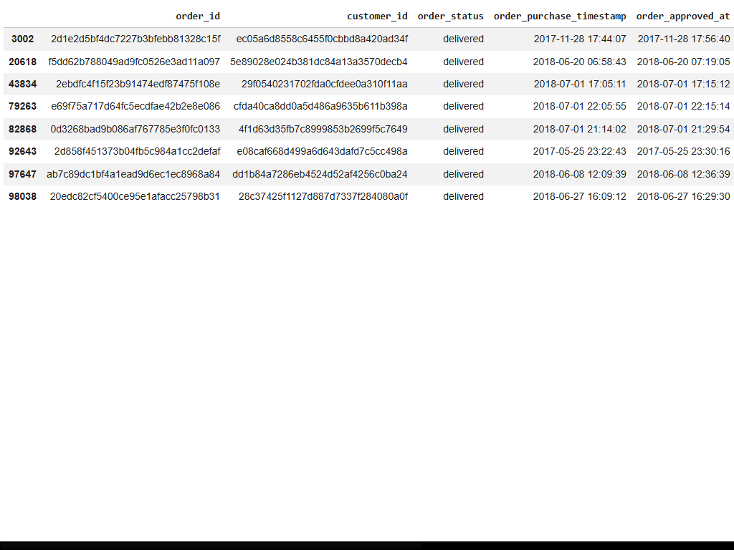
Figure 2: Missing-value and duplicate-record assessment

5. DATA CLEANING AND PREPROCESSING

5.1 Date Conversion
The date columns were converted from object/string format into Pandas datetime format.
date_columns = [
"order_purchase_timestamp",
"order_approved_at",
"order_delivered_carrier_date",
"order_delivered_customer_date",
"order_estimated_delivery_date"
]

for column in date_columns:
orders[column] = pd.to_datetime(
orders[column],
errors="coerce"
)
After conversion, the five date columns were stored as datetime64[ns], making them suitable for date arithmetic.

5.2 Selecting Valid Delivery Records
For delivery-performance analysis, delivered orders with an actual customer delivery date were selected.
task2_data = orders[
(orders["order_status"] == "delivered") &
(orders["order_delivered_customer_date"].notna())
].copy()
This produced a final analysis dataset of:
96,470 records
These records contain the information required to calculate actual delivery performance.

6. FEATURE ENGINEERING
Feature engineering was used to create logistics-specific variables from the existing date fields.

6.1 Delivery Time
Delivery time measures the number of days between the purchase date and the actual customer delivery date.

Formula
Delivery Time = Actual Delivery Date − Purchase Date

Python Code
task2_data["delivery_time_days"] = (
task2_data["order_delivered_customer_date"]
- task2_data["order_purchase_timestamp"]
).dt.total_seconds() / 86400

Delivery Time Results
Statistic | Result
Records | 96,470
Average | 12.56 days
Standard deviation | 9.55 days
Minimum | 0.53 days
Median | 10.22 days
Maximum | 209.63 days
The average delivery time was 12.56 days, while the median was approximately 10.22 days.

6.2 Delivery Delay
Delivery delay measures whether an order was delivered before or after its estimated delivery date.

Formula
Delivery Delay = Actual Delivery Date − Estimated Delivery Date
task2_data["delivery_delay_days"] = (
task2_data["order_delivered_customer_date"]
- task2_data["order_estimated_delivery_date"]
).dt.total_seconds() / 86400

Delivery Delay Results
Statistic | Result
Records | 96,470
Average | −11.18 days
Standard deviation | 10.18 days
Minimum | −146.02 days
Median | −11.95 days
Maximum | 188.98 days
The average delay was −11.18 days. Because the value is negative, it indicates that orders were generally delivered before their estimated delivery dates.

6.3 Late Delivery Classification
A binary variable was created to identify late deliveries.
task2_data["late_delivery"] = np.where(
task2_data["delivery_delay_days"] > 0,
1,
0
)
Where:
- 0 = Early or On-Time
- 1 = Late
The results were:
Delivery Category | Orders
Early/On-Time | 88,644
Late | 7,826
Total | 96,470
The resulting rates were:
- Early/On-Time Rate = 91.89%
- Late Delivery Rate = 8.11%
These variables can be used in future exploratory and predictive analysis.

7. OUTLIER DETECTION
Outlier detection was performed using the Interquartile Range (IQR) method.
The IQR method identifies observations that fall substantially outside the central 50% of the data.

Python Code
Q1 = task2_data["delivery_time_days"].quantile(0.25)
Q3 = task2_data["delivery_time_days"].quantile(0.75)

IQR = Q3 - Q1

lower_bound = Q1 - 1.5 * IQR
upper_bound = Q3 + 1.5 * IQR

Results
Measure | Result
Q1 | 6.77 days
Q3 | 15.72 days
IQR | 8.95 days
Lower Bound | −6.66 days
Upper Bound | 29.15 days
Potential Outliers | 4,896
There were 4,896 potential delivery-time outliers.
A separate check identified 0 negative delivery-time records, indicating that no order had an actual delivery timestamp earlier than its purchase timestamp.

Outlier Treatment
The potential outliers were not automatically removed.
In logistics analysis, an unusually long delivery time may represent a genuine operational problem such as transportation delays, processing issues, remote delivery locations, or other supply-chain challenges.
Therefore, the outliers were retained for further analysis rather than deleted.
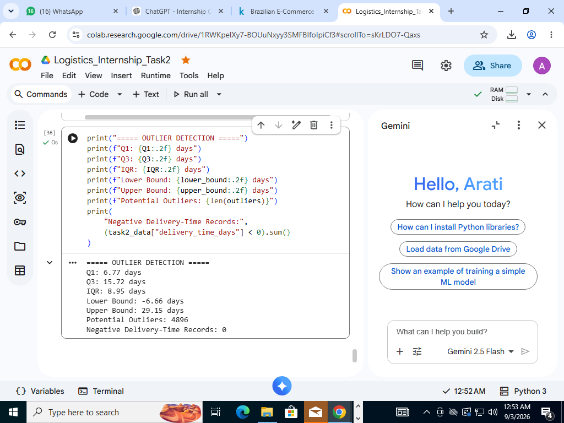
Figure 3: IQR-based delivery-time outlier detection

8. FINAL PREPROCESSED DATASET
The final Task 2 dataset contains delivered orders with valid actual delivery timestamps.
The final dataset was saved as:
Olist_Task2_Preprocessed_Data.csv

Python Code
task2_data.to_csv(
"Olist_Task2_Preprocessed_Data.csv",
index=False
)

print("Task 2 dataset saved successfully.")

Final Preprocessing Summary
Metric | Result
Original records | 99,441
Delivered orders | 96,478
Delivered orders with actual delivery date | 96,470
Final analysis records | 96,470
Average delivery time | 12.56 days
Average delivery delay | −11.18 days
Early/On-Time orders | 88,644
Late orders | 7,826
Early/On-Time rate | 91.89%
Late delivery rate | 8.11%
Potential delivery-time outliers | 4,896

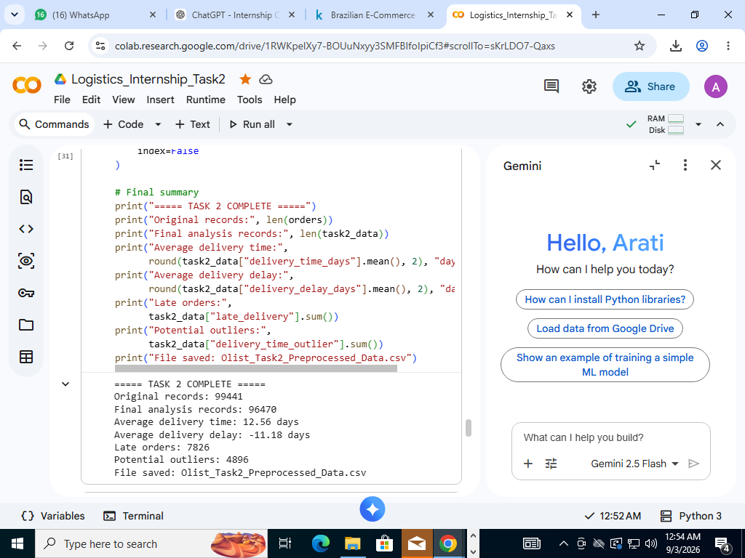
Figure 4: Final preprocessing results and output file

9. PREPROCESSING RESULTS AND BUSINESS INTERPRETATION
The preprocessing stage produced several useful logistics observations.

9.1 Delivery Performance
The analysis found that 91.89% of the analyzed orders were delivered early or on time, while 8.11% were delivered late.
This indicates generally good delivery performance, although the late orders remain an important area for further investigation.

9.2 Delivery Duration
The average delivery time was 12.56 days. The median was approximately 10.22 days, indicating that many orders were delivered within a shorter period than the average.
The difference between the mean and median suggests that some longer delivery times are increasing the average.

9.3 Delivery Delays
The average delivery delay was −11.18 days, indicating that orders were generally delivered before the estimated delivery date.
However, the maximum delay was approximately 188.98 days, showing that a small number of orders experienced extremely large delays.

9.4 Outliers
The IQR method identified 4,896 potential delivery-time outliers. These observations should not automatically be considered errors because they may represent real logistics problems.
Future analysis can investigate whether these observations are associated with particular customer locations, sellers, products, freight costs, or order periods.

10. CONCLUSION
The Week 2 task successfully completed the data collection, inspection, cleaning, and preprocessing stages of the Olist e-commerce logistics project.
The original dataset contained 99,441 records. After selecting delivered orders with valid customer delivery timestamps, 96,470 records were prepared for delivery-performance analysis.
The analysis calculated an average delivery time of 12.56 days and an average delivery delay of −11.18 days. A total of 7,826 late deliveries were identified, resulting in a late-delivery rate of 8.11%. The IQR method also identified 4,896 potential delivery-time outliers.
Missing values and duplicate records were investigated, date fields were converted into appropriate datetime formats, and new logistics features were created. The final preprocessed dataset was saved as Olist_Task2_Preprocessed_Data.csv.
This cleaned dataset provides a reliable foundation for the next stages of the internship project, particularly exploratory data analysis, visualization, and predictive modelling.

11. REFERENCES
- Olist. Brazilian E-Commerce Public Dataset by Olist. Kaggle.
- Pandas Documentation. Python Data Analysis Library.
- NumPy Documentation. Numerical Computing with Python.
- Scikit-learn Documentation. Preprocessing and Data Transformation.
- Scikit-learn Documentation. Machine Learning Methods.
Dataset: Brazilian E-Commerce Public Dataset by Olist.

