EXPERIMENT 07
Component-Based Web Application using React JS

Arav Arun | 16010125013 | FY COMPS | Div : A1

Course Outcome: CO4 – Understanding and implementing web application using React.
Aim: To develop a component-based web application using React JS by implementing JSX, functional components, props, state and event handling for case study on Irrigation Advisory System for Sugarcane Crop using AI and Sensor-based Technology

Objectives
Create and run a basic React application using Node.js and npm.
Understand JSX as an XML-like syntax extension used inside JavaScript for describing React UI.
Develop reusable functional components.
Pass data between components using props.
Manage changing UI data using state and useState().
Handle user interaction using React event handlers.
NOTE: Refer to the “Case Study you selected” and complete the tasks in React. This write-up uses Student Information Application as a sample.

Software Requirements
Node.js and npm
Visual Studio Code
Google Chrome or another modern browser
Command Prompt/PowerShell

Theory

React and Existing HTML/CSS/JavaScript Knowledge
HTML provides structure, CSS provides presentation, and JavaScript provides programming logic and browser interaction. React organizes UI development around reusable components, JSX, props and state.

JSX and XML Correlation
JSX stands for JavaScript XML. It looks similar to XML/HTML because it uses angle-bracket tags, but JSX is not XML. It is a syntax extension used to describe React UI inside JavaScript and is transformed by the build tooling.
const name = "Riya";
function App() { return <h1>Hello {name}</h1>; }
HTML: class="box" → JSX: className="box".
HTML onclick="..." → JSX onClick={...}.
JSX permits JavaScript expressions inside { }.
XML represents structured data using tags; JSX describes UI.
JSON represents data using key-value pairs and arrays.

Functional Components
A functional component is a JavaScript function that returns JSX. Components divide a UI into reusable units.
function Student() {
return <h2>Student Details</h2>;
}

Props
Props are read-only inputs supplied by a parent component to a child component.
function Student(props) {
return <p>{props.name} - {props.course}</p>;
}
<Student name="Riya" course="B.Tech" />

State and Event Handling
State represents data that can change during application execution. Updating state causes React to render the relevant UI again.
const [age, setAge] = useState(20);
<button onClick={() => setAge(age + 1)}>Increase Age</button>

Problem Statement
Develop a Student Information application that displays student details using a reusable Student component. The application must accept student information through props and provide an interactive control that changes the displayed age using React state and event handling.

Tasks to be Completed:
- Verify Node.js and npm installation.
- Create a React application named react-student.
- Run the application and identify the public and src folders.
- Modify App.js to display a Student Information heading.
- Create Student.js as a reusable functional component.
- Pass name, course and age from App.js to Student.js using props.
- Display the received information using JSX.
- Add a state variable for age using useState().
- Create an Increase Age button using onClick.
- Apply basic CSS using App.css.
- Run and test the application in the browser.
- Capture screenshots of the final output and important source code.

Procedure
1. Open Command Prompt and navigate to the practical folder, for example D:\React.
2. Run: npx create-react-app react-student
3. Run: cd react-student
4. Run: npm start
5. Open the project in VS Code.
6. Create Student.js inside src.
7. Write the Student component and export it.
8. Import Student into App.js and supply props.
9. Add useState and the Increase Age event.
10. Save and test the application.

Suggested Components
Keep the application very simple:
e.g. Student_Application
│
└── src
├── App.jsx
├── StudentInfo.jsx
├── Result.jsx
├── App.css
└── main.jsx

Program
// Student.js
import { useState } from "react";
function Student({ name, course, initialAge }) {
const [age, setAge] = useState(initialAge);
return (
<div className="card">
<h2>Student Details</h2>
<p>Name: {name}</p>
<p>Course: {course}</p>
<p>Age: {age}</p>
<button onClick={() => setAge(age + 1)}>
Increase Age
</button>
</div>
);
}
export default Student;
// App.js
import Student from "./Student";
import "./App.css";
function App() {
return (
<div>
<h1>Student Information</h1>
<Student name="Riya" course="B.Tech" initialAge={20} />
</div>
);
}
export default App;
/* App.css */
.card { border: 1px solid #999; padding: 20px; width: 300px; margin: 20px auto; }
button { padding: 8px 15px; }

Expected Output
The browser displays student name, course, age and an Increase Age button. Each click increases the displayed age by one. (Use your case study)

Result (Use your case Study)
The component-based Student Information application was developed successfully using JSX, functional components, props, state and event handling.

Post Lab Question:
- How is JSX different from HTML?
- What is a functional component?
- Why is className used instead of class in JSX?
- How is React different from direct DOM manipulation?

-------------------------------------------------------ANSWER--------------------------------------------------------
Component Structure :
KisanSaathi Irrigation Advisory
└── src
├── App.jsx
├── App.css
├── IrrigationAdvisory.jsx
├── Result.js
├── main.jsx
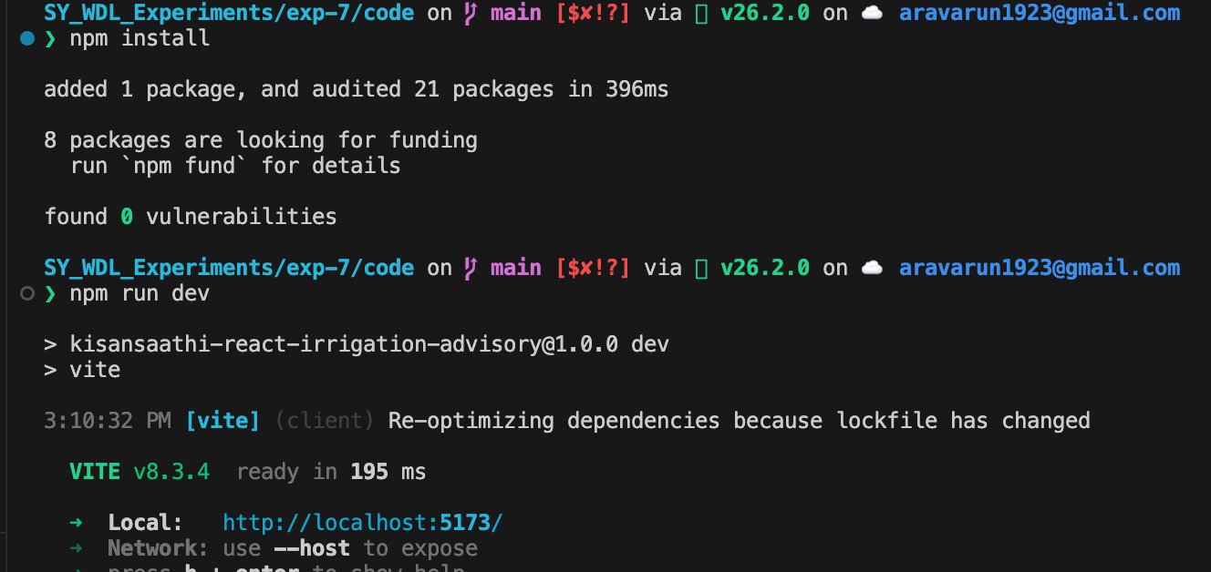

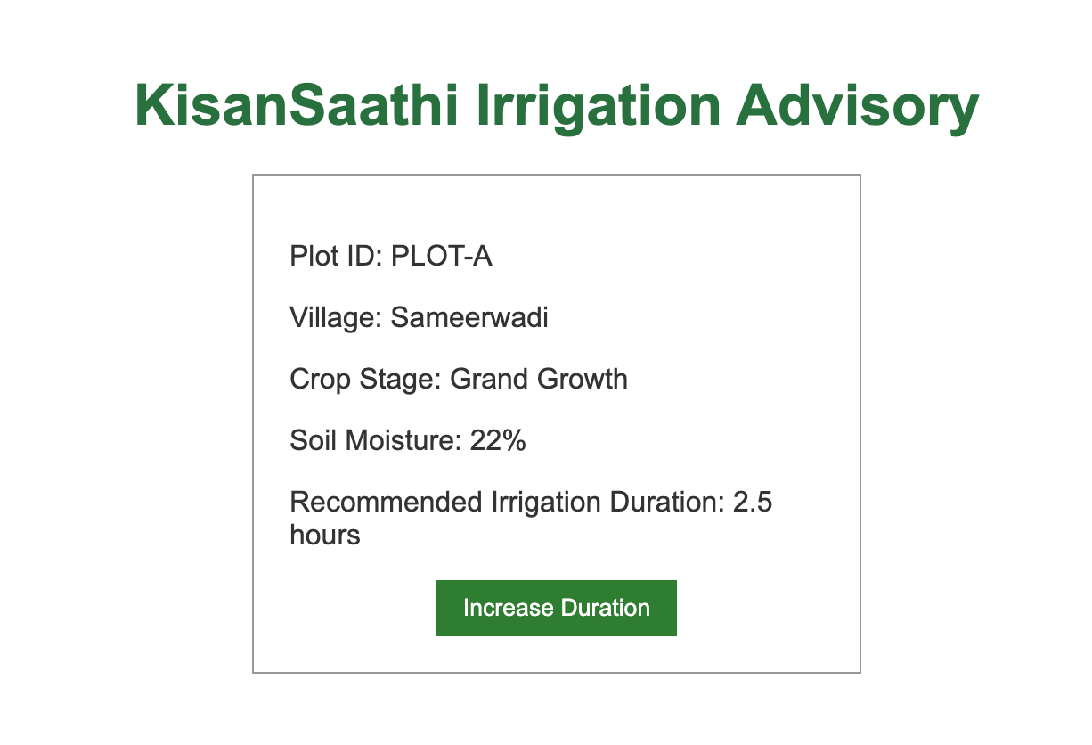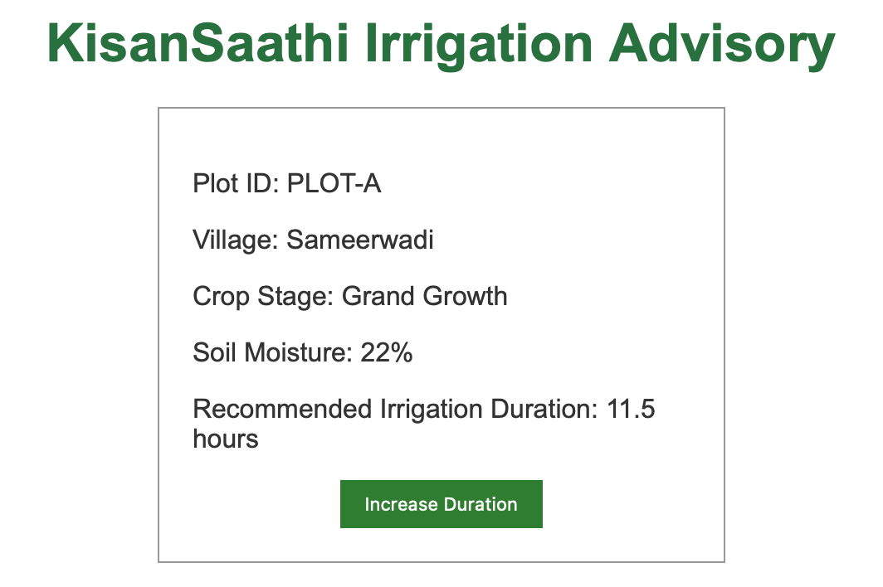
App.jsx
import IrrigationAdvisory from "./IrrigationAdvisory";

function App() {
return (
<div className="container">
<h1>KisanSaathi Irrigation Advisory</h1>

<IrrigationAdvisory
plotId="PLOT-A"
village="Sameerwadi"
cropStage="Grand Growth"
soilMoisture={22}
initialDuration={2.5}
/>
</div>
);
}

export default App;

App.css
body {
font-family: Arial, sans-serif;
margin: 0;
padding: 0;
background: #ffffff;
color: #333333;
}

.container {
text-align: center;
padding: 20px;
}

h1 {
color: #27713d;
margin-bottom: 20px;
}

.card {
width: 300px;
margin: 20px auto;
padding: 20px;
border: 1px solid #999999;
text-align: left;
}

button {
display: block;
margin: 0 auto;
padding: 8px 15px;
border: none;
background: #2e7d32;
color: #ffffff;
cursor: pointer;
}

IrrigationAdvisory.jsx
import { useState } from "react";

function IrrigationAdvisory({
plotId,
village,
cropStage,
soilMoisture,
initialDuration,
}) {
const [duration, setDuration] = useState(initialDuration);

return (
<div className="card">
<p>Plot ID: {plotId}</p>
<p>Village: {village}</p>
<p>Crop Stage: {cropStage}</p>
<p>Soil Moisture: {soilMoisture}%</p>
<p>Recommended Irrigation Duration: {duration} hours</p>

<button onClick={() => setDuration(duration + 0.5)}>
Increase Duration
</button>
</div>
);
}

export default IrrigationAdvisory;

Main.jsx
import { StrictMode } from "react";
import { createRoot } from "react-dom/client";
import App from "./App";
import "./App.css";

createRoot(document.getElementById("root")).render(
<StrictMode>
<App />
</StrictMode>,
);

Post Lab Question:
1. How is JSX different from HTML?
Ans : JSX is a JavaScript syntax extension used to describe React user interfaces, whereas HTML is the markup language interpreted directly by the browser. JSX is compiled to JavaScript before running. It uses className instead of class, camel-case event names such as onClick, and braces to embed JavaScript expressions.
2. What is a functional component?
Ans : A functional component is a JavaScript function that returns JSX. It receives inputs through props and can use React hooks such as useState() to maintain changing data. In this application, PlotCard and IrrigationAdvisory are functional components.

3. Why is className used instead of class in JSX?
Ans: JSX uses className because class is a reserved keyword in JavaScript. React converts className to the HTML class attribute when it renders the page.

4. How is React different from direct DOM manipulation?
Ans: With direct DOM manipulation, JavaScript code selects and changes individual browser elements manually. React represents the user interface as components and updates the required browser elements automatically when state or props change. This makes the application easier to organise and reuse.

