EXPERIMENT 8
Arav Arun | 16010125013 | SY COMPS | Division A
Simple Single Page Web Application using React JS
Course Outcome: CO5 – Illustrate the concepts of various front-end web application developments, mockApi technologies frameworks using different web development tools.

Aim: To develop a simple Single Page Web Application using React JS using reusable components, JavaScript data, JSX and React Router.

Objectives
- Understand the concept of a Single Page Application (SPA).
- Create multiple React components representing application views.
- Implement client-side navigation using React Router.
- Use JavaScript arrays and map() to generate UI elements.
- Reuse JSX, components and state concepts learned in Experiment 07.
NOTE: Refer to the “Case Study you selected” and complete the tasks in React. This write-up uses Student Information Application as a sample.

Software Requirements
- Node.js and npm
- Visual Studio Code
- Google Chrome or another modern browser

Theory

Single Page Application (SPA)
An SPA loads an application shell and changes the displayed view on the client without requiring a complete browser document reload for every internal route. React can implement this model using a routing library.

React Router
React Router provides BrowserRouter, Routes, Route and Link for mapping URL paths to React components and navigating between views.

Link and HTML Navigation
- HTML commonly uses <a href="/about">About</a>.
- React Router uses <Link to="/about">About</Link> for client-side navigation.
- The goal is to switch application views without a full page navigation.

JavaScript map() in React
students.map(student => (
<p key={student.id}>{student.name} - {student.course}</p>
));

Problem Statement
Develop a simple Student Portal SPA containing Home, Students and About views. Navigation must use React Router. The Students view must generate records from a JavaScript array using map().

Tasks to be Given to Students
- Create a React application named student-portal.
- Install react-router-dom.
- Create Home.js, Students.js and About.js components.
- Create navigation links for Home, Students and About.
- Configure BrowserRouter, Routes and Route.
- Display a welcome message on Home.
- Display at least three student records using an array and map().
- Use a unique key for each generated item.
- Display application information on About.
- Apply simple CSS.
- Test all routes and capture screenshots.

Procedure
- Open Command Prompt and navigate to the practical folder.
- Run: npx create-react-app student-portal
- Run: cd student-portal
- Run: npm install react-router-dom
- Run: npm start
- Create a pages folder inside src.
- Create Home.js, Students.js and About.js.
- Write the components.
- Import them into App.js.
- Configure BrowserRouter, Routes, Route and Link.
- Test /, /students and /about.

Program – Home.js
function Home() {
return (
<div>
<h1>Welcome to Student Portal</h1>
<p>This is the home page.</p>
</div>
);
}
export default Home;

Program – Students.js
function Students() {
const students = [
{ id: 1, name: "Riya", course: "B.Tech" },
{ id: 2, name: "Amit", course: "BCA" },
{ id: 3, name: "Neha", course: "B.Tech" }
];
return (
<div>
<h1>Student List</h1>
{students.map(student => (
<p key={student.id}>
{student.name} - {student.course}
</p>
))}
</div>
);
}
export default Students;

Program – About.js
function About() {
return (
<div>
<h1>About</h1>
<p>Student Portal is developed using React JS.</p>
</div>
);
}
export default About;

Program – App.js
import { BrowserRouter, Routes, Route, Link } from "react-router-dom";
import Home from "./pages/Home";
import Students from "./pages/Students";
import About from "./pages/About";
function App() {
return (
<BrowserRouter>
<nav>
<Link to="/">Home</Link> |{" "}
<Link to="/students">Students</Link> |{" "}
<Link to="/about">About</Link>
</nav>
<Routes>
<Route path="/" element={<Home />} />
<Route path="/students" element={<Students />} />
<Route path="/about" element={<About />} />
</Routes>
</BrowserRouter>
);
}
export default App;

Expected Output
The application provides Home, Students and About navigation. Selecting a navigation link displays the corresponding React component without creating separate HTML pages.

Result
A simple Single Page Web Application was developed successfully using React JS, reusable components and React Router.

Viva Questions
- Why is React Router used?
- What are BrowserRouter, Routes and Route?
- What is the difference between Link and an HTML anchor?
- Why is key used in React lists?
- How does map() help in React?
- How does Experiment 08 extend Experiment 07?

-------------------------------------------------------ANSWER--------------------------------------------------------
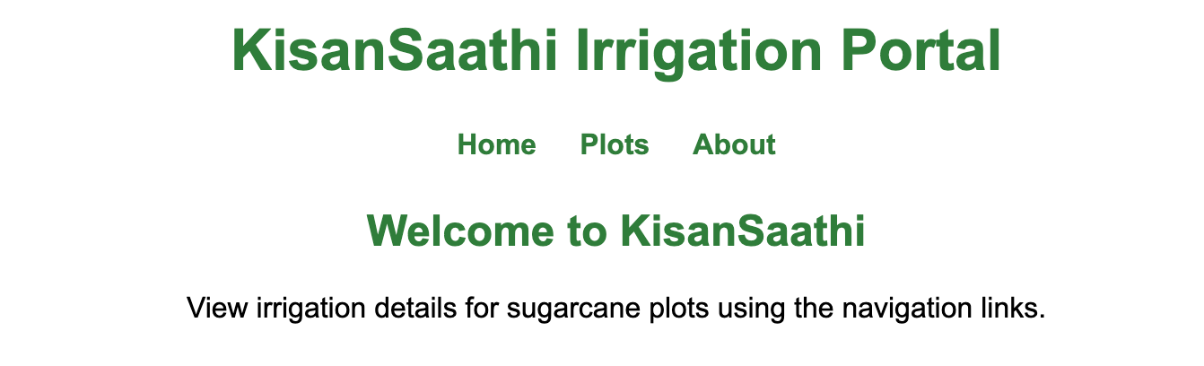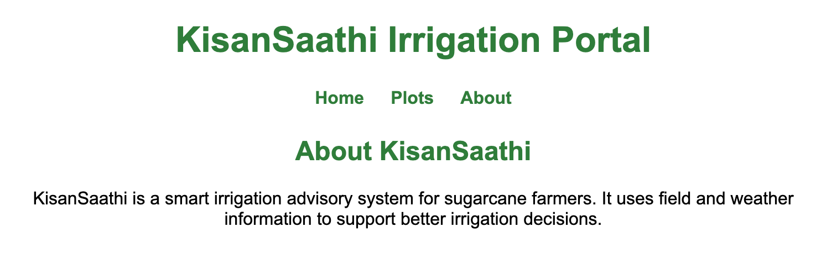
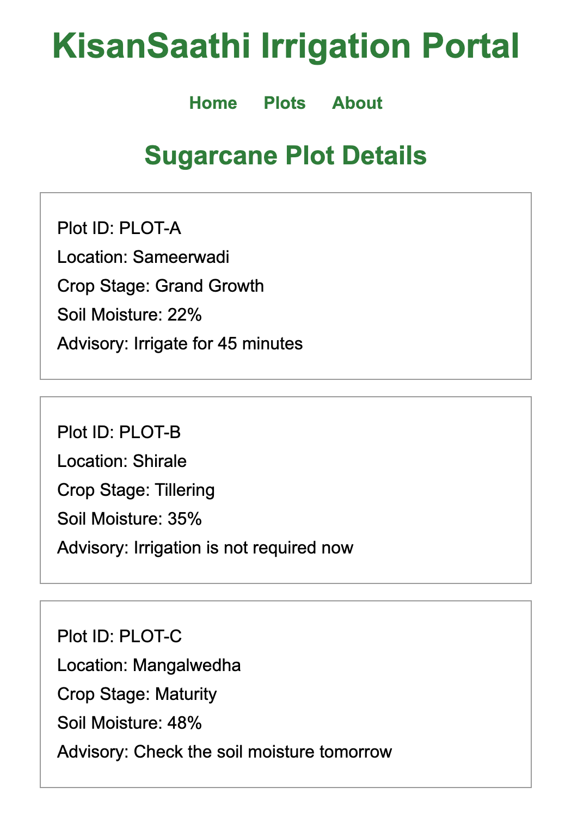
App.jsx
import { BrowserRouter, Link, Route, Routes } from "react-router-dom";
import About from "./About";
import "./App.css";
import Home from "./Home";
import Plots from "./Plots";

function App() {
return (
<BrowserRouter>
<main className="container">
<h1>KisanSaathi Irrigation Portal</h1>

<nav>
<Link to="/">Home</Link>
<Link to="/plots">Plots</Link>
<Link to="/about">About</Link>
</nav>

<Routes>
<Route path="/" element={<Home />} />
<Route path="/plots" element={<Plots />} />
<Route path="/about" element={<About />} />
</Routes>
</main>
</BrowserRouter>
);
}

export default App;

App.css
body {
margin: 0;
font-family: Arial, sans-serif;
}

.container {
width: 700px;
margin: 0 auto;
padding: 20px;
text-align: center;
}

h1,
h2 {
color: #2f7d3b;
}

nav {
margin: 25px 0;
}

nav a {
margin: 0 12px;
color: #2f7d3b;
font-weight: bold;
text-decoration: none;
}

.card {
width: 420px;
margin: 15px auto;
padding: 15px;
border: 1px solid #999;
text-align: left;
}

.card p {
margin: 8px 0;
}

About.jsx
function About() {
return (
<section>
<h2>About KisanSaathi</h2>
<p>
KisanSaathi is a smart irrigation advisory system for sugarcane farmers.
It uses field and weather information to support better irrigation
decisions.
</p>
</section>
);
}

export default About;

Home.jsx
function Home() {
return (
<section>
<h2>Welcome to KisanSaathi</h2>
<p>View irrigation details for sugarcane plots using the navigation links.</p>
</section>
);
}

export default Home;

main.jsx
import React from "react";
import ReactDOM from "react-dom/client";
import App from "./App";

ReactDOM.createRoot(document.getElementById("root")).render(
<React.StrictMode>
<App />
</React.StrictMode>
);

Plots.jsx
const plots = [
{
id: "PLOT-A",
location: "Sameerwadi",
cropStage: "Grand Growth",
soilMoisture: "22%",
irrigation: "Irrigate for 45 minutes",
},
{
id: "PLOT-B",
location: "Shirale",
cropStage: "Tillering",
soilMoisture: "35%",
irrigation: "Irrigation is not required now",
},
{
id: "PLOT-C",
location: "Mangalwedha",
cropStage: "Maturity",
soilMoisture: "48%",
irrigation: "Check the soil moisture tomorrow",
},
];

function Plots() {
return (
<section>
<h2>Sugarcane Plot Details</h2>

{plots.map((plot) => (
<div className="card" key={plot.id}>
<p>Plot ID: {plot.id}</p>
<p>Location: {plot.location}</p>
<p>Crop Stage: {plot.cropStage}</p>
<p>Soil Moisture: {plot.soilMoisture}</p>
<p>Advisory: {plot.irrigation}</p>
</div>
))}
</section>
);
}

export default Plots;

