Course Name: | Web Development Laboratory (316U01L306) | Semester: | III
Date of Performance: | ___ / ___ / ______ | DIV/ Batch No: | A1
Student Name: | Arav Arun | Roll No: | 16010125013

Experiment No: 3
Title: To implement a Version Control System using Git and GitHub for managing, tracking, and sharing the website files developed in Experiments 1 and 2.

Aim of the Experiment: Implementation of Version Control System (Git & GitHub)

Objectives for the Experiment:
- Understand the concept and importance of version control in web development.
- Install and configure Git and create a local Git repository.
- Track website files using the working directory, staging area, and local repository.
- Use essential Git commands such as init, status, add, commit, log, diff, branch, remote, push, pull, and clone.
- Create and manage a remote repository on GitHub.
- Upload the Experiment 1 and Experiment 2 case-study files to GitHub using meaningful commits.
- Demonstrate synchronization between a local repository and GitHub.

COs to be achieved:
CO1: Developing webpages using HTML and CSS

Books/ Journals/ Websites references:
- Git Documentation: https://git-scm.com/docs
- GitHub Documentation: https://docs.github.com/
- Git Exercises: https://gitexercises.fracz.com/

Theory:

Version Control
Version control is a system used to track and manage changes made to files during the development of a project. It allows developers to maintain different versions of a project and return to an earlier version when required.

Git
Git is a distributed version control system used to track changes in source code and other project files. It maintains a history of changes through commits.

GitHub
GitHub is a cloud-based platform that hosts Git repositories. It allows developers to store projects online, collaborate with others, and manage different versions of a project.

Git Repository
A repository is a location where Git stores the files and the history of changes made to those files.

Basic Git Workflow
The basic Git workflow can be represented as:
Working Directory → Staging Area → Local Repository → Remote Repository (GitHub)

Important Git Commands
Students should explain the purpose and syntax of the following commands:
Command | Purpose
git init | Initializes a new Git repository
git status | Displays the current state of the repository
git add | Adds files to the staging area
git commit | Saves staged changes in the local repository
git log | Displays commit history
git diff | Displays changes made to files
git branch | Displays or manages branches
git remote | Manages connections to remote repositories
git push | Uploads local commits to GitHub
git pull | Retrieves and integrates changes from GitHub
git clone | Creates a local copy of a remote repository

Problem statement:
Upload and maintain the website files developed for Experiments 1 and 2 of the assigned case studies using Git and GitHub. Students must demonstrate a complete version-control workflow by creating meaningful commits, pushing the project to GitHub, cloning the repository, making a change, pushing the change, and retrieving it using git pull. All tasks are compulsory.

Code:

Task 1: Create and Configure a GitHub Account
1. Create/sign in to a GitHub account using the student's own name "Your-Name" and email address "your-email@example.com".
2. Create a repository with a meaningful name related to the assigned case study, for example: smart-agriculture_GrpNo.
3. Add a suitable repository description. Do not upload unrelated files.

Task 2: Install and Configure Git
- Install Git and open Git Bash.
- Verify installation: git --version
- Configure identity: git config --global user.name "Your-Name"
- Configure email: git config --global user.email "your-email@example.com"
- Verify configuration: git config --list

Task 3: Prepare and Initialize the Local Project
- Create/open the folder containing the Experiment 1 and Experiment 2 website files. If required, create a project folder: mkdir smart-agriculture_GrpNo
- Enter the folder: cd smart-agriculture_GrpNo
- Confirm the files are present, such as index.html, style.css, script.js, images, and other files required by the case study.
- Initialize Git: git init
- Check the repository: git status
- Observe the files shown as untracked.

Task 4: Track Files and Create the Initial Commit
- Stage the project files: git add .
- Check staging status: git status
- Create a meaningful first commit: git commit -m "Initial case study website"
- View history: git log

Task 5: Modify the Website and Create a Second Commit
- Modify the website according to the assigned case study, such as changing content, adding a section, updating navigation, or modifying CSS.
- Check changes: git status
- View differences: git diff
- Stage the changes: git add .
- Commit them: git commit -m "Updated homepage and styling"
- View the history again: git log

Task 6: Connect the Local Repository to GitHub
- Copy the URL of the GitHub repository.
- Add the remote: git remote add origin <GitHub-Repository-URL>
- Verify: git remote -v
- Set the primary branch to main if required: git branch -M main

Task 7: Push the Project to GitHub
- Upload the local commits: git push -u origin main
- Open the GitHub repository and verify that the website files, project structure, and commit history are visible.
- Record the GitHub repository URL in the observation/deliverable section.

Task 8: Clone and Synchronize the Repository
- Clone the repository into another folder: git clone <GitHub-Repository-URL>
- Enter the cloned folder and make a small, identifiable website change.
- Stage and commit: git add . ; git commit -m "Updated website content"
- Push the change: git push
- Return to the original project folder and retrieve the latest changes: git pull
- Verify that the change appears in the original local project.

Commands to be used for the above tasks:
git --version
git config --global user.name "Your-Name"
git config --global user.email "your-email@example.com"
git config --list
mkdir smart-agriculture_GrpNo
cd smart-agriculture_GrpNo
git init
git status
git add .
git commit -m "Initial case study website"
git log
# After making changes
git status
git diff
git add .
git commit -m "Updated homepage and styling"
git log
# Connect to GitHub
git remote add origin <GitHub-Repository-URL>
git remote -v
git branch -M main
git push -u origin main
# Clone and synchronize
git clone <GitHub-Repository-URL>
git add .
git commit -m "Updated website content"
git push
git pull

Expected Output / Screenshots:
· Git version displayed successfully.
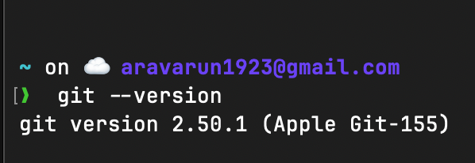
· Git username and email configuration displayed.
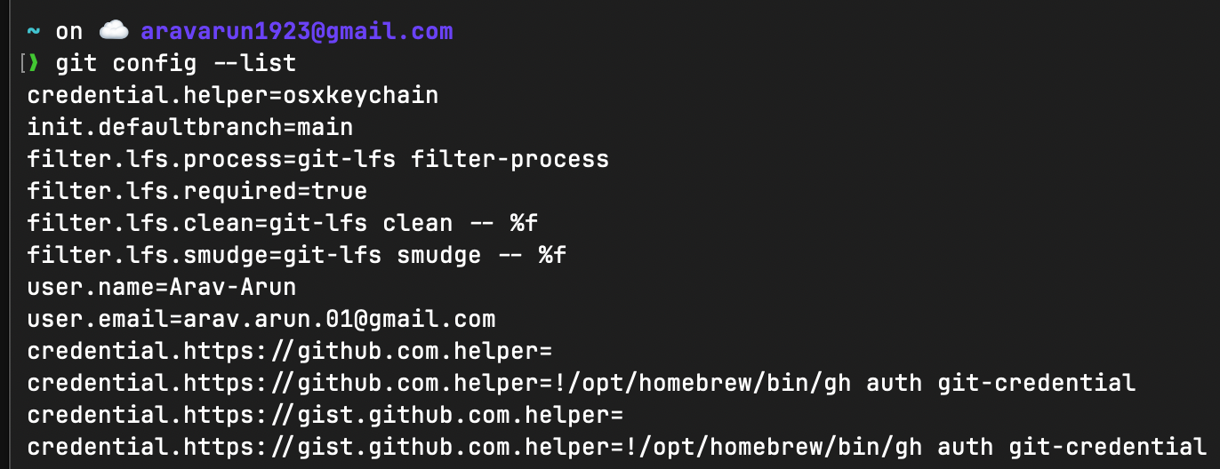
· git status showing the project files.

· Successful initial commit and commit history using git log.
· Changes displayed using git diff.
· Remote URL displayed using git remote -v.
· Successful git push to GitHub.
· GitHub repository showing the website files and commit history.
· Successful git clone and git pull demonstrating synchronization.

GitHub Repository URL:

Post Lab Subjective/Objective type Questions:
- What is the purpose of git clone? How is it different from downloading a ZIP file from GitHub?
git clone creates a local copy of a GitHub repository along with its Git history, branches, and remote connection, so you can pull updates and push changes later.
Downloading a ZIP only gives you the current project files. It does not include Git history, branches, or a connection to the original repository.
- Complete at least the relevant interactive exercises from Git Exercises (https://gitexercises.fracz.com/)and demonstrate basic branching, conflict resolution, and remote-repository operations.

Conclusion and Discussion:
Students should write the conclusion in their own words based on the work performed. The discussion should mention what was learned about Git/GitHub, how version history helped in tracking website changes, any difficulties encountered, and how those difficulties were resolved.
Peer feedback (minimum 3 classmates):
1. ______________________________________________
2. ______________________________________________
3. ______________________________________________

