Course Name: | Web Development Laboratory (316U01L306) | Semester: | III
Date of Performance: | 7 / 9 /2026 | DIV/ Batch No: | A1
Student Name: | Arav Arun | Roll No: | 16010125013

Experiment No: 4
Title
Form Validation using JavaScript for an AI-based Smart Irrigation Advisory Web Portal
Aim of the Experiment
To design and implement client-side form validation using JavaScript for the farmer registration form of an AI-based Smart Irrigation Advisory System, ensuring that user-entered data such as name, mobile number, email, plot ID, soil moisture, crop stage, irrigation method, and date is complete, valid, and meaningful before form submission.
Objectives of the Experiment
• To create an interactive HTML form for collecting farmer and farm information.
• To use JavaScript to validate text, numeric, email, date, and selection fields.
• To implement regular expressions for validating mobile numbers, email addresses, and plot IDs.
• To display meaningful error messages and prevent submission when invalid data is entered.
• To apply form validation to a real-world agriculture use case involving farmer and farm registration.
COs to be achieved
CO1: Developing webpages using HTML, CSS and JavaScript.
Books / Journals / Websites references
1. MDN Web Docs - JavaScript Guide and HTML Forms.
2. W3schools.com
3. JavaScript documentation/reference material prescribed by the course instructor.
Theory
Form validation is the process of checking whether the information entered by a user satisfies the required rules before it is submitted or processed. Validation improves data quality, usability, and reliability of web applications.
JavaScript provides client-side validation by accessing form elements through the DOM and checking their values using conditions, string methods, numeric comparisons, regular expressions, and event handlers such as submit and input. If invalid data is detected, JavaScript can display an error message and stop the form from being submitted.
Common validation rules include checking for empty fields, minimum and maximum length, valid email format, valid mobile number, acceptable numeric ranges, selected options, and valid dates. Regular expressions are useful for validating structured values such as mobile numbers and email addresses.
In this experiment, JavaScript validation is applied to a farmer registration form for the AI-based Smart Irrigation Advisory System. The use case calls for farmer-friendly web/mobile platforms and plot-specific advisory and decision support.
Problem Statement
"JavaScript Form Validation for Farmer Registration"
Develop a web-based farmer registration form for the Smart Irrigation Advisory System. The form should collect essential farmer and farm information and use JavaScript to validate the entered values before submission. Invalid or incomplete data must be identified and appropriate error messages must be displayed to the user.
Task 1: Create the Farmer Registration Form
Scenario
Design a registration form for farmers who will use the Smart Irrigation Advisory System.
Requirements
• Create fields for Farmer Name, Mobile Number, Email, Plot ID, Village, Crop Stage, Soil Type, Irrigation Method, Soil Moisture (%), Registration Date and Farm Photo.
• Use <form>, <label>, <input>, <select>, <option>, <fieldset> and <legend>.
• Provide Submit and Reset buttons.
• Assign unique id and name attributes to all fields.
Concepts Tested
• HTML Forms
• Form controls
• DOM element identification
Deliverable: registration.html
Task 2: Validate Required Text Fields
Scenario
Ensure that essential farmer and farm information is not left blank.
Requirements
• Check that Farmer Name, Plot ID and Village are not empty.
• Remove leading and trailing spaces using trim().
• Validate that Farmer Name contains alphabetic characters and spaces only.
• Display an error message beside each invalid field.
Concepts Tested
• JavaScript conditions
• String methods
• Required-field validation
Deliverable: registration.html
Task 3: Validate Mobile Number and Email
Scenario
Verify that the farmer's contact information follows the expected format.
Requirements
• Validate a 10-digit Indian mobile number using a suitable regular expression or any other rule.
• Validate the email address.
• Display specific messages for invalid mobile number and email.
• Do not allow the form to submit until both fields are valid.
Concepts Tested
• Regular expressions
• String validation
• Form submit event
Deliverable: registration.html
Task 4: Validate Selection and Date Fields
Scenario
Ensure that the farmer provides valid crop, soil, irrigation and date information.
Requirements
• Ensure that Crop Stage, Soil Type and Irrigation Method are selected.
• Validate that Registration Date is entered.
• Prevent future registration dates if the application rule requires the registration date to be today or earlier.
• Highlight the field when validation fails.
Concepts Tested
• Select validation
• Date validation
• DOM manipulation
Deliverable: registration.html

Code :
registration.html
<!DOCTYPE html>
<html lang="en">
<head>
<meta charset="UTF-8">
<meta name="viewport" content="width=device-width, initial-scale=1.0">
<title>Farmer Registration</title>
<link rel="stylesheet" href="css/style.css">
<link rel="stylesheet" href="css/layout.css">
<link rel="stylesheet" href="css/form.css">
<link rel="stylesheet" href="css/validation.css">
</head>
<body>

<header>
<h1>KisanSaathi</h1>
<p>Smart Irrigation using AI &amp; Sensor Technology</p>
</header>

<div class="page-wrapper">
<aside class="sidebar">
<h3>Navigation</h3>
<ul>
<li><a href="index.html">Home</a></li>
<li><a href="farm-info.html">Farm Info</a></li>
<li><a href="advisory.html">Advisory</a></li>
<li><a href="irrigation-table.html">Dashboard</a></li>
<li><a href="media.html">Media</a></li>
<li><a href="plot-map.html">Plot Map</a></li>
<li><a href="weather.html">Weather</a></li>
<li><a href="registration.html">Register</a></li>
</ul>
</aside>

<div class="main-content">
<section>
<h2>Farmer Registration Form</h2>

<form action="#" method="post" enctype="multipart/form-data"
name="regForm" id="regForm"
onsubmit="return validateForm()" novalidate>

<table style="width:100%; border:none; box-shadow:none;">
<tr>
<td style="width:50%; vertical-align:top;
border:none; padding:0 0.5rem 0 0;">
<!-- Personal Information -->
<fieldset>
<legend>Personal Information</legend>

<label for="name">Full Name:</label><br>
<input type="text" id="name" name="name"
placeholder="Enter your full name" autofocus>
<span class="error" id="errName"></span><br>

<label for="mobile">Mobile Number:</label><br>
<input type="tel" id="mobile" name="mobile"
placeholder="10-digit mobile number">
<span class="error" id="errMobile"></span><br>

<label for="email">Email Address:</label><br>
<input type="email" id="email" name="email"
placeholder="example@email.com">
<span class="error" id="errEmail"></span><br>

<label for="village">Village:</label><br>
<input type="text" id="village" name="village"
placeholder="Enter village name">
<span class="error" id="errVillage"></span><br>
</fieldset>
</td>
<td style="width:50%; vertical-align:top;
border:none; padding:0 0 0 0.5rem;">
<!-- Farm Details -->
<fieldset>
<legend>Farm Details</legend>

<label for="plotid">Plot ID:</label><br>
<input type="text" id="plotid" name="plotid"
placeholder="e.g. PLOT-A">
<span class="error" id="errPlot"></span><br>

<label for="cropstage">Crop Stage:</label><br>
<select id="cropstage" name="cropstage">
<option value="" disabled selected>
-- Select Crop Stage --</option>
<option value="germination">Germination</option>
<option value="tillering">Tillering</option>
<option value="grand-growth">Grand Growth</option>
<option value="maturity">Maturity</option>
</select>
<span class="error" id="errCrop"></span><br>

<label for="soiltype">Soil Type:</label><br>
<select id="soiltype" name="soiltype">
<option value="" disabled selected>
-- Select Soil Type --</option>
<option value="black-cotton">Black Cotton</option>
<option value="red-laterite">Red Laterite</option>
<option value="alluvial">Alluvial Soil</option>
<option value="sandy">Sandy Soil</option>
<option value="clay">Clay Soil</option>
</select>
<span class="error" id="errSoil"></span><br>

<label for="moisture">Soil Moisture (%):</label><br>
<input type="text" id="moisture" name="moisture"
placeholder="0 to 100">
<span class="error" id="errMoisture"></span><br>

<label>Irrigation Method:</label><br>
<input type="radio" id="drip" name="irrigation"
value="drip">
<label for="drip">Drip Irrigation</label><br>
<input type="radio" id="furrow" name="irrigation"
value="furrow">
<label for="furrow">Furrow Irrigation</label><br>
<input type="radio" id="sprinkler" name="irrigation"
value="sprinkler">
<label for="sprinkler">Sprinkler Irrigation</label><br>
<input type="radio" id="flood" name="irrigation"
value="flood">
<label for="flood">Flood Irrigation</label>
<span class="error" id="errMethod"></span><br>

<label for="date">Registration Date:</label><br>
<input type="date" id="date" name="date">
<span class="error" id="errDate"></span><br>

<label for="photo">Upload Farm Photo:</label><br>
<input type="file" id="photo" name="photo"
accept="image/*"><br><br>
</fieldset>
</td>
</tr>
</table>

<div style="text-align:center; margin-top:1rem;">
<input type="submit" value="Register">
<input type="reset" value="Clear Form" onclick="clearErrors()">
</div>

<p id="formMessage"></p>

</form>
</section>
</div>
</div>

<footer>
<p>WDL Experiment 4 | SY COMPS Sem 3 | A1 Batch</p>
</footer>

<script src="js/validation.js"></script>

</body>
</html>
css/validation.css
.error {
display: block;
color: #c62828;
font-size: 0.85rem;
margin-top: 0.2rem;
}

.invalid {
border: 1px solid #c62828;
background-color: #fdecea;
}

.invalid:focus {
border-color: #c62828;
}

#formMessage {
max-width: 640px;
margin: 1rem auto 0 auto;
padding: 0.7rem 1rem;
border-radius: 4px;
text-align: center;
font-weight: bold;
}

#formMessage.success {
background-color: #e8f5e9;
color: #1b5e20;
border: 1px solid #2e7d32;
}

#formMessage.failure {
background-color: #fdecea;
color: #c62828;
border: 1px solid #c62828;
}
js/validation.js
var namePattern = /^[A-Za-z ]+$/;
var mobilePattern = /^[6-9][0-9]{9}$/;
var emailPattern = /^[A-Za-z0-9._%+-]+@[A-Za-z0-9.-]+\.[A-Za-z]{2,}$/;
var plotPattern = /^PLOT-[A-Z0-9]{1,3}$/;

var fieldIds = ["name", "mobile", "email", "village", "plotid",
"cropstage", "soiltype", "moisture", "date"];

function getValue(id) {
return document.getElementById(id).value.trim();
}

function showError(fieldId, errorId, message) {
document.getElementById(errorId).innerHTML = message;
document.getElementById(fieldId).className = "invalid";
}

function getIrrigationMethod() {
var choices = document.getElementsByName("irrigation");
for (var i = 0; i < choices.length; i++) {
if (choices[i].checked) {
return choices[i].value;
}
}
return "";
}

function clearErrors() {
var boxes = document.getElementsByClassName("error");
for (var i = 0; i < boxes.length; i++) {
boxes[i].innerHTML = "";
}
for (var i = 0; i < fieldIds.length; i++) {
document.getElementById(fieldIds[i]).className = "";
}
var message = document.getElementById("formMessage");
message.innerHTML = "";
message.className = "";
}

function validateForm() {
clearErrors();
var valid = true;

var name = getValue("name");
var mobile = getValue("mobile");
var email = getValue("email");
var village = getValue("village");
var plotid = getValue("plotid");
var cropstage = getValue("cropstage");
var soiltype = getValue("soiltype");
var moisture = getValue("moisture");
var date = getValue("date");
var method = getIrrigationMethod();

if (name == "") {
showError("name", "errName", "Full name is required.");
valid = false;
} else if (!namePattern.test(name)) {
showError("name", "errName", "Use alphabets and spaces only.");
valid = false;
}

if (village == "") {
showError("village", "errVillage", "Village is required.");
valid = false;
}

if (plotid == "") {
showError("plotid", "errPlot", "Plot ID is required.");
valid = false;
} else if (!plotPattern.test(plotid.toUpperCase())) {
showError("plotid", "errPlot", "Use the format PLOT-A.");
valid = false;
}

/* Task 3: mobile number and email */
if (mobile == "") {
showError("mobile", "errMobile", "Mobile number is required.");
valid = false;
} else if (!mobilePattern.test(mobile)) {
showError("mobile", "errMobile",
"Enter a 10 digit number starting with 6 to 9.");
valid = false;
}

if (email == "") {
showError("email", "errEmail", "Email address is required.");
valid = false;
} else if (!emailPattern.test(email)) {
showError("email", "errEmail", "Enter a valid email address.");
valid = false;
}

/* Task 4: selections, soil moisture and date */
if (cropstage == "") {
showError("cropstage", "errCrop", "Select the crop stage.");
valid = false;
}

if (soiltype == "") {
showError("soiltype", "errSoil", "Select the soil type.");
valid = false;
}

if (method == "") {
document.getElementById("errMethod").innerHTML =
"Select an irrigation method.";
valid = false;
}

if (moisture == "") {
showError("moisture", "errMoisture", "Soil moisture is required.");
valid = false;
} else if (isNaN(moisture) || moisture < 0 || moisture > 100) {
showError("moisture", "errMoisture", "Enter a value from 0 to 100.");
valid = false;
}

if (date == "") {
showError("date", "errDate", "Registration date is required.");
valid = false;
} else {
var today = new Date();
today.setHours(0, 0, 0, 0);
var entered = new Date(date);
if (entered > today) {
showError("date", "errDate", "Future date is not allowed.");
valid = false;
}
}

var message = document.getElementById("formMessage");
if (valid) {
message.className = "success";
message.innerHTML = "Registration successful. Irrigation advisory " +
"for " + plotid.toUpperCase() + " will be sent " +
"to " + mobile + ".";
} else {
message.className = "failure";
message.innerHTML = "Please correct the highlighted fields.";
}

return false;
}

Output / Screenshot:
1. Registration form
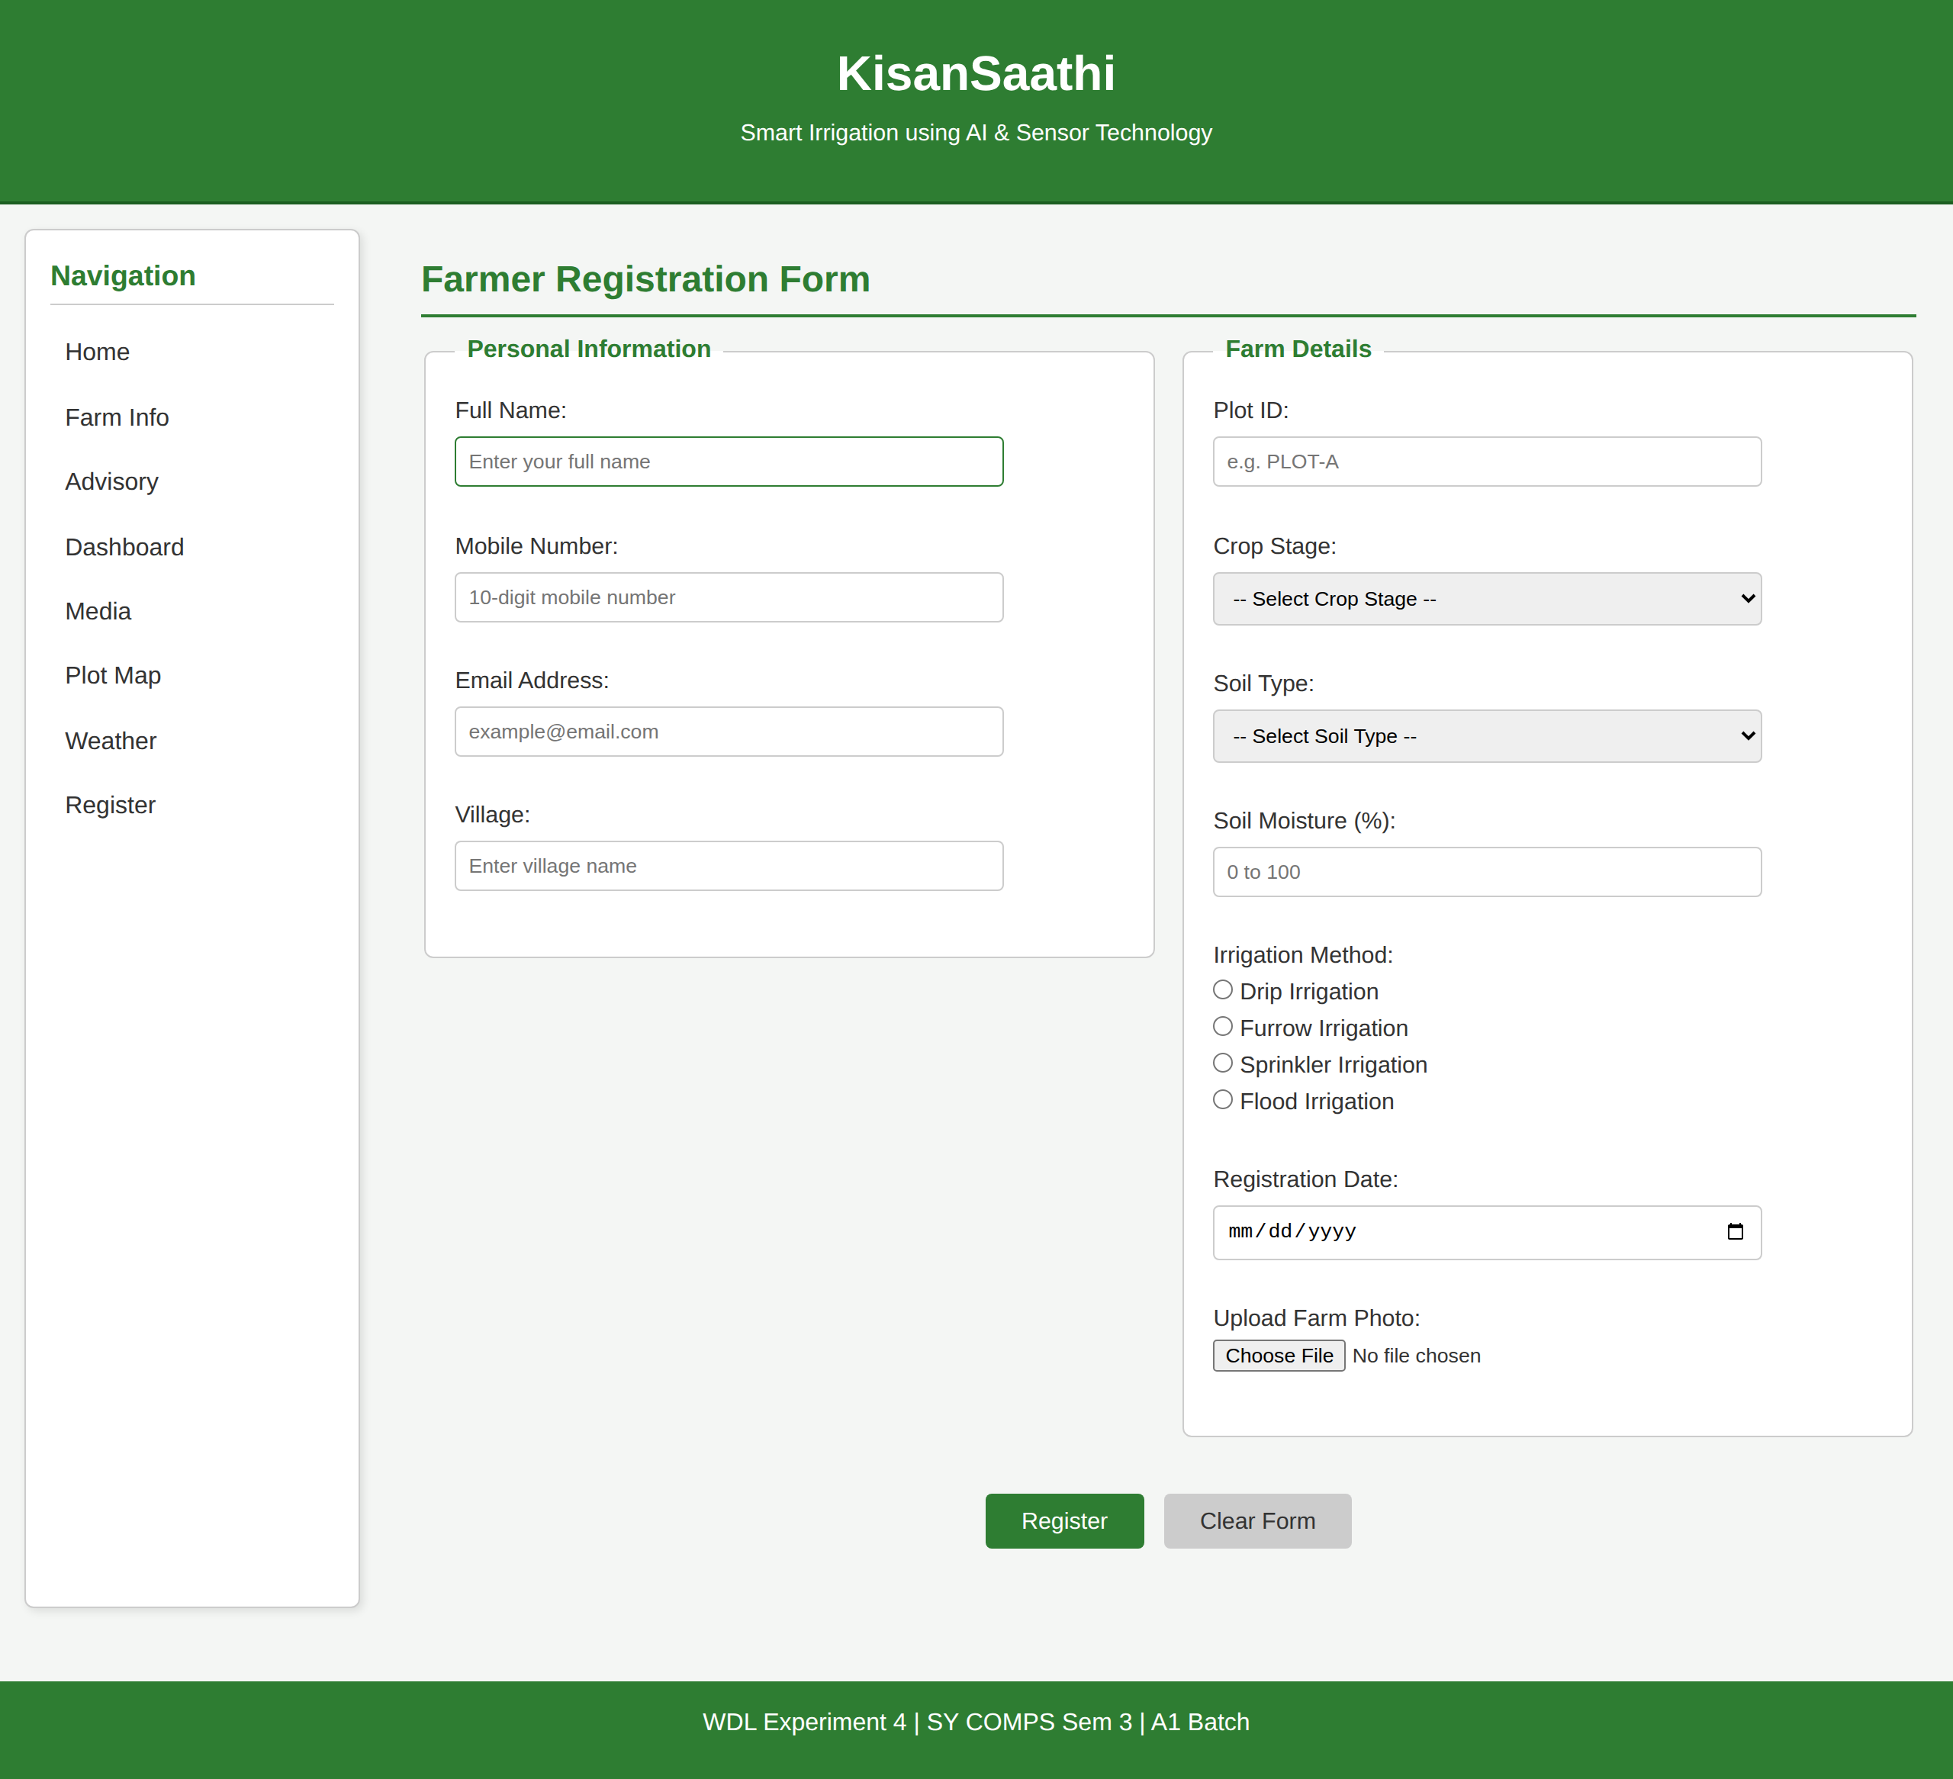
2. Validation messages shown beside each invalid field, with the field highlighted.
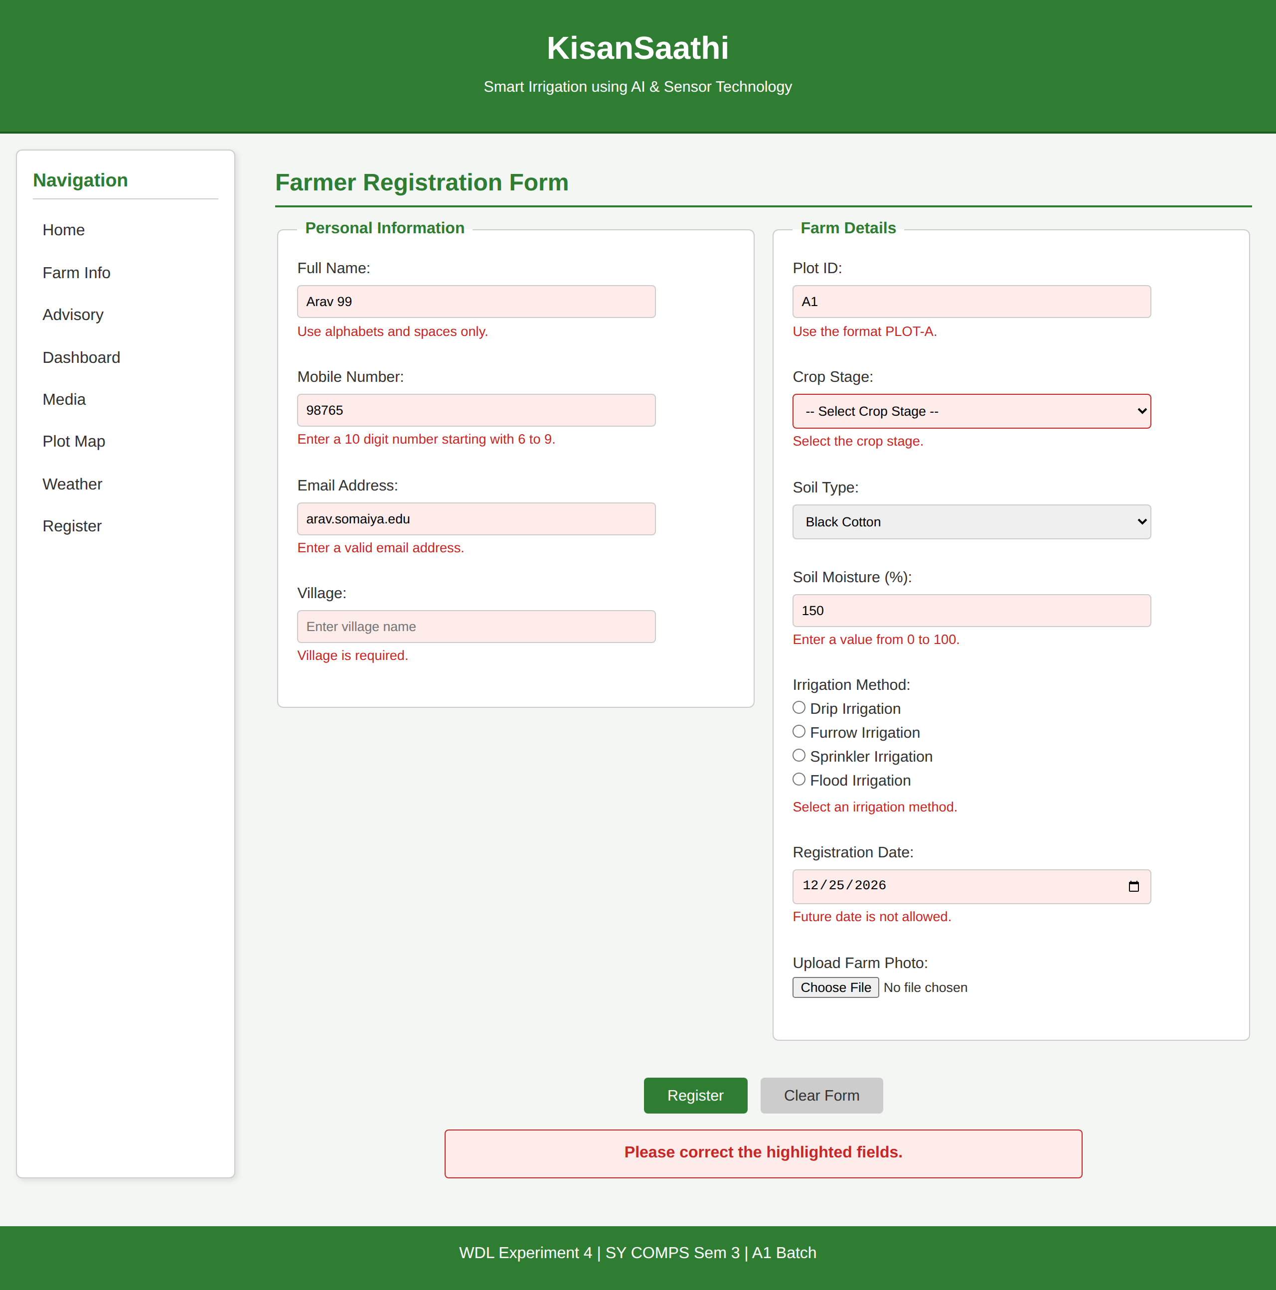
3. Success message displayed after all values pass validation.
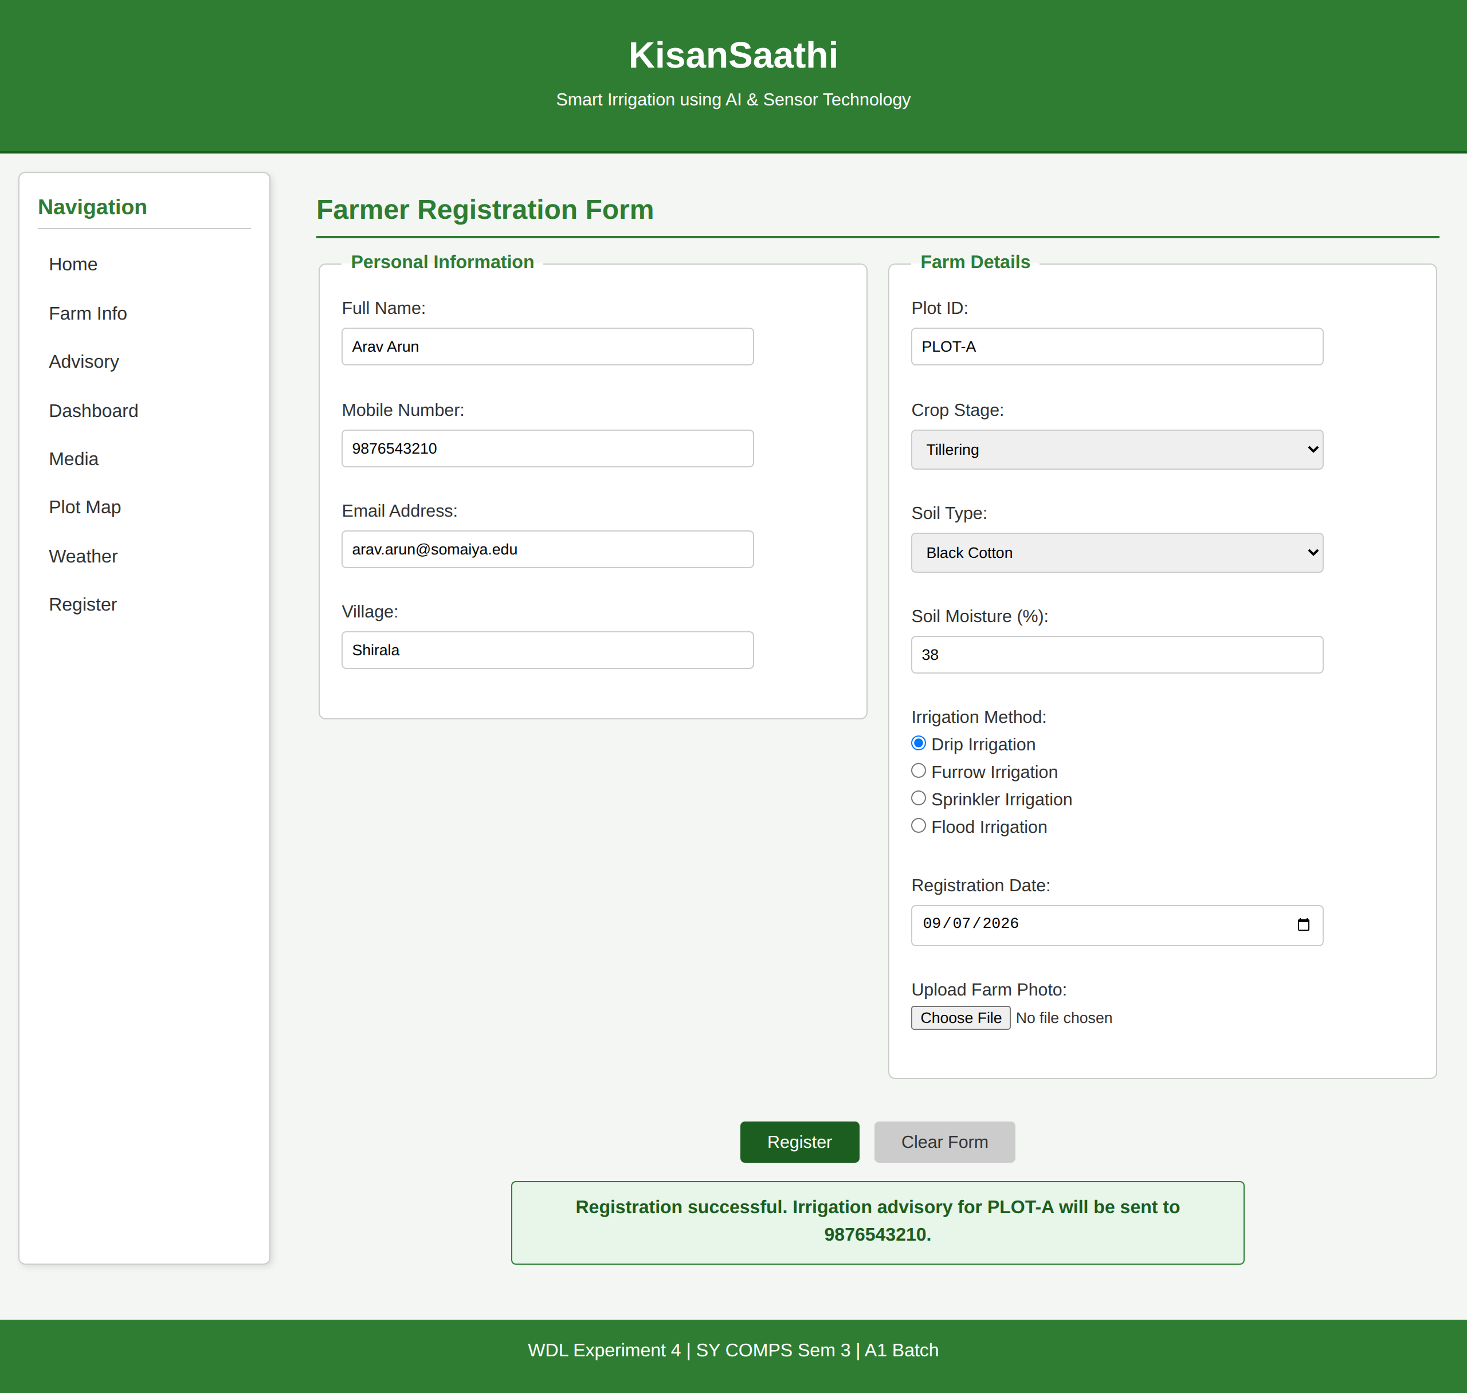
Conclusion and Discussion:
In this experiment I added JavaScript validation to the registration form. Every field is now checked before the form submits: the text fields are read with trim() so blank entries do not pass, regular expressions handle the mobile number, email and plot ID, the dropdowns and the irrigation radio group are checked for a selection, soil moisture has to fall between 0 and 100, and the registration date cannot be in the future. When a check fails the field is highlighted and the message appears beside it, and the page stays put until everything is correct.
Discussion:
I tested the form with wrong values on purpose: a name with digits in it, a five digit mobile number, an email with no @, a plot ID like A1, an empty village, no crop stage selected, moisture set to 150, and a date in December.
Each one showed its own message next to the field and the form did not submit. After fixing them the messages cleared and the success message appeared.

