Course Name: | Web Development Laboratory (316U01L306) | Semester: | III
Date of Performance: | 28 / 9 / 2026 | DIV/ Batch No: | A1
Student Name: | Arav Arun | Roll No: | 16010125013

Experiment No: 4
Title
Form Validation using jQuery for an AI-based Smart Irrigation Advisory Web Portal
Aim of the Experiment
To design and implement client-side form validation using jQuery for the farmer registration form of an AI-based Smart Irrigation Advisory System, ensuring that user-entered data such as name, mobile number, email, plot ID, soil moisture, crop stage, irrigation method, and date is complete, valid, and meaningful before form submission.
Objectives of the Experiment
• To create an interactive HTML form for collecting farmer and farm information.
• To use jQuery to validate text, numeric, email, date, and selection fields.
• To use regular expressions with jQuery for validating mobile numbers, email addresses, and plot IDs.
• To display meaningful error messages and prevent submission when invalid data is entered.
• To apply jQuery form validation to a real-world agriculture use case involving farmer and farm registration.
COs to be achieved
CO1: Developing webpages using HTML, CSS, JavaScript and jQuery.
Books / Journals / Websites references
1. jQuery API Documentation – Form events, selectors and DOM manipulation.
2. W3Schools – jQuery and HTML Forms.
3. JavaScript/jQuery documentation/reference material prescribed by the course instructor.
Theory
Form validation is the process of checking whether the information entered by a user satisfies the required rules before it is submitted or processed. Validation improves data quality, usability, and reliability.
jQuery is a JavaScript library that simplifies DOM selection, event handling, and manipulation. For client-side form validation, jQuery can select form elements using selectors, read their values using val(), remove extra spaces using trim(), test patterns using regular expressions, add or remove CSS classes, display error messages, and control form submission through the submit event.
Common validation rules include checking for empty fields, minimum and maximum length, valid email format, valid mobile number, acceptable numeric ranges, selected options, and valid dates. Regular expressions are useful for validating structured values such as mobile numbers, email addresses, and plot IDs.
In this experiment, jQuery validation is applied to a farmer registration form for the AI-based Smart Irrigation Advisory System. The use case calls for farmer-friendly web/mobile platforms and plot-specific advisory and decision support.
Problem Statement
"jQuery Form Validation for Farmer Registration"
Develop a web-based farmer registration form for the Smart Irrigation Advisory System. The form should collect essential farmer and farm information and use jQuery to validate the entered values before submission. Invalid or incomplete data must be identified and appropriate error messages must be displayed to the user.
Task 1: Create the Farmer Registration Form
Scenario
Design a registration form for farmers who will use the AI-based Smart Irrigation Advisory Web Portal.
Requirements
• Create fields for Farmer Name, Mobile Number, Email, Plot ID, Village, Crop Stage, Soil Type, Irrigation Method, Soil Moisture (%), Registration Date and Farm Photo.
• Use <form>, <label>, <input>, <select>, <option>, <fieldset> and <legend>.
• Include the jQuery library and provide Submit and Reset buttons.
• Assign unique id and name attributes to all fields.
Concepts Tested
• HTML Forms
• Form controls and jQuery selectors
• jQuery DOM manipulation
Deliverable: registration.html
Task 2: Validate Required Text Fields using jQuery
Scenario
Ensure that essential farmer and farm information is not left blank.
Requirements
• Check that Farmer Name, Plot ID and Village are not empty using jQuery.
• Remove leading and trailing spaces using $.trim() or JavaScript trim() through jQuery event handling.
• Validate that Farmer Name contains alphabetic characters and spaces only.
• Display an error message beside each invalid field and highlight the invalid field using jQuery.
Concepts Tested
• jQuery selectors and val()
• String validation
• Required-field validation and DOM manipulation
Deliverable: registration.html
Task 3: Validate Mobile Number and Email using jQuery
Scenario
Verify that the farmer's contact information follows the expected format.
Requirements
• Validate a 10-digit Indian mobile number using a suitable regular expression.
• Validate the email address using a regular expression.
• Display specific messages for invalid mobile number and email.
• Do not allow the form to submit until both fields are valid.
Concepts Tested
• jQuery event handling
• Regular expressions
• Form submit event
Deliverable: registration.html
Deliverable: registration.html

Output / Screenshot:
Github Repository : https://github.com/Arav-Arun/SY_WDL_Experiments
1. Farmer registration form
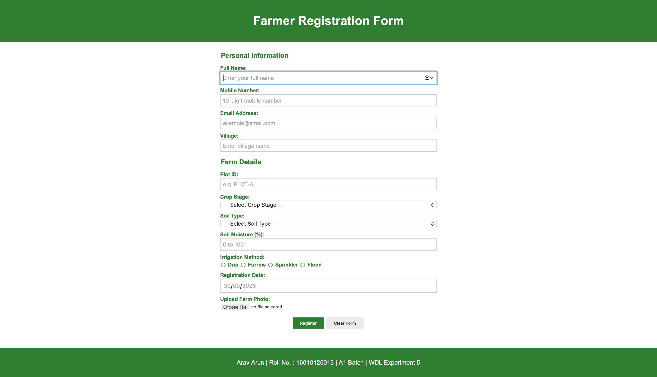
2. Validation errors for invalid inputs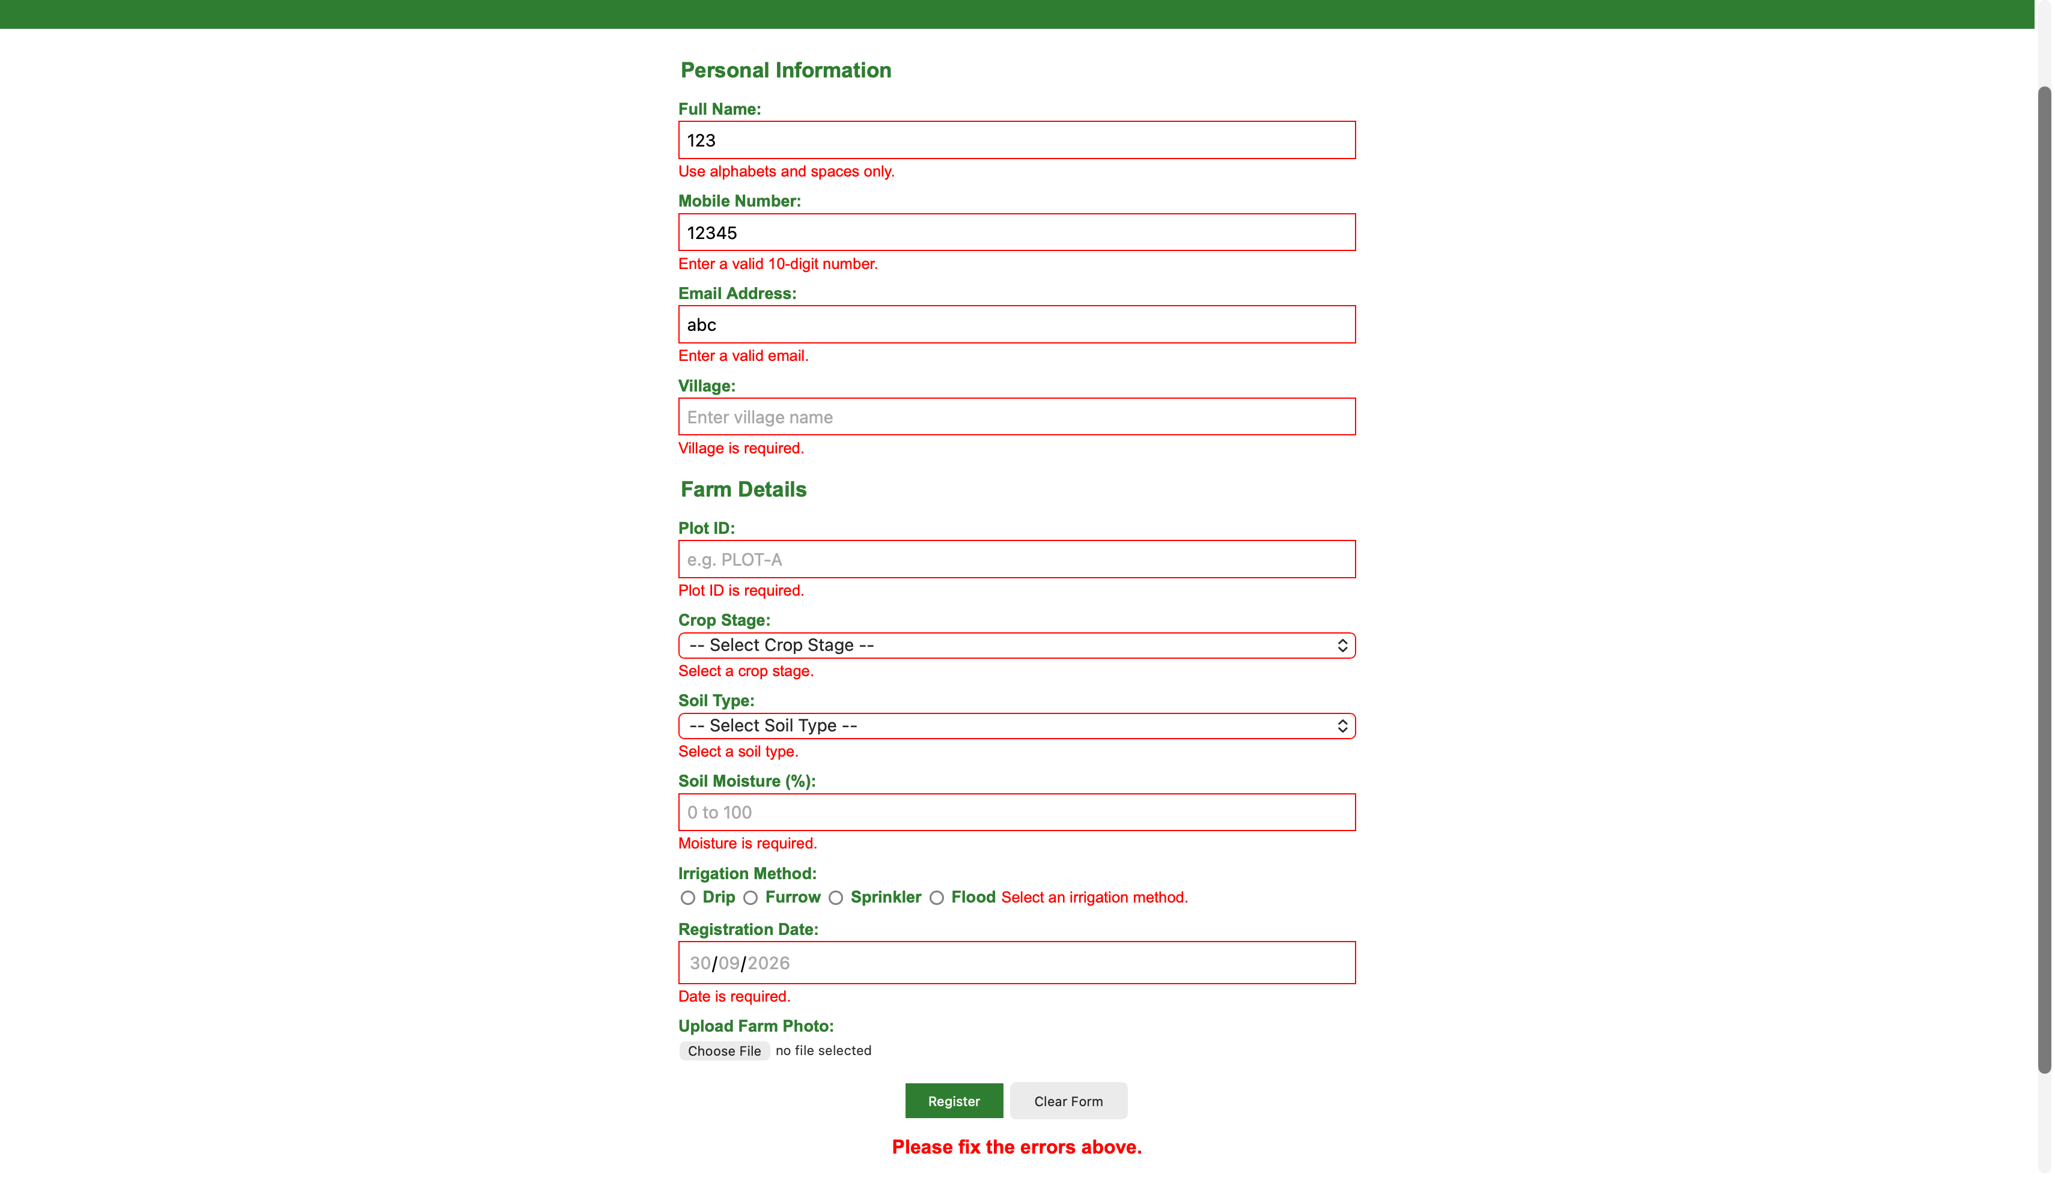
3. Success message after valid submission
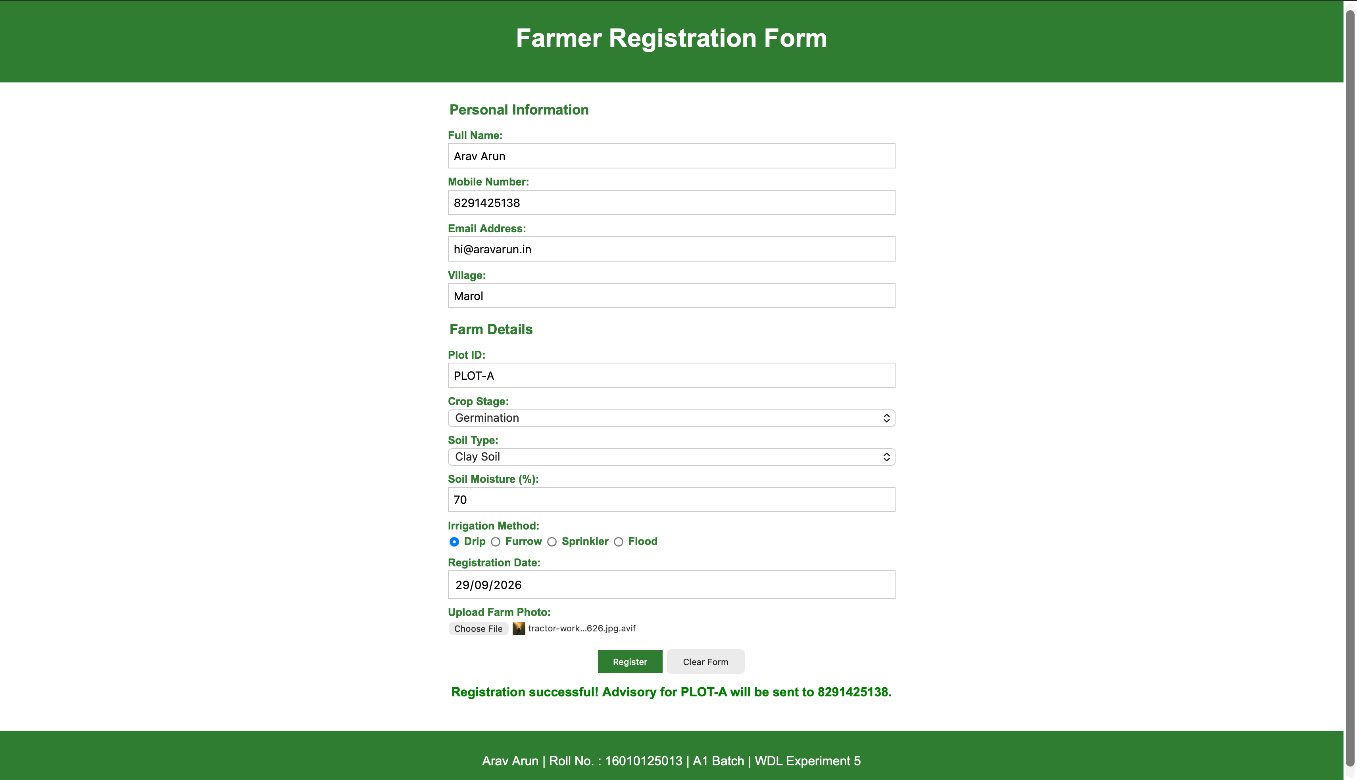
Conclusion and Discussion:
The experiment demonstrates how jQuery can be used to validate user input on a web form before submission.
Validation rules were applied to required text fields, mobile number, email, plot ID, selections, soil moisture range, and registration date. jQuery selectors, event handling, regular expressions, DOM manipulation, and error messages were used to improve the reliability and usability of the Smart Irrigation Advisory Web Portal.
Discussion:
1. Tested the form by submitting it empty and all error messages appeared correctly beside each field.
2. Entered invalid data like numbers in the name field, wrong mobile number format and incorrect email. jQuery showed the correct error for each case.
3. Future dates were correctly rejected by the date validation.
4. Soil moisture only accepted values between 0 and 100.
5. After entering all valid data, the green success message appeared with the plot ID and mobile number.
6. jQuery made the code shorter than plain JavaScript. Selecting elements with $() and using .val(), .html(), .addClass() was simpler to write.
7. $.trim() helped handle extra spaces in user input without writing extra code.
8. Regular expressions worked well with jQuery for validating mobile, email and plot ID formats.
9. One classmate suggested adding real time validation on each field instead of only on submit, which could be a future improvement.

