Project Documentation

1. Project Overview
The Personal Intro Script is a command-line Python application designed to collect basic personal information from the user and display it back in a structured form. The intent of the project is to introduce beginners to interactive input handling, formatted output, and basic console-based user interaction in Python.
Project Goals:
- Introduce user input handling (input() function).
- Demonstrate use of formatted strings for output (f-strings and string concatenation).
- Provide a foundational beginner-level programming project suitable for academic submission or portfolio use.
Objectives:
- Collect user attributes such as name, age, interests, languages, and skills.
- Display a formatted summary of collected data.
- Provide a stepping stone for more advanced interactive applications.

2. Setup Instructions
Prerequisites:
- Python 3.x installed on the system
- Terminal or command prompt access
- No external libraries or dependencies are required
Installation Steps:
1. Download or clone the project folder from the repository.
2. Open a terminal in the project directory.
3. Execute the script using:
python personal_intro.py

3. Code Structure
File Hierarchy:
project-root/
├── personal_intro.py
└── README.md (optional)
Primary Script:
- personal_intro.py handles all input prompts, stores user responses temporarily, and prints them to the terminal.
No classes, modules, or external packages are required for execution.

4. Visual Documentation
During runtime, the script interacts through the command-line interface. The screenshot below demonstrates the program execution:
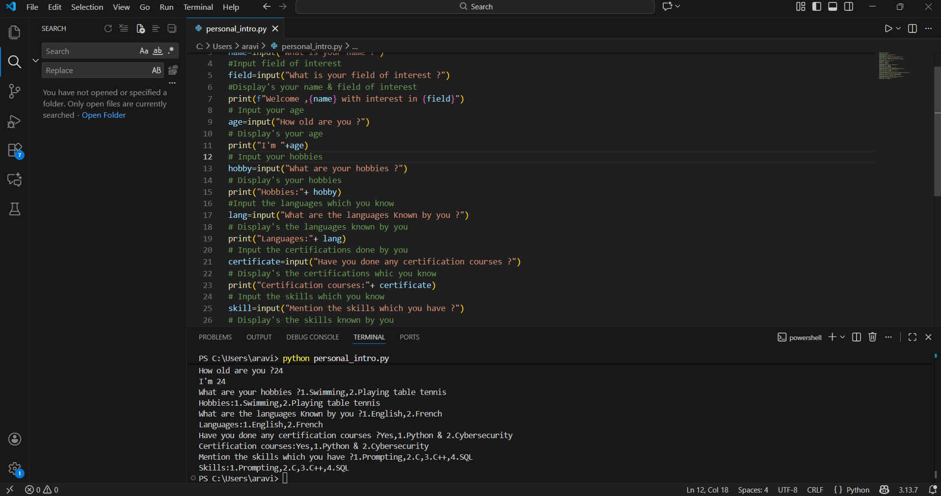

5. Technical Details
Programming Language:
Python 3.x
Core Concepts Demonstrated:
- Input prompt handling
- String interpolation using formatted print statements
- Sequential CLI-based user interaction
- Basic standard I/O handling
Algorithms / Data Structures:
The script does not implement complex algorithms or data structures. Collected data is stored only in temporary variables within the script execution context.
Architecture:
Linear procedural execution

6. Testing Evidence
Test Approach:
The script can be evaluated through manual test cases where multiple inputs are provided to verify successful output formatting.
Example Test Case:
Test Input | Expected Output
Name: John | Displays 'Welcome, John ...'
Age: 19 | Displays 'I'm 19'
Hobby: Music | Displays 'Hobbies: Music'
Skills: Python | Displays 'Skills: Python'
Validation Criteria:
- Script must not terminate prematurely during input collection.
- Output formatting must match expected structure.
- All fields must reflect correct user-provided values.
No automated test suite or unit tests are required due to the scope and simplicity of the project.

7. What I Learned (Reflection)
Through the development of this project, I learned the foundational steps of Python-based I/O processing, specifically:
- Collecting user input
- Formatting strings for output
- Structuring logical execution flow
- Interacting with users through the terminal
This project also helped reinforce basic programming habits such as clear variable naming, procedural thinking, and incremental testing.

