Game Design Document

Fill up the following document

1. Write the title of your project.

**Space Shooter Game**

1. What is the goal of the game?

**To defeat the aliens in the game and reach high scores without losing lives.**

1. Write a brief story of your game.

**A group of people had went to a space mission to a planet away from ours. They lost all contact with our planet and got lost in the space. They had prepared for the worst situation. Their spaceship had guns.Its upto you to shoot at the aliens and save their life.**

1. Which are the playing characters of this game?

* Playing characters are the ones who respond to the user based on the input from the user.
* Cars, monkeys, dinos, wizards, etc., are the playing characters in the game.

|  |  |  |
| --- | --- | --- |
| Number | Character Name | What can this character do? |
| 1 | Your Spaceship | It can shoot aliens |
|  |  |  |

1. Which are the Non-Playing Characters of this game?

* Non-Playing characters are the ones that don't have an action or behavior when the user interacts with the game.
* Hurdles, stones, bananas, coins, etc., are non-playing characters in the game.

|  |  |  |
| --- | --- | --- |
| Number | Character Name | What can this character do? |
| 1 | Other Spaceships | They can attack you and kill you |

Draw your imagination of this game. What does this game look like?

* Draw the game either on your computer or on paper.
* Add images of the game scenes to show each of the playing and non-playing characters at least once.

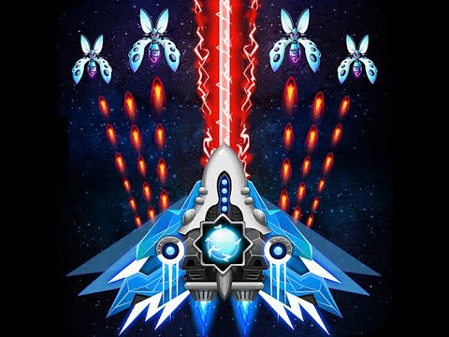

How do you plan to make your game engaging?

**I plan on making the game engaging by increasing the number of ships attacking as our score increases.**