**Conclusion**

* **8710 records** are fraud detecting cases out of 1,00,000 records **(8.71%)**

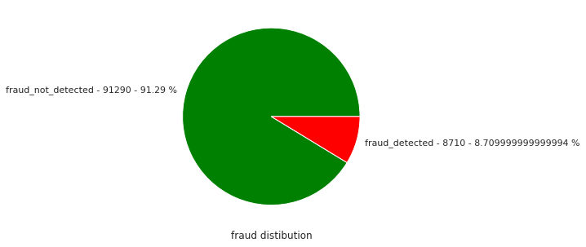

* Almost all fraud transactions are done by not using of pin numbers **(99.6%)**
* **6492 cases** of fraud transactions are not using of chip out of 8710 fraud transaction cases (**74.5%**)
* **94.5%** of fraud transactions are online_ordered
* **7663** records of fraud transactions are caused by repeat_retailer out of 8710 fraud transaction records (**88%**)

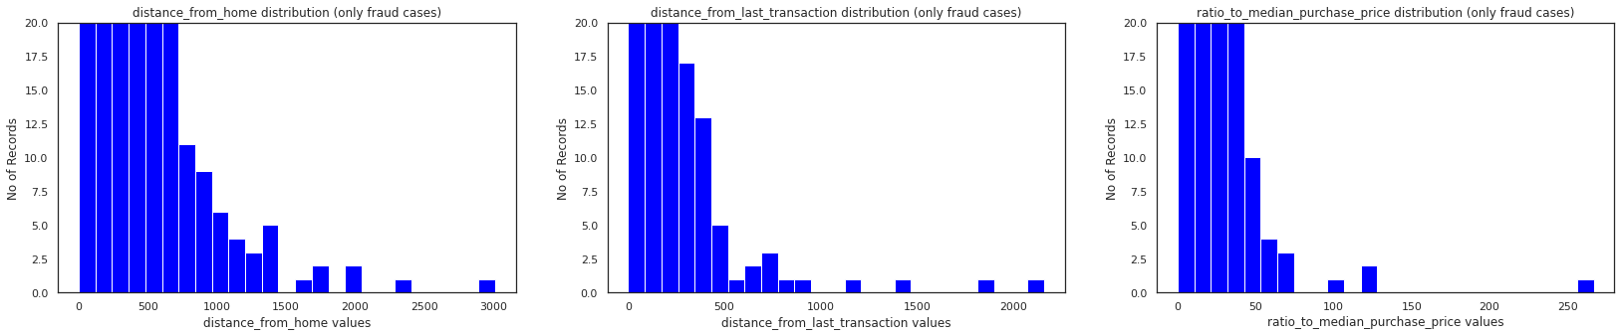

* Distribution of distance_from_home,distance_from_last_transaction,ratio_to_median_purchase_price are **right skewed** which it may consists of some **outliers** above upper limit

**Conclusion in Correlations**

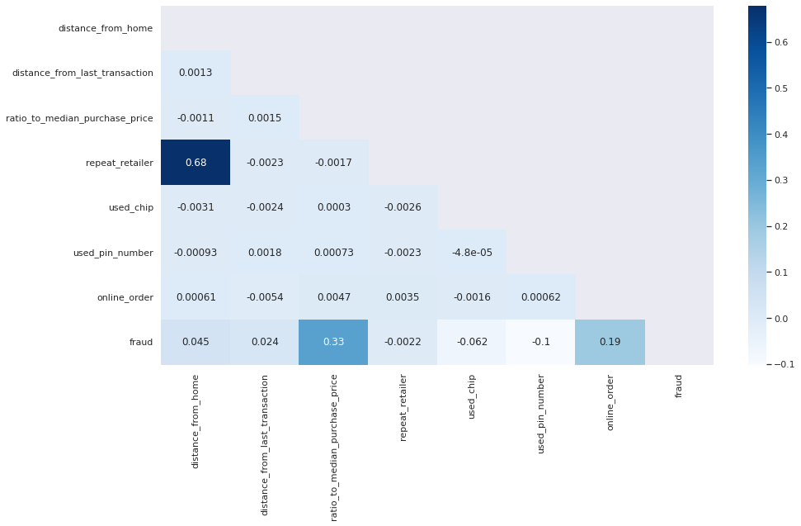

* The target variable is weakly correlated with all independent features
* The highest positive correlation value which the target variable having is with ratio_to_median_purchase_price(0.33) followed by online_order(0.19)
* The weak negative correlation value which the target value having is with used_pin_number (-0.1) and very negligible negative correlation is with repeat_retailer(-0.0022) & used_chip(-0.062)
* distance_from_home & repeat_retailer are having some strong correlation with each other**(multicollinearity)** but both are very negligibly correlated with target variable fraud
* distance_from_home,distance_from_last_transaction,repeat_retailer & used_chip are negligibly correlated with target variable.So,it can be neglected while training the model