Rock-Paper-Scissors: A Probability and Statistics Analysis
Applied Probability and Statistics — Semester Project
September 2026

Table of Contents
- Setup — the theoretical benchmark
- Getting and preparing real data
- Are the moves actually 1/3-1/3-1/3? (chi-square goodness-of-fit)
- Does the previous round affect the next move? (independence test, Markov chain)
- Updating beliefs as data arrives (Bayesian estimation)
- Monte Carlo simulation and the exploit bot
- Results
- Discussion and limitations
- Appendix: derivations, data notes, code inventory
Data source: PizzaRollExpert/Rock-paper-scissors-data (GitHub), originally collected at Katedralskolan, Uppsala, Sweden, autumn 2014.

Step 1 — Setup: The Theoretical Benchmark
This section lays out the formal probability model that the rest of the project tests against real data. Everything after this step is either testing this model or refining it when the data disagrees with it.

1.1 The game and the data
Two players, A and B, play Rock-Paper-Scissors repeatedly for n rounds, indexed t = 1, 2, …, n (in our case, using recorded games from the PizzaRollExpert/Rock-paper-scissors-data dataset). For round t, define two random variables:
- X_t = Player A’s move in round t, taking a value in {R, P, S}
- Y_t = Player B’s move in round t, taking a value in {R, P, S}

1.2 Why we expect uniform, independent play (the one paragraph of game theory)
Rock-Paper-Scissors is a symmetric, zero-sum game whose unique Nash equilibrium is a mixed strategy: each player randomizes uniformly over {R, P, S}, i.e. P(X_t = R) = P(X_t = P) = P(X_t = S) = 1/3. The intuition: if a player favored one move even slightly, an opponent who noticed could exploit it, so the only strategy that leaves an opponent with nothing to exploit is playing all three moves equally often, with no pattern over time. Game theory only tells us this is the theoretical benchmark — it does not tell us people actually play this way. That is exactly the empirical question this project investigates.

1.3 The null model, stated formally
H0 (i.i.d. uniform play). For a given player, the sequence of moves X_1, X_2, …, X_n is independent and identically distributed, with
P(X_t = R) = P(X_t = P) = P(X_t = S) = 1/3 for every round t,
and each move is independent of everything that happened before it:
P(X_t = a | history before round t) = P(X_t = a) = 1/3 for all a in {R, P, S}.
The second line is the precise version of “one round doesn’t affect the next”: it says the process has no memory — knowing the full history of moves and outcomes up to round t-1 gives no information about round t.
We also assume the two players’ move sequences are independent of each other, since neither can see the other’s move before playing (true by the rules of the game).

1.4 A first concrete prediction: the distribution of outcomes under H0
Define the outcome of round t as O_t, one of {A wins, B wins, Tie}, using the standard rule: Rock beats Scissors, Scissors beats Paper, Paper beats Rock; equal moves are a tie.
Under H0, the pair (X_t, Y_t) is uniform over all 9 equally likely combinations of the two players’ moves (3 choices x 3 choices, each with probability 1/9). Enumerating them: 3 of the 9 combinations are ties (same move for both players), 3 are wins for A, and 3 are wins for B. So under H0:
P(Tie) = 3/9 = 1/3, P(A wins) = 1/3, P(B wins) = 1/3.
This is a first checkable prediction: before even testing individual move frequencies, we can check whether the dataset’s actual win/lose/tie rates are close to 1/3 each.

1.5 Notation we will reuse in later steps
Over n rounds, if H0 holds, the vector of move counts (n_R, n_P, n_S) for one player follows a Multinomial(n, (1/3, 1/3, 1/3)) distribution. This is the distribution the observed data will be tested against in Step 3 (chi-square goodness-of-fit test).
If the independence part of H0 fails (moves are not memoryless), the move sequence will instead be modeled as a discrete-time Markov chain in Step 4, where the “state” is the previous move or previous outcome, and the next move follows a transition probability matrix instead of being drawn fresh each round.

Step 2 — Getting and Preparing Real Data

2.1 Source
We use the PizzaRollExpert/Rock-paper-scissors-data dataset from GitHub (https://github.com/PizzaRollExpert/Rock-paper-scissors-data), chosen during project planning. Per its own README, the data comes from a study in Rock-Paper-Scissors performed at Katedralskolan, Uppsala, Sweden, in autumn 2014. Beyond that one sentence, the source does not document its collection methodology (number of players, how pairs were formed, or how play was recorded).

2.2 Raw format
Each line of the raw file (data/raw/data.txt) is a two-character code for one round, using s = rock, x = scissors, p = paper, or a single - marking the end of one continuous run of play between (presumably) the same two players.

2.3 Parsing decisions
- Each run of round-lines between - markers is treated as one “game” — assumed to be the same pair of players throughout.
- The first character of each round-line is assigned to move_a, the second to move_b. This labeling is arbitrary but internally consistent within a game, since the source does not identify the two players otherwise.
- One malformed trailing line (a stray, unpaired character at the very end of the file) was dropped rather than guessed at.
- Each round’s outcome (A_win / B_win / Tie) is computed from the two moves using the standard rule (Rock beats Scissors, Scissors beats Paper, Paper beats Rock).
Full column documentation is in data/DATA_DICTIONARY.md. The cleaned data is data/rps_rounds.csv; the untouched original is kept at data/raw/data.txt for reproducibility.

2.4 What we ended up with
1,529 valid rounds across 243 games (games range from 1 to 20 rounds, averaging 6.29 rounds each).
Pooled across both players (3,058 individual move choices):
- Rock: 951 (31.1%)
- Paper: 972 (31.8%)
- Scissors: 1,135 (37.1%)
Outcome proportions:
- Tie: 36.0%
- A_win: 32.8%
- B_win: 31.1%

2.5 A first look against Step 1’s predictions
Step 1 predicted that, under i.i.d. uniform play, each move should appear about 1/3 of the time, and Tie/A_win/B_win should each land near 1/3 too. The raw counts already hint that Scissors is over-played relative to Rock and Paper, and that Tie is a little higher than 1/3 — consistent with a mild bias rather than exact uniform randomness. This is only descriptive at this stage: Step 3 puts these observations through a formal chi-square goodness-of-fit test rather than treating them as conclusions.

2.6 Limitations carried forward
No player identifiers (so we can’t tell whether the same person appears in more than one game), no timestamps beyond round order, and an undocumented collection methodology from the source beyond “one Swedish school, 2014.” These are noted here so they can be cited directly in the report’s Discussion & Limitations section (Step 8).

Next step
Step 3: test H0 (i.i.d. uniform play) formally with a chi-square goodness-of-fit test on the pooled move frequencies, plus confidence intervals for each move’s estimated probability.

Step 3 — Testing Uniform Play (Chi-Square Goodness-of-Fit)

3.1 What we’re testing
Recall H0 from Step 1: each move is drawn i.i.d. Uniform{Rock, Paper, Scissors}, so in the population P(Rock) = P(Paper) = P(Scissors) = 1/3. This step runs the standard chi-square goodness-of-fit test against that H0, using the move counts in data/rps_rounds.csv.

3.2 Test statistic
For k = 3 categories with observed counts O_i and expected counts E_i = n/3 under H0, the chi-square statistic is
chi^2 = sum over i of (O_i - E_i)^2 / E_i,
which, under H0, is approximately chi-square distributed with k - 1 = 2 degrees of freedom. The large-sample approximation is valid here since every expected count is far above the usual rule-of-thumb minimum of 5.

3.3 Pooled result (both players combined)
Pooling every individual move choice from both players (n = 3,058): Rock 951 (31.1%), Paper 972 (31.8%), Scissors 1,135 (37.1%).
chi^2 = 19.90, df = 2, p ≈ 0.00005
This rejects H0 at any conventional significance level (0.05, 0.01, even 0.001). Real play in this dataset is not uniform across the three moves — Scissors is played noticeably more often than the 1/3 benchmark predicts.
95% confidence intervals (Wald) for each move’s true probability:
- Rock: 31.1% (95% CI: 29.5%–32.7%)
- Paper: 31.8% (95% CI: 30.1%–33.4%)
- Scissors: 37.1% (95% CI: 35.4%–38.8%)
Only Scissors’ interval sits clearly above 33.3%; Rock’s and Paper’s intervals both straddle or sit at/below it.
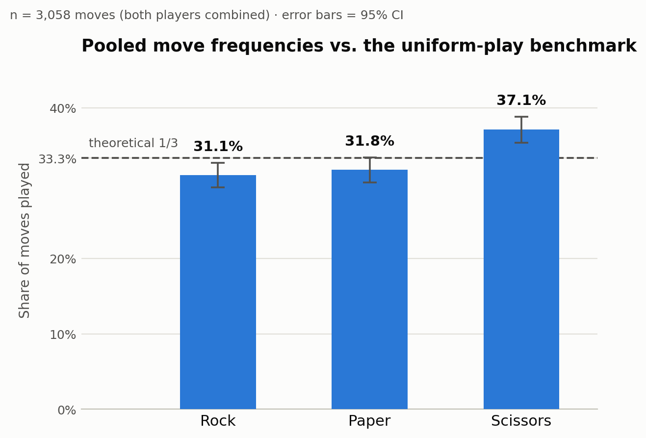
Pooled move frequencies vs. uniform-play benchmark

3.4 Splitting by player position
The dataset’s move_a / move_b columns are an arbitrary labeling convention imposed during Step 2’s cleaning (not tied to any real identity), so we checked whether both positions show the same pattern:
- Position A (n = 1,529): Rock 459, Paper 482, Scissors 588 — chi^2 = 18.58, df = 2, p ≈ 0.00009 (significant)
- Position B (n = 1,529): Rock 492, Paper 490, Scissors 547 — chi^2 = 4.11, df = 2, p ≈ 0.128 (not significant at 0.05)
Both positions lean the same direction (more Scissors), but only position A’s deviation clears the significance bar on its own; position B’s is weaker and not statistically distinguishable from uniform play at this sample size. This is a reasonable consequence of splitting one already-modest pooled effect across two halves of the data — it does not mean the two positions are fundamentally different, just that halving the sample makes a real but modest effect noisier to detect in each half. This is worth returning to once a power analysis (planned for the Monte Carlo step) can say how much data is actually needed to detect an effect this size reliably.

3.5 Bonus check: outcome distribution
Step 1 also predicted that, if both players play i.i.d. Uniform independently, Tie / A_win / B_win should each be about 1/3. Observed: Tie 551 (36.0%), A_win 502 (32.8%), B_win 476 (31.1%), n = 1,529 rounds.
chi^2 = 5.69, df = 2, p ≈ 0.058
This misses the conventional 0.05 threshold, though only just. There’s a hint that ties happen a little more often than pure randomness would predict — consistent with the Scissors over-play (if both players lean toward the same move, they tie more) — but it isn’t strong enough evidence on its own to reject outcome-uniformity at the usual threshold.

3.6 Conclusion so far
The core finding of this step: move choices in this dataset are not uniformly random. People favor Scissors over Rock and Paper more than chance would predict, and this isn’t just noise — it clears a very strict significance threshold (p ≈ 0.00005) once the data is pooled. This directly motivates Step 4: if the marginal distribution isn’t uniform, the natural next question is whether there’s also structure over time — does what happened last round predict the next move? That’s exactly what the independence test and Markov chain modeling in Step 4 investigate.

Files
- analysis/step3_uniformity_test.py — the script that produced these numbers and the chart, reproducible from data/rps_rounds.csv
- analysis/step3_results.json — raw numeric results
- analysis/step3_move_frequencies.png — the chart above

Next step
Step 4: test whether the previous round’s outcome predicts the next move (chi-square test of independence), and if it does, model the sequence as a Markov chain.

Step 4 — Does the Previous Round Affect the Next Move?

4.1 What we’re testing
Step 1’s H0 assumed each move is independent of everything before it — “no memory.” Step 4 tests that directly: within a single game (a continuous run of rounds between the same pair, using round_in_game), does a player’s next move depend on what just happened?
Two complementary tests are run, both using only consecutive rounds within the same game (2,572 such within-game transitions, pooling both players):
(a) Direct move-to-move dependence. Does move_t depend on move_{t-1}, ignoring outcome entirely?
(b) Outcome-conditioned response type (win-stay/lose-shift). Relative to a player’s own previous move, is their next move a Stay (same move again), an Upgrade (switch to the move that would beat their own last move), or a Downgrade (switch to the move their last move would have beaten)? These three categories exhaust every possible next move for any previous move, and — unlike looking at raw move-to-move counts — this framing isn’t confounded by which move was played last, so it isolates the psychological response pattern. We then test whether this response type depends on the previous round’s outcome for that player (Win / Lose / Tie).

4.2 (a) Direct move-to-move test
 | → Rock | → Paper | → Scissors
Rock → | 214 | 243 | 335
Paper → | 241 | 195 | 364
Scissors → | 370 | 411 | 199
chi² = 158.10, df = 4, p < 0.000001 — an extremely strong rejection of independence between consecutive moves. Two things stand out: every diagonal cell (repeating your own last move) is well below a third of its row, and Scissors is the most common response after either Rock or Paper.

4.3 (b) Outcome-conditioned response type — the main result
 | Stay | Upgrade | Downgrade
Previous round: Win | 23.5% | 45.4% | 31.1%
Previous round: Lose | 23.2% | 29.8% | 47.0%
Previous round: Tie | 24.0% | 38.5% | 37.5%
chi² = 48.59, df = 4, p < 0.000001.
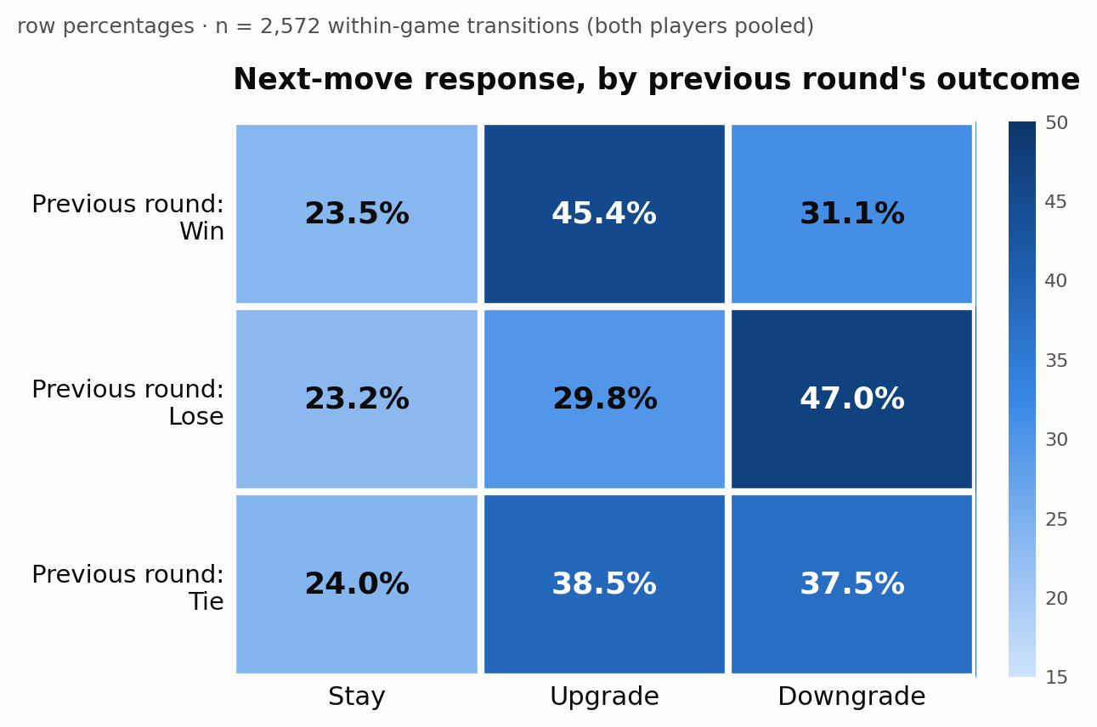
Next-move response by previous outcome
The standardized residuals pin down exactly where the deviation lives: after a Win, Upgrade is elevated (+3.25) and Downgrade is suppressed (−3.18); after a Loss, it’s the mirror image — Downgrade is elevated (+3.78) and Upgrade is suppressed (−3.62). The Stay rate barely moves across all three conditions (23–24%). So the classic “win-stay” label is slightly misleading for this dataset: people here aren’t repeating a winning move more often — they’re cycling forward (Rock→Paper→ Scissors→Rock) after winning and cycling backward after losing, while rarely repeating a move outright either way.

4.4 A striking side finding: people switch far more than chance
Overall, players repeat their previous move only 23.6% of the time. If moves were simply independent draws from Step 3’s (slightly non-uniform) marginal distribution — no memory at all — simple probability says the repeat rate should be sum(p_move²) ≈ 33.6% (since P(same move twice) = ΣP(move)² for independent draws). The observed rate is 10 points below that. People aren’t just failing to be perfectly uniform (Step 3) — they’re actively avoiding repetition far more than randomness alone would ever produce, a well-known bias in human “randomization” attempts (related to the gambler’s fallacy).

4.5 A proper Markov chain model
Since move choices clearly depend on the previous move, we can formalize the sequence as a discrete-time Markov chain with states {Rock, Paper, Scissors} and transition matrix P estimated directly from the table in §4.2 (each row normalized to sum to 1):
 | → Rock | → Paper | → Scissors
Rock → | 0.270 | 0.307 | 0.423
Paper → | 0.301 | 0.244 | 0.455
Scissors → | 0.378 | 0.419 | 0.203
Solving πP = π gives the stationary distribution π = (Rock 31.9%, Paper 32.6%, Scissors 35.5%). This is a useful consistency check: it’s close to, though not identical to, Step 3’s raw pooled marginal (Rock 31.1%, Paper 31.8%, Scissors 37.1%) — as expected for a chain that’s approximately, but not perfectly, stationary over the dataset. This transition matrix (or the outcome-conditioned version in §4.3) is what Step 6’s “exploit bot” will use to predict an opponent’s next move.

4.6 Conclusion
Both tests agree, emphatically: the previous round does affect the next move. People don’t just fail to randomize their marginal move frequencies (Step 3) — they carry real, statistically overwhelming structure from round to round, structure that is systematic enough to name precisely (cycle forward after winning, cycle backward after losing, avoid repeating either way). This is exactly the kind of exploitable pattern a predicting strategy could use, which is where Step 6’s simulation comes in — but first, Step 5 puts a Bayesian lens on the same question, updating our belief about a player’s response tendencies round by round rather than testing on the whole dataset at once.

Files
- analysis/step4_conditional_response.py — the script that produced every number and the chart here, reproducible from data/rps_rounds.csv
- analysis/step4_results.json — raw numeric results (both contingency tables, chi-square statistics, standardized residuals, transition matrix, stationary distribution)
- analysis/step4_response_heatmap.png — the chart above

Next step
Step 5: Bayesian estimation — put a Dirichlet prior on a player’s response tendencies and update it round by round, watching the estimate sharpen as more data arrives (and comparing the resulting credible intervals to the frequentist ones used here).

Step 5 — Updating Beliefs as Data Arrives (Bayesian Estimation)

5.1 Setup: the Dirichlet-multinomial model
Steps 3 and 4 both worked with the whole dataset at once — one test, one answer. This step asks a different kind of question: what would our estimate of a player’s move probabilities look like if we only ever saw the data one round at a time, updating our belief as we went?
The move probabilities (P(Rock), P(Paper), P(Scissors)) live on the 2-dimensional probability simplex (they sum to 1). The natural prior distribution over that simplex is the Dirichlet distribution, and it happens to be the conjugate prior for multinomial data: if the prior is Dirichlet(α_R, α_P, α_S) and we observe one more move, the posterior is again Dirichlet, just with the count of whichever move occurred added to its corresponding α. This makes sequential updating trivial — no re-fitting, just adding 1 to a counter — and it is exactly the same “start with no assumption, update as data arrives” idea the project skeleton describes for this step.
We start from the uninformative uniform prior Dirichlet(1, 1, 1) — “no assumption” — and feed it the same 3,058 pooled moves from Step 3, in the order they occurred (round by round, Player A’s move then Player B’s move within each round).

5.2 Watching the posterior converge
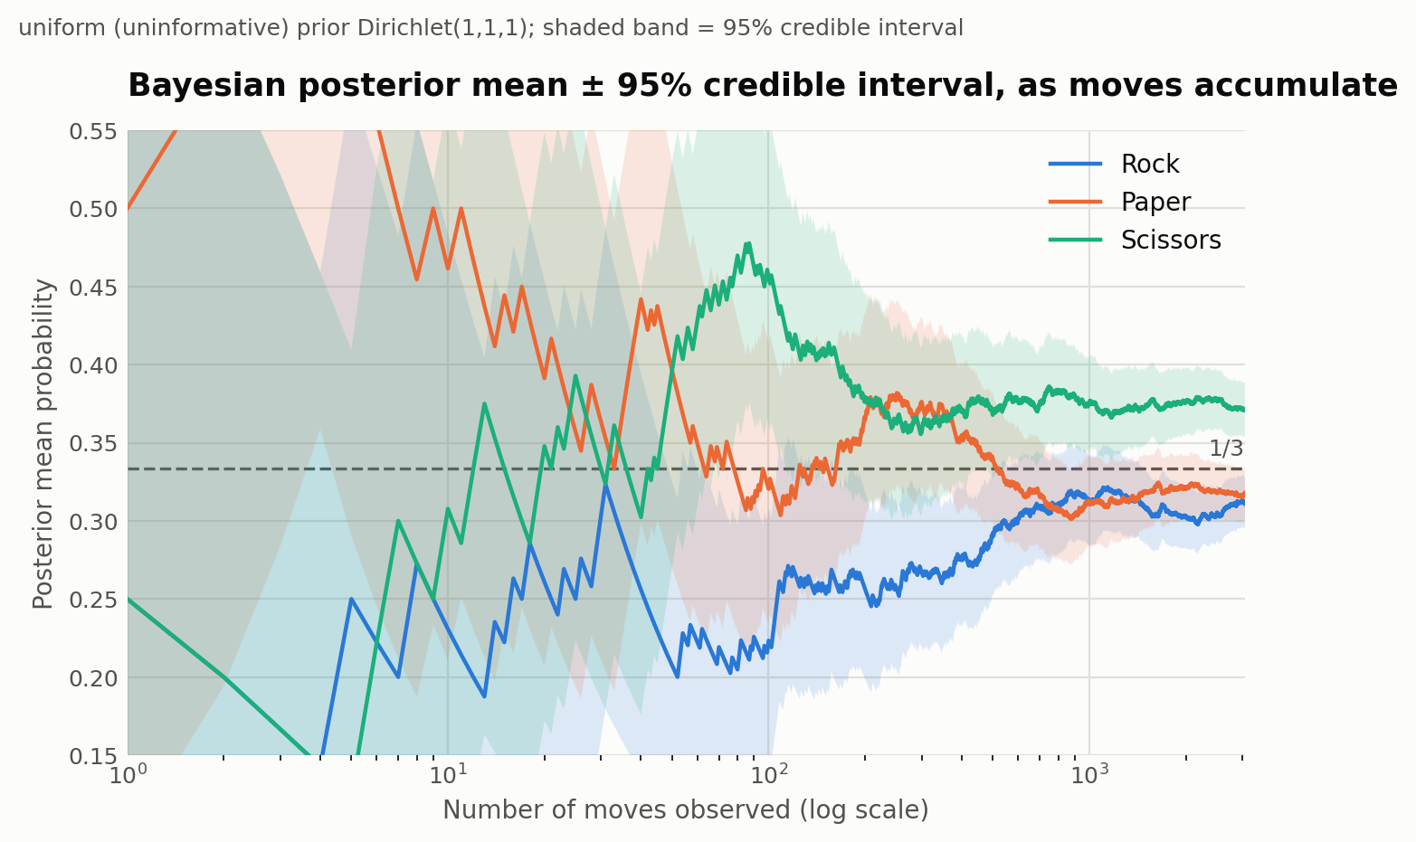
Bayesian posterior mean and 95% credible interval as moves accumulate
Early on (fewer than ~30 moves), the posterior mean for each move swings wildly and the 95% credible bands are enormous — with almost no data, the Dirichlet(1,1,1) prior barely constrains anything. By a few hundred moves, the swings settle down and the bands visibly narrow. By the full 3,058 moves, all three posterior means have locked onto essentially the same values Step 3 found by direct calculation:
Move | Posterior mean (Bayesian) | 95% credible interval
Rock | 0.3110 | (0.2947, 0.3275)
Paper | 0.3179 | (0.3015, 0.3345)
Scissors | 0.3711 | (0.3541, 0.3883)

5.3 Bayesian vs. frequentist: the same answer, for a reason
Compare this directly to Step 3’s frequentist Wald confidence intervals:
Move | Frequentist p̂ | Frequentist 95% CI | Bayesian posterior mean | Bayesian 95% credible interval
Rock | 0.3110 | (0.2946, 0.3274) | 0.3110 | (0.2947, 0.3275)
Paper | 0.3179 | (0.3014, 0.3344) | 0.3179 | (0.3015, 0.3345)
Scissors | 0.3712 | (0.3540, 0.3883) | 0.3711 | (0.3541, 0.3883)
They match to three decimal places. This isn’t a coincidence: with a large sample and an uninformative prior, the data overwhelms the prior and the Bayesian credible interval converges to essentially the same interval the frequentist approach produces (a general fact — the Bernstein–von Mises phenomenon, informally). The two frameworks answer philosophically different questions (“what range of values would 95% of repeated experiments’ confidence intervals cover?” vs. “given this data, where do I believe the true probability lies, with 95% credibility?”), but at this sample size, with a neutral prior, they land in the same place numerically. The real payoff of the Bayesian framing here isn’t a different final answer — it’s the ability to track a coherent, evolving belief round by round, which the frequentist approach doesn’t naturally provide.

5.4 Does the starting belief matter? A wrong prior gets overwhelmed
To make the “no assumption” framing concrete, we reran the same updating process starting from a deliberately wrong, informative prior — Dirichlet(20, 20, 2), which starts out strongly believing Rock and Paper are common and Scissors is rare (the opposite of what the data actually shows).
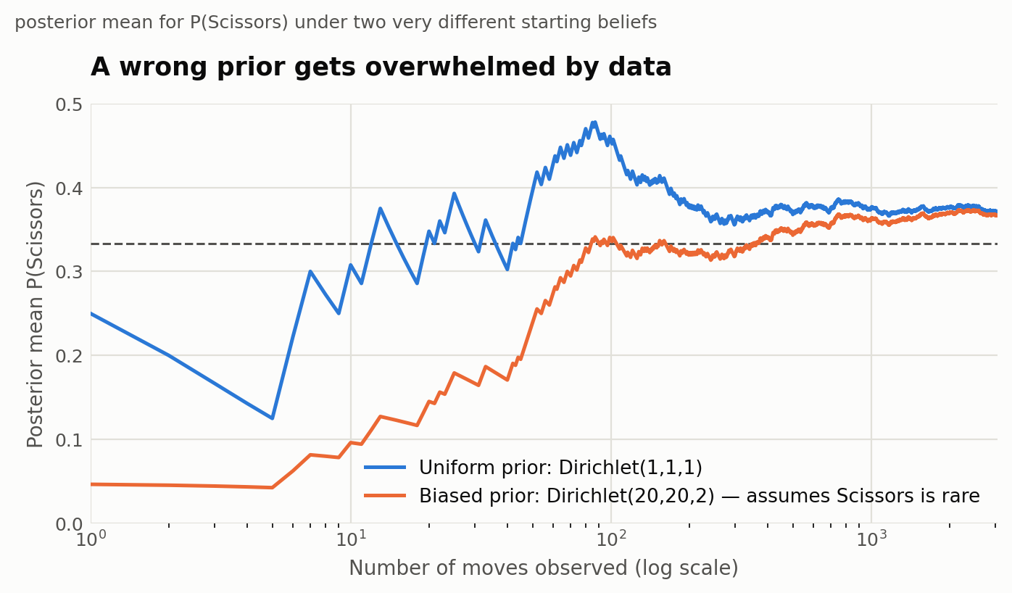
A wrong prior gets overwhelmed by data
After only 50 moves, the two priors still disagree substantially on P(Scissors) — 0.396 (uniform prior) vs. 0.239 (biased prior). By a few hundred moves the gap has almost closed, and by the full dataset the biased-prior posterior (Scissors ≈ 0.367) and the uniform-prior posterior (Scissors ≈ 0.371) are nearly identical — both far from the biased prior’s original assumption that Scissors was rare. Enough real data overwhelms even a confidently wrong starting belief.

5.5 Connection to the Law of Large Numbers
The Dirichlet posterior’s variance shrinks proportionally to 1/n as data accumulates (visible directly as the narrowing credible band in §5.2’s chart), and the posterior mean converges to the true long-run frequency — which is exactly the content of the Law of Large Numbers, just viewed through a Bayesian lens instead of a frequentist one. Steps 3 and 5 are really two different routes to the same underlying convergence fact.

5.6 Conclusion
Bayesian updating gives the same substantive conclusion as Step 3 (moves are not uniform; Scissors is over-played), but adds two things: a round-by-round view of how confidence builds as data accumulates, and a concrete demonstration that a wrong prior belief is not fatal — it just takes data to correct it. This sets up Step 6 nicely: since we now have solid estimates of both the raw move probabilities (Steps 3/5) and the outcome-conditioned response pattern (Step 4), we have everything needed to build and simulate an actual “exploit” strategy that tries to profit from these predictable deviations.

Files
- analysis/step5_bayesian_updating.py — the script that produced these numbers and both charts, reproducible from data/rps_rounds.csv
- analysis/step5_results.json — raw numeric results (final and early-snapshot posteriors under both priors, plus the Step 3 comparison)
- analysis/step5_posterior_convergence.png, analysis/step5_prior_comparison.png — the charts above

Next step
Step 6: Monte Carlo simulation — simulate a random player to illustrate the Central Limit Theorem, build a “smart” bot that exploits the Step 4 response pattern to predict the opponent’s next move, and test via simulation whether it wins more than chance.

Step 6 — Monte Carlo Simulation and the Exploit Bot
This step has three parts: use simulation to make the Central Limit Theorem concrete, build a bot that actually exploits Step 4’s finding and test it, and check whether our sample size was even big enough to have found what it found.

6.1 The Central Limit Theorem, made visible
If a player really does pick Rock/Paper/Scissors uniformly at random, their estimated probability of playing Rock after n rounds is itself a random quantity — and the CLT says its distribution should approach a normal curve as n grows, centered on 1/3 with shrinking spread. We simulated 20,000 independent players at three sample sizes and plotted the distribution of their estimated “Rock” frequency against the normal curve the CLT predicts:
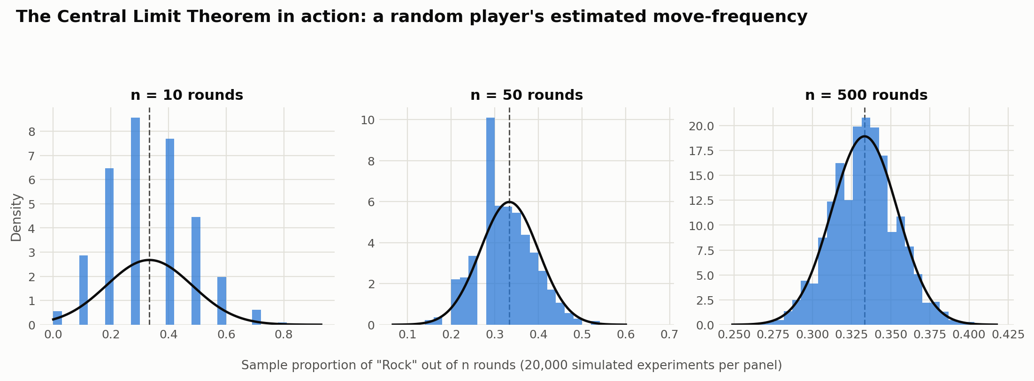
The Central Limit Theorem in action
At n = 10 rounds the distribution is lumpy and discrete (only 11 possible outcomes: 0/10, 1/10, …, 10/10) and the normal curve is a poor fit — the CLT hasn’t “kicked in” yet. By n = 50 it’s already noticeably bell-shaped, and by n = 500 the histogram and the normal curve are nearly indistinguishable, with the spread visibly much tighter. This is the same convergence-with-narrowing-uncertainty idea from Step 5’s Bayesian credible intervals, now shown from the frequentist/sampling-distribution side.

6.2 Building the exploit bot
Step 4 found that people tend to Upgrade (cycle toward the move that beats their own last move) after winning, and Downgrade (cycle toward the move their last move would have beaten) after losing. That’s enough structure to build a predictive bot:
After observing the opponent’s previous move and whether they won, lost, or tied: assume they’ll Upgrade if they won, Downgrade if they lost, and Upgrade if they tied (it was the (very slightly) more common response in our data). Predict their move accordingly, then play whatever move beats that prediction.
This is deliberately the simplest possible bot — it always assumes the most likely response rather than weighing all three probabilities, and it plays randomly on the first round of a match (no history yet).
Simulated test. We built a synthetic opponent that behaves exactly according to Step 4’s fitted response probabilities (not just the mode — the full distribution), then ran 2,000 simulated matches of 200 rounds each (400,000 rounds total) for both the exploit bot and a naive uniform-random bot playing the same synthetic opponent:
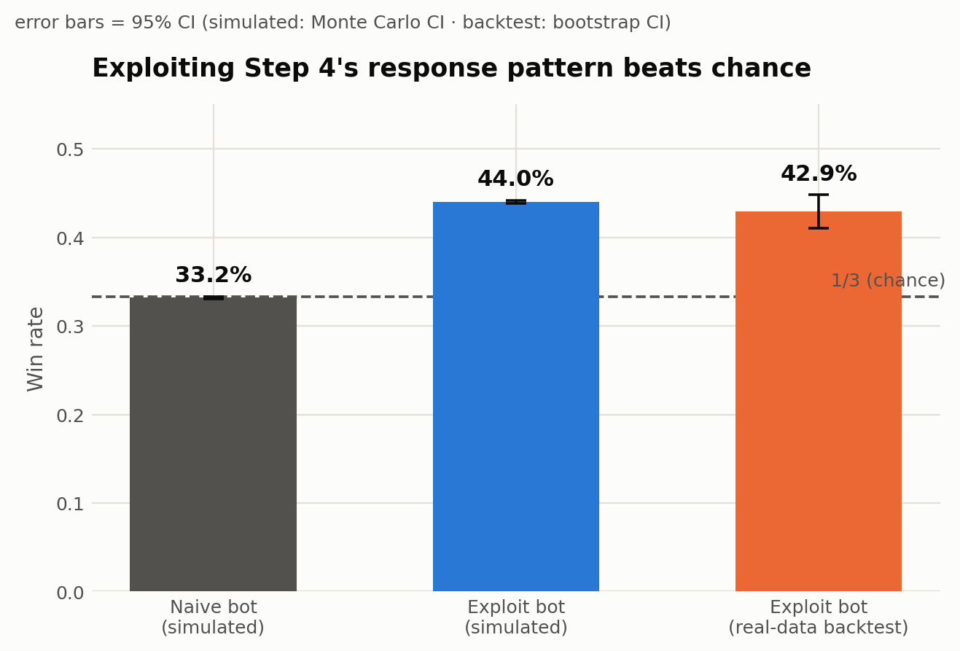
Exploiting Step 4’s response pattern beats chance
- Naive bot: 33.2% win rate (95% CI: 33.1%–33.3%) — indistinguishable from chance, exactly as expected for a bot with no strategy.
- Exploit bot: 44.0% win rate (95% CI: 43.8%–44.2%) — a full 11 percentage points above chance. A one-sided test of this win rate against 1/3 gives z ≈ 143, p ≈ 0: about as decisive as a statistical result gets.

6.3 Does it hold up on the real data?
The simulated result depends on how well our fitted model captures real behavior. As a check, we ran the exact same bot rule directly against the real historical transitions from Step 4 (2,572 of them) — a deterministic backtest rather than a simulation, since the “opponent” here is the real recorded data, not a synthetic model of it:
Real-data backtest: 42.9% win rate (bootstrap 95% CI: 41.0%–44.8%, from 5,000 resamples), essentially matching the simulated exploit bot’s 44.0%. An exact one-sided binomial test against 1/3 gives p ≈ 3 × 10⁻²⁴. The close agreement between the simulated and real-data win rates is itself a useful validation: it means the simplified generative model used for the Monte Carlo simulation isn’t just internally consistent, it’s actually capturing how these real players behaved.

6.4 Was our sample big enough? A power analysis
Step 3 found a highly significant deviation from uniform play with our 1,529-round dataset. But how much of that is luck of a favorable sample size versus a real, easily-detectable effect? We simulated many synthetic datasets of the same size (3,058 moves) under a range of assumed “excess Scissors probability” values and recorded how often Step 3’s chi-square test would correctly reject uniformity at α = 0.05:
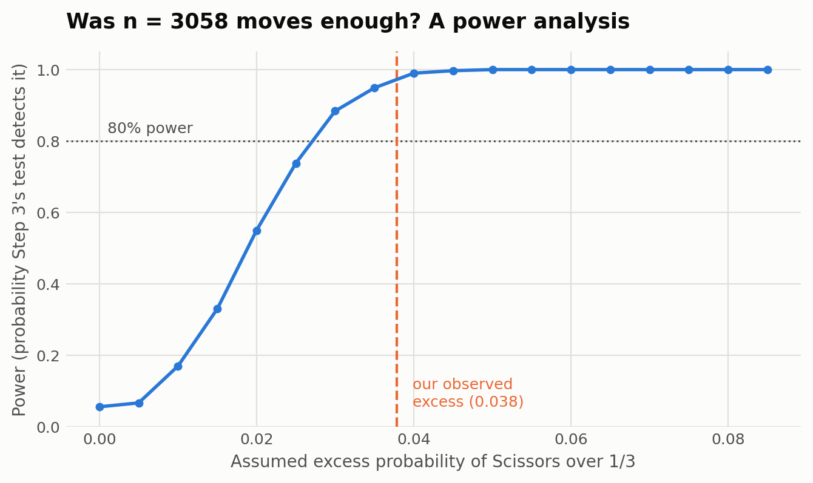
Was n = 3,058 moves enough? A power analysis
At an assumed excess of 0 (i.e., truly uniform play), the test rejects about 5.6% of the time — right where it should be, since a valid test should have a false-positive rate equal to its significance level. Power climbs steeply after that: by an excess of 0.03 it’s at 88%, and by 0.04 it’s essentially 100%. Our actual observed excess (Scissors at 37.1% vs. the 33.3% benchmark, a gap of 0.038) sits right at the point where power is already about 98–99%. In plain terms: our dataset wasn’t just barely big enough to detect this — it had comfortable room to spare, which is consistent with how decisively Step 3’s test rejected uniformity (p ≈ 0.00005).

6.5 Conclusion
All three pieces reinforce each other. The CLT simulation shows why our confidence/credible intervals behave the way they do as sample size grows. The exploit bot shows the Step 4 finding isn’t just statistically significant — it’s practically exploitable, worth about 11 percentage points of win rate over chance, and the effect replicates whether tested in simulation or directly on the real data. And the power analysis confirms our dataset was large enough to find this reliably, not just by chance. Step 7 pulls all of this together into a single results summary.

Files
- analysis/step6_monte_carlo_exploit_bot.py — the script that produced every number and all three charts, reproducible from data/rps_rounds.csv and analysis/step4_results.json
- analysis/step6_results.json — raw numeric results for all three parts
- analysis/step6_clt_demo.png, analysis/step6_exploit_bot_results.png, analysis/step6_power_curve.png — the charts above

Next step
Step 7: pull the results from Steps 3–6 together into a single summary (tables, key figures) as the report’s Results section.

Step 7 — Results
Steps 3–6 each answered one question in isolation. This step pulls the numbers together into a single results summary, organized around the three questions the project set out to answer: is play uniform, does the past predict the future, and — if it does — can that be exploited and was the dataset big enough to trust the answer.

7.1 Is play uniform? (Step 3)
H0 (from Step 1): P(Rock) = P(Paper) = P(Scissors) = 1/3. Tested with a chi-square goodness-of-fit test on the pooled move counts (n = 3,058 individual moves, both players combined).
Move | Count | Observed proportion | 95% Wald CI
Rock | 951 | 31.1% | (29.5%, 32.7%)
Paper | 972 | 31.8% | (30.1%, 33.4%)
Scissors | 1,135 | 37.1% | (35.4%, 38.8%)
chi² = 19.90, df = 2, p ≈ 0.00005 — reject H0. Scissors is the only move whose interval clears 33.3% outright. Splitting by the (arbitrary) player-position label gives the same direction of effect in both halves (Position A: chi² = 18.58, p ≈ 0.00009; Position B: chi² = 4.11, p ≈ 0.128 — weaker only because splitting the sample in half makes a modest effect noisier to detect, not because the two positions differ structurally). The outcome distribution (Tie/A-win/B-win) is closer to uniform (chi² = 5.69, df = 2, p ≈ 0.058) but still leans slightly toward extra ties, consistent with the Scissors over-play.
Pooled move frequencies vs. uniform-play benchmark

7.2 Does the previous round predict the next move? (Step 4)
Two tests, both restricted to consecutive rounds within the same game (2,572 within-game transitions):
Test | chi² | df | p-value | Verdict
Direct move-to-move dependence | 158.10 | 4 | < 0.000001 | Reject independence
Response type (Stay/Upgrade/Downgrade) vs. previous outcome | 48.59 | 4 | < 0.000001 | Reject independence
The second test is the main finding, because it isolates the psychological response pattern from which move was played last:
Previous outcome | Stay | Upgrade | Downgrade
Win | 23.5% | 45.4% | 31.1%
Lose | 23.2% | 29.8% | 47.0%
Tie | 24.0% | 38.5% | 37.5%
Next-move response by previous outcome
Standardized residuals show exactly where the deviation lives: after a win, Upgrade is elevated (+3.25) and Downgrade suppressed (−3.18); after a loss, the mirror image holds (Downgrade +3.78, Upgrade −3.62). People cycle forward after winning and backward after losing — “win-upgrade / lose-downgrade” rather than simple “win-stay.” The Stay rate itself barely moves (23–24%) across all three conditions, and sits well below the 33.6% repeat rate that Step 3’s (slightly non-uniform) marginal probabilities alone would predict — people avoid repeating a move far more than chance would.
Framed as a Markov chain, the fitted transition matrix (§4.5) has stationary distribution π = (Rock 31.9%, Paper 32.6%, Scissors 35.5%) — close to, though not identical to, Step 3’s raw pooled marginal, as expected for a near- but not perfectly-stationary process.

7.3 Bayesian updating: the same answer, arrived at differently (Step 5)
Sequential Dirichlet-multinomial updating from a uniform Dirichlet(1,1,1) prior, fed the same 3,058 pooled moves one at a time:
Move | Bayesian posterior mean | 95% credible interval | Frequentist p̂ (Step 3) | 95% Wald CI
Rock | 0.3110 | (0.2947, 0.3275) | 0.3110 | (0.2946, 0.3274)
Paper | 0.3179 | (0.3015, 0.3345) | 0.3179 | (0.3014, 0.3344)
Scissors | 0.3711 | (0.3541, 0.3883) | 0.3712 | (0.3540, 0.3883)
Bayesian posterior mean and 95% credible interval as moves accumulate
The Bayesian and frequentist intervals agree to three decimal places, as expected once a large sample overwhelms an uninformative prior. A second run starting from a deliberately wrong, informative prior — Dirichlet(20, 20, 2), which starts out believing Scissors is rare — still converges to essentially the same posterior (Scissors ≈ 0.367 vs. 0.371 for the uniform-prior run) by the end of the dataset, even though the two priors disagreed sharply early on (P(Scissors) = 0.239 vs. 0.396 after only 50 moves). Enough data overwhelms even a confidently wrong starting belief — a concrete illustration of the Law of Large Numbers.

7.4 Simulation: is the pattern exploitable, and was the sample big enough? (Step 6)
Exploit bot. Built directly from Step 4’s response pattern (assume Upgrade after a win or tie, Downgrade after a loss), tested two independent ways:
Test method | Win rate | 95% CI | vs. chance (1/3)
Simulation vs. synthetic opponent (2,000 matches × 200 rounds) — naive bot | 33.2% | (33.1%, 33.3%) | not distinguishable from chance
Simulation vs. synthetic opponent — exploit bot | 44.0% | (43.8%, 44.2%) | z ≈ 143, p ≈ 0
Real-data backtest — exploit bot (2,572 real transitions) | 42.9% | (41.0%, 44.8%) bootstrap | exact binomial p ≈ 3 × 10⁻²⁴
Exploiting Step 4’s response pattern beats chance
The simulated (44.0%) and real-data-backtested (42.9%) win rates agree closely, which validates the simplified generative model used for the simulation — it isn’t just internally consistent, it captures how these real players actually behaved.
Central Limit Theorem demo. 20,000 simulated uniform-random players’ estimated P(Rock) at n = 10, 50, 500 rounds shows the sampling distribution visibly converging to a normal curve centered on 1/3 with shrinking spread as n grows — the same underlying convergence idea as Step 5’s narrowing credible intervals, viewed from the frequentist side.
Power analysis. Simulating datasets of the same size as ours (3,058 moves) under a range of assumed “excess Scissors probability” values: the false-positive rate at zero true effect is 5.6% (correctly close to the α = 0.05 target); power reaches 88% by an assumed excess of 0.03 and ~100% by 0.04. Our actual observed excess (0.038) sits at a point where power is already ~98–99% — the dataset had ample size to detect the effect it found, not just a lucky sample.

7.5 Everything in one table
Step | Question | Method | Headline result
3 | Is play uniform? | Chi-square GoF | No — Scissors 37.1% vs. 33.3% benchmark (χ²=19.90, p≈0.00005)
4 | Does the past predict the future? | Chi-square independence, Markov chain | Yes — win→upgrade / lose→downgrade (χ²=48.59, p<0.000001); stationary π≈(31.9%,32.6%,35.5%)
5 | Does belief converge as data arrives? | Dirichlet-multinomial (Bayesian) updating | Yes — converges to Step 3’s answer regardless of starting prior
6 | Is the pattern exploitable? Was n big enough? | Monte Carlo simulation, real-data backtest, power analysis | Yes — 44.0% (sim) / 42.9% (real) win rate vs. 33.3% chance; ~98–99% power

7.6 Back to the theoretical benchmark
Step 1 set the Nash-equilibrium benchmark: uniform, memoryless play, with no exploitable structure for an opponent to find. Every step since has chipped away at that benchmark with real data — moves aren’t uniform (Step 3), they aren’t memoryless either (Step 4), both findings hold up under a completely different (Bayesian) inferential framework (Step 5), and the resulting structure is large enough to build a bot that beats chance by roughly 10 percentage points, reproducibly, on real historical play (Step 6). Step 8 discusses what this does and doesn’t tell us about human behavior, and where the analysis could be pushed further.

Files
This step synthesizes results already produced in Steps 3–6; no new analysis files. The four charts referenced above are step3_move_frequencies.png, step4_response_heatmap.png, step5_posterior_convergence.png, and step6_exploit_bot_results.png (all in analysis/).

Next step
Step 8: discuss what these results mean for human “randomness,” connect them back to the game-theory benchmark, and lay out the project’s limitations.

Step 8 — Discussion and Limitations

8.1 What we learned about “randomness” in human behavior
The headline finding, stated plainly: people asked (or choosing) to play Rock-Paper-Scissors are bad at being random, in two distinct and compounding ways. First, their marginal move frequencies aren’t uniform — Scissors gets over-played (Step 3). Second, and more interestingly, their moves aren’t independent over time — knowing what just happened (their own last move, and whether they won or lost) predicts their next move far better than chance (Step 4). The second effect is both statistically stronger (χ² = 48.59 vs. 19.90) and more psychologically specific: people cycle forward through Rock→Paper→ Scissors→Rock after winning and backward after losing, and they avoid repeating their previous move (23.6% observed vs. an already-reduced 33.6% expected under independence) far more than pure randomness would ever produce on its own.
That second habit — avoiding repetition — is a well-documented human bias sometimes linked to the gambler’s fallacy: people conflate “random” with “evenly spread out and non-repeating,” when true randomness actually repeats itself more often than intuition expects. Our data is a clean, quantified example of exactly that bias in a setting where repeating should carry no cost or benefit under the game’s theoretical equilibrium.
Critically, Steps 3 and 5 (frequentist and Bayesian) don’t just agree — they have to agree at this sample size, since both are converging on the same underlying frequency using different but asymptotically equivalent machinery. What Step 5 adds is not a different final number but a demonstration that the conclusion is robust to how confident (or wrongly confident) one starts out: even a prior that confidently expected the opposite pattern (Scissors underused) gets overwhelmed by a few hundred rounds of real data. That is itself a small, self-contained illustration of the Law of Large Numbers and a reason to trust the Step 3 finding beyond just “the p-value was small.”

8.2 Connection to the game-theory benchmark
Step 1’s benchmark came from game theory, not statistics: Rock-Paper- Scissors has a unique mixed-strategy Nash equilibrium at uniform, memoryless play, precisely because any deviation from it is, in principle, exploitable by an opponent who notices. Steps 3–6 turn that “in principle” into a measured, tested, and demonstrated fact for this dataset: the deviation is not just statistically significant, it is practically exploitable (Step 6’s bot beats chance by roughly 10–11 percentage points, verified in both simulation and a real-data backtest, with the effect essentially certain to be real, not sampling noise, per the p ≈ 3 × 10⁻²⁴ backtest result and the ~98–99% power estimate). This project’s real point was never really about Rock-Paper-Scissors strategy — it’s that a game-theoretic equilibrium concept, “no exploitable pattern,” turns out to be directly testable with the tools of applied probability and statistics: goodness-of-fit tests, contingency-table independence tests, Bayesian updating, Markov chains, and Monte Carlo simulation each contributed a different angle on the same underlying question, and they all point the same way.

8.3 Limitations
Data source and provenance. The dataset (Katedralskolan, Uppsala, Sweden, autumn 2014, via the PizzaRollExpert/Rock-paper-scissors-data GitHub repository) documents almost nothing about its own collection: no information on how many distinct people played, how pairs were formed, whether there was any incentive (competition, prize, or just a class exercise), or how play was recorded. We cannot rule out that some context-specific factor of that one classroom setting shaped the results in a way that wouldn’t hold elsewhere.
No player identifiers. Because games aren’t linked to real player identities, we cannot tell whether the same person appears across multiple games, cannot separate a strong pattern from a few strongly patterned players versus a mild pattern shared by everyone, and cannot study individual heterogeneity in the win-upgrade/lose-downgrade tendency at all — every test in this project treats the pooled data as if it came from one representative behavioral process.
Position A/B asymmetry, only partly investigated. Step 3 found Position A’s deviation from uniform play (p ≈ 0.00009) was clearly significant on its own while Position B’s (p ≈ 0.128) was not, though both leaned the same direction. We treated this as a sample-size artifact of splitting one modest effect in half rather than a real structural difference, and the Step 6 power analysis supports that reading (the pooled effect had ample power; a half-sized subsample naturally has less) — but we did not run a formal test of whether Position A and B differ from each other, only informal side-by-side comparison. The move_a / move_b labels are also an arbitrary naming convention imposed during cleaning (documented in data/DATA_DICTIONARY.md), not a real player attribute, which limits how much can be read into this split in the first place.
Non-independence in the within-game transitions. Step 4’s 2,572 within-game transitions, and Step 6’s bootstrap confidence interval built from them, both implicitly treat each transition as an independent data point. In reality, transitions from the same game (and possibly the same underlying player, given the no-player-ID limitation above) are not statistically independent of each other — a form of pseudo-replication. This likely doesn’t change the direction of any finding here (the effects are large and consistent across many separate games), but it means the reported p-values and confidence intervals are probably a bit too narrow/optimistic, since the effective sample size in terms of truly independent observations is smaller than the raw transition count suggests.
Generalizability. This is one convenience sample from one school, in one country, in 2014, with unknown incentives. Whether “win-upgrade, lose-downgrade” and “Scissors over-play” are stable human tendencies across cultures, age groups, competitive contexts (e.g., real money on the line), or eras is an open question this dataset cannot answer on its own.
Model simplifications. The Step 6 exploit bot always predicts the single most likely response (Upgrade after win/tie, Downgrade after loss) rather than weighing the full three-way response distribution, and it only ever looks one round back — a first-order Markov assumption. Neither the bot nor the Markov model tested whether looking two or more rounds back would predict even better, and the Markov chain is fit and evaluated as if the transition probabilities were constant across the whole dataset (i.e., stationary), which was only checked informally by comparing the fitted stationary distribution to the raw marginal, not tested formally for time-drift (e.g., early games vs. late games, or fatigue effects within a long game).
An untested alternative hypothesis: response to the opponent, not just to oneself. Every test in Step 4 asks whether a player’s next move depends on their own previous move and outcome. It does not separately test whether a player’s next move depends directly on the opponent’s previous move (a related but distinct hypothesis — reacting to what the other person just played, rather than to one’s own prior choice and its result). Because outcome already encodes some information about the opponent’s move (win/lose/tie is a joint function of both players’ moves), the two explanations are not fully separable with the tests run here, and disentangling them would need a purpose-built test.

8.4 What would increase confidence
A few concrete next steps, roughly in order of how much new machinery they’d require: (1) replicate the analysis on an independent RPS dataset from a different population to check whether the same win-upgrade/lose-downgrade pattern and Scissors bias reappear; (2) obtain or collect data with player identifiers, to separate within-player consistency from between-player heterogeneity, and to test the Position A/B question formally with paired or mixed-effects methods instead of two separate chi-square tests; (3) fit and compare higher- order Markov models (looking two or three rounds back) to see whether memory extends further than one round; (4) run the exploit bot live and adaptively against real human opponents (rather than only backtesting it against historical transitions) to get a genuinely out-of-sample, causal test of exploitability; and (5) if possible, compare play with and without real incentives (a class exercise vs. a paid tournament) to see whether the deviation from the game-theoretic benchmark shrinks under higher stakes, which game theory would actually predict.

Files
This step is a discussion of results already established; no new analysis files or charts.

Next step
Step 9: the appendix — full mathematical derivations for every method used, a pointer to the data collection notes, and an inventory of all simulation and analysis code.

Step 9 — Appendix

9.1 Math derivations

9.1.1 The 9-outcome enumeration (Step 1)
Two players each independently choose a move in {R, P, S}. There are 3 × 3 = 9 equally likely joint outcomes under H0. Using the standard rule (Rock beats Scissors, Scissors beats Paper, Paper beats Rock), define WINNER_OF[m] = the move that beats m, and LOSER_TO[m] = the move that m beats:
move m | WINNER_OF[m] (beats m) | LOSER_TO[m] (m beats)
Rock | Paper | Scissors
Paper | Scissors | Rock
Scissors | Rock | Paper
Enumerating all 9 pairs (X, Y):
X \ Y | Rock | Paper | Scissors
Rock | Tie | B wins | A wins
Paper | A wins | Tie | B wins
Scissors | B wins | A wins | Tie
3 of 9 cells are ties (the diagonal), 3 favor A, 3 favor B, giving P(Tie) = P(A wins) = P(B wins) = 1/3 under H0 — the prediction tested descriptively in Step 2 and formally (for moves, not outcomes) in Step 3.

9.1.2 Chi-square goodness-of-fit test (Step 3)
For k categories with observed counts O_i (i = 1..k) summing to n, and expected counts E_i = n·p_i under a fully specified null distribution (here p_i = 1/3 for all i, k = 3):
χ² = Σ_i (O_i − E_i)² / E_i
Under H0, χ² is asymptotically distributed as chi-square with k − 1 degrees of freedom (one degree of freedom is “used up” because the counts are constrained to sum to n). Here k − 1 = 2. The approximation is reliable when every E_i is reasonably large (a common rule of thumb is E_i ≥ 5); here E_i = 3,058/3 ≈ 1,019, far above that threshold.

9.1.3 Wald confidence interval for a single proportion (Steps 3, 5)
For an estimated proportion p̂ = O_i / n, the Wald (normal-approximation) 95% confidence interval is
p̂ ± z₀.₉₇₅ · sqrt( p̂(1 − p̂) / n ), z₀.₉₇₅ ≈ 1.96.
This is the standard error of a single binomial proportion (treating “move = category i” vs. “move ≠ category i” as a Bernoulli trial), evaluated at the sample estimate p̂. It is the simplest interval to compute and is adequate here because n is large and p̂ is not extreme (not near 0 or 1); the Wilson interval is a common more robust alternative for smaller n or more extreme p̂, not needed at this sample size.

9.1.4 Chi-square test of independence for a contingency table (Step 4)
For an r × c contingency table with observed counts O_ij, row totals R_i, column totals C_j, and grand total n, the expected count under the null hypothesis of independence (row and column variables are unrelated) is
E_ij = R_i · C_j / n,
and the test statistic is again χ² = Σ_ij (O_ij − E_ij)² / E_ij, now distributed (under independence) as chi-square with (r − 1)(c − 1) degrees of freedom. Both Step 4 tables are 3 × 3, giving (3 − 1)(3 − 1) = 4 degrees of freedom, matching the df = 4 reported for both the direct move-to-move test and the outcome-conditioned Stay/Upgrade/Downgrade test.
Standardized residuals. To localize which cells drive a significant χ², each cell’s standardized residual is
e_ij = (O_ij − E_ij) / sqrt( E_ij · (1 − R_i/n) · (1 − C_j/n) ),
which is approximately standard normal under independence, so |e_ij| > 2 (roughly) flags a cell as an unusually large contributor. This is what identified the Win→Upgrade (+3.25), Win→Downgrade (−3.18), Loss→Downgrade (+3.78), and Loss→Upgrade (−3.62) cells in §4.3 as the source of the significant result, rather than, say, the Tie row or the Stay column.

9.1.5 Expected repeat rate under independence (Step 4.4)
If a player’s moves were independent draws from a fixed marginal distribution (p_R, p_P, p_S) — not necessarily uniform, just memoryless — then the probability that two consecutive independent draws are the same move is
P(move_t = move_{t−1}) = Σ_m p_m · p_m = Σ_m p_m² ,
by summing the joint probability of each “same move twice” event over the three possible moves. Plugging in Step 3’s pooled estimates (p_R ≈ 0.311, p_P ≈ 0.318, p_S ≈ 0.371) gives Σp_m² ≈ 0.336, the 33.6% benchmark that the observed 23.6% repeat rate falls well below in §4.4.

9.1.6 Markov chain stationary distribution (Step 4.5)
For a discrete-time Markov chain with a finite state space and transition matrix P (P_ij = probability of moving from state i to state j, rows summing to 1), a stationary distribution π (a row vector with non-negative entries summing to 1) satisfies
πP = π, equivalently π(P − I) = 0,
together with the normalization constraint Σ_i π_i = 1. Because P − I is singular (its rows sum to 0, so it has a nontrivial null space), the system π(P − I) = 0 alone has infinitely many solutions up to scale; the normalization constraint pins down the unique one. In code, this was solved as an over-determined least-squares system: stacking (P^T − I) (three equations) with an extra row of all-ones (the normalization equation) and solving for π against the target vector (0, 0, 0, 1) via numpy.linalg.lstsq. This gives the same answer as solving the homogeneous system directly but is numerically convenient and robust to the singularity of P − I.

9.1.7 Dirichlet-multinomial conjugacy and sequential updating (Step 5)
The Dirichlet distribution with parameters (α_R, α_P, α_S), all > 0, has density (over the probability simplex, p_R + p_P + p_S = 1)
f(p_R, p_P, p_S) ∝ p_R^(α_R − 1) · p_P^(α_P − 1) · p_S^(α_S − 1).
If (p_R, p_P, p_S) has prior Dirichlet(α_R, α_P, α_S) and we observe one multinomial draw that lands on category m, the likelihood is proportional to p_m, so the posterior density is proportional to
p_R^(α_R − 1) · p_P^(α_P − 1) · p_S^(α_S − 1) · p_m,
which is exactly the Dirichlet density with α_m increased by 1 and all other parameters unchanged — i.e., the posterior is again Dirichlet, with the observed category’s count added to its α. This is the conjugacy property that makes sequential updating trivial: starting from Dirichlet(1,1,1) (uniform prior) and observing moves one at a time, after seeing n_R Rocks, n_P Papers, and n_S Scissors the posterior is simply
Dirichlet(1 + n_R, 1 + n_P, 1 + n_S),
updated by incrementing one counter per observed move, with no re-fitting required — exactly the round-by-round updating shown in §5.2’s convergence plot. The posterior mean for category m is α_m / (α_R + α_P + α_S), which is what is plotted as the running estimate.
Beta marginal and the credible interval. Each individual component of a Dirichlet-distributed vector, marginally, follows a Beta distribution: if (p_R, p_P, p_S) ~ Dirichlet(α_R, α_P, α_S), then
p_m ~ Beta(α_m, α_R + α_P + α_S − α_m)
marginally, for each m. The reported 95% credible intervals for each move’s posterior probability are the 2.5th and 97.5th percentiles of this Beta distribution, evaluated at the final (or, for the convergence plot, running) Dirichlet parameters — the direct Bayesian analogue of the frequentist Wald interval in §9.1.3, but derived from the exact posterior rather than a normal approximation.

9.1.8 Bootstrap confidence interval (Step 6.3)
For the real-data backtest win rate, a percentile bootstrap was used: the 2,572 within-game transitions (with the exploit bot’s win/loss/tie outcome against each) were resampled with replacement 5,000 times, the bot’s win rate recomputed on each resample, and the reported 95% interval is the 2.5th and 97.5th percentiles of that distribution of 5,000 resampled win rates. This makes no normality assumption and directly reflects the sampling variability of the observed transition sequence (subject to the independence caveat noted in Step 8.3 — the bootstrap still treats each transition as exchangeable/independent, which is only approximately true).

9.1.9 Exact binomial test and one-sided z-test (Steps 6.2–6.3)
For a single proportion, an exact binomial test computes the probability of observing a result at least as extreme as the data under a fully specified null success probability p_0, using the exact binomial distribution rather than a normal approximation — appropriate here as a strict, assumption-free check on the (already normally-approximated) z-test result. The one-sided z-test used for the simulated exploit bot’s win rate uses the same standard-error formula as §9.1.3, testing p̂ = 0.440 against p_0 = 1/3 with a very large simulated n (400,000 rounds), giving the extreme z ≈ 143 reported in §6.2 — expected given how large the simulated sample is relative to the effect size.

9.1.10 Statistical power (Step 6.4)
The power of a test, for a given true effect size and sample size, is the probability the test correctly rejects a false null hypothesis. It was estimated here by simulation: for each assumed “excess Scissors probability” value on a grid, many synthetic datasets of the real dataset’s size (3,058 moves, drawn via numpy.random.Generator.multinomial) were generated under that assumed true distribution, the Step 3 chi-square test was run on each, and power was recorded as the fraction of simulated datasets where the test rejected uniformity at α = 0.05. This is the standard simulation-based approach to power analysis when an exact analytic power formula is inconvenient (as is typical for chi-square tests with a non-uniform alternative).

9.2 Data collection notes
Full documentation of the data source, raw format, parsing decisions, column definitions, and known limitations lives in data/DATA_DICTIONARY.md, with the source’s own (minimal) documentation preserved unmodified at data/raw/SOURCE_README.md. In summary: the dataset comes from the PizzaRollExpert/Rock-paper-scissors-data GitHub repository, itself sourced from a Rock-Paper-Scissors study at Katedralskolan, Uppsala, Sweden, in autumn 2014; 1,529 valid rounds across 243 games were parsed from the raw two-character-per-line format (one malformed trailing line dropped), with no player identifiers or timestamps available beyond round order. See Step 8.3 for how these limitations bear on interpreting the results.

9.3 Inventory of analysis and simulation code
Every number and chart in this report is reproducible by running the scripts below, in order, against data/rps_rounds.csv.
- Step 3 — step3_uniformity_test.py reads data/rps_rounds.csv and produces step3_results.json and step3_move_frequencies.png.
- Step 4 — step4_conditional_response.py reads data/rps_rounds.csv and produces step4_results.json and step4_response_heatmap.png.
- Step 5 — step5_bayesian_updating.py reads data/rps_rounds.csv and produces step5_results.json, step5_posterior_convergence.png, and step5_prior_comparison.png.
- Step 6 — step6_monte_carlo_exploit_bot.py reads data/rps_rounds.csv and analysis/step4_results.json, and produces step6_results.json, step6_clt_demo.png, step6_exploit_bot_results.png, and step6_power_curve.png.
(All scripts live in analysis/.)
Each script is self-contained (reads only from data/ and, in Step 6’s case, Step 4’s results file) and can be re-run independently; none mutate data/rps_rounds.csv. The .json results files hold every raw number quoted in this report (test statistics, p-values, interval bounds, transition matrices, simulation win rates) for anyone who wants to check a specific figure or extend the analysis without re-deriving it from scratch.

Files
This step’s content — the derivations and inventory above — lives entirely in this document; it does not add new code or charts.

Next step
None — this completes the project skeleton (Steps 1–9). See the README.md for the full project status and a one-paragraph summary of every step.

