# SYNOPSIS

**ON**

* **PACK YOUR BAGS**

**Book – Pack – Travel**

**Submitted By**:

|  |  |
| --- | --- |
| Ajay Sunil | 11606333 |
| Krishna Vishwakarma | 11718906 |
| Aravind Nallajerla  **SECTION** | 11606361  KEO27 |
|  |  |
|  |  |



**Introduction**

Pack your bags, vehicle management system is a web based project and it has been developed in ASP, C#, MySQL and we can manage booking, vehicle, passenger, route, payment etc from this project. The main objective to develop the vehicle management system is to overcome the manual errors and make a computerized system.

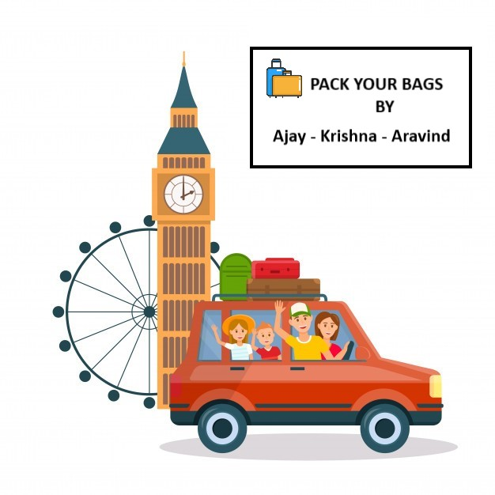

Search module has been implemented to search vehicle, customer, booking. Vehicle Management System is an online based web application, from which users can easily manage booking, bus route details from the browser. Admin user will be able to track all the information of booking, vehicle, user etc. Admin user has the rights to edit, add, delete and update all the records of Drivers, Customer,, vehicle, Type.

In this project, there are various types of modules available to manage Customer, vehicle, booking. We can also generate reports for vehicle, Booking, Driver, vehicle Type. Here the Booking module manages all the operations of the booking. Bus Details manages all the buses on board along with the routes following.



* **Modules:**
* Bus Details.
* Customer Details.
* Passenger Details.
* Bus Route.
* Payment.
* Booking Details.

**Project Lifecycle:**

**Description**

The waterfall Model is a linear sequential flow. In which progress is seen as flowing steadily downwards (like a waterfall) through the phases of software implementation. This means that any phase in the development process begins only if the previous phase is complete. The waterfall approach does not define the process to go back to the previous phase to handle changes in requirement. The waterfall approach is the earliest approach that was used for software development.

* **Hardware Requirement:**
* i3 Processor Based Computer or higher
* Memory: 2 GB
* Hard Drive: 50 GB
* Internet Connection
* **Software Requirement:**
* Windows 7 or higher
* Visual Studio
* SQL Server
* Google Chrome Browser
* **Advantages**
* Time consuming.
* Cost efficiency.
* Easy to find applicants.
* Easy to find job.
* **Limitation**
* Increase in competitions.
* Needs active internet connection.
* **Application**
* Search module has been implemented to search vehicle, customer, booking.
* Vehicle Management System is an online based web application, from which users can easily manage booking, bus route details from the browser.
* Admin user will be able to track all the information of booking, vehicle, user etc.
* Admin user has the rights to edit, add, delete and update all the records of Drivers, Customer,, vehicle, Type.
* **Reference**
* <https://shsu-ir.tdl.org/shsu-ir/bitstream/handle/20.500.11875/1164/0781.pdf?sequence=1>
* <https://ieeexplore.ieee.org/document/6208293/>
* https://ieeexplore.ieee.org/document/4679917/