**DEVOPS**

**ASSIGNMENT – 1**

Aravind – 420722106003

**DEPARTMENT OF ELECTRONICS AND COMMUNICATION**

**Complete Git & GitHub Workflow for an IoT-Based ECE Project**

**Objective:**

This assignment will help students understand the fundamentals of Git version control, gain hands-on experience with branching, merging, and conflict resolution, and learn how to use GitHub for remote repository management and team collaboration.

**TOOLS USED :** GIT(Bash) and GITHUB

**Repository url:** <https://github.com/Aravind-2510/ECE_Iot_Collab>

**Part A – Repository Setup & Commit History:**

**Steps performed:**

1. Open the Git bash and create the folder named “Smart_Agri_NodeMCU”.
2. Enter into the folder and created two files “sensor.py” and “project_notes.txt”.
3. Initialized my folder as the Git repository.
4. And by using “ls” to ensure my files were created correctly.

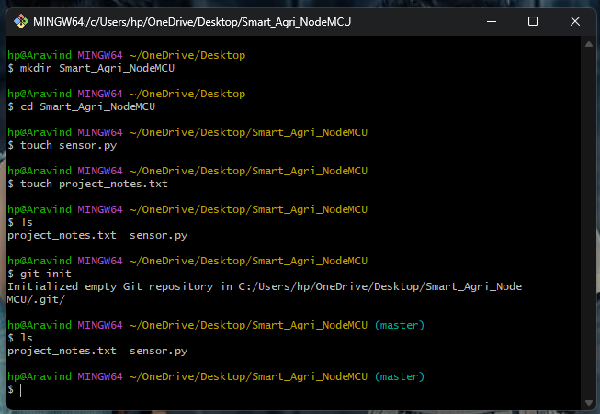

1. I have check the status of my file by using “Git status”
2. Then I configure the Git username and the email Id.
3. Initially commit my empty files into the local repository. There is no conflict were occurred.
4. I made some change in the file using the nano editor and add the files to the staging area for tracking, then commit the changed file into the local repository.
5. I had repeat the 8th steps for two times for make the 3 commits.
6. I had check the status of the files by using “git status” and also check the detail about the changes and commit happen in the local repository by using “git log”.
7. Try to export the commit’s history as text file I used command wrongly so it showed the error message, then I asked chatgpt it provide the command and I copy paste it and it work.
8. Then export commit’s history as text file into the repository

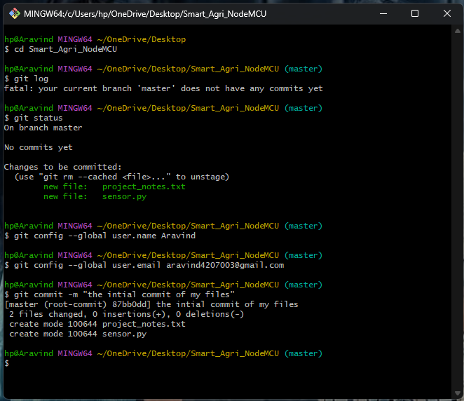 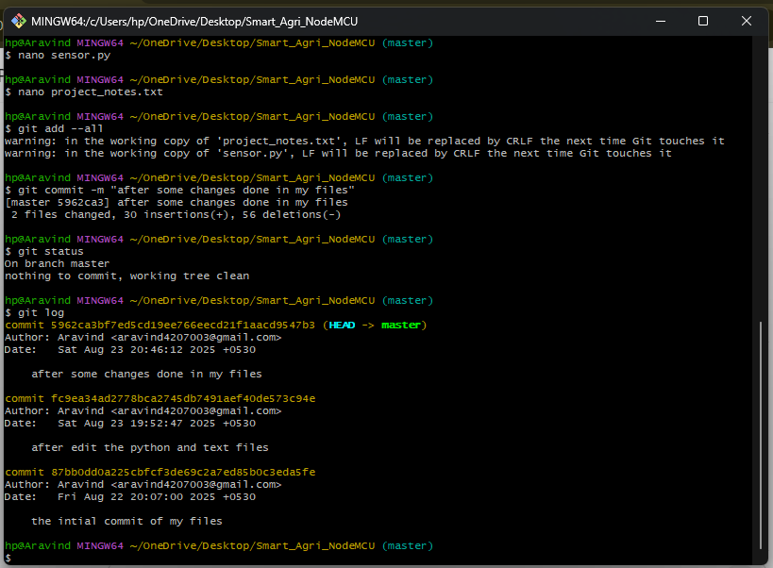

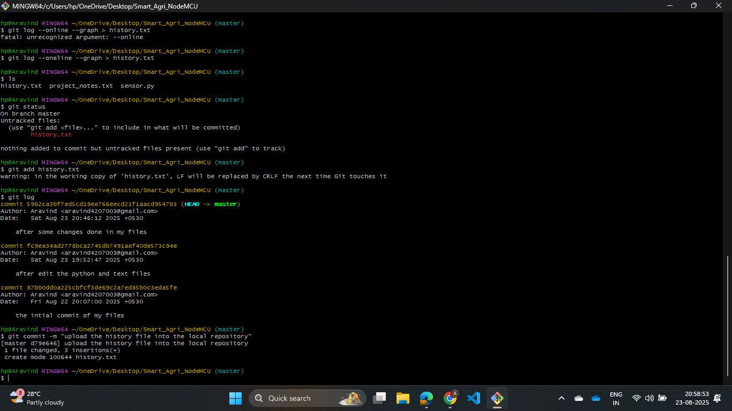

**Part B – Branching, Merging & Conflict Resolution:**

**Steps performed:**

1. When initialized the Git repository the “master” branch is created automatically.
2. I had created two branch “feature_sensor” and “feature_cloud”.
3. Checkout to the “feature sensor” branch and edit the “sensor.py” and try to commit it directly into repository, the command made the git some error if click enter nothing happen and no other line appear for enter command.
4. Closed the bash and I reopened the git bash, then first I try to add the file in staging area, it showed an error “another command in process” with the help of chatgpt I had cleared the error.
5. Then I had added the edited file and commit the file correctly without any error.

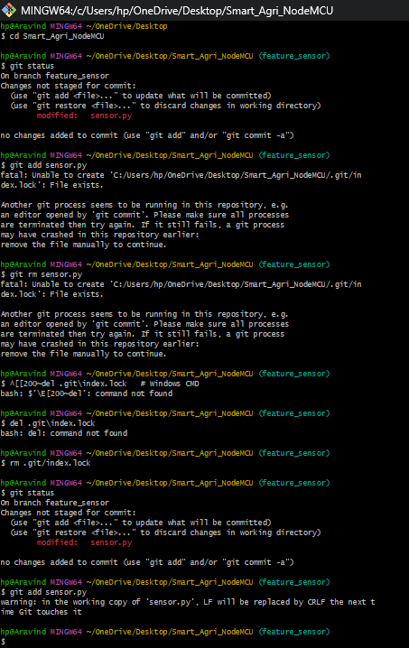

1. Checkout to the another branch “feature_cloud” and edit the “sensor.py” file.
2. Added the file to staging area and commit the file into the local repository.
3. Checkout to the master branch and merge the branches one after another to the master branch
4. There is no conflict message are occurred in this merging part.

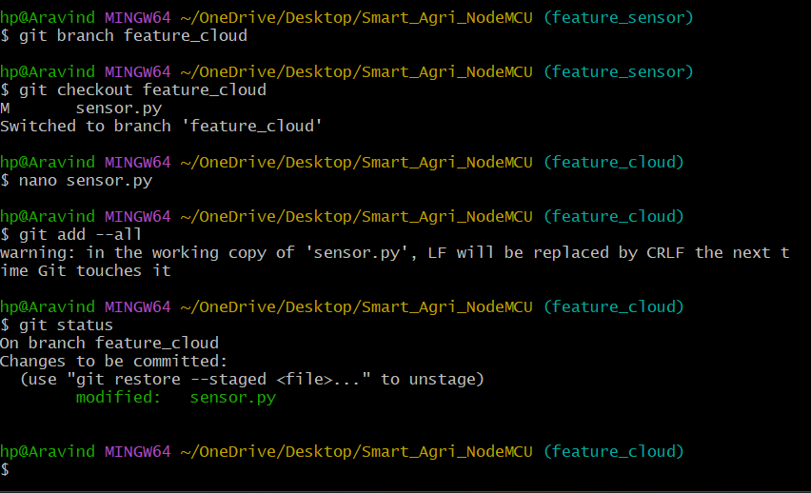 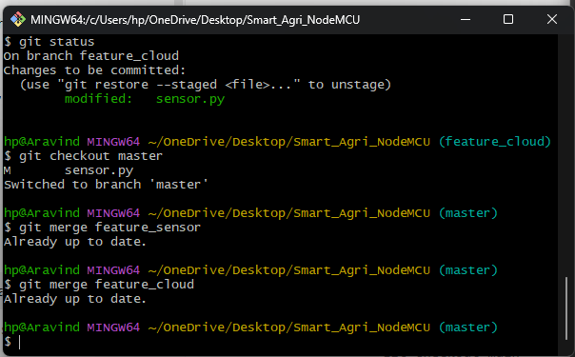

**Part C – GitHub Remote & Collaboration:**

**Steps performed:**

1. Created a GitHub account and create a repository named “ECE_ioT_Collab”.
2. In git link the local and remote repository by the remote repository link.
3. It asked password for the authorization eco system.
4. Then push the files from local repository to the GitHub repository “ECE_IoT_Collab”.

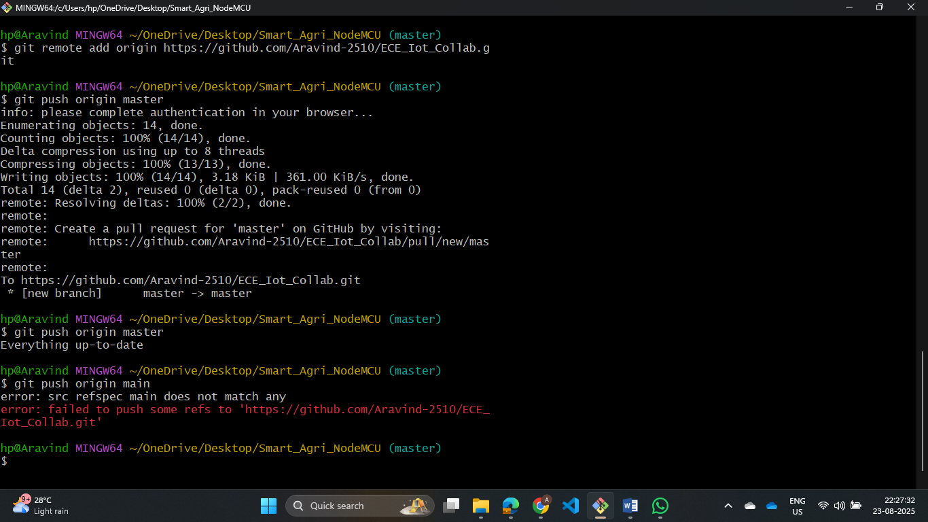

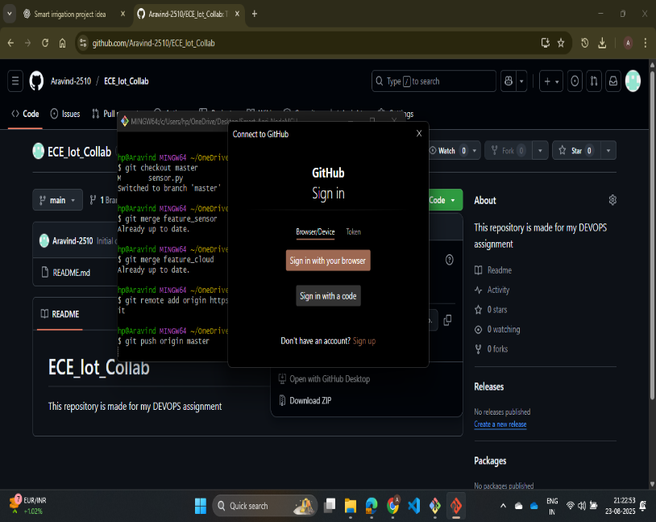 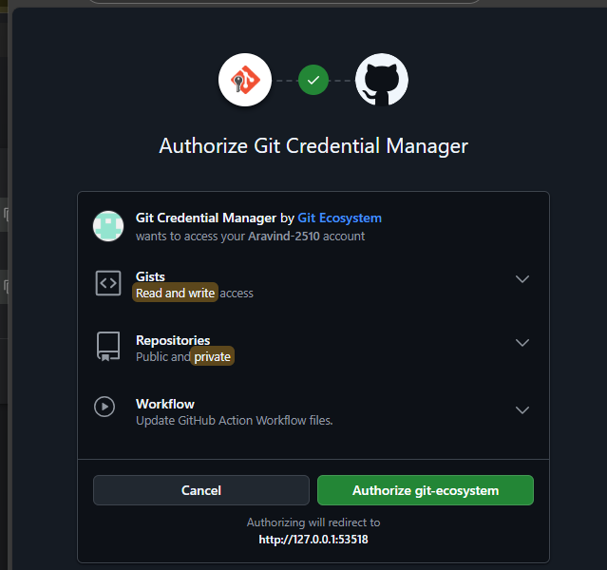

1. In GitHub the compare and pull request was appeared, but cannot edit that.
2. The pushed files are upload in my GitHub repository by creating a new branch (GitHub repo have two branch one contain readme file and another file contain the pushed files from the local repo)
3. Deleted the second branch in GitHub and create a branch in git named same as GitHub to make all files in one branch.
4. Checkout to new branch and fetch files from the GitHub repo and merge the files from and the origin.

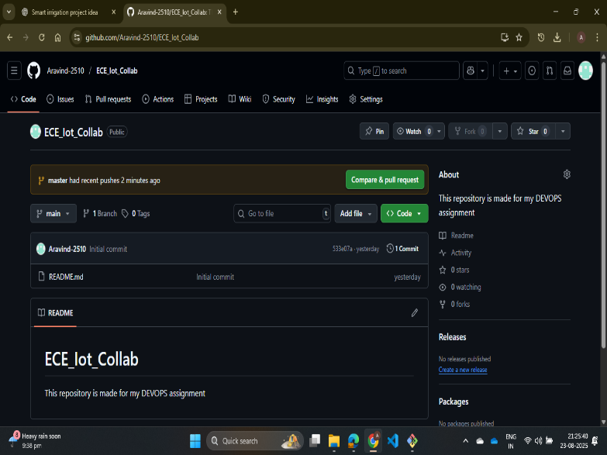 

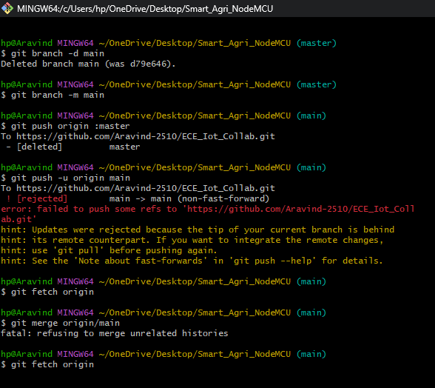 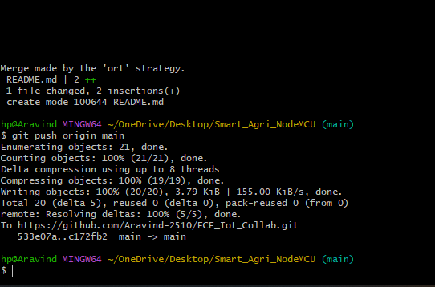

1. After merged the origin and main files push the main branch to the GitHub.
2. And successfully moved all the files from the local repo to the GitHub repo “ECE_IoT_Collab”

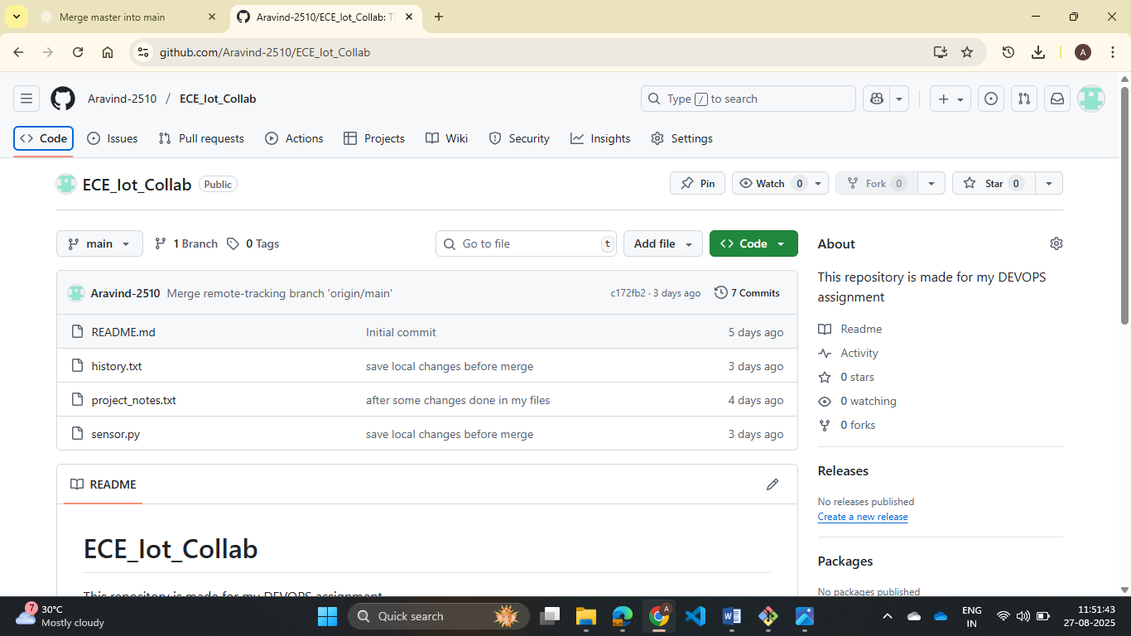

1. Invite the collaborator to my remote repository (collaborator – Thriumurugapandian)
2. He edits some files in my repository in their “student_update” and created a pull request.
3. In pull request tab of git hub account the request created by thiru was appeared
4. Accept the request and merge the changes in the repository.
5. The changes are only made in the remote repository. By using pull command fetch the change that happened in the remote repo to make the same in local repo without any conflict.
6. By using log, I have checked the changes in my repository it showed all the details.

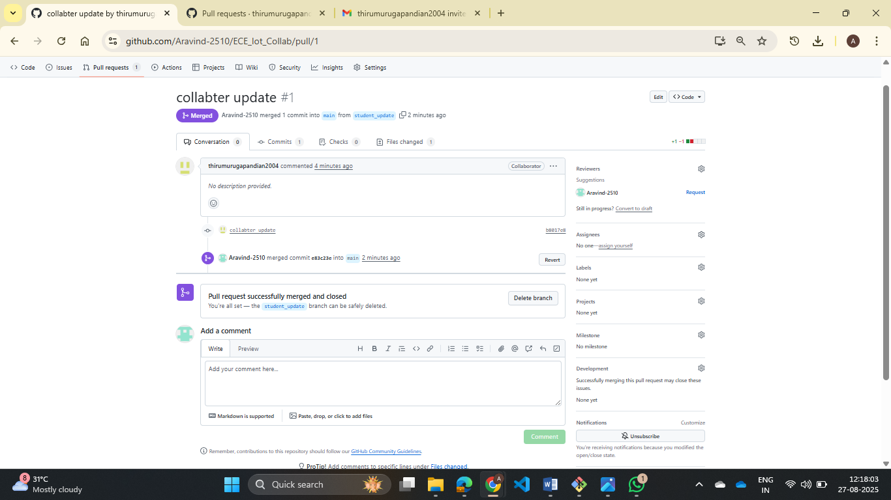

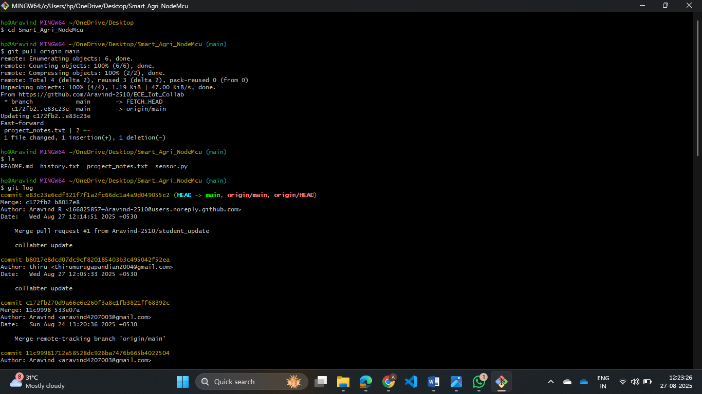

**CONCLUSION:**

This assignment provided a complete hands-on experience in using Git and GitHub for version control and collaboration. Through **Part A**, I learned the fundamentals of repository setup, file tracking, and maintaining a clear commit history. **Part B** demonstrated the importance of branching and merging in collaborative development, and resolving conflicts gave me practical insight into handling real-world code integration issues. **Part C** extended the learning to remote repositories and teamwork, where I practiced pushing code to GitHub, adding collaborators, and managing pull requests effectively.

Overall, the assignment enhanced my skills in **repository management, conflict resolution, and collaborative software development workflows**. These practices are essential in professional software engineering projects, especially when working in teams, ensuring that the project remains organized, transparent, and scalable.