**Purchase Management System**

**Users:**

* Employee
* Project Managers
* Purchase Managers/Admin (admin/Password)

**Workflow:**

* Admin only have the access to add, edit and delete the users to access this application.
* Employee can login with this application and raise the purchase request.
* Once the request raised by the employee, it will appear in employee’s home page, Respective project manager’s page and purchase manager’s / Admin’s page.
* Project manager has the privilege to ‘Approve and moves the request to purchase manager’ or ‘Reject’ the request.
* Purchase manager has the privilege to ‘Approve and place the order’ or ‘Reject’ the request even the request was already rejected by the project manager.
* Once Purchase manager ‘Approve and place the order’, he can update the delivery date against the request.
* After the delivery date has been updated, purchase manager can upload the invoice against the order.

**Screen Reference**

**Employee:**

**Home Page**

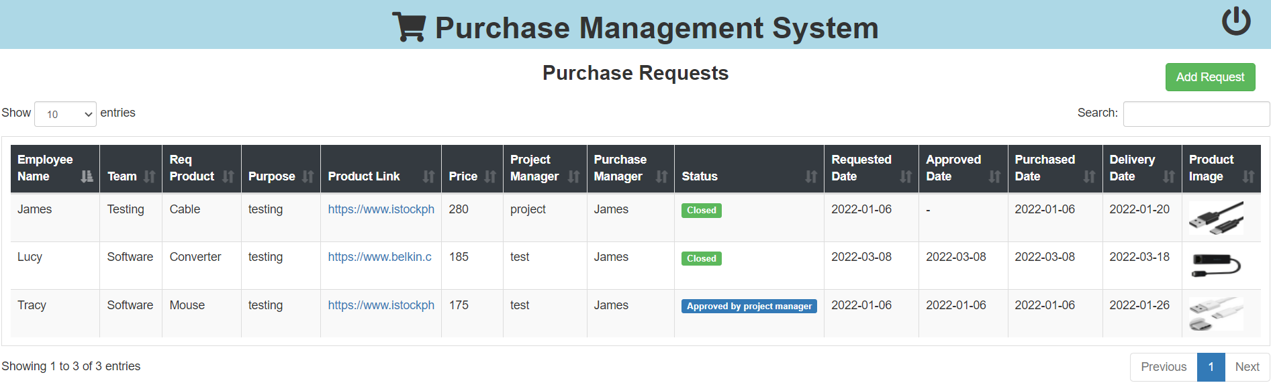

**Add request page**

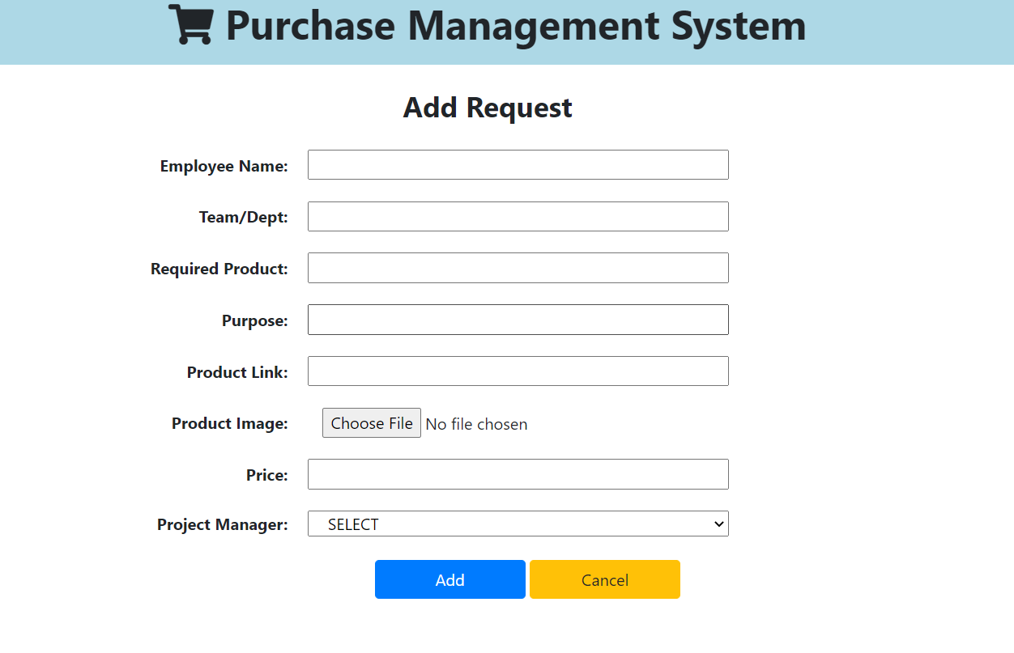

**Admin:**

**Home page**

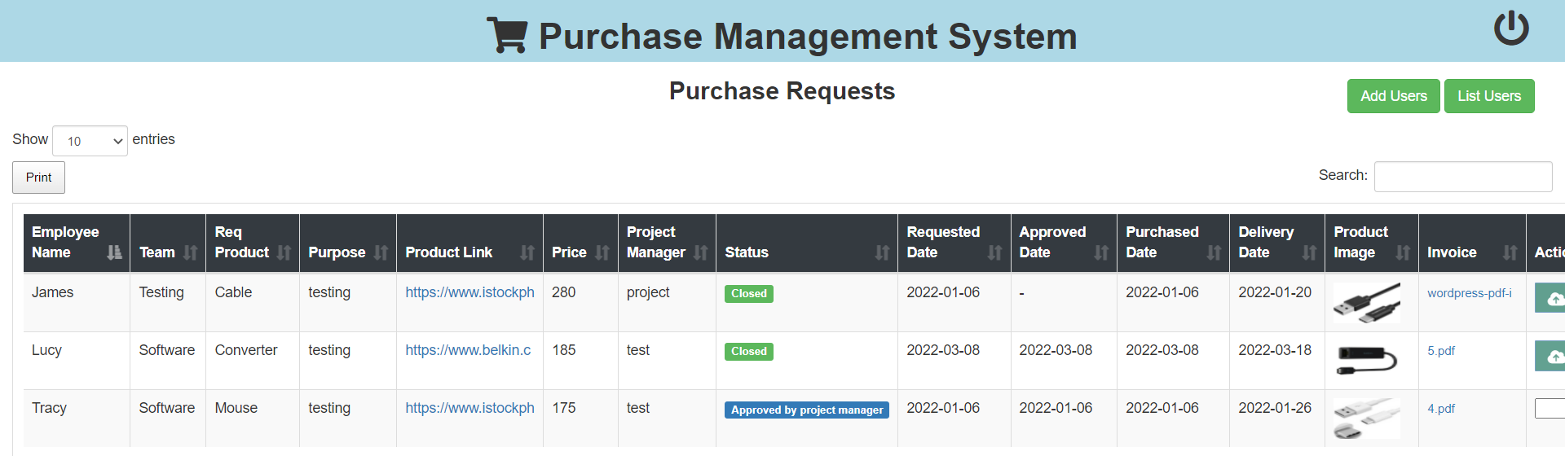

**Add user page**

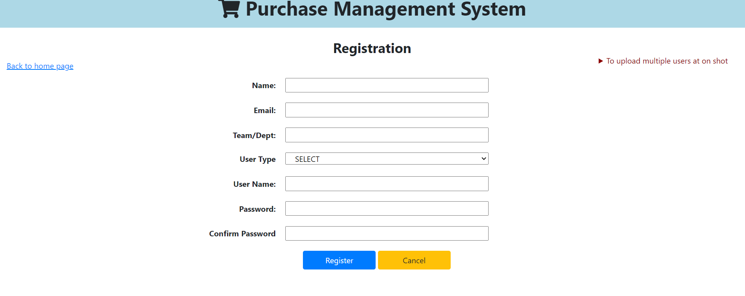

**List User page**

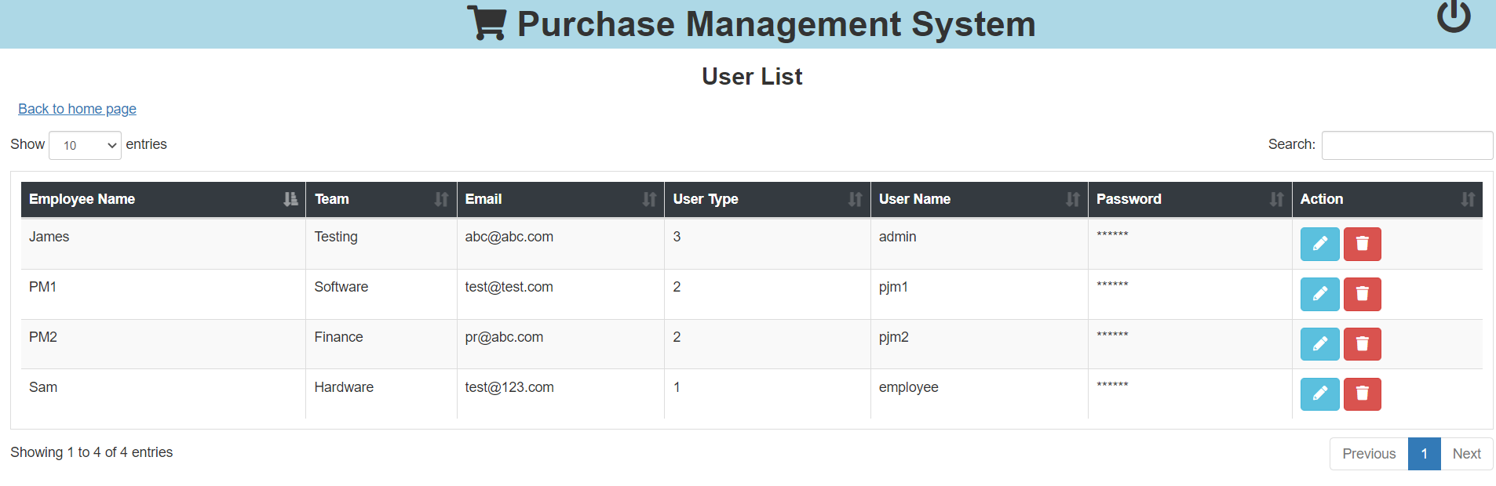

**Purchase Manager**

**Home page**

