💰 Revenue Intelligence Dashboard

🚀 Transforming Data into Strategic Business Insights
An executive-level Revenue Intelligence Dashboard built using Microsoft Power BI, designed to deliver actionable insights, performance tracking, and data-driven decision support.
This project demonstrates the ability to convert raw sales data into a high-impact, interactive dashboard that enables stakeholders to monitor revenue, analyze trends, and optimize business performance.

🧩 Project Overview
The Revenue Intelligence Dashboard provides a 360° view of business performance by integrating key revenue metrics, customer insights, and product analytics into a single, intuitive interface.
It empowers decision-makers to:
- Track revenue and profitability in real time
- Identify top-performing products and customers
- Analyze regional and channel performance
- Make informed, data-driven business decisions

🎯 Key Metrics Snapshot
Metric | Value
💰 Total Revenue | 154.57M
📈 Total Profit | 57.79M
📊 Profit Margin | 0.37
📦 Quantity Sold | 68K

📊 Dashboard Capabilities
✔ Revenue & Profit Analysis – Monitor financial performance with dynamic KPIs
✔ Time Intelligence – Monthly trend analysis with Year-over-Year comparison (CY vs PY)
✔ Product Performance – Identify high-performing and underperforming products
✔ Customer Insights – Analyze top customers and revenue contribution
✔ Regional Analysis – Evaluate sales distribution across cities
✔ Channel Performance – Compare Wholesale, Distributor, and Export channels

📈 Key Business Insights
💰 Revenue & Profitability
- Consistent growth observed across key revenue metrics
- High-margin products significantly influence profitability
📅 Trend Analysis
- Clear monthly sales patterns enabling better forecasting
- Identification of seasonal demand fluctuations
🌍 Regional Performance
- Revenue concentration in key cities
- Opportunities for expansion in underperforming regions
👥 Customer Intelligence
- A small segment of customers drives a large share of revenue
- Potential for targeted customer engagement strategies
📦 Channel Effectiveness
- Wholesale and Distributor channels dominate revenue
- Export channel presents future growth opportunities

🛠 Tools & Technologies
- Microsoft Power BI – Dashboard Development & Visualization
- DAX (Data Analysis Expressions) – Advanced Calculations
- Data Modeling – Relationship Building & Optimization
- Power Query – Data Cleaning & Transformation
- Microsoft Excel – Data Source & Preprocessing
- Git & GitHub – Version Control & Project Management

📁 Dataset Details
Source File: sales-data.xlsx
Key Attributes:
- Product Name
- Sales Amount
- Profit
- Customer Name
- City
- Sales Channel
- Order Date

💼 Business Value
This dashboard delivers measurable value by:
✔ Enabling real-time performance monitoring
✔ Supporting strategic decision-making
✔ Identifying revenue growth opportunities
✔ Improving operational efficiency
✔ Enhancing data-driven culture within organizations

🧠 Skills Demonstrated
- Data Cleaning & Transformation
- Data Modeling & DAX
- Exploratory Data Analysis (EDA)
- Data Visualization & Storytelling
- Business Insight Generation
- Dashboard Design (UI/UX Best Practices)
- Analytical & Critical Thinking

🚀 Future Enhancements
- 🔮 Predictive analytics for revenue forecasting
- 🌐 Integration with real-time data sources
- 📊 Advanced drill-through and interactivity
- 👥 Customer segmentation & cohort analysis
- ☁ Deployment via Power BI Service

📂 Project Structure
revenue-intelligence-dashboard/
│
├── revenue-intelligence-dashboard.pbix
├── sales-data.xlsx
├── README.md
└── images/
└── dashboard-preview.png

🖼 Dashboard Preview
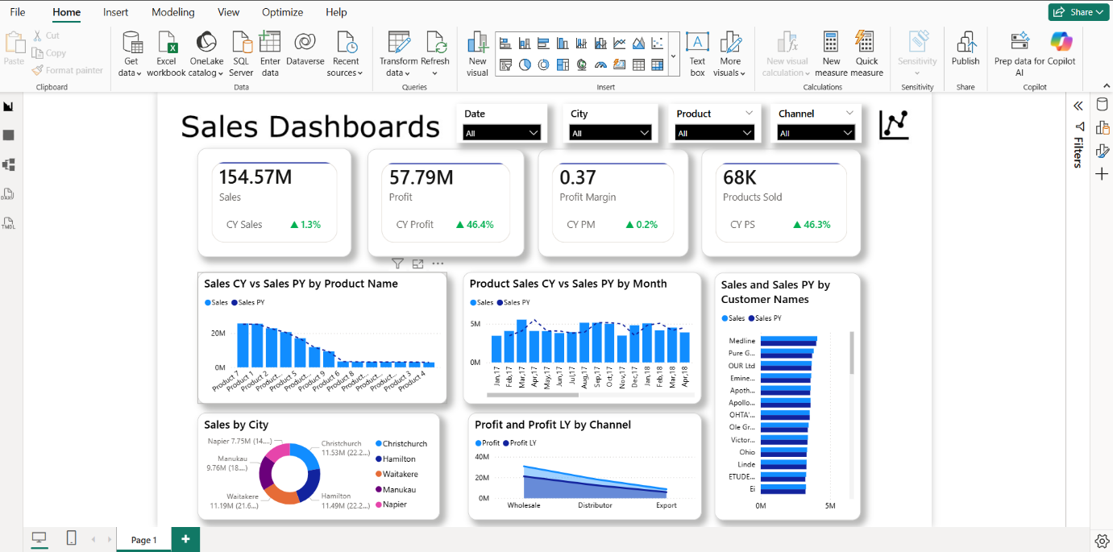

👨‍💻 Author
Aravind Kumar R
Data Analyst | Power BI Developer
📊 Passionate about transforming data into actionable insights
📈 Skilled in Power BI, DAX, and Business Intelligence
🚀 Focused on solving real-world business problems using data
🔗 GitHub: https://github.com/Aravind-Kumar-27
🔗 LinkedIn: linkedin.com/in/r-aravind-kumar
📧 Email: r.aravindkumar27@gmail.com

⭐ If you found this project useful
Give it a ⭐ on GitHub and feel free to connect!

