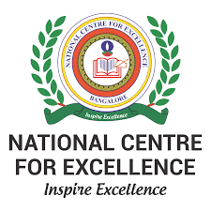

NATIONAL CENTRE FOR EXCELLENCE, BENGALURU

GRADE XI (2021-22)

MINI PROJECT SYNOPSIS

**PROJECT TITLE:**

Simple Units Convertor, Calculator and Equation Solver Software

**TEAM MEMBERS:**

Aarush Ghate, Aravind Sathesh, Naman Kasliwal

**ABSTRACT/SUMMARY OF THE PROJECT:**

-

-

-

-

-

-

-

-

-

-

-

-

**PYTHON CONCEPTS USED:**

Nested functions, Dictionaries, Sympy library, etc.