Resolution-Induced Performance Collapse of a CNN Change Detector: Simulated and Real Sentinel-2 Evidence
Aravind
Department of Computer Science and Engineering
Presidency University
Bengaluru, India
[author email address]
Abstract—Deep-learning change detectors are often trained on high-resolution imagery such as LEVIR-CD (0.5 m/pixel), while Sentinel-2 provides 10 m and 20 m bands. This paper reports a single-architecture case study of what happens when one such detector is applied across that gap. We train one MobileNetV2-based Siamese U-Net once on LEVIR-CD and freeze it. On the 2,048-image LEVIR-CD test split it reaches F1 87.06%, IoU 77.08%, precision 88.82% and recall 85.36%. We then blur and downsample the same test pairs to simulate 1, 2, 4, 8 and 10 m, upsample them back to 256×256, and re-evaluate the frozen model. F1 is 70.81% at 1 m and 4.41% at 2 m; at 8–10 m it is 2.61%, recall is 1.32%, and precision is 99.59%/99.47% while only 0.068% of pixels are predicted changed. Among the 935 changed test images, 924 (98.8%) receive no predicted change pixels at 10 m. The simulation shows that blur-and-resampling alone is sufficient to break this detector; it does not reproduce Sentinel-2 spectral, radiometric or atmospheric differences. We also evaluate the frozen CNN zero-shot on the ten official OSCD test cities: pooled F1 is 0.0007 with joint-percentile preprocessing and 0.0000 with reflectance preprocessing. Train-selected spectral rules reach pooled F1 0.0782 (hardcoded) and 0.1176 (percentile); Otsu predicts 67.35% of pixels changed and has overall accuracy 0.3439. These results do not establish spectral indices as a validated alternative. The OSCD test cities had been scored more than once before the reported run, so no one-shot claim is made. Only one architecture and one training run are tested.
Keywords—change detection, remote sensing, resolution mismatch, domain shift, convolutional neural networks, Sentinel-2, spectral indices, NDVI, NDBI, OSCD

Introduction
Automated change detection from satellite imagery underpins applications ranging from urban planning to disaster response and deforestation monitoring. Recent progress has been driven largely by deep convolutional and transformer-based architectures trained on high-resolution benchmark datasets such as LEVIR-CD [1], which provides 0.5 m/pixel imagery with pixel-level change annotations. Models trained on such data often report high F1 scores [CITE: LEVIR-CD baselines]; exact values should be taken from the original papers.
A gap exists between the resolution of these benchmark datasets and the resolution of satellite data available for continuous, low-cost monitoring. Sentinel-2 provides free, frequently revisited multispectral imagery at 10 m and 20 m, twenty times coarser linearly than 0.5 m LEVIR-CD. Whether a model trained at 0.5 m transfers to 10 m is not usually tested directly in the same study, since most evaluations remain at a benchmark's native resolution.
This paper reports an empirical case study of this resolution gap, motivated by integrating a trained detector into a live-data pipeline. Our contributions are as follows:
- We describe a dual-mode system: an upload path that runs a CNN trained on high-resolution imagery, and a live path that fetches Sentinel-2 imagery for a user-specified location and date pair. The system description is not a validation of operational accuracy.
- We quantify the effect of simulated blur-and-resampling on one frozen CNN across 2,048 LEVIR-CD test pairs at five degradation levels. This holds scene content fixed but does not reproduce all differences of a real Sentinel-2 sensor.
- We characterize prediction behavior at 10 m using per-image TP/FP/FN counts, showing near-empty predictions rather than a rise in false positives.
- We report a zero-shot OSCD evaluation of the same CNN and of train-selected NDVI/NDBI rules, with prior test-split exposure disclosed. The spectral rules are not presented as a validated replacement.

Related Work
CNN-based change detection. Fully convolutional Siamese networks [2] established the standard architecture family for pairwise change detection, with later work such as STANet [4] and BIT [5] reporting strong F1 scores on LEVIR-CD [CITE: exact STANet and BIT values from the original papers]. These studies train and evaluate at their benchmark's native resolution.
Cross-resolution and domain generalization. Domain shift between training and deployment imagery (sensor type, geography, atmospheric conditions) is an acknowledged challenge in remote sensing. Spatial-resolution shift specifically, as distinct from spectral, radiometric or geographic shift, is less often isolated in a controlled experiment.
Spectral index methods. Before the widespread adoption of deep learning, change detection was commonly performed using per-pixel spectral indices such as NDVI [6] and NDBI [7]. These methods need no training data and operate on reflectance values, but at 10 m a pixel mixes land covers. A spectral difference is therefore diluted by mixed pixels; these indices are not resolution-independent in practice.
Benchmarks at Sentinel-2 resolution. The Onera Satellite Change Detection (OSCD) dataset [3] provides labeled change masks on Sentinel-2 acquisitions aligned to a common grid. We use it for a zero-shot evaluation in Section V.

System Overview

Model Architecture and Training
The backbone is a MobileNetV2-based Siamese U-Net with a 3D-convolution fusion module. It was trained once on LEVIR-CD 256×256 patches at 0.5 m using a combined Dice and binary cross-entropy loss, AdamW (learning rate 5×10⁻⁴, weight decay 1×10⁻⁴), batch size 4, and cosine annealing. Training was configured for up to 100 epochs with early stopping (patience 10); it stopped after 27 epochs, with best validation IoU 0.7205. The checkpoint was exported to ONNX. On the 2,048-image LEVIR-CD test split the model reaches F1 87.06%, IoU 77.08%, precision 88.82% and recall 85.36% (Table I, factor 1×). These are results for one architecture and one training run; no comparison across seeds or architectures is made.

Live Acquisition Pipeline
The model is served behind a FastAPI backend with two modes. The first accepts uploaded before/after pairs and runs the CNN. The second resolves a place name or bounding box and two dates, authenticates against the Copernicus Data Space Ecosystem, retrieves Sentinel-2 L2A scenes (lowest cloud cover within a tolerance window), and builds a true-color composite for inference. Bounding boxes below a minimum extent are padded to avoid degenerate upsampling. These are implementation facts, not accuracy claims.

Spectral Index Fallback
During internal use of the live path, the CNN did not flag some visible construction. This observation was not a controlled study and is not used as evidence. As a heuristic fallback, the live path also computes per-pixel NDVI and NDBI differences. A vegetation decrease together with a built-up increase is treated as a candidate change. At 10 m, mixed pixels dilute both indices, so the heuristic is not resolution-independent; its accuracy is measured on OSCD below, where it is low.

Controlled Resolution Degradation Experiment

Methodology
To test whether simulated resolution loss alone can break the detector, we used the 2,048 LEVIR-CD test pairs and the frozen checkpoint. For each pair we formed six versions at 0.5, 1, 2, 4, 8 and 10 m. For factor f > 1, we applied a PIL Gaussian blur with radius f/2 pixels, downsampled to (256/f)×(256/f) with LANCZOS resampling, and upsampled back to 256×256 with LANCZOS. At 10 m this is a 12×12 intermediate. Images were normalized with ImageNet statistics and passed to the CNN at a 0.5 threshold. TP, FP and FN were counted per image; Table I pools these counts over all 2,048 pairs at each level. The procedure holds scene content and geography fixed while varying blur and sampling, so it isolates the simulated factor. It does not reproduce Sentinel-2 spectral bands, radiometric calibration, atmospheric correction or real sensor noise.

Quantitative Results
Table I reports pooled performance. F1 is 87.06% at 0.5 m, falls to 70.81% at 1 m (a 16.25-point absolute drop), and collapses to 4.41% at 2 m; it is 2.84% at 4 m and 2.61% at 8–10 m. Recall falls from 85.36% at 0.5 m to 57.01% at 1 m and 2.26% at 2 m, then 1.32% at 8–10 m. Precision is 88.82%, 93.43%, 90.78%, 97.69%, 99.59% and 99.47% across the six levels, so it does not decline; at 10 m, however, only 0.068% of all pixels are predicted changed (91,006 of 134,217,728), so the high precision is obtained with near-empty predictions. The decline in F1 is therefore recall-dominated, but the precision values at coarse levels should not be read as evidence of useful detections.
- Table I. CNN performance versus simulated spatial resolution (2,048 LEVIR-CD test pairs; micro-aggregated confusion counts).
Factor | Resolution | F1 (%) | IoU (%) | Precision (%) | Recall (%)
1× | 0.5 m | 87.06 | 77.08 | 88.82 | 85.36
2× | 1.0 m | 70.81 | 54.81 | 93.43 | 57.01
4× | 2.0 m | 4.41 | 2.25 | 90.78 | 2.26
8× | 4.0 m | 2.84 | 1.44 | 97.69 | 1.44
16× | 8.0 m | 2.61 | 1.32 | 99.59 | 1.32
20× | 10.0 m | 2.61 | 1.32 | 99.47 | 1.32

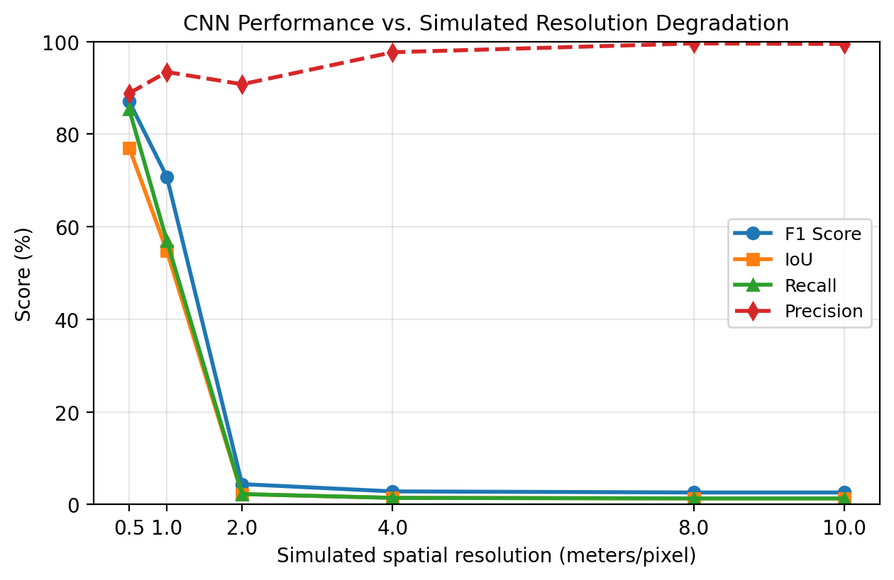
Metrics are computed from pooled TP/FP/FN counts over all 2,048 pairs at each level, not averaged per image. Percentages are rounded to two decimals.
- F1, IoU, precision and recall versus simulated spatial resolution. F1 and recall collapse beyond 1 m; precision stays high at coarse levels, where very few pixels are predicted changed.

Qualitative Failure Analysis
To characterize the predictions at 10 m, we counted outcomes for the 935 test images that contain ground-truth change. Table II groups them by predicted area and IoU. The categories are defined from the saved per-image TP/FP/FN counts; they are descriptive, not a causal explanation.
- Table II. Prediction behavior at 10 m for the 935 changed test images.
Behavior | Count | Percentage of 935
No predicted change pixels | 924 | 98.82%
Predicted, IoU < 0.1 | 3 | 0.32%
Predicted, 0.1 ≤ IoU < 0.5 | 6 | 0.64%
Predicted, IoU ≥ 0.5 | 2 | 0.21%
Total | 935 | 100.00%

At 10 m, 924 of 935 changed images (98.82%) receive no predicted change pixels. Only 11 images receive any prediction: three have IoU below 0.1, six between 0.1 and 0.5, and two at or above 0.5. The two higher-IoU cases show that a few larger changes survive; the remaining nine are less well localized. This is a description of outputs, not evidence for a specific mechanism. The aggregate precision of 99.47% at 10 m is computed from 91,006 predicted pixels against 6,837,404 changed ground-truth pixels, and therefore reflects how little the model predicts rather than reliable detection.

Real Sentinel-2 Evaluation on OSCD
OSCD provides ten official test cities and fourteen training cities with pixel-level change labels. Our evaluation uses five bands: B02, B03, B04, B08 and B11, all aligned to the label grid. The pooled test set contains 3,077,936 pixels; 5.17% are labeled change.
We evaluate three spectral rules and the frozen CNN. The hardcoded rule flags a pixel when NDVI drops by at least 0.30 or NDBI rises by at least 0.30; the percentile rule uses the 99.0th percentile of the observed NDVI-drop/NDBI-rise evidence; Otsu thresholds the same positive evidence. The hardcoded and percentile settings were selected on the fourteen training cities over fixed grids; the two hardcoded thresholds lie at grid edges, while the selected percentile (99.0) is interior to its grid. The CNN is evaluated zero-shot with two preprocessing variants. Its input is an RGB stack (B04, B03, B02): reflectance scaling divides raw values by 10,000 and maps to 0–255, while joint-percentile scaling uses the 2nd and 98th percentiles of both dates combined. Each scene is processed in 256×256 tiles with 32-pixel overlap, edge padding and averaged probabilities; no scene resizing is used.
Pooled F1 is 0.0782 for hardcoded, 0.1176 for percentile, 0.0953 for Otsu (OA 0.3439), 0.0007 for the CNN with joint-percentile preprocessing and 0.0000 with reflectance preprocessing. The spectral rules under-predict: 2.24% and 1.66% of pixels predicted changed against 5.17% true. Otsu over-predicts: 67.35% predicted changed, with recall 0.6684 and precision 0.0513; its OA is 0.3439. The CNN predicts 0.01% (joint-percentile) or 0.00% (reflectance) changed, so its F1 is near zero; its OA of 0.9483 is close to the 94.83% no-change prevalence and should not be read as detection performance. Table III reports these pooled values.
- Table III. OSCD v2 pooled test results (ten cities, 3,077,936 pixels; true change 5.17%).
Method | Predicted changed | F1 | OA | Note
Hardcoded | 2.24% | 0.0782 | 0.9317 | under-predicts
Percentile 99.0 | 1.66% | 0.1176 | 0.9397 | highest spectral F1
Otsu | 67.35% | 0.0953 | 0.3439 | over-predicts
CNN joint-percentile | 0.01% | 0.0007 | 0.9483 | near-empty
CNN reflectance | 0.00% | 0.0000 | 0.9483 | no positives
All methods share the same true-change fraction (5.17%). Otsu is reported with OA because its predicted fraction is 67.35%, which makes recall alone uninformative.
Per-city F1 varies widely: percentile 0.0005 (saclay_w) to 0.2481 (chongqing); hardcoded 0.0032 (dubai) to 0.3102 (chongqing); CNN joint-percentile 0 to 0.0024 (lasvegas). Otsu OA ranges 0.2205 to 0.5116. With ten cities, these ranges are descriptive; city-level uncertainty is not quantified in this draft.
Scoring history. The ten official test cities were scored more than once. At least one earlier preliminary run with a smaller threshold grid produced pooled F1 0.167 (percentile), 0.104 (hardcoded), 0.095 (Otsu) and 0.0 (CNN); the total number of scoring events is not recorded. The v2 results above are a re-evaluation after the configuration was fixed using training cities only. Because the test split had already been examined, v2 is not an independent first test, and we do not describe it as one-shot. The repository's preregistration note was written after that earlier scoring and is not treated as evidence of pre-registration or as validation.
The OSCD results show that neither the CNN nor the tested spectral rules provide a usable change detector under this protocol. The CNN's failure on real Sentinel-2 data is consistent with a domain gap, but these results do not identify its cause; spectral, radiometric, atmospheric and resolution differences are confounded. The spectral rules' low F1 does not support claims that NDVI/NDBI differencing is a validated resolution-robust alternative. No cloud/SCL mask is available in this OSCD layout, so cloud and shadow effects are not excluded.

Discussion
The simulation and the OSCD evaluation answer different questions. The simulation holds scene content fixed and shows that blur-and-resampling alone is sufficient; OSCD uses real 10 m data and shows that the frozen CNN also fails there, but it cannot isolate resolution from other differences. Together they motivate resolution-aware evaluation; they do not establish resolution as the sole cause of the OSCD failure.
The sharp transition between 1 m and 2 m is consistent with the loss of spatial information this architecture relies on, but the experiment does not identify which features cause it. The practical implication is narrower and better supported: a model validated only at its native resolution can fail on coarser imagery, and native benchmark metrics do not reveal that risk.
The recall-dominated pattern also means that a small threshold adjustment is unlikely to restore performance: at 10 m only 91,006 of 134,217,728 pixels exceed the 0.5 threshold across all 2,048 pairs. We did not test lower thresholds, so we do not claim that threshold tuning would or would not recover some detections.

Limitations and Future Work
The degradation experiment applies blur and resampling to LEVIR-CD, not real independent acquisitions at each resolution. It holds scene content fixed but omits Sentinel-2 band differences, radiometric calibration, atmospheric correction, mixed pixels and sensor noise. OSCD provides real 10 m data, but the benchmark layout used here lacks SCL/cloud masks and contains ten test cities. Only one architecture and one training run were tested; no retraining, fine-tuning, seed variation or architecture comparison was performed. The test cities were scored more than once, as disclosed in Section V, and the spectral configurations were selected on training cities but at grid edges. City-level confidence intervals and threshold robustness are not reported in this draft. Future work should (1) repeat the degradation study with additional architectures and seeds; (2) evaluate resolution-aware training or adaptation; (3) quantify city-level uncertainty and training-only threshold robustness; and (4) test cloud masking where SCL is available.

Conclusion
We report a single-architecture case study in which a CNN with 87.06% F1 at native 0.5 m resolution falls to 70.81% at 1 m and 4.41% at 2 m under blur-and-resampling, and to 2.61% at 8–10 m with near-empty predictions. The simulation shows that resolution-related information loss alone is sufficient to break this detector; it does not reproduce all differences of real Sentinel-2 data. A zero-shot OSCD evaluation of the same frozen CNN yields pooled F1 0.0007 or lower. Train-selected NDVI/NDBI rules also perform poorly (pooled F1 0.0782–0.1176), so the results do not establish spectral indices as a validated alternative. The test cities had been scored more than once. Resolution mismatch should be evaluated explicitly, and claims about low-resolution fallbacks require real-data validation.

Acknowledgment
The author thanks [Guide Name] for supervision and guidance throughout this project.

References
- H. Chen and Z. Shi, “A spatial-temporal attention-based method and a new dataset for remote sensing image change detection,” Remote Sensing, vol. 12, no. 10, 2020. [LEVIR-CD dataset / STANet]
- R. Caye Daudt, B. Le Saux, and A. Boulch, “Fully convolutional Siamese networks for change detection,” in Proc. IEEE Int. Conf. Image Processing (ICIP), 2018.
- R. Caye Daudt, B. Le Saux, A. Boulch, and Y. Gousseau, “Urban change detection for multispectral earth observation using convolutional neural networks,” in Proc. IEEE Int. Geosci. Remote Sens. Symp. (IGARSS), 2018. [OSCD dataset]
- H. Chen and Z. Shi, “STANet: spatial-temporal attention neural network for remote sensing image change detection,” 2020.
- H. Chen, Z. Qi, and Z. Shi, “Remote sensing image change detection with transformers (BIT),” IEEE Trans. Geosci. Remote Sens., 2021.
- J. W. Rouse, R. H. Haas, J. A. Schell, and D. W. Deering, “Monitoring vegetation systems in the Great Plains with ERTS,” NASA SP-351, 1974. [NDVI]
- Y. Zha, J. Gao, and S. Ni, “Use of normalized difference built-up index in automatically mapping urban areas from TM imagery,” Int. J. Remote Sens., vol. 24, no. 3, 2003. [NDBI]
Reference details in this draft are unverified. The list contains a duplicate STANet entry ([1] and [4]); exact venues, volumes and pages must be checked against the original publications before submission. Do not treat this list as verified.

