i - Introduction
We all have heard the word stock one way or the other. Particularly stock is related with the companies which are commercialized and are to settling in the world of marketization. The other word used for stock is share which is prominently used in day-to-day life. People even term it as an investment plan and it is actually something people see as a long-term investment that secures and provides an abundant funds during the retirement age.
Buying a company stock is purchasing a small share of it. People invest on the same to get a long-term benefit which they think has less value for now but has the potential to grow with the time. It is an investment that provides the long-time run and deals with long time goals with the fair objectives.
Market is unpredictable so are the resources and the factors that are taken to drive it off or on the set. It has never been on the same level and same pattern. Some closeness and prediction method had been derived and approximate values and the rough figures are generated hoping for the best but all of the resource cannot be trusted and are still unpredictable in nature.
Knowing the market situation and researching on the same is the best way to find reliability for which there are many agents who have taken the same as a profession and are making a fortune out of it. They predict and advise but the advisory cost and charge is higher and the stock evaluation is never less the same.

The Stock Market of India ranks 12th in the world in terms of market net worth. At the moment, the NSE India offers trading in 1659 companies. India's economy is based mainly on agricultural exports and related services such as software development and technical support. Regrettably, stock market trading accounts for only 4% of India's gross domestic product. It, therefore, is far less than the average for other developed countries like the USA is around 55%. This underutilized asset has the potential to be more effectively monetized to aid India's development. This section discusses the shortcomings of conventional stock price prediction methods and the advantages of applying machine learning.

- The conventional method for analyzing
stocks The stock market is highly variable and indeterministic due to various parameters impacting price movements in numerous sizes and layers. According to efficient market theory, the market corrects itself, meaning that the current share price represents the appropriate total combined price, which is neither excessively low nor excessively high. In simple terms, "the market is unbeatable," suggesting one cannot defeat the market, yet existing evidence shows otherwise. By monitoring stock movement patterns, it is possible to forecast market trends. The conventional approach emphasizes technical and fundamental analysis to forecast the share market on a massive level, which very seldom transforms to low-level selected stocks forecasting. Some particular stocks, on the other hand, lead to overall price movements in the market.

- Fundamental analysis
This strategy is primarily concerned with a company's prior success and reputation. Stocks that are prone to a positive price increase are filtered using performance criteria such as P/E ratios. It relies on the assumption that successful businesses will remain beneficial in the long run due to the market's rewarding nature.

- Technical analysis
This strategy relies on forecasting future pricing using timeseries analysis on historical trends. RSI, Bollinger Bands, VWAP, Moving averages are a few of the many indicators used to analyze and study the market trend and understand how the market is moving.

B. Stock market analysis with a modern perspective Machine learning methods such as SVM, RNN, and EML, developed by computer scientists, can evaluate and conduct information discovery at large scales in a short period. RNN is used to forecast stock market prices in this research paper. a. Qualitative Research Newsfeeds about the stock market significantly impact the market trend, resulting in a downward trend in lousy sentiment and an upward trend when there are positive sentiments. As a result, media/social networks and the share price are correlated and uncertain. Therefore, news acts as an essential medium for analyzing how a stock would perform on a subsequent day. Stocks mimic each other in times of crisis, resulting in market collapse. News can give the public a view of how the company is performing and how it might perform in the future. b. Quantitative research Most markets now have historical information readily available. One can use these historical values to study and analyze how a particular stock has been performing. This data can also be studied using various Machine Learning Algorithms to analyze the upward and downward trends of the data to generate predictions for the future. Such algorithms prefer learning the movement of a single stock rather than many different stocks cumulatively as each stock moves and trades differently. Additionally, these models can also perform under a variety of situations and economic conditions.
ii - Problem Definition
The Stock market appears in the news every day. You hear about it every time, when it reaches a new high or a new low. The rate of investment and business opportunities in the Stock market can increase if an efficient algorithm could be devised to predict the short-term price of an individual stock.
Previous methods of stock predictions involve the use of Artificial Neural Networks and Convolution Neural Networks which has an error loss at an average of 20%.
Here, we will see if there is a possibility of devising a model using LSTM which will predict stock price with a less percentage of error. And if the answer turns to be YES, we will also see how reliable and efficient will this model be.
iii - Objectives
- Based on the fundamental analysis predict the price/behaviour of the stock in short-term using deep learning techniques.
- Based on the technical analysis predict the price/behaviour of the stock in short-term using deep learning techniques.
iv - Motivation
- Intelligence fascinates mankind and having one in machine and integrating on the same is the hot key of research. All the learning system from the past are limited and are simplest in nature where learning of the simple algorithm for a computational mean is not enough which can even be done by human brain itself. The main motto of learning was limited and learning model was not efficient.
- As many have invested their time and effort in the world of trade, In the past years various strategies and plans had been derived and deployed, the topic is still a point of research where people are coming up with ideas to solve.

Advantages:
Stock market prediction aims to determine the future movement of the stock value of a financial exchange. The accurate prediction of share price movement will lead to more profit investors can make.
Prediction of shares offers huge chances for profit and is a major motivation for research in this area; knowledge of stock movements by a fraction of a second can lead to high profits.
Limitations:
The main aim of this system is to provide a general idea of where the stock market is headed. It is only limited to a very basic prediction tool. Thus, it cannot be used as a critical decision-making tool.
Since, there are many factors that affect the stock market, each and every one of them cannot be taken into account. So, our model only depends on the relationship of our selected parameters with the share price.

Proposed System:
1. To implement the LSTM model which will be trained on available historical data.
2. To forecast the next 30 days price of stock of a particular NIFTY 50 listed company in which the user is interested.
3. To integrate this model in order to develop a simple system through which a user can interact and perform predictions as per his requirements i.e company name and number of predictions.
4. To provide insights of data in graphical format such as bar charts,line charts,comparison between predicted vs actual,accuracy of prediction etc.

Purpose
Purpose of the project is to develop system which will able to predict stock price so that investors can make better decisions.

Scope
1. The project focuses on applications of model(LSTM) for stock price prediction.
2. In this project we are considering only NIFTY 50 listed companies as their historical data and real time data are easy to fetch.
3. To predict stock price user will have option of uploading dataset of that company
4. Users will be able to make predictions of the next 30 days.

LITERATURE SURVEY:
Ingle V et al. [1] developed a deep learning framework that predicted the stock market. Gradient Boosted Models (GBM), Generalized Linear Models (GLM), and other deep learning algorithms are some of the models developed by the deep learning framework. GBM is a technique for increasing the strength of a gradient. It produces a set of weak prediction models as a prediction model. It assembles the model in steps and is agnostic, as it accepts any differentiable loss function. The internet news feed comes from a variety of websites, including Yahoo finance and Google finance. The plain text retrieved from the text corpus has a lot of characteristics, one of them is Term Frequency–Inverse Document Frequency (TF-IDF). The word score is counted using TF-IDF weights computation. It has two parts: TF and IDF. When the document set is to be categorized, they use this algorithm. Stocks such as Sun, Airtel, Idea, HDFC, Hero, ICICI, ITC, Bajaj, Maruti, and TCS listed on the stock exchange are considered for experimentation. Between the 5th of July and the 9th of August 2016, roughly 1800 documents were collected on consecutive days. The accuracy of GBM, GLM, and deep learning was found to be 75%, 85%, and 78%, respectively.

Li Y et al. [2] had fostered a novel ensemble deep learning model for stock expectation relying on the current stock price and related insight about the organization. The authors utilize sentiment analysis to remove applicable data from an assortment of text-based information sources using a blending ensemble deep learning model which helps in anticipating future market practices. The primary level is comprised of two repetitive neural networks, one Long Short-Term Memory (LSTM), and one Gated Recurrent Units (GRU), which is trailed by a completely associated neural network as the subsequent level model. They found that stacking or joining numerous Recurrent Neural Networks (RNN) will deliver a more precise figure than a solitary LSTM network after huge examination and tests. To finish this intricate test, they picked to utilize a mixing group learning model that mixes LSTM and GRU. They determined the Mean Squared Error (MSE) and Mean Prediction Accuracy (MPA) values by contrasting the anticipated stock cost with the real stock cost.
Yadav An et al. [3] have used the LSTM model for stock value forecasting. Indian Stock Market was chosen as a dataset and LSTM model for predicting stock prices. By comparing stateful and stateless models, the number of hidden layers was adjusted accordingly. Different companies from various organizations were picked as a dataset. According to probability-values, the distinctions among stateless and stateful LSTM for stock value prediction are analytically negligible. Due to its superior stability, a stateless LSTM model is performed for time-stamped data prediction problems. Most issues will be advised with one layer being hidden because of more accurate values, quicker training, and a lesser chance of over-fitting.

Sen J et al. [4] have created a collection of predictive regression models based on deep learning algorithms for the accurate and reliable forecasting of future stock values on India's diverse industries' National Stock Exchange (NSE). Four Convolutional Neural Network (CNN) regression models were used in the prediction framework, and six regression models based on the LSTM model were used. The results of the many models proposed in this survey were summarized by the authors. They rated the models based on each statistic after evaluating them on two metrics: the accuracy metric and the speed metric were used to evaluate the model. Initially, it was observed that, while CNN models are quicker, precision of both models was equivalent. Later, compared to multivariate models, univariate models are both quicker as well as highly exact.

Goh TS et al. [5] have studied and inspected the securities exchange file determinants and the forecast utilizing the Fast Fourier Transform (FFT) bend fitting of the Jakarta Stock Exchange (JKSE) Composite Index during the COVID-19 pandemic. Spellbinding measurements, multicollinearity tests, theory tests, assurance tests, and forecast using FFT bend fitting are completely shrouded in this examination. The discoveries uncover four new and solid bits of proof. The loan cost significantly affects the securities exchange file to some extent. The conversion standard impressively affects the securities exchange file partially. The securities exchange list (JKSE) has been seriously impacted by the F-test result (F dissemination test), loan fee, and swapping scale all simultaneously. Besides, the financial exchange changes and increments with time, as per the FFT bend fitting. The free factors and the reliant factors essentially affected the outcomes.

Sunny MA et al. [6] proposed a new stock prediction model using the LSTM model and Bidirectional Long Short-Term Memory (BI-LSTM) model. The dataset was collected from Yahoo Finance. They used Google stocks from 2004 to 2019. A total of 4170 days was used as data. The information provided as input is numerical. 88% of the data was used for training and remaining for testing. They used Root Mean Squared Error (RMSE) for both BI-LSTM and LSTM to find a better model among these two, they used hidden layers, a number of epochs to find a better model. The BI-LSTM predicts stock more precisely than the LSTM model. The LSTM takes less time than BI-LSTM to predict the stocks and has a higher RMSE value compared to BI-LSTM.

Nabipour M et al. [7] proposed a model for predicting the stock market. Among all other known deep learning models, LSTM has high accuracy and error is minimum. The LSTM connects previous data to the current neuron. Dataset was taken from Tehran stock exchange, among the data four groups were taken. They are petroleum, basic metals, non-metallic minerals, and diversified financials. Past 10 years of data were chosen for the experiment. Diversified financials for different numbers of days were chosen for the experiment. RMSE, MSE, Mean Absolute Percentage Error (MAPE) and Mean Absolute Error (MAE) were used for error detection. This model predicted the stocks with 60% accuracy.

Nandakumar R et al. [8] have proposed a new type of stock forecast system. They proposed an internet learning calculation that uses a sort of RNN called LSTM. Yahoo finance and Google finance were utilized to assemble the securities exchange measurements. LSTM network is comprised of one info layer with five neurons and a few secret layers (n), each with a few LSTM memory cells (m), and one result layer. The model was fitted to the preparation information, and hyperparameter tweaking was utilized to decide the quantity of stowed away layers, number of neurons per stowed away layer, and the clump size. The RMSE measurement can then be utilized to assess the forecast model's exactness. This is because changing starting conditions on similar information cause neural organizations overall (counting LSTM) to create different results.

Chung H et al. [9] have built a modern stock market forecasting model using publicly available financial information. They used deep learning due to its greater capacity to learn from huge datasets and proposed a hybrid strategy that combines an LSTM network with the Genetic Algorithm (GA). For this study, data was gathered from Korea Stock Price Index (KOSPI) which spans over the period January 2000 to December 2016. The complete dataset is divided into two parts: training set (80%) and holdout set (20%). The training set is utilized to investigate the model's effective specifications, while the holdout set is used to compare prediction models and measure performance. Five scientific indicators and five historical values (high price, low price, opening price, closing price, and volume) are used as input variables in this study, with 15 and 7 hidden layers, respectively. To determine the outcome of the GA-LSTM model, the MSE, MAE, and MAPE of the real closing price of the stock, as well as the output of the suggested model are computed. The GA-optimized LSTM network exceeds the benchmark in all error metrics. According to the experimental results, the LSTM and GA hybrid model outperforms the benchmark model.

Hiransha M et al. [10] have utilized four kinds of significant learning models to anticipate an organization's stock price considering past prices: Multilayer Perceptron (MLP), RNN, LSTM, and CNN. Data required was gathered from the NSE's automobile, banking, and information technology sectors. They derived the day-by-day closing price of each stock from these datasets. The training dataset covers the period from January 1996 to June 2015 and includes 4861 days of closing prices. Information collected is normalized to bring all data into a standard range. The test datasets covered the period from October 2007 to June 2017. Algorithms used are capable of spotting patterns in the stock market, based on the results collected. CNN has been discovered to outperform the other models. When the findings were compared to the Auto-Regressive Integrated Moving Average (ARIMA) model it has been found that the deep learning networks outperformed the linear ARIMA.

In [2], V.K.S, Reddy mainly focused on Support Vector Machines (SVM). According to the author, the SVM algorithm works on large-scale data values gathered from the global economy. Overfitting is not a problem with SVM. The stock price is predicted using a variety of Machine Learning algorithms, but SVM proved to be the most accurate.
This article [6] estimated the share price using a deep learning algorithm of the Nikkei 225 and Nikkei 400 of Japan stock exchange index. Deep Neural Network, Backpropagation Neural Network, and Support Vector Machine Regression were the classification algorithms used to forecast the stock price.
The [5] objective of the authors of this paper is to use the linear regression technique to estimate stock price trends by training on historical data and testing on other data. Stocks are scored by dividing the regressed slope by the inverse mean squared errors.
The three aspects of this [4] project are preprocessing and data-extraction of the china Stock markets dataset, feature selection, and a price pattern prediction algorithm based on long short-term memory. They succeeded in developing a new algorithm component called feature extension. They employed feature expansion (FE) techniques in conjunction with recursive feature elimination (RFE) and principal component analysis (PCA) to achieve highly accurate results that outperformed the top methods in the majority of similar research.
The purpose of this [3] paper was to conduct a comprehensive comparative analysis of ensemble methods to predict the stock market based on four different stock market indexes (datasets). Three well-known machine learning algorithms were used in this study: decision trees, multilayer perceptron neural network, and support vector machines. They discovered that the substitution method of stacks for developing a classification model surpassed most other combinations compared to the Accuracy and loss statistics.

During the pre-deep learning era, Financial Time Series modelling has mainly concentrated in the field of ARIMA and any modifications on this, and the result has proved that the traditional time series model does provide decent predictive power to a limit. For example, due to the asymmetric distribution in financial time series return, Minyoung Kim has replaced the traditional Maximum Likelihood Estimation with an asymmetric loss function.[7] C.K. Lee et al. compared the forecasting performance of ARIMA and artificial neural networks on Korean stock price index. The work showed that ARIMA provided more accurate forecasts than the back-propagation neural network.[8] More recently, deep learning methods have demonstrated better performances thanks to improved computational power and the ability of learning non-linear relationships enclosed in various financial features. Sreelekshmy Selvin et al. compared three different deep learning architectures including RNN, LSTM, and CNN-sliding window models for the prediction of NSEI listed stocks.[11] They concluded that CNN architecture is capable of identifying changes in trend of stocks and outperforms other models. Yan and Ouyang combined the wavelet transform of the financial time series with the LSTM and showed that the resulting model beat the performance of traditional Support Vector Machine, and K-nearest Neighbours.[12] Thien Hai Nguyen et al. demonstrated that the integration of sediment features extracted from social media can improve the accuracy of prediction.[10] The performance of LSTM-RNN will be further boosted by feeding relevant data based on financial domain knowledge. [3, 5] Moreover, Kim Won has developed a hybrid approach to combine LSTM and GARCH models and the resulting model has much lower prediction errors. [6]

Dataset and Features
The data we utilized to train/develop and test our model include two aspects: 1. The daily prices and volumes for every SP 500 stock from 2004 to 2013. 2. The accounting and corporate statistics for the SP 500 stocks from 2004 to 2013. Two sets were merged by date and forward filled missing statistics between two releasing date. After large number of iterations in selecting the appropriate input, the input we use are ‘adjustment close price’, ‘trading volume’, ‘Debt-to-Equity Ratio’, ‘Return on Equity’, ’Price-to-Book’ ratio, ‘Profit Margin’, ‘Diluted Earnings Per Share’ and ‘Company Beta’. We applied the min-max scale to normalize the data between 0 and 1, hence prevent the magnitude of certain features overwhelms others. For each stock in SP 500 we have the daily data mentioned above from 2004 to 2013. We use the approximate ratio of 70-15-15 to split the data for each stock in training, development, and testing data. In other words, we use data from 2013 to 2011 as training data, 2012 as development data and 2013 as testing data. Our performance metrics and trading strategies are hence built on the data on 2013. A sample piece of our data is shown Figure 1.

Software Requirement Specification

The presentation of the Software Requirements Specification (SRS) gives a review of the whole SRS with reason, scope, definitions, abbreviations, contractions, references and diagram of the SRS. The point of this report is to assemble, dissect, and give a top to bottom knowledge of the total "Analysis of Nifty Stock Price" by characterizing the difficult articulation in detail. The point by point necessities of the stock market– client related capacities are given in this archive.

2.2 PURPOSE

The Purpose of the Software Requirements Specification is to give the specialized, Functional and non-useful highlights, needed to build up a web application App. The whole application intended to give client adaptability to finding the briefest as well as efficient way. To put it plainly, the motivation behind this SRS record is to give an itemized outline of our product item, its boundaries and objectives. This archive depicts the task's intended interest group and its UI, equipment and programming prerequisites. It characterizes how our customer, group and crowd see the item and its usefulness.

Scope
The Scope of this framework is to presents a survey on information digging strategies utilized for the expectation of Nifty analysis. It is obvious from the framework that information mining strategy, similar to grouping, is profoundly productive in expectation of Nifty Stock Price.

Software Architecture:
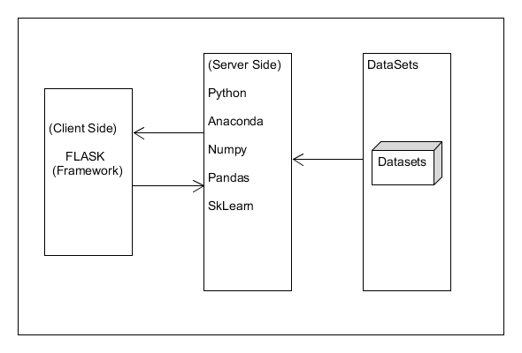

Acronyms And Abbreviation:

Python:

Python is a deciphered, significant level, broadly useful programming language. Made by Guido van Rossum and first delivered in 1991, Python's plan reasoning accentuates code meaningfulness with its prominent utilization of critical whitespace. Its language develops and object-arranged methodology plan to assist software engineers with composing clear, consistent code for little and huge scope ventures.
Python is progressively composed and trash gathered. It underpins numerous programming standards, including procedural, object-arranged, and practical programming. Python is frequently portrayed as a "batteries included" language because of its thorough standard library. Python is a multi-worldview programming language. Article arranged programming and organized writing computer programs are completely upheld, and a significant number of its highlights uphold useful programming and angle situated programming (counting by metaprogramming and metaobjects (enchantment methods)).] Many different standards are upheld by means of expansions, including plan by agreement and rationale programming.

Flask:
Flask is a miniature web system written in Python. It is delegated a microframework in light of the fact that it doesn't need specific apparatuses or libraries.[3] It has no information base deliberation layer, structure approval, or whatever other segments where prior outsider libraries give normal capacities. In any case, Flask upholds augmentations that can include application includes as though they were executed in Flask itself. Augmentations exist for object-social mappers, structure approval, transfer dealing with, different open confirmation advancements and a few basic system related devices. Augmentations are refreshed unmistakably more as often as possible than the center Flask program.

Anaconda:
Anaconda is a free and open-source circulation of the programming dialects Python and R . The dissemination accompanies the Python translator and different bundles identified with AI and information science.
Essentially, the thought behind Anaconda is to make it simple for individuals inspired by those fields to introduce all (or a large portion) of the bundles required with a solitary establishment.
An open-source bundle and condition the executives framework called Conda, which makes it simple to introduce/update bundles and make/load situations.
AI libraries like TensorFlow, scikit-learn and Theano.
Information science libraries like pandas, NumPy and Dask.
Perception libraries like Bokeh, Datashader, matplotlib and Holoviews.
Jupyter Notebook, a shareable note pad that joins live code, representations and text.
Numpy:
NumPy is the principal bundle for logical registering with Python. It contains in addition to other things:
• a amazing N-dimensional cluster object
• sophisticated (broadcasting) capacities
• tools for incorporating C/C++ and Fortran code
• useful straight polynomial math, Fourier change, and arbitrary number abilities

Pandas:
pandas is an open source, BSD-authorized library giving elite, simple to-utilize information structures and information investigation apparatuses for the Python programming language.
pandas is a Num FOCUS supported undertaking. This will help guarantee the achievement of improvement of pandas as an a-list open-source venture, and makes it conceivable to give to the task.

TensorFlow
TensorFlow is an open source machine learning framework for all developers. It is used for implementing machine learning and deep learning applications. To develop and research on fascinating ideas on artificial intelligence, Google team created TensorFlow. TensorFlow is designed in Python programming language, hence it is considered an easy to understand framework.
The TensorFlow software handles data sets that are arrayed as computational nodes in graph form. The edges that connect the nodes in a graph can represent multidimensional vectors or matrices, creating what are known as tensors. Because TensorFlow programs use a data flow architecture that works with generalized intermediate results of the computations, they are especially open to very large-scale parallel processing applications, with neural networks being a common example.

Keras:
Keras is an open-source library of neural network components written in Python. Keras is capable of running atop TensorFlow, Theano, PlaidML and others. The library was developed to be modular and user-friendly, however it initially began as part of a research project for the Open-ended Neuro-Electronic Intelligent Operating System or ONEIROS. The principal author of Keras is Francois Chollet, a Google engineer who also wrote XCeption, a deep neural network model. While Keras officially launched, it was not integrated into Google's TensorFlow core library until 2017. Additional support has also been added for Keras integration with Microsoft Cognitive Toolkit.

FUNCTIONAL REQUIREMENTS:

- Collecting Data The data is collected from previous Niftyrecords in Kaggle datasets.
- data pre-processing.
Data preprocessing is a process of preparing the raw data and making it suitable for a machine learning model
- Identifying missing Values
- Check for outlier
- Data Analysis
- Selection of Attribute
- Split into train and Test
- After the Pre Processing The Splitted train data are passed as input to the LSTM algorithms for training the data
- After Train the Test data validated for Accuracy purpose
- The Prediction for next 30 days is calculated
6. The analysis help in the prediction of price

Product Functions
1. Uploading Data Uploading data sets to the database.
2. Perform Prediction is done by each algorithm based on the constraints.
4. Comparison Study Prediction results and its stages of each algorithm is represented through graph.

General Constraints
The results generated have to be entered in to the system and any error or any value entered out of the boundary will not be understood by the system. In any case if the database crashes, the whole information collected and the results generated will be of no use.

3.3 Specific Requirements

3.3.1 External Interface Requirements
This section provides a detailed description of all inputs into and outputs from the system. It also gives a description of the hardware, software and communication interfaces and provides basic prototypes of the user interface

NON-FUNCTIONAL REQUIREMENTS
Non-Functional Requirement (NFR) specifies the quality attribute of a software system. They judge the software system based on Responsiveness, Usability, Security, Portability and other non-functional standards that are critical to the success of the software system. Example of nonfunctional requirement, “how fast does the website load?” Failing to meet non-functional requirements can result in systems that fail to satisfy user needs.
Non Functional requirements in Software Engineering allows you to impose constraints or restrictions on the design of the system across the various agile backlogs. Example, the site should load in 3 seconds when the number of simultaneous users are > 10000. Description of non-functional requirements is just as critical as a functional requirement.

Non-functional requirements include:-
Performance:
This developed application Nifty price prediction is handle multiple data related to user transaction data. The application predict the result based on build model using machine learning which is fast and accurate.

Availability:
The developed application is available for all the users who want to detect Nifty price prediction based on their datasets. this application accepts the 5 parameters.

Security:
The security-related features, functions, mechanisms, services, procedures, and architectures implemented within organizational information systems or the environments in which those systems operate.
Reusability: The program can be reused so that the source code again can be used for slightly or no alteration of new functionalities.
Response Time: The software that we are creating is going to furnish a overall performance measures. The developed model is accurate and predict the result faster compared to existing system.
Feasibility Study:
A feasibility study is a detailed analysis that considers all of the critical aspects of a proposed project in order to determine the likelihood of it succeeding. Success in business may be defined primarily by return on investment, meaning that the project will generate enough profit to justify the investment.

Economic feasibility:
The economic feasibility step of business development is that period during which a break-even financial model of the business venture is developed based on all costs associated with taking the product from idea to market and achieving sales sufficient to satisfy debt or investment requirements. in this Rad accident project whatever the tools and technology we used is freely available. The development cst is zero.

Technical feasibility:
The process of proving that the concept is technically possible. Objective: The objective of the technical feasibility step is to confirm that the product will perform and to verify that there are no production barriers. Product: The product of this activity is a working model.
Operational Feasibility:
Operational feasibility is the measure of how well a proposed system solves the problems, and takes advantage of the opportunities identified during scope definition and how it satisfies the requirements identified in the requirements analysis phase of system development.
Social Feasibility:
Social feasibility is a detailed study on how one interacts with others within a system or an organization. Social impact analysis is an exercise aimed at identifying and analyzing such impacts in order to understand the scale and reach of the project's social impacts.
Schedule Feasibility is defined as the probability of a project to be completed within its scheduled time limits, by a planned due date. If a project has a high probability to be completed on-time, then its schedule feasibility is appraised as high.

Hardware Specifications:
- Processor: Minimum 7th generation i5
- RAM: Minimum 4 GB
- Hard Disk: Minimum 500 GB
Software Specifications:
- Platform: Windows
- Language Used: Python
- IDE: Jupyter Notebook or Visual Studio Code
- Dataset: .csv file
- Visualization Tools: Matplotlib, Pandas

SYSTEM DESIGN

INTRODUCTION
The purpose of System Design is to create a technical solution that satisfies the functional requirements for the system. During analysis, the focus is on what needs to be done intendment of how it is done. During design, decisions are made about how the problem will be solved, first at a high level, then at increasingly detailed levels. System design is the first stage in which the basic approach to solving the problem is selected. During system designing the overall structure and style are decided.

3.2 OVERVIEW
This System Design provides the overall design of this application implemented during this project, the purpose and reasoning behind the system’s major components.

System Analysis
The introduction of the System analysis provides an overview of the entire SRS with purpose, scope, definitions, acronyms, abbreviations, references and overview of the SRS. The purpose of this document is to build an Nifty price prediction using machine learning techniques to help to analysis accident prediction. This project is a prototype for the government to take the precautions based on prediction. This has been implemented under the guidance of college professors.

PURPOSE

the purpose of this System analysis document is to provide a detailed overview of our software product, its parameters and goals. The purpose of the Nifty price prediction is to ease fatal rate to create a convenient and easy-to-use and identify fraud rate. The system is based on machine learning algrithms.the developed system uses some machine learning classification technique to identify the fraud and display the results with accuracy.

Scope
The scope of this system is to presents a review on data mining techniques used for the prediction of Nifty price. It is evident from the system that data mining technique, like classification, is highly efficient predicting fatal rate.

Block Diagram:
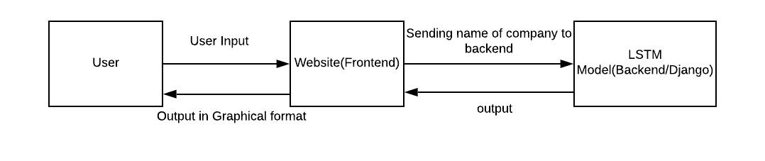

Architecture:
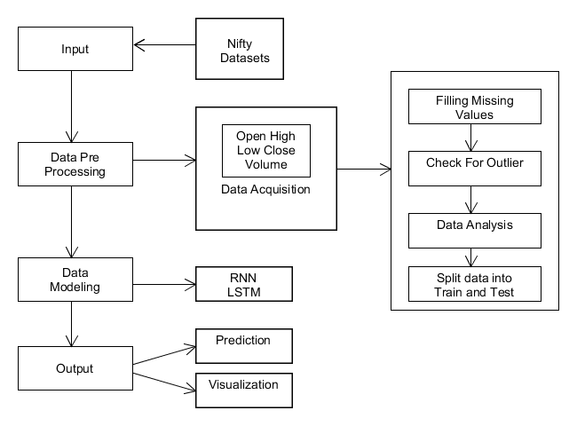
DFD:
A Data Flow Diagram (DFD) is a graphical portrayal of the "stream" of information through an Information System. An information stream outline can likewise be utilized for the representation of Data Processing. It is normal practice for a creator to draw a setting level DFD first which shows the cooperation between the framework and outside elements. This setting level DFD is then "detonated" to show more detail of the framework being displayed.

SYMBOLS | DESCRIPTION
 | Represents Data Flow
 | Represents Database
 | Represents the External Entity
 | Represents the Process that transforms incoming data flows into outgoing data flow.

DFD Level 1:
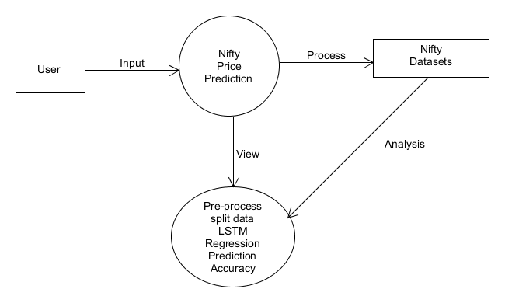

Activity Diagram:
An activivity diagram outwardly presents a progression of activities or stream of control in a framework like a flowchart or an information stream chart. Action graphs are regularly utilized in business measure demonstrating. They can likewise depict the means in an utilization case chart. Exercises demonstrated can be consecutive and simultaneous. In the two cases, an action outline will have a start (an underlying state) and an end (a last state).

initial state) and an end (a final state).
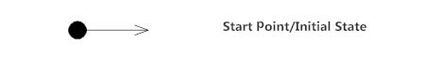
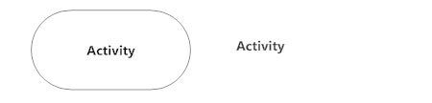
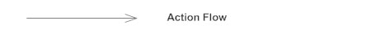
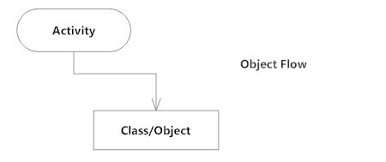
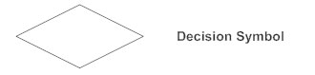
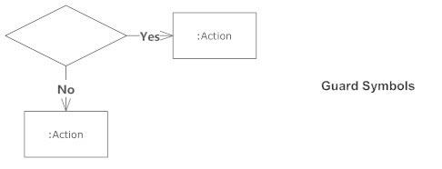
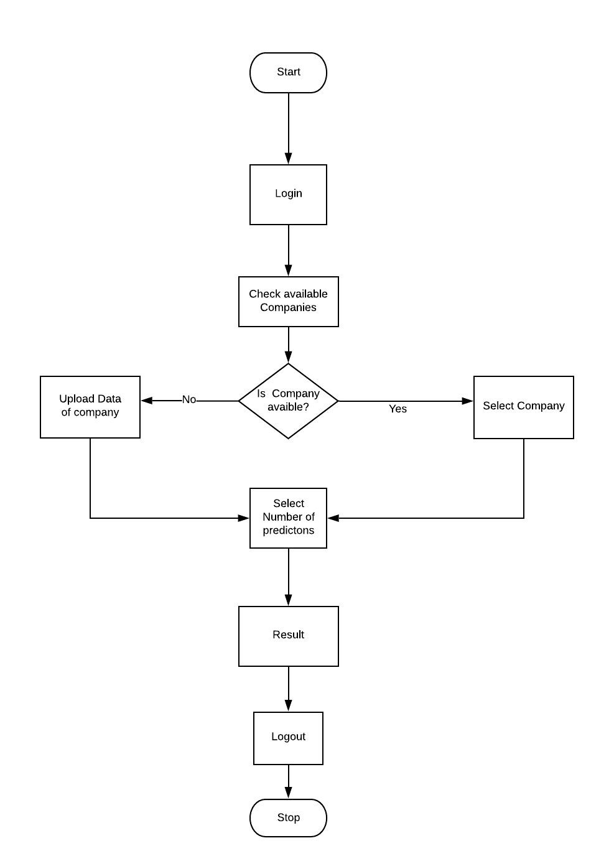

Sequence Diagram:
sequence diagram depict cooperations among classes as far as a trade of messages after some time. They're likewise called occasion charts. A grouping chart is a decent method to envision and approve different runtime situations. These can assist with anticipating how a framework will act and to find duties a class may need to have during the time spent demonstrating another framework.
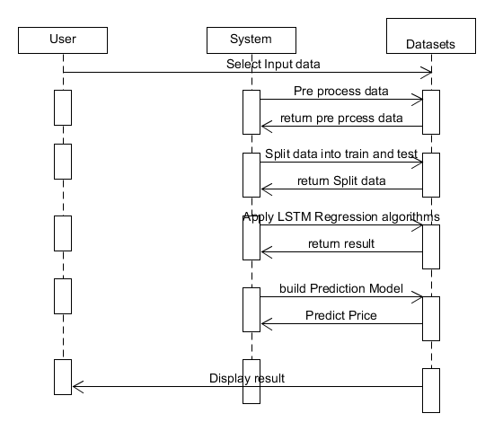

Usecase Diagram:

The motivation behind use case diagram is to catch the dynamic part of a framework. In any case, this definition is too nonexclusive to even think about describing the reason, as other four outlines (action, grouping, cooperation, and Statechart) likewise have a similar reason. We will investigate some particular reason, which will recognize it from other four charts.
Use case graphs are utilized to accumulate the prerequisites of a framework including inside and outside impacts. These prerequisites are generally plan necessities. Consequently, when a framework is investigated to accumulate its functionalities, use cases are readied and entertainers are distinguished.
