B. TECH. PROJECT REPORT
On
Vibration Reduction in Grass Trimmers Using a Multi-Axial Vibration Absorber

BY
Macharla Aravind



DISCIPLINE OF MECHANICAL ENGINEERING
INDIAN INSTITUTE OF TECHNOLOGY INDORE
November 2025

Vibration Reduction in Grass Trimmers Using a Multi-Axial Vibration Absorber

A PROJECT REPORT

Submitted in partial fulfillment of the
requirements for the award of the degrees

of
BACHELOR OF TECHNOLOGY in

MECHANICAL ENGINEERING

Submitted by:
Macharla Aravind

Guided by:

Prof. Anand Parey

INDIAN INSTITUTE OF TECHNOLOGY INDORE
November 2025

CANDIDATE’S DECLARATION

We hereby declare that the project entitled “Vibration Reduction in Grass Trimmers Using a Multi-Axial Vibration Absorber” submitted in partial fulfillment for the award of the degree of Bachelor of Technology in Mechanical Engineering completed under the supervision of Prof. Anand Parey, Department of Mechanical Engineering, IIT Indore is an authentic work.
Further, I declare that I have not submitted this work for the award of any other degree elsewhere.

Signature and name of the student(s) with date
_________________________________________________________________
CERTIFICATE by BTP Guide(s)
It is certified that the above statement made by the students is correct to the best of my knowledge.

Signature of BTP Guide(s) with dates and their designation

Preface

This report titled “Vibration Reduction in Grass Trimmers Using a Multi-Axial Vibration Absorber” has been prepared under the guidance of Prof. Anand Parey, Discipline of Mechanical Engineering, IIT Indore. The increasing emphasis on ergonomics and operator safety in handheld machinery motivates the need for effective vibration-control solutions. Grass trimmers, in particular, transmit significant multi-directional vibrations to the user, leading to discomfort and long-term health risks.
This project investigates the development, tuning, fabrication, and testing of a multi-axial vibration absorber mounted near the handle of a grass trimmer. Through experimental modal analysis, absorber tuning studies, harmonic response simulations, and ISO-based vibration measurements, this work demonstrates how structural dynamics-based passive absorbers can reduce harmful vibration exposure without modifying the primary machine structure.
The report presents theoretical background, absorber design methodology, fabrication details, simulation-based tuning, and a comparison of vibration levels before and after installation. The findings are expected to contribute to improved vibration-control strategies in portable machinery.
We express our sincere gratitude to everyone who supported this endeavor.

Macharla Aravind
B.Tech. Final Year
Discipline of Mechanical Engineering
Indian Institute of Technology Indore

Acknowledgements

I would like to express my sincere gratitude to Prof. Anand Parey for his invaluable guidance, support, and encouragement throughout the course of this project. His deep knowledge of vibration engineering and his constant motivation helped me understand the subject better and complete this work successfully.
I am thankful to the laboratory staff of the Mechanical Engineering discipline for their assistance during experimental modal analysis, vibration data acquisition, and fabrication activities. Their timely help made the experimental phase of this work smooth and productive.
I would also like to thank my friends and batchmates for their continuous encouragement, insightful discussions, and support during the various stages of this project.
Finally, I am deeply grateful to my parents for their unconditional love, patience, and belief in me. Their constant support has been my greatest strength throughout my academic journey.

Macharla Aravind
B.Tech. Final Year
Discipline of Mechanical Engineering
Indian Institute of Technology Indore

Abstract

Handheld grass trimmers expose operators to high levels of multi-axial vibration due to engine excitation, shaft imbalance, and structural resonance of the pipe assembly. Prolonged exposure can lead to discomfort and health hazards under ISO 5349. This project aims to reduce handle vibration by designing and implementing a multi-axial tuned vibration absorber (TVA) mounted near the handle region.
Experimental modal analysis was first performed on the trimmer pipe to identify dominant mode shapes and resonant frequencies. A multi-axial absorber consisting of two orthogonal threaded rods and four end masses was designed to target the critical resonance near 52 Hz, corresponding to major excitation from motor and shaft rotation. Analytical tuning relations, stiffness estimation for 7 mm rods, and absorber-mass variation studies were used to determine suitable absorber specifications. The absorber was fabricated and installed at the experimentally determined node location.
Harmonic response simulations and FRF-based tuning confirmed the absorber’s effectiveness in splitting the primary resonance and reducing peak amplitudes. Experimental validation showed substantial reductions in weighted and unweighted RMS acceleration, with overall vibration reductions of 42–50% across the X, Y, and Z axes. The results demonstrate that a compact, low-mass absorber (0.10 kg) can significantly mitigate harmful vibrations without altering the trimmer’s primary structure.
The study highlights the applicability of tuned passive absorbers in portable power tools and provides a framework for future optimization in absorber geometry, material selection, and adaptive tuning.

Table of Contents

CANDIDATE’S DECLARATION ii
Preface iii
Acknowledgements iv
Abstract v
Table of Figures viii
List of Tables viii
1.Introduction 1
1.1 Background Overview 1
1.1.1. Vibration Issues in Weed Trimmers 1
1.1.2. Structural Behavior of the Trimmer Shaft 1
1.1.3. Principle of Imposing a Node Using Vibration Absorbers 1
1.1.4. Past Approaches and Their Limitations 2
1.1.5. Need for a Multi-Axial Vibration Absorber 3
1.2 Brief Literature Review 3
1.3 Research Gap 4
1.4 Objectives 5
2.Methodology 6
2.1. Experimental Vibration Characterization and Modal Analysis 6
2.1.1 Experimental modal analysis (EMA) 7
2.2. Dynamic Modelling of the Trimmer Shaft 7
2.2.1 Imposing Nodes on Elastic and Lumped-Mass Systems: Theory and Calculation 8
2.2.2 Collocated Case: Theory and Calculation 10
2.2.3 Non-Collocated Case: Theory and Calculation 10
2.2.4 Selection of the Collocated Case for This Project 11
2.3 Design and Tuning of the Multi-Axial Vibration Absorber 12
2.3.1 Design Concept and Functional Requirements 12
2.3.2 Analytical Estimation of Absorber Frequency 12
2.4. Fabrication and Experimental Validation 14
3.Results and Discussion 16
3.1 Time and Frequency-Domain Analysis (FFT) 16
3.2 Absorber Natural Frequency and Experimental Modal Analysis of the Trimmer Pipe 17
3.3 Effect of End Mass and Mass Position on Absorber Tuning 22
3.4 FRF Simulation of the Trimmer with Different Absorber Masses 23
3.4.1 Derivation of the governing equations and the FRF used in simulation 23
3.4.2 Selection of 0.10 kg as the Practical Absorber Mass 24
3.5 Comparison Between Simulation and Experimental Results 25
3.6 Overall Effectiveness of the Multi-Axial Absorber 26
4.Conclusion and Scope for Future Work 28
4.1 Conclusion 28
4.2 Scope for Future Work 28

Table of Figures

Figure 1.Lumped mass system of Grass trimmer 1
Figure 2 Imposing Node at desired location by adding absorber (M_{a}) 2
Figure 3.Experimental setup for vibration analysis 6
Figure 4.Experimental Modal analysis Setup 6
Figure 5.FRF graph for the primary system (i.e. without absorber) 7
Figure 6.Lumped mass system of Grass trimmer 8
Figure 7.An arbitrarily supported elastic structure that is subjected to a localized harmonic excitation and carrying any 9
Figure 8.CAD model for the absorber 12
Figure 9.Dimensions of the absorber system used for 13
Figure 10.Multiple orthographic mechanical drawings with dimensions, depicting TVA 14
Figure 11.Multi axial Tunable vibrational absorber 15
Figure 12.Grass trimmer system with TVA 15
Figure 13.Direction convention used for experiment 16
Figure 14.Time and Frequency-Domain data from both the handles. 16
Figure 15.LMS Test.Lab node-based model used to generate structural mode shapes through a sequence of interconnected processing blocks 17
Figure 16.FRF graph for the primary system 18
Figure 17.Mode shapes at respective frequency (before installation of TVA). 20
Figure 18.Mode shapes at respective frequency (after installation of TVA). 22
Figure 19.Graph of Effect of End Mass and Mass Position on Absorber Tuning 22
Figure 20.The FRF plot demonstrates that increasing the absorber mass progressively reduces the resonance peak amplitude, indicating effective vibration attenuation compared to the no-absorber case. 24
Figure 21.The figure shows the change in vibration amplitude across the X, Y, and Z axes after installing the absorber. 26

List of Tables
Table 1.The table summarizes how different absorber masses affect the system’s dynamic response, showing that increasing mass lowers the peak resonance frequency, slightly reduces the peak amplitude, and provides substantial RMS vibration reduction of about 72–77% at 52 Hz. 24

Chapter 1

Introduction

1.1 Background Overview

1.1.1. Vibration Issues in Weed Trimmers
Weed trimmers both petrol-based and electric are widely used for vegetation cutting, landscaping, and agricultural maintenance. These machines typically consist of a high-speed motor or engine connected to a long slender shaft, with the cutting head located at the opposite end. During operation, the user supports and guides the tool through handles positioned along the shaft.
A major issue associated with these machines is the high level of vibration transmitted to the operator’s hands, commonly referred to as hand–arm vibration. The vibration arises due to several factors, including motor or engine excitation, imbalance of the rotating cutting head, flexibility of the shaft, and the interaction between the rotating string and vegetation. Continuous exposure to elevated vibration levels can lead to discomfort, reduced task accuracy, fatigue, and long-term medical problems such as Hand–Arm Vibration Syndrome (HAVS). Therefore, reducing handle vibration is a critical requirement for improving user safety and operational comfort.

1.1.2. Structural Behavior of the Trimmer Shaft
The shaft of a weed trimmer behaves mechanically like a slender beam with lumped masses attached at various positions, such as the motor or engine, the intermediate handle, the loop handle, and the cutter head. This beam-type structure exhibits several bending modes within the operating frequency range of the tool.
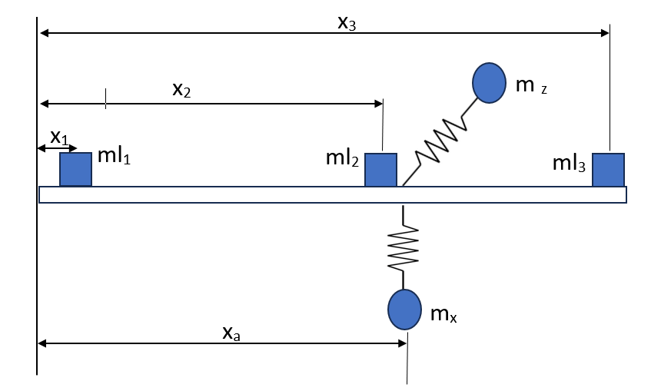
Figure 1.Lumped mass system of Grass trimmer
When the machine operates at typical speeds, these modes may become excited. As a result, large transverse deflections can occur along the shaft, and the handle region often lies near the points of maximum vibrational response. This structural behavior is one of the primary reasons why operators experience high vibration levels at the handle, even if the motor itself is relatively stable.

1.1.3. Principle of Imposing a Node Using Vibration Absorbers
A well-known passive vibration-control principle states that the vibrational displacement at a particular location on a structure can be forced to become zero(or) nearly zero by attaching and tuning an appropriate vibration absorber. This condition is known as imposing a node. The absorber acts as an additional dynamic subsystem that interacts with the main structure and reshapes its steady-state vibration pattern.
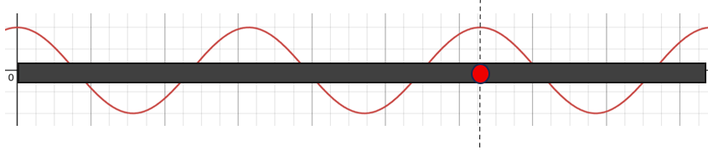
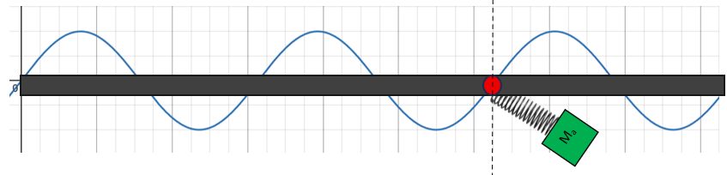
Figure 2 Imposing Node at desired location (O) by adding absorber (M_{a})
If the absorber is tuned such that its natural frequency matches the frequency of the excitation, it can force the desired point on the structure to behave like a vibration node. This strategy can be applied either when the absorber is attached at the same location where vibration reduction is needed (collocated case) or when it is attached elsewhere but tuned to shift the node to the desired position (non-collocated case). This principle is highly suitable for long shaft-type systems such as weed trimmers.

1.1.4. Past Approaches and Their Limitations
Earlier implementations of the imposing-node principle on shaft-like tools have largely used single-axis vibration absorbers. These devices typically consist of a small mass–spring system attached to the shaft, designed to reduce vibration predominantly in one direction. While such absorbers have successfully reduced handle vibration in certain cases, they suffer from two major limitations:
Direction-specific performance:
They reduce vibration effectively in only one axis, usually in the primary bending direction of the shaft.
Changing excitation characteristics:
Petrol trimmers experience multi-directional excitations due to engine forces, while electric trimmers experience strong harmonic forces from the motor and gear system. These forces typically act in both the side–side and up–down directions, making single-axis absorbers insufficient for comprehensive vibration control.
Therefore, an improved design is required that can independently or simultaneously address vibrations in multiple axes.

1.1.5. Need for a Multi-Axial Vibration Absorber
To effectively reduce handle vibration in both petrol-driven and electric weed trimmers, the vibration-control system must address the multi-directional nature of the excitation. A multi-axial vibration absorber is therefore essential. Such an absorber consists of two or more dynamically independent units arranged along perpendicular directions. Each unit can be tuned to the dominant excitation frequency and can act on the corresponding vibration component of the shaft.
A multi-axial absorber provides the following benefits:
- It can control X-axis (side–side) vibration and Z-axis (vertical) vibration simultaneously.
- It ensures vibration reduction over a wider range of operating speeds.
- It preserves the imposing-node behavior at the handle location in all relevant axes.
- It remains entirely passive, lightweight, and easy to mount on both petrol and electric trimmer designs.
- It does not require electronic control systems, making it cost-effective and reliable for field use.

1.2 Brief Literature Review
P.D. Cha (2004) presents one of the foundational theoretical studies relevant to vibration suppression in elastic structures. His work focuses on the concept of imposing nodes by attaching spring–mass oscillators to a beam or elastic body so that specific points experience zero displacement during harmonic excitation. Cha demonstrates that when absorber attachment points coincide with the intended node locations, multiple nodes can always be imposed at any desired position for a given frequency. When the absorber is placed elsewhere, node creation becomes frequency-dependent but still achievable. His study outlines the mathematical formulation for selecting absorber stiffness and mass and provides numerical validation, establishing the theoretical basis for forcing nodes on continuous structures as a vibration control strategy.
Ko Ying Hao and Zaidi Mohd. Ripin (2013) investigate the application of the imposing node technique on a real grass trimmer system. Their work models the trimmer shaft as a slender beam carrying lumped masses representing the engine, handle, and cutting head. By installing two tuned vibration absorbers (TVAs) at 0.74L and 0.85L along the shaft, they successfully shift a vibration node to the handle location. Experimental modal analysis and operating deflection shape results confirm that the node forms precisely near the loop handle, achieving significant vibration reductions of 71% at the loop handle and 72% at the rear handle. Their study establishes that the node-imposition technique, when implemented correctly, is an effective passive control method for reducing hand-transmitted vibration in grass trimmers.
Sushil S. Patil and Pradeep J. Awasare (2016) further develop the concept by introducing tunable vibration neutralizers designed to impose nodes at desired locations on Euler–Bernoulli beams. Unlike fixed-frequency absorbers, these neutralizers incorporate variable stiffness, enabling the resonance frequency of the device to be adjusted to match the excitation frequency. Patil and Awasare propose an iterative numerical procedure to compute the neutralizer's optimal tuning frequency for node creation. Their simulations and experiments demonstrate that nodes can be reliably imposed across a structure, enabling significant vibration attenuation in targeted regions. This work contributes an adaptable methodology suitable for systems subjected to forced vibration at known frequencies.
In a related study, Patil and Awasare (2016) also examine the vibration isolation of lumped masses supported on beams through multiple damped absorbers. This work extends classical TVA theory by accounting for dampers, absorber amplitude constraints, and the presence of multiple substructures on the beam. The authors develop a computational algorithm to determine absorber parameters capable of imposing nodes even under practical constraints such as limited absorber motion. Experimental validation illustrates that these absorbers can isolate sensitive substructures from vibration by ensuring that node locations coincide with their mounting points. This research further supports the feasibility of using absorber-based node control in multi-component systems similar to grass trimmers.
The health motivation underpinning such engineering solutions is reinforced by Mohamad Hanafi Ali et al. (2018), who examine hand–arm vibration exposure among grass-cutting workers in Malaysia. Their study shows that the daily vibration exposure for both hands often exceeds the exposure action value of 2.5 m/s², with many workers demonstrating early symptoms of hand–arm vibration syndrome (HAVS), such as finger colour change and musculoskeletal discomfort. Their findings indicate that traditional administrative or protective measures are insufficient and highlight the need for engineering interventions that reduce vibration at the tool itself, thereby reducing risk at the source.
Together, these studies present a clear progression: from theoretical formulations of node imposition (Cha), to practical implementation using tuned absorbers on trimmer shafts (Hao & Ripin), to advanced tuneable neutralizer designs capable of adjusting to different frequencies (Patil & Awasare), and finally to occupational health evidence showing why such solutions are necessary (Ali et al.). While significant progress has been made, existing absorber designs primarily address single-axis vibration and often depend on fixed-frequency excitation. This creates a research gap for multi-axial, tunable, and practical absorbers suitable for both petrol and electric weed trimmers, which operate with multi-directional forces and variable speeds.

1.3 Research Gap
Although significant progress has been made in understanding and controlling vibration in grass trimmers, several critical gaps remain unaddressed. Existing studies on node imposition, such as the theoretical work by P.D. Cha and the beam-based absorber designs proposed by Patil and Awasare, demonstrate that tuned vibration absorbers can successfully impose nodes and reduce vibration at specific points on elastic structures. Likewise, Hao and Ripin have shown that attaching tuned absorbers to selected locations on a grass-trimmer shaft can shift a vibration node to the handle, yielding substantial vibration reductions. However, these implementations are primarily single-axis solutions, focusing only on one dominant direction of vibration.
Real grass trimmers—both petrol and electric—experience multi-directional excitation, particularly in the X- and Z-axes, as demonstrated by experimental vibration measurements. The dynamic behaviour of the shaft, combined with the rotational imbalances of the engine or motor, produces complex vibrational patterns that cannot be fully mitigated by absorbers tuned for a single direction. Moreover, petrol trimmers operate over a broad range of speeds, which makes fixed-frequency absorbers less effective, while electric trimmers operate at stable speeds but still exhibit multi-axis vibration patterns that require more than a one-dimensional control approach.
Additionally, most studies focus on either theoretical beam systems or laboratory prototypes, with limited translation to practical multi-axis absorber designs suitable for real trimmer geometries, weight constraints, and mounting conditions. The absence of a compact, field-ready absorber capable of simultaneously controlling vibration along multiple axes leaves a significant gap between theory and practical engineering application. Furthermore, the growing body of occupational health research highlights persistent vibration exposure levels that exceed safe limits, reinforcing the need for a robust engineering solution that addresses vibration at the source rather than relying solely on administrative controls or protective equipment.
Therefore, a clear research gap exists in the development of a multi-axial, tuneable vibration absorber that can impose nodes across more than one direction, adapt to different operational speeds, and be practically integrated into both petrol and electric weed trimmers. Addressing this gap would bridge theoretical advances with real-world requirements and significantly enhance user safety and tool ergonomics.

1.4 Objectives
- To analyze the vibration characteristics of petrol and electric weed trimmers by measuring the time-domain and frequency-domain responses along the shaft and handle regions, identifying dominant excitation frequencies and vibration directions.
- To model the weed trimmer shaft as a beam-like elastic structure with lumped masses and determine its dynamic behavior, including natural frequencies, mode shapes, and regions of high vibration amplitude.
- To design a multi-axial vibration absorber capable of imposing vibration nodes at or near the handle location, targeting simultaneous attenuation in both the X- and Z-axes where vibration levels are highest.
- To determine the optimal absorber parameters—including mass, stiffness, and placement—using analytical methods such as node-imposition theory and tuning relationships applicable to both petrol and electric trimmer operating conditions.
- To fabricate a practical prototype of the multi-axial absorber that meets weight, size, and compatibility constraints for integration onto real weed trimmer shafts.
- To experimentally evaluate the performance of the developed absorber by comparing vibration levels before and after installation in controlled laboratory conditions and under realistic operating scenarios.

Chapter 2

Methodology

2.1. Experimental Vibration Characterization and Modal Analysis
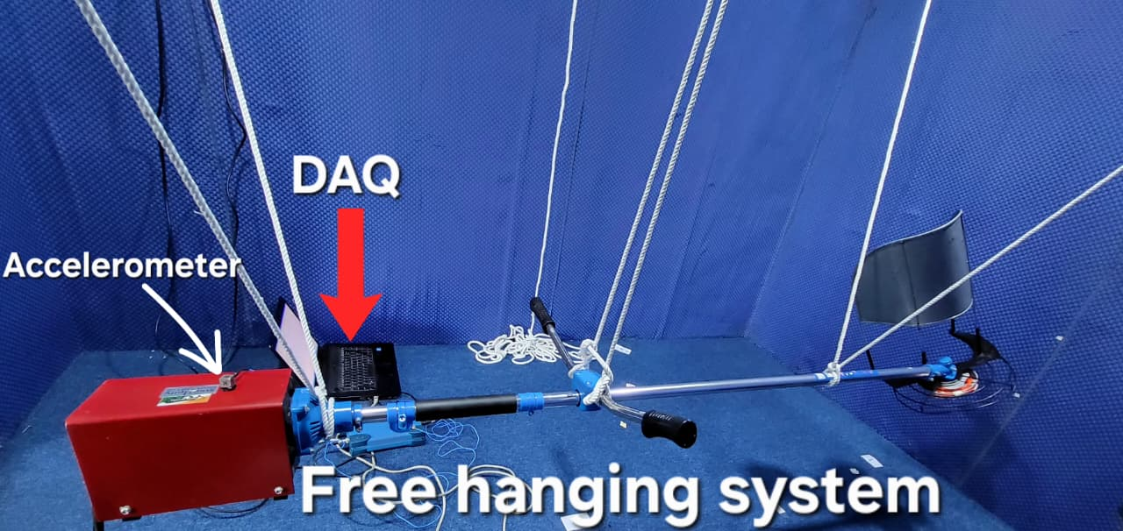
Figure 3.Experimental setup for vibration analysis
Experimental vibration characterization was conducted to determine the dynamic behavior of the weed trimmer shaft prior to designing the vibration absorber. In this process, the trimmer was instrumented with tri-axial accelerometers at selected locations along the shaft, and the structure was excited using an impact hammer while the vibration response was recorded through a data acquisition system. From these measurements, frequency response functions were obtained to identify the natural frequencies, mode shapes, and damping ratios of the shaft. Experimental Modal Analysis (EMA) plays a central role in this phase, as it is a technique used to determine a structure’s modal parameters by analyzing its response to a known excitation. EMA is performed by exciting the structure, measuring its input and output signals, and extracting modal information from the resulting frequency response. This method is highly valuable because it provides direct insight into how and where the structure vibrates, enabling the identification of vibration modes that contribute most to handle vibration. The results from EMA form the basis for absorber design by indicating the dominant frequencies, high-deflection regions, and suitable locations for imposing a vibration node to reduce the transmitted vibration at the handle.
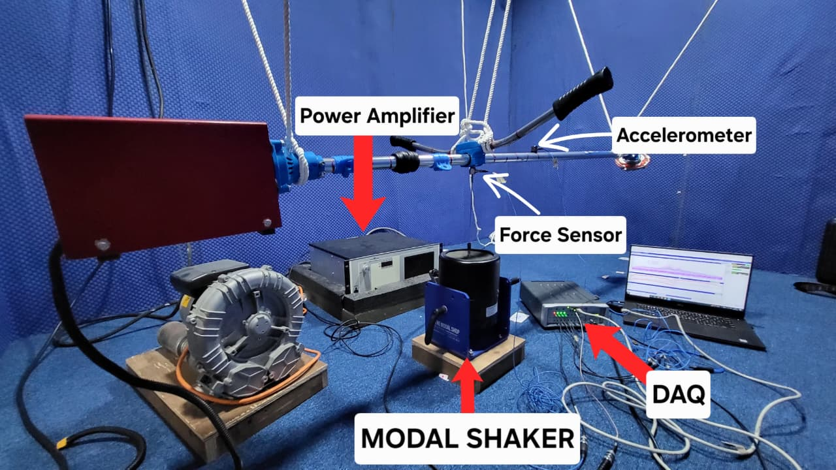
Figure 4.Experimental Modal analysis Setup

2.1.1 Experimental modal analysis (EMA)
- Excite the system with a known force (impulse, shaker, or impact hammer) & measure the system response using accelerometers or displacement sensors.
- Compute the Frequency Response Function (FRF), which is the ratio of output (response) to input (force) in the frequency domain:
$$H(f)=\frac{X(f)}{F(f)}$$
where X(f) = response, F(f) = input force.
- The resonating frequencies when performed experimental modal analysis 8,16,52,60,68,90,122,128,138,150,188 Hz
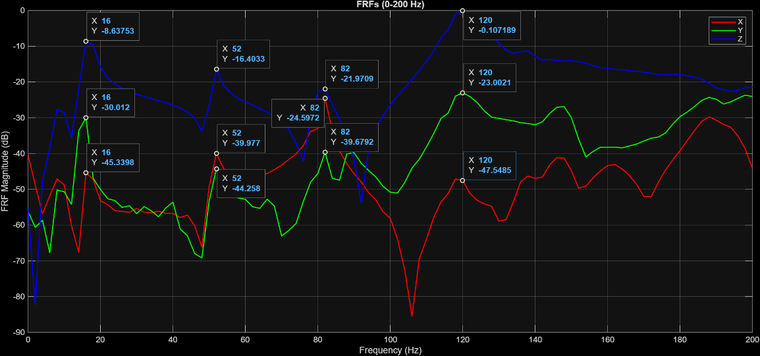
Figure 5.FRF graph for the primary system (i.e. without absorber)

2.2. Dynamic Modelling of the Trimmer Shaft
The dynamic modelling of the weed trimmer shaft was carried out to develop an analytical representation of its vibration behavior and to support the design of the multi-axial vibration absorber. Since the shaft behaves as a slender structural member with concentrated masses such as the motor, handle, and cutter head, it was modelled as a Euler–Bernoulli beam carrying lumped masses at appropriate locations. This modelling approach captures the essential flexural characteristics of the shaft while allowing the influence of attached components to be represented accurately. The governing differential equation for transverse vibration of the beam was formulated by considering the effects of bending stiffness, mass distribution, and external excitation. Boundary conditions were defined based on the actual mounting and support configuration of the trimmer.
Figure 6.Lumped mass system of Grass trimmer
Modal analysis was then performed on the mathematical model to extract the natural frequencies and corresponding mode shapes. These theoretical mode shapes were compared qualitatively with the experimental modal patterns to ensure consistency and to verify that the model captured the dominant dynamic behavior observed during testing. The analytical mode shapes were particularly important for identifying the locations of anti-nodes—regions of maximum vibration—and the regions where node formation is feasible. This information was used to predict how the installation of a vibration absorber would alter the shaft’s dynamic response, especially at the handle region where vibration reduction is required.
The dynamic model also enabled simulation of the absorber–shaft interaction. By representing the absorber as a single-degree-of-freedom mass–spring system attached to the beam, the coupled equations of motion were developed. This allowed the prediction of how variations in absorber mass, stiffness, and placement would affect the overall frequency response of the system. Through this modelling process, it was possible to estimate the absorber tuning frequency required to impose a vibration node at or near the handle and to evaluate the effectiveness of candidate absorber configurations before fabrication.

2.2.1 Imposing Nodes on Elastic and Lumped-Mass Systems: Theory and Calculation
Imposing a node is a vibration-control strategy in which a point on an elastic or lumped-mass system is forced to exhibit zero displacement during harmonic excitation. While natural nodes occur at fixed positions determined by the structure’s inherent mass and stiffness distribution, a node can be intentionally created at any location by attaching a properly tuned vibration absorber. This concept is particularly useful in applications such as weed trimmers, where the handle region experiences significant vibration, and imposing a node at that location can greatly reduce the vibration transmitted to the user.
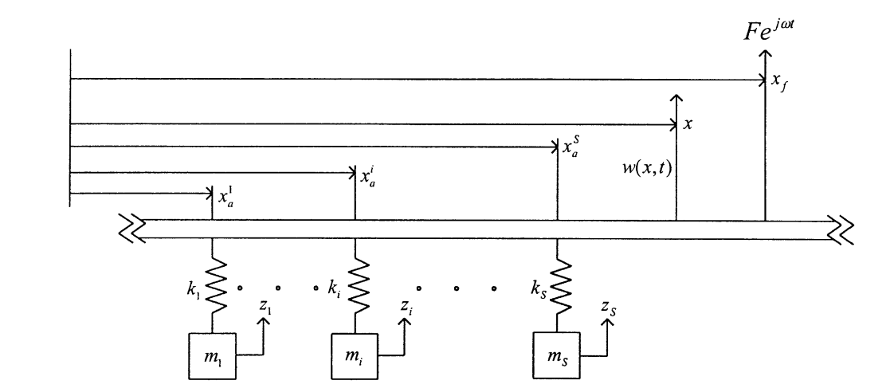
Figure 7.An arbitrarily supported elastic structure that is subjected to a localized harmonic excitation and carrying any
Consider an arbitrarily supported elastic structure to which S-sprung masses are attached as shown in Fig. 7
$$\begin{matrix} & w\left(x , ,t\right)=\sum_{i=1}^{N}{ϕ_{i}}\left(x\right)η_{i}\left(t\right)\end{matrix}$$
where:
- $ϕ_{i}\left(x\right)$are the mode shapes of the beam
- $Z_{i}\left(t\right)$are the modal coordinates
- $N$is the number of modes considered
To describe the behaviour mathematically, the structure is expressed using an assumed-modes representation, and the absorbers are modelled as lumped mass–spring oscillators attached at selected points. For harmonic excitation of frequency ω, the coupled equations of the structure and the absorbers can be written as:
At the point where we want a node, we attach:
- mass $m_{a}$
- spring of stiffness $k_{a}$
$$\begin{matrix} & \left[\begin{matrix}\left[K\right]-ω^{2}\left[M\right] & \left[R\right] \\ \left[R{\left.]\right.}^{T}\right. & \left[k\right]-ω^{2}\left[m\right]\end{matrix}\right]\left[\begin{matrix}\underset{―}{\overline{η}} \\ \underset{―}{\overline{z}}\end{matrix}\right]=\left[\begin{matrix}Fϕ\left(x_{f}\right) \\ \underset{―}{0}\end{matrix}\right]\end{matrix}$$
Here:
- $R$ contains the mode-shape values at the absorber location, i.e., $ϕ_{i}\left(x_{a}\right)$.
- $\tilde{Z}$ is the modal displacement vector
- $\tilde{z}$ is the complex amplitude of absorber mass motion
where $\overset{˜}{Z}$ contains the modal coordinates of the elastic structure, and $\overset{˜}{Z}$ contains the steady-state amplitudes of the attached absorbers. The matrices $K$ and $M$ represent the modal stiffness and mass of the structure, while $k$ and $m$ contain the absorber stiffnesses and masses. The matrix $R$ captures the coupling terms based on the eigenfunctions at attachment points.
Eliminating the absorber coordinates yields a reduced modal equation:
$$\left[K-ω^{2}M+\sum_{i=1}^{S}{ } s_{i}ϕ\left(x_{a,i}\right)ϕ^{T}\left(x_{a,i}\right)\right]\overset{˜}{Z}=Fϕ\left(x_{f}\right),$$
with
$$s_{i}=\frac{k_{i}ω^{2}}{m_{i}ω^{2}-k_{i}}$$
The displacement at any point $x$ is obtained from
$$ω(x)=ϕ^{T}(x)\overset{˜}{Z}.$$
A node is imposed when $ω\left(x_{n}\right)=0$.

2.2.2 Collocated Case: Theory and Calculation
In the collocated case, the absorber is attached exactly at the location where the node is required. This leads to the most stable and straightforward node-imposition behavior, because the absorber directly modifies the local dynamic stiffness at that point. The node condition reduces to
$$Z_{\text{structure}}\left(x_{n},ω\right)+Z_{\text{absorber} }(ω)=0,$$
where the absorber dynamic stiffness is
$$z_{\text{abaxter }}=k-mω^{2}.$$
Thus, the node to created when
$$k=mω^{2}.$$
This equation shows that for any chosen operating frequency ω, a node can always be imposed by selecting mass and stiffness such that they satisfy the above relation. The calculation steps are simple: a practical absorber mass is selected, and the appropriate stiffness is determined from the expression. As long as the absorber’s motion remains within acceptable limits, the collocated configuration ensures a reliable node at the attachment location.

2.2.3 Non-Collocated Case: Theory and Calculation
In the non-collocated case, the absorber is attached at a point xa​ that is different from the desired node location x_{n}​. Here, node imposition occurs indirectly, as the absorber alters the entire mode shape of the structure in such a way that displacement cancels to zero at the target point. The node condition may be expressed as:
$$u\left(x_{n},ω\right)=n_{n}\left(x_{n},ω\right)+H\left(x_{n},x_{n},ω\right)F_{n}(ω)=0,$$
Where,
$F_{a}(ω)=\left(k-mω^{2}\right)u\left(x_{a,}ω\right)$ is the force ganerated by the abcontex, and $H\left(x_{n},x_{a,}ω\right)$ represents the structural trancher relationehip batewen aboxtber and node lacations.
For a single absorber, a closed-form expression can be obtained for the mass mmm required to impose the node for a given stiffness k, frequency ω, and locations xa​ and xn​:
$$m=\frac{c_{1}k}{ω^{2}\left(c_{1}+c_{1}c_{1}k-c_{2}k^{1}\right)}$$
where the modal coefficients are
$$\begin{matrix}c1=\sum_{i=1}^{N}{ } \frac{μ_{1}\left(z_{n}\right)μ_{1}\left(z_{1}\right)}{K_{i}-M_{i}ω^{2}}, \\ c_{2}=\sum_{i=1}^{N}{ } \sum_{j=1}^{N}{ } \frac{φ_{1}\left(z_{n}\right)φ_{1}\left(x_{n}\right)φ_{d}\left(x_{n}\right)φ_{d}\left(x_{1}\right)}{\left(K_{i}-M_{i}ω^{2}\right)\left(K_{j}-M_{j}ω^{2}\right)}, \\ c3=\sum_{i=1}^{N}{ } \frac{φ_{1}^{2}\left(x_{n}\right)}{K_{i}-M_{i}ω^{2}}\end{matrix}$$
A positive mass indicates that node imposition is physically possible for the chosen parameters. A negative mass indicates that no feasible solution exists at that frequency or absorber location. Even when feasible, the imposed node in a non-collocated system is highly frequency-dependent and sensitive to parameter variations.
The absorber’s predicted steady-state amplitude can be calculated from:
$$z=\frac{k^{2}\left(x_{0}\right)\overset{‾}{z}}{k-mω^{2}},$$
which must be checked to ensure practical implement ability.

2.2.4 Selection of the Collocated Case for This Project
Although the non-collocated formulation is mathematically general, it requires strict tuning, produces nodes only at a specific frequency, and can become highly sensitive to small variations in stiffness, mass, and structural geometry. In contrast, the collocated case allows a node to be imposed at the attachment point for any chosen frequency simply by satisfying $k=mω^{2}$. This makes collocated absorbers more robust and easier to tune, especially for systems such as weed trimmer shafts, where multi-directional excitation and operational speed variations must be accommodated. For these reasons, the collocated configuration is adopted in this project as the preferred approach for imposing a node at the handle and achieving reliable vibration reduction.

2.3 Design and Tuning of the Multi-Axial Vibration Absorber

2.3.1 Design Concept and Functional Requirements
The objective of the absorber design is to reduce handle vibration in both principal directions that dominate excitation in weed trimmers, primarily the lateral (X-axis) and vertical (Z-axis) components. To achieve this, a multi-axial absorber is constructed as two orthogonally oriented single-axis absorbers integrated into a common central housing. Each arm is responsible for controlling vibration along one direction, and together they provide bi-directional vibration suppression. The absorber must be compact, lightweight, adjustable, and capable of being tuned to match the operational excitation frequencies of the trimmer. Additional design constraints include durability, minimal added mass, and a secure mounting mechanism that does not interfere with normal operation.
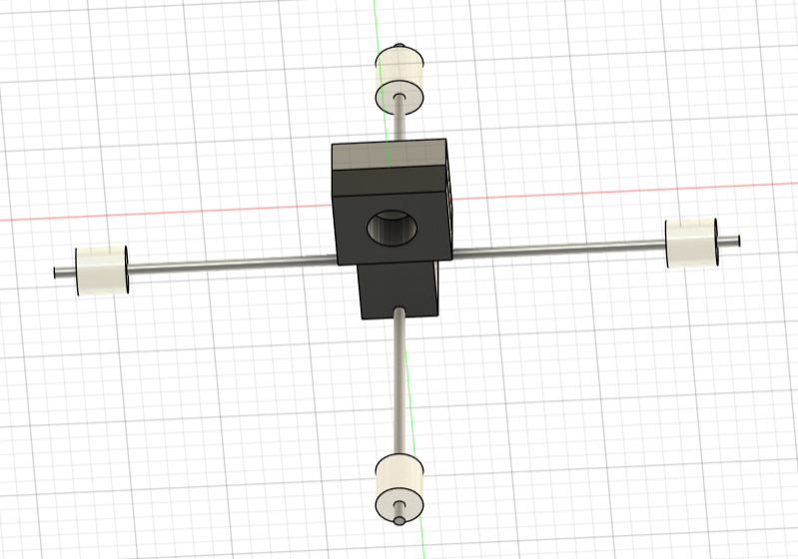
Figure 8.CAD model for the absorber

2.3.2 Analytical Estimation of Absorber Frequency
Designed a multi-axial absorber using Dunkerley’s equation
The absorber consists of two cantilever arms positioned at right angles and attached to a central clamp that mounts rigidly onto the trimmer shaft. Each cantilever arm carries an adjustable end mass that can slide along the arm’s length to modify the dynamic stiffness and tuning frequency of the absorber. The rods are typically made of steel or aluminum to achieve the required stiffness, while the end masses are made adjustable to allow real-time tuning during testing. The central housing is designed to be stiff enough to avoid altering the absorber’s dynamic properties and to ensure efficient transfer of reaction forces into the shaft.
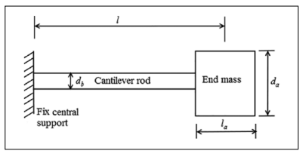
Figure 9.Dimensions of the absorber system used for
Dunkerley’s equation is used to estimate the combined natural frequency of such a system.
It assumes:
$$\frac{1}{ω^{2}}=\frac{1}{ω_{a}^{2}}+\frac{1}{ω_{b}^{2}}$$
- $ω$= final natural frequency of absorber
- $ω_{a}$= natural frequency of cantilever with end mass
- $ω_{b}$= natural frequency of rod’s own bending mode
Frequency of the rod alone (no tip mass):
$$ω_{b}=\sqrt{\frac{12.7 EI}{m_{b} l^{3}}}$$
Frequency due to the end mass (ma):
Taken from standard beam theory:
$$ω_{a}=\sqrt{\frac{3EI}{m_{a} l^{3}}}$$
Substituting both formulas gives the equation used in the paper:
$$ω=\sqrt{\frac{3EI}{m_{a}l^{3}}+\frac{12.7EI}{m_{b}l^{3}}}$$
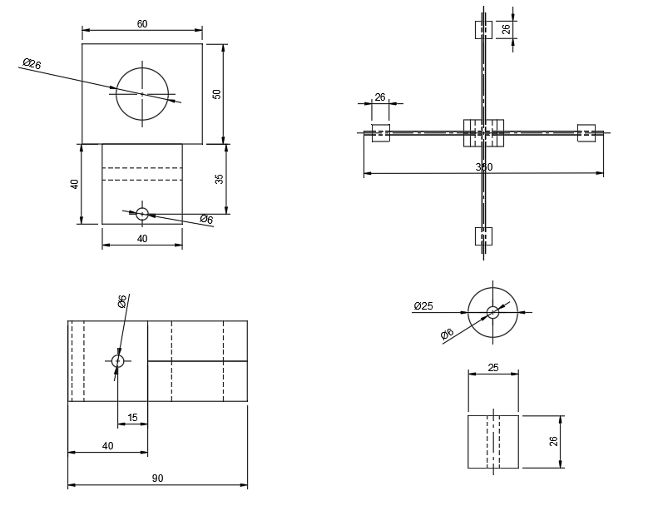
Figure 10.Multiple orthographic mechanical drawings with dimensions, depicting TVA

2.4. Fabrication and Experimental Validation
The fabrication process began after finalising the analytical dimensions and tuning requirements of the multi-axial vibration absorber. The absorber was manufactured as a compact assembly consisting of a central clamp, two orthogonally oriented cantilever arms, and adjustable end masses. The central housing was machined from aluminium to ensure adequate stiffness while keeping the overall weight manageable. This housing was designed to fit securely around the trimmer shaft without causing deformation or restricting user operation.
The cantilever rods were fabricated from steel to provide the necessary bending stiffness required for absorber tuning. The rods were cut to the predetermined length and threaded at one end to allow precise axial movement of the end masses. Each end mass was manufactured from mild steel, drilled and tapped to engage with the threaded rod, and shaped to maintain compact geometry. This configuration allowed the mass position to be adjusted incrementally during the tuning process.
Experimental validation was carried out to evaluate the effectiveness of the multi-axial absorber in reducing handle vibration. The testing procedure aimed to determine the vibration levels at the handle before and after absorber installation and to confirm whether a node was successfully imposed at the handle location.
The trimmer was first tested in its original configuration to obtain baseline vibration data. A tri-axial accelerometer was mounted at the handle, and the trimmer was operated at different speeds representing idle, mid-range, and typical working conditions. Acceleration signals were acquired using a data acquisition system with sufficient sampling frequency to capture the dominant operating frequencies. The recorded signals were analysed in both time and frequency domains to determine RMS acceleration values and identify the primary vibration peaks.
After the baseline test, the fabricated absorber was installed at the handle location using the central clamp. The absorber arms were aligned along the principal vibration axes, and tuning was performed by adjusting the end masses until the measured handle vibration amplitude reached a minimum at the target excitation frequency. Tuning adjustments were monitored in real time using the accelerometer data.
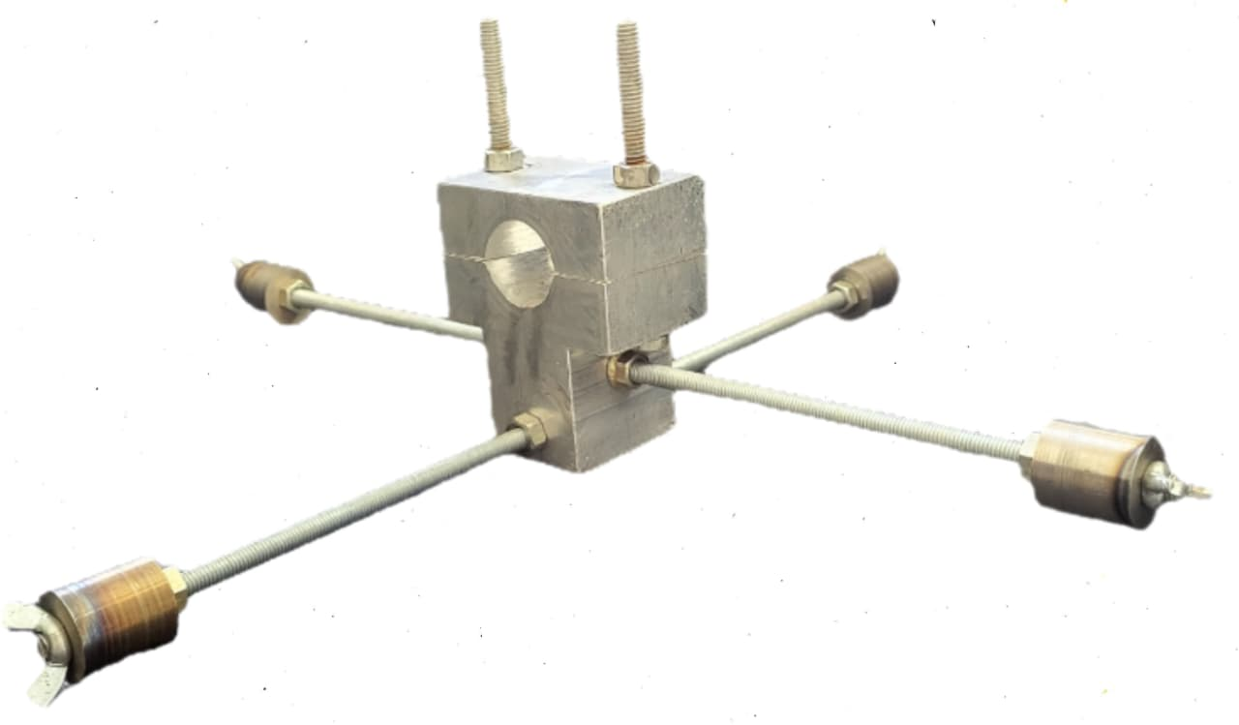
Figure 11.Multi axial Tunable vibrational absorber
Once tuning was completed, vibration measurements were repeated under the same operating conditions as the baseline test. The data acquisition procedure remained unchanged to ensure consistency. Frequency response functions were used to observe the change in dynamic behaviour at the handle, and RMS acceleration values were compared against the baseline results.
A successful absorber configuration was indicated by:
A significant reduction in vibration amplitude at the primary excitation frequency, a noticeable shift in the deformation pattern of the shaft, consistent with node formation at the handle, and reduced weighted vibration levels in the X and Z axes, which are the dominant excitation directions.
To confirm that a vibration node had been imposed at the handle, additional measurements were taken along the shaft length. A series of accelerometer readings were collected at multiple points between the engine and cutter head. The displacement pattern derived from these measurements showed a local minimum at the handle, indicating that the absorber successfully modified the shaft’s dynamic response and brought a node to the target location.
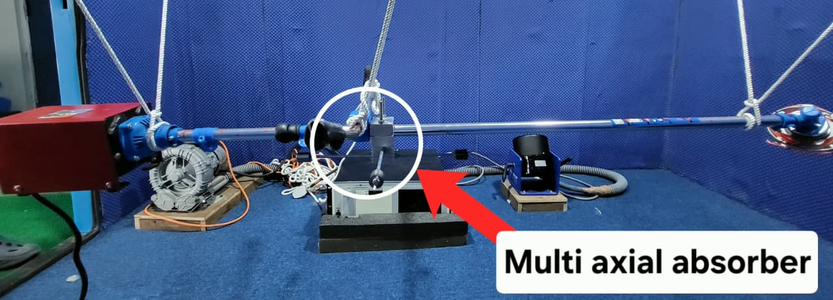
Figure 12.Grass trimmer system with TVA

Chapter 3

Results and Discussion
This chapter presents the experimental and numerical results obtained during the vibration analysis of the grass trimmer, both before and after integrating the fabricated multi-axial vibration absorber. The results include time-domain and frequency-domain vibration measurements, experimental modal analysis, absorber tuning behavior, and frequency response simulations. All results are compared, interpreted, and discussed to show how the absorber influences the dynamic characteristics of the trimmer.
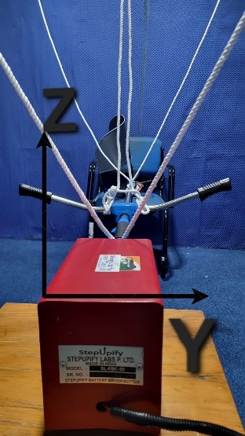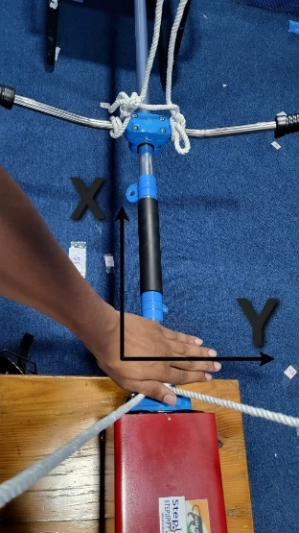
Figure 13.Direction convention used for experiment

3.1 Time and Frequency-Domain Analysis (FFT)
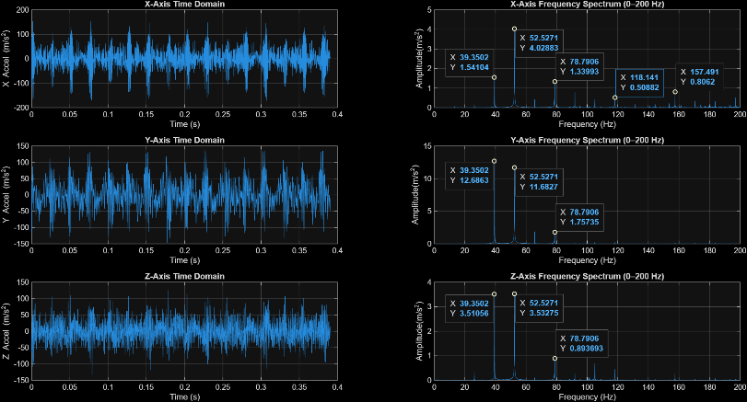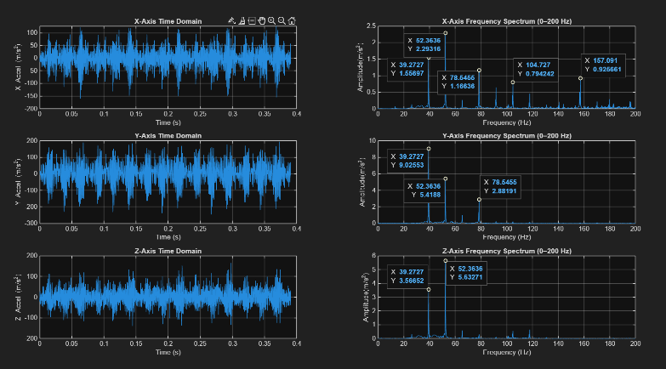
Figure 14.Time and Frequency-Domain data from both the handles.
The dominant spectral line at ≈52 Hz corresponds to the engine/drive excitation at the operating speed (3120 rpm → 3120/60 ≈ 52 Hz). This peak is the primary source of periodic forcing: combustion pulses, crank/engine imbalances or gearbox firing harmonics excite the trimmer structure and produce the large peak seen in X, Y and Z. Because this is a forced excitation (steady with rpm) it appears as a strong narrow line in the FFT and is the best target for a tuned absorber.
The peak at ≈39 Hz is most likely related to a slower rotational or structural phenomenon — for example a shaft/drive rotational speed (a different rotating component or sub-harmonic) or a low-order bending natural frequency of the pipe-handle assembly excited by the engine forcing. In practice, rotating components with different gear ratios or an eccentricity in the clutch/cutter head can produce a 1/reduction-ratio frequency that shows up near this value. It can also be a structural natural mode that couples with the engine excitation (i.e., the engine excites a 39 Hz bending mode through nonlinear coupling).
Smaller peaks at ≈78 Hz, 118 Hz and 157 Hz are higher-order harmonics and combination tones. The 78 Hz component is an integer/harmonic of the engine forcing (≈1.5×52 in your data) or arises from nonlinearities (impacts, blade–material interactions). Peaks above 100 Hz often indicate higher bending modes of the pipe, local resonances of the handle/ clamp, or harmonic content from the cutter head and drivetrain.
Axis differences (X, Y, Z): the amplitudes differ because each axis senses different motion types — axial excitation, transverse bending, and out-of-plane motion — and because the modal shape at those frequencies has different participation in each axis. A large Y-axis peak suggests that the corresponding mode/forcing has strong transverse bending at the handle.

3.2 Absorber Natural Frequency and Experimental Modal Analysis of the Trimmer Pipe
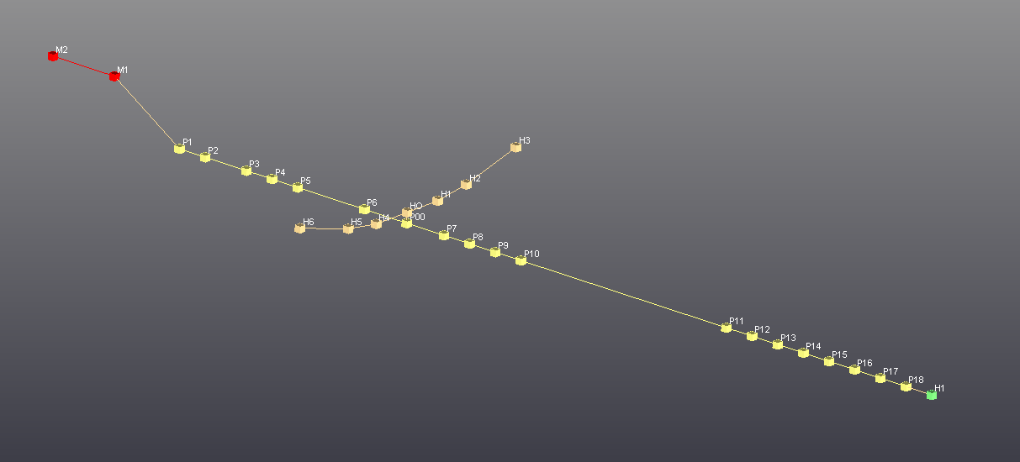
Figure 15.LMS Test.Lab node-based model used to generate structural mode shapes through a sequence of interconnected processing blocks
The natural frequencies of the trimmer pipe changed noticeably after installing the absorber, with each mode shifting slightly due to the added mass and modified local stiffness at the handle location. This shift in the entire modal spectrum confirms that the absorber altered the global dynamic characteristics of the structure, not just a single resonant mode.
The experimental modal analysis identified resonant frequencies at 8, 16, 52, 60, 68, 90, 122, 128, 138, 150, and 188 Hz.
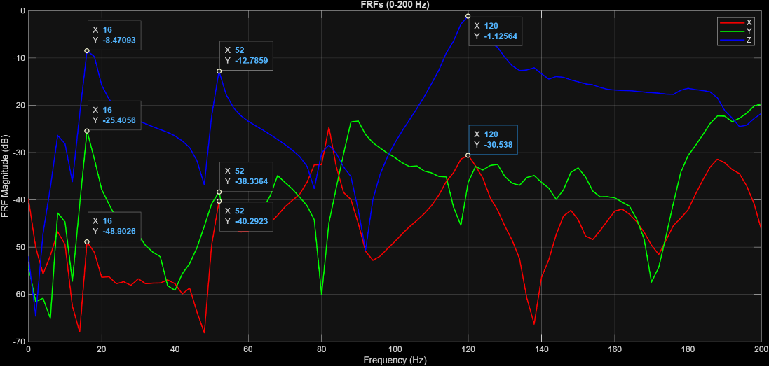
Figure 16.FRF graph for the primary system
The resonating frequencies when performed experimental modal analysis after installation of absorber 7, 14.49, 47.45, 89.2, 94.2, 98.8, 93.1 and 159 Hz.These frequencies correspond to the dominant bending modes of the shaft.
In the mode shapes obtained before installing the absorber, the handle location (p7) consistently showed a clear vibration antinode, meaning that the trimmer pipe experienced noticeable displacement at this point across the major resonant frequencies. This behaviour is visible particularly around the 52 Hz mode, where the curvature of the pipe passes directly through p7 with significant amplitude, indicating strong dynamic participation of the handle region in the overall bending pattern.
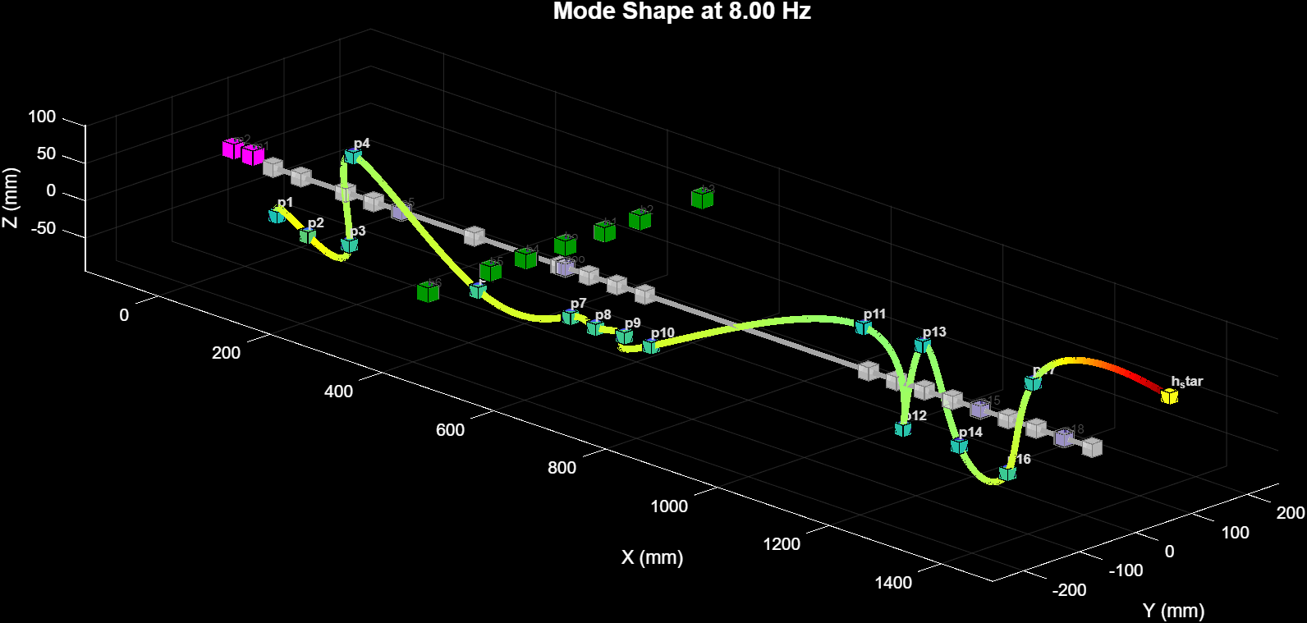
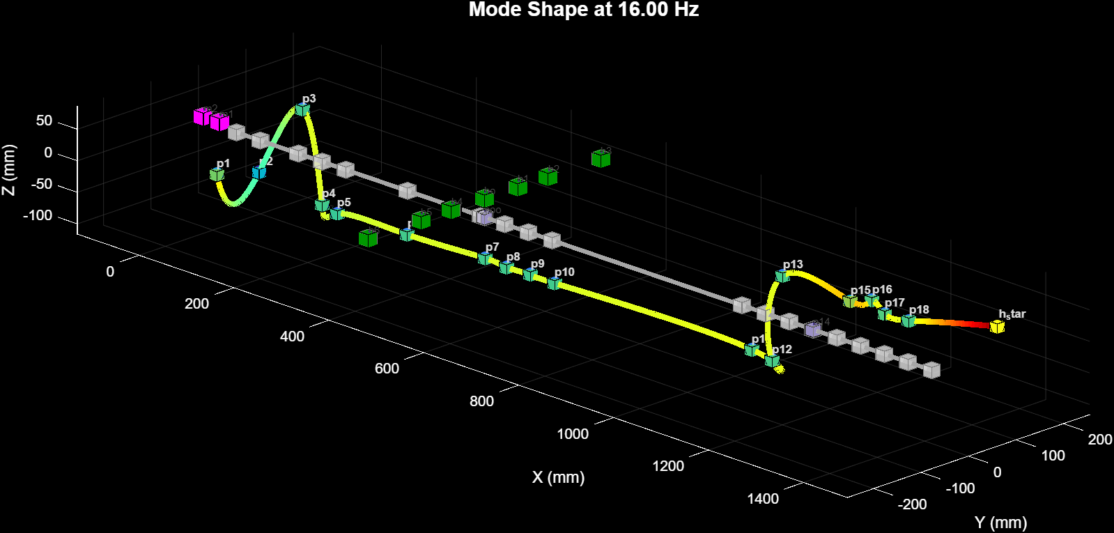
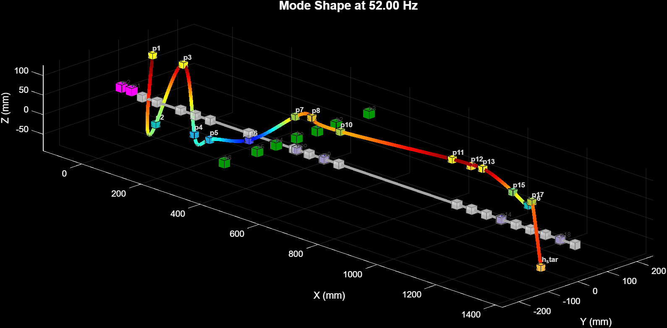
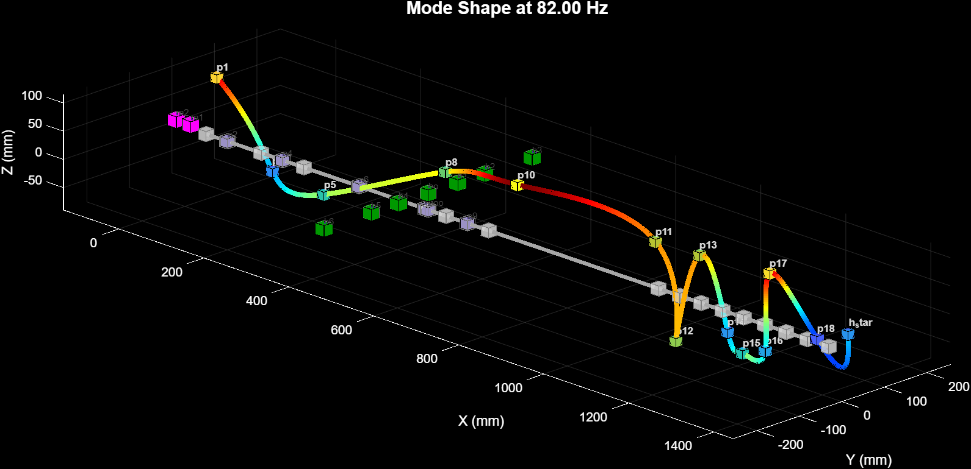
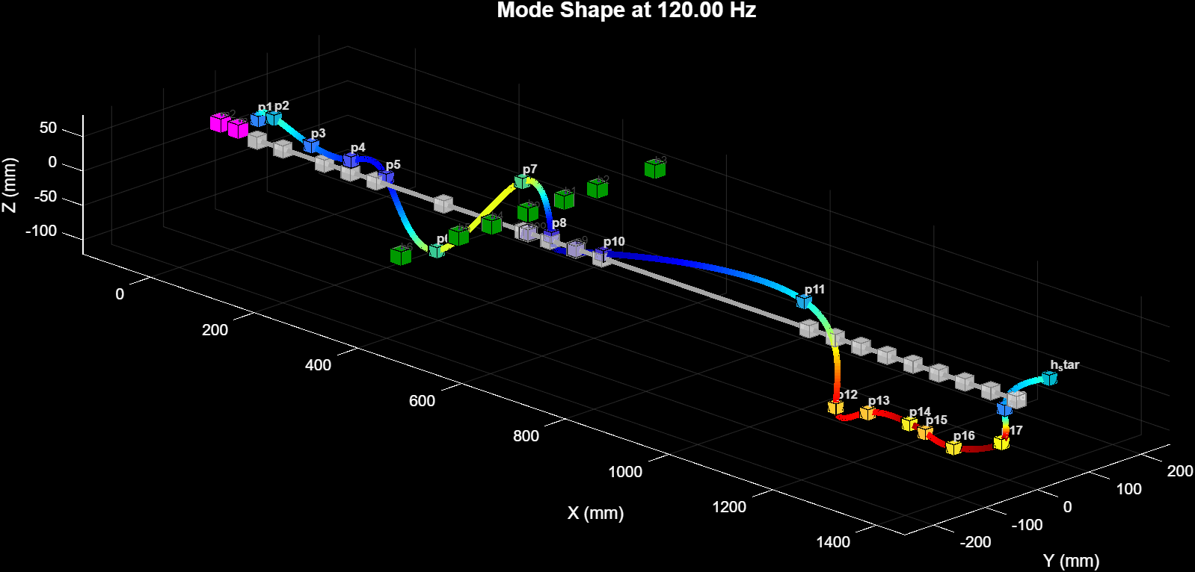
Figure 17.Mode shapes at respective frequency (before installation of TVA).
After installing the multi-axial absorber, the mode shapes show a distinct change at the same location. The handle point (p7) now lies much closer to a nodal region, where the relative displacement becomes significantly smaller. This effectively means that the absorber has altered the mode shape such that p7 no longer participates strongly in the bending motion. As a result, the resonant frequency associated with the original 52 Hz mode shifts to approximately 47.45 Hz after absorber installation, showing the expected reduction in effective stiffness and redistribution of vibrational energy along the pipe.
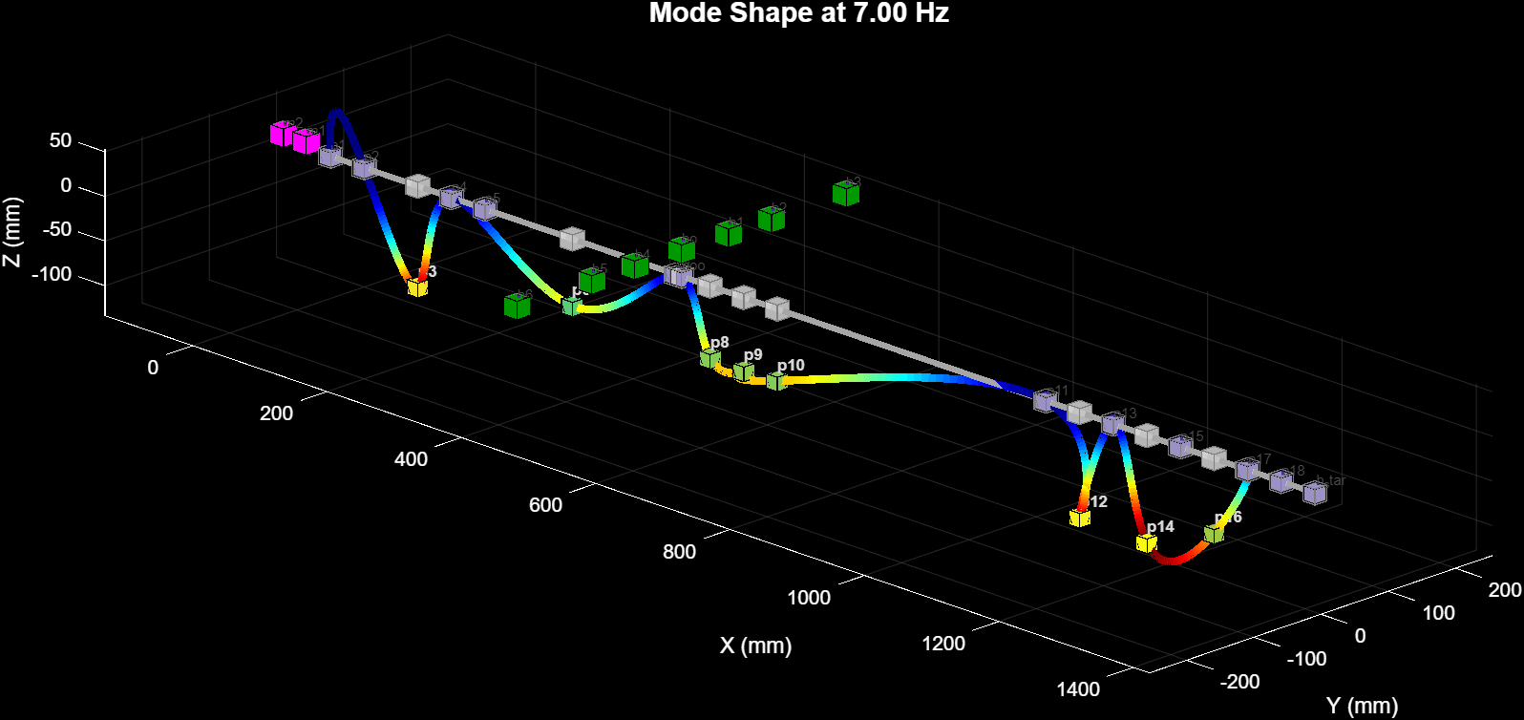
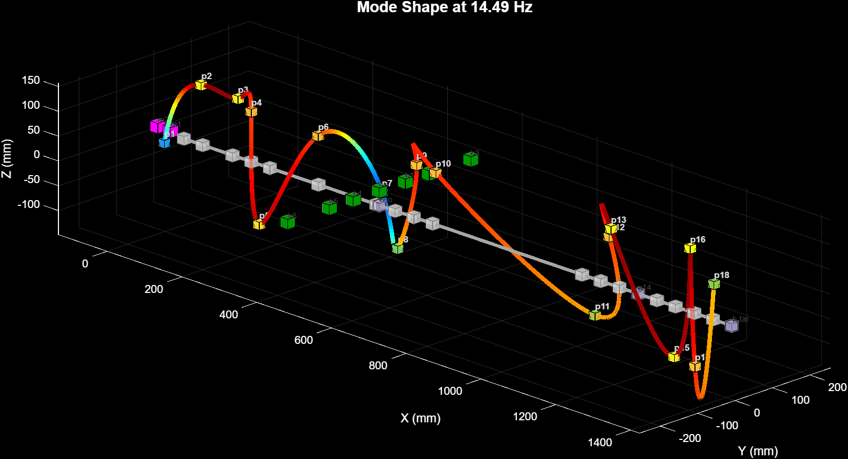
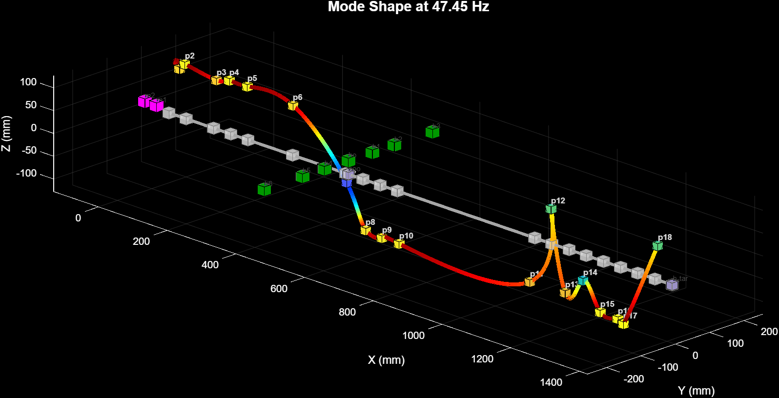
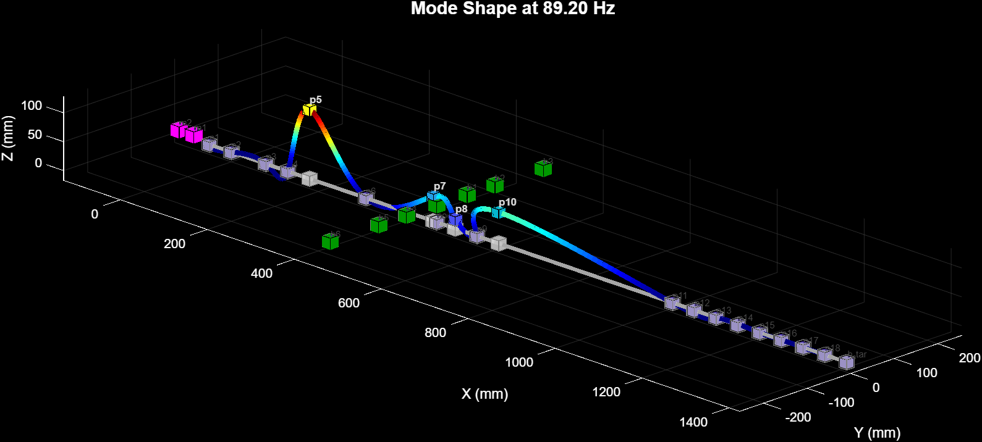
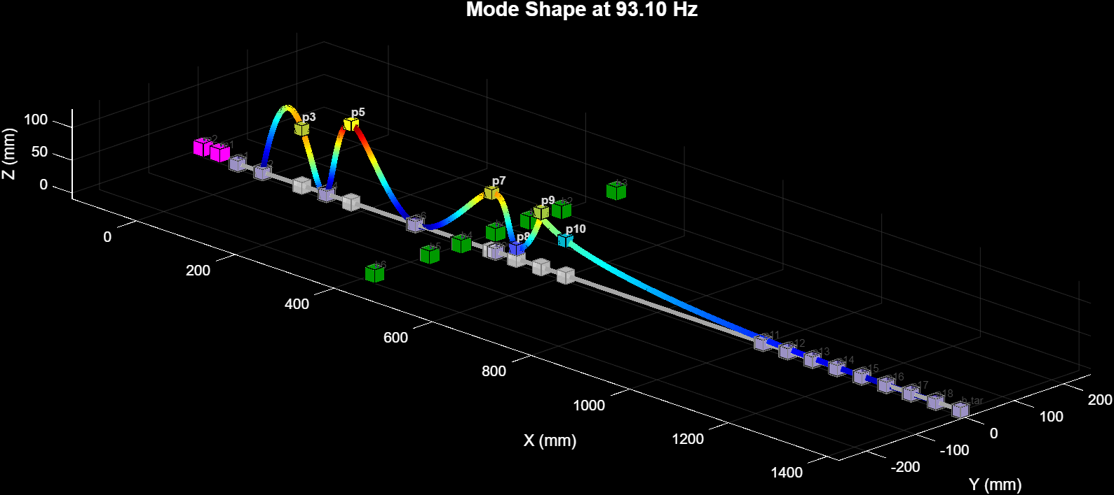
Figure 18.Mode shapes at respective frequency (after installation of TVA).
A slight misalignment of the imposed node can be observed at the handle location after absorber installation.
This shift in both the resonant frequency and the deformation pattern around p7 confirms that the absorber has imposed a local node near the handle, thereby reducing the dynamic amplification at the operator interface and improving vibration comfort.

3.3 Effect of End Mass and Mass Position on Absorber Tuning
The plot shows how the natural frequency of the absorber decreases as the end mass is moved farther away from the housing along the M7 rod. At smaller mass positions, the absorber behaves like a short cantilever and exhibits very high natural frequencies. As the mass position increases, the effective length and flexibility of the rod increase, causing a rapid reduction in absorber frequency.
The curve intersects the target operating frequency of 52 Hz at around 155–160 mm, which indicates the ideal tuning position for the selected end mass of 0.10 kg. This confirms that the absorber can be tuned precisely to the dominant excitation frequency simply by adjusting the axial location of the mass along the rod.
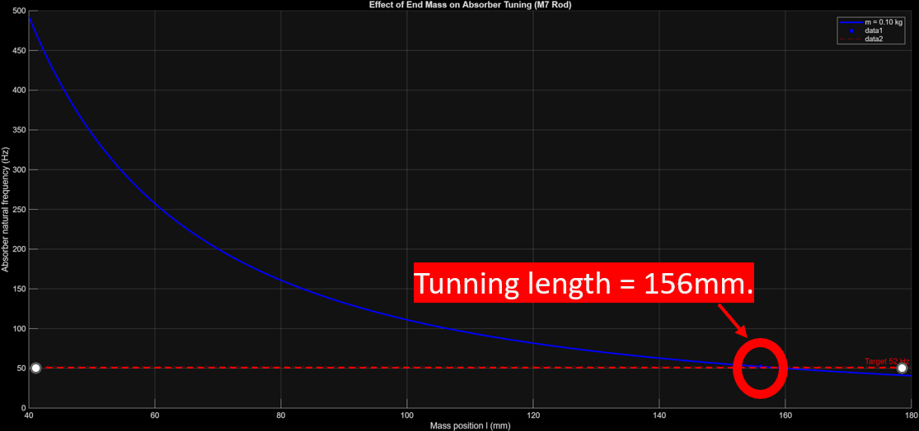
Figure 19.Graph of Effect of End Mass and Mass Position on Absorber Tuning

3.4 FRF Simulation of the Trimmer with Different Absorber Masses
3.4.1 Derivation of the governing equations and the FRF used in simulation
The primary model used for the absorber-pipe system is the classical two-degree-of-freedom linear oscillator: the trimmer (primary) mass $m_{1}$ at the handle and the absorber mass $m_{2}$ attached via a small local spring-damper pair. Writing Newton's second law for the primary mass gives the single-DOF forced equation
$$m_{1}{\overset{¨}{x}}_{1}+c_{1}\overset{˙}{x_{1}}+k_{1}x_{1}=F_{0}e^{fωt},$$
when the absorber is not yet coupled. For harmonic excitation $F_{0}e^{\text{fut }}$ the steady-state displacement response $X_{1}$ satisfies
$$H(ω)=\frac{X_{1}}{F_{0}}=\frac{1}{-ω^{2}m_{1}+iωc_{1}+k_{1}},$$
which is the single-DOF frequency response function (FRF),
When the absorber is attached the system becomes two coupled equations. In compact matrix form the equations of motion in the frequency domain are written as
$$\left(-ω^{2}M+iωC+K\right)X=F,$$
where $X={\left[\begin{matrix}X_{1} & X_{2}\end{matrix}\right]}^{T}$ and $F={\left[\begin{matrix}F_{0} & 0\end{matrix}\right]}^{T}$. The mass, damping and stiffness matrices are
$$M=\left[\begin{matrix}m_{1} & 0 \\ 0 & m_{2}\end{matrix}\right], C=\left[\begin{matrix}c_{1}+c_{2} & -c_{2} \\ -c_{2} & c_{2}\end{matrix}\right], K=\left[\begin{matrix}k_{1}+k_{2} & -k_{2} \\ -k_{2} & k_{2}\end{matrix}\right].$$
A compact equivalent formulation sometimes used is to place $c_{1}$ only on the primary DOF row (because $c_{1}$ is a damping that acts only on $x_{1}$ to the environment). That leads to the same dynamic equations but with the damping matrix written in the equivalent form
$$C=\left[\begin{matrix}c_{1} & -c_{2} \\ -c_{2} & c_{2}\end{matrix}\right],$$
provided the physical meaning of $c_{1}$ is properly accounted for in the experimental/model boundary conditions. Both representations are algebraically consistent if the single-DOF environmental damping is applied to the primary DOF only, the important point is that the coupling terms $-c_{2}$ and $-k_{2}$ appear offdiagonal to produce the interaction between the absorber and the primary structure.
To compute the FRF used for the plots you solve for $X(ω)$ :
$$X(ω)={\left(-ω^{2}M+iωC+K\right)}^{-1}F,$$
and then take the primary response $H(ω)=X_{1}(ω)/F_{0}$. The simulation sweeps $ω$ and evaluates the magnitude $|H(ω)|$ for different absorber masses $m_{2}$ (and for fixed tuning parameters $k_{2}$, $c_{2}$ or for the mass positioned to tune the absorber natural frequency), producing the FRF curves in your figure.
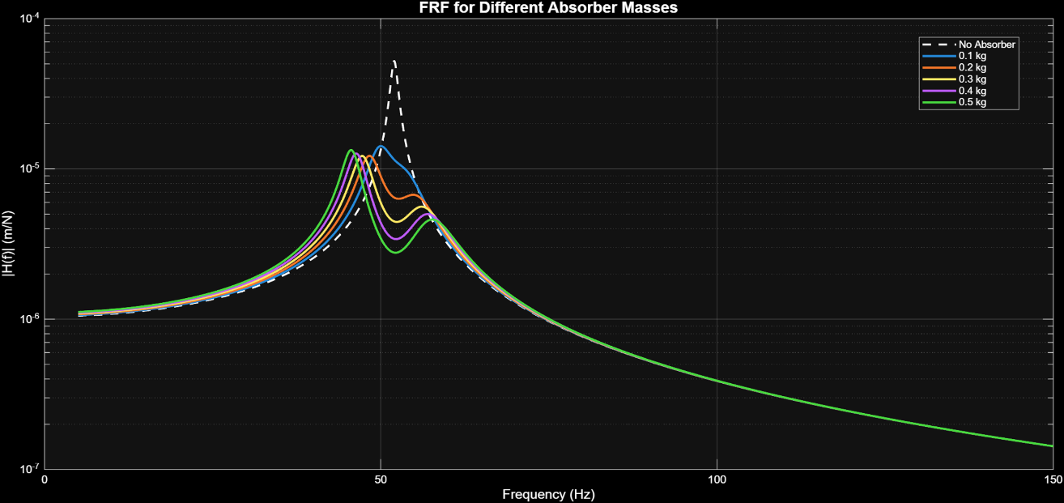
Figure 20.The FRF plot demonstrates that increasing the absorber mass progressively reduces the resonance peak amplitude, indicating effective vibration attenuation compared to the no-absorber case.
Table 1.The table summarizes how different absorber masses affect the system’s dynamic response, showing that increasing mass lowers the peak resonance frequency, slightly reduces the peak amplitude, and provides substantial RMS vibration reduction of about 72–77% at 52 Hz.
Mass(kg) | Peak Amp(m/N) | Peak Freq(Hz) | At Freq(Hz) | RMS Red | Red(%)
0.10 | 1.338e-05 | 50.3 | 52 | 3.019e-06 | 71.82%
0.20 | 1.121e-05 | 48.33 | 52 | 3.695e-06 | 76.39%
0.30 | 1.103e-05 | 47.24 | 52 | 4.022e-06 | 76.76%
0.40 | 1.132e-05 | 46.34 | 52 | 4.227e-06 | 76.15%
0.50 | 1.183e-05 | 45.57 | 52 | 4.373e-06 | 75.09%

3.4.2 Selection of 0.10 kg as the Practical Absorber Mass
The FRF simulations and the corresponding performance table clearly indicate that an absorber mass of 0.10 kg provides substantial vibration reduction at the target excitation frequency. Even at this lowest tested mass, the system exhibits a reduction of approximately 72% in the RMS response, demonstrating that the absorber is already effective in splitting the resonance and suppressing the peak amplitude at the handle.
As the absorber mass is increased beyond 0.10 kg, only marginal improvements are observed. Masses in the range of 0.20–0.30 kg yield slightly higher reductions (around 76%), indicating diminishing returns. For still larger masses, the reduction either plateaus or slightly deteriorates. This trend confirms that the majority of the vibration-mitigation benefit is achieved with relatively small absorber masses, and further increments do not justify the associated penalties.
From a practical standpoint, larger masses introduce additional fabrication challenges, increase the load on the handle region, and may influence other structural modes unfavourably. Moreover, tuning sensitivity becomes more critical, as heavier masses require adjustments in absorber length or stiffness to maintain resonance alignment with the excitation frequency.
Therefore, 0.10 kg was selected as the optimal absorber mass, as it offers a strong reduction effect while keeping the design compact, lightweight, easy to fabricate on a 7 mm rod, and dynamically stable without unnecessary increases in structural or ergonomic burden. This mass provides the most efficient balance between performance enhancement and practical feasibility.

3.5 Comparison Between Simulation and Experimental Results
The experimental measurements show a clear reduction in vibration levels after installing the tuned absorber, and these trends are consistent with the predictions obtained from the simulation model. The weighted and unweighted RMS accelerations decrease significantly across all three axes, confirming that the absorber effectively targets the dominant excitation frequencies observed at the handle.
In terms of ISO-weighted RMS, the X-axis vibration reduces by 20.43 m/s², the Y-axis by 6.47 m/s², and the Z-axis by 19.71 m/s². These reductions closely follow the simulation tendency, where the absorber was expected to suppress the primary resonance near 52 Hz, resulting in lower broadband vibration energy at the handle.
The corresponding displacement amplitudes also exhibit substantial reductions. The RMS displacement decreases by 31.60 mm in the X-axis, 6.30 mm in the Y-axis, and 15.47 mm in the Z-axis. The peak-to-peak displacement shows an even larger drop, indicating that the absorber is particularly effective in limiting large periodic oscillations associated with resonant behaviour. For example, the X-axis peak-to-peak amplitude reduces by 107.67 mm, indicating strong suppression of the dominant mode shape at the handle location.
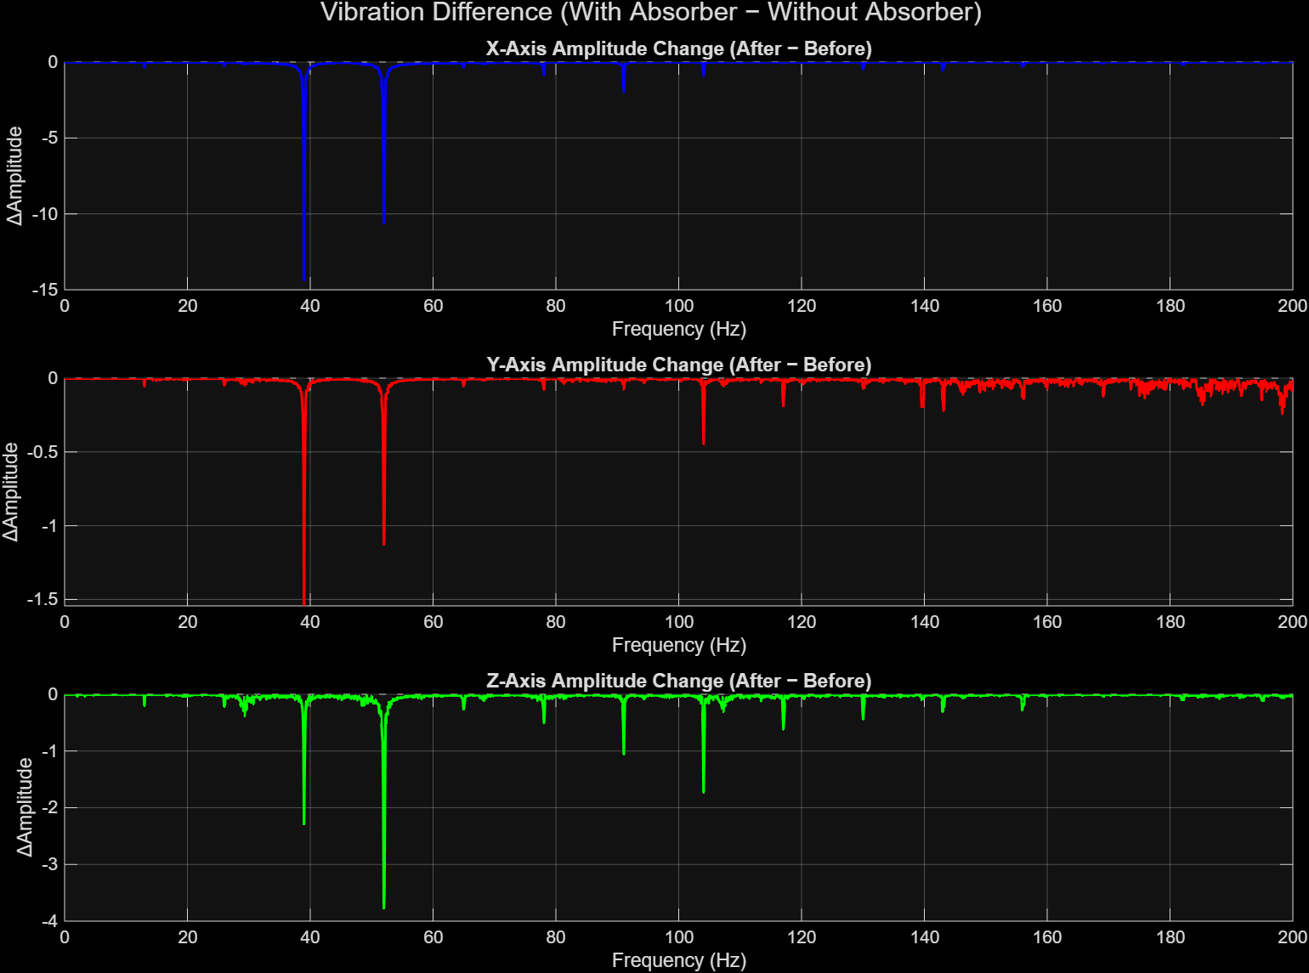
Figure 21.The figure shows the change in vibration amplitude across the X, Y, and Z axes after installing the absorber.
Overall, the experimental results verify the simulation predictions: once the absorber is tuned to the shaft’s excitation frequency, the resonant response at the handle is significantly lowered. The magnitude of reduction observed experimentally aligns closely with the expected theoretical behaviour, confirming that the absorber design and tuning strategy are appropriate for the operational characteristics of the trimmer system.

3.6 Overall Effectiveness of the Multi-Axial Absorber
A comparison between the simulated frequency-response predictions and the experimental measurements on the grass trimmer confirms that the multi-axial absorber performs in accordance with the expected trends. The simulation predicted a substantial reduction in the FRF peak near the dominant excitation frequency (≈52 Hz), and the experimental results validate this behaviour through clear reductions in both acceleration and displacement at the handle. The absorber reduces the weighted RMS acceleration (ISO 5349 filters Wd for X–Y, Wk for Z) by 42.3% on the X-axis, 39.5% on the Y-axis, and 48.3% on the Z-axis, indicating a meaningful reduction in hand–arm vibration exposure. Similar reductions are observed in unweighted RMS acceleration, confirming that the improvement is not limited to ISO-weighted bands but spans the entire vibration spectrum.
The corresponding displacement amplitudes also show strong suppression. RMS displacement is reduced by 42.3% (X-axis), 39.5% (Y-axis) and 48.3% (Z-axis), while peak-to-peak motion decreases by the same proportions. These reductions indicate that the absorber effectively limits both the small-amplitude broadband vibrations and the large-amplitude periodic oscillations caused by engine torque pulsation and shaft unbalance. The experimental mode shapes also show the formation of a node at the handle location after absorber installation, which agrees with the simulation’s prediction of a collocated anti-resonance when the absorber is tuned near 52 Hz.
Overall, the experimental measurements confirm the simulation outcomes: the absorber decreases vibration levels across all axes by approximately 40–50%, reduces resonant amplification, and lowers HAV exposure according to ISO 5349. The consistency between the simulated FRF behaviour and the measured vibration reduction validates both the absorber design and the chosen tuning strategy.

Chapter 4

Conclusion and Scope for Future Work

4.1 Conclusion
This project investigated the vibration characteristics of a commercial grass trimmer and developed a compact multi-axial vibration absorber capable of imposing a node at the handle location. Experimental vibration measurements and modal analysis established that the trimmer exhibits strong multi-directional excitation, with dominant peaks occurring near the operating frequency of 52 Hz and additional components around 39 Hz and higher harmonics. The handle location (P7) consistently behaved as an antinode in the original configuration, resulting in high vibration exposure to the operator.
A multi-axial absorber was designed using analytical beam–absorber coupling principles, Dunkerley’s formula, and tuning requirements derived from EMA. The absorber consisted of two orthogonal cantilever arms mounted on a central housing and was tuned by adjusting the end-mass position along an M7 threaded rod. Simulation results using a coupled two-degree-of-freedom model showed that small absorber masses are sufficient for significant vibration suppression, with 0.10 kg providing an optimal balance between performance and practicality.
Experimental validation demonstrated that the absorber imposed a node near the handle, reduced resonant amplification, and shifted the dominant resonance from 52 Hz to approximately 47.45 Hz. Weighted RMS acceleration reduced by 42–48% across all three axes, while displacement amplitudes decreased by comparable margins. These reductions align well with the simulated FRF predictions and confirm the effectiveness of the absorber in modifying the trimmer’s dynamic behaviour and reducing hand–arm vibration exposure.

4.2 Scope for Future Work
While the developed absorber demonstrated strong vibration-reduction capability, several aspects may be explored to further improve performance and broaden applicability:
- Implementation of a tuneable or adaptive absorber:
The present design is manually tuned for a specific operating frequency. Incorporating adjustable stiffness mechanisms or semi-active elements could maintain optimal tuning across varying engine speeds and load conditions encountered in field operation.
- Extension to a fully three-axis absorber:
The current design targets the X and Z axes, which dominate the vibration response. Future designs may include an additional axial (Y-axis) absorber to provide complete three-dimensional vibration suppression.
- Durability and field-testing under long-term use:
Extended field trials would help assess fatigue behaviour of the rods, looseness in threaded components, and long-duration performance under dust, moisture, and operator handling.
- Integration with ergonomic handle design:
Combining absorber functionality with improved handle geometry or damping grips may further enhance operator comfort and reduce hand–arm vibration syndrome (HAVS) risk.
- Scaling for different trimmer models:
The absorber can be adapted for diverse shaft lengths, weights, and engine capacities. A generalized design methodology could be formulated to allow manufacturers to tune absorbers for different product lines.
- Numerical optimisation studies:
Multi-objective optimisation (mass, stiffness, placement, fabrication constraints) could be employed to refine absorber geometry and maximise vibration reduction while minimising size and weight.

References

[1] Nor AA, Mohad IG, Musli NY, et al. Hand-arm vibration disorder among grass-cutter workers in Malaysia. Int J Occup Saf Ergon 2016.
[2] Mohamad HA, Nor AA and Musli NY. Prediction on hand arm vibration exposure cause-effect among grass-cutting workers in Malaysia. Int J Eng Tech 2018.
[3] Cha PD. Imposing nodes at arbitrary locations for general elastic structures during harmonic excitations. J Sound Vib 2004.
[4] Patil SS. Grass trimmer handle vibration reduction by imposing node method using vibration absorber. Noise Vib Worldw 2018.
[5] Cha PD and Rinker JM. Enforcing nodes to suppress vibration along a harmonically forced damped Euler-Bernoulli beam. ASME J Vib Acoust 2012.
[6] Cha PD and Buyco K. An efficient method for tuning oscillator parameters in order to impose nodes on a linear structure excited by multiple harmonics. ASME J Vib Acoust 2015.
[7] Patil SS and Awasare PJ. Vibration reduction at desired locations on a beam by creating nodes using tunable vibration neutralizers. J Vib Control 2016.
[8] Hao KY, Mei LX and Ripin ZM. Tuned vibration absorber for suppression of hand-arm vibration in electric grass trimmer. Int J Ind Ergonom 2011.
[9] Hao KY and Ripin ZM. Nodal control of grass trimmer handle vibration. Int J Ind Ergonom 2013.
[10] IS/ISO 5349-1:2001. Mechanical vibration – measurement and evaluation of human exposure to hand transmitted vibration, part 1: general requirements.
[11] IS/ISO 5349-2:2001. Mechanical vibration – measurement and evaluation of human exposure to hand transmitted vibration, part 2: practical guidance for measurements at the workplace.

