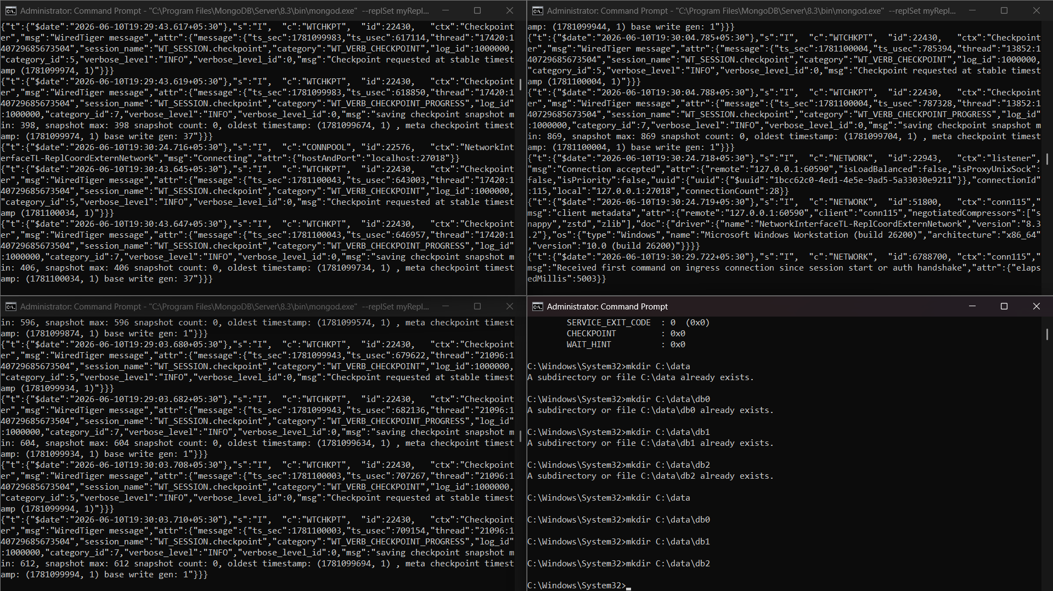

Compass
My Queries
Data Modeling

Connections(2)

Databases and Collections
127.0.0.1:27017
127.0.0.1:27018
admin
college
students
config
local
mongosh: 127.0.0.1:27017
students
mongosh: 127.0.0.1:27018
>_MONGOSH
rs.initiate({
_id: "myReplSet",
members: [
{ _id: 0, host: "localhost:27017" },
{ _id: 1, host: "localhost:27018" },
{ _id: 2, host: "localhost:27019" }
]
})
{
ok: 1,
'$clusterTime': {
clusterTime: Timestamp({ t: 1781097117, i: 1 }),
signature: {
hash: Binary.createFromBase64('AAAAAAAAAAAAAAAAAAAAAAAAAAA=', 0),
keyId: Long('0')
}
},
operationTime: Timestamp({ t: 1781097117, i: 1 })
}
rs.status()
{
set: 'myReplSet',
date: 2026-06-10T13:12:18.980Z,
myState: 1,
term: Long('1'),
syncSourceHost: '',
syncSourceId: -1,
heartbeatIntervalMillis: Long('2000'),
majorityVoteCount: 2,
writeMajorityCount: 2,
votingMembersCount: 3,
writableVotingMembersCount: 3,
optimes: {
lastCommittedOpTime: { ts: Timestamp({ t: 1781097128, i: 17 }), t: Long('1') },
lastCommittedWallTime: 2026-06-10T13:12:08.226Z,
readConcernMajorityOpTime: { ts: Timestamp({ t: 1781097128, i: 17 }), t: Long('1') },
appliedOpTime: { ts: Timestamp({ t: 1781097128, i: 17 }), t: Long('1') },
durableOpTime: { ts: Timestamp({ t: 1781097128, i: 17 }), t: Long('1') },
writtenOpTime: { ts: Timestamp({ t: 1781097128, i: 17 }), t: Long('1') },
lastAppliedWallTime: 2026-06-10T13:12:08.226Z,
lastDurableWallTime: 2026-06-10T13:12:08.226Z,
lastWrittenWallTime: 2026-06-10T13:12:08.226Z
},
lastStableRecoveryTimestamp: Timestamp({ t: 1781097117, i: 1 }),
electionCandidateMetrics: {
lastElectionReason: 'electionTimeout',
lastElectionDate: 2026-06-10T13:12:08.112Z,
electionTerm: Long('1'),
lastCommittedOpTimeAtElection: { ts: Timestamp({ t: 1781097117, i: 1 }), t: Long('-1') },
lastSeenWrittenOpTimeAtElection: { ts: Timestamp({ t: 1781097117, i: 1 }), t: Long('-1') },
lastSeenOpTimeAtElection: { ts: Timestamp({ t: 1781097117, i: 1 }), t: Long('-1') },
numVotesNeeded: 2,
priorityAtElection: 1,
electionTimeoutMillis: Long('10000'),
numCatchUpOps: Long('0'),
newTermStartDate: 2026-06-10T13:12:08.155Z,
wMajorityWriteAvailabilityDate: 2026-06-10T13:12:08.640Z
},
members: [
{
_id: 0,
name: 'localhost:27017',
health: 1,
state: 1,
stateStr: 'PRIMARY',
uptime: 100,
optime: { ts: Timestamp({ t: 1781097128, i: 17 }), t: Long('1') },
optimeDate: 2026-06-10T13:12:08.000Z,
optimeWritten: { ts: Timestamp({ t: 1781097128, i: 17 }), t: Long('1') },
optimeWrittenDate: 2026-06-10T13:12:08.000Z,
lastAppliedWallTime: 2026-06-10T13:12:08.226Z,
lastDurableWallTime: 2026-06-10T13:12:08.226Z,
lastWrittenWallTime: 2026-06-10T13:12:08.226Z,
syncSourceHost: '',
syncSourceId: -1,
infoMessage: 'Could not find member to sync from',
electionTime: Timestamp({ t: 1781097128, i: 1 }),
electionDate: 2026-06-10T13:12:08.000Z,
configVersion: 1,
configTerm: 1,
self: true,
lastHeartbeatMessage: ''
},
{
_id: 1,
name: 'localhost:27018',
health: 1,
state: 2,
stateStr: 'SECONDARY',
uptime: 21,
optime: { ts: Timestamp({ t: 1781097128, i: 17 }), t: Long('1') },
optimeDurable: { ts: Timestamp({ t: 1781097128, i: 17 }), t: Long('1') },
use college
switched to db college
db.students.insertOne({
name: "Arav",
course: "Finance Apex"
})
{
acknowledged: true,
insertedId: ObjectId('6a296303363e9735f77db860')
}
myReplSet [direct: secondary] college

After Kill 17 port
Compass
My Queries
Data Modeling

Connections(2)

Databases and Collections
127.0.0.1:27017
127.0.0.1:27018
admin
college
students
config
local
mongosh: 127.0.0.1:27017
students
mongosh: 127.0.0.1:27018
>_MONGOSH
rs.secondaryOk()
DeprecationWarning: .setSecondaryOk() is deprecated. Use .setReadPref("primaryPreferred") instead
Setting read preference from "primary" to "primaryPreferred"
use college
switched to db college
db.students.find()
{
_id: ObjectId('6a296303363e9735f77db860'),
name: 'Arav',
course: 'Finance Apex'
}
rs.status()
{
set: 'myReplSet',
date: 2026-06-10T13:15:58.921Z,
myState: 1,
term: Long('2'),
syncSourceHost: '',
syncSourceId: -1,
heartbeatIntervalMillis: Long('2000'),
majorityVoteCount: 2,
writeMajorityCount: 2,
votingMembersCount: 3,
writableVotingMembersCount: 3,
optimes: {
lastCommittedOpTime: { ts: Timestamp({ t: 1781097354, i: 11 }), t: Long('2') },
lastCommittedWallTime: 2026-06-10T13:15:54.082Z,
readConcernMajorityOpTime: { ts: Timestamp({ t: 1781097354, i: 11 }), t: Long('2') },
appliedOpTime: { ts: Timestamp({ t: 1781097354, i: 11 }), t: Long('2') },
durableOpTime: { ts: Timestamp({ t: 1781097354, i: 11 }), t: Long('2') },
writtenOpTime: { ts: Timestamp({ t: 1781097354, i: 11 }), t: Long('2') },
lastAppliedWallTime: 2026-06-10T13:15:54.082Z,
lastDurableWallTime: 2026-06-10T13:15:54.082Z,
lastWrittenWallTime: 2026-06-10T13:15:54.082Z
},
lastStableRecoveryTimestamp: Timestamp({ t: 1781097298, i: 1 }),
electionCandidateMetrics: {
lastElectionReason: 'stepUpRequestSkipDryRun',
lastElectionDate: 2026-06-10T13:15:32.524Z,
electionTerm: Long('2'),
lastCommittedOpTimeAtElection: { ts: Timestamp({ t: 1781097328, i: 1 }), t: Long('1') },
lastSeenWrittenOpTimeAtElection: { ts: Timestamp({ t: 1781097328, i: 1 }), t: Long('1') },
lastSeenOpTimeAtElection: { ts: Timestamp({ t: 1781097328, i: 1 }), t: Long('1') },
numVotesNeeded: 2,
priorityAtElection: 1,
electionTimeoutMillis: Long('10000'),
priorPrimaryMemberId: 0,
numCatchUpOps: Long('0'),
newTermStartDate: 2026-06-10T13:15:32.534Z,
wMajorityWriteAvailabilityDate: 2026-06-10T13:15:32.548Z
},
electionParticipantMetrics: {
votedForCandidate: true,
electionTerm: Long('1'),
lastVoteDate: 2026-06-10T13:12:08.115Z,
electionCandidateMemberId: 0,
voteReason: '',
lastWrittenOpTimeAtElection: { ts: Timestamp({ t: 1781097117, i: 1 }), t: Long('-1') },
maxWrittenOpTimeInSet: { ts: Timestamp({ t: 1781097117, i: 1 }), t: Long('-1') },
lastAppliedOpTimeAtElection: { ts: Timestamp({ t: 1781097117, i: 1 }), t: Long('-1') },
maxAppliedOpTimeInSet: { ts: Timestamp({ t: 1781097117, i: 1 }), t: Long('-1') },
priorityAtElection: 1
},
members: [
{
_id: 0,
name: 'localhost:27017',
health: 0,
state: 8,
stateStr: '(not reachable/healthy)',
uptime: 0,
optime: { ts: Timestamp({ t: 0, i: 0 }), t: Long('-1') },
optimeDurable: { ts: Timestamp({ t: 0, i: 0 }), t: Long('-1') },
optimeWritten: { ts: Timestamp({ t: 0, i: 0 }), t: Long('-1') },
rs.status()
{
set: 'myReplSet',
date: 2026-06-10T13:17:29.577Z,
myState: 1,
term: Long('2'),
syncSourceHost: '',
syncSourceId: -1,
heartbeatIntervalMillis: Long('2000'),
majorityVoteCount: 2,
writeMajorityCount: 2,
votingMembersCount: 3,
writableVotingMembersCount: 3,
optimes: {
lastCommittedOpTime: { ts: Timestamp({ t: 1781097442, i: 1 }), t: Long('2') },
lastCommittedWallTime: 2026-06-10T13:17:22.619Z,
readConcernMajorityOpTime: { ts: Timestamp({ t: 1781097442, i: 1 }), t: Long('2') },
appliedOpTime: { ts: Timestamp({ t: 1781097442, i: 1 }), t: Long('2') },
durableOpTime: { ts: Timestamp({ t: 1781097442, i: 1 }), t: Long('2') },
writtenOpTime: { ts: Timestamp({ t: 1781097442, i: 1 }), t: Long('2') },
lastAppliedWallTime: 2026-06-10T13:17:22.619Z,
lastDurableWallTime: 2026-06-10T13:17:22.619Z,
lastWrittenWallTime: 2026-06-10T13:17:22.619Z
},
lastStableRecoveryTimestamp: Timestamp({ t: 1781097422, i: 1 }),
electionCandidateMetrics: {
lastElectionReason: 'stepUpRequestSkipDryRun',
lastElectionDate: 2026-06-10T13:15:32.524Z,
electionTerm: Long('2'),
lastCommittedOpTimeAtElection: { ts: Timestamp({ t: 1781097328, i: 1 }), t: Long('1') },
lastSeenWrittenOpTimeAtElection: { ts: Timestamp({ t: 1781097328, i: 1 }), t: Long('1') },
lastSeenOpTimeAtElection: { ts: Timestamp({ t: 1781097328, i: 1 }), t: Long('1') },
numVotesNeeded: 2,
priorityAtElection: 1,
electionTimeoutMillis: Long('10000'),
priorPrimaryMemberId: 0,
numCatchUpOps: Long('0'),
newTermStartDate: 2026-06-10T13:15:32.534Z,
wMajorityWriteAvailabilityDate: 2026-06-10T13:15:32.548Z
},
electionParticipantMetrics: {
votedForCandidate: true,
electionTerm: Long('1'),
lastVoteDate: 2026-06-10T13:12:08.115Z,
electionCandidateMemberId: 0,
voteReason: '',
lastWrittenOpTimeAtElection: { ts: Timestamp({ t: 1781097117, i: 1 }), t: Long('-1') },
maxWrittenOpTimeInSet: { ts: Timestamp({ t: 1781097117, i: 1 }), t: Long('-1') },
lastAppliedOpTimeAtElection: { ts: Timestamp({ t: 1781097117, i: 1 }), t: Long('-1') },
maxAppliedOpTimeInSet: { ts: Timestamp({ t: 1781097117, i: 1 }), t: Long('-1') },
priorityAtElection: 1
},
members: [
{
_id: 0,
myReplSet [direct: secondary] college

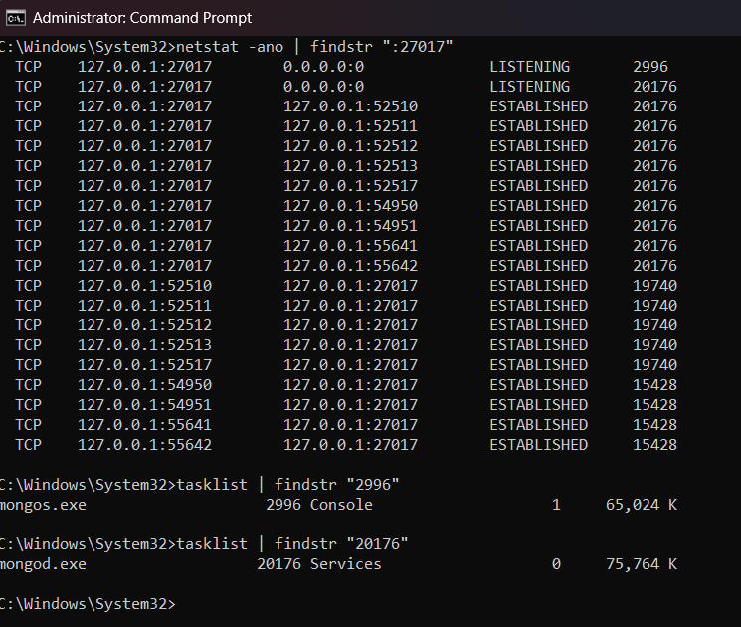
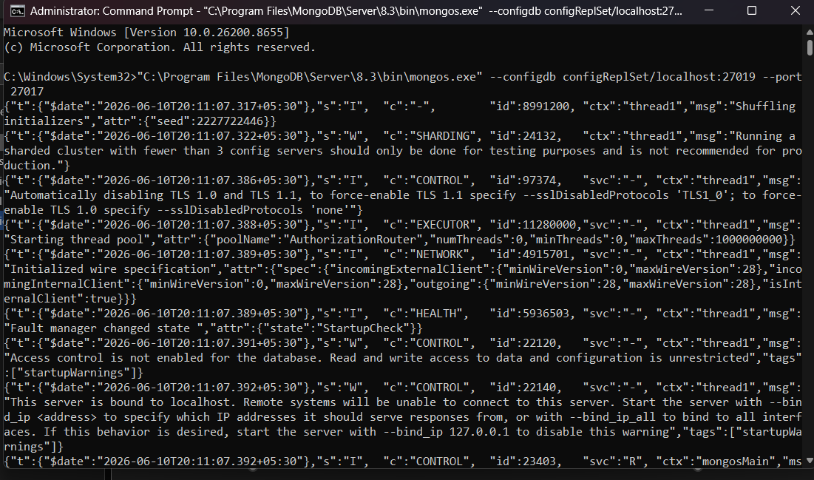
27012
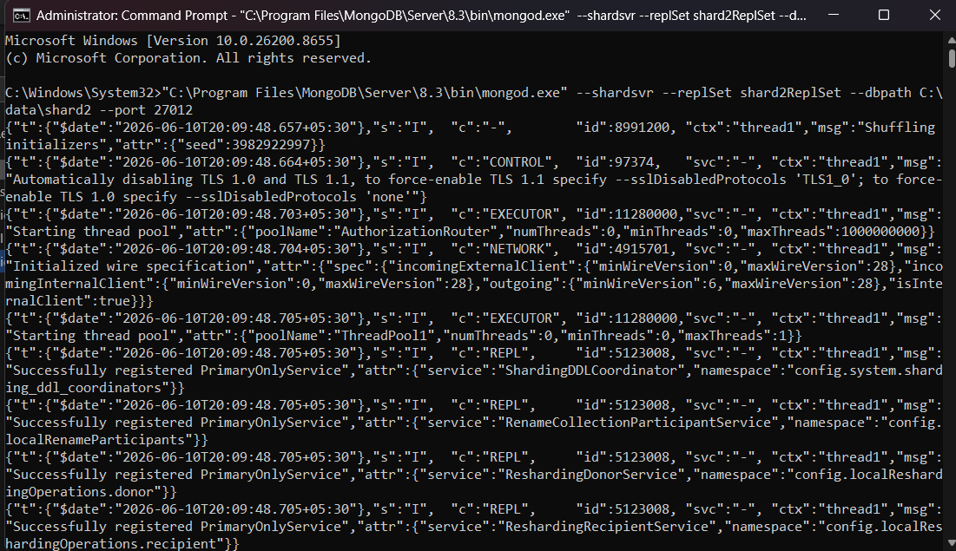
27011
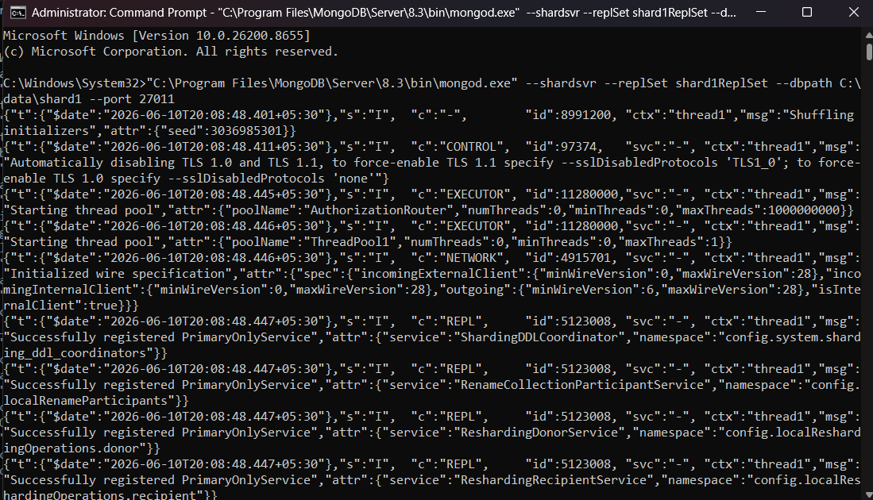
Microsoft Windows [Version 10.0.26200.8655]
(c) Microsoft Corporation. All rights reserved.

C:\Windows\System32>net stop MongoDB
The MongoDB Server (MongoDB) service is stopping.
The MongoDB Server (MongoDB) service was stopped successfully.

C:\Windows\System32>"C:\Users\heyar\Downloads\mongosh-2.8.3-win32-x64\mongosh-2.8.3-win32-x64\bin\mongosh.exe" --port 27017
Current Mongosh Log ID: 6a29786ab45c508eb3abc113
Connecting to: mongodb://127.0.0.1:27017/?directConnection=true&serverSelectionTimeoutMS=2000&appName=mongosh+2.8.3
Using MongoDB: 8.3.2
Using Mongosh: 2.8.3

For mongosh info see: https://www.mongodb.com/docs/mongodb-shell/

------
The server generated these startup warnings when booting
2026-06-10T20:11:07.391+05:30: Access control is not enabled for the database. Read and write access to data and configuration is unrestricted
2026-06-10T20:11:07.392+05:30: This server is bound to localhost. Remote systems will be unable to connect to this server. Start the server with --bind_ip <address> to specify which IP addresses it should serve responses from, or with --bind_ip_all to bind to all interfaces. If this behavior is desired, start the server with --bind_ip 127.0.0.1 to disable this warning
------

[direct: mongos] test> db.adminCommand({ hello: 1 })
{
isWritablePrimary: true,
msg: 'isdbgrid',
topologyVersion: { processId: ObjectId('6a2977831f94334a5ce70748'), counter: Long('0') },
maxBsonObjectSize: 16777216,
maxMessageSizeBytes: 48000000,
maxWriteBatchSize: 100000,
localTime: ISODate('2026-06-10T14:45:05.046Z'),
logicalSessionTimeoutMinutes: 30,
connectionId: 11,
maxWireVersion: 28,
minWireVersion: 0,
ok: 1,
'$clusterTime': {
clusterTime: Timestamp({ t: 1781102699, i: 1 }),
signature: {
hash: Binary.createFromBase64('AAAAAAAAAAAAAAAAAAAAAAAAAAA=', 0),
keyId: Long('0')
}
},
operationTime: Timestamp({ t: 1781102699, i: 1 })
}
[direct: mongos] test> sh.addShard("shard1ReplSet/localhost:27011")
| sh.addShard("shard2ReplSet/localhost:27012")
{
shardAdded: 'shard2ReplSet',
ok: 1,
'$clusterTime': {
clusterTime: Timestamp({ t: 1781102716, i: 80 }),
signature: {
hash: Binary.createFromBase64('AAAAAAAAAAAAAAAAAAAAAAAAAAA=', 0),
keyId: Long('0')
}
},
operationTime: Timestamp({ t: 1781102716, i: 80 })
}
[direct: mongos] test> sh.status()
shardingVersion
{
_id: ObjectId('6a2976a4cb616ab59f65f033'),
clusterId: ObjectId('6a2976a4cb616ab59f65f032')
}
---
shards
[
{
_id: 'shard1ReplSet',
host: 'shard1ReplSet/localhost:27011',
topologyTime: Timestamp({ t: 1781102716, i: 8 }),
replSetConfigVersion: Long('-1')
},
{
_id: 'shard2ReplSet',
host: 'shard2ReplSet/localhost:27012',
topologyTime: Timestamp({ t: 1781102716, i: 56 }),
replSetConfigVersion: Long('-1')
}
]
---
active mongoses
[ { '8.3.2': 1 } ]
---
autosplit
{ 'Currently enabled': 'yes' }
---
balancer
{
'Currently enabled': 'yes',
'Currently running': 'no',
'Failed balancer rounds in last 5 attempts': 0,
'Migration Results for the last 24 hours': 'No recent migrations'
}
---
shardedDataDistribution
[]
---
databases
[
{
database: { _id: 'config', primary: 'config', partitioned: true },
collections: {}
}
]
[direct: mongos] test> sh.enableSharding("eCommerceDB")
{
ok: 1,
'$clusterTime': {
clusterTime: Timestamp({ t: 1781102749, i: 21 }),
signature: {
hash: Binary.createFromBase64('AAAAAAAAAAAAAAAAAAAAAAAAAAA=', 0),
keyId: Long('0')
}
},
operationTime: Timestamp({ t: 1781102749, i: 21 })
}
[direct: mongos] test> sh.shardCollection(
| "eCommerceDB.orders",
| { customer_id: "hashed" }
| )
{
collectionsharded: 'eCommerceDB.orders',
ok: 1,
'$clusterTime': {
clusterTime: Timestamp({ t: 1781102768, i: 49 }),
signature: {
hash: Binary.createFromBase64('AAAAAAAAAAAAAAAAAAAAAAAAAAA=', 0),
keyId: Long('0')
}
},
operationTime: Timestamp({ t: 1781102768, i: 49 })
}
[direct: mongos] test> use eCommerceDB
switched to db eCommerceDB
[direct: mongos] eCommerceDB> for (let i = 0; i < 1000; i++) {
| db.orders.insertOne({
| customer_id: "cust_" + i,
| amount: Math.random() * 100
| });
| }
{
acknowledged: true,
insertedId: ObjectId('6a2978c1b45c508eb3abc4fb')
}
[direct: mongos] eCommerceDB> sh.status()
shardingVersion
{
_id: ObjectId('6a2976a4cb616ab59f65f033'),
clusterId: ObjectId('6a2976a4cb616ab59f65f032')
}
---
shards
[
{
_id: 'shard1ReplSet',
host: 'shard1ReplSet/localhost:27011',
topologyTime: Timestamp({ t: 1781102716, i: 8 }),
replSetConfigVersion: Long('-1')
},
{
_id: 'shard2ReplSet',
host: 'shard2ReplSet/localhost:27012',
topologyTime: Timestamp({ t: 1781102716, i: 56 }),
replSetConfigVersion: Long('-1')
}
]
---
active mongoses
[ { '8.3.2': 1 } ]
---
autosplit
{ 'Currently enabled': 'yes' }
---
balancer
{
'Currently running': 'no',
'Currently enabled': 'yes',
'Failed balancer rounds in last 5 attempts': 0,
'Migration Results for the last 24 hours': 'No recent migrations'
}
---
shardedDataDistribution
[
{
ns: 'eCommerceDB.orders',
shards: [
{
shardName: 'shard2ReplSet',
numOrphanedDocs: 0,
numOwnedDocuments: 509,
ownedSizeBytes: 32067,
orphanedSizeBytes: 0
},
{
shardName: 'shard1ReplSet',
numOrphanedDocs: 0,
numOwnedDocuments: 491,
ownedSizeBytes: 30933,
orphanedSizeBytes: 0
}
]
}
]
---
databases
[
{
database: { _id: 'config', primary: 'config', partitioned: true },
collections: {}
},
{
database: {
_id: 'eCommerceDB',
primary: 'shard2ReplSet',
version: {
uuid: UUID('26a103e0-f0b1-4628-8480-33dcc98af53c'),
timestamp: Timestamp({ t: 1781102749, i: 9 }),
lastMod: 1
}
},
collections: {
'eCommerceDB.orders': {
shardKey: { customer_id: 'hashed' },
unique: false,
balancing: true,
allowMigrations: true,
chunkMetadata: [
{ shard: 'shard1ReplSet', nChunks: 1 },
{ shard: 'shard2ReplSet', nChunks: 1 }
],
chunks: [
{ min: { customer_id: MinKey() }, max: { customer_id: Long('0') }, 'on shard': 'shard2ReplSet', 'last modified': Timestamp({ t: 1, i: 0 }) },
{ min: { customer_id: Long('0') }, max: { customer_id: MaxKey() }, 'on shard': 'shard1ReplSet', 'last modified': Timestamp({ t: 1, i: 1 }) }
],
tags: []
}
}
}
]
[direct: mongos] eCommerceDB> db.orders.countDocuments()
1000
[direct: mongos] eCommerceDB> use eCommerceDB
| db.orders.countDocuments()
already on db eCommerceDB
[direct: mongos] eCommerceDB>
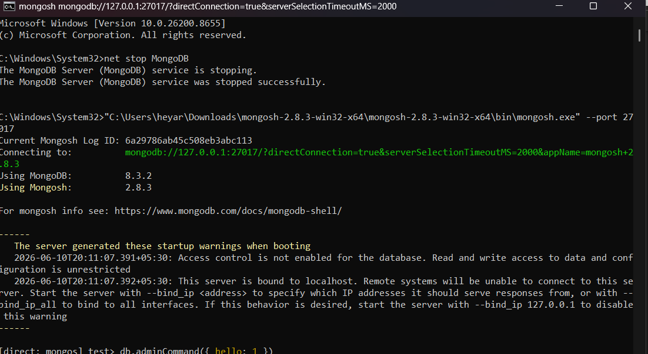
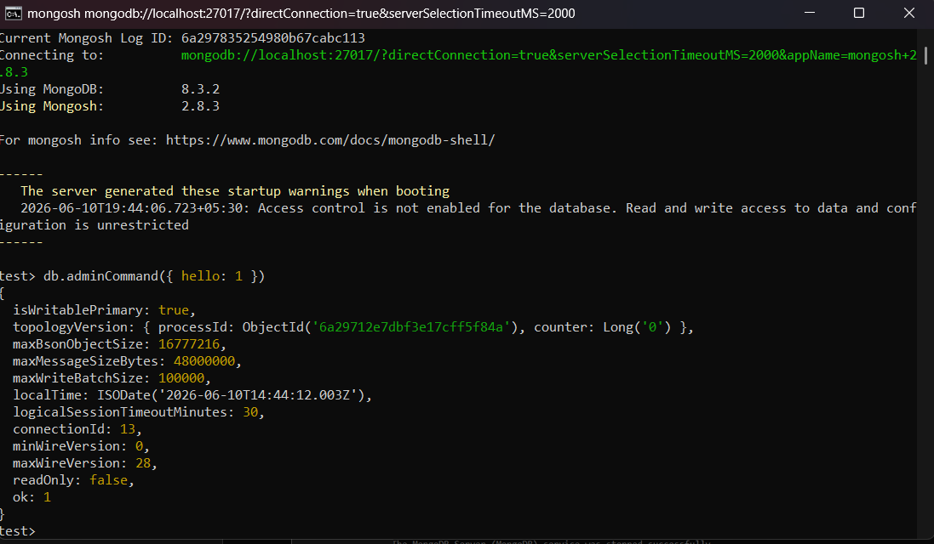
Microsoft Windows [Version 10.0.26200.8655]
(c) Microsoft Corporation. All rights reserved.

C:\Windows\System32>

C:\Windows\System32>"C:\Users\heyar\Downloads\mongosh-2.8.3-win32-x64\mongosh-2.8.3-win32-x64\bin\mongosh.exe" --port 27019
Current Mongosh Log ID: 6a297693fac23f0d0dabc113
Connecting to: mongodb://127.0.0.1:27019/?directConnection=true&serverSelectionTimeoutMS=2000&appName=mongosh+2.8.3
Using MongoDB: 8.3.2
Using Mongosh: 2.8.3

For mongosh info see: https://www.mongodb.com/docs/mongodb-shell/

------
The server generated these startup warnings when booting
2026-06-10T20:06:45.898+05:30: Access control is not enabled for the database. Read and write access to data and configuration is unrestricted
2026-06-10T20:06:45.899+05:30: This server is bound to localhost. Remote systems will be unable to connect to this server. Start the server with --bind_ip <address> to specify which IP addresses it should serve responses from, or with --bind_ip_all to bind to all interfaces. If this behavior is desired, start the server with --bind_ip 127.0.0.1 to disable this warning
------

test> rs.initiate({
| _id: "configReplSet",
| configsvr: true,
| members: [
| {
| _id: 0,
| host: "localhost:27019"
| }
| ]
| })
{
ok: 1,
'$clusterTime': {
clusterTime: Timestamp({ t: 1781102244, i: 1 }),
signature: {
hash: Binary.createFromBase64('AAAAAAAAAAAAAAAAAAAAAAAAAAA=', 0),
keyId: Long('0')
}
},
operationTime: Timestamp({ t: 1781102244, i: 1 })
}
configReplSet [direct: secondary] test> rs.status()
{
set: 'configReplSet',
date: ISODate('2026-06-10T14:37:31.989Z'),
myState: 1,
term: Long('1'),
syncSourceHost: '',
syncSourceId: -1,
configsvr: true,
heartbeatIntervalMillis: Long('2000'),
majorityVoteCount: 1,
writeMajorityCount: 1,
votingMembersCount: 1,
writableVotingMembersCount: 1,
optimes: {
lastCommittedOpTime: { ts: Timestamp({ t: 1781102251, i: 1 }), t: Long('1') },
lastCommittedWallTime: ISODate('2026-06-10T14:37:31.663Z'),
readConcernMajorityOpTime: { ts: Timestamp({ t: 1781102251, i: 1 }), t: Long('1') },
appliedOpTime: { ts: Timestamp({ t: 1781102251, i: 1 }), t: Long('1') },
durableOpTime: { ts: Timestamp({ t: 1781102251, i: 1 }), t: Long('1') },
writtenOpTime: { ts: Timestamp({ t: 1781102251, i: 1 }), t: Long('1') },
lastAppliedWallTime: ISODate('2026-06-10T14:37:31.663Z'),
lastDurableWallTime: ISODate('2026-06-10T14:37:31.663Z'),
lastWrittenWallTime: ISODate('2026-06-10T14:37:31.663Z')
},
lastStableRecoveryTimestamp: Timestamp({ t: 1781102244, i: 1 }),
electionCandidateMetrics: {
lastElectionReason: 'electionTimeout',
lastElectionDate: ISODate('2026-06-10T14:37:24.372Z'),
electionTerm: Long('1'),
lastCommittedOpTimeAtElection: { ts: Timestamp({ t: 1781102244, i: 1 }), t: Long('-1') },
lastSeenWrittenOpTimeAtElection: { ts: Timestamp({ t: 1781102244, i: 1 }), t: Long('-1') },
lastSeenOpTimeAtElection: { ts: Timestamp({ t: 1781102244, i: 1 }), t: Long('-1') },
numVotesNeeded: 1,
priorityAtElection: 1,
electionTimeoutMillis: Long('10000'),
newTermStartDate: ISODate('2026-06-10T14:37:24.406Z'),
wMajorityWriteAvailabilityDate: ISODate('2026-06-10T14:37:24.589Z')
},
members: [
{
_id: 0,
name: 'localhost:27019',
health: 1,
state: 1,
stateStr: 'PRIMARY',
uptime: 46,
optime: { ts: Timestamp({ t: 1781102251, i: 1 }), t: Long('1') },
optimeDate: ISODate('2026-06-10T14:37:31.000Z'),
optimeWritten: { ts: Timestamp({ t: 1781102251, i: 1 }), t: Long('1') },
optimeWrittenDate: ISODate('2026-06-10T14:37:31.000Z'),
lastAppliedWallTime: ISODate('2026-06-10T14:37:31.663Z'),
lastDurableWallTime: ISODate('2026-06-10T14:37:31.663Z'),
lastWrittenWallTime: ISODate('2026-06-10T14:37:31.663Z'),
syncSourceHost: '',
syncSourceId: -1,
infoMessage: 'Could not find member to sync from',
electionTime: Timestamp({ t: 1781102244, i: 2 }),
electionDate: ISODate('2026-06-10T14:37:24.000Z'),
configVersion: 1,
configTerm: 1,
self: true,
lastHeartbeatMessage: ''
}
],
ok: 1,
'$clusterTime': {
clusterTime: Timestamp({ t: 1781102251, i: 1 }),
signature: {
hash: Binary.createFromBase64('AAAAAAAAAAAAAAAAAAAAAAAAAAA=', 0),
keyId: Long('0')
}
},
operationTime: Timestamp({ t: 1781102251, i: 1 })
}
configReplSet [direct: primary] test>
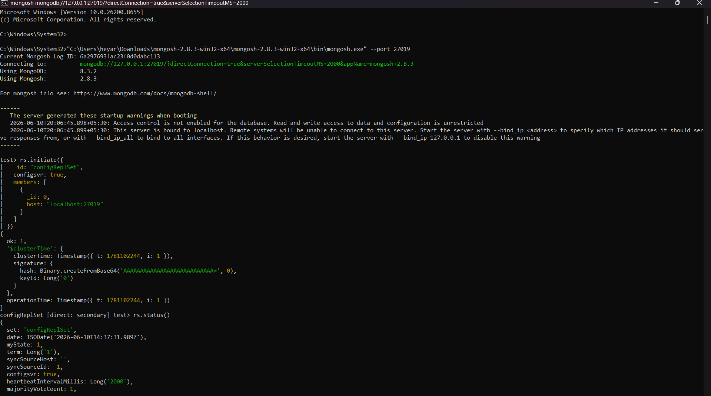
Microsoft Windows [Version 10.0.26200.8655]
(c) Microsoft Corporation. All rights reserved.

C:\Windows\System32>"C:\Users\heyar\Downloads\mongosh-2.8.3-win32-x64\mongosh-2.8.3-win32-x64\bin\mongosh.exe" --port 27012
Current Mongosh Log ID: 6a29773e25eaf66fe1abc113
Connecting to: mongodb://127.0.0.1:27012/?directConnection=true&serverSelectionTimeoutMS=2000&appName=mongosh+2.8.3
Using MongoDB: 8.3.2
Using Mongosh: 2.8.3

For mongosh info see: https://www.mongodb.com/docs/mongodb-shell/

------
The server generated these startup warnings when booting
2026-06-10T20:09:48.809+05:30: Access control is not enabled for the database. Read and write access to data and configuration is unrestricted
2026-06-10T20:09:48.810+05:30: This server is bound to localhost. Remote systems will be unable to connect to this server. Start the server with --bind_ip <address> to specify which IP addresses it should serve responses from, or with --bind_ip_all to bind to all interfaces. If this behavior is desired, start the server with --bind_ip 127.0.0.1 to disable this warning
------

test> rs.initiate({
| _id: "shard2ReplSet",
| members: [
| {
| _id: 0,
| host: "localhost:27012"
| }
| ]
| })
{
ok: 1,
'$clusterTime': {
clusterTime: Timestamp({ t: 1781102407, i: 1 }),
signature: {
hash: Binary.createFromBase64('AAAAAAAAAAAAAAAAAAAAAAAAAAA=', 0),
keyId: Long('0')
}
},
operationTime: Timestamp({ t: 1781102407, i: 1 })
}
shard2ReplSet [direct: secondary] test> rs.status()
{
set: 'shard2ReplSet',
date: ISODate('2026-06-10T14:40:11.806Z'),
myState: 1,
term: Long('1'),
syncSourceHost: '',
syncSourceId: -1,
heartbeatIntervalMillis: Long('2000'),
majorityVoteCount: 1,
writeMajorityCount: 1,
votingMembersCount: 1,
writableVotingMembersCount: 1,
optimes: {
lastCommittedOpTime: { ts: Timestamp({ t: 1781102407, i: 16 }), t: Long('1') },
lastCommittedWallTime: ISODate('2026-06-10T14:40:07.574Z'),
readConcernMajorityOpTime: { ts: Timestamp({ t: 1781102407, i: 16 }), t: Long('1') },
appliedOpTime: { ts: Timestamp({ t: 1781102407, i: 16 }), t: Long('1') },
durableOpTime: { ts: Timestamp({ t: 1781102407, i: 16 }), t: Long('1') },
writtenOpTime: { ts: Timestamp({ t: 1781102407, i: 16 }), t: Long('1') },
lastAppliedWallTime: ISODate('2026-06-10T14:40:07.574Z'),
lastDurableWallTime: ISODate('2026-06-10T14:40:07.574Z'),
lastWrittenWallTime: ISODate('2026-06-10T14:40:07.574Z')
},
lastStableRecoveryTimestamp: Timestamp({ t: 1781102407, i: 1 }),
electionCandidateMetrics: {
lastElectionReason: 'electionTimeout',
lastElectionDate: ISODate('2026-06-10T14:40:07.472Z'),
electionTerm: Long('1'),
lastCommittedOpTimeAtElection: { ts: Timestamp({ t: 1781102407, i: 1 }), t: Long('-1') },
lastSeenWrittenOpTimeAtElection: { ts: Timestamp({ t: 1781102407, i: 1 }), t: Long('-1') },
lastSeenOpTimeAtElection: { ts: Timestamp({ t: 1781102407, i: 1 }), t: Long('-1') },
numVotesNeeded: 1,
priorityAtElection: 1,
electionTimeoutMillis: Long('10000'),
newTermStartDate: ISODate('2026-06-10T14:40:07.504Z'),
wMajorityWriteAvailabilityDate: ISODate('2026-06-10T14:40:07.549Z')
},
members: [
{
_id: 0,
name: 'localhost:27012',
health: 1,
state: 1,
stateStr: 'PRIMARY',
uptime: 23,
optime: { ts: Timestamp({ t: 1781102407, i: 16 }), t: Long('1') },
optimeDate: ISODate('2026-06-10T14:40:07.000Z'),
optimeWritten: { ts: Timestamp({ t: 1781102407, i: 16 }), t: Long('1') },
optimeWrittenDate: ISODate('2026-06-10T14:40:07.000Z'),
lastAppliedWallTime: ISODate('2026-06-10T14:40:07.574Z'),
lastDurableWallTime: ISODate('2026-06-10T14:40:07.574Z'),
lastWrittenWallTime: ISODate('2026-06-10T14:40:07.574Z'),
syncSourceHost: '',
syncSourceId: -1,
infoMessage: 'Could not find member to sync from',
electionTime: Timestamp({ t: 1781102407, i: 2 }),
electionDate: ISODate('2026-06-10T14:40:07.000Z'),
configVersion: 1,
configTerm: 1,
self: true,
lastHeartbeatMessage: ''
}
],
ok: 1,
'$clusterTime': {
clusterTime: Timestamp({ t: 1781102407, i: 16 }),
signature: {
hash: Binary.createFromBase64('AAAAAAAAAAAAAAAAAAAAAAAAAAA=', 0),
keyId: Long('0')
}
},
operationTime: Timestamp({ t: 1781102407, i: 16 })
}
shard2ReplSet [direct: primary] test> db.adminCommand({ hello: 1 })
{
topologyVersion: { processId: ObjectId('6a297734a2406f9e603fdd57'), counter: Long('7') },
hosts: [ 'localhost:27012' ],
setName: 'shard2ReplSet',
setVersion: 1,
isWritablePrimary: true,
secondary: false,
primary: 'localhost:27012',
me: 'localhost:27012',
electionId: ObjectId('7fffffff0000000000000001'),
lastWrite: {
opTime: { ts: Timestamp({ t: 1781102607, i: 1 }), t: Long('1') },
lastWriteDate: ISODate('2026-06-10T14:43:27.000Z'),
majorityOpTime: { ts: Timestamp({ t: 1781102607, i: 1 }), t: Long('1') },
majorityWriteDate: ISODate('2026-06-10T14:43:27.000Z')
},
isImplicitDefaultMajorityWC: true,
maxBsonObjectSize: 16777216,
maxMessageSizeBytes: 48000000,
maxWriteBatchSize: 100000,
localTime: ISODate('2026-06-10T14:43:32.167Z'),
logicalSessionTimeoutMinutes: 30,
connectionId: 2,
minWireVersion: 0,
maxWireVersion: 28,
readOnly: false,
ok: 1,
'$clusterTime': {
clusterTime: Timestamp({ t: 1781102607, i: 1 }),
signature: {
hash: Binary.createFromBase64('AAAAAAAAAAAAAAAAAAAAAAAAAAA=', 0),
keyId: Long('0')
}
},
operationTime: Timestamp({ t: 1781102607, i: 1 })
}
shard2ReplSet [direct: primary] test>
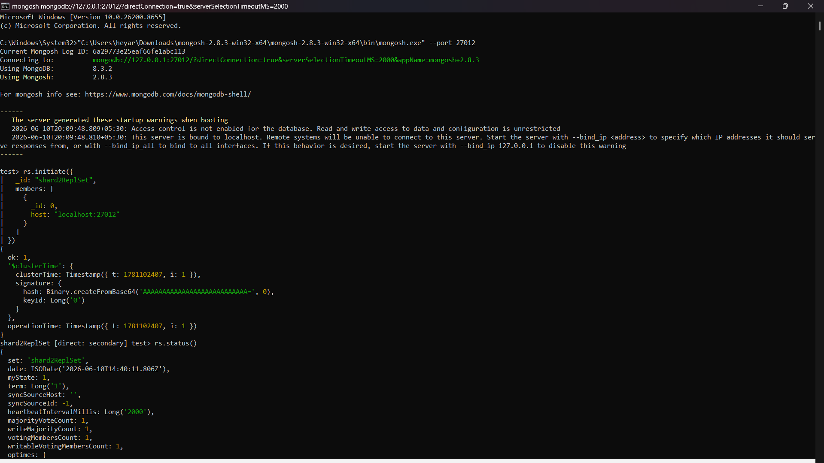
Microsoft Windows [Version 10.0.26200.8655]
(c) Microsoft Corporation. All rights reserved.

C:\Windows\System32>"C:\Users\heyar\Downloads\mongosh-2.8.3-win32-x64\mongosh-2.8.3-win32-x64\bin\mongosh.exe" --port 27011
Current Mongosh Log ID: 6a2977127eb1934164abc113
Connecting to: mongodb://127.0.0.1:27011/?directConnection=true&serverSelectionTimeoutMS=2000&appName=mongosh+2.8.3
Using MongoDB: 8.3.2
Using Mongosh: 2.8.3

For mongosh info see: https://www.mongodb.com/docs/mongodb-shell/

------
The server generated these startup warnings when booting
2026-06-10T20:08:48.551+05:30: Access control is not enabled for the database. Read and write access to data and configuration is unrestricted
2026-06-10T20:08:48.551+05:30: This server is bound to localhost. Remote systems will be unable to connect to this server. Start the server with --bind_ip <address> to specify which IP addresses it should serve responses from, or with --bind_ip_all to bind to all interfaces. If this behavior is desired, start the server with --bind_ip 127.0.0.1 to disable this warning
------

test> rs.initiate({
| _id: "shard1ReplSet",
| members: [
| {
| _id: 0,
| host: "localhost:27011"
| }
| ]
| })
{
ok: 1,
'$clusterTime': {
clusterTime: Timestamp({ t: 1781102362, i: 1 }),
signature: {
hash: Binary.createFromBase64('AAAAAAAAAAAAAAAAAAAAAAAAAAA=', 0),
keyId: Long('0')
}
},
operationTime: Timestamp({ t: 1781102362, i: 1 })
}
shard1ReplSet [direct: secondary] test> rs.status()
{
set: 'shard1ReplSet',
date: ISODate('2026-06-10T14:39:27.937Z'),
myState: 1,
term: Long('1'),
syncSourceHost: '',
syncSourceId: -1,
heartbeatIntervalMillis: Long('2000'),
majorityVoteCount: 1,
writeMajorityCount: 1,
votingMembersCount: 1,
writableVotingMembersCount: 1,
optimes: {
lastCommittedOpTime: { ts: Timestamp({ t: 1781102362, i: 16 }), t: Long('1') },
lastCommittedWallTime: ISODate('2026-06-10T14:39:22.221Z'),
readConcernMajorityOpTime: { ts: Timestamp({ t: 1781102362, i: 16 }), t: Long('1') },
appliedOpTime: { ts: Timestamp({ t: 1781102362, i: 16 }), t: Long('1') },
durableOpTime: { ts: Timestamp({ t: 1781102362, i: 16 }), t: Long('1') },
writtenOpTime: { ts: Timestamp({ t: 1781102362, i: 16 }), t: Long('1') },
lastAppliedWallTime: ISODate('2026-06-10T14:39:22.221Z'),
lastDurableWallTime: ISODate('2026-06-10T14:39:22.221Z'),
lastWrittenWallTime: ISODate('2026-06-10T14:39:22.221Z')
},
lastStableRecoveryTimestamp: Timestamp({ t: 1781102362, i: 1 }),
electionCandidateMetrics: {
lastElectionReason: 'electionTimeout',
lastElectionDate: ISODate('2026-06-10T14:39:22.120Z'),
electionTerm: Long('1'),
lastCommittedOpTimeAtElection: { ts: Timestamp({ t: 1781102362, i: 1 }), t: Long('-1') },
lastSeenWrittenOpTimeAtElection: { ts: Timestamp({ t: 1781102362, i: 1 }), t: Long('-1') },
lastSeenOpTimeAtElection: { ts: Timestamp({ t: 1781102362, i: 1 }), t: Long('-1') },
numVotesNeeded: 1,
priorityAtElection: 1,
electionTimeoutMillis: Long('10000'),
newTermStartDate: ISODate('2026-06-10T14:39:22.151Z'),
wMajorityWriteAvailabilityDate: ISODate('2026-06-10T14:39:22.198Z')
},
members: [
{
_id: 0,
name: 'localhost:27011',
health: 1,
state: 1,
stateStr: 'PRIMARY',
uptime: 39,
optime: { ts: Timestamp({ t: 1781102362, i: 16 }), t: Long('1') },
optimeDate: ISODate('2026-06-10T14:39:22.000Z'),
optimeWritten: { ts: Timestamp({ t: 1781102362, i: 16 }), t: Long('1') },
optimeWrittenDate: ISODate('2026-06-10T14:39:22.000Z'),
lastAppliedWallTime: ISODate('2026-06-10T14:39:22.221Z'),
lastDurableWallTime: ISODate('2026-06-10T14:39:22.221Z'),
lastWrittenWallTime: ISODate('2026-06-10T14:39:22.221Z'),
syncSourceHost: '',
syncSourceId: -1,
infoMessage: 'Could not find member to sync from',
electionTime: Timestamp({ t: 1781102362, i: 2 }),
electionDate: ISODate('2026-06-10T14:39:22.000Z'),
configVersion: 1,
configTerm: 1,
self: true,
lastHeartbeatMessage: ''
}
],
ok: 1,
'$clusterTime': {
clusterTime: Timestamp({ t: 1781102362, i: 16 }),
signature: {
hash: Binary.createFromBase64('AAAAAAAAAAAAAAAAAAAAAAAAAAA=', 0),
keyId: Long('0')
}
},
operationTime: Timestamp({ t: 1781102362, i: 16 })
}
shard1ReplSet [direct: primary] test>
