Aravindkumar R

Sample Document for Migration Assessment

1. Introduction
This document is designed to test complex document structures used in documentation migrations. It includes multiple formatting types such as italic text, lists, tables, hyperlinks, and code blocks.

2. Nested Bullet Lists
- Main Feature 1
- Sub Feature 1.1
- Sub Feature 1.2
- Main Feature 2
- Sub Feature 2.1

3. Nested Numbered Lists

Numbered List Example
This document is designed to test complex document structures used in documentation migrations. It includes multiple formatting types such as italic text, lists, tables, hyperlinks, and code blocks.

Numbered List Example for your reference
- Step 1: Prepare environment
- Step 1.1: Install dependencies
- Step 1.2: Configure settings
- Step 2: Execute migration
- Step 2.1: Validate results
Lorem Ipsum is simply dummy text of the printing and typesetting industry. Lorem Ipsum has been the industry's standard dummy text ever since the 1500s, when an unknown printer took a galley of type and scrambled it to make a type specimen book. It has survived not only five centuries, but also the leap into electronic typesetting, remaining essentially unchanged. It was popularised in the 1960s with the release of Letraset sheets containing Lorem Ipsum passages, and more recently with desktop publishing software like Aldus PageMaker including versions of Lorem Ipsum.
Lorem Ipsum is simply dummy text of the printing and typesetting industry. Lorem Ipsum has been the industry's standard dummy text ever since the 1500s, when an unknown printer took a galley of type and scrambled it to make a type specimen book. It has survived not only five centuries, but also the leap into electronic typesetting, remaining essentially unchanged. It was popularised in the 1960s with the release of Letraset sheets containing Lorem Ipsum passages, and more recently with desktop publishing software like Aldus PageMaker including versions of Lorem Ipsum.

4. Feature Comparison Table
Feature | Description | Supported
Headings | Multiple heading levels | Yes
Lists | Bullet and numbered lists | Yes
Tables | Structured data representation | Yes
Images | Embedded visuals | Optional

5. Migration Status Table
Article ID | Title | Migration Status | Remarks
A101 | Getting Started Guide | Completed | Validated
A102 | Installation Steps | In Progress | Formatting review pending
A103 | API Integration | Pending | Awaiting customer confirmation

6. Hyperlinks
Useful documentation resources: Microsoft Learn
Another useful resource is OpenAI: https://www.openai.com

7. Code Block Example
public static void Main(string[] args)
{
Console.WriteLine("Hello World");
}

8. Image Section
Image placeholder:
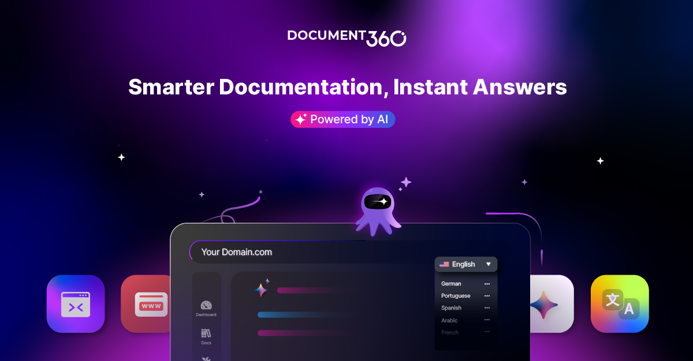
Figure 1

9. Conclusion
This advanced test document contains nested lists, multiple tables, hyperlinks, and formatted text. It is suitable for validating document parsing, HTML conversion, or knowledge base migration scripts.
Lorem Ipsum is simply dummy text of the printing and typesetting industry. Lorem Ipsum has been the industry's standard dummy text ever since the 1500s, when an unknown printer took a galley of type and scrambled it to make a type specimen book. It has survived not only five centuries, but also the leap into electronic typesetting, remaining essentially unchanged. It was popularised in the 1960s with the release of Letraset sheets containing Lorem Ipsum passages, and more recently with desktop publishing software like Aldus PageMaker including versions of Lorem Ipsum.
End of the Sample Documentation. All the best.

