FIFO VERIFICATION PLAN

1. Introduction
This document describes the verification plan for a 16-entry synchronous FIFO. It covers the DUT, the features to be verified, the SystemVerilog testbench architecture, the checking strategy, the test plan and the functional coverage plan. It follows the testbench files fifo_if.sv, fifo_trans.sv, fifo_gen.sv, driver.sv, write_mon.sv, fifo_rd_mon.sv, fifo_model.sv, fifo_score.sv, fifo_env.sv, fifo_test.sv, fifo_package.sv and fifo_top.sv.

2. DUT Summary
The Device Under Test (DUT) is a synchronous FIFO with the following specification:
Table 1: FIFO Configuration
Parameter | Specification
FIFO Type | Synchronous FIFO
Data Width | 8 bits
FIFO Depth | 16 entries
Pointer Width | 5 bits (4 address bits + 1 phase bit)
Clock | Single clock, rising edge
Reset | Asynchronous, active HIGH
Write Interface | wr_en, wdata
Read Interface | rd_en
Status | full, empty
Read Data | rdata (registered, valid one cycle after an accepted read)
Table 2: Port Description of FIFO
Signal | Direction | Width | Description
clk | Input | 1 | System clock
rst | Input | 1 | Active HIGH reset
wr_en | Input | 1 | Write enable
rd_en | Input | 1 | Read enable
wdata | Input | 8 | Write data bus
rdata | Output | 8 | Read data bus
full | Output | 1 | FIFO full flag
empty | Output | 1 | FIFO empty flag

3. Key Features to Verify
The testbench must confirm the following functional requirements:
- Data Integrity: 8-bit data must be stored and returned strictly in First-In, First-Out order.
- Flag Generation: full must assert when all 16 entries are occupied and empty must assert when the FIFO holds no data.
- Pointer Wraparound: the read and write pointers must wrap correctly after 16 entries; the phase bit must keep full and empty distinct.
- Overflow Protection: a write attempted while full is high must be ignored.
- Underflow Protection: a read attempted while empty is high must be ignored.
- Data Boundary Values: 00 and FF must be stored and returned correctly.
- Reset Behavior: after reset the FIFO must be empty and not full.

4. Verification Architecture
Figure 1 shows the testbench. The generator creates transactions and passes them to the driver through the gen2drv mailbox. The driver applies them to the DUT through the interface. The write monitor observes accepted writes and sends the written data to the reference model through wmon2ref. The reference model stores the data in a queue and sends the expected read data to the scoreboard through ref2scb. The read monitor observes accepted reads and sends the actual read data to the scoreboard through rmon2scb. The scoreboard compares actual and expected data and samples functional coverage. Assertions in the interface check protocol rules on every clock.
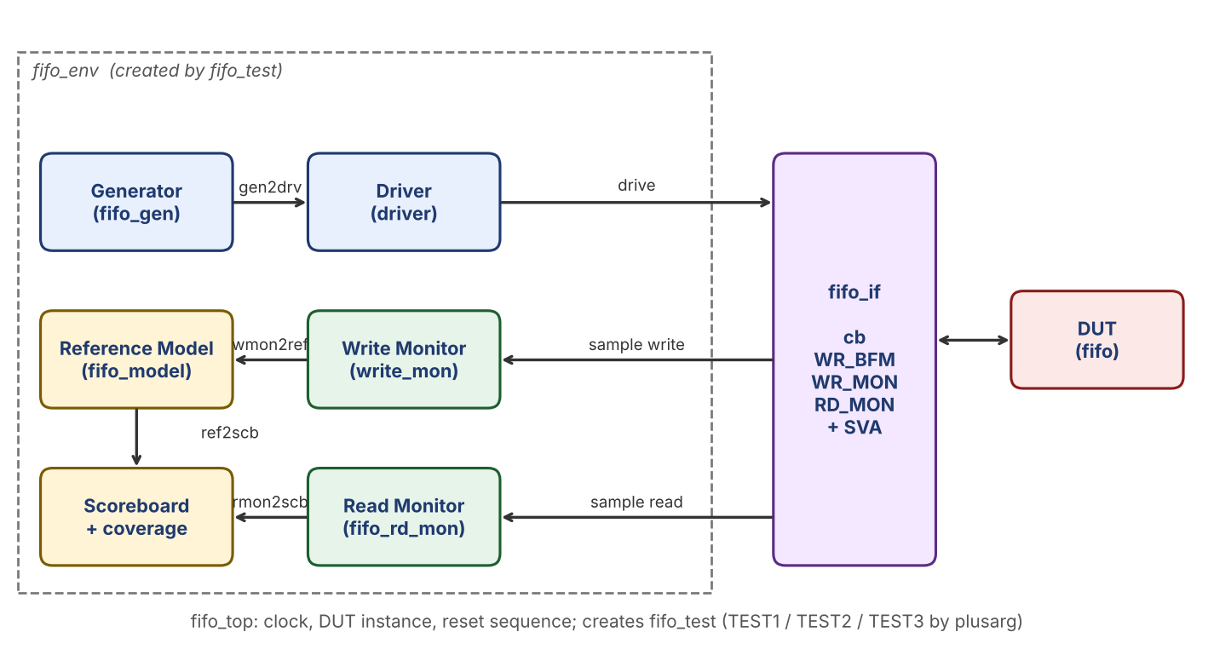
Figure 1: FIFO Testbench Architecture

5. Component Description
Component | File | Role
fifo_if | fifo_if.sv | Interface bundling clk, rst, wr_en, rd_en, wdata, rdata, full and empty. One clocking block (cb) with 1 ns input and output skew. Modports WR_BFM, RD_BFM, WR_MON and RD_MON. Contains three concurrent assertions.
fifo_trans | fifo_trans.sv | One bus cycle: random wr_en, rd_en and wdata plus observed rdata, full and empty. Default distribution: write 50 percent, read 45 percent. Has a display function.
fifo_gen | fifo_gen.sv | Creates num_transactions randomized transactions and puts them in the gen2drv mailbox. A handle (gen_trans) lets a test substitute a constrained subclass. Triggers the done event when finished.
driver | driver.sv | Takes a transaction from gen2drv and drives wr_en, rd_en and wdata through the clocking block on the next clock.
write_mon | write_mon.sv | Each clock, if wr_en is high and full is low, captures wdata and sends it to the reference model.
fifo_rd_mon | fifo_rd_mon.sv | Each clock, if rd_en is high and empty is low, captures rdata, wr_en, rd_en, full and empty and sends them to the scoreboard.
fifo_model | fifo_model.sv | Reference model. Receives written data, keeps it in a queue (golden_queue) and sends the expected read data to the scoreboard.
fifo_score | fifo_score.sv | Compares actual read data with the expected data, prints MATCH or MISMATCH, and samples the functional covergroup.
fifo_env | fifo_env.sv | Builds all components and mailboxes and starts them in parallel.
fifo_test | fifo_test.sv | Selects TEST1, TEST2 or TEST3 using plusargs. TEST2 and TEST3 use constrained subclasses of fifo_trans.
fifo_package | fifo_package.sv | Package that includes all the testbench classes.
fifo_top | fifo_top.sv | 100 MHz clock, DUT instance, reset sequence (high for 2 clocks), creates fifo_test and runs it.

6. Testbench Flow
- fifo_top generates the clock, instantiates the interface and DUT and creates fifo_test.
- The top module holds rst high for 2 clock cycles with wr_en and rd_en low, then releases reset.
- build_and_run() reads the plusarg (+TEST1, +TEST2 or +TEST3), builds the environment and sets the number of transactions.
- The environment starts generator, driver, both monitors, reference model and scoreboard in parallel.
- When the generator triggers its done event, the test waits 100 ns so the last transactions complete, then calls $finish.
- Scoreboard messages (MATCH or MISMATCH) and assertion messages are printed during the run, and the coverage report is produced by the simulator.

7. Checking Strategy

7.1 Scoreboard Checks
Check | Description
Read data | For each accepted read, the actual rdata from the read monitor is compared with the expected value from the reference model. A mismatch raises an $error.
Write capture | The write monitor only reports a write when wr_en is high and full is low, so rejected writes are not stored in the model.
Read capture | The read monitor only reports a read when rd_en is high and empty is low, so rejected reads are not compared.

7.2 Assertions
Assertion | Property
assert_flags_mutex | full and empty are never high together (disabled during reset).
assert_overflow_protection | If full is high with a write and no read, full stays high on the next clock.
assert_underflow_protection | If empty is high with a read and no write, empty stays high on the next clock.

The assertions are written in the interface and check the DUT signals on every clock, independent of the stimulus.

8. Test Plan
Tests are selected at run time with a plusarg, for example +TEST1.
Test | Stimulus | Objective
TEST1 | 400 random transactions, write 50 percent, read 45 percent | General data integrity and mixed traffic; flags change in normal operation.
TEST2 | 500 transactions, wdata limited to 00 and FF, write 70 percent, read 30 percent | Boundary data values; write-heavy traffic that drives the FIFO towards full and exercises overflow protection.
TEST3 | 300 transactions, write 90 percent, read 90 percent | Heavy simultaneous read and write traffic; pointer wraparound and both boundaries under load.

9. Functional Coverage Plan
Coverage is defined in fifo_score.sv and sampled by the scoreboard.
Coverpoint / Cross | Bins | Purpose
cp_wr | 0, 1 | Write enable seen both values
cp_rd | 0, 1 | Read enable seen both values
cp_fl | 0, 1 | Full flag seen both values
cp_mt | 0, 1 | Empty flag seen both values
cross_overflow | cp_wr x cp_fl | Write attempted while full
cross_underflow | cp_rd x cp_mt | Read attempted while empty

Coverage goal: 100% of every coverpoint and both crosses, with zero scoreboard mismatches and no assertion failures.

