Chennai, Tamil Nadu ALAMELU J
Country PIN - 600 095 alamume17@gmail.com
+91-9043058582

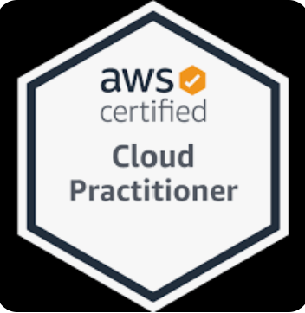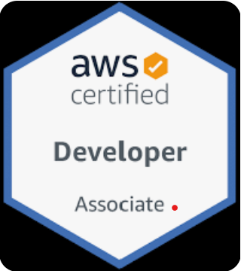

EMPLOYEMENT

Accenture Pvt ltd
Packaged App Development Senior Analyst Cloud Technology 15th March 2023 - Present

- Orchestrated the provisioning of resources on Cloud platforms, optimizing performance through Terraform
modules and configurations
- Architected and developed a robust AWS application leveraging Velocity core UI
- Integrated Velocity Core client UI to provide an user friendly front end interface for efficient user interaction

Infosys Pvt ltd
Senior Technology Analyst Cloud Technology November 2019- 14th March 2023

- Developed Web based application using AWS Lambda ,AWS Cloudfront Services
- Managing internal projects developed on AWS using various AWS services
- Managing the backend part of the application involving AWS RDS, AWS Dynamo DB and Redshift Databases
- Automating the AWS service resource cleanup written in python programming language
- Conducted many certifications preparatory workshops on AWS SAA and AWS Developer Associate
Certification to the internal and external clients
- Handling Client Trainings on Cloud technology and its Cloud service providers
- Experienced in resolving various issues on AWS services
- Certified in AWS Cloud practitioner and also hold many internal certifications from Infosys
- Certified in AWS Solutions Architect Associate examination as well.
- Conducting many internal trainings to 1000+ Infosys employees.
- Conducting various training on AWS Service hands-on to the employees
- Scaled up on basic services from GCP technology
- Have provided logical trainings on API’s and Serverless computing

Senior Systems Engineer Unix& Python June 2017-October 2019

- Migration of servers from AIX to Linux platform
- End to end analysis of shell and Perl scripts summing up the entire flow of the application
- Testing and debugging of shell and Perl scripts along with batches
- Code compilation and movement from backend to frontend using GitHub and Looper
- Integration and functional testing of applications getting triggered from Stored Procedures, .Net and Java frameworks
- Granting permissions and executing procedures by triggering the SPs
- Monitoring, analysing and rectifying the code during failure in runtime execution.
- Updating and modifying the queries to pull data from the databases using DDL and DML statements
- Remediating the code for interconnection between DB2 and Informix in order to extract data

Systems Engineer Trainee Unix Shell Scripting December 2016 – May 2017

- Undergone Infosys training on Open source technology
- Created a mini project on a shopping cart application on Python technology

TECHNICAL KNOWLEDGE
Technology | : Cloud Computing,EC2, AWS Lambda, API gateway, IAM, AWS Services, AWS DMS, Serverless services, AWS Kinesis,Google Cloud Platform
System Languages | : C, Python, Shell Scripting, Perl(basics),4GL
Web Technologies | : HTML, CSS, JavaScript, PHP, Angular(basics)
Databases | : AWS RDS, AWS Dynamo DB, AWS Redshift, AWS Neptune, Amazon Elastic Cache, MySQL, Informix, DB2,Oracle.

EDUCATION

Chennai,India RMK Engineering College 2014 -2016
- Master of Engineering in Applied Electronics with 8.84 /10

Vellore,India Sri Balaji Chockalingam Engineering College 2010 – 2014
- Bachelor of Engineering in Electronics and Communication Engineering with 8.19/10

CO-CURRICULAR ACHIEVEMENTS

- Received Best educator award for the year 2021 -2022
- Received Best Insta Award from Infosys for conducting various trainings
- Received Rise Gracious Award from Infosys for the year 2022
- Received many goodies from Infosys for performing best during trainings
- Received Best performer of the year on 2020 on working with AIX migration project
- Secured 11th rank under Anna University in Post Graduate course
- Secured 1st rank in Post graduate course in academics at RMK Engineering College
- Secured Second place in department level in Under graduate course in SBC Engineering College
- Secured Third place in college level in Under graduate course in SBC Engineering college
- Received the “Best Outgoing Girl student” award in HSC. Active member of NSO in HSC

PERSONAL DETAILS

Father’s Name : Janakiraman R
Date of Birth : 17.09.1992
Gender : Female
Nationality : Indian
Hobbies : Gardening, Drawing and Surfing net.
Language Known : Tamil &English

I hereby declare that all the information given above is true to the best of my knowledge.

Place: Chennai Signature
Date: (Alamelu J)

