ABHILASH PRADHAN
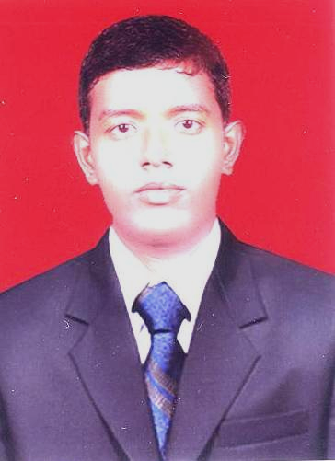

Plot No.- B/L- 104
VSS Nagar, Bhubaneswar
Dist- Khurda, Odisha
Email: abhilash90pradhan@gmail.com
Mob No.-+91-9438357730 / 9040183166

OBJECTIVE:

Quest to work in a professional and competent atmosphere involving my enthusiasm aided with my efforts contributing to the growth of the organization and to strive and achieve excellence in the area of work undertaken with honesty, commitment and dedication.

ACADEMIC QUALIFICATION:

- Continue in B.Tech (2010-2013) in Mechanical Engineering from KMBB, BBSR under BPUT .
- Diploma from Nilachal Polytechnic, Bhubaneswar (2006-2009), Odisha with 62.00%.
- 10th from Sri Pingaleswar Bidyapitha, Raniamunha under B.S.E (2006), Odisha with 59.00%.

SOFTWARE SKILL:

- Ms. Office, Internet
- C, C++

TRAINING:

- Attended a one-month training program on AutoCAD at CTTC, BBSR.

PROJECT DETAILS:

Rainwater Harvesting (Diploma)
Objective :
- Rainwater harvesting is the accumulation and deposition of rainwater for reuse before it reaches the aquifer. Uses include water for garden, water for livestock, water forirrigation, etc.
- In many places the water collected is just redirected to a deep pit with percolation. The harvested water can be used as drinking water as well as for storage and other purpose like irrigation.
Tools and Technology Used:
- PVC pipes, Water tank

PERSONAL PROFILE:

Father’s Name : Kanduri Chanran Pradhan
Date of Birth : 12th Aug -1990
Gender : Male
Nationality : Indian
Religion : Hindu
Language Known : English, Hindi and Oriya
Permanent Address : C/o – Kanduri Chanran Pradhan
At- Kanpur,Po- Bagalosahi
Ps- Niali, Dist- Cuttack
Odisha, Pin- 754004

DECLARATION:

Hereby, I assure that the information furnished above is true to the best of my knowledge & belief. If I get an opportunity to work in your concern, I assure that I shall discharge my duties to the fullest satisfaction of my Employer and to the best of my ability.

Date :
Place : Abhilash Pradhan

