Jagannath Aravind Ganti

Senior DevOps Engineer

Jnt.aravind@gmail.com | (940) 489- 2758 |LinkedIn

{{ABOUT_ME}}

Professional Summary
{% for k in SUMMARY %}
- {{r k }} {% endfor %}

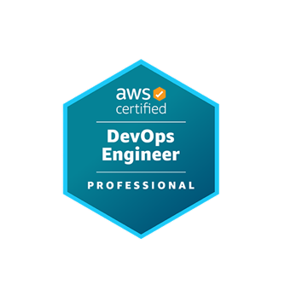
Certifications
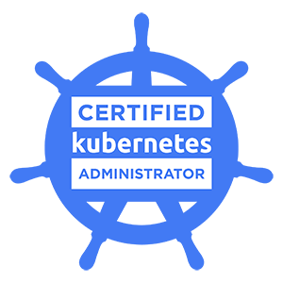

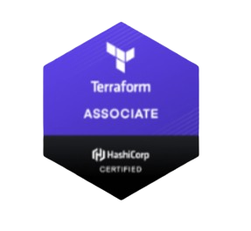
- AWS DevOps Engineer – Professional
- Azure DevOps Engineer - Expert
- HashiCorp Certified: Terraform Associate
- Certified Kubernetes Administrator

Technical Skills

{%tr for category in TECHNICAL_SKILLS %}
{{ category.NAME }} | {{ category.SKILLS }}
{%tr endfor %}

Professional Experience

Client: Fiserv Mar 2024 – Current
Role: Sr. DevOps Engineer
Responsibilities:
{% for k in RESPONSIBILITES_FS %}
{{r k }} {% endfor %}
Environment:
{{ENVIRONMENT_FS}}
Client: Grocery Outlet Aug 2020 – Nov 2023
Role: Sr. Site Reliability Engineer (SRE)
Responsibilities:
{% for k in RESPONSIBILITES_GO %}
- {{r k }} {% endfor %}

Environment:
{{ENVIRONMENT_GO}}

Client: RxSense Jun 2017 - Aug 2020

Role: Site Reliability Engineer (SRE)
Responsibilities:
{% for k in RESPONSIBILITES_RX %}
{{r k }} {% endfor %}
Environment:
{{ENVIRONMENT_RX}}

Client: T- Mobile Jun 2015 – Apr 2017
Role: DevOps Engineer
Responsibilities:
{% for k in RESPONSIBILITES_TM %}
- {{r k }} {% endfor %}

Environment:
{{ENVIRONMENT_TM}}

Client: Apollo Home Healthcare Ltd May 2013 - Jun 2015
Role: Linux Administrator
Responsibilities:
{% for k in RESPONSIBILITES_AP %}
- {{r k }} {% endfor %}

Environment:
{{ENVIRONMENT_AP}}

Education

- Masters in Computer Science from University of Central Missouri 2025
- Bachelors in Computer Science from Siddhartha Institute of Technology and Science 2013

