**Team 5**

**Group Project**

**Employee Management System**

**Group Members: Aravind S 700757083**

**Triveni P 700756042**

**SRI VIGNA JEENIGIRI 700758097**

**Save employee data:**

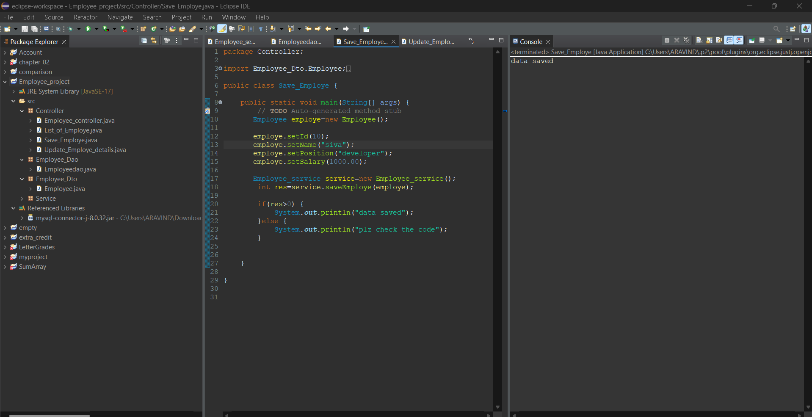

**Update employee data:**

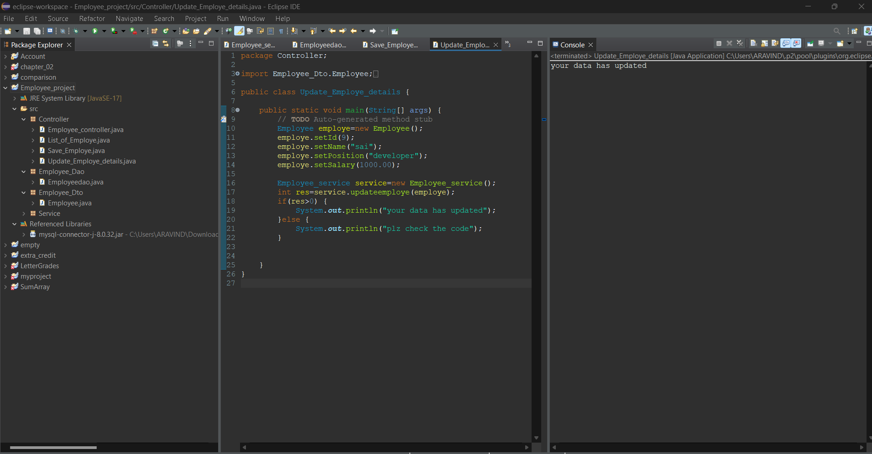

**Employee list:**

