**DBMS PROJECT**

**TRACK MACHINE MANAGEMENT**

**SYSTEM**

PREPARED BY

**TEAM 15**

**1) M V PAVAN (1215316956)**

**2) SAMUEL (1215316904)**

**3) ARAVIND (1215316908)**

**4) PEEYUSH (1215316922)**

THIRD YEAR C.S.E DEPARTMENT



GITAM INSTITUTE OF TECHNOLOGY

GITAM UNIVERSITY

**Track Machine Management for Railways**

Railways is a big organization that needs to maintain the details of different things like tracks and their material so it is a tedious job to maintain all these details manually, in order to overcome track procurement management system is providing the successful tools and techniques to a broad range of activities like maintaining inventory of the material needed for tracks like bolts, nuts, joints. the project mainly contains the modules like material purchasing, materials issuing, stock maintenance, zonal issuing, monitoring of track machines.

**Introduction:**

**ER Diagram:**

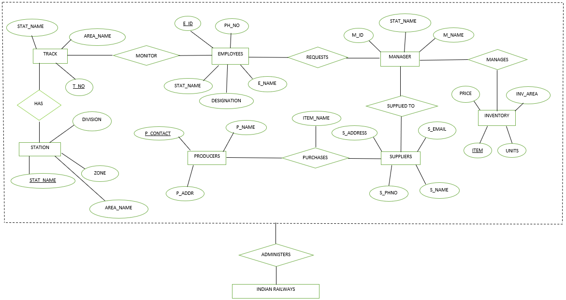

**Explanation:**

**Tables Creation:**

**SCHEMA:**

1. STATION(station name: char, area name: char, division: char, zone: char)
2. TRACK (track number: integer, station name: char, area name: char)
3. EMPLOYEES (employee id: integer, employee name: char, designation: char (Employee or ), station name: char, phone: integer)
4. MANAGERS (manager id: integer, manager name: char, station name: char)
5. SUPPLIERS (suppliers name: char, suppliers phone: integer, supplier email: char, supplier address: char)
6. INVENTORY (manager id: integer, item name: char, units: integer, price: integer, inventory area: char)

**SQL COMMANDS:**

CREATE TABLE Station

(stat_name char(25),

area_name char(25),

division char(15),

zone_name char(40),

CONSTRAINT Station PRIMARY KEY (stat_name));

CREATE TABLE Track

(track_id integer,

stat_name char(25),

area_name char(25),

CONSTRAINT Track PRIMARY KEY (track_id),

FOREIGN KEY (stat_name) REFERENCES Station(stat_name));

CREATE TABLE Employees

(employee_id integer,

employee_name char(30),

designation char(15),

stat_name char(25),

phone_no integer,

CONSTRAINT Employees PRIMARY KEY (employee_id),

CONSTRAINT phon_unique UNIQUE (phone_no),

FOREIGN KEY (stat_name) REFERENCES Station(stat_name));

CREATE TABLE Managers

(manager_id integer,

manager_name char(20),

stat_name char(25),

CONSTRAINT Managers PRIMARY KEY (manager_id),

FOREIGN KEY (manager_id) REFERENCES Employees(employee_id),

FOREIGN KEY (stat_name) REFERENCES Station(stat_name));

CREATE TABLE Inventory

(manager_id integer,

item_name char(30),

units integer,

price integer,

inv_area char(15),

CONSTRAINT Inventory PRIMARY KEY (item_name),

FOREIGN KEY (manager_id) REFERENCES Managers(manager_id));

CREATE TABLE Suppliers

(supplier_name char(25),

supplier_phone integer,

supplier_email char(25),

supplier_address char(25),

CONSTRAINT Suppliers PRIMARY KEY (supplier_name));

**Inserting values:**

insert into Station values('Anakapalle','Visakhapatnam','Vijayawada','South Central Railway');

insert into Station values('Annavaram','West Godavari','Vijayawada','South Central Railway');

insert into Station values('Bapatla','Guntur','Vijayawada','South Central Railway');

insert into Station values('Bhimavaram','Guntur','West Godavari','South Central Railway');

insert into Station values('Vijayawada','Vijayawada','Vijayawada','South Central Railway');

insert into Station values('Bapatla','Guntur','Vijayawada','South Central Railway');

insert into Station values('Kacheguda','Hyderabad','Hyderabad','South Central Railway');

insert into Station values('Kamareddi','Nizamabad','Hyderabad','South Central Railway');

insert into Station values('Kurnool City','Kurnool','Hyderabad','South Central Railway');

insert into Station values('Malakpet','Hyderabad','Hyderabad','South Central Railway');

insert into Station values('Shadnagar','Mahabubnagar','Hyderabad','South Central Railway');

insert into Station values('Bhadrachalam','Khammam','Secunderabad','South Central Railway');

insert into Track values(210856,'Anakapalle','Visakhapatnam');

insert into Track values(210832,'Annavaram','West Godavari');

insert into Track values(210808,'Bapatla','Guntur');

insert into Track values(210804,'Vijayawada','Vijayawada');

insert into Track values(210836,'Kurnool City','Kurnool');

insert into Track values(210812,'Bhadrachalam','Khammam');

insert into Track values(210842,'Malakpet','Hyderabad');

insert into Employees values(2010531231,'Rajesh','employee','Anakapalle',9848291474);

insert into Employees values(2010531321,'Rohith','employee','Anakapalle',9847543474);

insert into Employees values(2010531721,'Krishna','employee','Shadnagar',9848973474);

insert into Employees values(2010031721,'Kumar','manager','Shadnagar',9848567474);

insert into Employees values(2010533221,'Raghu','manager','Malakpet',9844563474);

insert into Employees values(2010631721,'prasad','manager','Vijayawada',9348973474);

insert into Managers values(2010031721,'Kumar','Shadnagar');

insert into Managers values(2010533221,'Raghu','Malakpet');

insert into Managers values(2010631721,'prasad','Vijayawada');

insert into Inventory values(2010031721,'Track Spikes',30,10,'Shadnagar');

insert into Inventory values(2010533221,'Track Bolts',20,5,'Malakpet');

insert into Inventory values(2010533221,'CMS Blocks',20,56,'Malakpet');

insert into Inventory values(2010031721,'Ground Pole',20,220,'Shadnagar');

insert into Inventory values(2010631721,'Wagon Springs',100,10000,'Vijayawada');

insert into Inventory values(2010631721,'Stud FIttings',50,10000,'Vijayawada');

insert into Suppliers values('Rail Udyog',9945772013,'railudyog@gmail.com','Kolkata');

insert into Suppliers values('Vulcan Works',9945756323,'vulcanworks34@gmail.com','Kolkata');

insert into Suppliers values('Goodworks',9543472013,'goodworks@gmail.com','Punjab');

insert into Suppliers values('InvoluteWorks',9357720132,'involute@gmail.com','Kolkata');

**JDBC:**

import java.sql.*;

class OracleCon2{

public static void main(String args[]){

try{

//step1 load the driver class

Class.forName("oracle.jdbc.driver.OracleDriver");

//step2 create the connection object

Connection con=DriverManager.getConnection(

"jdbc:oracle:thin:@192.168.23.144:1521/ORCL","cseb1908","aravind08");

//step3 create the statement object

Statement stmt=con.createStatement();

//step4 execute query

ResultSet rs=stmt.executeQuery("select * from employees");

while(rs.next())

System.out.println(rs.getLong(1)+" "+rs.getString(2)+" "+rs.getString(3)+" " +rs.getString(4)+" "+rs.getLong(5));

//step5 close the connection object

con.close();

}catch(Exception e){ System.out.println(e);}

}

} Output:

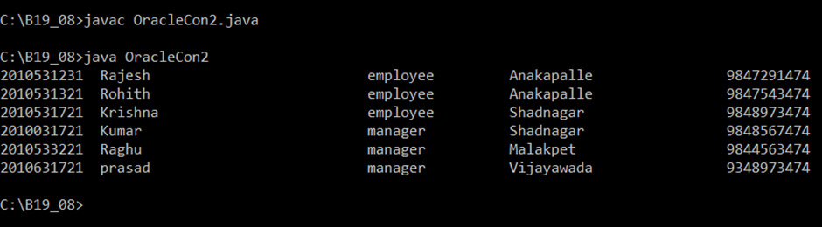

**Insertion:**

import java.sql.*;

class OracleCon{

public static void main(String args[]){

try{

//step1 load the driver class

Class.forName("oracle.jdbc.driver.OracleDriver");

//step2 create the connection object

Connection con=DriverManager.getConnection(

"jdbc:oracle:thin:@192.168.23.144:1521/ORCL","cseb1908","aravind08");

//step3 create the statement object

int employee_id = 201073;

String employee_name = "srinivas";

String designation = "manager";

String stat_name = "Vijayawada";

int phone_no = 83269;

String sql = "insert into employees values('" +employee_id+"','"+employee_name+"','" +designation+"','" +stat_name+"','" +phone_no+ "')";

Statement stmt=con.createStatement();

//step4 execute query

int m =stmt.executeUpdate(sql);

//while(rs.next())

//System.out.println(rs.getInt(1)+" "+rs.getString(2)+" "+rs.getInt(3));

if(m==1)

System.out.println("inserted succesfully");

else

System.out.println("insertion failed");

//step5 close the connection object

con.close();

}catch(Exception e){ System.out.println(e);}

}

Output:

