AUTOMATED HEALTH INSURANCE
RENEWAL DATA & REPORTING SOLUTION
Project Documentation
Excel • Power Query • Power Pivot • DAX • Operational Reporting
Project type | Recurring multi-source insurance renewal reporting automation
Primary platform | Microsoft Excel with Power Query and Power Pivot
Analytical layer | DAX calculated measures and PivotTable reporting
Reporting cadence | Daily operational reporting + month-on-month reporting
Evidence | Actual workbook plus screenshots of queries, Data Model, DAX and report outputs
Confidentiality: Mask real customer names, mobile numbers, email addresses, policy identifiers and other sensitive records before external sharing.
Built from the implementation evidence supplied for this project.

Document Map
DOCUMENT MAP
1. Executive Summary
2. Business Background and Problem
3. Project Objective
4. Solution Architecture
5. Source Data Architecture
6. Power Query ETL Design
7. Current-Month and Previous-Month Loading
8. Paid/Unpaid File Standardization
9. Date Parameter and Daytype Design
10. MARK / Disposition Mapping
11. Power Pivot Data Model
12. DAX KPI and Business Logic
13. DRR and Month-End Boundary Handling
14. Reporting Layer
15. Daily and Monthly Operating Workflow
16. Challenges and Design Decisions
17. Skills Demonstrated and Evidence

1. Executive Summary
This project is a reusable Excel-based reporting and data-processing solution for health insurance renewal operations. It brings together customer/policy base information, CRM/disposition information and paid/unpaid renewal information, then converts the consolidated information into operational KPIs and management reports.
The implementation uses Power Query as the ETL layer, Power Pivot as the analytical model, and DAX as the KPI/calculation layer. A user-controlled Date parameter and Daytype calendar support month-aware calculations such as working-day counts, DRR and previous-day reporting.
Business outcome | Reduce repetitive daily/monthly manual consolidation and report rebuilding.
Technical outcome | Standardized source ingestion → transformation → model → measures → reports.
Core KPIs | Base/Paid NOP and Premium, Target, Achievement, Deficit, MTD/FTD, DRR, yesterday and upsell.
Design principle | Keep the downstream reporting framework reusable even as source files change.

2. Business Background and Problem
The reporting process supports policies approaching renewal. The business needs visibility into renewal due volume, customer-contact outcomes, payment/renewal completion, performance by plan/region and performance against targets.
The information is distributed across different sources and refresh frequencies:
- Monthly customer/policy base file.
- Daily CRM / disposition information reflecting customer interactions and statuses.
- Daily paid/unpaid information used to identify payment/renewal completion.
The manual process required repeatedly opening source files, cleaning data, matching records, consolidating datasets, updating calculations and preparing reports.
Analytical significance: The project addresses ETL, business-rule modeling, KPI calculation and repeatable reporting—not only presentation formatting.

3. Project Objective
- Create a reusable reporting framework for changing reporting periods.
- Automate multi-source data extraction and transformation.
- Standardize required fields and data types.
- Consolidate policy, CRM/disposition and paid/unpaid information.
- Create reusable Power Pivot/DAX measures.
- Support daily and month-on-month refresh-driven reporting.
- Control date-sensitive calculations through a reporting-period parameter.
- Provide visibility into actuals, targets, deficits, daily movement and upsell performance.

4. Solution Architecture
SOURCE FILES → POWER QUERY ETL → CONSOLIDATED TABLES → POWER PIVOT DATA MODEL → DAX KPIs → PIVOTTABLE REPORTS
Source layer | Current month, previous month, paid/unpaid, CRM dump and mapping data.
ETL layer | Extraction, promotion of headers, type conversion, column selection, merges and expansions.
Calendar layer | Date parameter → date list → DayName → Day Type.
Model layer | RETAIL_BASE, Daytype and RETAIL_DISPOSITION visible in the Data Model.
KPI layer | Target, paid/received, pending, deficit, DRR, yesterday, upsell and achievement measures.
Presentation layer | Plan, month, premium and NOP performance reports.

Power Pivot Data Model
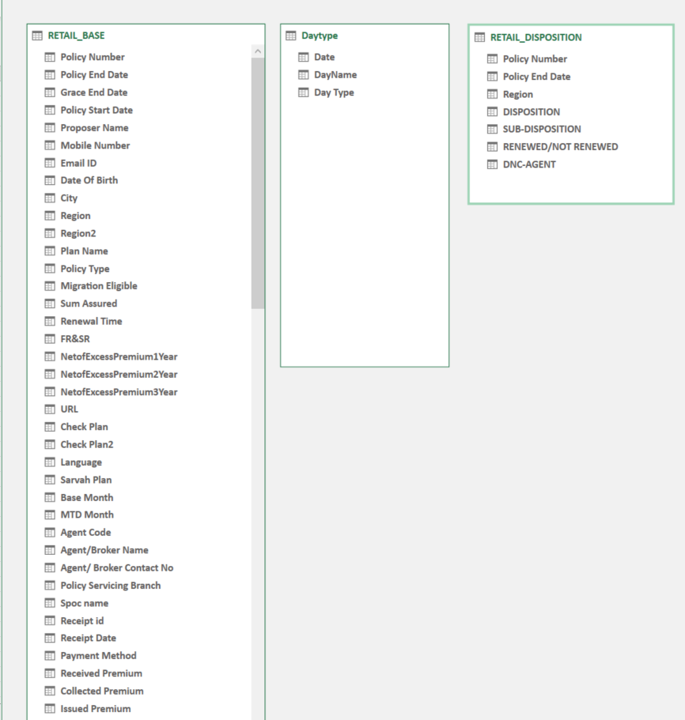
Data Model view supplied for the project. RETAIL_BASE is the main analytical table, with Daytype and RETAIL_DISPOSITION shown as supporting tables.

5. Source Data Architecture
The workbook shows a separate query architecture for current month, previous month, paid/unpaid information, CRM dump, Date, Daytype, MARK, RETAIL_BASE and RETAIL_DISPOSITION.
Source / object | Role | Evidence
Current_Month | Monthly customer/policy base for the selected period. | Current month query
Previous_Month | Prior-period b customer/policy base for the selected period. | Previous month query
PAID_UNPAID_FILE | Payment/renewal source for paid vs unpaid KPIs. | Paid/Unpaid query
DUMP | CRM/call status source enriched with MARK mappings. | DUMP query
MARK | Status → disposition → sub-disposition reference mapping. | MARK query
Date / Daytype | Reporting calendar and working-day classification. | Parameter + Daytype
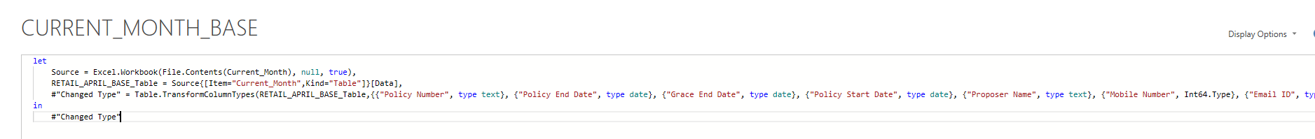

Current-Month Source Query
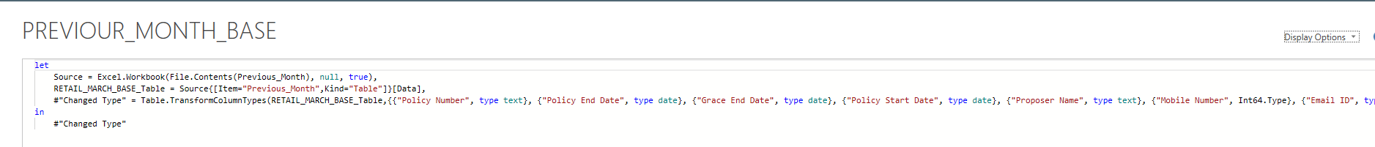

Previous-Month Source Query

6. Power Query ETL Design
Power Query is the central ETL layer. Queries are separated by business function so that source ingestion, mapping and analytical tables remain organized.

Paid/Unpaid Query
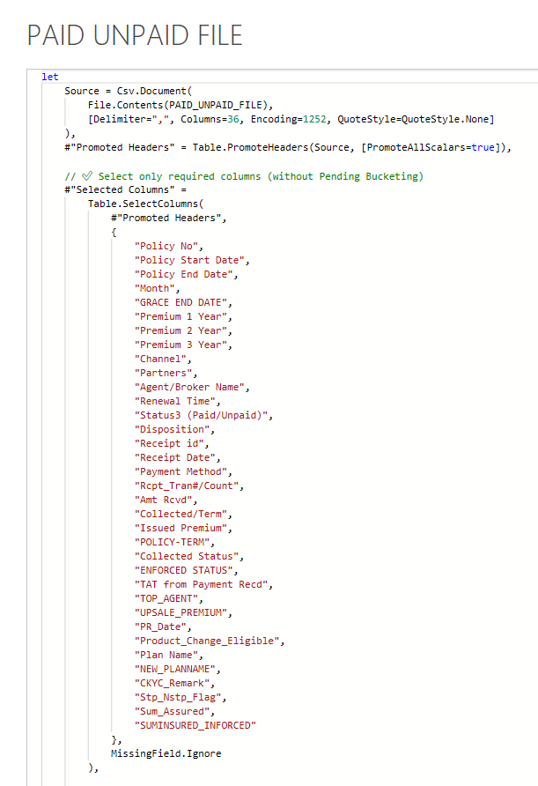
Required fields are explicitly selected from the paid/unpaid source.
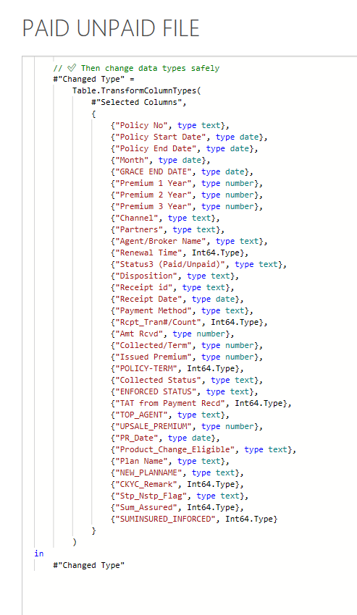
Selected fields are explicitly typed after extraction.

6.1 Controlled Field Selection and Schema Tolerance
The paid/unpaid query uses Table.SelectColumns with MissingField.Ignore. This is a controlled schema approach: the downstream model has a known required-field list, while extra source fields are not automatically loaded and missing requested fields do not automatically terminate the query.
#"Selected Columns" =
Table.SelectColumns(
#"Promoted Headers",
{
"Policy No",
"Policy Start Date",
"Policy End Date",
"Month",
...
"Sum_Assured",
"SUMINSURED_INFORCED"
},
MissingField.Ignore
)
The next step explicitly assigns types to date, numeric, integer and text columns. This improves the reliability of filters and KPI aggregations.
Interview phrasing: Call this a controlled, schema-tolerant ETL pattern—not a fully dynamic schema-discovery mechanism.

7. Current-Month and Previous-Month Loading
The solution maintains Current_Month and Previous_Month as separate configurable source paths and Power Query queries to support the two-month working lifecycle of the monthly customer/policy data.
The approach avoids rebuilding the underlying Power Query transformations and reporting structure each month. Instead, it updates the appropriate monthly source paths, and the existing queries and reports refresh for the new reporting cycle.

Current-Month and Previous-Month Queries

Current month query: Excel.Workbook reads the configured source and extracts the base table.

Previous month query: analogous loading pattern for the prior period.

8. Paid/Unpaid File Standardization
The paid/unpaid source includes policy dates, premiums, channel/partner information, payment identifiers, receipt dates, received amounts, issued/collected premium, policy term, status fields and plan information.
- Select a defined set of downstream-required columns using MissingField.Ignore.
- Apply explicit data types after selection.
This separation makes the data ingestion step predictable and keeps the analytical model focused on fields actually used for reporting.


Required-Field Selection


Data Type Standardization

9. Date Parameter and Daytype Design
The workbook uses a user-controlled Date parameter to establish the reporting period. The query derives the month end from that parameter and generates a daily date list.
StartDate = Date,
EndDate = Date.EndOfMonth(StartDate),
Dates = List.Dates(
StartDate,
Duration.Days(EndDate - StartDate) + 1,
#duration(1, 0, 0, 0)
)
A DayName field is then added. The resulting Daytype structure is used to classify working days and holidays/non-working days for operational calculations.
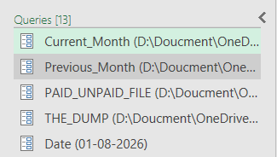

Reporting Date Parameter
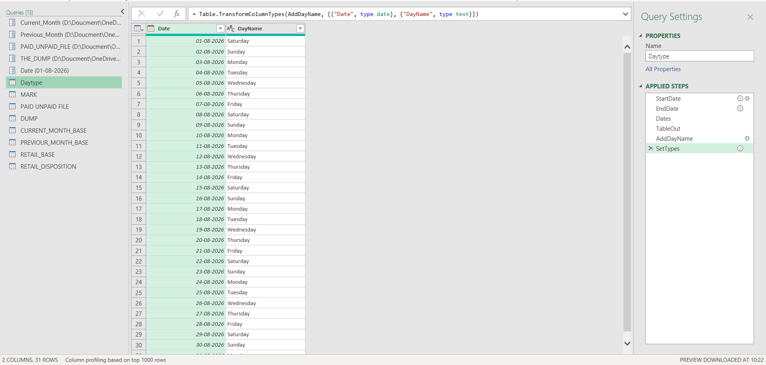

Daytype Query
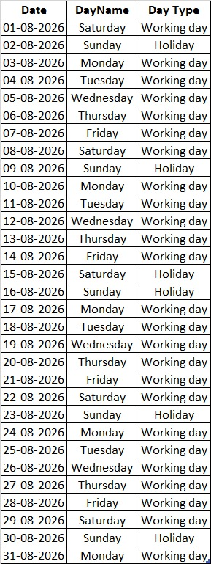

Daytype Output

10. MARK / Disposition Mapping
MARK is a reference mapping table. The visible columns include STATUS, DISPOSITION, SUB-DISPOSITION, RENEWED/NOT RENEWED and DNC-AGENT.
The DUMP query joins raw CRM statuses to MARK, expands the mapped fields and renames them for downstream use. This converts a detailed status vocabulary into reporting-friendly business categories.

MARK and CRM Enrichment
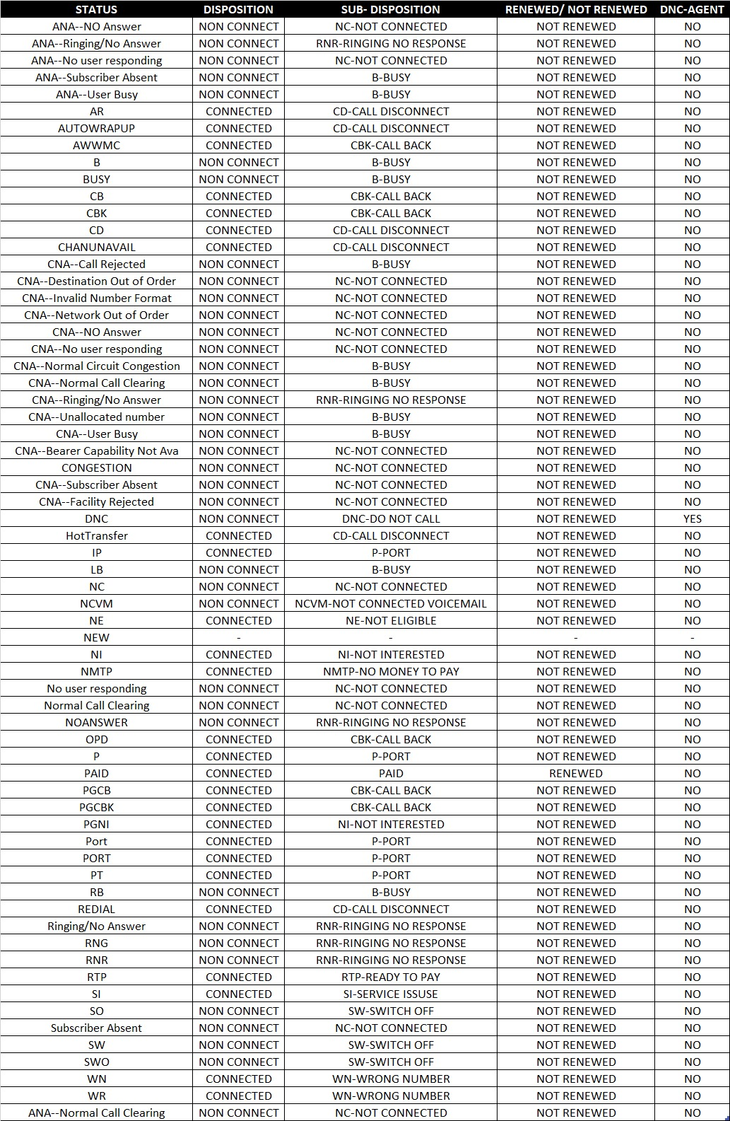

MARK Mapping Table
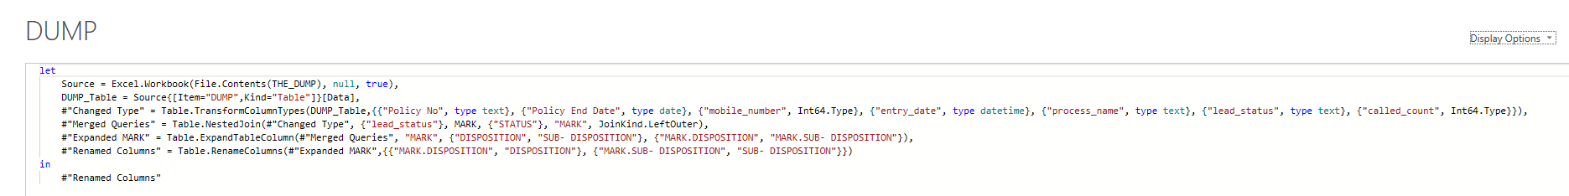

DUMP Query and MARK Enrichment
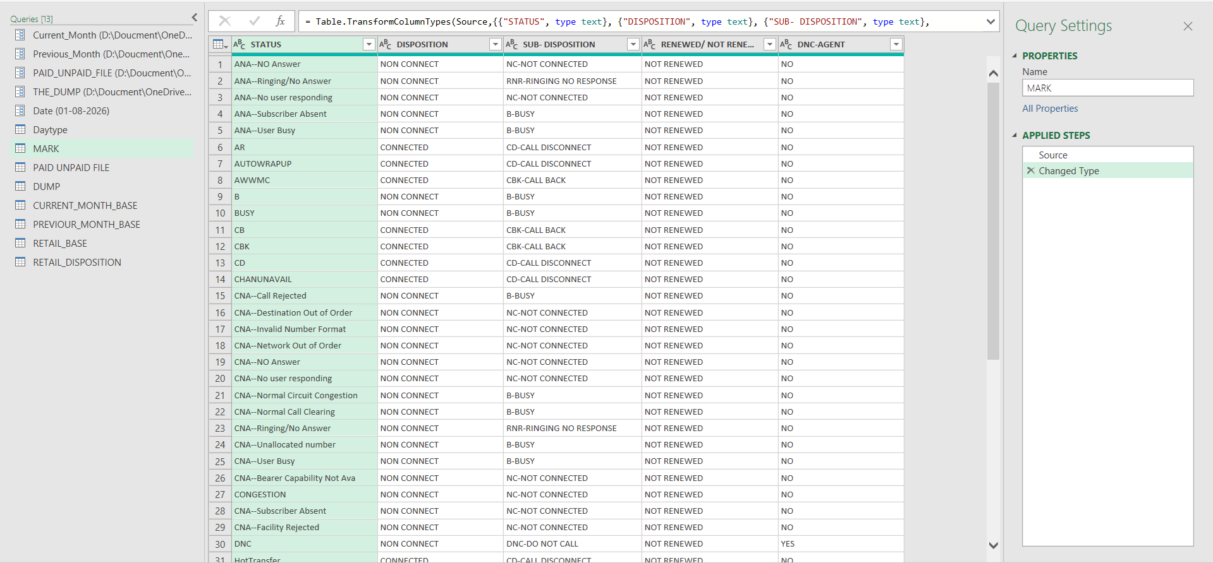

MARK Query

11. Power Pivot Data Model
The Data Model screenshot shows three important analytical tables: RETAIL_BASE, Daytype and RETAIL_DISPOSITION. RETAIL_BASE is the primary renewal population, Daytype provides reporting-calendar logic, and RETAIL_DISPOSITION carries interaction/disposition information.
- RETAIL_BASE — customer/policy renewal attributes and KPI source fields.
- Daytype — reporting dates, day names and working-day classification.
- RETAIL_DISPOSITION — CRM interaction and disposition outcomes.
Modeling principle: Use structured tables for business facts and a dedicated calendar-style table for date-sensitive KPI logic.

12. DAX KPI and Business Logic
The measure layer shown in the DAX screenshot covers target, received/paid, pending, DRR, achievement, deficit, premium, NOP, working-day, previous-day and upsell metrics.
DAX pattern | Role | Observed use in the project
VAR | Intermediate values | Selected date, month, last date, effective date.
CALCULATE | Filter/context control | Target, received/paid and daily measures.
FILTER | Business conditions | Current-month and received-premium filtering.
SUM / COUNTROWS | Aggregation | Premium and NOP-style measures.
SUMX | Row-level rules + aggregation | Target logic and plan-dependent weighting.
IF | Conditional logic | Fallbacks and business conditions.
MAX / MIN | Date boundaries | Month-end and effective-date controls.
TODAY | System-date reference | Previous-day/current-day logic where needed.

DAX Measure Catalog
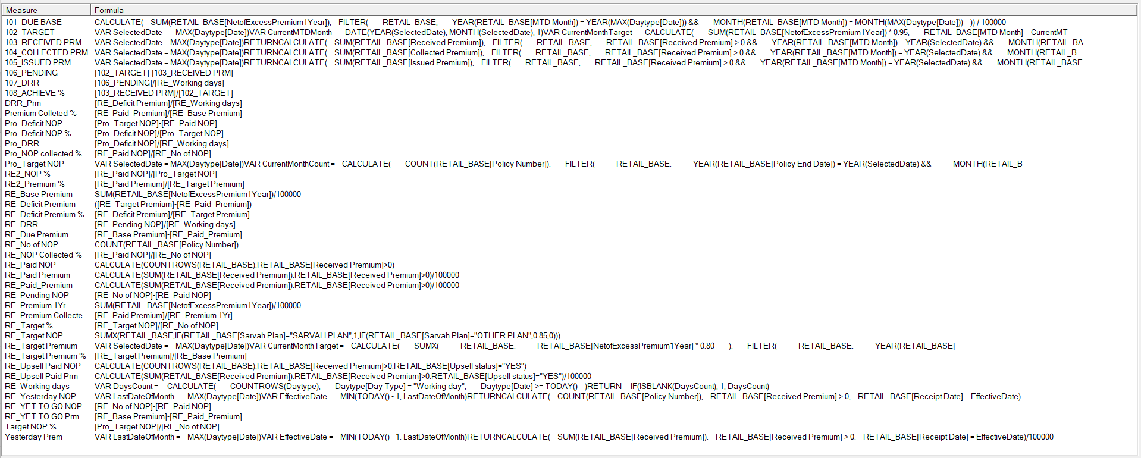
DAX measure catalog supplied for the project. Visible measures include target, received, pending, DRR, achievement, deficit, paid NOP/premium, working days, yesterday and upsell calculations.

13. DRR and Month-End Boundary Handling
The project includes deliberate reporting-period boundary logic. A visible DAX pattern uses the last date in Daytype and an EffectiveDate based on the minimum of TODAY()-1 and the selected reporting calendar's last date.
VAR LastDateOfMonth = MAX(Daytype[Date])
VAR EffectiveDate = MIN(TODAY() - 1, LastDateOfMonth)
The intent is to prevent a previous-day measure from rolling into a later month when the business is still reporting the selected month. The Daytype table supplies working-day context for DRR.
Important technical nuance: The design combines a business-controlled reporting period with system-date awareness. For production hardening, all DRR/date measures should consistently derive their comparison boundary from the same reporting-date parameter.

14. Reporting Layer
The reporting layer provides operational views across plan, language, state and month, including base and paid NOP/premium, target performance, collection percentages, deficits, yesterday movement, MTD/FTD performance, DRR, premium collection status and upsell performance. The additional views below extend the report coverage across these operational dimensions.
Report area | Key metrics | Business question
Plan performance | Base NOP, Premium 1Yr, Paid NOP, Paid Premium, NOP %, Premium % | Which plans are performing better?
Overall NOP | Base, Paid, Target, Collected %, Deficit, Yesterday NOP | Are renewals on target?
Premium | Due Base, Target, Received, Collected, Issued, Pending, DRR, Achieve % | Are premium collections on pace?
Month-on-month | Current vs prior period views | How is performance?
Upsell | Upsell paid NOP / premium | What longer-term renewal opportunity is being captured?
Disposition | Status/disposition categories | What are customers doing/responding?
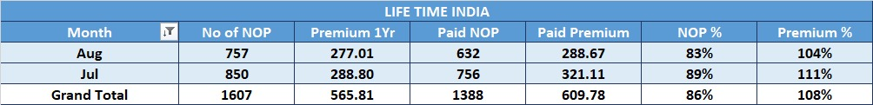

Plan-Level Performance
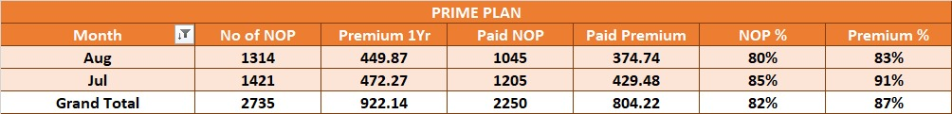

Plan-Level Performance Detail
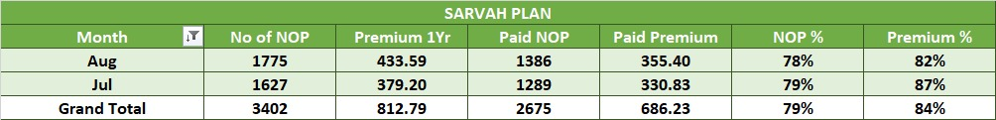

Plan-Level Performance Detail
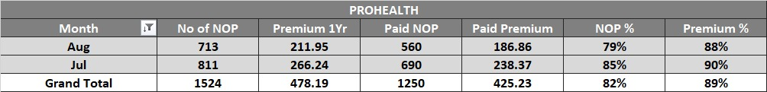

Plan / KPI Performance
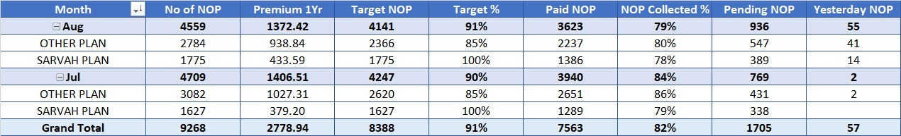

Overall NOP / Target / Deficit
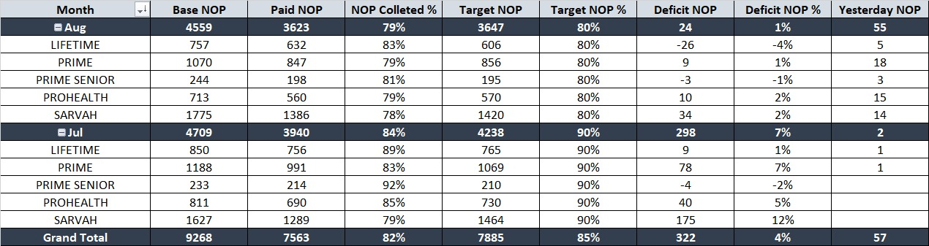

Detailed PED and Plan Performance
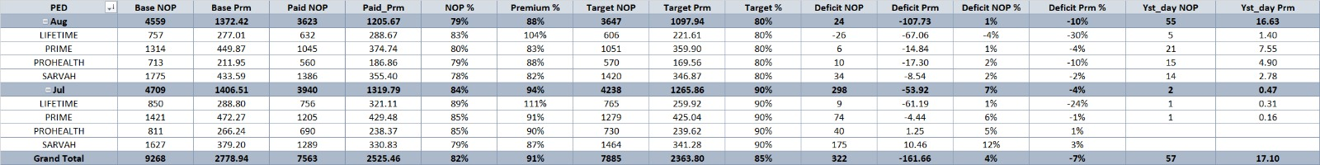

Premium Due / Target / Collection / DRR (MTD)
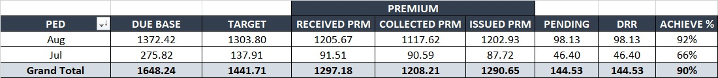

Additional reporting views used in the operational reporting layer.

MTD and FTD Performance by Language
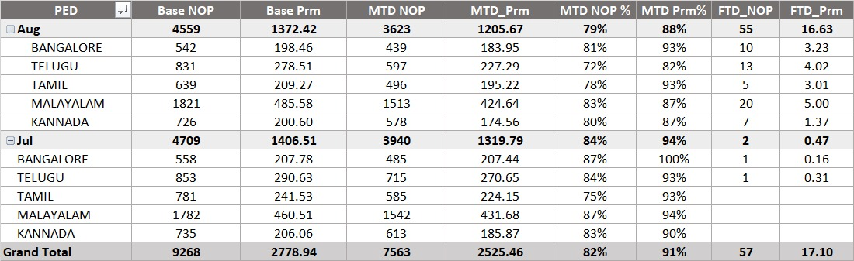

Upsell Paid NOP and Premium
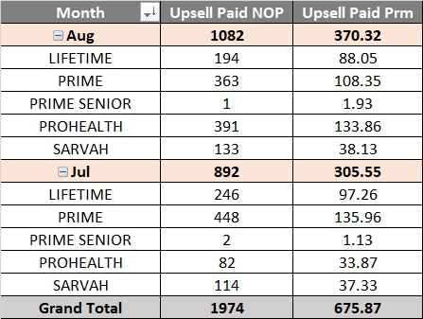

Plan-Level Target, Paid, Collection and Yesterday Performance
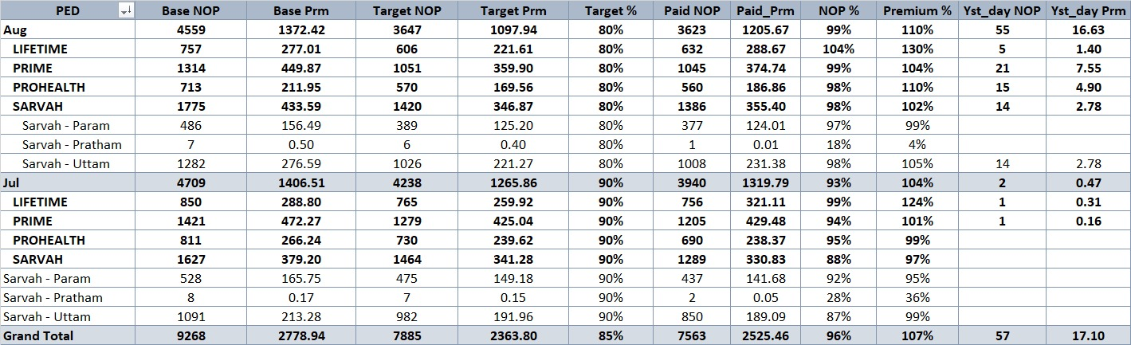

Premium Due, Target, Collection, Pending, DRR and Achievement
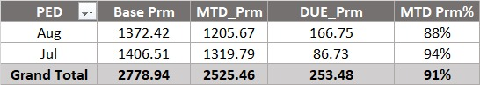

State, Plan and Month Performance Analysis
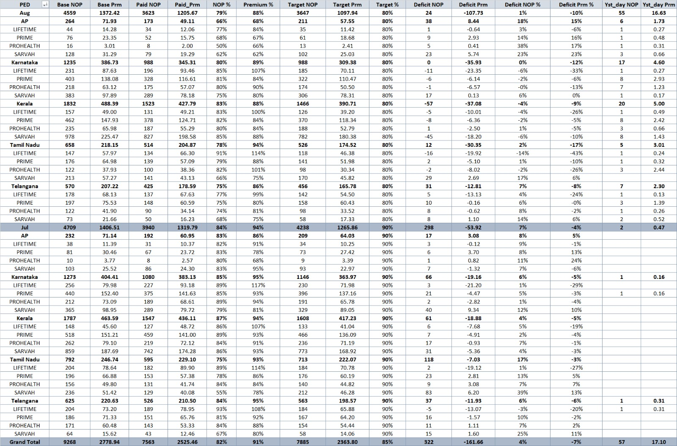

15. Daily and Monthly Operating Workflow

15.1 Daily workflow
1. Receive latest CRM/disposition data.
2. Receive latest paid/unpaid data.
3. Place or update files in the configured locations.
4. Verify relevant file paths/parameters.
5. Refresh Power Query.
6. Refresh the Data Model/PivotTables.
7. Review updated KPI and performance reports.

15.2 Month-start workflow
1. Set the reporting Date parameter for the new month.
2. Provide the new monthly base file.
3. Continue the daily CRM and paid/unpaid refresh cycle.
4. Reuse the same model and report layer for the new period.

16. Challenges and Design Decisions
Challenge | Design response | Evidence
Changing source files | Configurable source locations + standardized queries. | Current/Previous query evidence
Schema variation | Required-field selection + MissingField.Ignore. | Paid/Unpaid M code
Multiple refresh frequencies | Separate monthly and daily sources. | Query architecture
Complex CRM statuses | MARK mapping and DUMP enrichment. | MARK/DUMP evidence
Month boundary effects | Date parameter + Daytype + effective-date cap. | Parameter/Daytype/DAX evidence
Dynamic performance reporting | Reusable Power Pivot measures. | DAX + reports

17. Skills Demonstrated and Evidence
Area | Evidence
Excel / Reporting | Multiple operational PivotTable report outputs.
Power Query / ETL | Multi-source queries, field selection, type control, mapping and refresh design.
Power Pivot / Data Model | Visible analytical model with core fact/supporting tables.
DAX | VAR, CALCULATE, FILTER, SUMX, COUNTROWS, conditional and date logic.
Business / KPI modeling | Target, deficit, achievement, DRR, paid/base and upsell logic.
Automation / reusability | Parameter-driven reporting period and repeatable refresh workflow.

