Name: Aravind kasanagottu

EID: mvsnarav

Task 1:

Create a Directory with the Name Linux Practice.

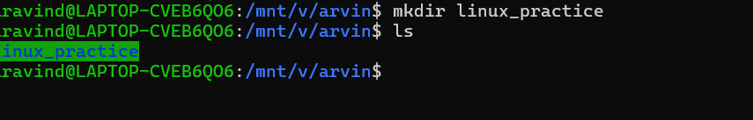

Task2:

Change to the directory



Task 3:

Create a file names TestFile1.txt and add the content to it.

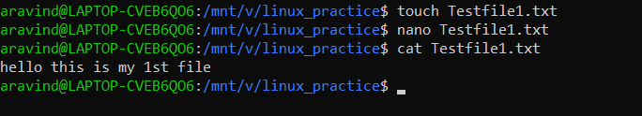

Task 4:

Create a Folder named Dummy and try to delete it.

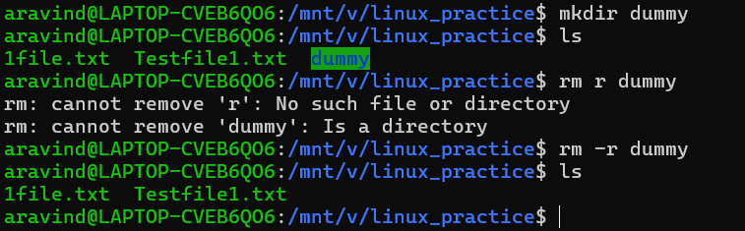

Task 5:

Plz check the working directory (Hint : pwd)

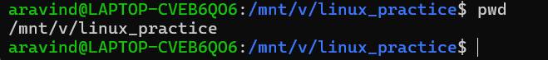

Task 6:

How do you check all the files and directories in the directory you are in?

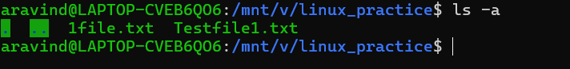

Task 7:

Create five files named TestFile2.txt.. TestFile3.txt… and so on till TestFile6.txt



Task 8:

Copy all files from Dir 1 ti Dir 2

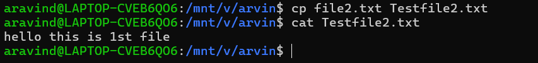

Task 9:

Move all files from Dir 2 to Dir 3 (finally ur Dir 2 should be empty)

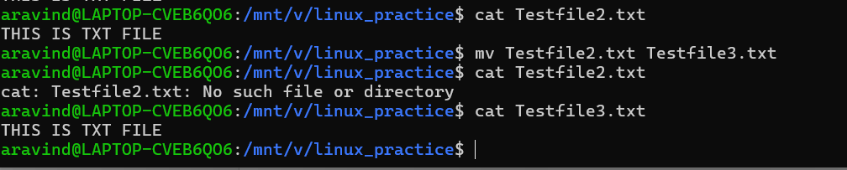

Task 10:

Task 10:

Can you plz show me the diff between **rm** and **rmdir** commands with screen shots ?

Ans: rm is used to del the files and rm -r is used del empty dir

Rmdir is used to del dir

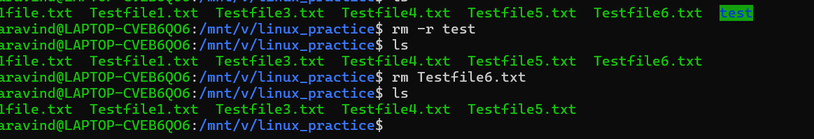

Task 11:

Now use specifically use cat command to create a file

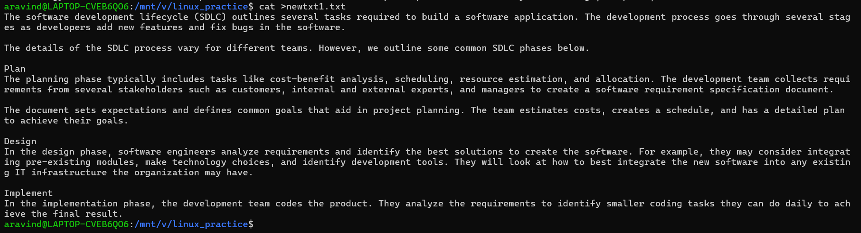

Task 12:

How to get only the top part of your file..

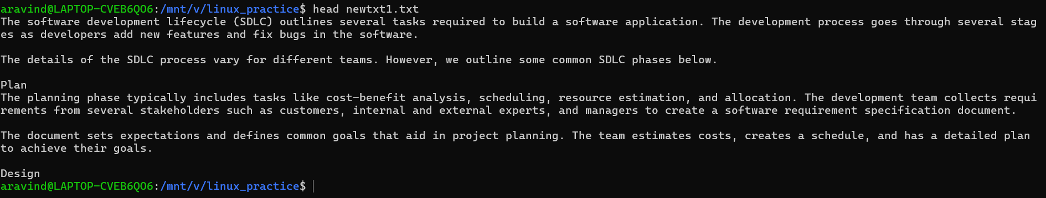

Task 13:

How to get only the last part of your file

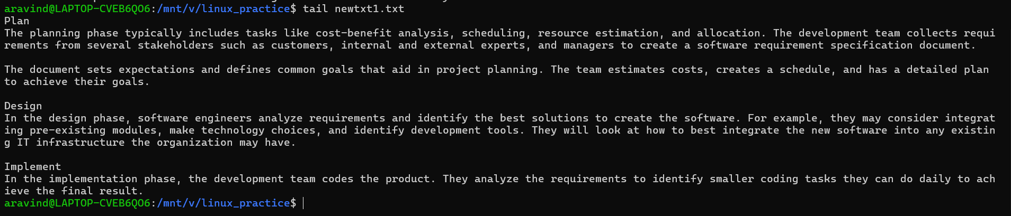

Task 14:

Plz add dummy text of 5 to 6 pages in to the same file

And

Now show the file in page by page

`

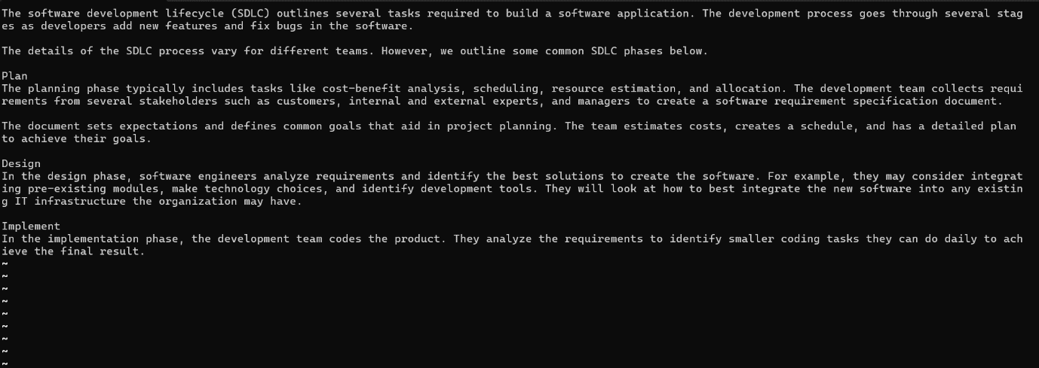

The above pic is after using less command it’s opened on diff page unable to click ss along with command here is the command “less newtxt1.txt”

Task 15:

Use more command on the above file and find out the diff between less command and more command.

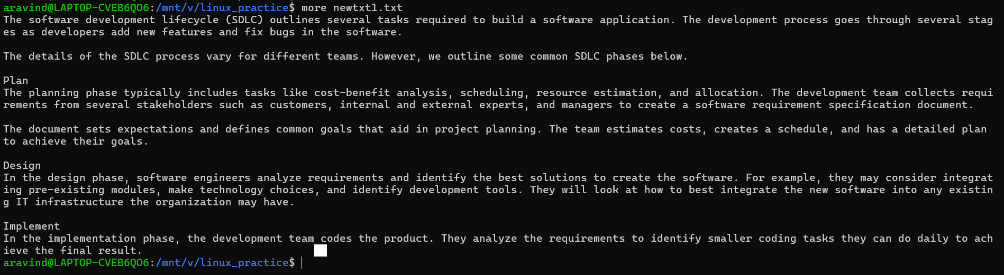

What is e in echo command..?

The e in the echo command is an option that enables the interpretation of backslash escape sequences. These sequences allow you to insert special characters and formatting into the output.

Task 16:

Can you use echo command with -e and see the diff.. Also take a ss and paste .

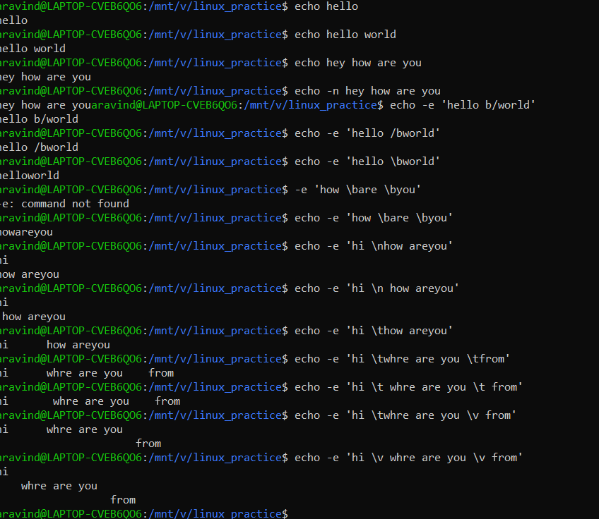

Task 17:

What is diff between ls and ls -l command .. ss plz

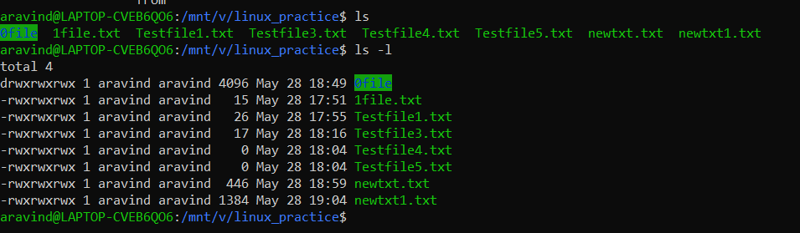

Task 18:

Create  a file using **touch** command , **cat** command and **echo** command and take ss (screen shot)..

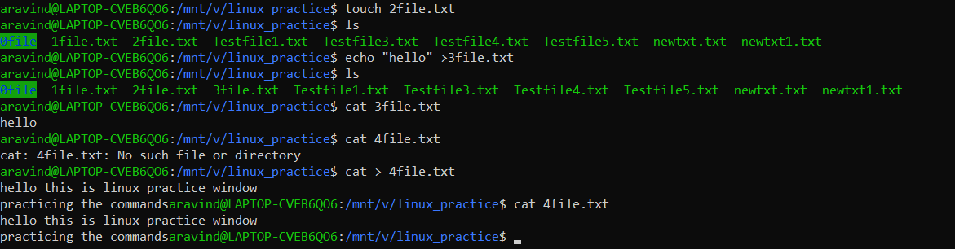

Touch: with is command we can create a file without content

Cat: when you need to combine files, pipe contents, or create/edit multi-line text without an editor..

Echo: with is command we can create a file without content for quick, single-line output

Task 19:

Can you guys try to display the calendar by using a command..

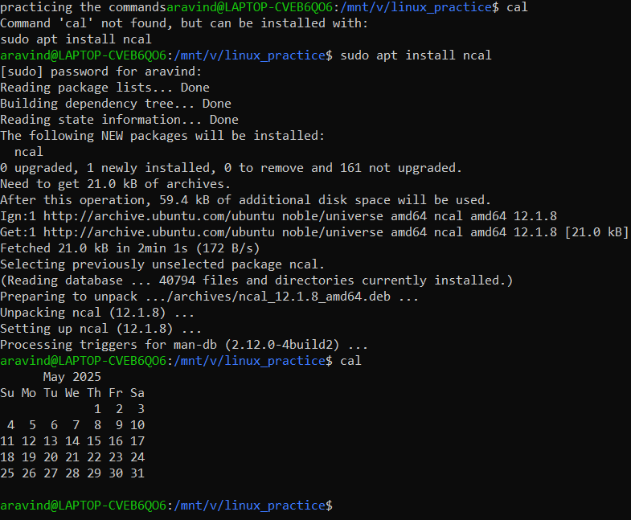

Task 20:

Can you go back to 1 directory .. at a time  whats the command

**Ans : CD ..**

Task 21:

How to know whose user u are working on ?

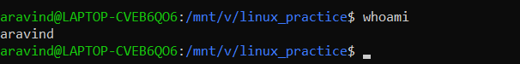

Task 22:

Try to find out who is peeping into your system..

Use users, who and w commands with ss

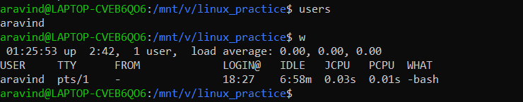

Task 23:

Can you guys try to check how much disk space is consumed..

Hint : use df -h

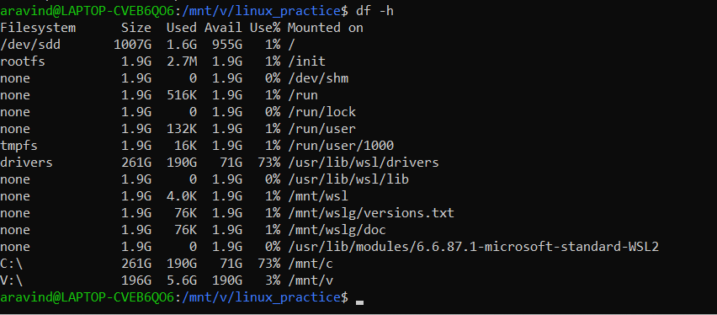

Task 24:

Can you plz try using the below commands

|  |  |
| --- | --- |
| **Prefix** | **Description** |
| **-** | **Regular file**, such as an ASCII text file, binary executable, or hard link. |
| **b** | **Block special file**. Block input/output device file such as a physical hard drive. |
| **c** | **Character special file**. Raw input/output device file such as a physical hard drive. |
| **d** | **Directory** which contains a listing of other files and directories. |
| **l** | **Symbolic link file**. Links on any regular file. |
| **p** | **Named pipe**. A mechanism for interprocess communications. |
| **s** | **Socket** which is used for interprocess communication.  Task 25:  Find the list of all files ending with .txt    Task 26:  In Linux all the hidden files starts with . (period)  How to check all the hidden files in Linux..  Hint : use  ls -a    Task 27:  What is the difference between . and .. in linux  Line 1 line for each  ANS: **.**  Refers to the **current** directory.  **..** Refers to the **parent** directory (one level up).  Task 28:  Can you create a file using vi editor and show the details in ss  Hint:   Esc is for come out of the edit mode  Press two keys Shift &plus; ZZ together to come out of the file completely   * I - to insert   To move inside the file     * **l** key to move to the right side. * **h** key to move to the left side. * **k** key to move upside in the file. * **j** key to move downside in the file.   Task 29:  How to find the no of words in the file    Here is the detail of all the four columns of wc command  −   * **First Column** − Represents the total number of lines in the file. * **Second Column** − Represents the total number of words in the file. * **Third Column** − Represents the total number of bytes in the file. This is the actual size of the file. * **Fourth Column** − Represents the file name.   Task 30:  What is the use of cat -b myfilename.txt command?    Task 31:  Can I use the wc with 2 or more files?  Yes we can  Wc file1 file2 file3    Task 32:  How to copy content of one file to another file  Hint: use cp:    Task 33:  Now I want to rename my file with MYFILENEW can i do that if so how ?  Hint use : mv    Task 34:  Can i remove or delete multiple files in linux..? How?  Yes rm file1,file2……..    Task 35:  In directory / slash is root  …  can you try cd / what is it doing?  Ss plz      Charging to root dir  Task 36:  What is the way go go to home directory ?  Hint : use cd ~      Task 37:  If i want to move to different users home directory  Hint : use ~username |

