Day 6 - 29th May 2025

Name:Aravind kasanagottu id:mvsnarav

Task 1:

RegEX Symbols in linux

^ **(Caret):** This symbol means **"starts with."**

$ **(Dollar Sign):** This one means **"ends with."**

**.(Dot):** This is your handy wildcard for **"any single character."**

When you type grep "f.le", it's smart enough to match "file," "fale," will display

[] **(Brackets):** This lets you define a **"set of characters"** to match just one from that list.

Task 2:

What are the imp features of Linux os ?

Open Source & Free: You can use, modify, and distribute it without cost.

Stability & Security: It's highly reliable, rarely crashes, and built with strong security.

Customization: Users have immense control to tailor the system to their needs.

Powerful Command Line: Offers robust tools for efficient task automation and system management.

Task 3:

WHAT IS Kernel and can you explain its functions

Resource Management: It decides which programs get to use the CPU, how much memory they can use, and how they share devices like printers or network cards.

Process Management: It handles starting, stopping, and scheduling all the different programs (processes) running on your computer

Memory Management: It allocates and manages the computer's memory, making sure programs don't interfere with each other's data.

Device Management (Drivers): It controls all the hardware connected to your computer (like your keyboard, mouse, or hard drive) through special software called device drivers.

Task 4:

What is BASH? Full form with explanation.

BASH stands for Bourne Again Shell.

It's the most common command-line interpreter in Linux, taking your typed commands and running them on the system, while also offering powerful scripting capabilities.

Task 5:

What is the diffrenece between window and linux

Windows: You buy it; it's generally easier for everyday users right out of the box, with lots of ready-made software.

Linux: It's free and open-source; you can change almost anything, making it popular for technical users and servers.

Software Availability: Windows has more commercial software and games designed just for it.

Security & Stability: Linux is often seen as more secure and runs for very long periods without needing reboots or having crashes.

Task 6:

Define the basic components of Linux

The Kernel is the "brain," managing all your computer's hardware.

The Shell is how you talk to Linux, usually by typing commands.

The File System organizes all your files and folders .

Task 7:

Is it legal to edit Kernal?

Yes, it is **legal** to edit the Linux Kernel.

Task 8:

Can you explain LILO

LILO (LInux Loader) was a key program that helped older Linux systems start up by loading the operating system into memory. It’s flexible, able to boot from floppy disks or hard drives.

Task 9:

What is shell? How many shells are there and what are they ? can you explain.

A **Shell** is a program that lets you talk to the Linux operating system by typing commands.

There are several types of shells, with **Bash** being the most common default, but others like **Zsh** and **sh** (Bourne Shell) are also widely used.

Task 10:

What is Swap space ?

Swap space (or virtual memory) is a dedicated area on your hard drive acting as an **extension of RAM.** It's used when your **RAM gets full,** temporarily storing less-used data. This prevents your system from crashing due to memory shortages.

Task 11:

What is Mount ? how do you mount and unmount file system in Linux?

"mounting" is the is process of **connect a hard drive, USB, or DVD** so you can actually see and use its files. You use the mount command to connect it, and umount to safely disconnect it when you're done.

Task 12:

What is chmod command ? how to use it?

The chmod command is used to **change file permissions** in Linux. It controls who can **read (r), write (w), or execute (x)** a file or directory.

To use the chmod command, type chmod, followed by the permissions to set, and then the name of the file or directory.

To change permissions: You specify who (user,group, others) gets what permissions (read,write,execute).

Task 13:

Can you add a new user account? Crate a new user in different ways and paste ss

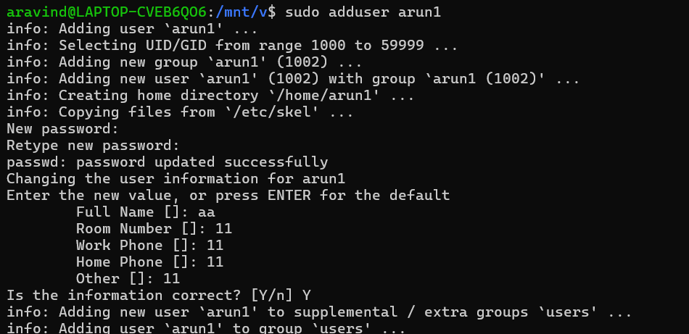

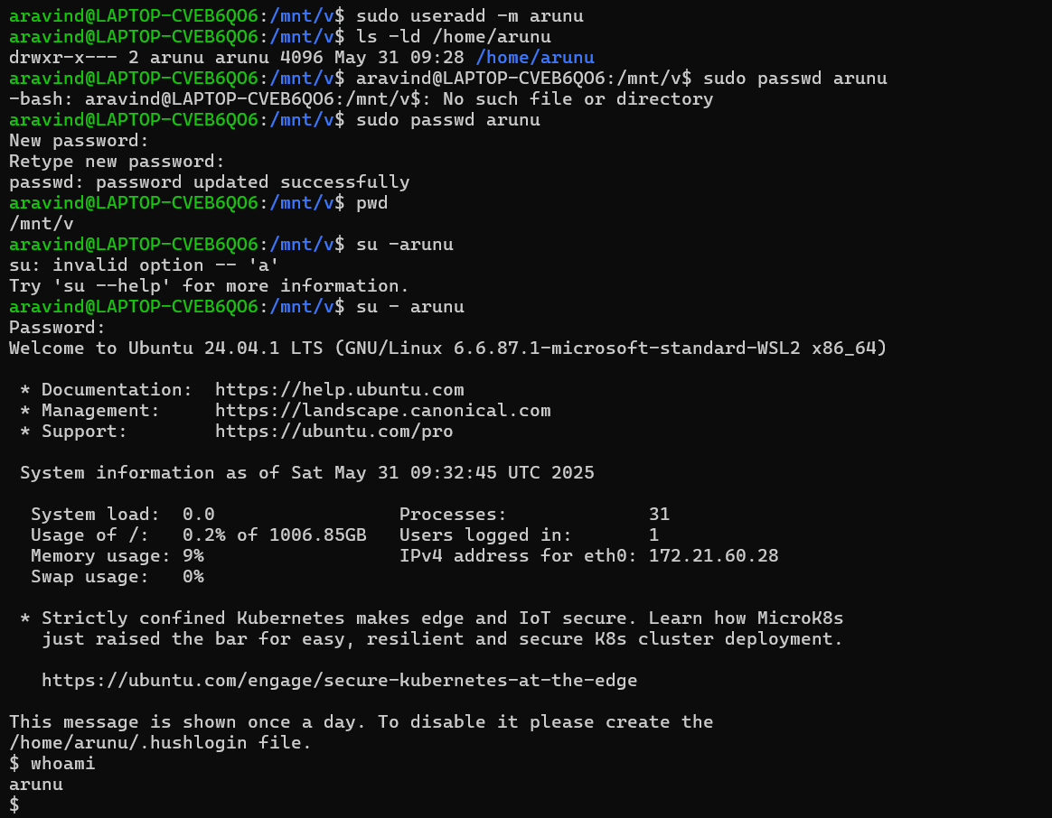

Task 14:

Can you change the password of a user?

How do you do that? Plz share ss

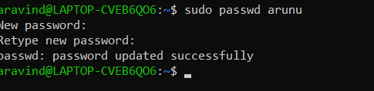

Task 15:

What is diff between Process and Thread?

A **process** is a self-contained program running, with its own dedicated memory and resources. If it crashes, others are safe.

A **thread** is a smaller part of a process that shares the process's memory and resources. Multiple threads can run inside one process.

Threads are quicker to create and switch between than processes. However, if one thread fails, the entire process might go down.

Task 16:

Doc 14 Linux Grep commands .. plz work on it..

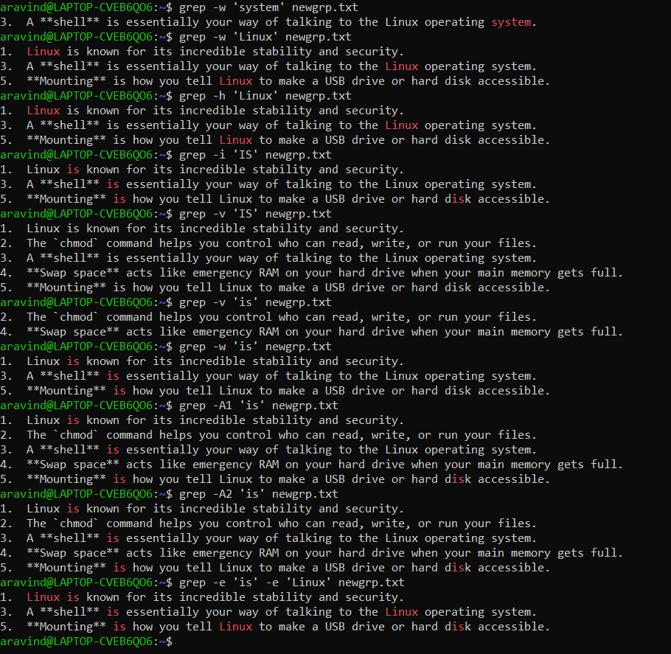

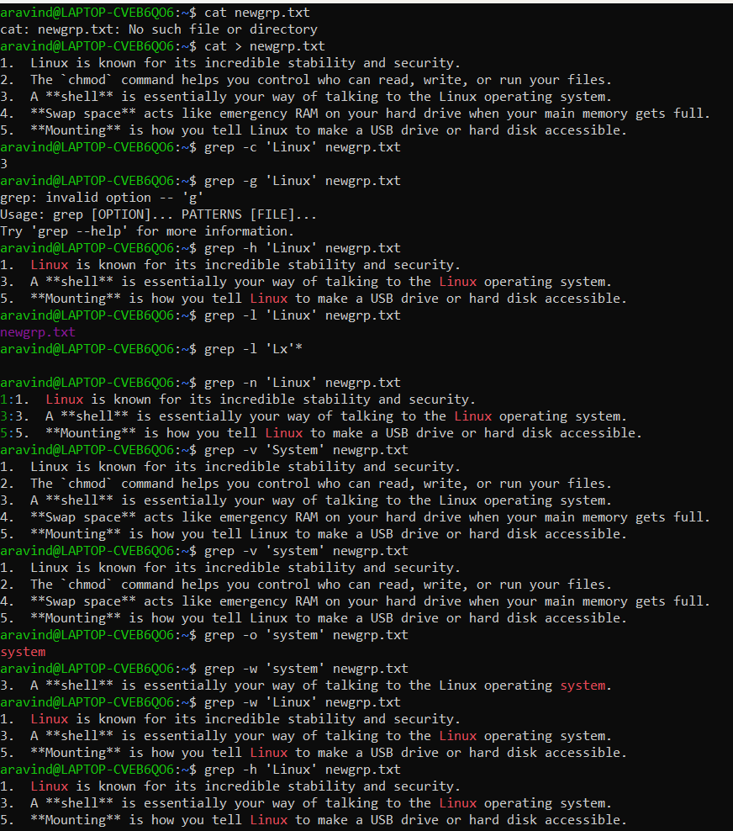

Task 17 AWK commands in doc 15 Linux AWK commands..

Attached end of the file

This is the link to open ODs files in linux..  You need to download the compatibles

Task 18:

How to check file access permission in Linux?

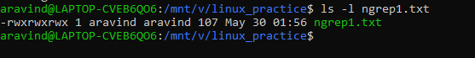

Task 19:

What are the default permissions for a new file ?

(rw-rw-r--)

Owner  : Can read and write.

Group : Can read and write.

All and others : Can only read.

Task 20:

What is the command to change the permisssion to read only for the owner, group and all other users

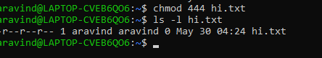

Task 21:

Can you change the file permissions to match the following:

* owner: Read and Write
* group: Read
* other: no permissions (None)

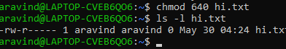

Task 22:

What was the command for changing the file permissions to -rw-r-----?

Hint : use chmod 640 filename

* owner: Read and Write
* group: Read
* other: no permissions (None)

Task 23:

Change chmod.exercises permissions to -rwxr-x--x

Change the file permissions to match the following:

owner: Read, Write and Execute

group: Read and Execute

other: Execute

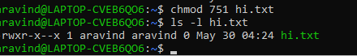

Task 24:

What was the command for changing the file permissions to -rwxr-x--x

Hint : use chmod 751 filename

owner: Read, Write and Execute

group: Read and Execute

other: Execut

Task 25:

Guys what will this command do?

chown -c master file1.txt

chown: This is the command to change owner.

master: This is the **new username**

file1.txt ownership will change

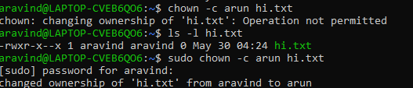

Task 26:

Can you define what is  a process

Ans: A Linux process is a running instance of a program that the kernel represents with a unique PID, its own memory space, open files, and scheduling state.

Task 27:

What is command to check foreground process and background process

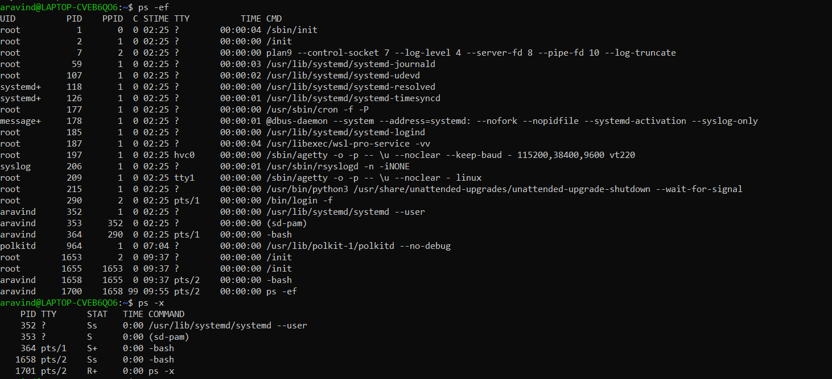

Task 28:

Can you list all the running processes?

Hint use ps

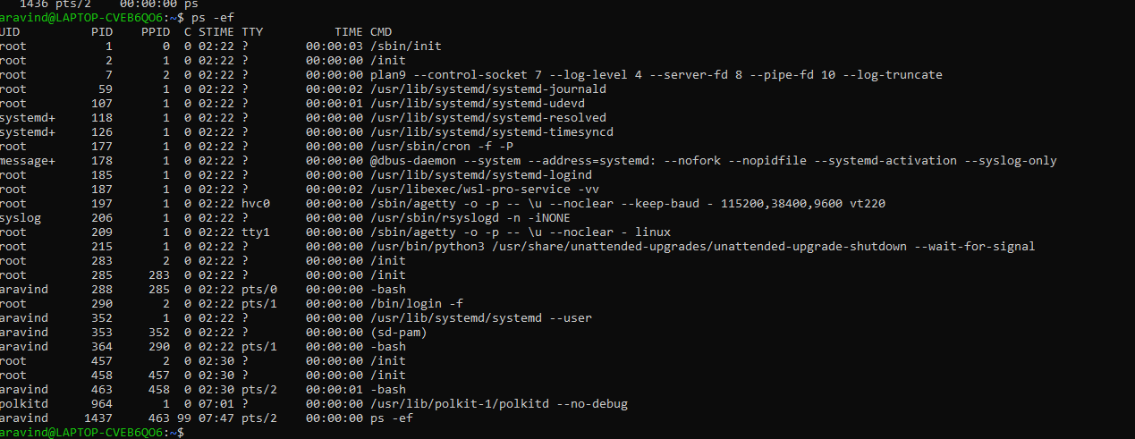

Task 29:

What will ps -f command do ? plz try n check .. ss required.

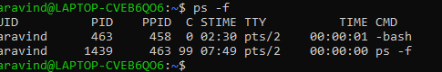

ps -f displays a full-format listing of processes, showing detailed columns like UID, PID, PPID, C, STIME, TTY, TIME, and CMD

Lets play with shell variables

Task 30:

Can you createa  a variable name with your name in it

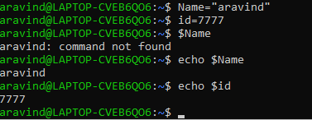

Task 31:

Can you make the above name variable read only..

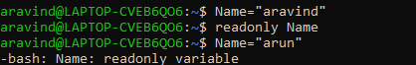

Task 32:

Now will unset or delete the variables

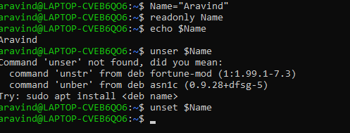

Task 33:

CAn u try to add a list of your friends names in an array and try to printout

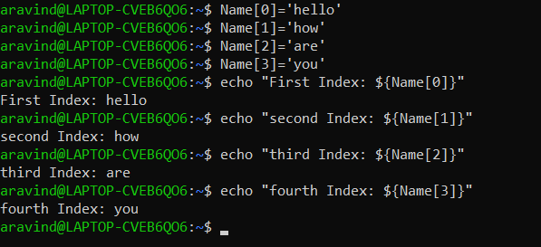

Task 34:

Can you print all the list at once in an array.. Try the below cmds and check

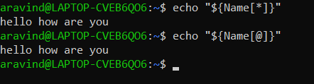

Echo “${array_name[*]}”

Echo “${array_name[@]}”

Opetrators 👍

* Arithmetic Operators
* Relational Operators
* Boolean Operators
* String Operators
* File Test Operators

If else

if...fi statement

if...else...fi statement

if...elif...else...fi statement

case...esac statement

The while loop

The for loop

The until loop

The select loop

Task 35:

Plz let me know whats the output of the below snippet:

a=0

while [ "$a" -lt 10 ]    # this is loop1

do

   b="$a"

   while [ "$b" -ge 0 ]  # this is loop2

   do

      echo -n "$b "

      b=`expr $b - 1`

   done

   echo

   a=`expr $a + 1`

Done

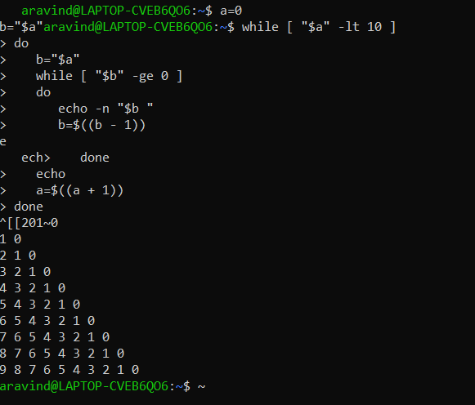

Awk commands

