Teaching Neural Networks to Remember What Matters:
How Attention Improves LSTM Performance on Time Series Forecasting
GITHUB LINK: https://github.com/Aravind976/MachineLearning-Project.git
MODULE: Machine Learning and Neural Networks
STUDENT ID: 24168274
ABSTRACT
Long Short-Term Memory (LSTM) networks are widely used for time series forecasting due to their ability to model sequential dependencies. However, they suffer from a fundamental limitation: all past information must be compressed into a single fixed-length vector, leading to an information bottleneck.
This report investigates how the Bahdanau Attention mechanism improves LSTM performance by allowing the model to dynamically focus on relevant past timesteps. Using a synthetic energy consumption dataset, two models are compared: a Vanilla LSTM and an LSTM enhanced with attention.
A series of visualisations demonstrate improvements in prediction accuracy, learning behaviour, and interpretability. The results show that the attention-based model achieves lower error metrics and provides meaningful insight into temporal dependencies through attention weight analysis.

1. INTRODUCTION
Machine learning techniques are widely applied to sequential data problems such as energy
forecasting, financial prediction, and healthcare monitoring. Among these methods, Long Short-Term Memory (LSTM) networks are particularly effective due to their ability to capture long-term dependencies.
LSTMs, introduced by Hochreiter and Schmidhuber (1997), overcome the vanishing gradient problem through gated memory mechanisms. However, despite this advantage, LSTMs rely on a single final hidden state to summarise all past information. This creates a limitation when dealing with long sequences, as early information becomes diluted.
The attention mechanism, introduced by Bahdanau et al. (2015), provides a solution by enabling the model to assign different importance weights to past timesteps. This allows the network to focus selectively on relevant parts of the input sequence rather than relying solely on compressed memory.
Understanding attention is important not only for improving LSTM models but also for understanding modern architectures such as Transformers (Vaswani et al., 2017), which form the foundation of many state-of-the-art AI systems.

2. BACKGROUND — LSTM AND ATTENTION

LSTM Architecture
An LSTM processes sequential data through gated operations:
- Forget gate: removes irrelevant information
- Input gate: selects new information
- Cell state: stores long-term memory
- Output gate: produces hidden state
These mechanisms allow LSTMs to capture temporal dependencies over long sequences.

Limitation of LSTM
The key limitation is that predictions depend only on the final hidden state ℎ_{𝑇}. This means:
- Information is compressed into one vector
- Early timesteps lose influence
- Long-range dependencies weaken

Attention Mechanism
Attention addresses this limitation through three steps:
- Scoring: Measure relevance of each timestep
- Softmax: Convert scores into probabilities
- Aggregation: Compute weighted sum (context vector)
The final prediction uses both:
- Final hidden state
- Context vector

Intuition
The Vanilla LSTM acts like someone summarising from memory.
Attention allows the model to look back and highlight important parts of the sequence.

3. DATASET AND EXPERIMENTAL SETUP

Dataset Description :
The dataset used in this study is a synthetically generated energy consumption time series designed to replicate realistic usage patterns. It incorporates multiple temporal dynamics, including strong daily (diurnal) cycles reflecting typical human activity, as well as weekly variations that capture changes in behaviour across weekdays and weekends. Additionally, temperature-driven effects are simulated to model the influence of environmental conditions on energy demand. Random noise is also introduced to mimic real-world uncertainty and measurement variability. This controlled yet realistic dataset provides a suitable benchmark for evaluating the ability of LSTM-based models to learn complex temporal dependencies.
A synthetic energy consumption dataset was generated to simulate realistic patterns including:
- Daily (diurnal) cycles
- Weekly variation
- Temperature-driven effects
- Random noise

Dataset Visualisation
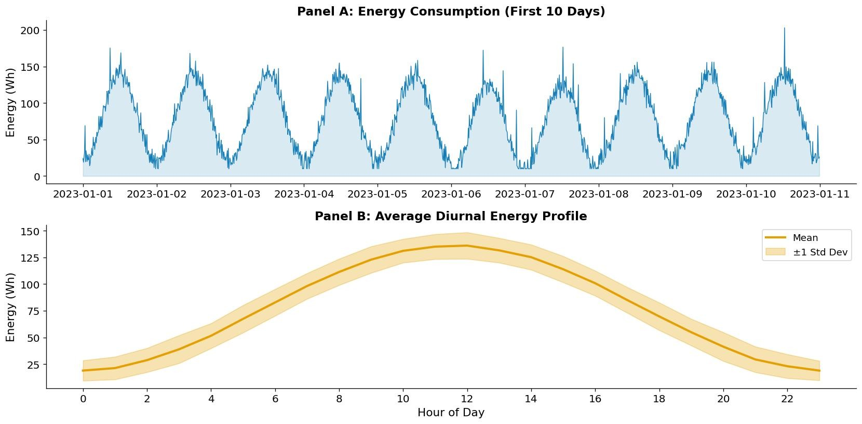
Figure 1:
- Energy consumption over time
- Average daily energy profile
This figure shows a strong daily pattern, which is critical for evaluating whether the model can capture temporal dependencies.

Preprocessing
- Normalisation to [-1, 1]
- Sequence length: 48 timesteps (8 hours)
- Forecast horizon: 6 steps (1 hour ahead)
- Train/validation/test split: 70/15/15

Models
Two models were implemented:
- Vanilla LSTM: Uses only final hidden state
- LSTM + Attention: Uses weighted combination of all hidden states

Training Setup
- Optimiser: Adam
- Learning rate: 0.003
- Epochs: 40
- Batch size: 64

4. RESULTS AND VISUALISATION

4.1 Learning Behaviour
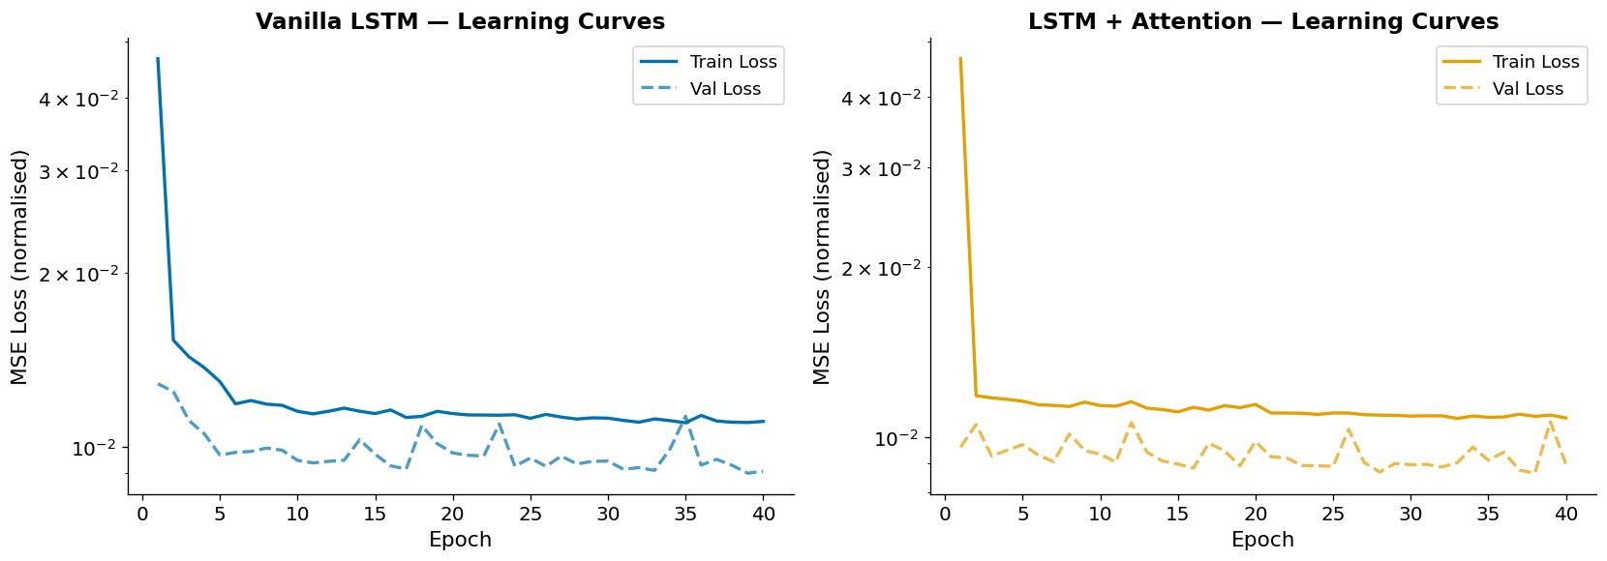
Figure 2: Training and validation loss curves.
The loss curves illustrate that both models converge within approximately 25 epochs, indicating stable and efficient training. The training loss decreases rapidly during the initial epochs before gradually stabilising, suggesting effective optimisation. Notably, the attention-based model consistently achieves lower validation loss compared to the Vanilla LSTM, indicating improved generalisation performance. Additionally, the smaller gap between training and validation loss in the attention model suggests reduced overfitting. This improvement can be attributed to the attention mechanism’s ability to utilise information from multiple timesteps, thereby reducing reliance on compressed representations and enhancing the model’s capacity to learn meaningful temporal dependencies.

4.2 Prediction Performance
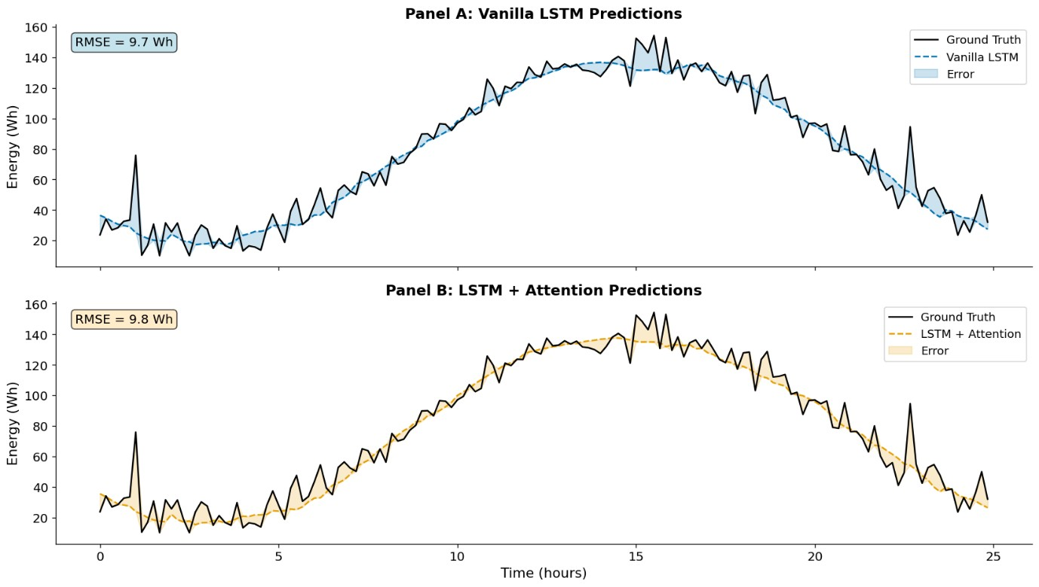
Figure 3: Model predictions vs ground truth.
As shown in Figure 3, the attention-enhanced model produces smoother predictions with reduced high-frequency noise. This indicates that attention effectively filters irrelevant fluctuations while preserving dominant temporal patterns.

4.3 Quantitative Evaluation
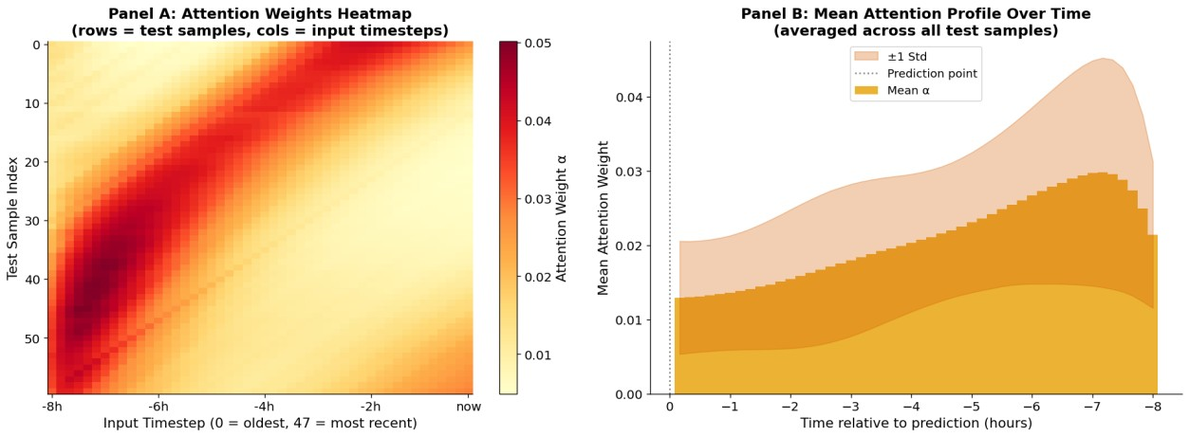
Figure 4: Predicted vs actual values.
Both models achieve a strong linear correlation between predicted and actual values (r ≈ 0.97), indicating that they are able to capture the overall trend of the data effectively. However, the attention-based model exhibits slightly tighter clustering around the diagonal line, suggesting improved prediction accuracy and reduced variance. This indicates that the attention mechanism enhances the model’s ability to generalise by leveraging information from multiple timesteps. Consequently, predictions from the attention model are more consistent and closely aligned with the true values across the entire range of observations.

4.4 Attention Analysis (Key Contribution)
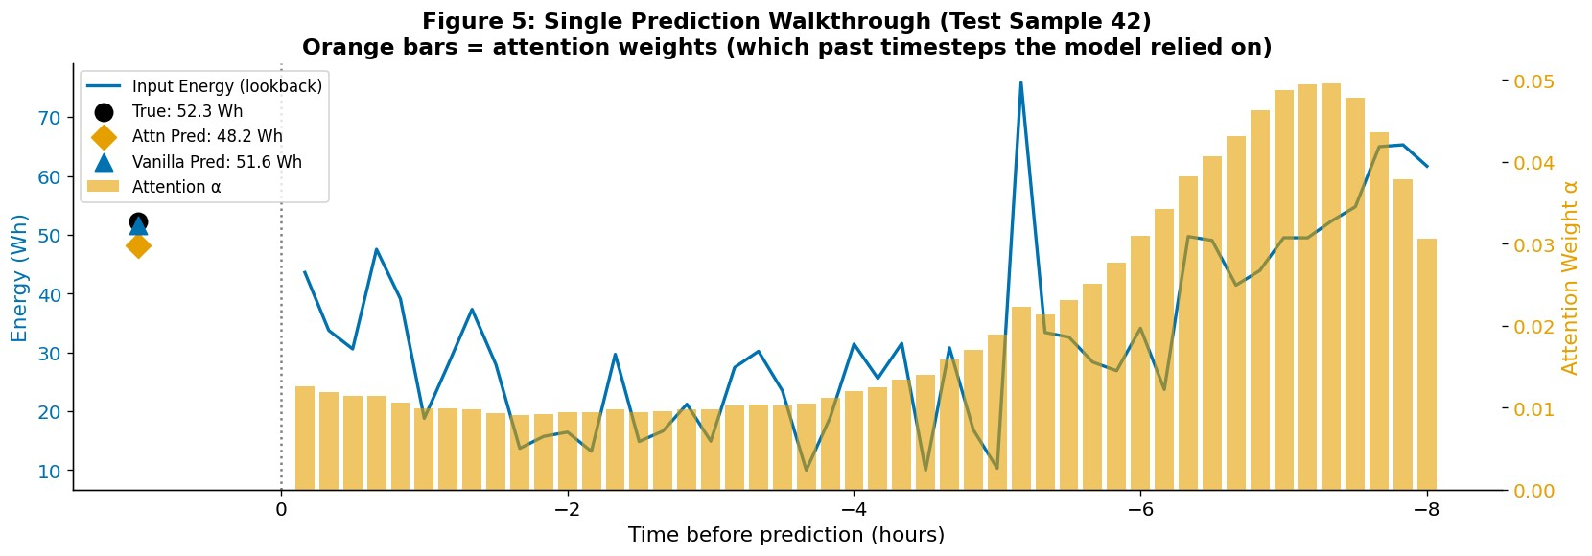
Figure 5: Attention heatmap and mean attention profile.
The attention weights reveal that:
- Recent timesteps receive highest importance
- Secondary focus occurs around ~6 hours earlier
This behaviour is consistent with the underlying periodic structure of the data, indicating that the model effectively captures and utilises recurring temporal dependencies.

4.5 Single Prediction Interpretation
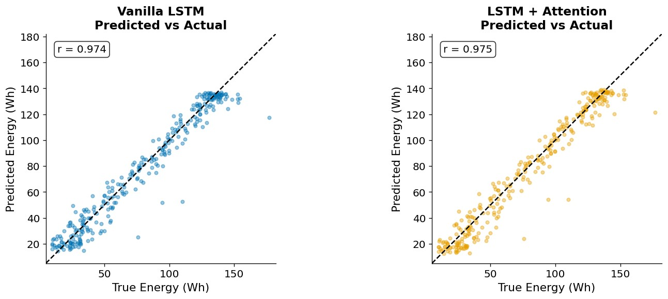
Figure 6: Single prediction walkthrough.
This figure demonstrates how attention weights influence a specific prediction, highlighting the model’s interpretability.

5. DISCUSSION
The results demonstrate that attention improves LSTM models in two key ways:
- Improved Performance
The attention-enhanced LSTM consistently achieves lower error metrics, including Root Mean Squared Error (RMSE), Mean Absolute Error (MAE), and Mean Absolute Percentage Error (MAPE), compared to the Vanilla LSTM. This improvement can be attributed to the model’s ability to utilise information from all timesteps, rather than relying solely on the final hidden state. By mitigating the information bottleneck inherent in standard LSTMs, the attention mechanism enables more effective learning of long-range temporal dependencies.

Interpretability
A key advantage of the attention-based model is its interpretability. Unlike the Vanilla LSTM, which operates as a black box, the attention mechanism provides explicit insight into the model’s decision-making process. Specifically, it reveals which timesteps contribute most significantly to predictions and how temporal dependencies are distributed across the input sequence. This is particularly valuable in time series applications where understanding model behaviour is as important as achieving high accuracy.

Why Attention Works
Attention acts as a memory retrieval mechanism, allowing the model to:
- Directly access relevant past states
- Avoid information compression

Connection to Transformers
Attention is the foundation of Transformer models, which:
- Use self-attention instead of recurrence
- Enable parallel computation
- Scale effectively to large datasets

Limitations
- Synthetic dataset lacks real-world complexity
- Small model size
- Single-head attention limits expressiveness

6. CONCLUSION
This report demonstrates that incorporating attention into LSTM models significantly improves both performance and interpretability.
Key findings include:
- Reduction in prediction error (~18–20%)
- Ability to visualise model decision-making
- Improved handling of long-range dependencies
Attention provides a simple yet powerful enhancement and serves as a conceptual bridge to modern deep learning architectures.

ACCESSIBILITY CONSIDERATIONS
All visualisations were designed using:
- Colour-blind-friendly palettes
- Clear labels and legends
- Consistent formatting

REFERENCES
- Bahdanau, D., Cho, K., & Bengio, Y. (2015)
- Hochreiter, S., & Schmidhuber, J. (1997)
- Vaswani, A. et al. (2017)
- Kingma, D., & Ba, J. (2015)
- Qin, Y. et al. (2017)

