

LiveStock

CSE 305: User Guide



Wendy Zheng: wendy.zheng@stonybrook.edu

Ryan Goepfert: [ryan.goepfert@stonybrook.edu](mailto:ryan.goepfert@stonybrook.edu)

Yuliya Astapova: yuliya.astapova@stonybrook.edu

**Login**

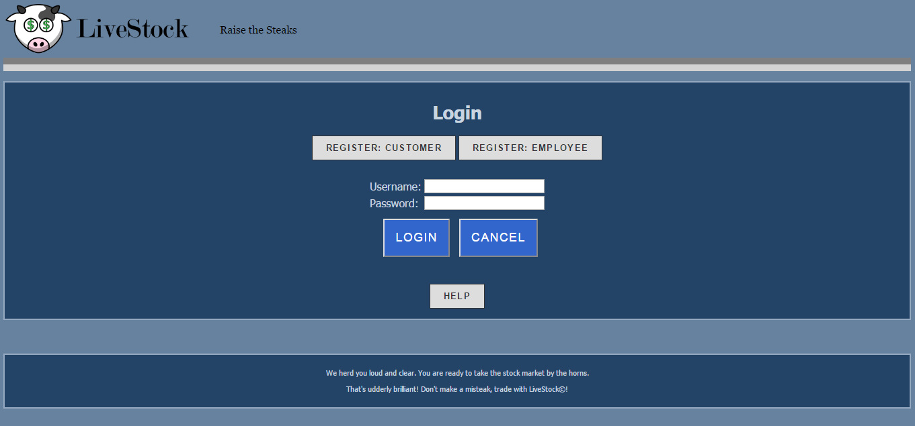

|  |  |
| --- | --- |
| **Object** | **Function** |
| Register Customer | Register as a customer |
| Register Employee | Register as an employee |
| Username | Where you put your username (case sensitive) |
| Password | Where you put your password (case sensitive) |
| Login | Click this button to login once you have input your username and password |
| Cancel | Click this button to clear out the login and password fields |
| Help | Click this button to bring you to the main help page describing the transactions that different user classes can perform |

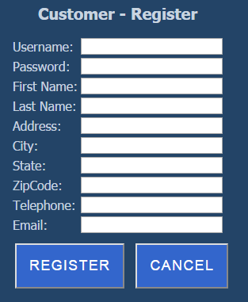**Register Customer**

|  |  |
| --- | --- |
| **Object** | **Function** |
| Username | Your username (case sensitive) |
| Password | Your password (case sensitive) |
| First Name | Your first name |
| Last Name | Your last name |
| Address | Your address |
| City | Your city |
| State | Your state |
| Zip Code | Your zip code |
| Telephone | Your telephone number with no dashes |
| Email | Your email |
| Register | Register for a new account once you have filled in all the information |
| Cancel | Go back to the login page |

**Register Employee**

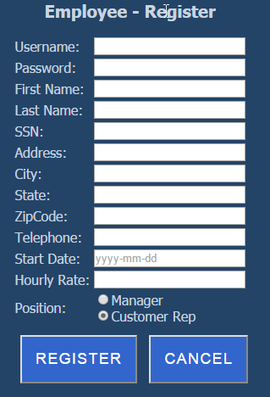

|  |  |
| --- | --- |
| **Object** | **Function** |
| Username | Your username |
| Password | Your password |
| First Name | Your first name |
| Last Name | Your last name |
| SSN | Your Social Security Number |
| Address | Your address |
| City | Your city |
| State | Your state |
| Zip Code | Your zip code |
| Telephone | Your telephone number with no dashes |
| Start Date | Your start date (Format yyyy-mm-dd) |
| Hourly Rate | Your hourly rate |
| Register | Register for a new account once you have filled in all the information |
| Cancel | Go back to the login page |

**Help**

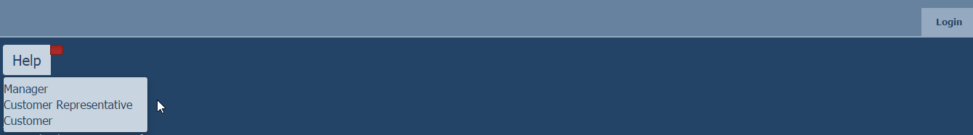

|  |  |
| --- | --- |
| **Object** | **Function** |
| Help | Click to reveal drop down menu |
| Login | Return to the login page |
| Manager | Go to the help section for Manager |
| Customer Representative | Go to the help section for Customer Representative |
| Customer | Go to the help section for Customer |

**Customer**



|  |  |
| --- | --- |
| **Object** | **Function** |
| Account Info | View your account information |
| Portfolios | View information about the stocks that you currently own |
| Orders | View your pending and completed orders |
| Stocks | Search for stocks and place orders |
| Help | View the help manual for customers |
| Logout | Logout of your account |

**Account Info**

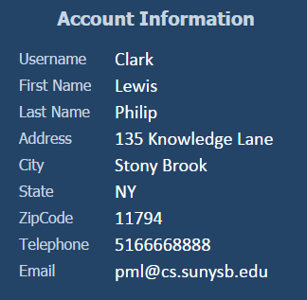

**Portfolios**

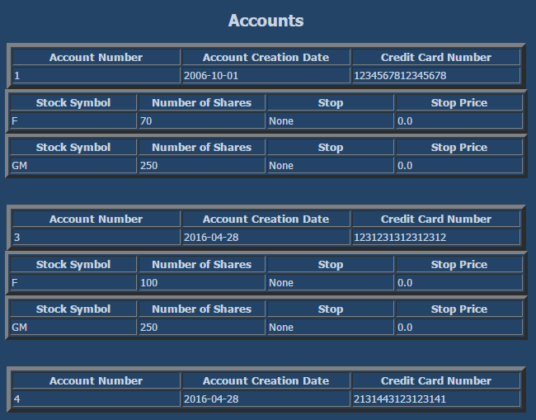

**Orders**

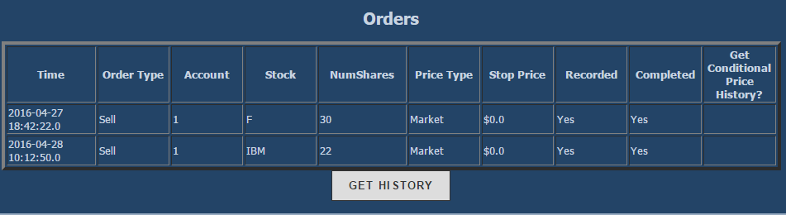

|  |  |
| --- | --- |
| **Object** | **Function** |
| Get History | Get the Conditional Price History of your Orders |

**Stocks**

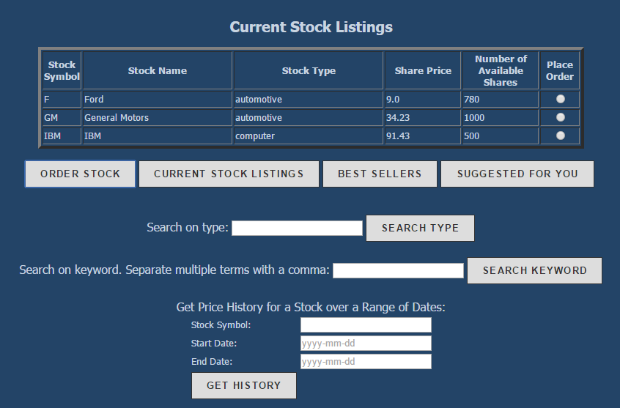

|  |  |
| --- | --- |
| **Object** | **Function** |
| Order Stock | Order a particular stock by marking the appropriate radio button |
| Current Stock Listings | View the current stock listings |
| Best Sellers | View the best selling stocks |
| Suggested For You | View the stocks that are suggested for you |
| Search Type | Search for a specific stock type |
| Search Keyword | Search for specific stocks using keywords |
| Get History | Get the price of a given Stock over a Start Date and End Date |

**Help**

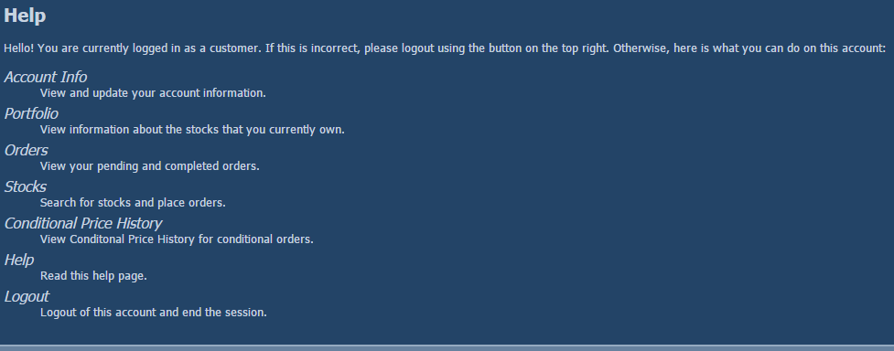

**Customer Representative**



|  |  |
| --- | --- |
| **Object** | **Function** |
| Account Info | View your account information |
| Utilities | Generate Mailing lists and stock suggestions for a given customer |
| Customers | View, Add, Edit, and Delete Customers |
| Orders | View and record Orders |
| Stocks | Search for stocks |
| Help | View the help manual for customers representatives |
| Logout | Log out of your account |

**Account Info**

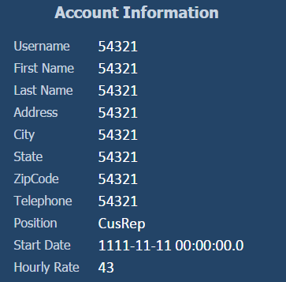

**Utilities**

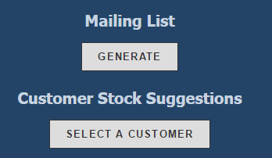

|  |  |
| --- | --- |
| **Object** | **Function** |
| Generate | Generate the customer mailing list |
| Select a Customer | Select a customer to preview their stock suggestions |

**Customers**

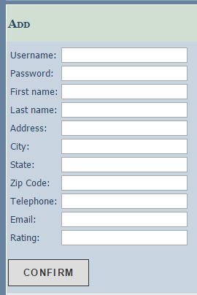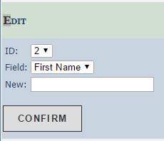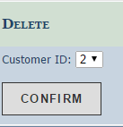

|  |  |
| --- | --- |
| **Object** | **Function** |
| Add | Form where you can add a customer |
| Edit | Form where you can edit a specific field for a customer |
| Delete | Form where you can delete a customer |

**Colleagues**

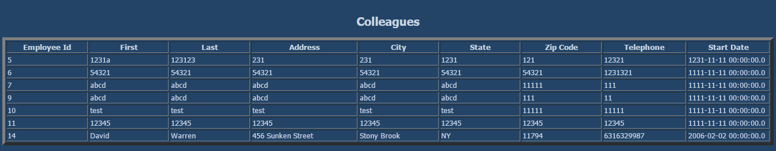

**Orders**

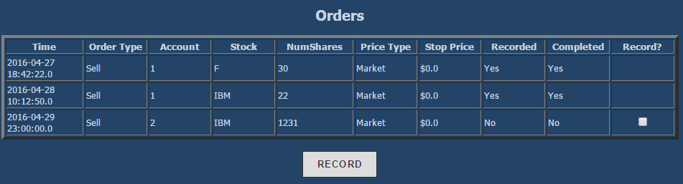

|  |  |
| --- | --- |
| **Object** | **Function** |
| Record | Record an order that has not yet been recorded |

**Stocks**

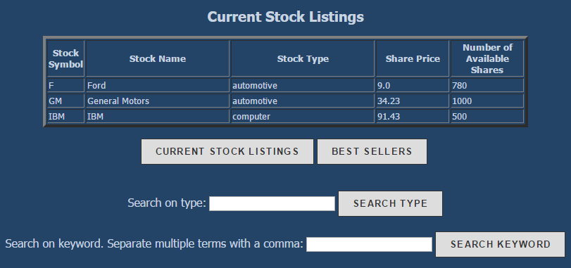

|  |  |
| --- | --- |
| **Object** | **Function** |
| Current Stock Listings | View the current stock listings |
| Best Sellers | View the best selling stocks |
| Suggested For You | View the stocks that are suggested for you |
| Search Type | Search for a specific stock type |
| Search Keyword | Search for specific stocks using keywords |

**Help**

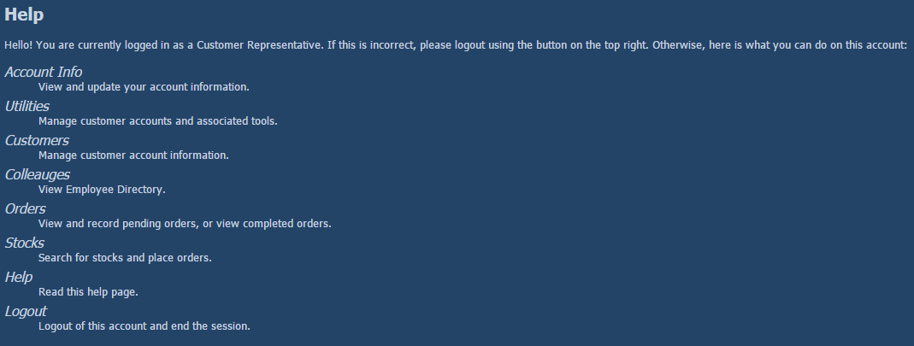

**Manager**



|  |  |
| --- | --- |
| **Object** | **Function** |
| Account Info | View your account information |
| Employees | View, Add, Edit, and Delete Employees |
| Users | View, Add, and Delete Employees and Customers |
| Finances | View the Revenue related information |
| Orders | View and record Orders |
| Stocks | Search for stocks and set stock prices |
| Utilities | Backup and Restore the database |
| Help | View the help manual for managers |
| Logout | Log out of your account |

**Account Info**

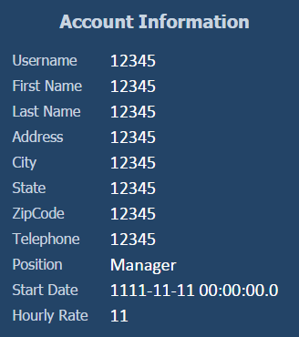

**Employees**

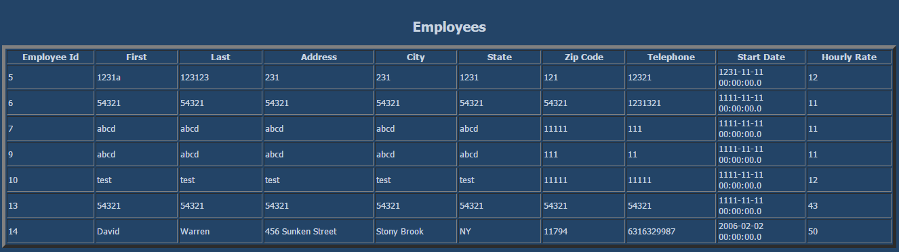

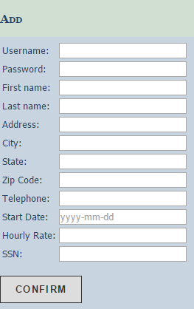 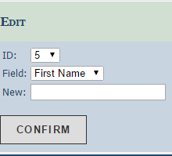 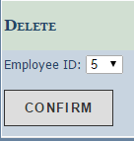

|  |  |
| --- | --- |
| **Object** | **Function** |
| Add | Form where you can add an employee |
| Edit | Form where you can edit a specific field for an employee |
| Delete | Form where you can delete an employee |

**Users**

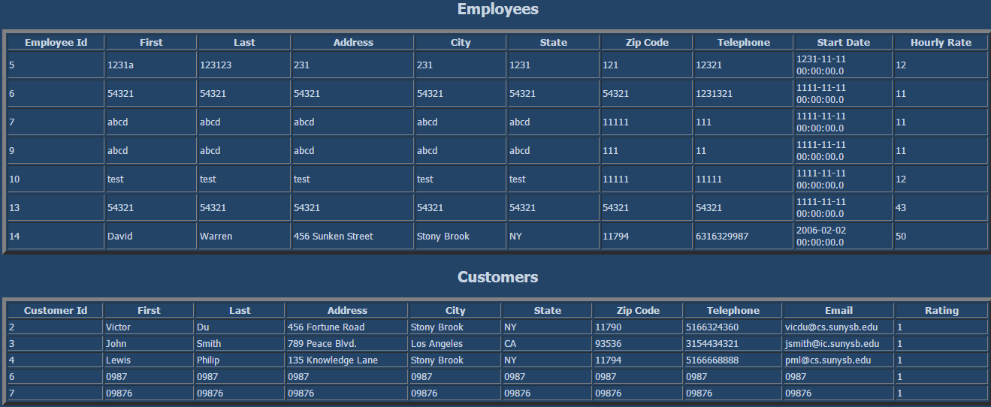

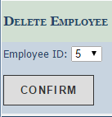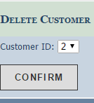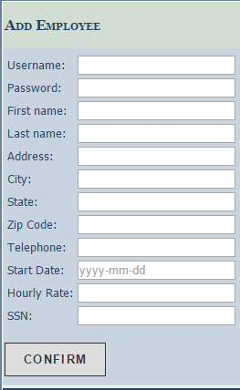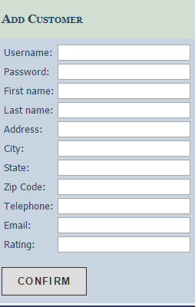

|  |  |
| --- | --- |
| **Object** | **Function** |
| Add Employee | Form where you can add an employee |
| Add Customer | Form where you can add a customer |
| Delete Employee | Form where you can delete an employee |
| Delete Customer | Form where you can delete a customer |

**Finances**

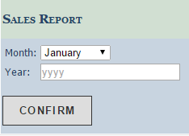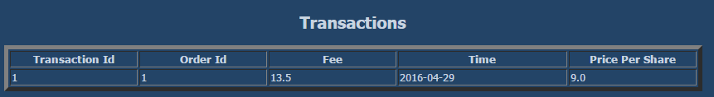

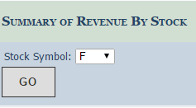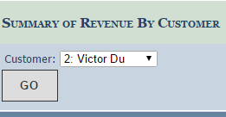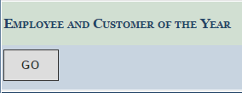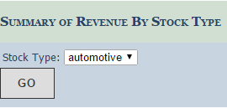

|  |  |
| --- | --- |
| **Object** | **Function** |
| Sales Report | Get the sales report for a particular month and year |
| Employee and Customer of the Year | Get the employee and customer who generated the most revenue this year |
| Summary of Revenue by Stock Type | Get the revenue generated by a certain stock type |
| Summary of Revenue by Stock | Get the revenue generated by a particular stock |
| Summary of Revenue by Customer | Get the revenue generated by a specific customer |

**Orders**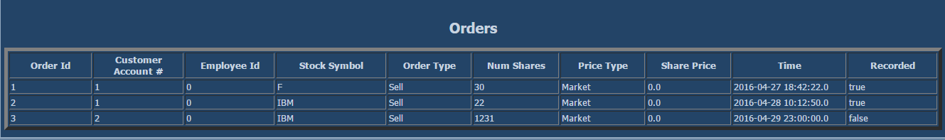

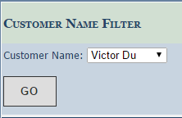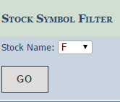

|  |  |
| --- | --- |
| **Object** | **Function** |
| Customer Name Filter | Filter the Orders by Customer Name |
| Stock Symbol Filter | Filter the Orders by Stock Symbol |

**Stocks**

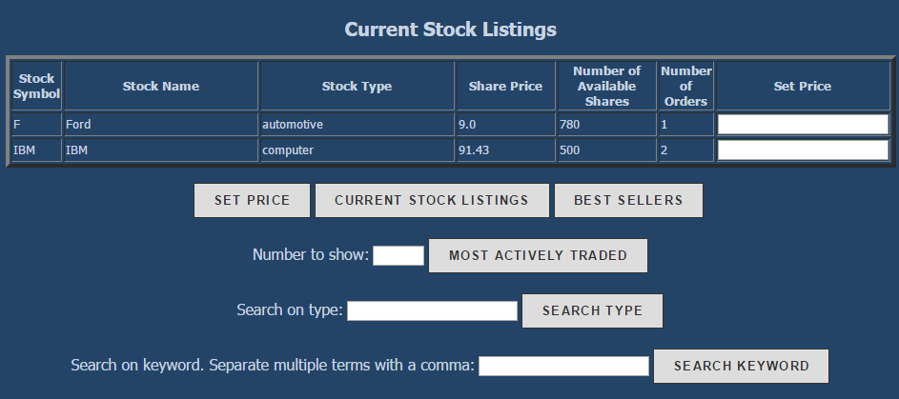

|  |  |
| --- | --- |
| **Object** | **Function** |
| Set Price | Set the price for a particular stock |
| Current Stock Listings | View the current stock listings |
| Best Sellers | View the best selling stocks |
| Most Actively Traded | View a certain number of most actively traded stocks |
| Search Type | Search for a specific stock type |
| Search Keyword | Search for specific stocks using keywords |

**Utilities**

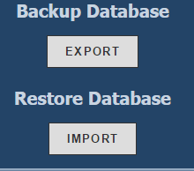

|  |  |
| --- | --- |
| **Object** | **Function** |
| Export | Export the database into the dump.sql file |
| Import | Import the database stored in the dump.sql file |

**Help**

