**Smart Internz Project Report**

1. Introduction

1.1 Overview

The project, titled "Qlik Analysis of Road Safety and Accident Patterns in India," aims to leverage Qlik's data analytics platform to analyze and visualize road safety and accident patterns across India. By integrating various data sources such as traffic data, accident reports, weather conditions, road infrastructure details, and demographic information, the project seeks to identify trends, hotspots, and factors contributing to road accidents. The insights gained from this analysis can help stakeholders, including government authorities, transportation agencies, and road safety organizations, make data-driven decisions to improve road safety measures, reduce accidents, and save lives.

1.2 Purpose

The primary purpose of this project is to utilize Qlik's advanced data analytics capabilities to enhance road safety in India by:

* **Hotspot Identification**: Pinpointing regions or specific roads with a high frequency of accidents. By correlating accident data with factors like traffic volume, road conditions, and time of day, the platform can identify accident-prone hotspots. This information is crucial for implementing targeted interventions such as enhanced traffic monitoring, improved signage, and speed limit adjustments.
* **Trend Analysis**: Performing trend analysis on historical accident data to identify patterns and recurring factors leading to accidents. This includes analyzing accident types (e.g., collisions, pedestrian accidents), seasonal variations, and driver behavior (e.g., speeding, distracted driving). Insights gained can guide awareness campaigns, driver training programs, and policy reforms aimed at addressing root causes.
* **Predictive Modeling**: Using predictive analytics to forecast potential accident scenarios based on real-time data inputs. By considering variables like weather forecasts, traffic flow patterns, and historical accident trends, the platform can provide early warnings and proactive measures to prevent accidents. This predictive capability empowers authorities to deploy resources strategically and implement preemptive safety measures.

1.3 Technical Architecture

The technical architecture for this project involves the following components:

* **Data Sources**: Various data sources, including traffic data, accident reports, weather conditions, road infrastructure details, and demographic information.
* **Data Analytics Tool**: Qlik Sense is used for data integration, analysis, and visualization.
* **Responsive Dashboard**: A dynamic dashboard designed to provide interactive insights into the data, enabling users to explore and analyze accident patterns.
* **Visualization Sheets**: Specific sheets focusing on different aspects of the data, such as causes of accidents, weather conditions, and demographic details of pedestrians involved.
* **Storytelling**: Creating snapshots of visualisation sheets and making a story.
* **Predictive Analytics Engine**: Utilizing Qlik's predictive analytics capabilities to forecast potential accident scenarios and provide early warnings.

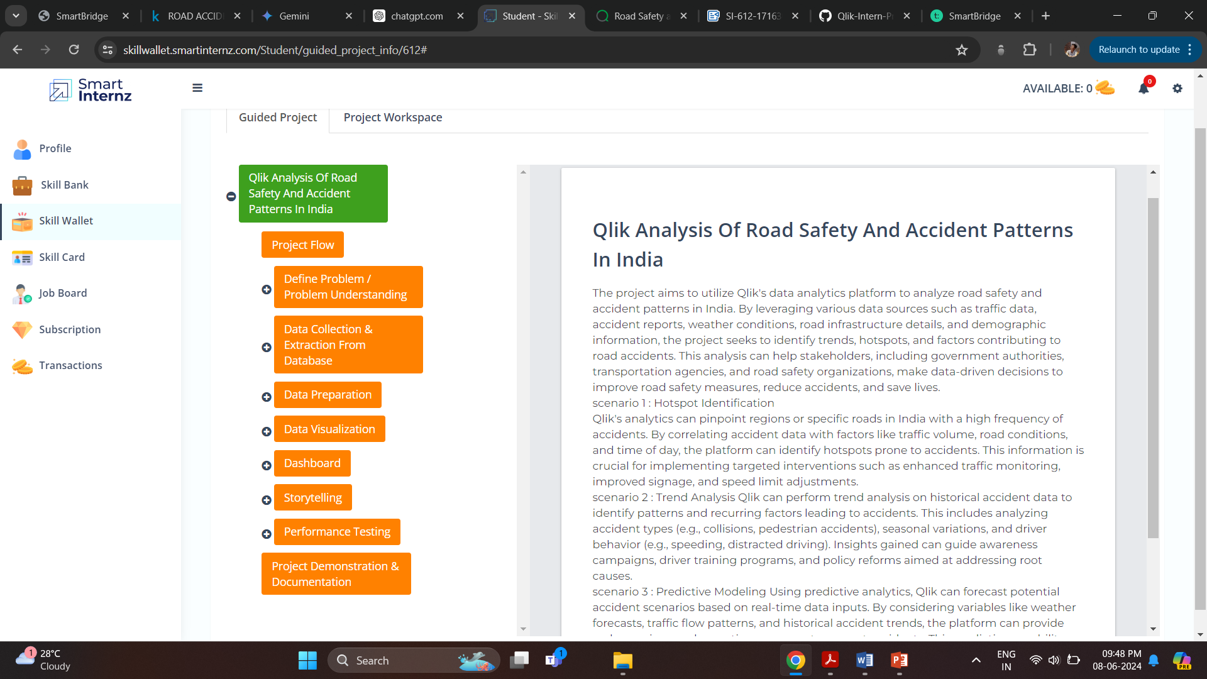2. Define Problem / Problem Understanding

2.1 Business Problem

Technological advancements in transportation have minimized distances but increased risks to life. Every year, accidents result in the loss of lakhs of lives and cause serious injuries to crores of people. This project aims to analyze road safety and accident trends in India using Qlik Sense, a data analytics platform. The study examines data related to road incidents, such as types of accidents, locations, causes, and contributing factors. By utilizing visualizations and insights generated from Qlik Sense, the project seeks to understand patterns and inform strategies to improve road safety in India.

**2.2 Business Requirements**

The analysis aims to provide valuable insights into user demographics, accident patterns, and problem areas. The primary focus is on creating interactive and visually compelling dashboards to support strategic planning and operational improvements. The insights derived from this analysis will be instrumental in making informed decisions, implementing better safety protocols, and ensuring compliance with regulations. Key requirements include:

* Comprehensive analysis of accident data to identify key trends and patterns.
* User-friendly visualizations for policymakers and stakeholders.
* Responsive and interactive dashboard for detailed data exploration.

2.3 Literature Survey

A review of existing literature reveals that road accidents are influenced by various factors including traffic control measures, weather conditions, and demographic variables. Previous studies have highlighted the importance of data-driven approaches in improving road safety and have demonstrated the effectiveness of visual analytics tools like Qlik in identifying critical insights.

3. Data Collection

3.1 Collect the Dataset

The various datasets used in this project includes the following:

* Traffic control types
* Weather conditions during accidents
* Pedestrians involved (male, female with age group)
* Pedestrians killed
* Vehicles for pedestrians killed
* Road users killed
* Causes of accidents
* Total accidents and persons killed on a state-wise basis

**Source Link frpm kaggle** : <https://www.kaggle.com/datasets/aryakittukrishnasai/road-accidents-in-india>

3.2 Connect Data **with** Qlik Sense

The collected dataset was imported into Qlik Sense for analysis. The tool was configured to read and process the data, allowing for efficient visualization and interaction.

4. Data Preparation

4.1 Prepare the Data for Visualization

Data preparation involves :

* Cleaning the dataset to remove any missing values.
* Normalizing data formats to ensure compatibility with Qlik Sense.
* Also renamed the column names that raised conflicts due to different cases used in different datasets.
* Structuring the data to facilitate effective visualization (e.g., categorizing variables, creating relevant metrics).

5. Data Visualizations

5.1 Visualizations

The visualizations created in Qlik Sense include:

* Insights on Causes of Accidents: Charts illustrating the primary causes of road accidents.
* Insights on State-wise Accidents and Persons Killed: Visuals highlighting the distribution of accidents and fatalities across different states.
* Insights on Pedestrians Killed: Analysis of pedestrian fatalities, segmented by demographics.
* Insights on Weather Conditions: Visualization of the impact of weather conditions on accident rates.
* Insights on Traffic Control Types: Charts showing the effectiveness of various traffic control measures.
* Accidents on Pedestrians Male vs Female: Comparative analysis of accidents involving male and female pedestrians using various chart types.

**[ [Visualization sheets source](https://github.com/AravindG-4/Qlik-Intern-Project/tree/main/sheets%20and%20story) ]**

6. Dashboard

6.1 Responsive and Design of Dashboard

The responsive dashboard created in Qlik Sense includes interactive charts that allow users to filter data by the states that changes the total number of accidents, number of persons killed associated by them. The design prioritizes ease of use, ensuring that users can quickly derive insights from the data.

[ **[Source](https://github.com/AravindG-4/Qlik-Intern-Project/blob/main/sheets%20and%20story/road_accidents_dashboard.pdf)** ]

7. Report

7.1 Report Creation

The report is structured to provide a comprehensive overview of the analysis conducted. It includes detailed sections on each visualization, with explanations and interpretations of the findings. The report also discusses the implications of the insights for road safety policies.

8. Performance Testing

8.1 Amount of Data Rendered

Performance testing was conducted to ensure that the dashboard and visualizations could handle the volume of data without significant lag or performance issues. The tool successfully rendered the entire datasets, providing smooth and responsive interactions.

8.2 Utilization of Data Filters

Various data filters were implemented in the dashboard to allow users to drill down into specific subsets of data. The filters performed efficiently, enabling users to explore the data from different angles and gain detailed insights.

