**AN EFFICIENT INVESTIGATION OF HUMAN STRESS BY USING SUPPORT VECTOR MACHINE(SVM)**

1Nandhini.T, 2Pragathi.V, 3Shanmugapriya.A, 4Dr. S.Kumarganesh

1to3UG Scholor,ECE, Paavai Engineering College, Pachal, Namakkal

4Professor, ECE, Paavai Engineering College, Pachal, Namakkal

3[shanmukalai55@gmail.com](mailto:shanmukalai55@gmail.com), 1nandhu.thangaraj1998@gmail.com

**Abstract**

Signal analysis using medical imaging is an important process. The function of the brain and heart is also very essential. If the brain is not properly functioning, there occur some problem it cannot functions well. The function of the heart is also very essential. If the heart functions properly, then the blood circulates throughout the body with help of systolic and diastolic process. Suppose if it is affected by any fact content, the blood gets clotted and it cannot function well and occur some problem. In other terms our minds get diverted and mentally disturbed from stress. So the detection of heart beat level is required to monitor the stress and heart beat level.

***Keywords: Imaging, brain, heart, systolic, diastolic, stress, heart beat level***

1. **Introduction**

Psychological stress is a phenomenon related to thoughts, emotion, physiological changes and everyday social activities. High level of psychological stress can cause health related problems. It has been observed in recent researches that high level of mental stress adversely affects cardiovascular, endocrine and immune system health, etc. and psychological health (Cohen et al., 2007). Stress is surveyed to be an unavoidable aspect of college student’s life. A survey conducted by Nightline Association reported about 65% of university students observe some kind of mental or psychological stress in their daily academic and other activities (Zheng et al., 2016). Cognitive as well as physical performance can also be affected due to daily stress conditions. High risk professions, such as defense services, industrial process plants, vehicle, locomotives and flight operation and control are more prone to get affected due to high stress condition and can be highly dangerous (Driskell et al., 2013).

Diagnose and measurement of stress level profiles; quantitatively and qualitatively with abnormality spotting can be achieved by majorly three methods: task oriented, questionnaire based and physiological parameters assessment based evaluations. Psychological questionnaire based methods are widely used to examine the stress profile, but this is mostly only empirical to subject’s response and is prone to misrepresentation or manipulation, and it can result to incorrect measurement. Also, evaluation requires an extensive training and expertise.

Present method is an attempt to develop a method to measure overall psychological stress advent through physiological signals and it’s parameters, visually EEG. EEG signal is an electrical impression of bioelectric potential from brain, during regular stimulus and triggering of neuronal activity, due to neuronal cell-dendrite current dipole dynamic change. Using EEG as a signature of regular brain neuronal activity, discrete stress levels can be evaluated. In this method, metrics generated from B-Alert X10 based EEG system and questionnaire based; differential stress inventory (DSI), are together used for discrete level stress profile assessment. Features processed and generated through EEG-based metrics and discrete levels of stress profile evaluated from DSI are incorporated on a support vector machine (SVM) based supervisory learning system, which is further used to assess discrete class of stress profile of particular subject.

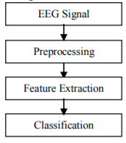

***Figure: Flow diagram***

It has two methods to capture EEG signal, they are invasive and non-invasive. Using EEG, the summed activity of nerve cells in the brain can be recorded using electrodes attached temporarily to the scalp surface. There is no recording about side effects and cost. For analysis stress using EEG signal are as shown in Fig.

1. **Literature Review**

An EEG technician placed the electrodes on the scalp. It uses four anatomical landmarks to made a measurement. The names of the electrode sites use alphabetical abbreviations that identify the lobe or area of the brain to which each electrode refers: F, Fp, T, C, P, O, A. Whenever a neuron is active, its voltage changes. Millions of neurons fire together. It produces a distinct pattern of electrical activity of each mental state.

ICA (Independent Component Analysis) ICA is a method that transforms random multivariate signal into a signal. ICA can separate and remove a wide variety of artifacts from a data of EEG. It denotes the information carried by one component cannot be others. The mixed signal can be extracted from the independent signal. [12]

1. **Proposed System**

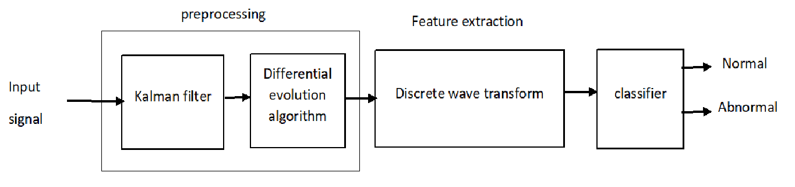

***Figure: Block diagram***

The different patterns of brain activity feature extraction are used for representing and classifying. In this phase, techniques are highly used as ICA (Independent Component Analysis) and PCA (Principal Component Analysis).

1. **Preprocessing:**

Preprocessing is one of the method to convert analog to digital conversion. It extracts the noises from the signal and produce the right signal.

Preprocessing is used to suppresses unwanted distortion are enhancing the input and give clear image of the data.

Differential evaluation algorithms are used in preprocessing techniques it is a testing method to optimize the correct P, Q, R, S signal. While combining differential evaluation into Kalman filter value it extracts the noises from P, Q, R, S values and produce correct signal.

1. **Feature extraction**

Segmentation is the process of partitioning a digital image into multiple segments ie., the goal of segmentation is to simplify the image and extract the noises from the signal and give correct data or image. It is a method used to reduce the noise from this signal and give accurate signal.

**DWT**

DWT stands for Discrete Wave Transform. In this project DWT technique is highly used. It is used to separate and classify.

1. **Classification**

Classification is a method compare to values and produce the best result. We can get correct signal where stress is indicator using classifier and get the accurate result.

**Feature Extraction**

The signal classification for each signal is used to extract the features. The following features used to extract on 8 blocks of each signal approximately one minute in duration (8192 samples):

* Autoregressive model (AR) coefficients of order 4
* Shannon entropy (SE) values for the maximal overlap discrete wavelet packet transform (MODPWT) at level
* The wavelet leader estimates of the scaling exponents and the range of Holder exponents.

Each signal over the entire data length variance estimates are extracted [6]. The wavelet variance is used for an unbiased estimate. Boundary conditions are used in the variance estimates by unaffected Wavelet coefficient. A signal length of 2^16 (65,536) and the 'db2' wavelet results in 14 levels.

It was selected based on their effectiveness in ECG waveforms. An exhaustive or optimized list of features is not intended.

The AR coefficients for each window are estimated using the Burg method, used model order selection methods to determine that an AR (4) model provided the best fit for ECG waveforms in a similar classification problem. A wavelet packet tree and used with a random forest classifier on the terminal nodes. Here we use the non-decimated wavelet packet transform, modest, down to level 4.

The definition of the Shannon entropy for the undecimated wavelet packet transform by: https://ww2.mathworks.cn/help/examples/wavelet/win64/XpwWaveletMLExample_eq00578405578507823257.png where https://ww2.mathworks.cn/help/examples/wavelet/win64/XpwWaveletMLExample_eq03672095713503266041.png is the number of the corresponding coefficients in the jth node and https://ww2.mathworks.cn/help/examples/wavelet/win64/XpwWaveletMLExample_eq08894933848492756978.png are the normalized squares of the wavelet packet coefficients in the jth terminal node.

Estimated by wavelet methods of two fractal measures are used. The width of the singularity spectrum obtained from dwt leader as a measure of the ECG signal. It also uses the second cumulant of the scaling exponents. The scaling exponents are scale-based exponents describing power-law behavior in the signal at different resolutions.

The entire signal is obtained to use modwtvar. It measures variability of a signal by scale, or equivalently variable.

In total there are 190 features: 32 AR features, 128 Shannon entropy values, 16 fractal estimates, and 14 wavelet variance estimates.

To find the source code for this helper function in the Supporting Functions section.

**Classification**

The features extracted have different classes. In this process we used SVM and K-means algorithm to find out wheather the person is normal or ubnormal.

For each signal the data has been reduced to a feature vector, the ECG signal of these feature vector as the next step. The Classification Learner app is used to evaluate the classifiers. A quadratic kernel a multi-class SVM is used. Two analyses are performed. The entire dataset and estimate the misclassification rate and confusion matrix using 5-fold cross-validation.

**Wavelet transform**

Wavelet transform offers effective time-frequency representation of signals. These shifting and scaling of "mother" wavelet function are the basic function to be formed:

(1)

Signal  can be then represented as

 (2)

where are spectral wavelet coefficients

 (3)

In this paper we can use orthogonal Haar wavelet transform, where:

 (4)

Example of Haar basis and its  functions are shown in Figure 1. There are no linear dependencies, the magnitude dependencies across the scales. This property is advantageous and strongly used for image compression. The statistical estimation and modeling of parent child allow the magnitude dependencies.Across the scales this dependencies contain the information .

1. **Result**

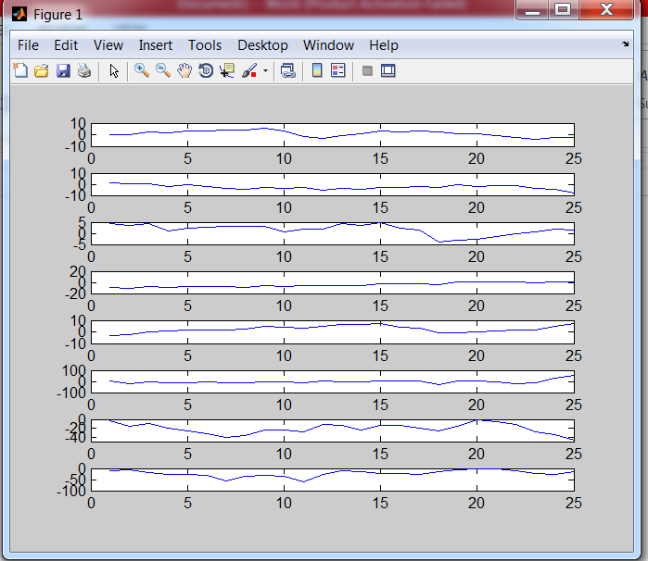

***Figure: Input signal for ECG and EEG signals***

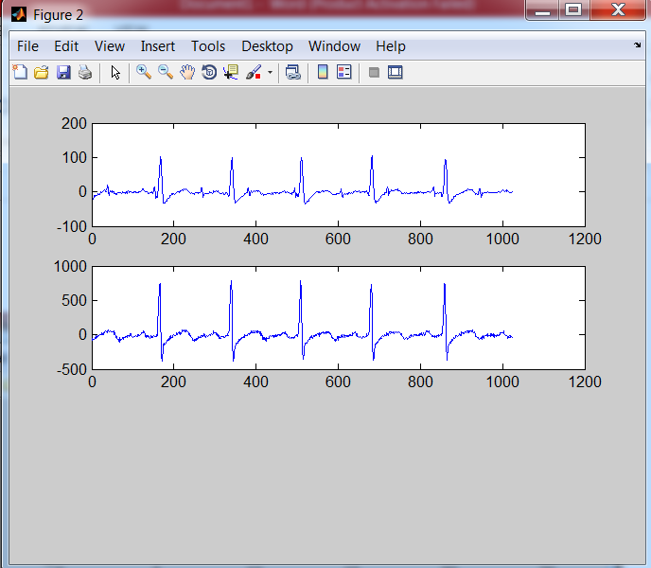

***Figure: Noise cancellation of the signal in ECG and EEG***

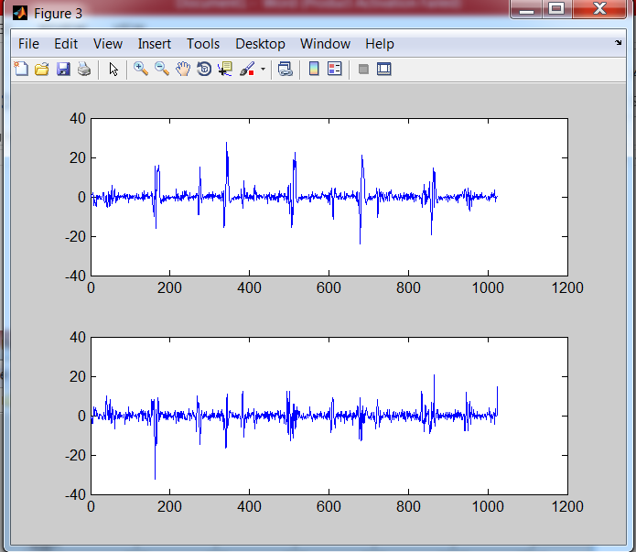

***Figure: To identify the original signal of ECG and EEG will be classified.***

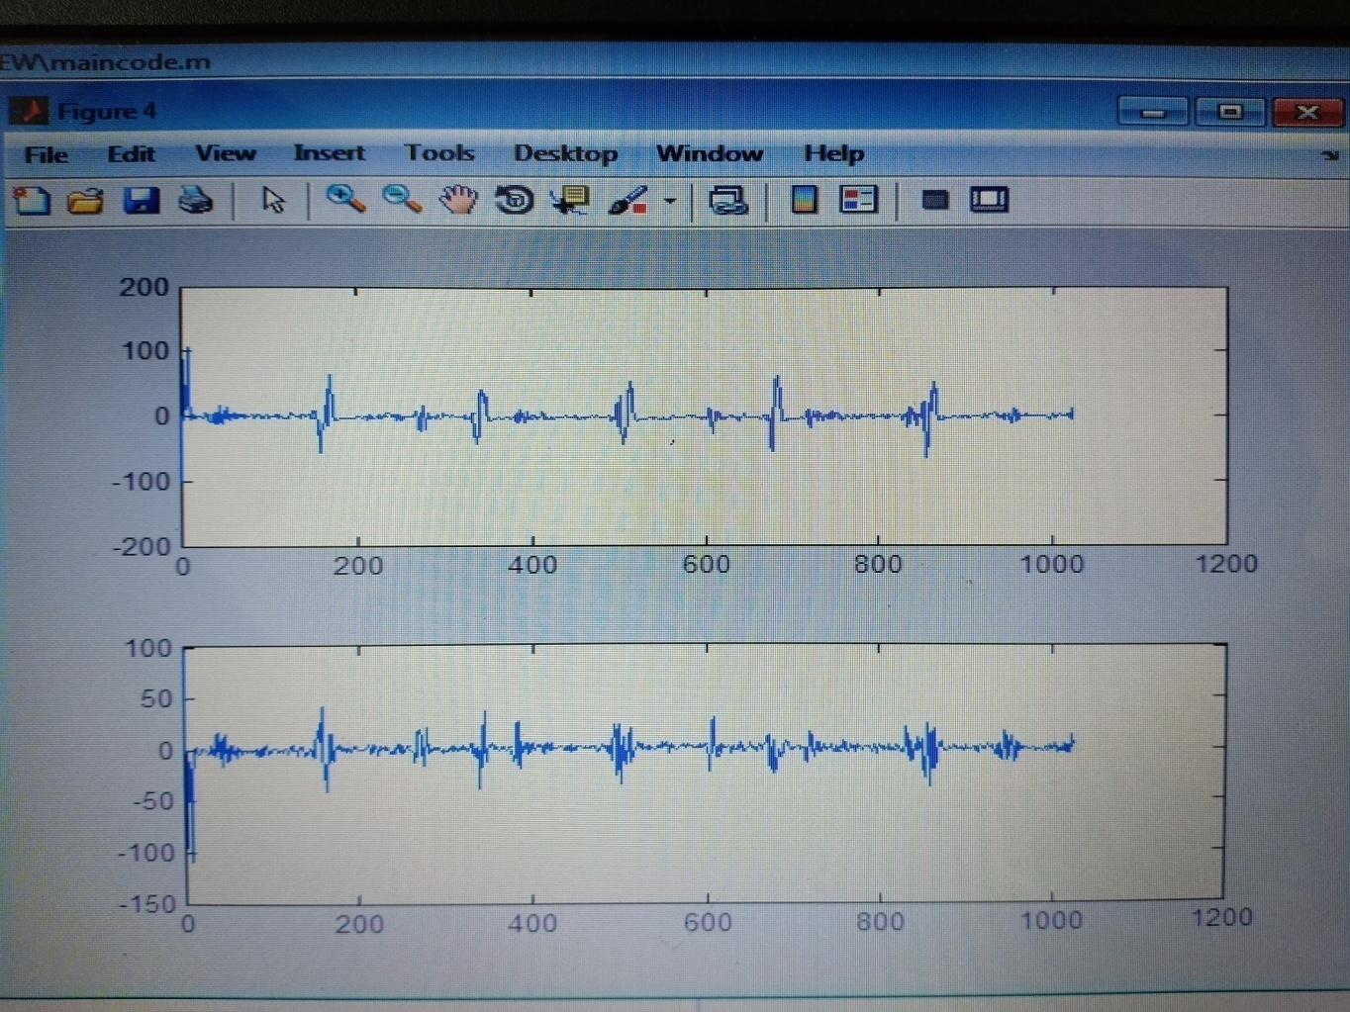

***Figure:*** ***A Patient’s ECG Signal Testing***

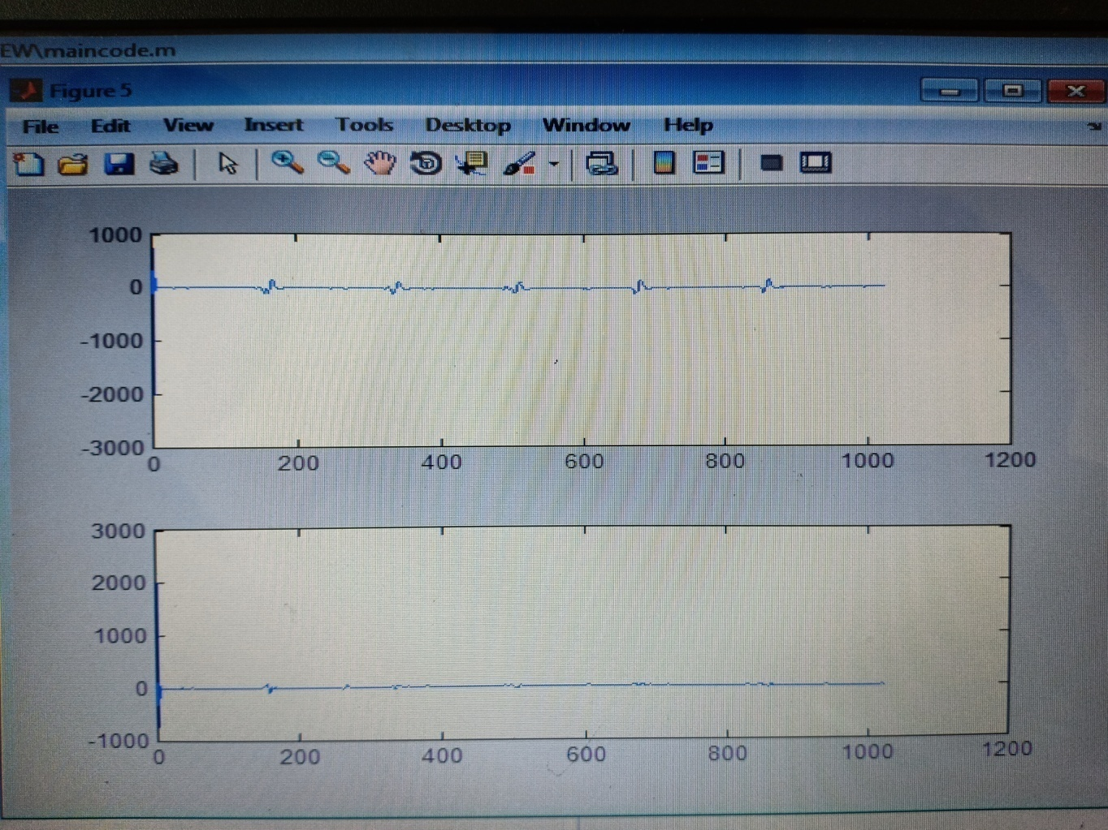

***Figure: A Patient’s EEG Signal Testing***

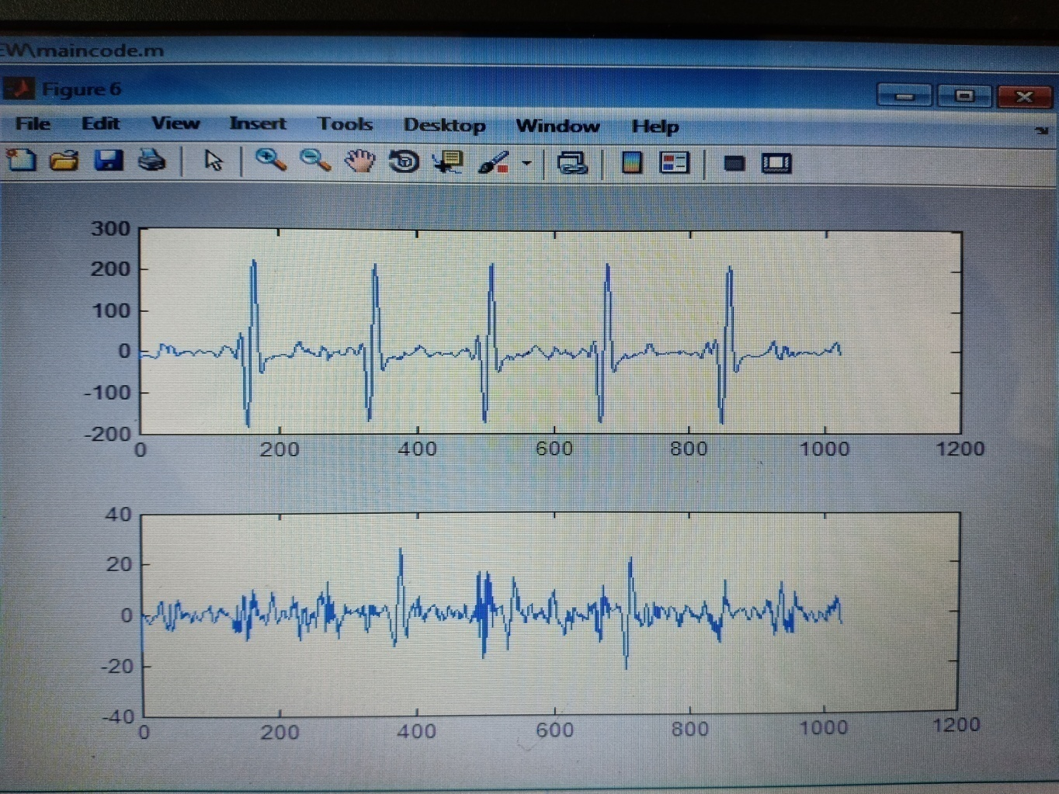

***Figure: The Original Signal of Normal Person***

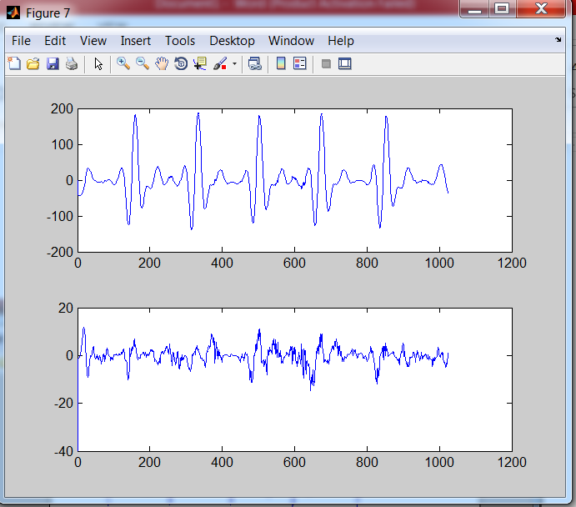

***Figure: The original signal of normal and abnormal person.***

1. **Conclusion**

This work EEG has been comprehensively used for detection of stress levels. Feature extraction and classification techniques of EEG signals have been suggested for higher level of accuracy. This work provides a review of the most efficient techniques developed in the past. This technique can be judged upon its level of accuracy and speed. The future work concentrates on developing an efficient algorithm. It can be used for various diagnostic activities to reveal stress levels. The diagnosed conditions can then be acted upon appropriately and at the earliest stage. Therefore, the future work has to improve the identifying and acting depend upon the stressed condition.

**References**

[1]. S. Karpagachelvi, Dr. M.Arthanari, M. Sivakumar, “ECG Feature Extraction Techniques – A Survey Approach,” IJCSIS, vol. 8, no. 1, April 2010.

[2]. George Rigas, YorgosGoletsis, “Real-Time Driver‟s Stress Event Detection,” IEEE Transactions On Intelligent Transportation Systems, vol. 13, no. 1, March 2012.

[3]. NorizamSulaiman , MohdNasirTaib, SahrimLias, ZunairahHjMurat,SitiArmizaMohdAris, Noor Hayatee Abdul Hamid, “Novel Methods for Stress Features Identification using EEG Signals,” IJSSST, vol. 12, no. 1.

[4]. Sarah Garrity,“EEG Signal Acquisition and Analysis for Mental Workload Monitoring,” Progress Report, December 2010. [5]. VeronikaBartosova, OldrichVysata, and Ales Prochazka, “Graphical User Interface for EEG Signal Segmentation,”Institute of Chemical Technology, Department of Computing and Control Engineering. [6]. Liang Wu and PredragNeskovic,“Feature extraction for EEG classification:representing electrode outputs as a Markovstochasticprocess,”Department of Physics and Institute for Brain and Neural Systems Brown University, Providence, RI 02906.

[7]. Mina Mikhail, “Real Time Emotion Detection using EEG,” Computer Science and Engineering Department, The American University in Cairo.

[8]. Alberto de Santos Sierra, Carmen Sánchez Ávila, Javier Guerra CasanovaandGonzalo BailadordelPozo, “A Stress-Detection System Based on Physiological Signals and Fuzzy Logic,” IEEE Transactions On Industrial Electronics, vol. 58, no. 10, October 2011.

[9]. VioletaMonasterio, Pablo Laguna and Juan Pablo Martinez, “Multilead Analysis of T-Wave Alternans in the ECGUsing Principal Component Analysis,” IEEE Transactions On Biomedical Engineering, vol. 56, no. 7, July 2009.

[10]. JieLuo, Bo Hu, Xie-Ting Ling, Ruey-Wen Liu,“Principal independent component analysis,” IEEE Transactions On Neural Networks, vol. 10, no. 4, July 1999.

[11]. M. Ungureanu, C. Bigan, R. Strungaru, V. Lazarescu,“Independent Component Analysis Applied in Biomedical Signal Processing,” Measurement Science Review, vol. 4, section 2, 2004.

[12]. Claudio G. Carvalhaes, Marcos Perreau-Guimaraes, Logan Grosenick and Patrick Suppes. “EEG Classification by ICA Source Selection of Laplacian-Filtered data,” IEEE International Symposium on Biomedical, ISBI 2009

[13]. Giovanni Costantini, Daniele Casali, Massimiliano, Todisco, “An SVM based Classification Method for EEG Signals,” WSEAS, Stevens Point, Wisconsin, USA 2010

[14]. Yuan-Pin Lin, Chi-Hong Wang, Tien-Lin Wu, Shyh-Kang Jeng,“Support Vector Machine for EEG signal classification during listening to emotional music,” Multimedia Signal Processing, IEEE 10th Workshop, 2008.

[15]. KardiTeknomo,“K-Means Clustering Tutorial,” Last Update: July 2007.

[16]. Tapas Kanungo, David M. Mount, Nathan S. Netanyahu, Christine D. Piatko, Ruth Silverman, and Angela Y. Wu,“AnEfficient Kmeans Clustering Algorithm: Analysis and Implementation,” IEEE Transactions On Pattern Analysis And Machine Intelligence, vol. 24, no. 7, July 2002.

[17]. Shi Na, Liu Xumin, Guan Yong, “Research on k-means Clustering Algorithm: An Improved k-means Clustering Algorithm,” IITSI, 2010