**SmartIntern Long Term Virtual Internship**

## An Internship Report submitted in partial fulfillment of the requirements for the award of degree of

**BACHELOR OF TECHNOLOGY**

## In

**CSE - ARTIFICIAL INTELLIGENCE & MACHINE LEARNING, ELECTRONICS AND COMMUNICATION ENGINEERING, ELECTRICAL AND ELECTRONIC ENGINEERING.**

**Submitted by:**

**Chebolu Ashish kumar 21MH5A4201 Balla Gana Rohith 20MH1A0204**

**Tatikonda Aparna 21MH5A0430**



**Department Of Computer Science and Engineering**

**ARTIFICIAL INTELLIGENCE & MACHINE LEARNING ELECTRONICS AND COMMUNICATION ENGINEERING ELECTRICAL AND ELECTRONIC ENGINEERING**

**ADITYA COLLEGE OF ENGINEERING**

**Approved by AICTE, Permanently affiliated to JNTUK & Accredited by NAAC Recognized by UGC under the sections 2(f) and 12(B) of the UGC act 1956**

**Aditya Nagar, ADB Road –Surampalem 533437, E.G. Dist., A.P., 2022-2023.**



1

SMARTINTERNZ VIRTUAL INTERNSHIP

Network Vulnerability Assessment

Altoro Mutual



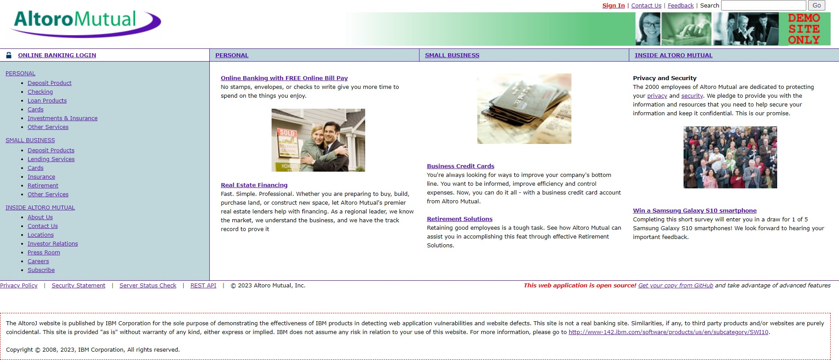

Part 1: Executive Summary **Social Engineering Simulation**

**Social Engineering Simulation**

Executive Summary: Kali linux **Social Engineering Simulation**

The Kali linux was conducted between July 27, 2023, and August 02, 2023, to evaluate the security posture of the Altoro Mutual website's network infrastructure. The primary objective of this assessment was to identify potential vulnerabilities and weaknesses within the network that could pose a threat to the website's integrity, conﬁdentiality, and availability.

Using a combination of manual analysis and automated scanning tools, the assessment aimed to detect vulnerabilities that could be exploited by malicious actors to gain unauthorized access or compromise the website's sensitive data. Rigorous testing was performed, taking into account various attack vectors and techniques commonly used by hackers.

The assessment revealed several ﬁndings regarding the website's network security. Multiple high-severity vulnerabilities were detected, including unpatched software, open ports with inadequate security controls, and weaknesses in the password policy implementation. These critical issues exposed the website to potential cyberattacks, data breaches, and service disruptions.

To address the identiﬁed vulnerabilities, a set of comprehensive recommendations has been provided. Altoro Mutual can signiﬁcantly enhance the security of its website's network infrastructure, mitigate potential vulnerabilities, and fortify its defense against cyber threats. Regular follow-up assessments are encouraged to ensure continuous improvement in network security.

# Overview

### Overview: Network Vulnerability Assessment on Altoro Mutual

The Network Vulnerability Assessment on Altoro Mutual is a comprehensive evaluation of the organization's network infrastructure to identify potential security weaknesses and vulnerabilities. Altoro Mutual is a ﬁnancial services company that handles sensitive data, making it imperative to maintain a robust and secure network environment. This assessment aims to identify and address security gaps that could expose the company to cyber threats, data breaches, and ﬁnancial losses.

The primary objectives of the Network Vulnerability Assessment on Altoro Mutual are as follows:

1. **Identify Vulnerabilities**: The assessment aims to identify potential vulnerabilities in the network infrastructure, including unpatched software, misconﬁgurations, and open ports.
2. **Evaluate Security Controls**: The eﬀectiveness of existing security controls, such as ﬁrewalls, intrusion detection systems (IDS), and access controls, is assessed to determine their ability to detect and prevent attacks.
3. **Assess Network Architecture:** The network architecture is reviewed to ensure proper segmentation, isolation of critical assets, and a robust perimeter defense.
4. **Password Policy Evaluation**: The assessment examines the strength of password policies and their adherence to industry best practices to prevent unauthorized access.
5. **Physical Security Analysis**: Physical security measures in place to protect network infrastructure and data centers are evaluated to prevent unauthorized physical access.

### Methodology:

The assessment follows a well-deﬁned methodology, including the following steps

1. **Reconnaissance**: Passive reconnaissance techniques are used to gather information about the network and its assets.
2. **Vulnerability Scanning**: Automated scanning tools are employed to identify potential vulnerabilities in the network.
3. **Manual Veriﬁcation**: The identiﬁed vulnerabilities are manually veriﬁed to eliminate false positives and prioritize critical issues.
4. **Exploitation (with Authorization)**: Ethical exploitation of vulnerabilities is conducted to determine the extent of potential damage if exploited maliciously.
5. **Analysis and Reporting**: The assessment ﬁndings are analyzed, and a detailed report is generated, including a list of vulnerabilities, risk severity, and actionable recommendations.

### Deliverables:

The assessment will provide the following deliverables:

1. **Network Vulnerability Assessment Report**: A comprehensive report detailing the assessment methodology, ﬁndings, risk analysis, and actionable recommendations.
2. **Executive Summary:** A concise summary highlighting key ﬁndings and critical vulnerabilities for executive stakeholders.
3. **Remediation Plan:** A roadmap outlining the prioritized actions required to address identiﬁed vulnerabilities and improve network security.

# Part 2 : Detail Report

### Information Gathering:

Information gathering is a crucial phase in the cybersecurity and assessment process. It involves collecting relevant data and intelligence about a target system, network, or organization to understand its vulnerabilities and potential attack surfaces. Here are diﬀerent aspects of information gathering:

1. Email Footprint Analysis:

Email footprint analysis involves collecting information related to an organization's email infrastructure, such as email addresses, email servers, and email security measures. This analysis helps in understanding how email communications are handled and identifying potential points of entry for attackers.

1. DNS Information Gathering:

DNS (Domain Name System) information gathering involves querying and analyzing DNS records to gather details about domain names, IP addresses, mail exchange servers, and other crucial information. It helps in understanding the network structure and identifying potential targets for cyberattacks.

1. WHOIS Information Gathering:

WHOIS information gathering involves querying the WHOIS database to retrieve registration details of domain names and IP addresses. This data includes contact information of domain owners and registrars, which can be valuable for understanding the ownership and potential aﬃliations of a target domain.

1. Information Gathering for Social Engineering Attacks:

Social engineering attacks involve manipulating individuals into divulging sensitive information or performing speciﬁc actions. Information gathering for social engineering

attacks includes researching potential targets' online presence, interests, and connections to craft convincing and personalized attack scenarios.

1. Information Gathering for Physical Security Assessments:

Physical security assessments involve gathering information about the physical premises, access controls, security measures, and personnel protocols of an organization. This assessment helps identify potential physical vulnerabilities and weaknesses in an organization's security.

1. Emerging Trends and Technologies in Information Gathering:

As technology evolves, so do the methods of information gathering. Emerging trends include the use of artiﬁcial intelligence and machine learning algorithms for automated data collection and analysis, advanced OSINT (Open-Source Intelligence) tools, and social media analysis for gathering valuable intelligence.

The result of the information gathering performed on Altoro Mutual (ip: 65.61.131.117) domain name : testfire.net

### Email Footprint Analysis:

**Tool used :** the Harvester

The Harvester is a powerful open-source tool used for information gathering and reconnaissance in the ﬁeld of cybersecurity. It is designed to gather data from various sources, such as search engines, public databases, and social media platforms, to extract valuable information about a target organization or individual. The tool primarily focuses on harvesting email addresses, subdomains, hostnames, and other related information that can be used for further analysis or exploitation.

**Command used :** theHarvester -d testfire.net -b all

### Output:

[*] IPs found: 3

65.61.137.117

[*] No emails found. [*] Hosts found: 41

altoro.testfire.net:65.61.137.117 demo-analytics.testfire.net demo.testfire.net:65.61.137.117 demo2.testfire.net:65.61.137.117 evil.testfire.net:65.61.137.117 ftp.testfire.net:65.61.137.117 ftp.testfire.net:testfire.net

http---demo.testfire.net localhost.testfire.net:65.61.137.117 owtf.pydemo.testfire.net srchttpdemo.testfire.net [www.demo.testfire.net](http://www.demo.testfire.net/) www.testfire.net:testfire.net www.testfire.net:testfire.net. www.testfire.net:65.61.137.117

**Result :** No email found in Altoro Mutual

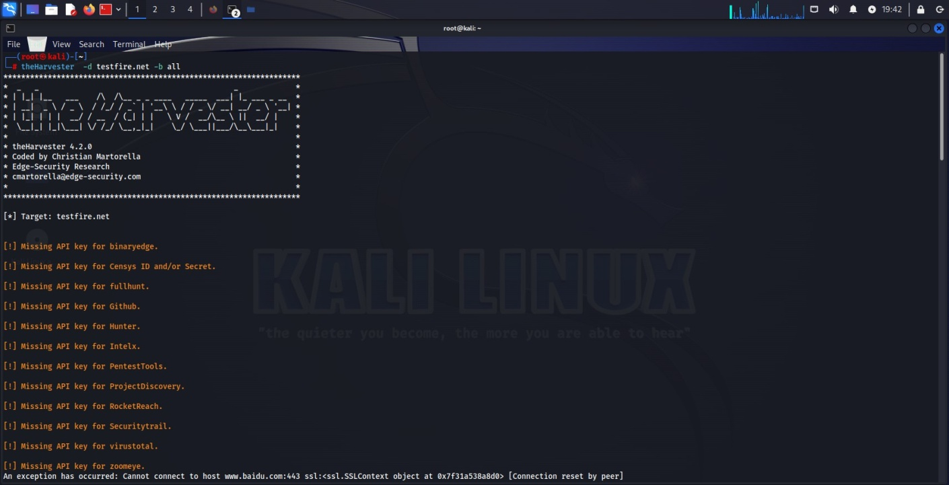

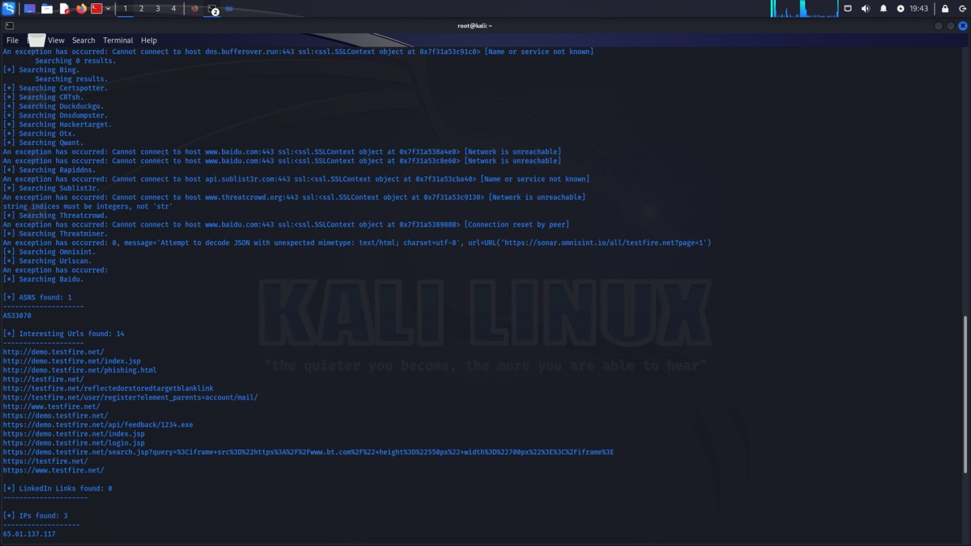

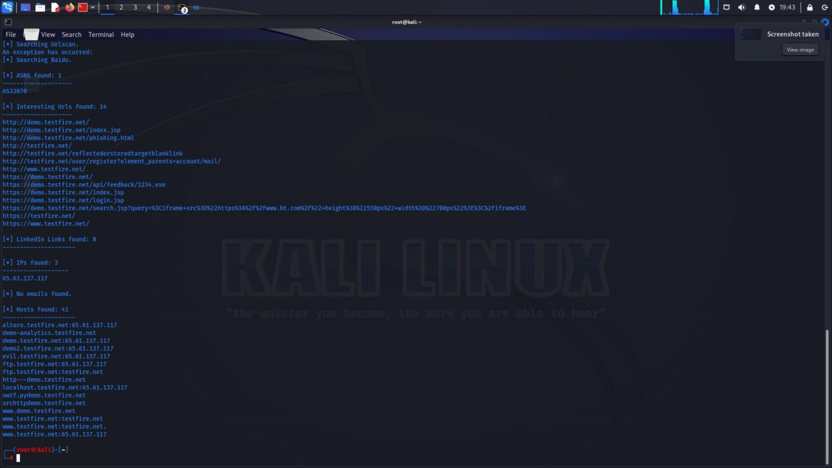

### DNS INFORMATION GATHERING

**Website link of Altoro Mutual Dns result**

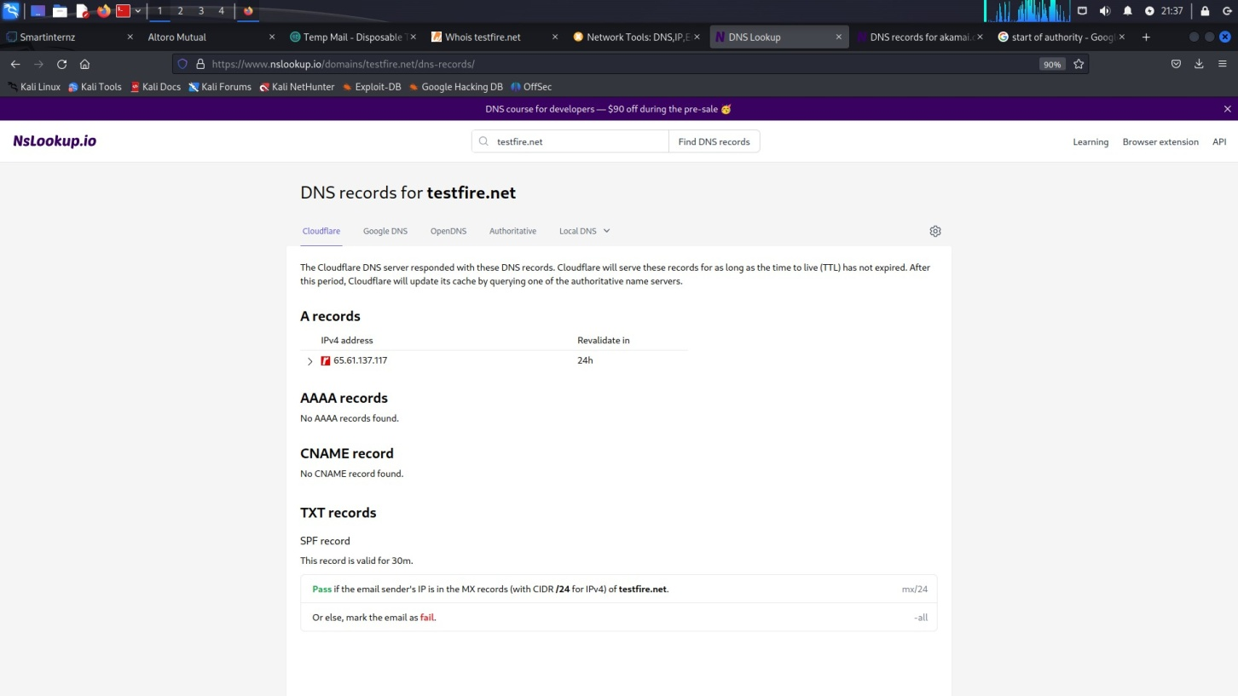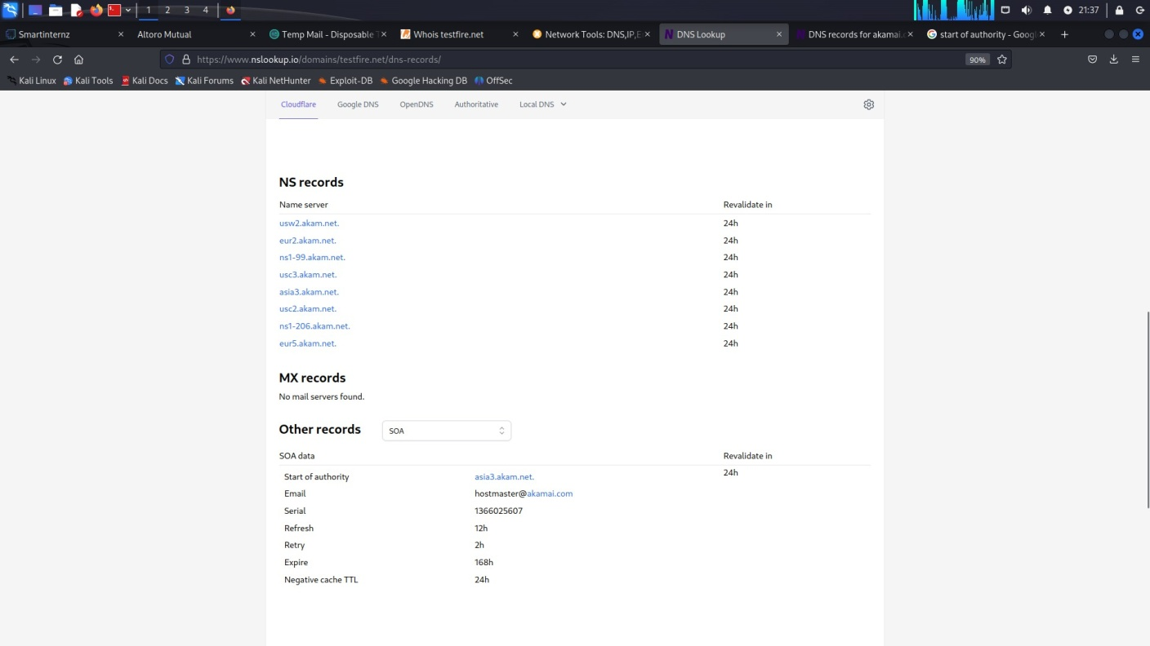[https://www.nslookup.io/domains/testﬁre.net/dns-records/](https://www.nslookup.io/domains/testfire.net/dns-records/)

### WHOIS INFORMATION GATHERING

**Website of whois ip result link of Altoro Mutual**

[https://www.whois.com/whois/testﬁre.net](https://www.whois.com/whois/testfire.net)

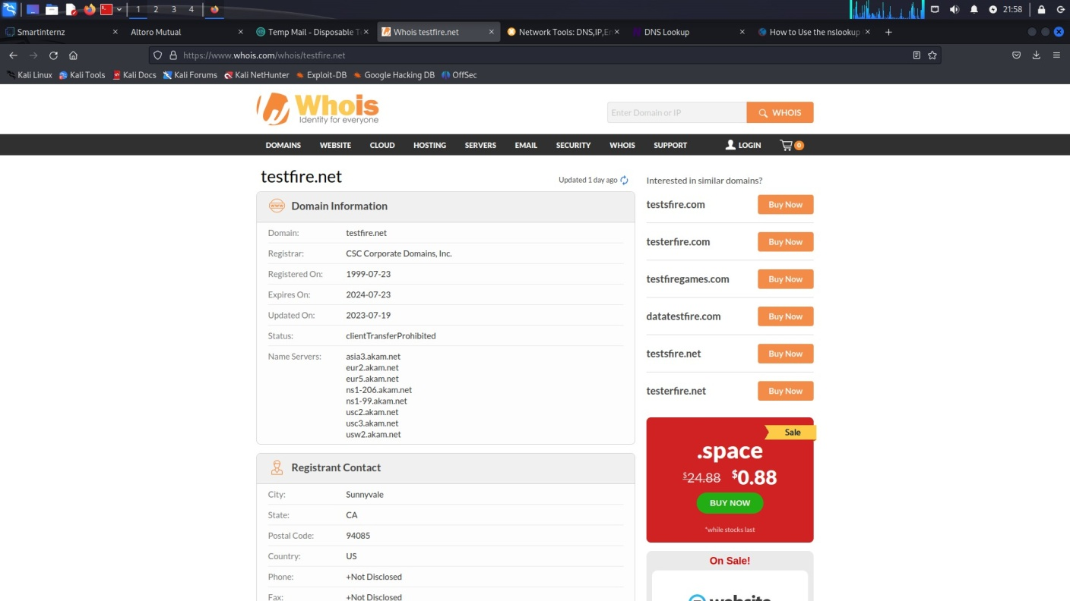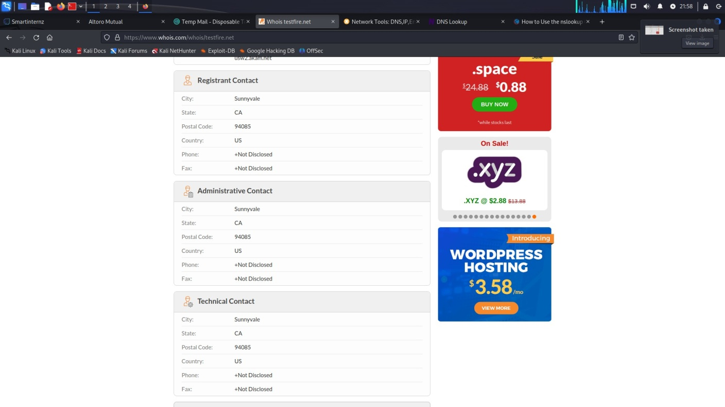

### SHADON

SHODAN: Shodan is a search engine designed to ﬁnd internet-connected devices and systems. It can provide information about a website's servers, open ports, and other internet-facing assets.

**Website of shodan result of Altoro Mutual**

<https://www.shodan.io/host/65.61.137.117>

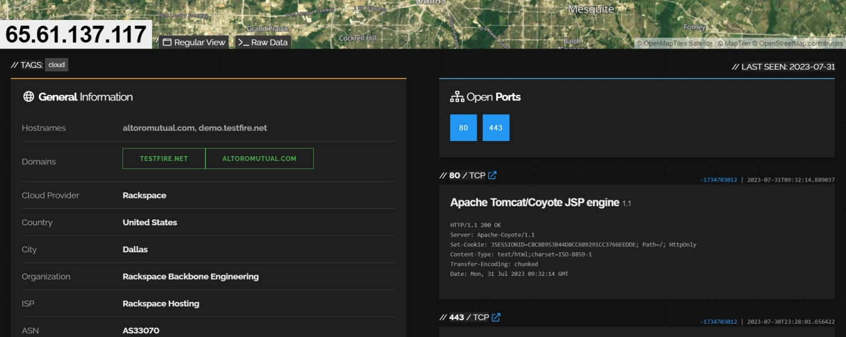

### Vulnerability Report





**altoroMutual**

Report generated by Nessus™ Sun, 30 Jul 2023 20:46:19 IST

**Vulnerabilities by Host**

* 65.61.137.117



•

# Vulnerabilities by Host

|  |  |  |  |  |
| --- | --- | --- | --- | --- |
|  | | **65.61.137.117** |  | |
| 0 | 0 | 1 | 0 | 20 |
| CRITICAL | HIGH | MEDIUM | LOW | INFO |

Scan Information

Start time: Sun Jul 30 19:36:58 2023

End time: Sun Jul 30 20:46:19 2023



Host Information

IP: 65.61.137.117

OS: CISCO PIX 7.0

Vulnerabilities

Synopsis

The remote service encrypts traffic using an older version of TLS.

Description

The remote service accepts connections encrypted using TLS 1.0. TLS 1.0 has a number of cryptographic design flaws. Modern implementations of TLS 1.0 mitigate these problems, but newer versions of TLS like

1.2 and 1.3 are designed against these flaws and should be used whenever possible.

As of March 31, 2020, Endpoints that aren’t enabled for TLS 1.2 and higher will no longer function properly with major web browsers and major vendors.

PCI DSS v3.2 requires that TLS 1.0 be disabled entirely by June 30, 2018, except for POS POI terminals (and the SSL/TLS termination points to which they connect) that can be verified as not being susceptible to any known exploits.

See Also

<https://tools.ietf.org/html/draft-ietf-tls-oldversions-deprecate-00>

Solution

Enable support for TLS 1.2 and 1.3, and disable support for TLS 1.0.

Risk Factor Medium

CVSS v3.0 Base Score

6.5 (CVSS:3.0/AV:N/AC:H/PR:N/UI:N/S:U/C:H/I:L/A:N)

CVSS v2.0 Base Score

* 1. (CVSS2#AV:N/AC:H/Au:N/C:C/I:P/A:N)

References

XREF [CWE:327](http://cwe.mitre.org/data/definitions/327)

Plugin Information

Published: 2017/11/22, Modified: 2023/04/19

Plugin Output



tcp/443/ww



Synopsis

Nessus has detected potential virtual hosts.

Description

Hostnames different from the current hostname have been collected by miscellaneous plugins. Nessus has generated a list of hostnames that point to the remote host. Note that these are only the alternate hostnames for vhosts discovered on a web server.

Different web servers may be hosted on name-based virtual hosts.

See Also <https://en.wikipedia.org/wiki/Virtual_hosting>

Solution

If you want to test them, re-scan using the special vhost syntax, such as : [www.example.com](http://www.example.com/)[192.0.32.10]

Risk Factor None

Plugin Information

Published: 2010/04/29, Modified: 2022/08/15

Plugin Output tcp/0

Synopsis

It was possible to enumerate CPE names that matched on the remote system.

Description

By using information obtained from a Nessus scan, this plugin reports CPE (Common Platform Enumeration) matches for various hardware and software products found on a host.

Note that if an official CPE is not available for the product, this plugin computes the best possible CPE based on the information available from the scan.

See Also <http://cpe.mitre.org/>

<https://nvd.nist.gov/products/cpe>

Solution n/a Risk Factor None

Plugin Information

Published: 2010/04/21, Modified: 2023/07/27 Plugin Output tcp/0

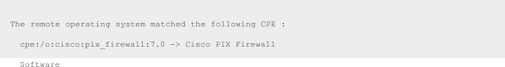



Synopsis

It is possible to guess the remote device type.

Description

Based on the remote operating system, it is possible to determine what the remote system type is (eg: a printer, router, general-purpose computer, etc).

Solution n/a Risk Factor None

Plugin Information

Published: 2011/05/23, Modiﬁed: 2022/09/09 Plugin Output tcp/



Synopsis

It is possible to determine which TCP ports are open.

Description

This plugin is a SYN 'half-open' port scanner. It shall be reasonably quick even against a firewalled target.

Note that SYN scans are less intrusive than TCP (full connect) scans against broken services, but they might cause problems for less robust firewalls and also leave unclosed connections on the remote target, if the network is loaded.

Solution

Protect your target with an IP filter. Risk Factor None

Plugin Information

Published: 2009/02/04, Modified: 2023/06/20 Plugin

Output



tcp/80



Synopsis

It is possible to determine which TCP ports are open.

Description

This plugin is a SYN 'half-open' port scanner. It shall be reasonably quick even against a firewalled target.

Note that SYN scans are less intrusive than TCP (full connect) scans against broken services, but they might cause problems for less robust firewalls and also leave unclosed connections on the remote target, if the network is loaded.

Solution

Protect your target with an IP filter. Risk Factor None

Plugin Information

Published: 2009/02/04, Modified: 2023/06/20 Plugin Output tcp/443/www





Synopsis

It is possible to determine which TCP ports are open.

Description

This plugin is a SYN 'half-open' port scanner. It shall be reasonably quick even against a firewalled target.

Note that SYN scans are less intrusive than TCP (full connect) scans against broken services, but they might cause problems for less robust firewalls and also leave unclosed connections on the remote target, if the network is loaded.

Solution

Protect your target with an IP filter. Risk Factor None

Plugin Information

Published: 2009/02/04, Modified: 2023/06/20 Plugin Output tcp/8080



Synopsis

This plugin displays information about the Nessus scan.

Description

This plugin displays, for each tested host, information about the scan itself :

* The version of the plugin set.
* The type of scanner (Nessus or Nessus Home).
* The version of the Nessus Engine.
* The port scanner(s) used.
* The port range scanned.
* The ping round trip time
* Whether credentialed or third-party patch management checks are possible.
* Whether the display of superseded patches is enabled
* The date of the scan.
* The duration of the scan.
* The number of hosts scanned in parallel.
* The number of checks done in parallel. Solution n/a

Risk Factor None

Plugin Information

Published: 2005/08/26, Modified: 2023/04/27 Plugin Output tcp

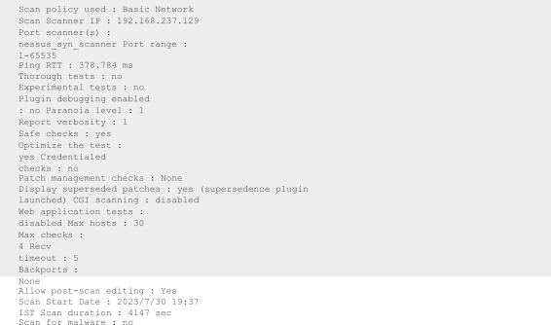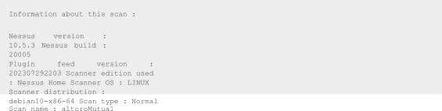



Synopsis

It is possible to guess the remote operating system.

Description

Using a combination of remote probes (e.g., TCP/IP, SMB, HTTP, NTP, SNMP, etc.), it is possible to guess the name of the remote operating system in use. It is also possible sometimes to guess the version of the operating system.

Solution n/a Risk Factor None

Plugin Information

Published: 2003/12/09, Modified: 2022/03/09

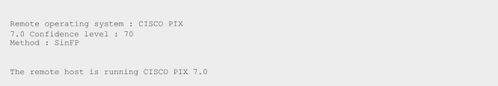



Synopsis

The remote service encrypts communications.

Description

This plugin detects which SSL and TLS versions are supported by the remote service for encrypting communications.

Solution n/a Risk Factor None

Plugin Information

Published: 2011/12/01, Modified: 2023/07/10 Plugin Output tcp/443/www





Synopsis

This plugin displays the SSL certificate.

Description

This plugin connects to every SSL-related port and attempts to extract and dump the X.509 certificate. Solution n/a

Risk Factor None

Plugin Information

Published: 2008/05/19, Modified: 2021/02/03

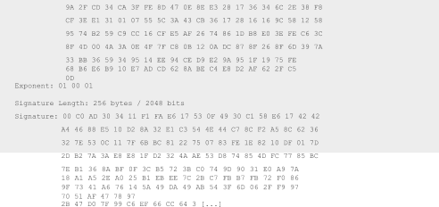

Synopsis

A known CA SSL certificate in the certificate chain has been signed using a weak hashing algorithm.

Description

The remote service uses a known CA certificate in the SSL certificate chain that has been signed using a cryptographically weak hashing algorithm (e.g., MD2, MD4, MD5, or SHA1). These signature algorithms are known to be vulnerable to collision attacks (CVE-2004-2761, for example). An attacker can exploit this to generate another certificate with the same digital signature, allowing the attacker to masquerade as the affected service.

Note that this plugin reports all SSL certificate chains signed with SHA-1 that expire after January 1, 2017 as vulnerable. This is in accordance with Google's gradual sunsetting of the SHA-1 cryptographic hash algorithm.

Note that this plugin will only fire on root certificates that are known certificate authorities as listed in Tenable Community Knowledge Article 000001752. That is what differentiates this plugin from plugin 35291, which will fire on any certificate, not just known certificate authority root certificates.

Known certificate authority root certificates are inherently trusted and so any potential issues with the signature, including it being signed using a weak hashing algorithm, are not considered security issues.

See Also

<http://www.nessus.org/u?ae636e78> <https://tools.ietf.org/html/rfc3279> <http://www.nessus.org/u?9bb87bf2>

Solution

Contact the Certificate Authority to have the certificate reissued. Risk Factor None

References

BID [11849](http://www.securityfocus.com/bid/11849)

BID [33065](http://www.securityfocus.com/bid/33065)

XREF [CWE:310](http://cwe.mitre.org/data/definitions/310)

Plugin Information

Published: 2016/12/08, Modified: 2022/10/12 Plugin Output tcp/443/www



The following known CA certificates were part of the certificate chain sent by the remote host, but contain hashes that are considered to be weak.

Subject Services

: C=GB/ST=Greater Manchester/L=Salford/O=Comodo CA Limited/CN=AAA Certificate

Signature Algorithm : SHA-1 With RSA Encryption Valid From : Jan 01 00:00:00 2004 GMT Valid To : Dec 31 23:59:59 2028 GMT

Raw PEM certificate :

-----BEGIN CERTIFICATE-----

MIIEMjCCAxqgAwIBAgIBATANBgkqhkiG9w0BAQUFADB7MQswCQYDVQQGEwJHQjEbMBkGA1UECAwSR3JlYXRlciBNYW5jaGVzdGV yMRAwDgYDVQQHDA

+GB+O5AL686tdUIoWMQuaBtDFcCLNSS1UY8y2bmhGC1Pqy0wkwLxyTurxFa70VJoSCsN6sjNg4tqJVfMiWPPe3M/ vg4aijJRPn2jymJBGhCfHdr/jzDUsi14HZGWCwEiwqJH5YZ92IFCokcdmtet4YgNW8IoaE+oxox6gmf049vYnMlhvB/ VruPsUK6+3qszWY19zjNoFmag4qMsXeDZRrOme9Hg6jc8P2ULimAyrL58OAd7vn5lJ8S3frHRNG5i1R8XlKdH5kBjHYpy

+g8cmez6KJcfA3Z3mNWgQIJ2P2N7Sw4ScDV7oL8kCAwEAAaOBwDCBvTAdBgNVHQ4EFgQUoBEKIz6W8Qfs4q8p74Klf9AwpLQwDg YDVR0PAQH/ BAQDAgEGMA8GA1UdEwEB/

wQFMAMBAf8wewYDVR0fBHQwcjA4oDagNIYyaHR0cDovL2NybC5jb21vZG9jYS5jb20vQUFBQ2VydGlmaWNhdGVTZXJ2aWNlcy5j cmwwNqA0oDKGMGh

+k+tZ7xkSAzk/ExfYAWMymtrwUSWgEdujm7l3sAg9g1o1QGE8mTgHj5rCl7r

+8dFRBv/38ErjHT1r0iWAFf2C3BUrz9vHCv8S5dIa2LX1rzNLzRt0vxuBqw8M0Ayx9lt1awg6nCpnBBYurDC/ zXDrPbDdVCYfeU0BsWO/8tqtlbgT2G9w84FoVxp7Z8VlIMCFlA2zs6SFz7JsDoeA3raAVGI/6ugLOpyypEBMs1OUIJqsil2D4kF 501KKaU73yqWjgo

+ev+to51byrvLjKzg6CYG1a4XXvi3tPxq3smPi9WIsgtRqAEFQ8TmDn5XpNpaYbg==

-----END CERTIFICATE-----



Synopsis

The remote service supports the use of SSL Cipher Block Chaining ciphers, which combine previous blocks with subsequent ones.

Description

The remote host supports the use of SSL ciphers that operate in Cipher Block Chaining (CBC) mode. These cipher suites offer additional security over Electronic Codebook (ECB) mode, but have the potential to leak information if used improperly.

See Also

[https://www.openssl.org/docs/manmaster/man1/ciphers.](https://www.openssl.org/docs/manmaster/man1/ciphers.html) [html](https://www.openssl.org/docs/manmaster/man1/ciphers.html) <http://www.nessus.org/u?cc4a822a> <https://www.openssl.org/~bodo/tls-cbc.txt>

Solution n/a Risk Factor None

Plugin Information

|  |  |  |  |  |  |  |
| --- | --- | --- | --- | --- | --- | --- |
| Here is the list of SSL CBC ciphers supported  : High Strength Ciphers (>= 112-bit key)  Name Code | | by | the remote  KEX | server  Auth | Encryption | MAC |
| DHE-RSA-AES128-SHA | 0x00,  0x33  0x00,  0x39  0xC0,  0x13  0xC0,  0x14  0x00,  0x67 | DH | | RSA | AES-CBC(128) |  |
| SHA1 |  | |  |  |
| DHE-RSA-AES256-SHA | DH | | RSA | AES-CBC(256) |
| SHA1 |  | |  |  |
| ECDHE-RSA-AES128-SHA | ECDH | | RSA | AES-CBC(128) |
| SHA1 |  | |  |  |
| ECDHE-RSA-AES256-SHA | ECDH | | RSA | AES-CBC(256) |
| SHA1 |  | |  |  |
| DHE-RSA-AES128-SHA256 | DH | | RSA | AES-CBC(128) |
| SHA256 |  | |  |  |

Published: 2013/10/22, Modified: 2021/02/03 Plugin Output tcp/443/www

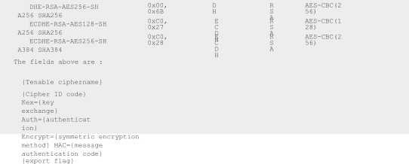

Synopsis

The remote service encrypts communications using SSL.

Description

This plugin detects which SSL ciphers are supported by the remote service for encrypting communications.

See Also

[https://www.openssl.org/docs/man1.0.2/man1/ciphers.ht](https://www.openssl.org/docs/man1.0.2/man1/ciphers.html) [ml](https://www.openssl.org/docs/man1.0.2/man1/ciphers.html) <http://www.nessus.org/u?e17ffced>

Solution n/a Risk Factor None

Plugin Information

Published: 2006/06/05, Modified: 2023/07/10

Plugin Output tcp/443/ww w

|  |  |  |  |  |  |  |  |  |  |
| --- | --- | --- | --- | --- | --- | --- | --- | --- | --- |
| Here is the list of SSL ciphers supported  : Each group is reported per SSL Version.  SSL Version : TLSv12  High Strength Ciphers (>= 112-bit key)  Name Code | | by | | the | remote  KEX | server | Auth | Encryption | MAC |
| DHE-RSA-AES128-SHA256  SHA256 | 0x00,  0x9E | | DH | | | RSA | | AES-GCM(128) |  |

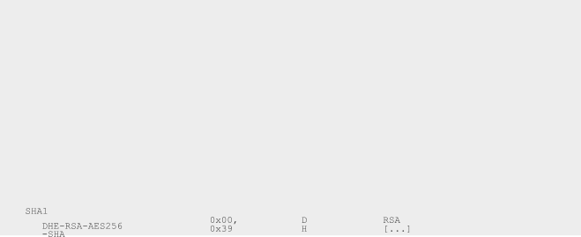

DHE-RSA-AES256-SHA384

SHA384

ECDHE-RSA-AES128-SHA256

SHA256

ECDHE-RSA-AES256-SHA384

SHA384

DHE-RSA-AES128-SHA

SHA1

DHE-RSA-AES256-SHA

SHA1

ECDHE-RSA-AES128-SHA

SHA1

0x00,

0x9F

DH

RSA

AES-GCM(256)

0xC0,

0x2F

ECDH

RSA

AES-GCM(128)

0xC0,

0x30

ECDH

RSA

AES-GCM(256)

0x00,

0x33

DH

RSA

AES-CBC(128)

0x00,

0x39

DH

RSA

AES-CBC(256)

0xC0,

0x13

ECDH

RSA

AES-CBC(128)

ECDHE-RSA-AES256-SH A SHA1

DHE-RSA-AES128-SHA25 6 SHA256

DHE-RSA-AES256-SHA25 6 SHA256

ECDHE-RSA-AES128-SHA25 6 SHA256

ECDHE-RSA-AES256-SHA38 4 SHA384

0xC0,

0x14

0x00,

0x67

0x00,

0x6B

0xC0,

0x27

0xC0,

0x28

ECD

RSA

AES-CBC(256

H

RSA

)

DH

RSA

AES-CBC(128

DH

RSA

)

ECD

RSA

AES-CBC(256

H

)

ECD AES-CBC(128

H

)

AES-CBC(256

)

SSL Version : TLSv1

High Strength Ciphers (>= 112-bit key)



Synopsis

The remote service supports the use of SSL Perfect Forward Secrecy ciphers, which maintain confidentiality even if the key is stolen.

Description

The remote host supports the use of SSL ciphers that offer Perfect Forward Secrecy (PFS) encryption. These cipher suites ensure that recorded SSL traffic cannot be broken at a future date if the server's private key is compromised.

See Also

[https://www.openssl.org/docs/manmaster/man1/ciphers.](https://www.openssl.org/docs/manmaster/man1/ciphers.html) [html](https://www.openssl.org/docs/manmaster/man1/ciphers.html)

[https://en.wikipedia.org/wiki/Diffie-Hellman_key_exchang](https://en.wikipedia.org/wiki/Diffie-Hellman_key_exchange) [e](https://en.wikipedia.org/wiki/Diffie-Hellman_key_exchange) <https://en.wikipedia.org/wiki/Perfect_forward_secrecy>

Solution n/a Risk Factor None

Plugin Information

Published: 2011/12/07, Modified: 2021/03/09 Plugin Output tcp/443/ww

|  |  |  |  |  |  |  |  |
| --- | --- | --- | --- | --- | --- | --- | --- |
| Here is the list of SSL PFS ciphers supported  : High Strength Ciphers (>= 112-bit key)  Name Code | | | by | the remote  KEX | server  Auth | Encryption | MAC |
| DHE-RSA-AES128-SHA256  SHA256  DHE-RSA-AES256-SHA384  SHA384  ECDHE-RSA-AES128-SHA256  SHA256  ECDHE-RSA-AES256-SHA384  SHA384  DHE-RSA-AES128-SHA  SHA1 | 0x00,  0x9E  0x00,  0x9F  0xC0,  0x2F  0xC0,  0x30  0x00,  0x33 | DH | | | RSA | AES-GCM(128) |  |
| DH | | | RSA | AES-GCM(256) |
| ECDH | | | RSA | AES-GCM(128) |
| ECDH | | | RSA | AES-GCM(256) |
| DH | | | RSA | AES-CBC(128) |

|  |  |  |  |  |  |
| --- | --- | --- | --- | --- | --- |
| DHE-RSA-AES256-SHA | 0x00, | 0x39 | DH | RSA | AES-CBC(256) |
| SHA1  ECDHE-RSA-AES128-SHA | 0xC0, | 0x13 | ECDH | RSA | AES-CBC(128) |
| SHA1  ECDHE-RSA-AES256-SHA | 0xC0, | 0x14 | ECDH | RSA | AES-CBC(256) |
| SHA1  DHE-RSA-AES128-SHA256 | 0x00, | 0x67 | DH | RSA | AES-CBC(128) |
| SHA256  DHE-RSA-AES256-SHA256 | 0x00, | 0x6B | DH | RSA | AES-CBC(256) |
| SHA256  ECDHE-RSA-AES128-SHA256 | 0xC0, | 0x27 | ECDH | RSA | AES-CBC(128) |
| SHA256  ECDHE-RSA-AES256-SHA384 | 0xC0, | 0x28 | ECDH | RSA | AES-CBC(256) |
| SHA384 |  |  |  |  |  |
| The fields above are :  {Tenable ciphername}  {Cipher ID code} Kex={key exchange} Auth={authentication  }  Encrypt={symmetric encryption method} MAC={message authentication code}  {export flag} | | | | | |



Synopsis

A root Certification Authority certificate was found at the top of the certificate chain.

Description

The remote service uses an SSL certificate chain that contains a self-signed root Certification Authority certificate at the top of the chain.

See Also

[https://docs.microsoft.com/en-us/previous-versions/windows/it-pro/windows-server-2003/](https://docs.microsoft.com/en-us/previous-versions/windows/it-pro/windows-server-2003/cc778623(v%3Dws.10)) [cc778623(v=ws.10)](https://docs.microsoft.com/en-us/previous-versions/windows/it-pro/windows-server-2003/cc778623(v%3Dws.10))

Solution

Ensure that use of this root Certification Authority certificate complies with your organization's acceptable use and security policies.

Risk Factor None Plugin Information

Published: 2016/11/14, Modified: 2018/11/15 Plugin Output tcp/443/www

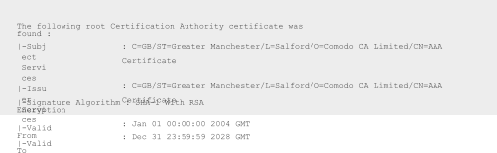

Synopsis

The remote host advertises discouraged SSL/TLS ciphers.

Description

The remote host has open SSL/TLS ports which advertise discouraged cipher suites. It is recommended to only enable support for the following cipher suites:

TLSv1.3:

- 0x13,0x01 TLS13_AES_128_GCM_SHA256

- 0x13,0x02 TLS13_AES_256_GCM_SHA384

- 0x13,0x03 TLS13_CHACHA20_POLY1305_SHA256

TLSv1.2:

* 0xC0,0x2B ECDHE-ECDSA-AES128-GCM-SHA256
* 0xC0,0x2F ECDHE-RSA-AES128-GCM-SHA256
* 0xC0,0x2C ECDHE-ECDSA-AES256-GCM-SHA384
* 0xC0,0x30 ECDHE-RSA-AES256-GCM-SHA384
* 0xCC,0xA9 ECDHE-ECDSA-CHACHA20-POLY1305
* 0xCC,0xA8 ECDHE-RSA-CHACHA20-POLY1305
* 0x00,0x9E DHE-RSA-AES128-GCM-SHA256
* 0x00,0x9F DHE-RSA-AES256-GCM-SHA384

This is the recommended configuration for the vast majority of services, as it is highly secure and compatible with nearly every client released in the last five (or more) years.

See Also

[https://wiki.mozilla.org/Security/Server_Side_](https://wiki.mozilla.org/Security/Server_Side_TLS) [TLS](https://wiki.mozilla.org/Security/Server_Side_TLS) <https://ssl-config.mozilla.org/>

Solution

Only enable support for recommened cipher suites. Risk Factor None

Plugin Information

Published: 2022/01/20, Modified: 2023/07/1

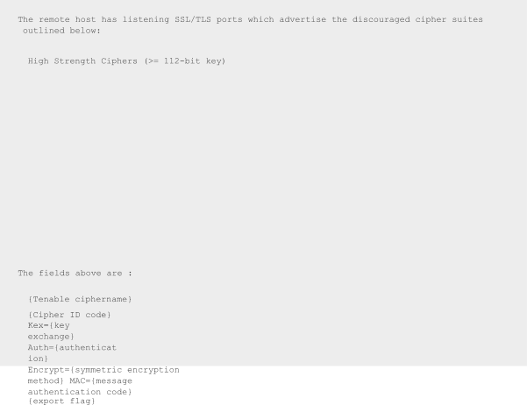Plugin Output tcp/443/www

|  |  |  |  |  |  |
| --- | --- | --- | --- | --- | --- |
| Name | Code | KEX | Auth | Encryption | MAC |
| DHE-RSA-AES128-SHA  SHA1  DHE-RSA-AES256-SHA  SHA1  ECDHE-RSA-AES128-SHA  SHA1  ECDHE-RSA-AES256-SHA  SHA1  DHE-RSA-AES128-SHA256  SHA256  DHE-RSA-AES256-SHA256  SHA256  ECDHE-RSA-AES128-SHA256  SHA256  ECDHE-RSA-AES256-SHA384  SHA384 | 0x00,  0x33  0x00,  0x39  0xC0,  0x13  0xC0,  0x14  0x00,  0x67  0x00,  0x6B  0xC0,  0x27  0xC0,  0x28 | DH | RSA | AES-CBC(128) |  |
| DH | RSA | AES-CBC(256) |
| ECDH | RSA | AES-CBC(128) |
| ECDH | RSA | AES-CBC(256) |
| DH | RSA | AES-CBC(128) |
| DH | RSA | AES-CBC(256) |
| ECDH | RSA | AES-CBC(128) |
| ECDH | RSA | AES-CBC(256) |



Synopsis

The remote service could be identified.

Description

Nessus was able to identify the remote service by its banner or by looking at the error message it sends when it receives an HTTP request.

Solutio n n/a

Risk Factor None

Plugin Information

Published: 2007/08/19, Modified: 2023/07/10 Plugin Output tcp/443/www

tcp/443/www



Synopsis

The remote service encrypts traffic using a version of TLS.

Description

The remote service accepts connections encrypted using TLS 1.2.

See Also <https://tools.ietf.org/html/rfc5246>

Solution N/A Risk Factor None

Plugin Information



Published: 2020/05/04, Modified: 2020/05/04 Plugin Output tcp/443/www

Synopsis

It was possible to obtain traceroute information.

Description

Makes a traceroute to the remote host. Solution n/a

Risk Factor None

Plugin Information

Published: 1999/11/27, Modified: 2023/06/26 Plugin Output udp/0

### Business Impact

**Plugin ID: 46180 - Additional DNS Hostnames Synopsis:**

The Nessus vulnerability scan has detected potential virtual hosts with diﬀerent hostnames pointing to the remote host

### Impact:

* + 1. Resource Allocation
    2. Security Implications
    3. Website Reputation and Trust
    4. Search Engine Optimization (SEO)

### Recommended Actions:

1. Review Virtual Host Conﬁguration
2. Monitor Resource Usage
3. Implement Security Measures
4. Monitor Website Reputation
5. Address SEO Concerns

### Plugin ID: 45590 - Common Platform Enumeration (CPE) Synopsis:

The Nessus scan has enumerated Common Platform Enumeration (CPE) names that match the remote system.

### Impact:

1. Vulnerability Identiﬁcation and Management
2. Asset Inventory and Visibility
3. Regulatory Compliance

5. Risk Assessment and Mitigation

### Recommended Actions:

1. Regular Scanning and Enumeration
2. Patch Management
3. Vulnerability Monitoring
4. Asset Inventory and Lifecycle Management
5. Compliance Reporting

### Plugin ID: 45590 - Common Platform Enumeration (CPE) Synopsis:

The Nessus scan has enumerated Common Platform Enumeration (CPE) names that match the remote system.

### Impact:

1. Vulnerability Identiﬁcation and Management
2. Asset Inventory and Visibility
3. Regulatory Compliance
4. Vendor Support and Updates
5. Risk Assessment and Mitigation

### Recommended Actions:

1. Regular Scanning and Enumeration
2. Patch Management
3. Vulnerability Monitoring
4. Asset Inventory and Lifecycle Management
5. Compliance Reporting

### Plugin ID: 54615 - Device Type Synopsis:

The Nessus scan has identiﬁed the remote device type based on the remote operating system.

### Impact:

1. Device Proﬁling
2. Security Policy Implementation
3. Network Visibility
4. Incident Response
5. Change Management and Patching

### Recommended Actions:

1. Accurate Device Identiﬁcation
2. Network Segmentation
3. Security Policy Tuning
4. Incident Response Planning

### Plugin ID: 11219 - Nessus SYN scanner Synopsis:

The Nessus SYN scanner is capable of determining which TCP ports are open on a target system.

### Impact:

1. Network Visibility
2. Vulnerability Identiﬁcation
3. Firewall Resilience Assessment
4. Network Load and Performance

### Recommended Actions:

1. Responsible Scanning
2. Firewall Hardening
3. Vulnerability Remediation
4. Monitoring and Incident Response

### Plugin ID: 19506 - Nessus Scan Information Synopsis:

The plugin provides information about the Nessus scan, including details about the version of the plugin set, the type of scanner used the version of the Nessus Engine, the port scanner(s) employed, the port range scanned, ping round trip time, patch management checks, display of superseded patches, date of the scan, scan duration, number of hosts scanned in parallel, and number of checks performed in parallel.

### Impact:

1. Scan Eﬀectiveness
2. Network Resource Utilization
3. Patch Management and Vulnerability Assessment
4. Security Posture Evaluation

### Recommended Actions:

1. Review Scan Conﬁguration
2. Patch Management Improvement
3. Regular Scanning and Updates
4. Network Monitoring

### Plugin ID: 11936 - OS Identiﬁcation Synopsis:

The plugin performs OS identiﬁcation using various remote probes, such as TCP/IP, SMB, HTTP, NTP, SNMP, etc.

### Impact:

1. System Proﬁling
2. Vulnerability Assessment
3. Security Posture Evaluation
4. Network Hardening
5. Compliance and Regulatory Requirements:

### Recommended Actions:

1. Asset Inventory and Documentation
2. Patch Management
3. Security Control Customization
4. Network Segmentation

### Plugin ID: 56984 - SSL / TLS Versions Supported Synopsis:

The plugin is used to detect which SSL and TLS versions are supported by the remote service for encrypting communications.

### Impact:

1. Data Security
2. Compliance and Industry Standards
3. Vulnerability Assessment
4. Public Trust and Reputation

### Recommended Actions:

1. TLS Conﬁguration Review
2. Patch and Update SSL/TLS Libraries
3. Regular Security Assessments
4. Compliance Alignment

### Plugin ID: 10863 - SSL Certiﬁcate Information Synopsis:

The plugin connects to every SSL-related port and attempts to extract and dump the X.509 certiﬁcate.

### Impact:

1. Certiﬁcate Validity and Trustworthiness
2. Mitigating Certiﬁcate-Related Risks
3. Trust and User Conﬁdence
4. Vulnerability Assessment

### Recommended Actions:

1. Certiﬁcate Monitoring and Renewal
2. SSL Conﬁguration Review
3. Certiﬁcate Transparency
4. Public Key Infrastructure (PKI) Management

### Plugin ID: 95631 - SSL Certiﬁcate Signed Using Weak Hashing Algorithm (Known CA) Synopsis:

The plugin identiﬁes that the remote service uses a known Certiﬁcate Authority (CA) SSL certiﬁcate in the certiﬁcate chain that has been signed using a cryptographically weak hashing algorithm (e.g., MD2, MD4, MD5, or SHA1).

### Impact:

1. Trustworthiness and Integrity
2. Data Privacy and Conﬁdentiality
3. Compliance and Regulatory Concerns
4. Business Reputation

### Recommended Actions:

1. Certiﬁcate Replacement
2. SSL/TLS Conﬁguration Review
3. Certiﬁcate Lifecycle Management
4. Compliance Alignment

### Plugin ID: 70544 - SSL Cipher Block Chaining Cipher Suites Supported Synopsis:

The plugin identiﬁes that the remote service supports the use of SSL Cipher Block Chaining (CBC) ciphers. CBC mode is a cryptographic technique.

### Impact:

1. Data Conﬁdentiality
2. Vulnerability to Padding Oracle Attacks
3. Compliance and Security Standards
4. Mitigation Strategies

### Recommended Actions:

1. SSL/TLS Conﬁguration Review
2. Regular Software Updates
3. Vulnerability Assessments
4. Monitoring and Logging

### Plugin ID: 21643 - SSL Cipher Suites Supported Synopsis:

The plugin identiﬁes that the remote service encrypts communications using SSL.

### Impact:

1. Data Conﬁdentiality
2. Secure Communication Channel
3. Compliance with Security Standards

### Recommended Actions:

1. SSL/TLS Conﬁguration Review
2. Regular Software Updates
3. Vulnerability Assessments
4. Compliance Validation

### Plugin ID: 57041 - SSL Perfect Forward Secrecy Cipher Suites Supported Synopsis:

The plugin identiﬁes that the remote service supports the use of SSL Perfect Forward Secrecy (PFS) cipher suites.

### Impact:

1. Data Conﬁdentiality
2. Mitigation of Future Threats
3. Compliance and Regulatory Requirements
4. Protection against Forward Secrecy Attacks

### Recommended Actions:

1. SSL/TLS Conﬁguration Review
2. Regular Software Updates
3. Key Management Practices
4. Security Monitoring and Incident Response

### Plugin ID: 94761 - SSL Root Certiﬁcation Authority Certiﬁcate Information Synopsis:

The plugin identiﬁes that the remote service uses an SSL certiﬁcate chain containing a self-signed root Certiﬁcation Authority (CA) certiﬁcate at the top of the chain.

### Impact:

1. Certiﬁcate Trust and Security
2. Lack of Third-party Validation
3. Compliance and Regulatory Concerns
4. Certiﬁcate Chain Validation

### Recommended Actions:

1. Obtain a Trusted Root CA Certiﬁcate
2. Certiﬁcate Lifecycle Management
3. Certiﬁcate Chain Validation
4. Compliance and Security Policy Review

### Plugin ID: 156899 - SSL/TLS Recommended Cipher Suites Synopsis:

The plugin identiﬁes that the remote host advertises discouraged SSL/TLS cipher suites.

### Impact:

1. Data Security
2. Compatibility and Interoperability
3. Trust and Reputation
4. Compliance with Security Standards

### Recommended Actions:

1. SSL/TLS Conﬁguration Review
2. Regular Software Updates
3. Vulnerability Assessments
4. Testing and Monitoring

### Plugin ID: 22964 - Service Detection Synopsis:

The plugin identiﬁes that the remote service could be identiﬁed based on its banner or the error message it sends when it receives an HTTP request.

### Impact:

1. System Identiﬁcation
2. Vulnerability Assessment
3. Attack Surface Evaluation
4. Security Conﬁguration Review

### Recommended Actions:

1. Service Hardening
2. Patch Management
3. Security Monitoring
4. Access Control

### Plugin ID: 136318 - TLS Version 1.2 Protocol Detection Synopsis:

The plugin identiﬁes that the remote service encrypts traﬃc using TLS 1.2.

### Impact:

1. Data Security
2. Compliance with Security Standards
3. Trust and Reputation
4. Compatibility and Interoperability

### Recommended Actions:

1. TLS Conﬁguration Review
2. Regular Software Updates
3. Vulnerability Assessments
4. Security Awareness Training

### Plugin ID: 10287 - Traceroute Information Synopsis:

The plugin indicates that it was possible to obtain traceroute information from the remote host.

### Impact:

1. Network Topology Understanding
2. Network Performance Assessment
3. Security Implications
4. Potential Misconﬁguration Detection

### Recommended Actions:

1. Regular Network Monitoring
2. Access Control
3. Network Segmentation

### Steps to reproduce the vulnerabilities

**Step 1: Creating a Scan**

Once you have installed and launched Nessus, you’re ready to start scanning. First, you have to create a scan. To create your scan:

* In the top navigation bar, click Scans.
* In the upper-right corner of the My Scans page, click the New Scan button.

### Step 2: Choose a Scan Template

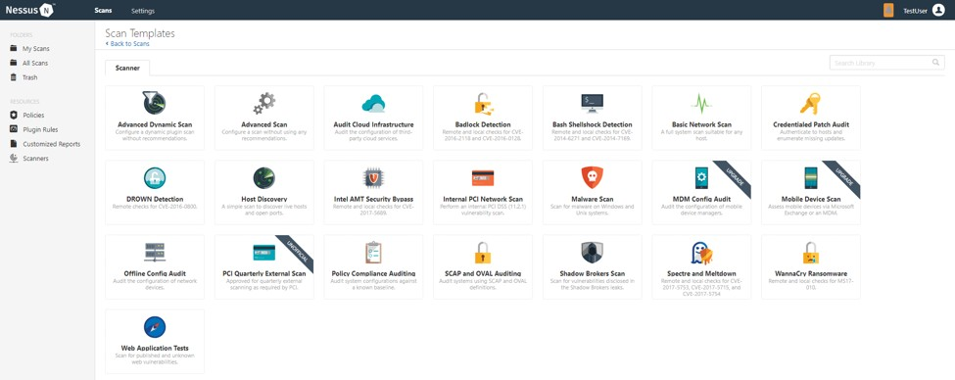

Next, click the scan template you want to use. Scan templates simplify the process by determining which settings are conﬁgurable and how they can be set. For a detailed explanation of all the options available, refer to [Scan and Policy Settings](https://docs.tenable.com/nessus/8_2/Content/TemplateSettings.htm) in the Nessus User Guide.

A scan policy is a set of predeﬁned conﬁguration options related to performing a scan. After you create a policy, you can select it as a template in the User Deﬁned tab when you create a scan. For more information, see [Create a Policy](https://docs.tenable.com/nessus/Content/CreateAPolicy.htm) in the Nessus User Guide.

The Nessus interface provides brief explanations of each template in the product. Some templates are only available when you purchase a fully licensed copy of Nessus Professional.

To see a full list of the types of templates available in Nessus, see [Scan and Policy Templates](https://docs.tenable.com/nessus/Content/ScanAndPolicyTemplates.htm). To quickly get started with Nessus, use the Basic Network Scan template.

### Step 3: Conﬁgure Scan Settings

Prepare your scan by conﬁguring the [settings](https://docs.tenable.com/nessus/Content/ScanAndPolicyTemplates.htm) available for your chosen template. The Basic Network Scan template has several default settings preconﬁgured, which allows you to quickly perform your ﬁrst scan and view results without a lot of eﬀort.

### Follow these steps to run a basic scan:

1. 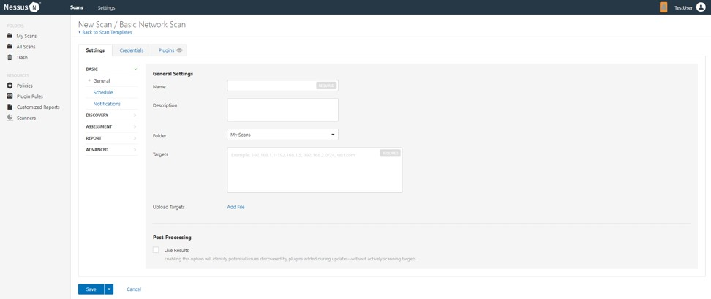**Conﬁgure the settings in the Basic Settings section.**

### The following are Basic settings:

|  |  |
| --- | --- |
| **Setting** | **Description** |
| **Name** | **Speciﬁes the name of the scan or policy. This value is displayed on the Nessus interface.** |
| **Descrip tion** | **(Optional) Speciﬁes a description of the scan or policy.** |
| **Folder** | **e folder where the scan appears after being saved.** |
| **Targets** | **Speciﬁes one or more targets to be scanned. If you select a target group or upload a targets ﬁle, you are not required to specify additional targets.** |

1. **Conﬁgure remaining settings**

Although you can leave the remaining settings at their pre-conﬁgured default, Tenable recommends reviewing the Discovery, Assessment, Report and Advanced settings to ensure they are appropriate for your environment**.**

### For more information, see the [Scan Settings](https://docs.tenable.com/nessus/Content/TemplateSettings.htm) documentation in the Nessus User Guide.

1. **Conﬁgure Credentials**

Optionally, you can conﬁgure Credentials for a scan. This allows credentialed scans to run, which can provide much more complete results and a more thorough evaluation of the vulnerabilities in your environment.

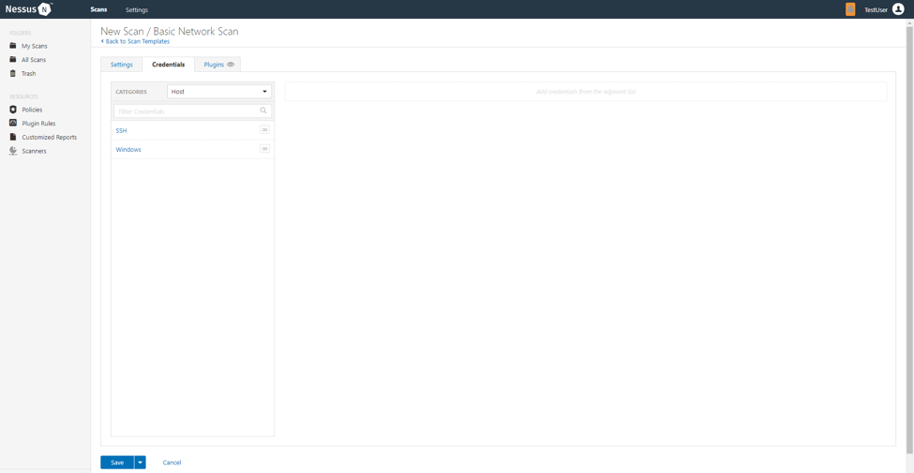

### Launch Scan

After you have conﬁgured all your settings, you can either click the Save button to launch the scan later, or launch the scan immediately.

If you want to launch the scan immediately, click the  button, and then click Launch. Launching the scan will also save it.

The time it takes to complete a scan involves many factors, such as network speed and congestion, so the scan may take some time to run.

### Step 4: Viewing Your Results

Viewing scan results can help you understand your organization’s security posture and vulnerabilities. Color-coded indicators and customizable viewing options allow you to tailor how you view your scan’s data**.**

### You can view scan results in one of several views:

|  |  |
| --- | --- |
| **Page** | **Description** |
| **Hosts** | **Displays all scanned targets.** |

|  |  |
| --- | --- |
| **Vulnerab ilities** | **List of identiﬁed vulnerabilities, sorted by severity.** |
| **Remedia tions** | **If the scan's results include remediation information, this list displays all remediation details, sorted by the number of vulnerabilities.** |
| **Notes** | **Displays additional information about the scan and the scan’s results.** |
| **History** | **Displays a list of scans: Start Time, End Time, and the Scan Statuses.** |

**Viewing scan results by vulnerabilities gives you a view into potential risks on your assets.**

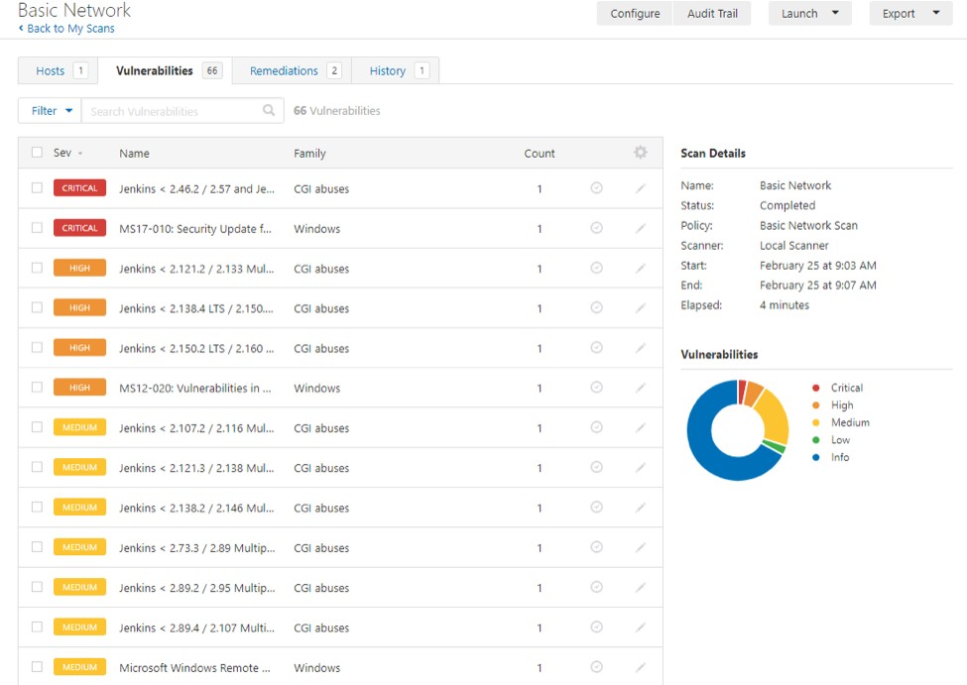

### To view vulnerabilities:

* 1. In the top navigation bar, click Scans.
  2. Click the scan for which you want to view results.
  3. Do one of the following:
     + Click a speciﬁc host to view vulnerabilities found on that host.
     + Click the Vulnerabilities tab to view all vulnerabilities.
  4. (Optional) To sort the vulnerabilities, click an attribute in the table header row to sort by that attribute.
  5. Clicking on the vulnerability row will open the vulnerability details page, displaying plugin information and output for each instance on a host.

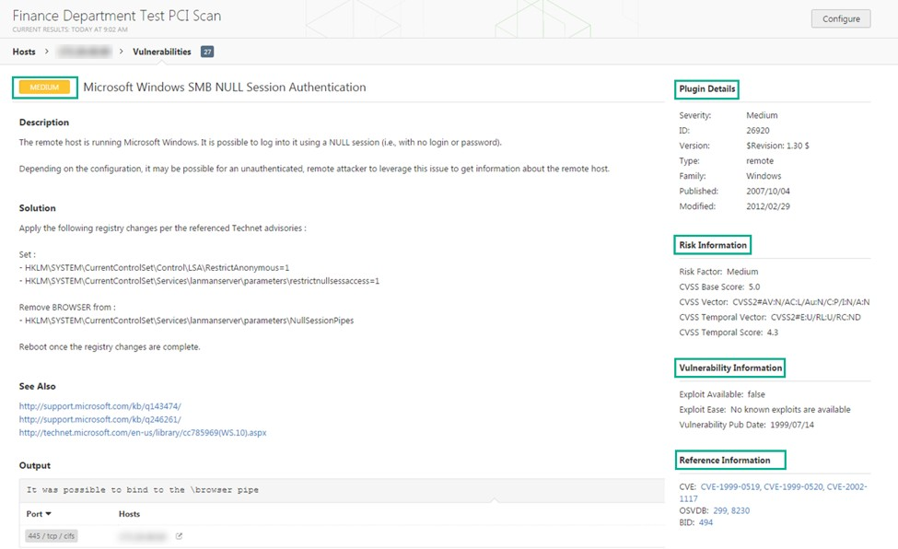

### Step 5: Reporting Your Results

Chances are your job isn’t done yet. You need to report your ﬁndings to your team.

Scan results can be exported in several ﬁle formats. Some of these report formats are customizable, while others are designed to be imported into another application or product, such as Microsoft Excel or Tenable.sc. For an explanation of the various report formats and the purpose of each, see the [Nessus User Guide](https://docs.tenable.com/nessus/8_2/Content/ScanReportFormats.htm).

To Export a Scan Report:

1. Start from a scan's results page
2. In the upper-right corner, click Export.
3. From the drop-down box, select the format in which you want to export the scan results.
4. Click Export to download the report.

### Conclusion

The network vulnerability assessment on the "altoroMutual" system conducted using Nessus Essentials reveals several vulnerabilities that need attention. Here is a summary of the key ﬁndings:

### TLS Version 1.0 Protocol Detection (Vulnerability ID: 104743):

The remote service supports TLS version 1.0, which is considered outdated and has known cryptographic design ﬂaws. Modern implementations of TLS 1.2 and 1.3 are recommended to mitigate these vulnerabilities. TLS 1.0 should be disabled to enhance security and comply with industry standards.

### Additional DNS Hostnames (Vulnerability ID: 46180):

The Nessus scan detected additional DNS hostnames pointing to the remote host. It is important to verify these hostnames to ensure they are legitimate and do not pose security risks.

### Common Platform Enumeration (CPE) (Vulnerability ID: 45590):

The Nessus scan enumerated CPE names that match the remote system. Understanding the CPE information can help in identifying potential vulnerabilities associated with hardware and software products on the host.

### Device Type (Vulnerability ID: 54615):

The Nessus scan inferred the remote device type as a "ﬁrewall" based on the remote operating system information. This helps to identify the nature of the system but does not indicate a vulnerability.

### Nessus SYN Scanner (Vulnerability ID: 11219):

The Nessus scan detected open TCP ports on the remote host using SYN scanning. While this information can be useful for legitimate purposes, it should be monitored to prevent any potential misuse.

### Nessus Scan Information (Vulnerability ID: 19506):

Details about the Nessus scan, including the version of the plugin set, the scanner edition, and the scan duration, were provided. This information helps in understanding the scan results and its conﬁguration.

### OS Identiﬁcation (Vulnerability ID: 11936):

The Nessus scan identiﬁed the remote operating system as "CISCO PIX 7.0" using remote probes. While this information is helpful for system administrators, it does not indicate any security risks.

### 8. SSL/TLS Vulnerabilities (Vulnerability IDs: 56984, 95631, 70544, 10863, 21643, 94761,

**156899):**

Various SSL/TLS-related vulnerabilities were detected, including weak hashing algorithm usage, known CA SSL certiﬁcate usage, support for SSL Cipher Block Chaining, and support for discouraged SSL/TLS cipher suites. These vulnerabilities can potentially compromise the conﬁdentiality and integrity of encrypted communications.

### Recommendations:

Based on the assessment results, the following recommendations are suggested to improve the security of the "altoroMutual" system:

1. Disable TLS version 1.0 and enable support for TLS 1.2 and 1.3 to enhance encryption security and comply with industry standards.
2. Investigate and verify the additional DNS hostnames to ensure that they are legitimate and do not pose security risks.
3. Monitor the open TCP ports identiﬁed by the Nessus SYN scanner to prevent any potential security issues or unauthorized access.
4. Review and understand the CPE information to identify any potential vulnerabilities associated with hardware and software products on the host.
5. Address SSL/TLS-related vulnerabilities, such as replacing certiﬁcates signed with weak hashing algorithms, verifying root Certiﬁcation Authority certiﬁcates, and enabling recommended cipher suites.
6. Regularly update and patch the system to address any known vulnerabilities and improve overall security.
7. Implement proper network security controls, including ﬁrewalls and intrusion detection/prevention systems, to protect against potential threats.

It is essential to address these vulnerabilities promptly to enhance the security posture of the "altoroMutual" system and safeguard sensitive data and communications. Regular vulnerability assessments and security best practices should be followed to ensure ongoing protection against potential threats.